Question – 1

Code:

HTML

<!DOCTYPE html>
<html>
<head>
<title>Q-1</title>
<meta charset="utf-8">
<meta name="viewport" content="width=device-width, initial-scale=1">
<link rel="stylesheet" href="https://maxcdn.bootstrapcdn.com/bootstrap/3.4.1/css/bootstrap.min.css">
<script src="https://ajax.googleapis.com/ajax/libs/jquery/3.7.1/jquery.min.js"></script>
<script src="https://maxcdn.bootstrapcdn.com/bootstrap/3.4.1/js/bootstrap.min.js"></script>
<style>
body {
text-align: center;
}
input {
padding: 5 5;
}
div.v-container {
text-align: left;
display: flex;
flex-direction: column;
margin: 0px 50px;
margin-bottom: 30px;
}
div.h-container {
display: flex;
flex-direction: row;
align-items: start;
gap: 10px;
}
</style>
</head>
<body class="d-flex align-items-center">
<div style="padding: 5px 0px; margin-bottom: 20px; background-color: aquamarine;">
<h2>Online Quiz</h2>
</div>

<div class="v-container">
<b>Q1) Which is the fourth planet from the Sun?</b>
<div class="h-container">
<input type="radio" name="q1" value="Saturn">
<p>Saturn</p>
</div>
<div class="h-container">
<input type="radio" name="q1" value="Mars">
<p>Mars</p>
</div>
<div class="h-container">
<input type="radio" name="q1" value="Earth">
<p>Earth</p>
</div>
<div class="h-container">
<input type="radio" name="q1" value="Venus">
<p>Venus</p>
</div>
</div>
<div class="v-container">
<b>Q2) Who is the first Prime Minister of India?</b>
<div class="h-container">
<input type="radio" name="q2" value="Jawaharlal Nehru">
<p>Jawaharlal Nehru</p>
</div>
<div class="h-container">
<input type="radio" name="q2" value="Gandhi">
<p>Gandhi</p>
</div>
<div class="h-container">
<input type="radio" name="q2" value="Ambedkar">
<p>Ambedkar</p>
</div>
<div class="h-container">
<input type="radio" name="q2" value="Nahrandra Modi">
<p>Nahrendra Modi</p>
</div>
</div>

<div class="v-container">
<b>Q3) Who is famous for playing a pirate?</b>
<div class="h-container">
<input type="radio" name="q3" value="Keira Knightley">
<p>Keira Knightley</p>
</div>
<div class="h-container">
<input type="radio" name="q3" value="Johnny Depp">
<p>Johnny Depp</p>
</div>
<div class="h-container">
<input type="radio" name="q3" value="Orlando Bloom">
<p>Orlando Bloom</p>
</div>
<div class="h-container">
<input type="radio" name="q3" value="All of the above">
<p>All of the above</p>
</div>
</div>

<div class="v-container">
<b>Q4) What is the chemical formula of baking soda?</b>
<div class="h-container">
<input type="radio" name="q4" value="Na2C">
<p>Na2C</p>
</div>
<div class="h-container">
<input type="radio" name="q4" value="Na2CO3">
<p>Na2CO3</p>
</div>
<div class="h-container">
<input type="radio" name="q4" value="NaHCO3">
<p>NaHCO3</p>
</div>
<div class="h-container">
<input type="radio" name="q4" value="NaHCO2">
<p>NaHCO2</p>
</div>
</div>

<div class="v-container">
<b>Q5) Which of the following would you not expect to see in a circus??</b>
<div class="h-container">
<input type="radio" name="q5" value="Lion">
<p>Lion</p>
</div>
<div class="h-container">
<input type="radio" name="q5" value="Clown">
<p>Clown</p>
</div>
<div class="h-container">
<input type="radio" name="q5" value="Monkey">
<p>Monkey</p>
</div>
<div class="h-container">
<input type="radio" name="q5" value="Pirhana">
<p>Pirhana</p>
</div>
</div>

<div style="margin: 20px 0px 0px 0px; padding: 10px 0px; background-color: bisque; display: flex; flex-direction: row; gap: 30px; justify-content: center;">
<button class="button" onclick="submit();">Submit</button>
<div id="result" style="display: none; padding: 2px 5px; border-radius: 5px;"></div>
</div>
</body>
<script src="q1.js"></script>
</html>

JS

function submit () {
let score = 0;
let radio_value = document.querySelector('input[name="q1"]:checked').value;
if (radio_value === "Mars")
score++;
radio_value = document.querySelector('input[name="q2"]:checked').value;
if (radio_value === "Jawaharlal Nehru")
score++;
radio_value = document.querySelector('input[name="q3"]:checked').value;
if (radio_value === "All of the above")
score++;
radio_value = document.querySelector('input[name="q4"]:checked').value;
if (radio_value === "NaHCO3")
score++;
radio_value = document.querySelector('input[name="q5"]:checked').value;
if (radio_value === "Pirhana")
score++;

let result_div = document.getElementById("result");
let result_string;
if (score < 3){
result_string = "Fail";
result_div.style.backgroundColor = 'red';
}
else {
result_string = "Pass";
result_div.style.backgroundColor = 'green';
}
result_div.innerText = `Score: ${score}/5. ${result_string}!!!`;
result_div.style.display = 'block';
}

Output:

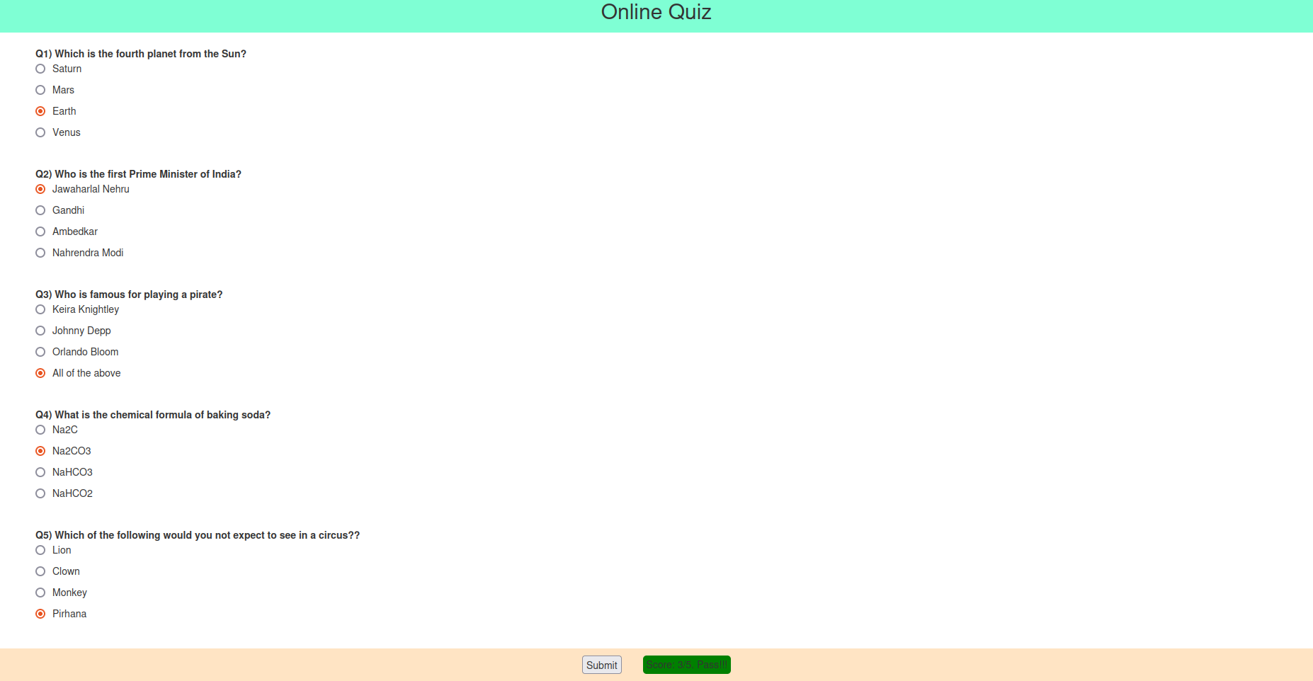

Question – 2

Code:

HTML

<!DOCTYPE html>
<html lang="en">
<head>
<meta charset="UTF-8">
<meta name="viewport" content="width=device-width, initial-scale=1.0">
<title>Q-2</title>
<link rel="stylesheet" href="q2.css">
</head>
<body>
<div class="container">
<h1 id="greeting"></h1>
<div class="clock" id="clock"></div>
<button class="button" onclick="wishUser();">Request a greeting!</button>
</div>

<script src="q2.js"></script>
</body>
</html>

CSS

/* Basic Styles */
body {
font-family: Arial, sans-serif;
background: #f0f8ff;
display: flex;
justify-content: center;
align-items: center;
height: 100vh;
margin: 0;
flex-direction: column;
}

/* Container for the greeting and clock */
.container {
text-align: center;
}

/* Greeting message style */
#greeting {
font-size: 2rem;
margin: 20px;
color: #333;
}

/* Clock style */
.clock {
font-size: 3rem;
color: #000;
font-weight: bold;
}

/* Styling for the message box */
.dialog-box {
font-size: 1.2rem;
padding: 10px;
margin-top: 20px;
border: 2px solid #2900bd;
background-color: #72e782;
}

button {
padding: 15px 15px;
background-color: darkcyan;
color: chartreuse;
}

JS

// Function to wish the user based on the time of the day
function wishUser() {
const today = new Date();
const hour = today.getHours();
let greeting = '';

if (hour >= 0 && hour < 12) {
greeting = 'Good Morning!';
} else if (hour >= 12 && hour < 18) {
greeting = 'Good Afternoon!';
} else {
greeting = 'Good Evening!';
}

// Display greeting in an alert
alert(greeting);
// Update greeting message on the page
document.getElementById('greeting').textContent = greeting;
}

// Function to update the clock every second
function updateClock() {
const today = new Date();
let hours = today.getHours();
let minutes = today.getMinutes();
let seconds = today.getSeconds();

// Add leading zero if necessary
hours = (hours < 10 ? '0' : '') + hours;
minutes = (minutes < 10 ? '0' : '') + minutes;
seconds = (seconds < 10 ? '0' : '') + seconds;

const timeString = hours + ':' + minutes + ':' + seconds;

// Display clock on the webpage
document.getElementById('clock').textContent = timeString;
}

// Initialize the wish and clock update
window.onload = function() {
wishUser(); // Wish the user when the page loads
setInterval(updateClock, 1000); // Update the clock every second
};

Output:

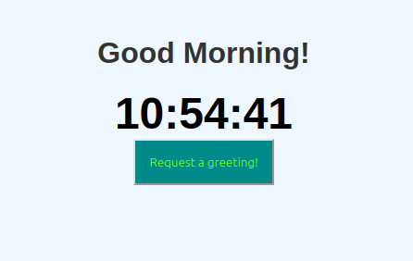

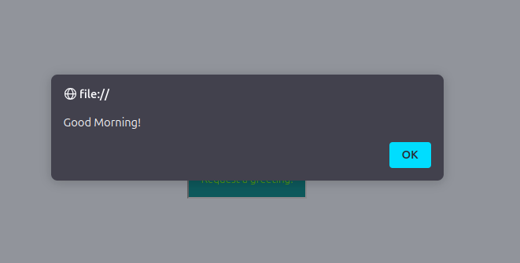

Question – 3

Code:

HTML

<!DOCTYPE html>
<html>
<head>
<title>Q-3</title>
<meta charset="utf-8">
<meta name="viewport" content="width=device-width, initial-scale=1">
<link rel="stylesheet" href="https://maxcdn.bootstrapcdn.com/bootstrap/3.4.1/css/bootstrap.min.css">
<script src="https://ajax.googleapis.com/ajax/libs/jquery/3.7.1/jquery.min.js"></script>
<script src="https://maxcdn.bootstrapcdn.com/bootstrap/3.4.1/js/bootstrap.min.js"></script>
<link rel="stylesheet" href="q3.css">
</head>
<body class="container align-items-center">
<form class="form">
<fieldset>
<legend>Enter your marks!</legend>
<div class="input">
<label>English</label>
<input type="number" min="0" max="100" required>
</div>
<div class="input">
<label>Mathematics</label>
<input type="number" min="0" max="100" required>
</div>
<div class="input">
<label>Computer Science</label>
<input type="number" min="0" max="100" required>
</div>
<div class="input">
<label>Science</label>
<input type="number" min="0" max="100" required>
</div>
<div style="display: flex; flex-direction: row; align-items: center;">
<button type="button" onclick="submit_form();">Submit!</button>
<div id="result" style="display: none; padding: 2px 5px; border-radius: 5px;"></div>
</div>
</fieldset>
</form>
</body>
<script src="q3.js"></script>
</html>

CSS

div.input {
display: flex;
flex-direction: row;
gap: 20px;
margin: 0px 30px 30px 20px;
}

button {
padding: 10px 15px;
background-color: darkcyan;
color: rgb(255, 255, 255);
margin: 0px 30px 30px 20px;
}

JS

function submit_form() {
let inputs = Array.from(document.getElementsByTagName('input'));
let result_div = document.getElementById("result");
const length = inputs.length;
let values = inputs.map((input_element) => input_element.value).map(Number);
const avg = values.reduce((partialSum, a) => partialSum + a, 0) / length;
console.log(avg);
let result_string;
if (avg > 90){
result_string = "A";
}
else if (avg > 80){
result_string = "B";
}
else if (avg > 70){
result_string = "C";
}
else if (avg > 60){
result_string = "D";
}
else{
result_string = "F";
}

if (result_string === "F") {
result_div.style.color = 'red';
}
else {
result_div.style.color = 'green';
}

result_div.innerText = `Grade: ${result_string}`;
result_div.style.display = 'block';
}

Output:

