Question - 1

<!DOCTYPE html>
<html>
<body style="background-color: aquamarine;">
<div style="margin-left: auto; margin-right: auto; height: 100%;">
<h3 style="text-align: center;">The Road Not Taken</h3>
<div style="text-align: center;">
Two roads diverged in a yellow wood, <br>

And sorry I could not travel both <br>

And be one traveler, long I stood <br>

And looked down one as far as I could <br><br>

To where it bent in the undergrowth; <br>

Then took the other, as just as fair, <br>

And having perhaps the better claim, <br>

Because it was grassy and wanted wear; <br><br>

Though as for that the passing there <br>

Had worn them really about the same, <br>

And both that morning equally lay <br>

In leaves no step had trodden black. <br><br>

Oh, I kept the first for another day! <br>

Yet knowing how way leads on to way, <br>

I doubted if I should ever come back. <br>

I shall be telling this with a sigh <br><br>

Somewhere ages and ages hence: <br>

Two roads diverged in a wood, and I— <br>

I took the one less traveled by, <br>

And that has made all the difference. <br><br>
</div>
</div>
</body>
</html>

Output

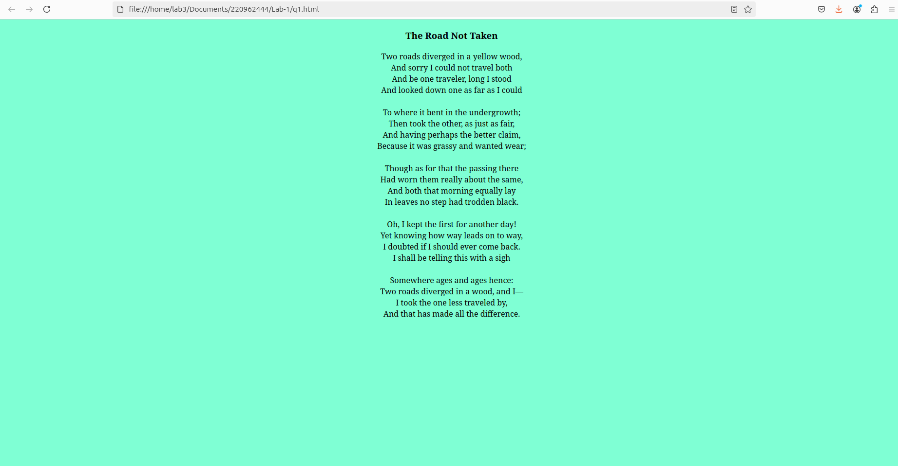

Question - 2

<!DOCTYPE html>
<html>
<body style="height: 500px; background-color: azure;">
<div style="height:100%; flex-direction:row; display: flex; justify-content: space-evenly; align-items: center;">
<div style="background-color: aqua; padding: 20px 20px; border-radius: 25%;">
<h3>
Additional Accessories:
</h3>
<ul>
<li>Backup tyres</li>
<li>Portable electric charger</li>
<li>Food</li>
<li>Water</li>
<li>Fuel</li>
<li>Mechanic toolkit</li>
</ul>
</div>
<div style="background-color: blueviolet; padding: 20px 20px; border-radius: 25%;">
<h3>
Travel Plans:
</h3>
<ol>
<li>Go to Bangalore</li>
<li>Take flight to Punjab</li>
<li>Visit Shimla</li>
<li>Ride horse</li>
<li>Head to Manali and stay for a week</li>
<li>Take bus to Delhi</li>
<li>Take return flight to home</li>
</ol>
</div>
</div>
</body>
</html>

Output
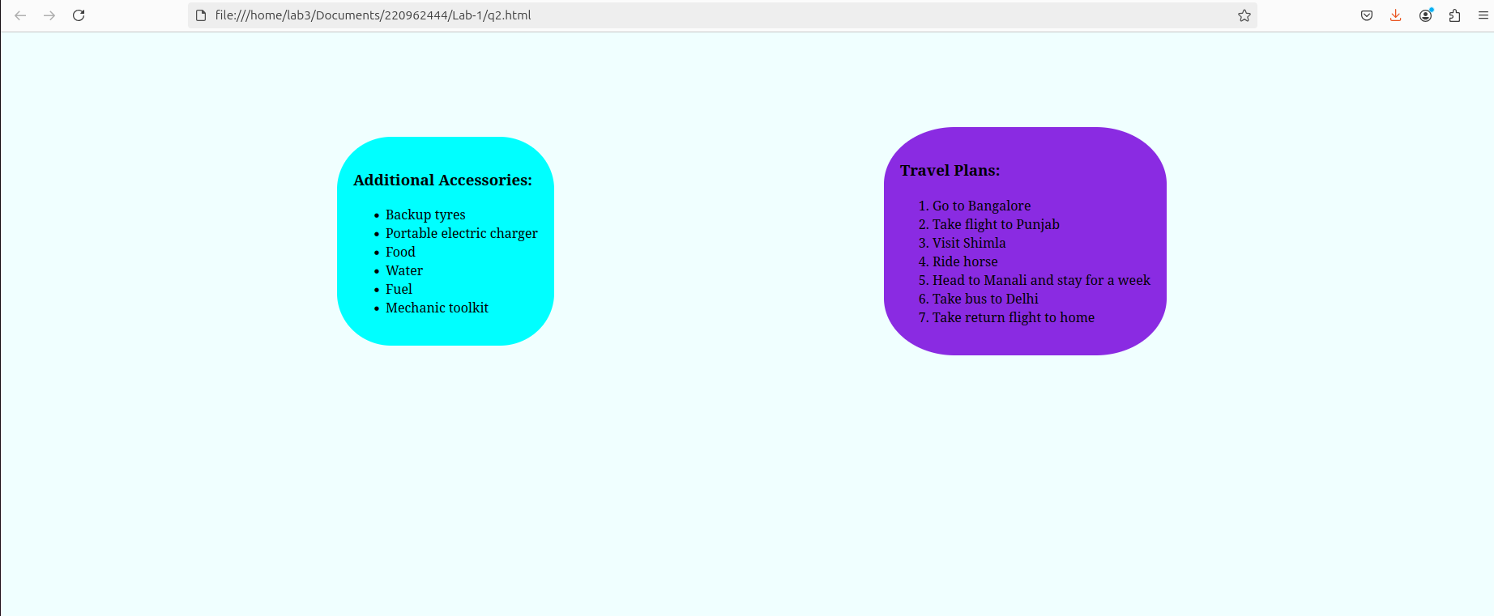

Question - 3

<!DOCTYPE html>
<html>
<body style="background-color: beige;">
<div style="background-color: black; padding: 0px 10px; margin-right: 10px;">
<h2 style="font-family: cursive; color: white;">Share Your Winter Vacation Videos</h2>
</div>
<div style="padding: 20px 20px; background-image: linear-gradient(to bottom,aqua, beige); margin-right: 10px;">
<h2 style="font-family: cursive;">HTML5 Videos</h3>
<div style="flex-direction: row; display: flex;">
<figure>
<video width="480" height="360" autoplay muted>
<source src="/home/lab3/Downloads/vid1.mp4">
</video>
<figcaption style="text-align: center;">Walking</figcaption>
</figure>
<figure>
<video width="480" height="360" autoplay muted>
<source src="/home/lab3/Downloads/vid2.mp4">
</video>
<figcaption style="text-align: center;">Cycling</figcaption>
</figure>
<figure>
<video width="480" height="360" autoplay muted>
<source src="/home/lab3/Downloads/vid3.mp4">
</video>
<figcaption style="text-align: center;">Forest</figcaption>
</figure>
</div>
</div>
</body>
</html>

Output

