**Report of Industrial Training**

At

**Decibel Labs , Bangalore**

*Submitted by*

**Sriram.T**

170921136

*In partial fulfilment of the requirements for the award of the degree of*

**BACHELOR OF TECHNOLOGY**

**IN**

**INSTRUMENTATION AND CONTROL ENGINEERING**

|  |  |
| --- | --- |
|  | **DEPARTMENT OF ELECTRICAL AND ELECTRONICS ENGINEERING**  **MANIPAL INSTITUTE OF TECHNOLOGY**  MANIPAL – 576104, KARNATAKA, INDIA  **May 2021** |

|  |  |
| --- | --- |
|  | **DEPARTMENT OF INSTRUMENTATION AND CONTROL ENGINEERING**  **MANIPAL INSTITUTE OF TECHNOLOGY**  MANIPAL – 576104, KARNATAKA, INDIA  **May 2021** |

Manipal

1.05.21

**CERTIFICATE**

This is to certify that the industrial training report submitted is a record of the bonafide work done by **Sriram.T** (*Reg. No. 170921136*) in partial fulfilment of the requirements for the award of the Degree of Bachelor of Technology in Electrical and Electronics Engineering of Manipal Institute of Technology Manipal, Karnataka, (A Constituent College of Manipal Academy of Higher Education).

|  |  |  |
| --- | --- | --- |
| *Coordinator Industrial Training* | *HOD, ICE*  *M.I.T, MANIPAL* | |
|  | |

|  |  |  |  |
| --- | --- | --- | --- |
| Index | | | Page |
|  | | Acknowledgement | 1 |
|  | | Abstract | 2 |
|  | |  |  |
| Chapter 1 | | Introduction | 3 |
|  | 1.1 | Why do we need to model Electric Powertrain | 3 |
|  | 1.2 | Chassis modelling | 3 |
|  | 1.3 | Transmission Modelling | 5 |
|  | 1.4 | Electric motor modelling | 6 |
|  | | | |
| Chapter 2 | | Training Highlights | 8 |
|  | 2.1 | Importance of modelling Electric Powertrain | 8 |
|  | 2.2 | Program Introduction | 8 |
|  | 2.3 | Internship Timeline | 8 |
|  | 2.4 | Workload and Project details | 9 |
|  | | | |
| Chapter 3 | | Conclusions & Summary | 10 |
|  | 3.1 | Expected outcomes | 10 |
|  | 3.2 | conclusions | 10 |
|  | |  |  |
| Chapter 4 | | About the Company | 13 |
|  | 1.1 | Company Profile | 13 |
|  | 1.2 | Office Locations | 13 |
|  | 1.3 | Product Profile | 13 |
|  | 1.4 | Prominent Customers | 13 |
|  | 1.5 | Organization of the Company (public, private, listed etc, brief structure) |  |
|  | | | |
|  | | |  |

**ACKNOWLEDGMENT**

This section should contain the acknowledgments due to the Director, Dept HOD, company personnel, and faculty members whose assistance was sought during the training.

I want to express my sincere gratitude to my supervisors Mr. Suraj and Dr. Sumit Tiwari, for providing their invaluable guidance, comments, and suggestions throughout the project. I would specially thank the head of the Department of Instrumentation and control engineering Dr. Shreesha Chokkadi for motivating me to work harder.

Also, I would like to thank Dr. I Thirunavakkarasu for his assistance in my final year project by providing constant support and guidance.

**ABSTRACT**

The following report represents my work as a Powertrain simulation intern at Decibels Pvt Ltd, Bangalore, lndia. The internship was completed in the time period of May 2020 to June 2020. The internship consisted of Powertrain modelling for different types of drivecycle (FTP-75 and MNEDC). The obtained results could then be used to predict how the vehicle is will perform on roads and further emission details can be investigated. The work also supports the idea that electric vehicles are more efficient than conventional combustion engines. The chapter 3 discusses about plots obtained from modelling of transmission, chassis and motor configuration. The report ends with the future impact of electric vehicles and how it can be leveraged to its full potential.

**CHAPTER 1**

**INTRODUCTION**

* 1. Why do we need to model Electric Powertrain

Today, as world is battling the issues of environmental changes and its ill-effects, automobile world is on the verge of major turnover. The famous and extensively exploited IC engine technology is set to be replaced by cleaner and sustainable electric powertrain technology. In a country like India where the old small cities are proving inefficient of managing its pollution levels, Electric Vehicle(EV) is of great importance here. But as compared to other places in world, India is only taking Baby steps in developing EV infrastructure. India is home to largest pool of engineers through numerable start-ups, like Decibels is now accelerating the efforts towards EV literacy.

This creates an immediate need for study and application of first step of building a EV i.e. modelling. During the internship, simulation and modelling for consumer vehicles like Ather 450, Nissan leaf were completed along with analysis of results. Similarly, formula student vehicle electric powertrain analysis was done. Modelling and simulation was done with the standard drive cycles on Scilab and Matlab Simulink Software.

FTP-75, MNEDC, WLTP drive-cycles were used for modelling of consumer vehicles where ac; specifically developed drive cycle for formula student vehicle was used for racing car analysis. For the report we will consider the modelling procedure and understand the results for Ather 450 with MNEDC Drive-cycle. Similarly, analysis with FTP-75 and WLTP drive-cycles was done for Ather 450. Also on the same lines analysis for Nissan Leaf and formula Student vehicle for all the drive cycles was carried out.

* 1. Chassis modelling:

Powertrain analysis can be majorly done through two approaches which are well to wheel and wheel to well analysis. Here we are using Wheel to well analysis.

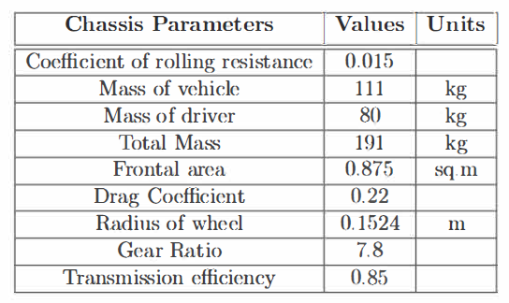

•The above table shows the basic vehicle chassis and transmission characteristics for Ather- 450.

•The first step for powertrain modelling is to calculate the total effort the vehicle has to overcome in order to propel forward. The velocity input is taken in the means of the M ED drive cycle.

•The total effort is calculated as the sum of four kinds of resistances the vehicle experiences while moving.

1. Rolling resistance force(RRF)

2. Grade resistance force(GRF)

3. Aerodynamic resistance force(ARF)

4. Accelerating force(ACF)

•When we calculate the total effort expressed in terms of force, we can easily calculate the Wheel Torque which serves as an input for further modelling. Also, wheel speed was obtained from the calculations.

•We can see the modelling for above mentioned process in the following figure.

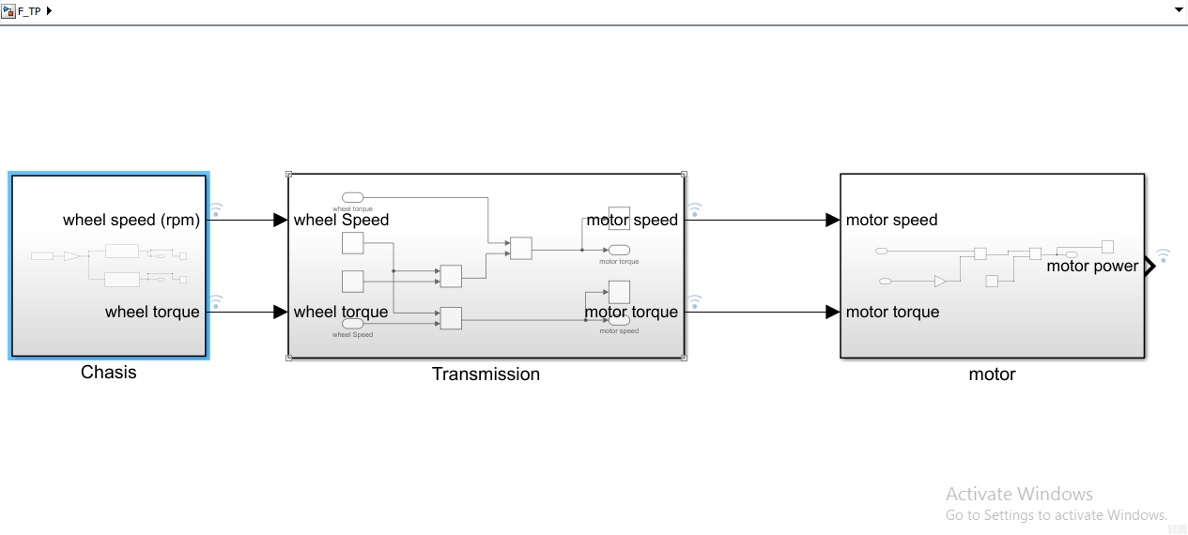

Fig.1 Overall view of the model

1.3 Transmission Modelling

•The outputs from chassis subsystem which arc wheel speed and wheel torque arc used as inputs for transmission subsystem.

•Transmission subsystem uses simple equations constituting gear ratio and transmission efficiency to calculate motor speed and motor torque.

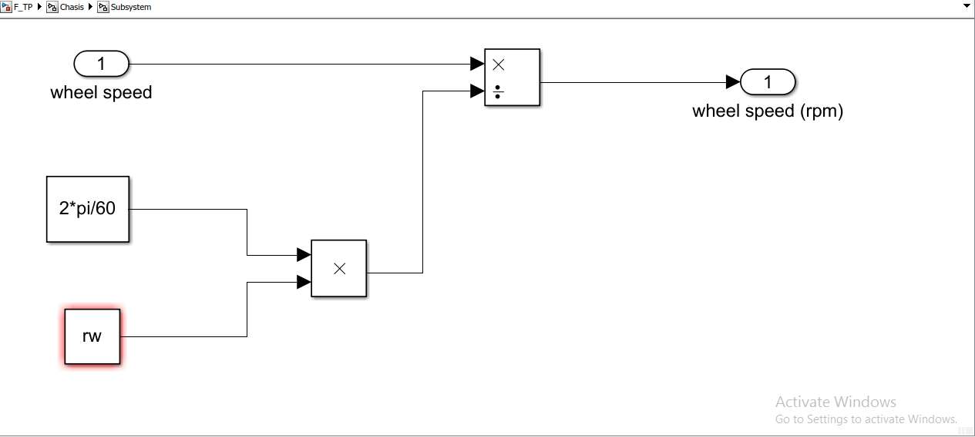

Fig.2a Transmission subsystem

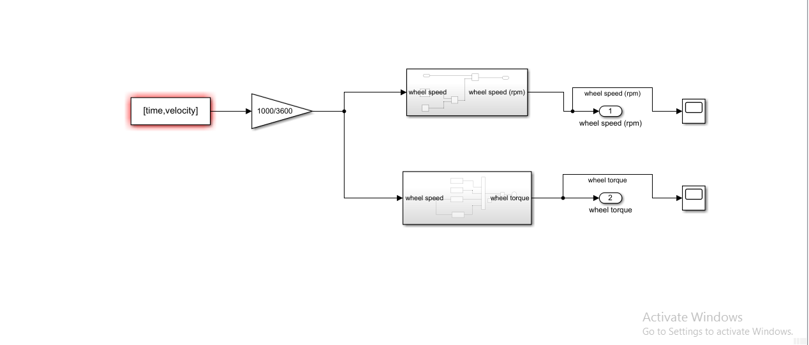

Fig.2b Transmission subsystem

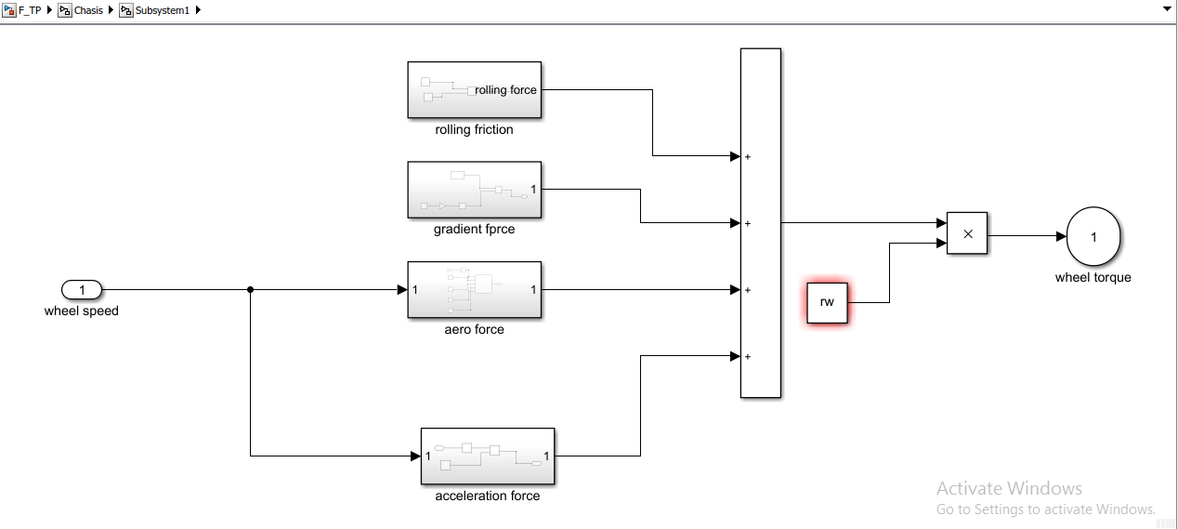

Fig.2c Transmission subsystem

* 1. Electric Motor Modelling
* This block takes the input from transmission block which are motor speed and motor power
* Certain motor and battery parameters arc considered for modelling which arc given in following table.

|  |  |  |
| --- | --- | --- |
| Motor and Battery parameters | Values | Units |
| Motor efficiency | 0.90 |  |
| Motor control efficiency | 0.85 |  |
| Battery capacity | 2400 | Wh |
| Battery Voltage | 51.1 | V |
| Cell Voltage | 3.6 | V |
| Cell Capacity | 2.7 | Ah |

#### The modelling is shown in the following figure. We get Electric power output an output of this modelling his shown below.

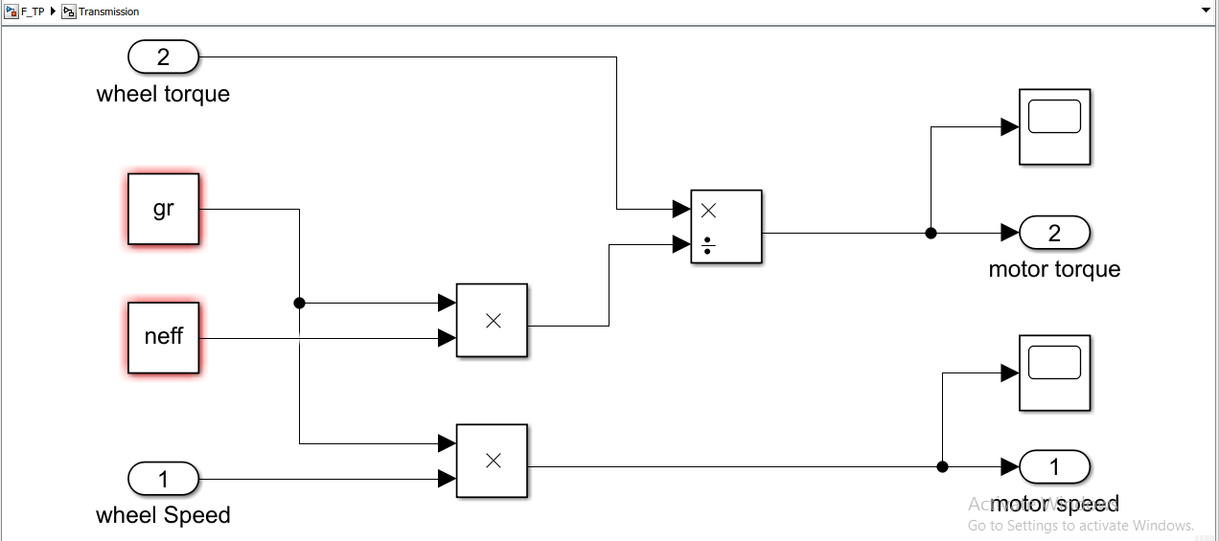

Fig.3 Overall Motor system modelling

This block will provide the necessary plots for the power generated by the motors, from which we can calculate the required motor size and wheel.

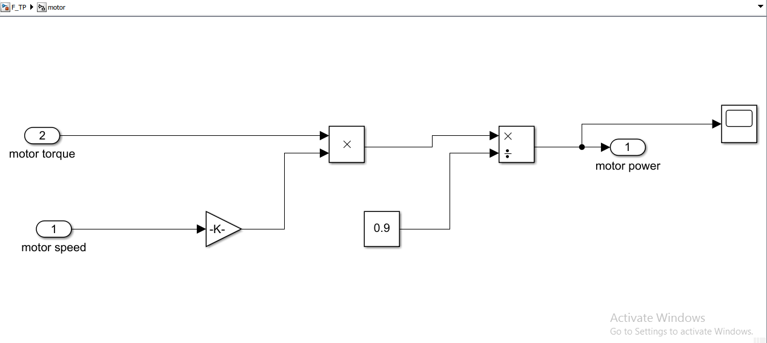

Fig.4 Motor power output model

**CHAPTER 2**

**TRAINING HIGHLIGHTS**

2.1 Importance of modelling Electric Powertrain

One of the key parameters for every EV manufactures are striving is Energy consumed/Km (Wh/Km) (Tesla overbeats all the other auto manufactures in this).

If you have got the right component sizing, done the best optimization studies, made every possible influencing parameter considered for studies & have performed 10000+ hours of simulations to understand how the system would behave in the real world. This is the fortray of the Simulation engineering team (MBD), system architecture team & component design team. MBD being the core competency of Decibels.

2.2 Program Introduction

The program stated with basic introduction to Electric vehicle ecosystem. This included understanding of various subsystems in an electric vehicle and also the list of component manufactures of the various parts in the subsystem.

The electric vehicle ecosystem consists of battery packs, chassis, transmission , motor controller , embedded electronics and charging ports.

2.3 Internship Timeline

The internship program was scheduled was 6 weeks. The first week consisted about the basic knowledge of electric vehicle. The second week was followed with understanding a chassis configuration in an EV, followed by mathematical modelling of chassis. The third week was followed by modelling of transmission of EV and analysing the outputs of various drive cycles. The final week of training, introduced the modelling aspect of motor drives in EV and introduction of battery packs. For the next two weeks, the interns were assigned a project to develop an entire powertrain of an electric vehicle and perform simulation on Matlab/Simulink software.

2.4 Workload and Project details

The workload consisted of contributing minimum of 35 to maximum of 50 hours in a week. Small assignments and tests were given during the week to gauge the students understanding. At the end of every week, all the interns must present a topic about the recent developments in the EV sector. The presentation should last for atleast 10 minutes.

The project consisted of obtaining different values for wheel speed and torque ; motor speed and torque and motor power for different drive cycles. The different plots were plotted in Matlab environment and found the performance for each configuration of powertrain.

**CHAPTER 3**

**SUMMARY AND CONCLUSION**

3.1 Expected outcomes

The project consisted of obtaining different values for wheel speed and torque ; motor speed and torque and motor power for different drive cycles. The different plots were plotted in Matlab environment and found the performance for each configuration of powertrain.

3.2 Conclusion

The obtained plots concluded the performance of an electric powertrain for FTP-75 drive-cycle. Using the motor power plot we can find the possible amount of emission that can be produced from the vehicle.

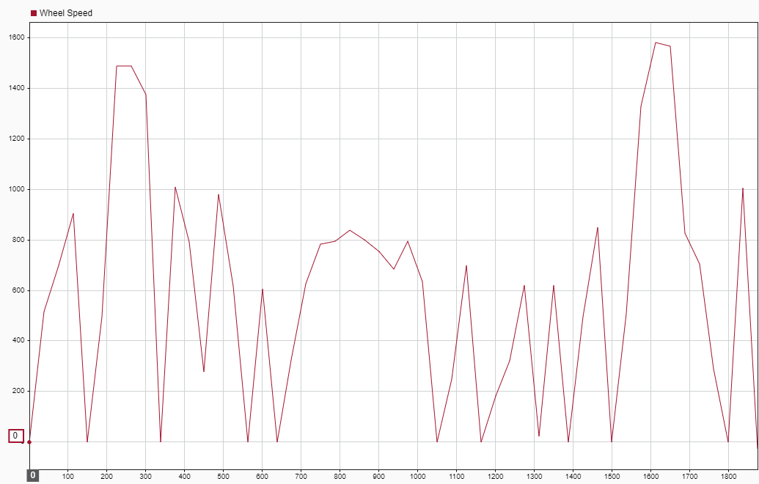

Fig.5 Wheel Speed Plot

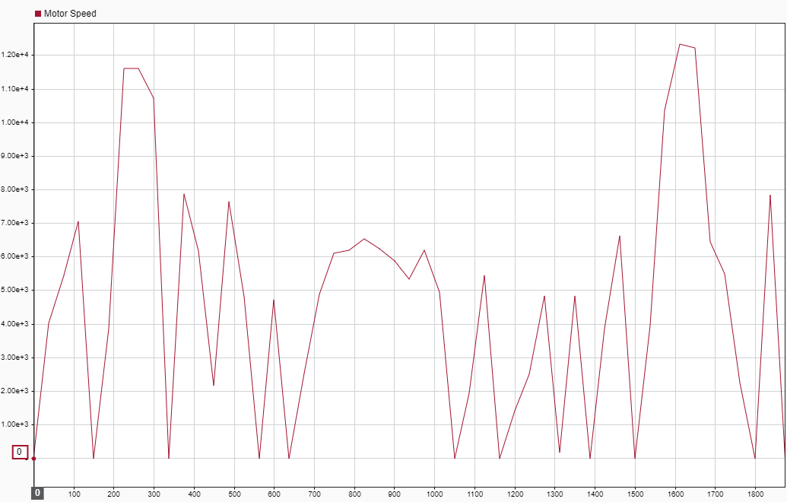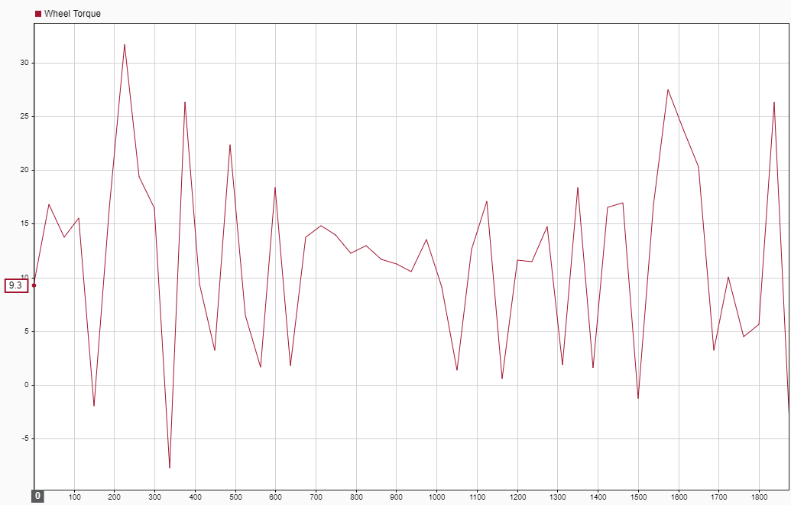

Fig.6 Wheel torque Plot

Fig.7 Motor Speed Plot

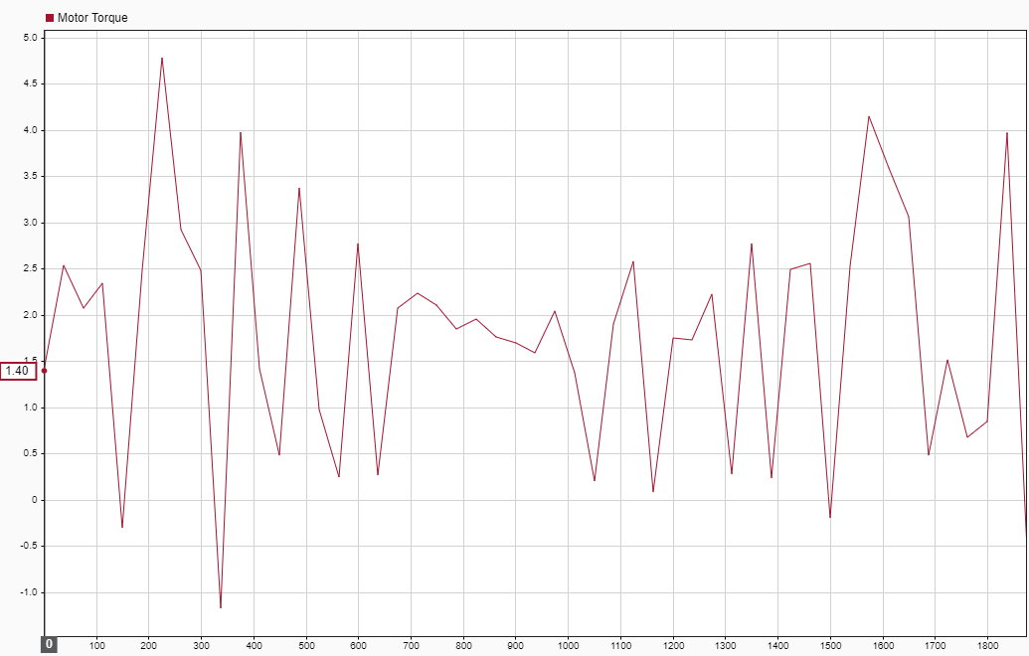

Fig.8 Motor torque Plot

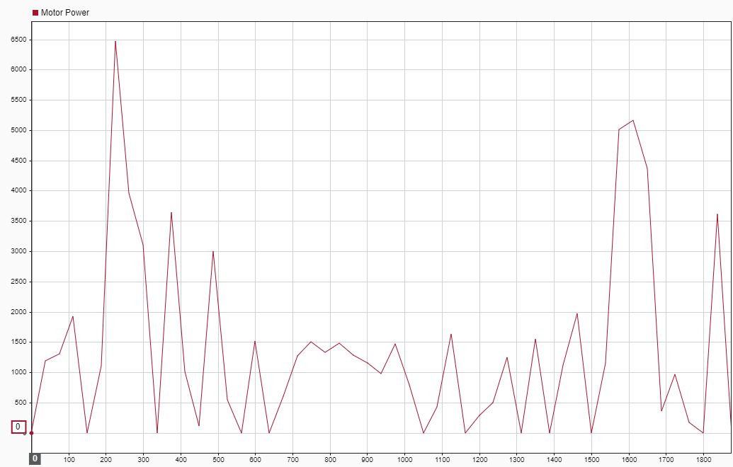

**CHAPTER 4**

Fig.9 Motor Power Plot

**ABOUT THE COMPANY**

* 1. Introduction of the company

Decibels labs Pvt Ltd. is a start up based in Bangalore, India established in 2019; that promotes both academic and industry related advancements and research in the field of electric vehicle and sustainable mobility. To promote academic conversations or dialogue that fosters creativity and Integrate critical thinking skills within and across all content areas. The company aims to provide students with repeated opportunities to practice higher-order thinking and establish safe, Intellectually risk-free learning environments and resources. Decibels Lab consistently cultivates problem-solving and logical thinking capabilities in students and develop communication & collaboration within by sharing ideas and working together.

* 1. Operational Details

The company conducts both online and offline workshops across the country. The office located in Bangalore works on testing of electric powertrain hardware and software. The firm is also involved in consulting works to help other companies in their automobile hardware testing.

The company aims to build its own Electric scooter by the end of 2022 and is currently involved in purchasing battery packs and other components from Indian vendors. Decibels Lab signed the strategic partnership with SLOKI software technologies LLP for component supply & R&D to for Electric 2W & 4W platform engineering projects.

* 1. End products

The company focusses on producing tested and verified hardware and software tools for automobile testing and provides consultancy services for start-ups in the electric vehicle segment