ADITYA UNIVERSITY
Surampalem
Department of AI & ML

DBMS CAPSTONE PROJECT

LIBRARY MANAGEMENT SYSTEM
Project Documentation Report

S.No | Student Name | Roll Number
1 | M. Sri Ramana | 25B11AI704
2 | K. Chandru | 25B11AI465
3 | G. Suhas | 25B11AI384
4 | A. Datta Sri Sai | 25B11AI049

Field | Details
Course | Database Management Systems (DBMS)
Course Code | Not provided
Faculty Coordinator | Mrs. V. G. L. Narasamba
Academic Year | 2026-27
Date of Submission | 15 September 2026
GitHub Repository Link | To be added

TABLE OF CONTENTS
Update the table of contents in Microsoft Word after opening this report, if required.

1. ABSTRACT
The Library Management System is a database-driven application designed to automate and organize daily library activities. Manual registers for books, members, issue records, return dates, reservations, and fines are time-consuming and may cause duplicate entries, missing records, calculation errors, and difficulty tracking overdue books. The proposed system stores information in a structured relational database and supports book registration, member registration, searching, issuing, returning, reservations, and fine management. Separate tables represent books, authors, publishers, categories, members, staff, loans, reservations, and fines, connected through primary and foreign keys. Constraints and normalization improve accuracy, reduce redundancy, and preserve referential integrity. SQL queries support availability checking, overdue analysis, category-wise counting, and member borrowing history. The system can support librarians, administrators, and members through a future web or desktop interface. Overall, the project demonstrates how DBMS concepts can be applied to develop a reliable, scalable, and user-friendly library information system.

2. INTRODUCTION
2.1 Background
A library manages a large collection of books and serves many members. Books may have authors, publishers, categories, and multiple physical copies. Members borrow and return copies at different times, so the library must monitor due dates, availability, reservations, and fines. A relational database stores this related information in connected tables and retrieves it accurately using SQL.
2.2 Purpose of the Database
The database provides a centralized repository for library operations. Librarians can maintain catalogue and member information, record loans and returns, calculate fines, and generate reports. Members can search books, view availability, place reservations, and review borrowing history.

3. PROBLEM STATEMENT
Manual library management requires repeated writing and checking of records. It is difficult to determine copy availability, identify overdue loans, track borrowing history, calculate fines, and update information consistently. Duplicate data and missing records can lead to inaccurate reports and poor service. The proposed system solves these problems through a normalized relational database with validation, relationships, constraints, and SQL operations for cataloguing, circulation, reservations, and reporting.

4. OBJECTIVES
• Create a centralized database for books, copies, authors, publishers, categories, members, staff, and transactions.
• Enable fast searching by title, ISBN, author, category, and availability.
• Record issue and return transactions with due dates and overdue fines.
• Maintain integrity using primary keys, foreign keys, unique constraints, checks, and defaults.
• Generate reports for inventory, overdue loans, circulation, categories, and member history.

5. TOOLS & TECHNOLOGIES USED

Category | Tool / Technology Used
Database Server | PostgreSQL
Query / Admin Tool | pgAdmin 4 / PostgreSQL CLI
Front-end | HTML, CSS, JavaScript or Python Flask
Programming | Python and SQL
IDE | Visual Studio Code
Operating System | Microsoft Windows
Version Control | Git and GitHub

6. DATABASE DESIGN

6.1 Identified Entities
Entity | Description
Book | Logical bibliographic record with title and ISBN.
Book Copy | Physical copy that can be issued.
Author | Person who wrote a book.
Publisher | Organization publishing a book.
Category | Subject classification.
Member | Registered borrower.
Staff | Librarian or administrator.
Loan | Issue and return transaction.
Reservation | Request for a book.
Fine | Charge for an overdue loan.

6.2 Entity Attributes
Entity | Important Attributes | Keys / Notes
Book | book_id, isbn, title, publisher_id, category_id, publication_year | book_id PK; isbn UNIQUE; publisher_id/category_id FK
Book Copy | copy_id, book_id, accession_no, status | copy_id PK; book_id FK
Author | author_id, author_name | author_id PK
Publisher | publisher_id, publisher_name | publisher_id PK
Category | category_id, category_name | category_id PK
Member | member_id, name, email, phone, join_date, status | member_id PK; email UNIQUE
Staff | staff_id, name, email, role | staff_id PK
Loan | loan_id, copy_id, member_id, staff_id, issue_date, due_date, return_date | loan_id PK; FKs
Reservation | reservation_id, book_id, member_id, reservation_date, status | reservation_id PK; FKs
Fine | fine_id, loan_id, amount, paid_status, paid_date | fine_id PK; loan_id FK

6.3 ER Diagram

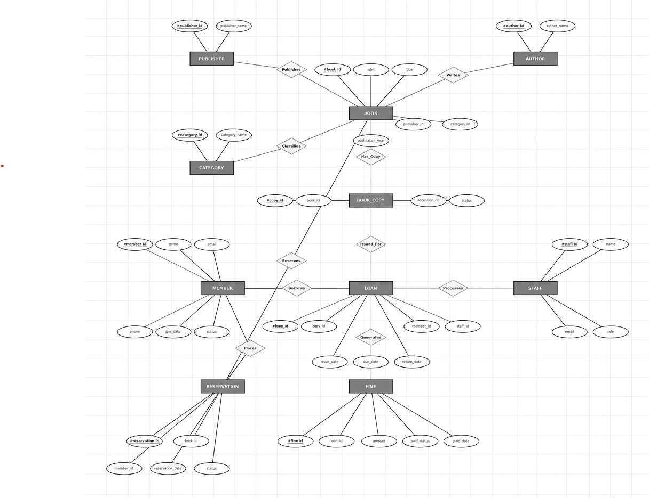

6.4 Relationships & Cardinality
Entity 1 | Relationship | Entity 2 | Cardinality
Publisher | publishes | Book | 1:N
Category | classifies | Book | 1:N
Book | has copies | Book Copy | 1:N
Book | written by | Author | M:N
Member | borrows | Loan | 1:N
Staff | records | Loan | 1:N
Member | places | Reservation | 1:N
Loan | generates | Fine | 1:0..1

6.5 Relational Database Schema
Table | Primary Key | Foreign Keys | Constraints
publishers | publisher_id | — | name UNIQUE NOT NULL
categories | category_id | — | name UNIQUE NOT NULL
authors | author_id | — | name NOT NULL
books | book_id | publisher_id, category_id | isbn UNIQUE; title NOT NULL
book_authors | book_id + author_id | book_id, author_id | Composite PK
book_copies | copy_id | book_id | accession UNIQUE; status CHECK
members | member_id | — | email UNIQUE; status CHECK
staff | staff_id | — | role CHECK
loans | loan_id | copy_id, member_id, staff_id | date CHECKs
reservations | reservation_id | book_id, member_id | status CHECK
fines | fine_id | loan_id | amount CHECK; loan UNIQUE

6.6 Normalization
UNF: One register contains repeating book, author, member, and loan details. 1NF: Fields are atomic and repeating groups are separated. 2NF: The M:N book-author relation is moved to BOOK_AUTHORS. 3NF: Publisher, category, member, staff, loan, reservation, and fine details are separated so non-key attributes depend only on their table key. This reduces insertion, update, and deletion anomalies.
Constraint | Purpose
PRIMARY KEY | Unique row identification.
FOREIGN KEY | Referential integrity.
UNIQUE | Prevents duplicate ISBN, email, and accession numbers.
NOT NULL | Ensures required data.
CHECK | Restricts invalid statuses, dates, years, and amounts.
DEFAULT | Supplies consistent dates and initial statuses.

7. DATABASE IMPLEMENTATION

7.1 DDL - Database and Table Creation

IMPORTANT: Execute CREATE DATABASE separately first.

Step 1: Connect to the postgres database and run:

CREATE DATABASE library_management;

Step 2: Connect to the library_management database and execute the following code:

CREATE TABLE publishers (

publisher_id SERIAL PRIMARY KEY,

publisher_name VARCHAR(120) NOT NULL UNIQUE

);

CREATE TABLE categories (

category_id SERIAL PRIMARY KEY,

category_name VARCHAR(80) NOT NULL UNIQUE

);

CREATE TABLE authors (

author_id SERIAL PRIMARY KEY,

author_name VARCHAR(120) NOT NULL

);

CREATE TABLE books (

book_id SERIAL PRIMARY KEY,

isbn VARCHAR(20) UNIQUE NOT NULL,

title VARCHAR(200) NOT NULL,

publisher_id INT NOT NULL REFERENCES publishers(publisher_id),

category_id INT NOT NULL REFERENCES categories(category_id),

publication_year INT CHECK (publication_year BETWEEN 1000 AND 2100)

);

CREATE TABLE book_authors (

book_id INT NOT NULL REFERENCES books(book_id) ON DELETE CASCADE,

author_id INT NOT NULL REFERENCES authors(author_id) ON DELETE CASCADE,

PRIMARY KEY (book_id, author_id)

);

CREATE TABLE book_copies (

copy_id SERIAL PRIMARY KEY,

book_id INT NOT NULL REFERENCES books(book_id),

accession_no VARCHAR(30) UNIQUE NOT NULL,

status VARCHAR(20) DEFAULT 'Available' CHECK (status IN ('Available', 'Issued', 'Lost', 'Damaged'))

);

CREATE TABLE members (

member_id SERIAL PRIMARY KEY,

name VARCHAR(120) NOT NULL,

email VARCHAR(150) UNIQUE NOT NULL,

phone VARCHAR(20),

join_date DATE DEFAULT CURRENT_DATE,

status VARCHAR(15) DEFAULT 'Active' CHECK (status IN ('Active', 'Inactive'))

);

CREATE TABLE staff (

staff_id SERIAL PRIMARY KEY,

name VARCHAR(120) NOT NULL,

email VARCHAR(150) UNIQUE NOT NULL,

role VARCHAR(20) CHECK (role IN ('Librarian', 'Admin'))

);

CREATE TABLE loans (

loan_id SERIAL PRIMARY KEY,

copy_id INT NOT NULL REFERENCES book_copies(copy_id),

member_id INT NOT NULL REFERENCES members(member_id),

staff_id INT NOT NULL REFERENCES staff(staff_id),

issue_date DATE DEFAULT CURRENT_DATE,

due_date DATE NOT NULL,

return_date DATE,

CHECK (due_date >= issue_date),

CHECK (return_date IS NULL OR return_date >= issue_date)

);

CREATE TABLE reservations (

reservation_id SERIAL PRIMARY KEY,

book_id INT NOT NULL REFERENCES books(book_id),

member_id INT NOT NULL REFERENCES members(member_id),

reservation_date DATE DEFAULT CURRENT_DATE,

status VARCHAR(15) DEFAULT 'Pending' CHECK (status IN ('Pending', 'Fulfilled', 'Cancelled'))

);

CREATE TABLE fines (

fine_id SERIAL PRIMARY KEY,

loan_id INT UNIQUE NOT NULL REFERENCES loans(loan_id),

amount NUMERIC(8,2) NOT NULL CHECK (amount >= 0),

paid_status BOOLEAN DEFAULT FALSE,

paid_date DATE,

CHECK (

(paid_status = FALSE AND paid_date IS NULL)

OR (paid_status = TRUE AND paid_date IS NOT NULL)

)

);

CREATE UNIQUE INDEX one_active_loan_per_copy

ON loans(copy_id)

WHERE return_date IS NULL;

CREATE VIEW current_loans AS

SELECT * FROM loans WHERE return_date IS NULL;

7.2 Sample Data - DML

INSERT INTO publishers(publisher_name) VALUES

('Pearson'),

('OReilly Media');

INSERT INTO categories(category_name) VALUES

('Computer Science'),

('Fiction'),

('Artificial Intelligence');

INSERT INTO authors(author_name) VALUES

('Ramez Elmasri'),

('Robert C. Martin'),

('Stuart Russell');

INSERT INTO books(isbn, title, publisher_id, category_id, publication_year) VALUES

('9780133970777', 'Database Systems', 1, 1, 2016),

('9780132350884', 'Clean Code', 1, 1, 2008),

('9780134610993', 'Artificial Intelligence: A Modern Approach', 2, 3, 2021);

INSERT INTO book_authors VALUES

(1, 1),

(2, 2),

(3, 3);

INSERT INTO book_copies(book_id, accession_no) VALUES

(1, 'ACC-001'),

(1, 'ACC-002'),

(2, 'ACC-003'),

(3, 'ACC-004');

INSERT INTO members(name, email, phone) VALUES

('Anil Kumar', 'anil@example.com', '9876543210'),

('Priya Reddy', 'priya@example.com', '9876501234');

INSERT INTO staff(name, email, role) VALUES

('Library Admin', 'admin@library.edu', 'Admin'),

('S. Lakshmi', 'lakshmi@library.edu', 'Librarian');

INSERT INTO loans(copy_id, member_id, staff_id, due_date)

VALUES (1, 1, 2, CURRENT_DATE + 14);

UPDATE book_copies

SET status = 'Issued'

WHERE copy_id = 1;

INSERT INTO reservations(book_id, member_id) VALUES

(3, 2);

7.3 Constraints & Data Integrity

Constraint Purpose

PRIMARY KEY Unique row identification.

FOREIGN KEY Referential integrity.

UNIQUE Prevents duplicate ISBN, email, and accession numbers.

NOT NULL Ensures required data.

CHECK Restricts invalid statuses, dates, years, and amounts.

DEFAULT Supplies consistent dates and initial statuses.

7.4 SQL Operations & Queries

SELECT b.title, bc.accession_no

FROM books b

JOIN book_copies bc USING (book_id)

WHERE bc.status = 'Available';

SELECT m.name, b.title, l.issue_date, l.due_date

FROM loans l

JOIN members m USING (member_id)

JOIN book_copies bc USING (copy_id)

JOIN books b USING (book_id)

WHERE l.return_date IS NULL;

SELECT * FROM loans

WHERE return_date IS NULL

AND due_date < CURRENT_DATE;

SELECT c.category_name, COUNT(b.book_id) AS book_count

FROM categories c

LEFT JOIN books b USING (category_id)

GROUP BY c.category_name;

UPDATE loans

SET return_date = CURRENT_DATE

WHERE loan_id = 1;

UPDATE book_copies

SET status = 'Available'

WHERE copy_id = (

SELECT copy_id

FROM loans

WHERE loan_id = 1

);

SELECT

l.loan_id,

m.name AS member_name,

b.title,

CURRENT_DATE - l.due_date AS overdue_days,

(CURRENT_DATE - l.due_date) * 5.00 AS calculated_fine

FROM loans l

JOIN members m ON l.member_id = m.member_id

JOIN book_copies bc ON l.copy_id = bc.copy_id

JOIN books b ON bc.book_id = b.book_id

WHERE l.return_date IS NULL

AND l.due_date < CURRENT_DATE;

7.5 Sample Outputs / Screenshots

Query 1-Shows all tables created

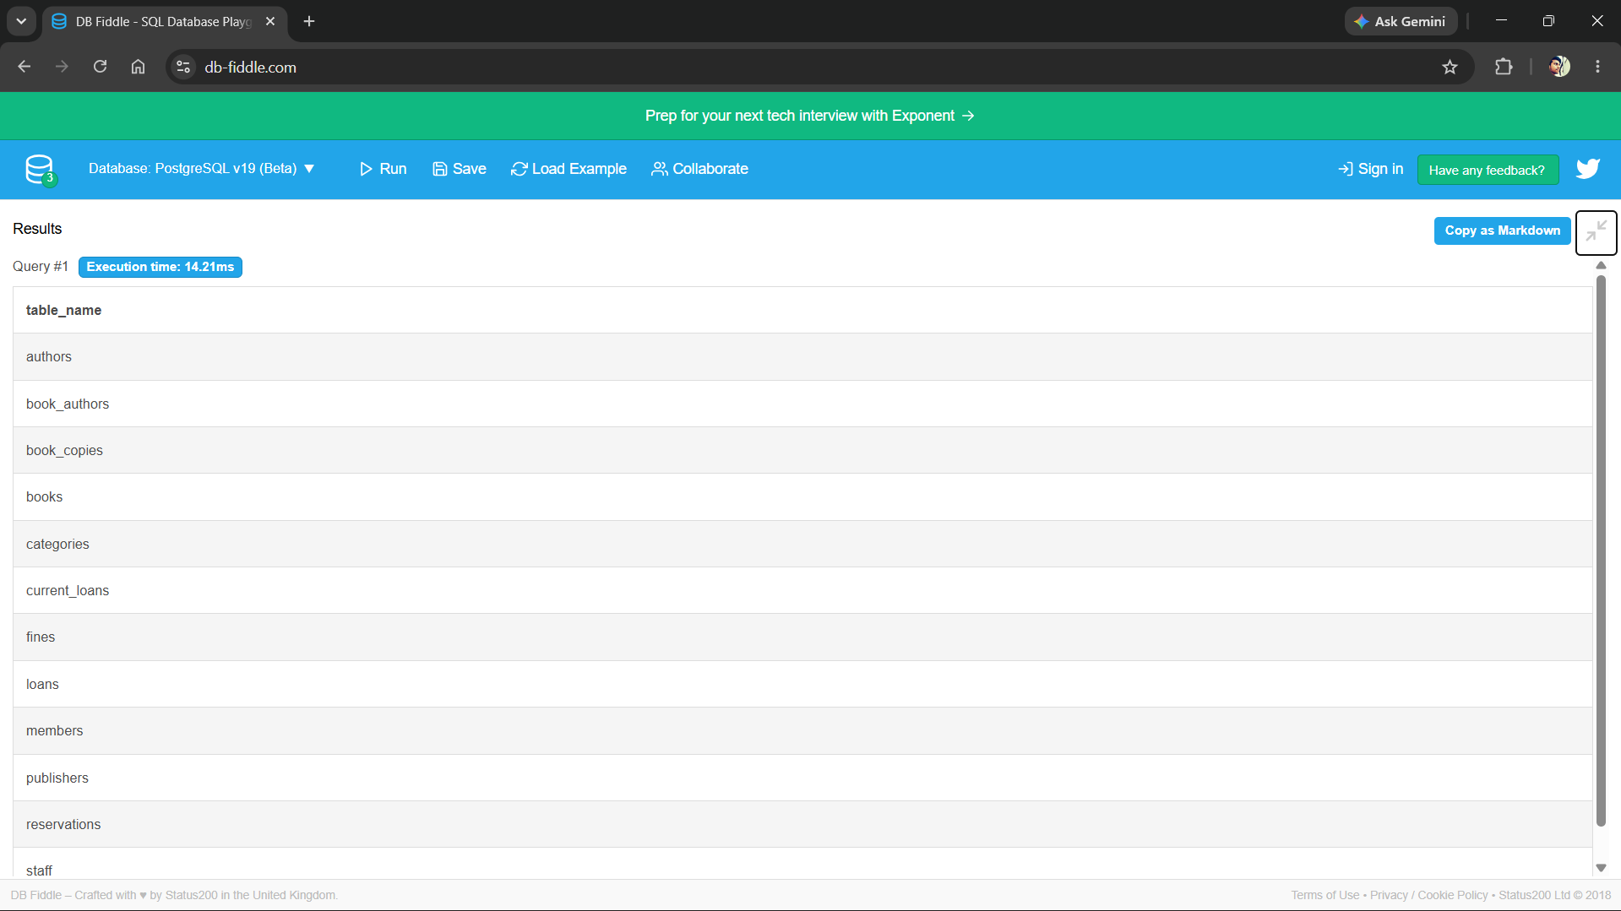

Query 2-Show sample data from books table
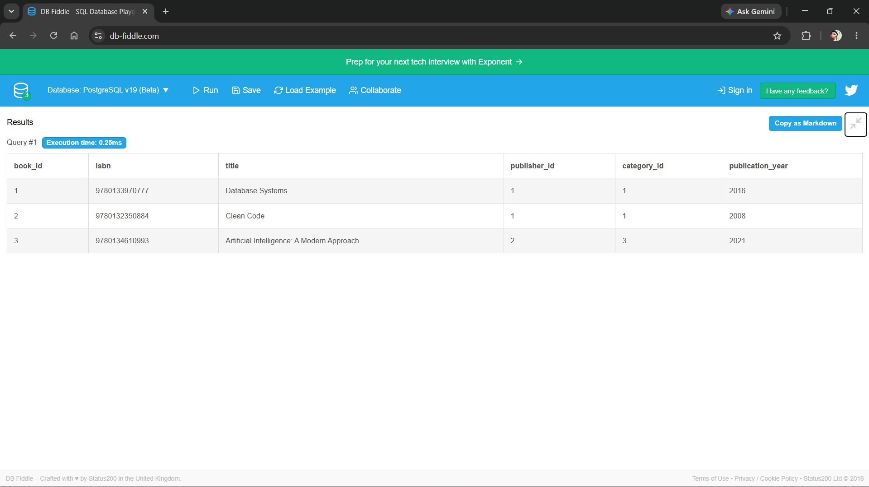

Query 3 - Show available books

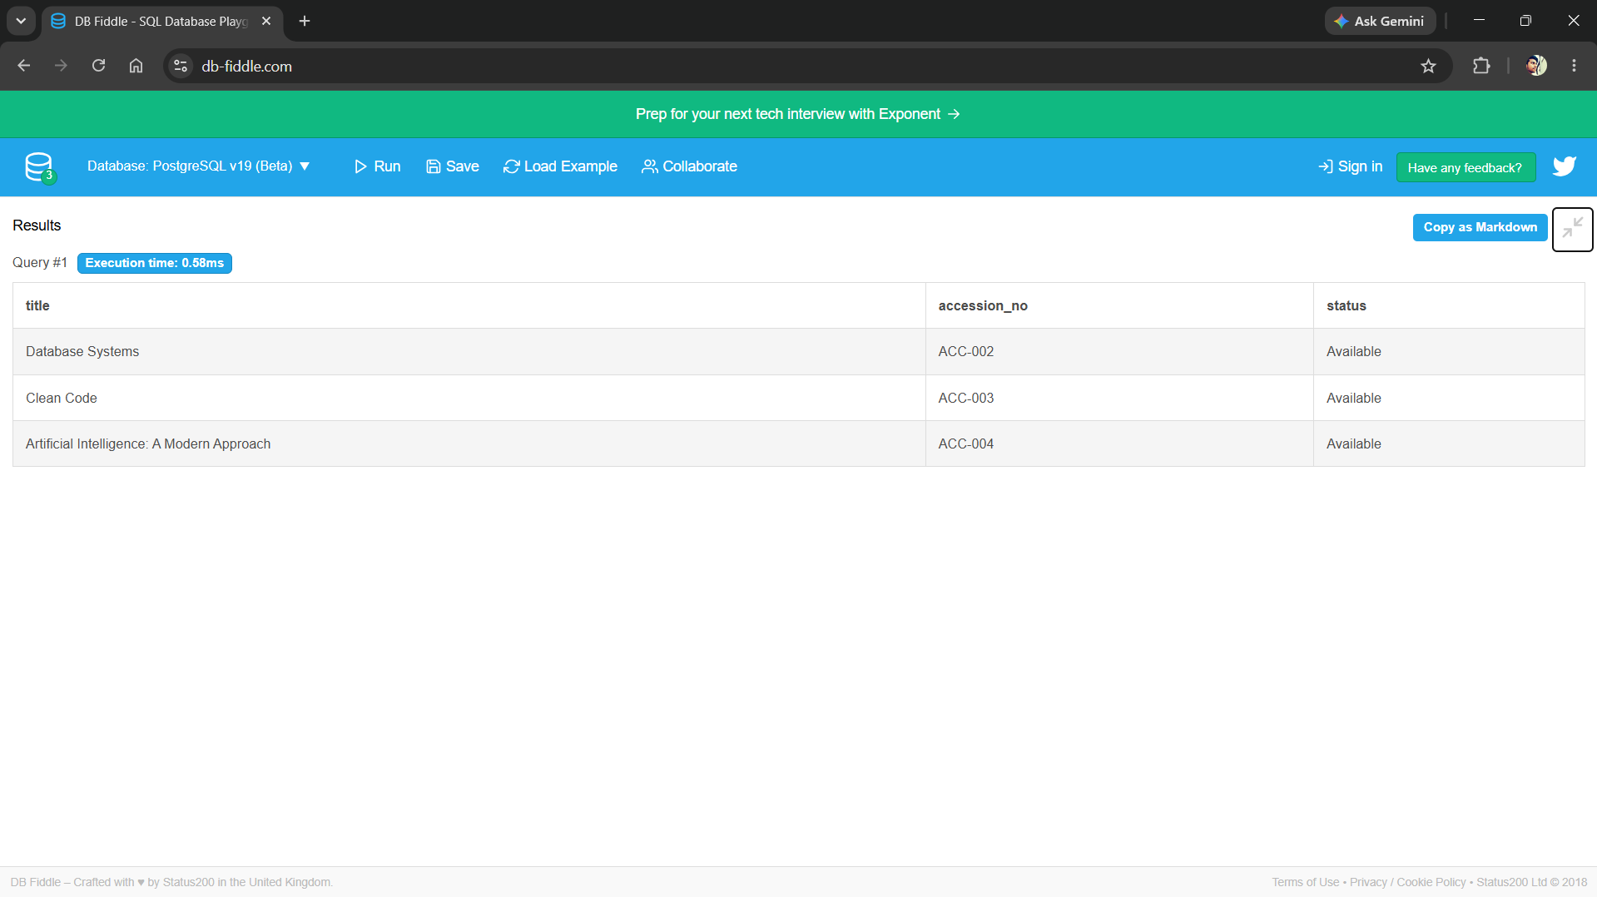

Query 4 -Show active loans
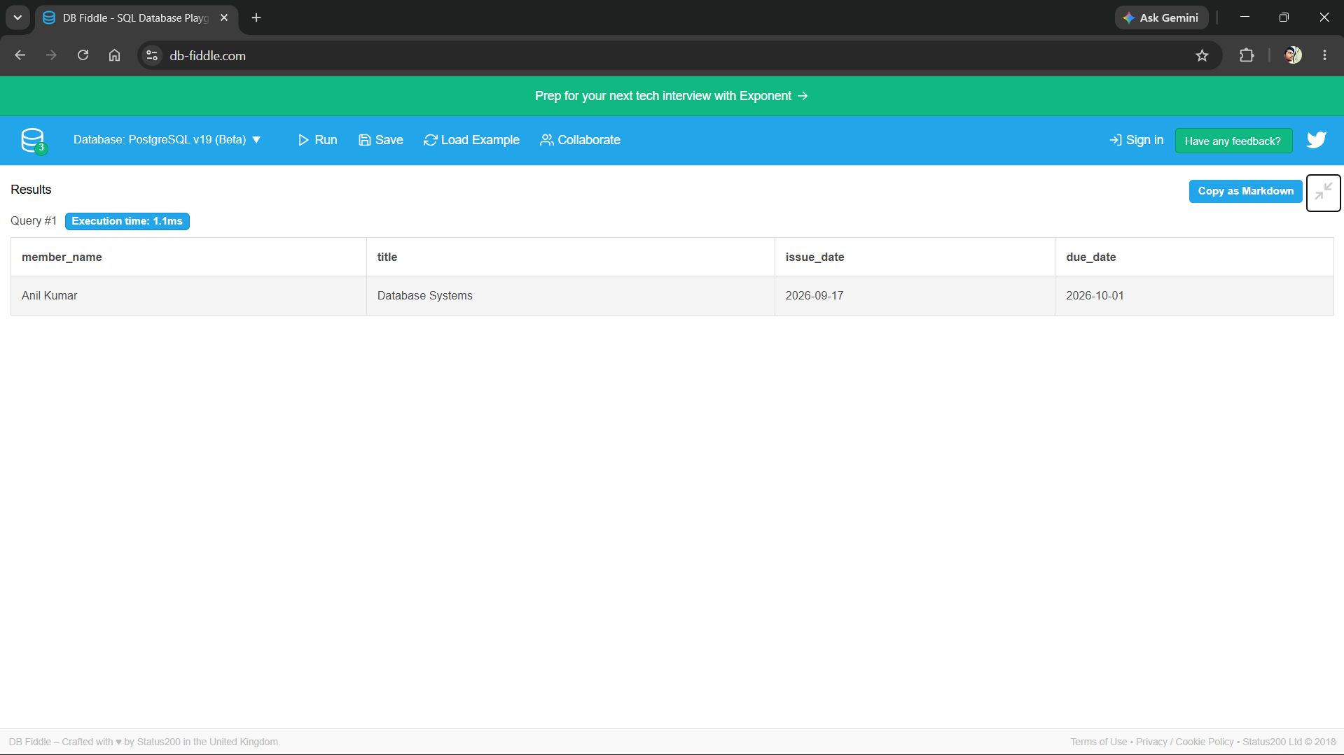

Query 5 - Show category-wise book count
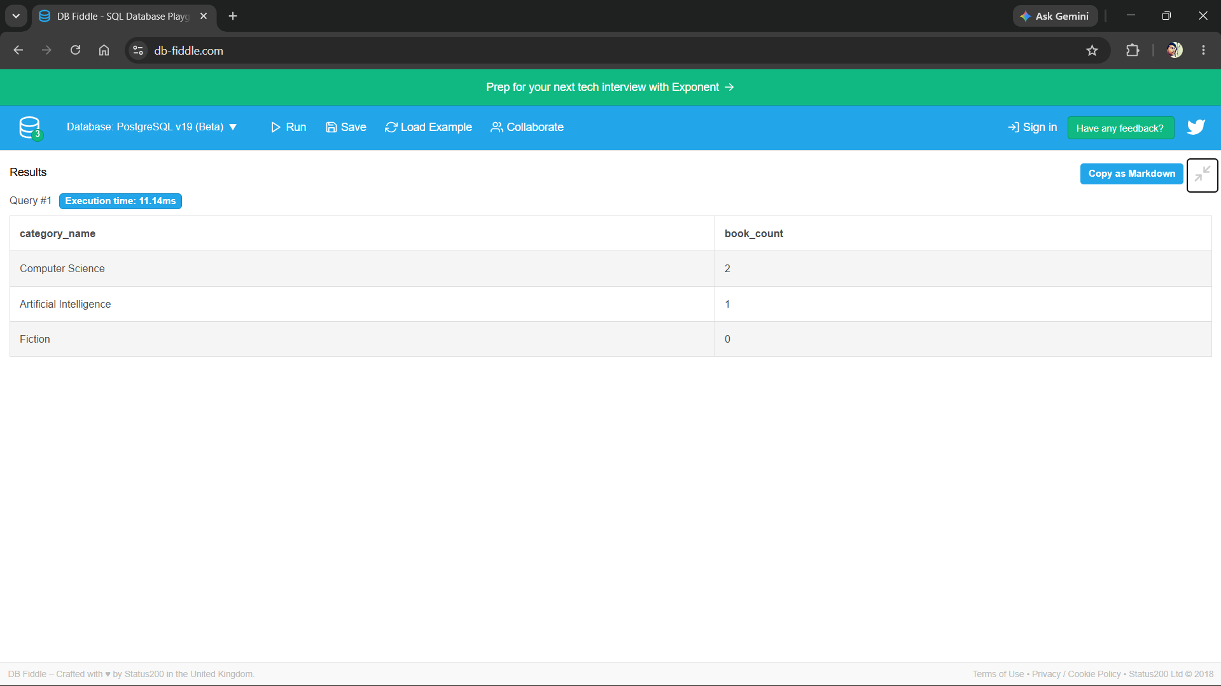

8. MODULES & FUNCTIONALITIES
Module | Functionality
Authentication | Role-based librarian/admin access.
Book Catalog | Add, edit, delete, search, and display books.
Copy Management | Track physical copy status.
Member Management | Register members and update details.
Issue and Return | Record loans, dates, returns, and status changes.
Reservation | Manage requests for unavailable books.
Fine Management | Record overdue charges and payments.
Reports | Inventory, overdue, circulation, and category reports.

9. GITHUB REPOSITORY & TEAM RESPONSIBILITIES
Repository Link: To be added by the project team
Student | Roll Number | Suggested Responsibility
M. Sri Ramana | 25B11AI704 | Coordination, integration, documentation
K. Chandru | 25B11AI465 | ER model, schema, normalization
G. Suhas | 25B11AI384 | DDL, DML, queries, testing
A. Datta Sri Sai | 25B11AI049 | UI, screenshots, GitHub organization

10. ENHANCEMENTS & FUTURE IMPROVEMENTS

The current Library Management System provides a robust database foundation. However, several enhancements can be implemented to transform it into a complete production-ready application:

10.1 User Interface Development

Develop a responsive web application using HTML, CSS, JavaScript, and Python Flask or Django

Create a mobile application using Flutter for Android and iOS platforms

Design an intuitive dashboard for librarians with quick access to frequently used features

Implement a member portal for self-service operations like searching books and viewing borrowing history

10.2 Security Enhancements

Add secure user authentication with username and password login

Implement password hashing using bcrypt or Argon2 for storing credentials securely

Create role-based access control (RBAC) with different permissions for Admin, Librarian, and Member

Add audit logs to track all critical operations like book issues, returns, and fine payments

Implement session management and timeout for security

10.3 Notification System

Send automated email or SMS reminders to members before due dates

Notify members when their reserved books become available

Alert librarians about low stock in popular categories

Send overdue notices automatically after the due date passes

10.4 Advanced Features

Integrate barcode or QR code scanning for quick book identification during issue and return

Add ISBN lookup API integration to auto-populate book details

Implement recommendation system suggesting books based on member's borrowing history

Add support for e-books and digital resources management

Enable bulk operations for importing book data from Excel or CSV files

10.5 Analytics and Reporting

Create interactive dashboard charts showing circulation statistics, popular categories, and member activity

Generate monthly and annual reports for library administration

Add data visualization for borrowing trends, peak hours, and seasonal patterns

Implement export functionality for reports in PDF and Excel formats

10.6 Performance and Scalability

Add database indexes on frequently queried columns for faster search operations

Implement connection pooling for better database performance

Set up automated daily backups with point-in-time recovery capability

Optimize queries and add caching for frequently accessed data

Deploy on cloud platforms like AWS, Azure, or Google Cloud for scalability

10.7 Integration Capabilities

Integrate with college ERP system for automatic member registration from student database

Add payment gateway integration for online fine payments

Connect with email services like SendGrid or SMTP for automated notifications

Enable API endpoints for third-party integrations and mobile app connectivity

11. CONCLUSION
The Library Management System provides a structured solution for library data and operations. Its normalized schema, relationships, constraints, and SQL queries support cataloguing, members, circulation, reservations, fines, and reporting. The project demonstrates practical DBMS concepts and can be extended with a web or mobile interface.

12. REFERENCES
1. Elmasri and Navathe, Fundamentals of Database Systems.
2. PostgreSQL Documentation.
3. Silberschatz, Korth, and Sudarshan, Database System Concepts.
4. Microsoft Word Documentation.

APPENDIX

A. Complete SQL Script
Save the DDL and DML from Section 7 as library_management.sql and upload it to GitHub. Add the final repository path here.

B. Additional Screenshots / Outputs
Attach execution and interface screenshots here.

