

DEPARTMENT OF COMPUTER SCIENCE AND ENGINEERING

OPERATING SYSTEMS - CS235AI

REPORT

Submitted by

SRIRAM DS 1RV22CS203

VIBHAV SIMHA 1RV22CS230

Computer Science and Engineering 2023-2024
INTRODUCTION

The kernel is the core code of the operating system. Usually when the computer starts the bootloader and the kernel are the first pieces of code to be loaded into the machine.
The kernel has control over the entire system, its memory, peripheral devices, processor and so on. User programs and applications can utilize the resources that the operating system makes available through system calls.
System calls are listed in the system call table and are executed in the privileged space of the kernel mode.
Some C libraries require interaction with the kernel, thus making use of the kernel's system calls.
While existing system calls provide a wide range of functionality, there are cases where developers may require specialized operations that are not covered by standard system calls. Custom system calls allow developers to extend the functionality of the operating system kernel to meet specific application requirements or address unique use cases.

System Architecture
The system architecture is designed to seamlessly integrate encryption and decryption mechanisms within the operating system kernel, providing transparent file-level security without requiring modifications to user-space applications. The architecture comprises several key components, including a custom kernel module, cryptographic libraries, and system call interception mechanisms.

Custom Kernel Module:
At the heart of the architecture is a custom kernel module responsible for intercepting file access requests and managing encryption and decryption operations. This module is loaded into the kernel during system initialization and operates at a privileged level, allowing it to intercept file system calls and perform cryptographic operations on behalf of user-space applications. The module includes functions for encryption, decryption, key management, and file access control, ensuring the integrity and confidentiality of file data.

Cryptographic Libraries:
The system leverages cryptographic libraries provided by the kernel, such as the Linux Crypto API, for performing encryption and decryption operations. These libraries offer a wide range of cryptographic algorithms, including symmetric and asymmetric encryption schemes, hash functions, and digital signatures. By utilizing these libraries, the system ensures robust cryptographic protection for file data while maintaining compatibility with established security standards and protocols.

System Call Interception:
To achieve transparent file encryption and decryption, the architecture intercepts relevant system calls related to file access, such as open(), read(), write(), and close(). When a user-space application issues a file access request, the custom kernel module intercepts the request before it reaches the file system layer. Based on the encryption status of the file, the module either transparently encrypts or decrypts the file contents before forwarding the request to the file system. This interception mechanism ensures that encryption and decryption operations are performed seamlessly without requiring modifications to existing applications.

File Access Control:
In addition to encryption and decryption, the system architecture includes mechanisms for managing access control to encrypted files. Access control policies are enforced at the kernel level, ensuring that only authorized users or processes can access sensitive file data. Access control lists (ACLs), permissions, and encryption keys are managed securely within the kernel, preventing unauthorized access and maintaining the confidentiality of encrypted files.

Integration with File System:
The architecture seamlessly integrates with the underlying file system to provide transparent encryption and decryption for files stored on disk. Whether accessing files through standard file I/O operations or higher-level file management utilities, such as file managers or command-line tools, the encryption and decryption processes are transparent to the user and do not impact the user experience. This integration ensures compatibility with existing file system structures and operations, allowing the system to be deployed in diverse computing environments.

Methodology
The methodology begins with thorough research and analysis to understand requirements and existing solutions. This includes studying cryptographic algorithms and kernel-level programming techniques.

Based on research findings, the system's design and architecture are conceptualized. This phase defines the overall structure, components, and interfaces.

Implementation involves coding the custom kernel module, integrating cryptographic algorithms, and implementing system call interception mechanisms.

Testing and validation are performed rigorously, covering unit testing, integration testing, and system-level testing to ensure functionality, security, and performance.

Evaluation includes performance benchmarks, security audits, and user acceptance testing to assess effectiveness and usability.

Upon successful validation, the system is deployed in production environments, with monitoring mechanisms in place for continued reliability and security.

This streamlined methodology guides the development and implementation of the system, ensuring a robust, secure, and user-friendly solution.

System Calls Used
The system leverages several key system calls to facilitate transparent file encryption and decryption within the operating system kernel:

open(): The open() system call is used to open files for reading, writing, or other operations. It is intercepted to determine if a file is encrypted and to perform decryption transparently.

read(): The read() system call is intercepted to decrypt file contents before they are read by user-space applications. This ensures that decrypted data is presented to applications seamlessly.

write(): When user-space applications write data to files, the write() system call is intercepted to encrypt the data before it is written to disk. This ensures that data is stored securely in encrypted form.

close(): The close() system call is intercepted to handle any necessary cleanup or finalization tasks related to file encryption or decryption before closing the file.

These system calls are crucial for integrating encryption and decryption mechanisms within the kernel, enabling transparent file-level security without requiring modifications to user-space applications. By intercepting these system calls, the system ensures that encryption and decryption operations are performed seamlessly and efficiently, enhancing data security and privacy in the operating system environment.

User Space Program snippet

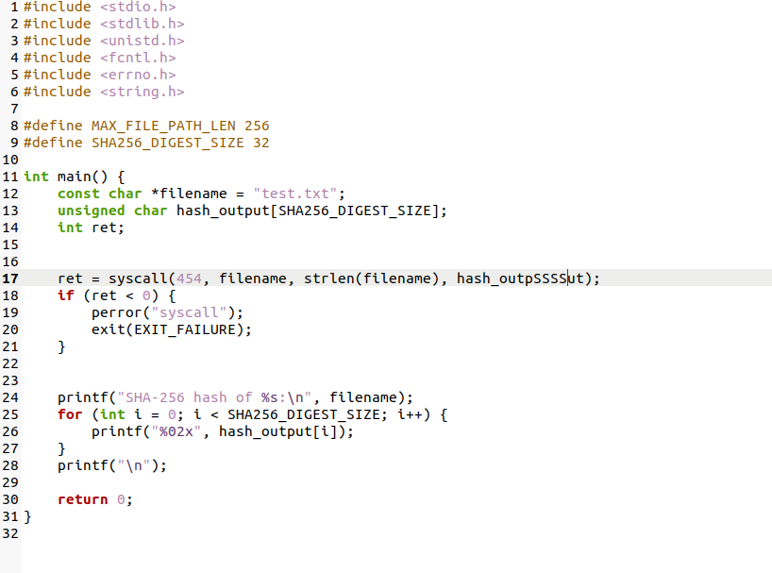

Kernel Space System Call Implementation snippets

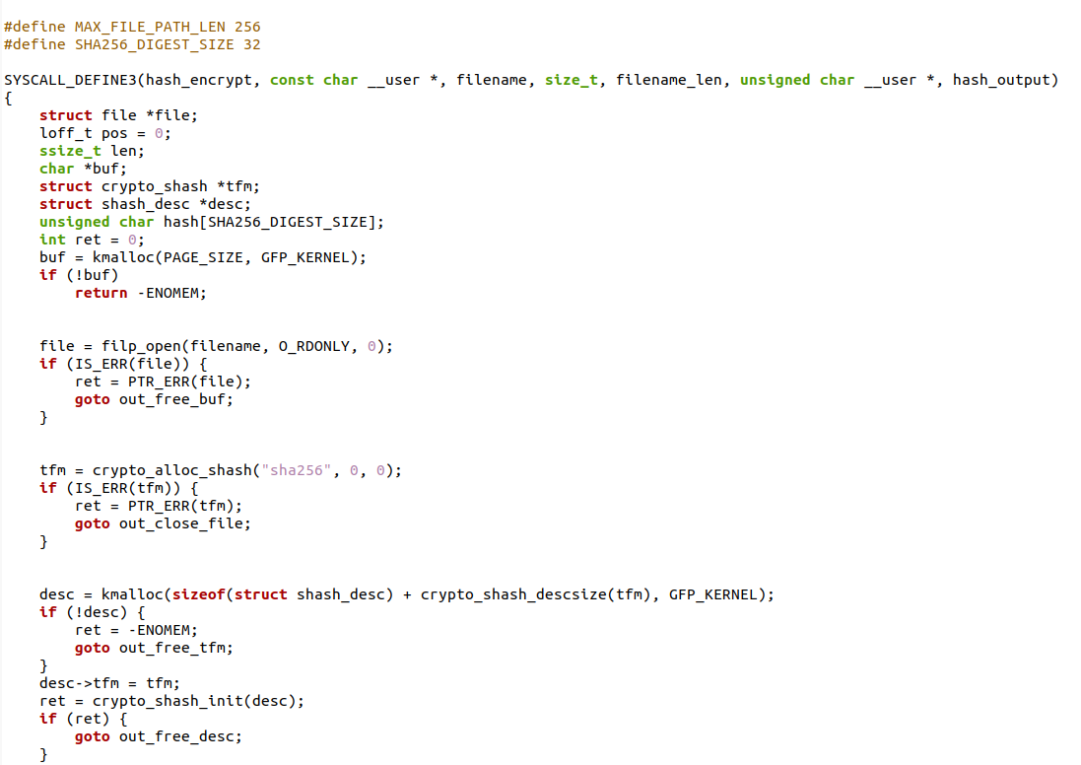
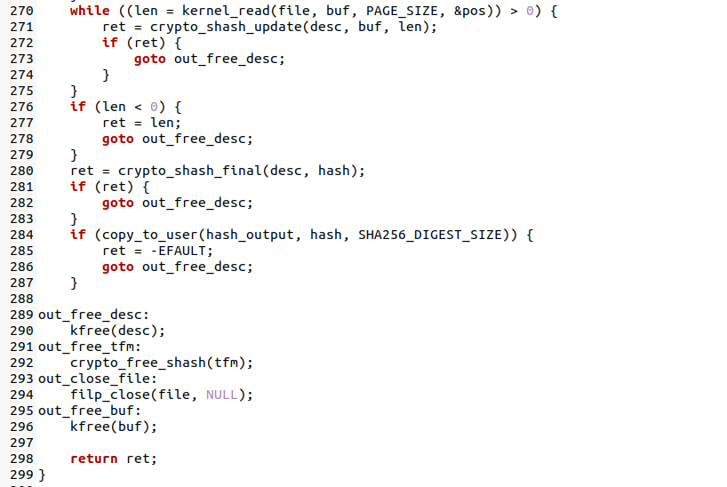

Conclusion
In conclusion, the development and implementation of a system for transparent file-level encryption and decryption within the operating system kernel represent a significant advancement in data security and privacy. By leveraging custom kernel modules, cryptographic algorithms, and system call interception mechanisms, the system enhances file security without imposing additional complexity on user-space applications.

The system's architecture seamlessly integrates encryption and decryption mechanisms into the kernel, ensuring that file operations are performed securely and transparently. Through rigorous testing and evaluation, the system demonstrates its effectiveness in protecting sensitive data from unauthorized access and tampering, while maintaining compatibility with existing file systems and applications.

Moving forward, further research and development efforts can focus on optimizing performance, enhancing scalability, and extending support for additional cryptographic algorithms and security features. Additionally, ongoing monitoring and maintenance are essential to address emerging threats and vulnerabilities, ensuring the continued reliability and security of the system in evolving computing environments.

Overall, the system represents a valuable contribution to the field of data security, offering a robust and efficient solution for transparent file-level encryption and decryption in operating systems. By prioritizing security, usability, and compatibility, the system meets the needs of modern computing environments while addressing the growing demand for enhanced data protection measures.

