**Distance Measuring using Ultrasonic Sensor**

**Abstract** : The capacity of a smart car to detect and classify an obstruction at various distances from it is critical to the system's design. An ultrasonic sensor is a very valuable sensor in the automation area. A mobile robot, for example, takes environmental data, turns it into a signal, and then performs the signalled duty of avoiding obstacles. This particular sensor provides satisfactory results at a reasonable price

**High Level Requirements :**

* Arduino uno for working of circuit
* using LCD display to show the distance of the obstacle
* using buzzer for warning of the obstacle
* using ultrasonic sensor to detect the obstacle by SONAR
* using LED to show if its safe or not

**Low Level Requirements :**

|  |  |  |
| --- | --- | --- |
| HLR-1 | LLR-1 | Receives data from the sensor |
|  | LLR-2 | Performs mathematical operations if any |
|  | LLR-3 | Sends data to the LCD display. |
|  | LLR-4 | May warn with buzzer if the obstacle is within a particular distance |
| HLR-2 | LLR-1 | This LCD display shows the distance of the obstacle in centimetres or inches |
| HLR-3 | LLR-1 | This is a sound device that warns with a buzzer |
| HLR-4 | LLR-1 | HC-SR04 is a ultrasonic sensor which works using SONAR to detect obstacles |

**Components :**

**Arduino Uno :** The Arduino Uno is an open-source microcontroller board based on the Microchip ATmega328P microcontroller and developed by Arduino.cc. The board is equipped with sets of digital and analog input/output (I/O) pins that may be interfaced to various expansion boards and other circuits. The board has 14 digital I/O pins, 6 analog I/O pins, and is programmable with the Arduino IDE, via a type B USB cable.

**LCD display :** A liquid-crystal display (LCD) is a flat-panel display that uses the light-modulating properties of liquid crystals combined with polarizers. Liquid crystals do not emit light directly, instead using a backlight or reflector to produce images in colour or monochrome.

**Ultrasonic Sensor – HC-SR04**

**Range** : 2cm to 450cm

**Operating frequency** : 40Hz

**Pins** : Vcc, Trigger, Echo, Ground

**Vcc** : Powers the sensor, with +5V.

**Trigger** : It’s an input pin. This pin has to be kept high for 10µs within which it gets a clock pulse to initialize measurement by sending Ultrasonic wave.

**Echo** : It’s an output pin. This pin goes high for a period of time which will be equal to the time taken for the ultrasonic wave to return back to the sensor from the obstacle.

**Ground** : This pin is connected to the ground of the system.

**Potentiometer :** The potentiometer is a device that is used to measure the voltage or electric potential. It provides a variable resistance when the shaft of the device is turned.

**5V source :** Voltage source for the peripherals to work.

**Buzzer** : It works as a actuator alerting the user.

**LED** : LED can be used to display safe and danger signal

**Block Diagram** : 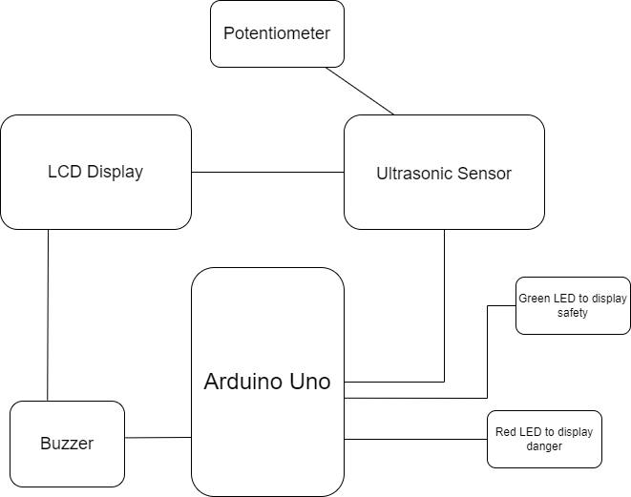

**Circuit :** 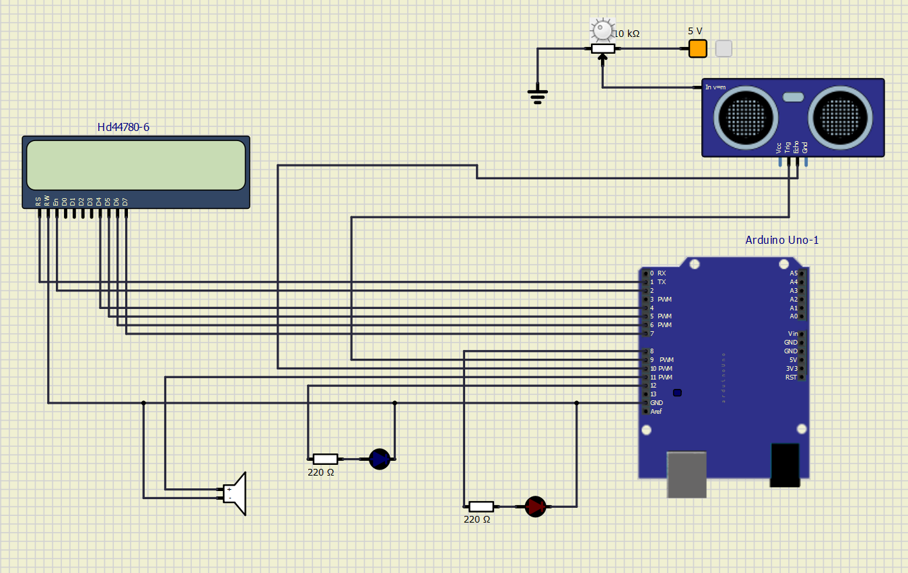

**Flowchart :**

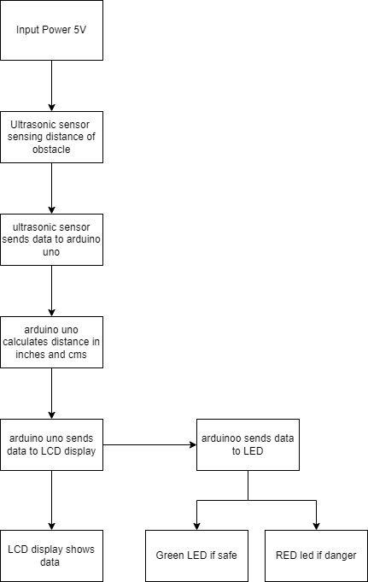

**Functions used in Code**

**pinmode()** : configures the specified pin to behave either as an input or an output. ‘pin’ is the pin number to set the mode of.

**‘mode’** : INPUT, OUTPUT, or INPUT_PULLUP.

**Syntax** : pinmode(pin, mode)

**digitalWrite()** : if the pin is configured as OUTPUT with pinmode(), its voltage will be 5V for HIGH, 0V for LOW. If the pin is configured as an INPUT, digitalWrite() will enable (HIGH) or disable (LOW) the internal pullup on the input pin.

**Syntax** : digitalWrite(pin, value)

**delayMicroseconds(µs)** : pausing the program for number of microseconds.

**analogWrite()** : Writes an analog value (PWM wave) to a pin. After a call to analogWrite(), the pin will generate a steady rectangular wave of the specified duty cycle until the next call to analogWrite().

**Syntax**  :analogWrite(pin, value)

**SWOT Analysis :**

**Strengths**

* It can be use din vehicles for obstacle detection

* It is a good system to avoid collisions

**opportunities**

* can be used in vehicles for obstacle detection

* more peripherals can be added to show warning messages

* It can also be used in water level sensing in tanks

**Weaknesses**

* If the device is not fast enough may cause accidents

* Different devices with more accurate detection may become a competition

**Threats**

* Ultrasonic sensors cannot work in vaccum.

* Sensing accuracy affected by soft materials

**Applications**

* Anti-Collision Detection.

* People Detection.

* Contouring or Profiling.

* Presence Detection.

**Conclusion** : In this project distance measurement of an obstacle has been successful by using Arduino uno and ultrasonic sensor .

This data is displayed on LCD display. LED and buzzer are used as actuators to give a message if it is at a safer distance or not. This application can be used in Vehicles.