**React code:**

**<!DOCTYPE html>**

**<html lang="en">**

**<head>**

**<meta charset="utf-8" />**

**<link rel="icon" href="%PUBLIC_URL%/favicon.ico" />**

**<meta name="viewport" content="width=device-width, initial-scale=1" />**

**<meta name="theme-color" content="#000000" />**

**<meta**

**name="description"**

**content="Web site created using create-react-app"**

**/>**

**<link rel="apple-touch-icon" href="%PUBLIC_URL%/logo192.png" />**

**<!--**

**manifest.json provides metadata used when your web app is installed on a**

**user's mobile device or desktop. See https://developers.google.com/web/fundamentals/web-app-manifest/**

**-->**

**<link rel="manifest" href="%PUBLIC_URL%/manifest.json" />**

**<!--**

**Notice the use of %PUBLIC_URL% in the tags above.**

**It will be replaced with the URL of the `public` folder during the build.**

**Only files inside the `public` folder can be referenced from the HTML.**

**Unlike "/favicon.ico" or "favicon.ico", "%PUBLIC_URL%/favicon.ico" will**

**work correctly both with client-side routing and a non-root public URL.**

**Learn how to configure a non-root public URL by running `npm run build`.**

**-->**

**<title>React App</title>**

**</head>**

**<body>**

**<noscript>You need to enable JavaScript to run this app.</noscript>**

**<div id="root"></div>**

**<!--**

**This HTML file is a template.**

**If you open it directly in the browser, you will see an empty page.**

**You can add webfonts, meta tags, or analytics to this file.**

**The build step will place the bundled scripts into the <body> tag.**

**To begin the development, run `npm start` or `yarn start`.**

**To create a production bundle, use `npm run build` or `yarn build`.**

**-->**

**</body>**

**</html>**

**Steps on AWS LAB:**

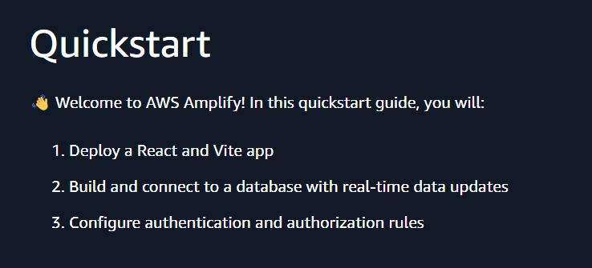

**Setting up:**

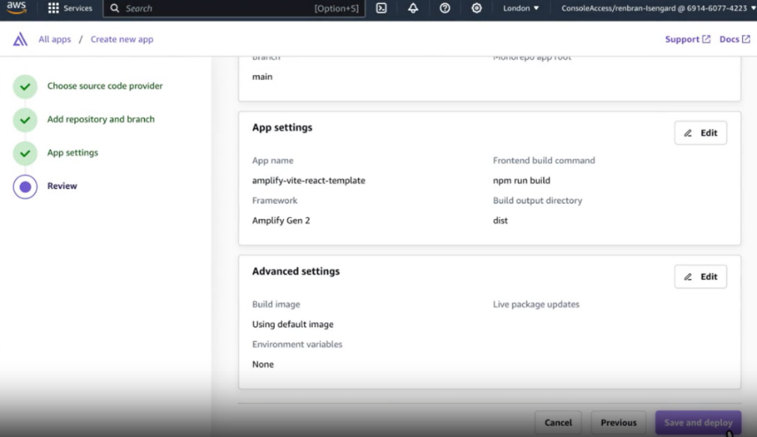

**AWS Amplify console:**

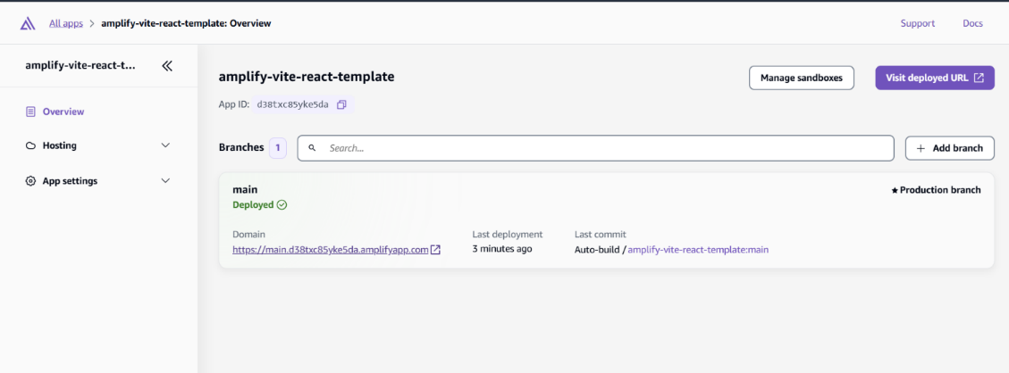

**Deployed App testing:**

