COMPUTER VISION-CO4-AT1

1. Preprocessing Impact Analysis
What are we doing?
We take an original image and apply preprocessing techniques:
Original Image → Noise Removal → Normalization → Feature Detection → Comparison
Techniques
- Noise removal: Gaussian Blur / Median Blur
- Normalization: Scale pixel values to a standard range
- Feature detection: Canny edges or Harris corners
Main purpose
To determine whether preprocessing improves the quality of detected features.
Expected observation
Image | Expected Result
Original | More noise and unwanted features
After noise removal | Smoother image and fewer false edges
After normalization | Better intensity consistency
After preprocessing + detection | Cleaner and more reliable features
Conclusion
Preprocessing generally improves feature detection by reducing unwanted noise and making image intensity more consistent. However, excessive smoothing can remove important edges and details.

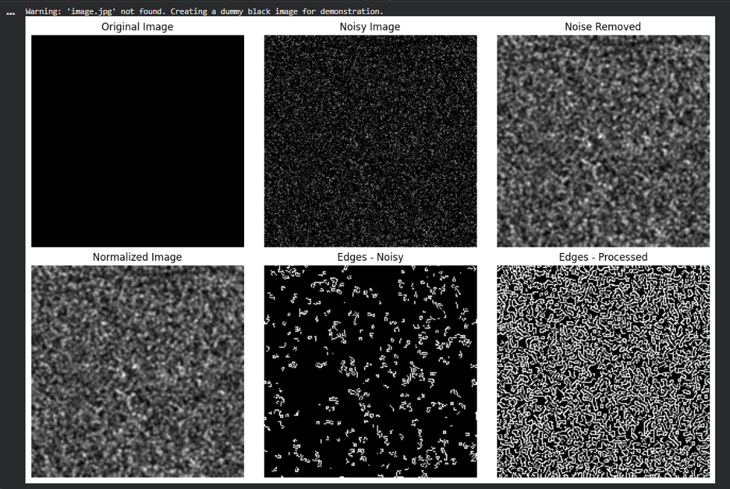

2. Image Representation Study
What are we doing?
Convert one color image into:
Color Image → Grayscale → Binary
Representations
RGB/Color
Contains three color channels:
- Red
- Green
- Blue
Grayscale
Each pixel contains one intensity value, usually:
0–255
Binary
Contains only two values:
0 = Black
255 = White
Simple workflow
Input Color Image
↓
Grayscale
↓
Thresholding
↓
Binary
↓
Edge Detection
Expected observation
- Grayscale retains intensity information.
- Binary simplifies the image considerably.
- Binary images are useful for segmentation and object extraction.
- Grayscale is usually more suitable than binary when detecting natural image edges.
Conclusion
Different representations provide different levels of information. Grayscale is useful for edge and feature detection, while binary representation is useful for segmentation and shape-based analysis.

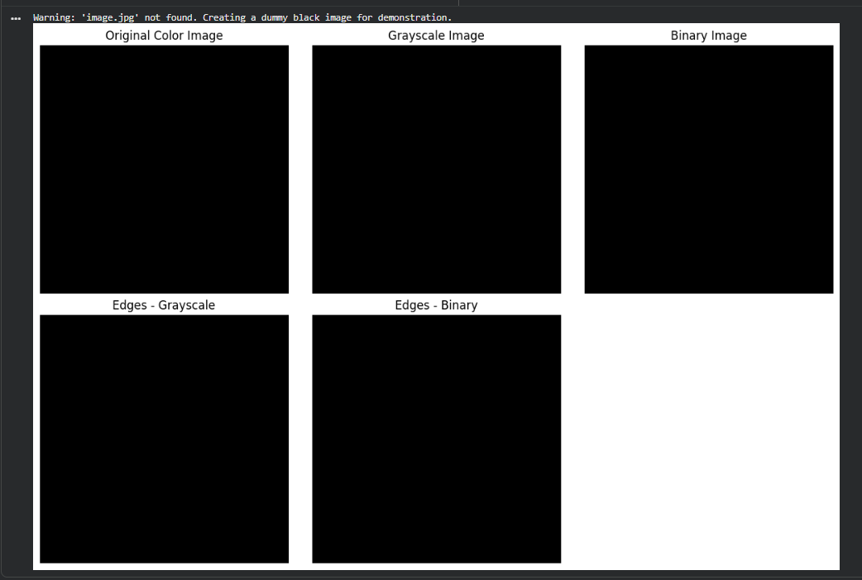

3. Edge Detection Comparison
Here you compare:
Sobel vs Canny
Both are applied to the same image.
Sobel
Sobel calculates intensity changes in horizontal and vertical directions.
Image
↓
Sobel X
↓
Sobel Y
↓
Gradient Magnitude
↓
Edges
Canny
Canny uses multiple stages:
Noise Reduction
↓
Gradient Calculation
↓
Non-Maximum Suppression
↓
Double Threshold
↓
Edge Tracking
↓
Final Edges
Comparison
Feature | Sobel | Canny
Complexity | Low | Higher
Noise sensitivity | Higher | Lower
Edge quality | Moderate | High
Thin edges | Less accurate | Better
Parameters | Simple | More parameters
Applications | Basic gradient analysis | Accurate edge detection
Conclusion
Canny generally produces thinner, cleaner, and more reliable edges, while Sobel is simpler and faster for basic gradient-based edge detection.

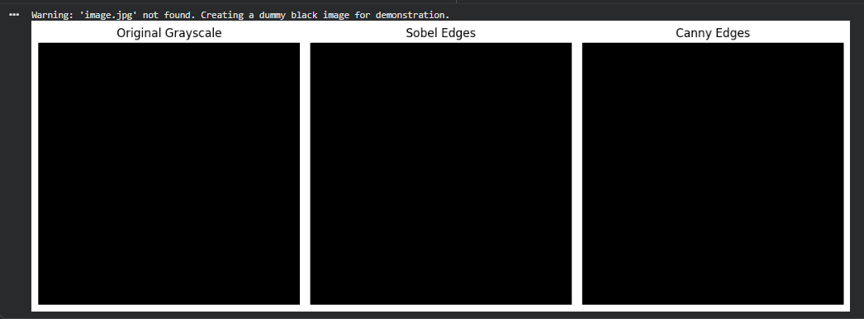

4. Harris Corner Detection Analysis
What are we doing?
We detect points where image intensity changes significantly in two directions.
These points are called corners.
For example:
|
|
--------●--------
|
|
The ● represents a corner.
Why corners are important
Corners are useful for:
- Image matching
- Object recognition
- Image stitching
- Tracking
- Feature extraction
- Computer vision applications
Harris principle
Harris analyzes how much the image changes when a small window is shifted.
The Harris response can be represented as:
R=det(M)−k(trace(M))2
where:
- M = structure tensor
- k = Harris constant
- R = corner response
Experiment
Use images with different patterns:
- Building
- Textured surface
- Simple object
Then apply Harris detection and compare the number/distribution of corners.
Expected observation
Highly textured images should produce more corner points, while smooth regions produce fewer corners.
Conclusion
Harris corner detection effectively identifies points with strong intensity changes in multiple directions. The number and distribution of corners depend strongly on image texture and patterns.

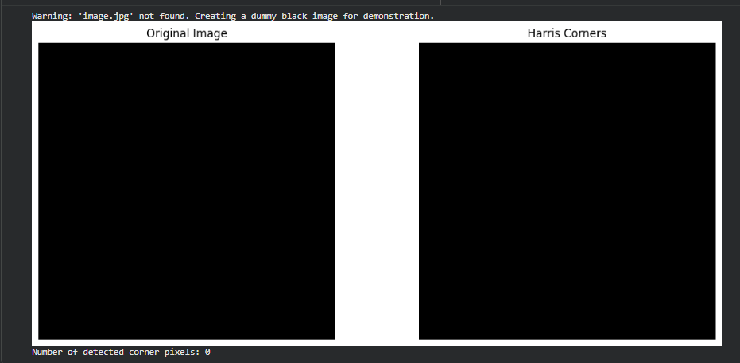

5. Effect of Noise on Corner Detection
This experiment is an extension of Experiment 4.
What are we doing?
Start with:
Original Image
Then artificially add noise:
Original Image
↓
Add Noise
↓
Noisy Image
↓
Harris Corner Detection
↓
Compare Results
You can use:
- Gaussian noise
- Salt-and-pepper noise
Comparison
Condition | Harris Detection
Original image | Normal corner points
Low noise | Some additional false corners
Medium noise | More incorrect corners
High noise | Many false/unstable corners
Improvement
Apply preprocessing before Harris:
Noisy Image
↓
Gaussian/Median Blur
↓
Harris Corner Detection
↓
Cleaner Corners
Conclusion
Noise can create false corner responses and reduce the reliability of Harris corner detection. Applying appropriate noise-removal techniques before corner detection can significantly improve detection stability.
