COMPUTER VISION-CO3-AT2

1. Preprocessing and Feature Detection
Problem
Images are captured under different lighting conditions. For example:
- Image 1 → bright lighting
- Image 2 → dark lighting
- Image 3 → uneven lighting
Feature detectors may produce different results for the same object.
Solution
Apply preprocessing before feature detection:
Original Image → Grayscale → Noise Removal → Contrast/Intensity Normalization → Feature Detection
Useful techniques include:
- Gaussian/median filtering
- Histogram equalization
- CLAHE
- Intensity normalization
Why does it help?
Preprocessing makes the image intensity more consistent and removes unwanted noise.
For example:
Without preprocessing
Image → Feature Detector → Inconsistent Features

With preprocessing
Image → Noise Removal → Normalization → Feature Detector
↓
More reliable features
Conclusion
Preprocessing improves feature detection by reducing noise and lighting variations. However, excessive smoothing should be avoided because it can remove important image details.

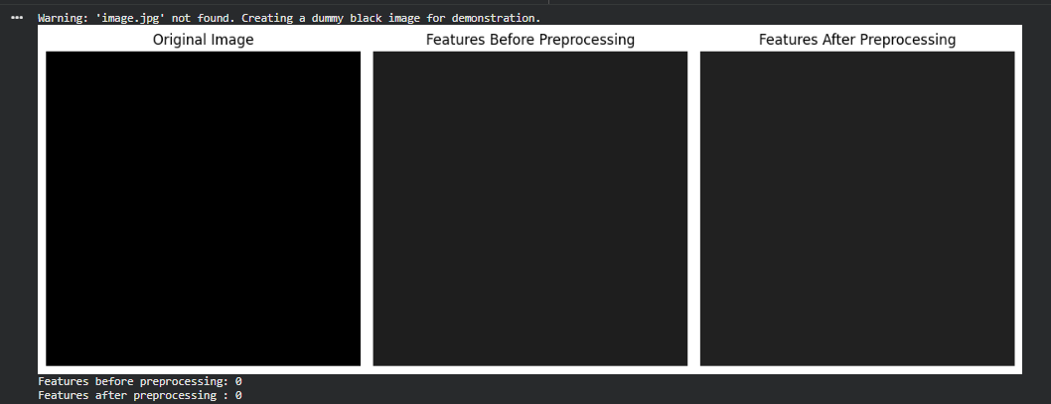

2. Edge vs Corner Detection
Problem
The image contains:
- Straight edges
- Textured regions
The system uses only edge detection but cannot identify useful matching points.
Why is edge detection insufficient?
An edge represents a boundary where image intensity changes.
For example:
-------------------------
Edge
-------------------------
But an edge does not necessarily provide a unique location.
A feature matcher needs distinctive points.
Corner detection
A corner has significant intensity changes in two directions.
|
|
-------●-------
|
|
The corner ● provides a much more distinctive location.
Comparison
Edge Detection | Corner Detection
Detects boundaries | Detects distinctive points
Good for shapes/objects | Good for feature matching
May produce long continuous lines | Produces localized key points
Less suitable for point correspondence | Suitable for image matching
Conclusion
Edge detection is useful for finding object boundaries, but corner detection is better for identifying distinctive key points required for image matching, tracking, and recognition.

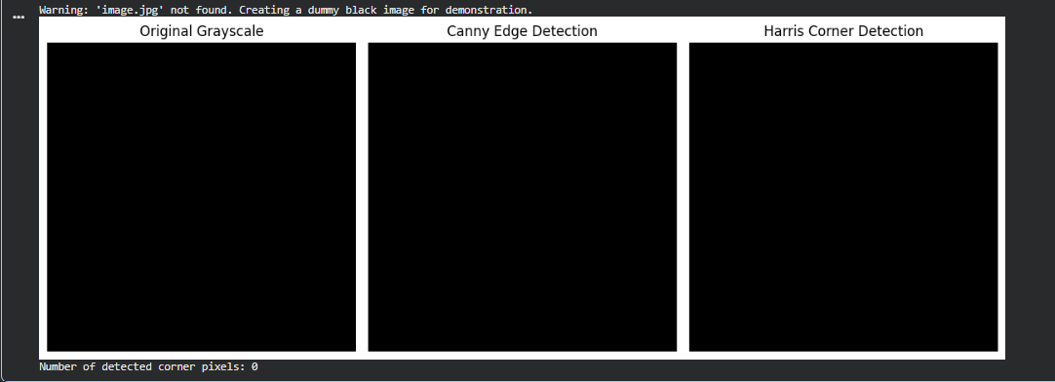

3. Hough Transform in Noisy Images
Problem
The Hough Transform is being used to detect lines, but noise creates inaccurate lines.
Why does noise cause problems?
Noise introduces random intensity changes.
The Hough Transform may interpret these random changes as possible edges or line evidence.
Original:
----------------------

Noisy:
---.-.--.------------.
.---.-.----.---------
Therefore, the accumulator receives votes from unwanted pixels.
Solution 1: Preprocessing
Before Hough Transform:
Noisy Image
↓
Gaussian/Median Filter
↓
Edge Detection
↓
Hough Transform
↓
Detected Lines
Solution 2: Parameter selection
Important parameters include:
- Hough threshold
- Minimum line length
- Maximum line gap
- Canny thresholds
For probabilistic Hough Transform:
HoughLinesP(
image,
rho,
theta,
threshold,
minLineLength,
maxLineGap
)
Increasing the threshold can reduce false lines, while appropriate minLineLength and maxLineGap values can improve detection.
Conclusion
Noise should be reduced before applying the Hough Transform. Appropriate edge-detection and Hough parameters are also necessary to eliminate false lines and improve detection accuracy.

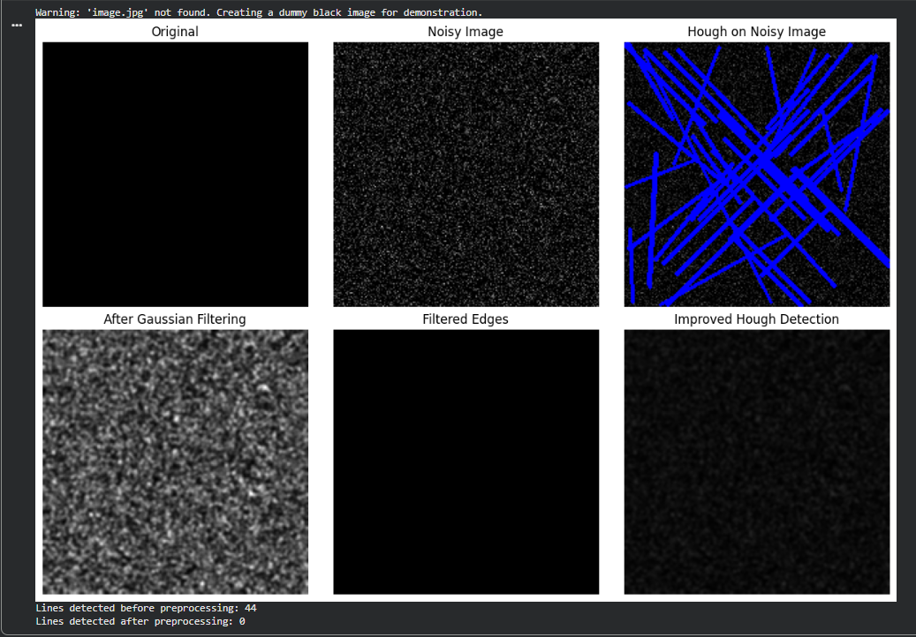

4. Feature Matching under Transformations
Problem
Two images contain the same object, but:
- Image 1 → normal scale and orientation
- Image 2 → different scale and orientation
Traditional feature matching fails.
Why?
Some traditional feature descriptors are sensitive to:
- Scale changes
- Rotation
- Viewpoint changes
- Illumination changes
Therefore, the same object may generate different feature descriptions.
Scale-invariant feature matching
Methods such as SIFT are designed to identify features that remain recognizable when the image is scaled or rotated.
Image 1
↓
Feature Detection
↓
Scale/Rotation-Invariant Descriptor
↓
Matching
↑
Scale/Rotation-Invariant Descriptor
↑
Image 2
Example
Suppose the original object is:
🔷
and the second image is:
🔷
but larger and rotated.
A scale-invariant method can still identify corresponding feature points.
Conclusion
Scale-invariant feature methods perform better because their descriptors are designed to remain stable under changes in scale and orientation. This makes them suitable for object recognition, image matching, panorama creation, and tracking.




5. PCA for Feature Optimization
Problem
A system extracts thousands of features.
For example:
1000 Features
↓
High memory
↓
High computation
↓
Redundant information
↓
Slower ML model
Solution: PCA
Principal Component Analysis (PCA) transforms the original features into a smaller number of new features called principal components.
Example:
1000 Original Features
↓
PCA
↓
100 Important Components
↓
Machine Learning Model
How PCA works
Simplified process:
- Standardize the data.
- Calculate the covariance matrix.
- Find eigenvalues and eigenvectors.
- Rank components according to their variance.
- Select the most important components.
- Transform the original data into the reduced feature space.
Example
Suppose:
Original features = 500
After PCA:
Principal components = 50
If those 50 components preserve most of the important variance, we can train the model using only those 50 features.
Benefits
- Reduces dimensionality
- Removes redundancy
- Reduces computational cost
- Reduces memory requirements
- Can improve model training speed
- Helps visualization
Conclusion
PCA reduces a large feature set into a smaller set of informative components while preserving most of the important variation in the data. This makes feature processing and machine-learning models more efficient.

