COMPUTER VISION-CO4-AT1

1. Real-Time System Design Trade-off
Problem
Compare:
- Viola-Jones → 78% accuracy, fast
- YOLO → 92% accuracy, moderate speed
- Deep Learning → 95% accuracy, slow
The program compares accuracy and processing speed and recommends a method for a strict-latency surveillance system.
Python
Run
import matplotlib.pyplot as plt

# Detection methods
methods = ["Viola-Jones", "YOLO", "Deep Learning"]

# Given accuracy values
accuracy = [78, 92, 95]

# Simulated processing speed in FPS
fps = [30, 20, 8]

# Plot accuracy
plt.figure(figsize=(8, 5))
plt.bar(methods, accuracy)
plt.ylabel("Accuracy (%)")
plt.xlabel("Detection Method")
plt.title("Accuracy Comparison")
plt.ylim(0, 100)
plt.show()

# Plot speed
plt.figure(figsize=(8, 5))
plt.bar(methods, fps)
plt.ylabel("Frames Per Second (FPS)")
plt.xlabel("Detection Method")
plt.title("Speed Comparison")
plt.show()

# Display results
for i in range(len(methods)):
print(methods[i])
print("Accuracy:", accuracy[i], "%")
print("Speed:", fps[i], "FPS")
print()

# Decision
print("Recommended Method: YOLO")
print("Reason:")
print("YOLO provides high accuracy (92%) with moderate speed.")
print("It provides a better balance between accuracy and latency.")
Conclusion
YOLO is the best choice when strict latency is required while maintaining acceptable accuracy.
- Viola-Jones → fastest but accuracy is lower.
- YOLO → good balance.
- Deep Learning → highest accuracy but too slow for strict real-time conditions.

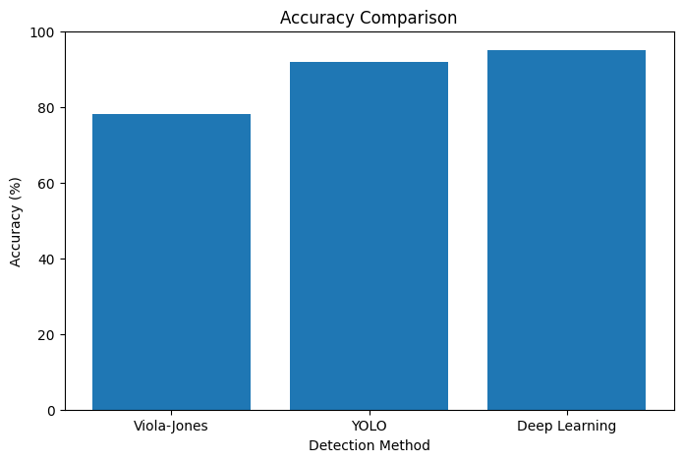
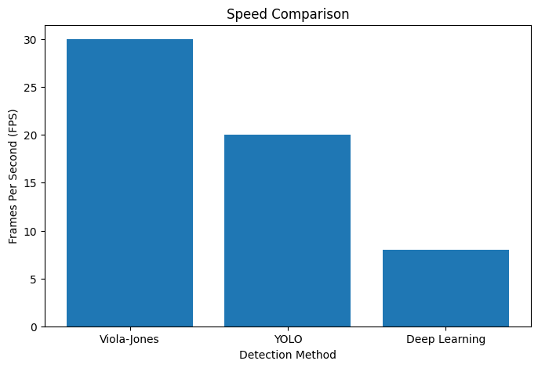

2. Robust Detection under Environmental Variations
Problem
Compare detection under:
- Normal conditions
- Occlusion
- Low light
Python
Run
import numpy as np
import matplotlib.pyplot as plt

methods = [
"Viola-Jones",
"YOLO",
"Deep Learning"
]

normal = [80, 90, 95]
occlusion = [60, 75, 85]
low_light = [55, 70, 80]

x = np.arange(len(methods))
width = 0.25

plt.figure(figsize=(10, 6))

plt.bar(
x - width,
normal,
width,
label="Normal"
)

plt.bar(
x,
occlusion,
width,
label="Occlusion"
)

plt.bar(
x + width,
low_light,
width,
label="Low Light"
)

plt.xticks(x, methods)
plt.ylabel("Accuracy (%)")
plt.title("Robustness under Environmental Variations")
plt.ylim(0, 100)
plt.legend()

plt.show()

# Calculate average accuracy
for i in range(len(methods)):
average = (
normal[i] +
occlusion[i] +
low_light[i]
) / 3

print(
methods[i],
"Average Accuracy:",
round(average, 2),
"%"
)

# Best method
averages = [
np.mean([80, 60, 55]),
np.mean([90, 75, 70]),
np.mean([95, 85, 80])
]

best_index = np.argmax(averages)

print()
print("Best Overall Method:", methods[best_index])
print(
"Average Accuracy:",
round(averages[best_index], 2),
"%"
)
Expected average accuracy
Method | Average
Viola-Jones | 65.00%
YOLO | 78.33%
Deep Learning | 86.67%
Conclusion
Deep Learning provides the best overall robustness, especially under occlusion and low-light conditions.
However:
- It requires more computation.
- It may have higher latency.
- YOLO provides a better speed/accuracy compromise.

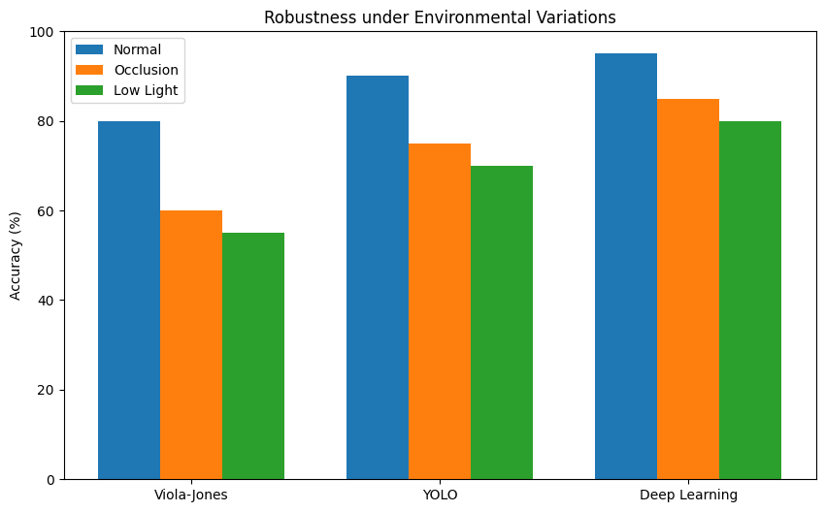

3. Optical Flow Reliability vs Noise Sensitivity
Problem
Method A:
- Stable vectors
- Misses small motions
Method B:
- Detects small/fine motion
- Produces noisy vectors
We can simulate both methods using optical flow.
Python
Run
import cv2
import numpy as np
import matplotlib.pyplot as plt

# Create two synthetic frames
frame1 = np.zeros((300, 400), dtype=np.uint8)
frame2 = np.zeros((300, 400), dtype=np.uint8)

# Add moving objects
cv2.circle(frame1, (120, 150), 30, 255, -1)
cv2.circle(frame2, (130, 155), 30, 255, -1)

cv2.rectangle(frame1, (250, 100), (300, 150), 255, -1)
cv2.rectangle(frame2, (255, 105), (305, 155), 255, -1)

# Detect good feature points
features = cv2.goodFeaturesToTrack(
frame1,
maxCorners=100,
qualityLevel=0.01,
minDistance=10
)

# Calculate optical flow
next_points, status, error = cv2.calcOpticalFlowPyrLK(
frame1,
frame2,
features,
None
)

# Select valid points
old_points = features[status == 1]
new_points = next_points[status == 1]

# Display Method A
method_a = cv2.cvtColor(
frame2,
cv2.COLOR_GRAY2RGB
)

for old, new in zip(old_points, new_points):

x1, y1 = old.astype(int)
x2, y2 = new.astype(int)

# Stable vector
cv2.arrowedLine(
method_a,
(x1, y1),
(x2, y2),
(0, 255, 0),
2
)

# Add artificial noise to vectors for Method B
method_b = cv2.cvtColor(
frame2,
cv2.COLOR_GRAY2RGB
)

for old, new in zip(old_points, new_points):

x1, y1 = old.astype(int)
x2, y2 = new.astype(int)

# Add random noise
x2 += np.random.randint(-5, 6)
y2 += np.random.randint(-5, 6)

cv2.arrowedLine(
method_b,
(x1, y1),
(x2, y2),
(255, 0, 0),
2
)

# Display
plt.figure(figsize=(12, 5))

plt.subplot(1, 2, 1)
plt.imshow(method_a)
plt.title("Method A - Stable Vectors")
plt.axis("off")

plt.subplot(1, 2, 2)
plt.imshow(method_b)
plt.title("Method B - Fine but Noisy Vectors")
plt.axis("off")

plt.show()
Analysis
Method | Advantage | Disadvantage
A | Stable and reliable | Misses small movements
B | Detects fine motion | Noisy vectors
Conclusion
The best method depends on the application.
For surveillance and large-object tracking → Method A is preferable because stability is more important.
For applications such as gesture recognition or microscopic motion → Method B may be better because detecting small movements is important.

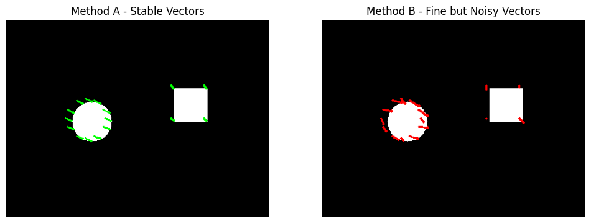

4. Background Modeling Strategy – GMM
Problem
A Gaussian Mixture Model is used for background subtraction.
Problems:
- Dynamic background → false positives
- Static background → missed detections
This program uses OpenCV's MOG2 background subtraction, which is based on Gaussian mixture background modeling.
Python
Run
import cv2
import numpy as np
import matplotlib.pyplot as plt

# Create background subtractor
background_subtractor = cv2.createBackgroundSubtractorMOG2(
history=100,
varThreshold=50,
detectShadows=True
)

# Create synthetic frames
frames = []

for i in range(10):

frame = np.zeros(
(300, 400, 3),
dtype=np.uint8
)

# Static background
cv2.rectangle(
frame,
(0, 0),
(400, 300),
(80, 80, 80),
-1
)

# Moving object
x = 50 + i * 20

cv2.rectangle(
frame,
(x, 120),
(x + 50, 180),
(255, 255, 255),
-1
)

# Dynamic background: moving small circle
circle_x = 300 + int(20 * np.sin(i))

cv2.circle(
frame,
(circle_x, 70),
20,
(150, 150, 150),
-1
)

frames.append(frame)

# Apply background subtraction
masks = []

for frame in frames:

mask = background_subtractor.apply(frame)

# Remove noise
kernel = np.ones(
(5, 5),
np.uint8
)

mask = cv2.morphologyEx(
mask,
cv2.MORPH_OPEN,
kernel
)

mask = cv2.morphologyEx(
mask,
cv2.MORPH_CLOSE,
kernel
)

masks.append(mask)

# Display selected frame
plt.figure(figsize=(12, 6))

plt.subplot(1, 3, 1)
plt.imshow(
cv2.cvtColor(
frames[5],
cv2.COLOR_BGR2RGB
)
)
plt.title("Input Frame")
plt.axis("off")

Improvement techniques
The GMM system can be improved using:
- Gaussian/median filtering
- Morphological opening and closing
- Shadow removal
- Proper varThreshold
- Proper history length
- Combining GMM with object detection such as YOLO
Conclusion
GMM alone is not always sufficient. It works well for relatively stable backgrounds but can struggle with waving trees, water, moving shadows, and other dynamic backgrounds.
A hybrid system can provide better results:
Video
↓
Noise Removal
↓
GMM Background Subtraction
↓
Morphological Filtering
↓
Object Detection
↓
Final Detection

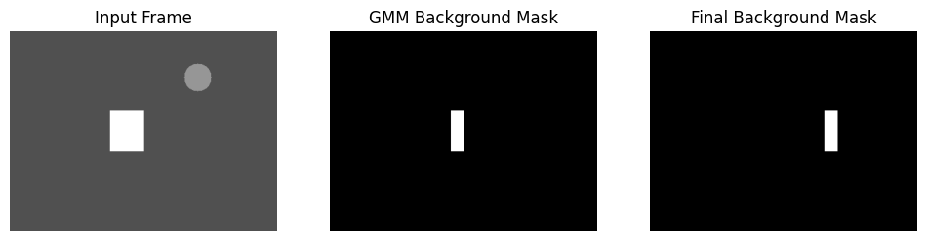

5. Motion Estimation vs Computational Cost
Problem
Method A:
- Error = 5%
- Computational cost = High
Method B:
- Error = 10%
- Computational cost = Low
We can compare their error and computational cost using a simple program.
Python
Run
import matplotlib.pyplot as plt

methods = [
"Method A",
"Method B"
]

error = [
5,
10
]

# Relative computational cost
computation = [
90,
30
]

# Error comparison
plt.figure(figsize=(8, 5))

plt.bar(
methods,
error
)

plt.ylabel("Error (%)")
plt.title("Motion Estimation Error")
plt.show()

# Computational cost
plt.figure(figsize=(8, 5))

plt.bar(
methods,
computation
)

plt.ylabel("Relative Computational Cost")
plt.title("Computational Cost")
plt.show()

# Display values
for i in range(2):

print(methods[i])
print("Error:", error[i], "%")
print(
"Computational Cost:",
computation[i]
)
print()

# Recommendations
print("Real-Time Application:")
print("Method B is preferred because computational cost is low.")

print()

print("Offline Application:")
print("Method A is preferred because it provides lower error.")

