DSA0204 – Open CV
Constraint-Based Evaluation
1. Smart Surveillance System Selection
Model | Accuracy | Latency | Hardware | Meets Constraints?
Viola-Jones | 78% | Low | Low | ❌ No — accuracy < 85%
YOLO | 92% | Moderate | Moderate | ✅ Yes
Deep Learning | 95% | High | High | ❌ No — latency > 100 ms / hardware too demanding
Decision: YOLO
- Accuracy = 92% ≥ 85%, so accuracy requirement is satisfied.
- Latency is moderate, making it suitable for the moderate-computation hardware.
- Viola-Jones fails because its accuracy is only 78%.
- Deep Learning has higher accuracy, but its high latency and computational requirement make it unsuitable.
Conclusion: YOLO is the best choice because it satisfies the accuracy and hardware constraints while providing practical response speed.

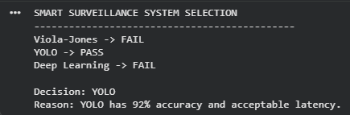

2. Autonomous Vehicle Detection Logic
Method | Accuracy | Response Time | Meets Both Constraints?
Method A | 88% | 30 ms | ❌ No — accuracy < 90%
Method B | 93% | 70 ms | ❌ No — response time > 50 ms
Method C | 91% | 45 ms | ✅ Yes
Decision: Method C
- Safety requires accuracy > 90%.
- Response time must be < 50 ms.
- Method C provides 91% accuracy and 45 ms response time.
- Method A is fast but fails the safety requirement.
- Method B is accurate but too slow.
Conclusion: Method C should be selected because it is the only method satisfying both safety and response-time constraints.

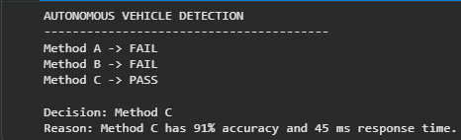

3. Motion Analysis Decision Problem
Approach | Advantage | Limitation in Dense Traffic
Optical Flow | Accurate motion direction and detailed information | Becomes noisy
Motion Estimation | Stable and robust | Less detailed
Decision: Motion Estimation
In high-density traffic, many vehicles and objects move simultaneously. Optical Flow may produce noisy results because objects overlap and motion patterns become complex.
Motion Estimation is more stable in dense scenes, which is more important for reliable traffic monitoring.
Conclusion: Motion Estimation is more suitable for high-density traffic because robustness and stability are more important than fine motion details in this scenario.

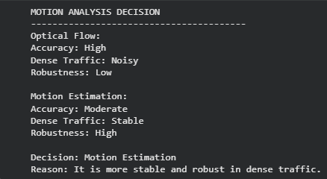

4. Background Modeling Evaluation
Scenario | GMM Accuracy | Requirement
Static scenes | 90% | ≥ 80%
Dynamic scenes | 65% | ≥ 80%
Decision: GMM alone is NOT sufficient.
Logical evaluation:
- Static scene: 90% ≥ 80% → satisfies requirement.
- Dynamic scene: 65% < 80% → fails requirement.
- Since the system must maintain at least 80% accuracy across all scenarios, failure in dynamic scenes means GMM alone cannot be accepted.
Suggested decision: Use GMM together with a more robust dynamic-background or motion-handling technique.
Conclusion: GMM performs well in static environments but does not satisfy the overall requirement because its dynamic-scene accuracy is only 65%.

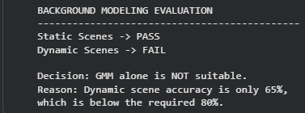

5. Retail Motion Tracking Logic
Approach | Low Crowd Density | High Crowd Density | Main Issue
Optical Flow | ✅ Accurate | ❌ Noisy | Poor in crowds
Motion Models | ⚠️ Less detailed | ✅ Stable | Lower detail
Decision: Use a combination of both approaches.
The requirements are different for the two situations:
- Low density → Optical Flow because it provides accurate and detailed tracking.
- High density → Motion Models because they remain stable when many people are present.
- A hybrid system can switch between the methods based on crowd density.
For example:
Detect Crowd Density
|
+----------+----------+
| |
Low Density High Density
| |
Optical Flow Motion Model
| |
Accurate Tracking Stable Tracking
Conclusion: A hybrid/adaptive approach is the best solution. Optical Flow should handle low-density situations, while Motion Models should handle high-density situations. This satisfies both accuracy and stability requirements better than using either method alone.

