DSA0204 – Open CV

1. Detection Performance Comparison
Given:
Model | TP | FP | FN
Viola-Jones | 80 | 20 | 30
YOLO | 90 | 15 | 20
(a) Precision and Recall
Formulas:
Precision=TPTP+FPPrecision = \frac{TP}{TP+FP} Recall=TPTP+FNRecall = \frac{TP}{TP+FN}
Viola-Jones
Precision=8080+20=80100=0.80Precision = \frac{80}{80+20} = \frac{80}{100} = 0.80
Precision = 80%
Recall=8080+30=80110=0.7273Recall = \frac{80}{80+30} = \frac{80}{110} = 0.7273
Recall = 72.73%
YOLO
Precision=9090+15=90105=0.8571Precision = \frac{90}{90+15} = \frac{90}{105} = 0.8571
Precision = 85.71%
Recall=9090+20=90110=0.8182Recall = \frac{90}{90+20} = \frac{90}{110} = 0.8182
Recall = 81.82%
(b) Comparison
Model | Precision | Recall
Viola-Jones | 80% | 72.73%
YOLO | 85.71% | 81.82%
Answer: YOLO is better because it has both higher precision and higher recall. It produces more correct detections while reducing false positives and false negatives.
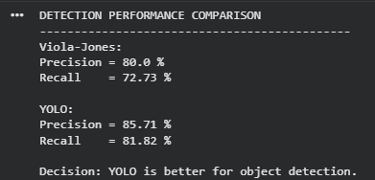

2. Motion Estimation Error Analysis
Given:
Frame | Method A | Method B
1 | 2 | 3
2 | 3 | 5
3 | 2 | 4
(a) Average Error
Method A:
Average=2+3+23=73=2.33Average = \frac{2+3+2}{3} =\frac{7}{3} =2.33
Average error = 2.33 pixels
Method B:
Average=3+5+43=123=4Average = \frac{3+5+4}{3} =\frac{12}{3} =4
Average error = 4 pixels
(b) Comparison
Method | Average Error
Method A | 2.33 pixels
Method B | 4 pixels
Answer: Method A is more accurate because it has a lower average displacement error. In motion estimation, a smaller error indicates better accuracy.
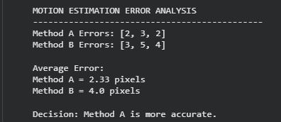

3. Optical Flow Magnitude Comparison
Given:
Region | Method A | Method B
R1 | 5 | 8
R2 | 6 | 10
R3 | 5 | 9
(a) Average Motion Magnitude
Method A:
Average=5+6+53=163=5.33Average = \frac{5+6+5}{3} =\frac{16}{3} =5.33
Average magnitude = 5.33 pixels/frame
Method B:
Average=8+10+93=273=9Average = \frac{8+10+9}{3} =\frac{27}{3} =9
Average magnitude = 9 pixels/frame
(b) Comparison
Method | Average Magnitude
Method A | 5.33 pixels/frame
Method B | 9 pixels/frame
Answer: Method B captures stronger motion because its average optical-flow magnitude is higher at 9 pixels/frame, compared with 5.33 pixels/frame for Method A.
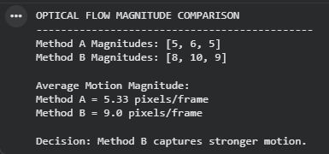

4. Depth Estimation Comparison — Stereo vs SfM
Given:
Object | Stereo Vision | SfM | Actual Depth
A | 2.0 | 2.5 | 2.0
B | 3.0 | 3.8 | 3.0
C | 4.0 | 5.0 | 4.0
(a) Absolute Error
Formula:
Absolute Error=∣Estimated Depth−Actual Depth∣Absolute\ Error = |Estimated\ Depth - Actual\ Depth|
Stereo Vision
For A:
∣2.0−2.0∣=0|2.0-2.0|=0
For B:
∣3.0−3.0∣=0|3.0-3.0|=0
For C:
∣4.0−4.0∣=0|4.0-4.0|=0
Stereo errors = 0, 0, 0 meters
Average error:
0+0+03=0\frac{0+0+0}{3}=0
Average error = 0 meters
Structure from Motion (SfM)
For A:
∣2.5−2.0∣=0.5|2.5-2.0|=0.5
For B:
∣3.8−3.0∣=0.8|3.8-3.0|=0.8
For C:
∣5.0−4.0∣=1.0|5.0-4.0|=1.0
SfM errors = 0.5, 0.8, 1.0 meters
Average error:
0.5+0.8+1.03=2.33=0.77\frac{0.5+0.8+1.0}{3} =\frac{2.3}{3} =0.77
Average error ≈ 0.77 meters
(b) Comparison
Method | Errors (m) | Average Error
Stereo Vision | 0, 0, 0 | 0 m
SfM | 0.5, 0.8, 1.0 | 0.77 m
Answer: Stereo Vision is more accurate because it has zero error for all three objects, while SfM has an average error of approximately 0.77 meters.
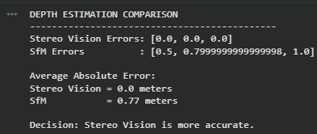

5. Pattern Recognition Accuracy Comparison
Given:
System | Correct Predictions | Total Samples
Traditional | 85 | 100
Deep Learning | 92 | 100
(a) Accuracy
Formula:
Accuracy=Correct PredictionsTotal Samples×100Accuracy = \frac{Correct\ Predictions}{Total\ Samples}\times100
Traditional System
Accuracy=85100×100=85%Accuracy = \frac{85}{100}\times100 = 85\%
Accuracy = 85%
Deep Learning
Accuracy=92100×100=92%Accuracy = \frac{92}{100}\times100 = 92\%
Accuracy = 92%
(b) Comparison
System | Accuracy
Traditional | 85%
Deep Learning | 92%
Answer: Deep Learning performs better because it achieves 92% accuracy, which is 7 percentage points higher than the Traditional system's 85%.
