CO-1 AT-01- Data Interpretation

Name: V.Sri Sadhvik.
Reg No: 192424289.
Course Code: DSA-0502
Course Name: Query Processing for Data Science with Real Time Applications
27. Examination Result Processing
Files:
1.Students.csv
2.Results.csv
3.Results.json
4.Results.xml
Calculate grades, identify failed students, summarize pass percentage department-
wise, and export the cleaned dataset.
Code:
import csv
import json
import xml.etree.ElementTree as ET
# -------------------- Read students.csv --------------------
students = []
with open("students.csv", "r") as file:
reader = csv.DictReader(file)
for row in reader:
students.append(row)
# -------------------- Read marks.csv --------------------
marks = []
with open("marks.csv", "r") as file:
reader = csv.DictReader(file)
for row in reader:
marks.append(row)
# -------------------- Read results.json --------------------
with open("results.json", "r") as file:
json_data = json.load(file)
# -------------------- Read results.xml --------------------
tree = ET.parse("results.xml")
root = tree.getroot()
print("\nStudent Results")
print("-" * 60)
passed = 0
failed = 0
department = {}
for student in students:
sid = student["StudentID"]
name = student["StudentName"]
dept = student["Department"]
# Find student's marks
for mark in marks:
if mark["StudentID"] == sid:
m = int(mark["Marks"])
# Grade Calculation
if m >= 90:
grade = "A+"
result = "Pass"
elif m >= 80:
grade = "A"
result = "Pass"
elif m >= 70:
grade = "B"
result = "Pass"
elif m >= 60:
grade = "C"
result = "Pass"
elif m >= 50:
grade = "D"
result = "Pass"
else:
grade = "F"
result = "Fail"
print(f"{sid}\t{name}\t{dept}\t{m}\t{grade}\t{result}")
# Count pass/fail
if result == "Pass":
passed += 1
else:
failed += 1
# Department-wise pass count
if dept not in department:
department[dept] = {"pass": 0, "total": 0}
department[dept]["total"] += 1
if result == "Pass":
department[dept]["pass"] += 1
break
# -------------------- Failed Students --------------------
print("\nFailed Students")
for student in students:
sid = student["StudentID"]
for mark in marks:
if mark["StudentID"] == sid and int(mark["Marks"]) < 50:
print(student["StudentName"])
# -------------------- Department-wise Pass Percentage --------------------
print("\nDepartment-wise Pass Percentage")
for dept in department:
p = (department[dept]["pass"] / department[dept]["total"]) * 100
print(dept, ":", round(p, 2), "%")
# -------------------- Export Cleaned Dataset --------------------
with open("student_report.csv", "w", newline="") as file:
writer = csv.writer(file)
writer.writerow(["StudentID", "StudentName", "Department", "Marks"])
for student in students:
sid = student["StudentID"]
for mark in marks:
if mark["StudentID"] == sid:
writer.writerow([
sid,
student["StudentName"],
student["Department"],
mark["Marks"]
])
break
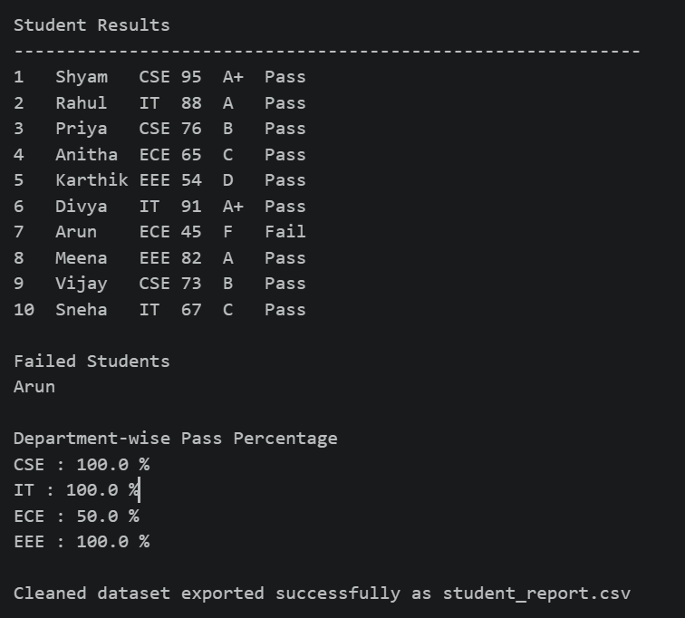
print("\nCleaned dataset exported successfully as student_report.csv").
Output:
28. Agriculture Crop Yield Analysis
Files:
1.Farmers.csv
2.Crops.csv
3.Crops.json
4.Crops.xml
Merge farmer and crop datasets, calculate average crop yield, identify top performing
farmers, summarize district-wise production, and export the processed dataset.
code:
import csv
import json
import xml.etree.ElementTree as ET
# ------------------ Read Farmers.csv ------------------
farmers = []
with open("farmers.csv", "r") as file:
reader = csv.DictReader(file)
for row in reader:
farmers.append(row)
# ------------------ Read Crops.csv ------------------
crops = []
with open("crops.csv", "r") as file:
reader = csv.DictReader(file)
for row in reader:
crops.append(row)
# ------------------ Read Crops.json ------------------
with open("crops.json", "r") as file:
crop_json = json.load(file)
print("\nJSON File Loaded Successfully")
# ------------------ Read Crops.xml ------------------
tree = ET.parse("crops.xml")
root = tree.getroot()
print("XML File Loaded Successfully")
# ------------------ Merge Farmer and Crop Data ------------------
print("\nFarmer Details")
print("-" * 70)
total_yield = 0
highest = 0
top_farmer = ""
district_production = {}
for crop in crops:
fid = crop["Farmer_ID"]
for farmer in farmers:
if farmer["Farmer_ID"] == fid:
print("Farmer ID :", fid)
print("Farmer Name :", farmer["Farmer_Name"])
print("District :", farmer["District"])
print("Crop :", crop["Crop"])
print("Yield :", crop["Yield"])
print("-" * 70)
y = float(crop["Yield"])
total_yield += y
if y > highest:
highest = y
top_farmer = farmer["Farmer_Name"]
district = crop["District"]
if district not in district_production:
district_production[district] = 0
district_production[district] += y
# ------------------ Average Yield ------------------
average = total_yield / len(crops)
print("\nAverage Crop Yield =", average)
# ------------------ Top Performing Farmer ------------------
print("\nTop Performing Farmer")
print(top_farmer, "-", highest)
# ------------------ District-wise Production ------------------
print("\nDistrict-wise Production")
for district, production in district_production.items():
print(district, ":", production)
# ------------------ Export Processed Dataset ------------------
with open("Processed_Crops.csv", "w", newline="") as file:
writer = csv.writer(file)
writer.writerow(["Farmer_ID",
"Farmer_Name",
"District",
"Crop",
"Yield"])
for crop in crops:
for farmer in farmers:
if crop["Farmer_ID"] == farmer["Farmer_ID"]:
writer.writerow([
crop["Farmer_ID"],
farmer["Farmer_Name"],
farmer["District"],
crop["Crop"],
crop["Yield"]
])
print("\nProcessed_Crops.csv created successfully.")
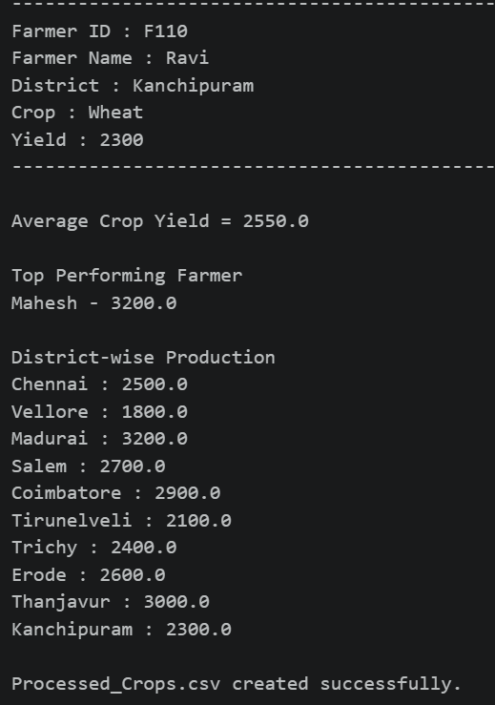
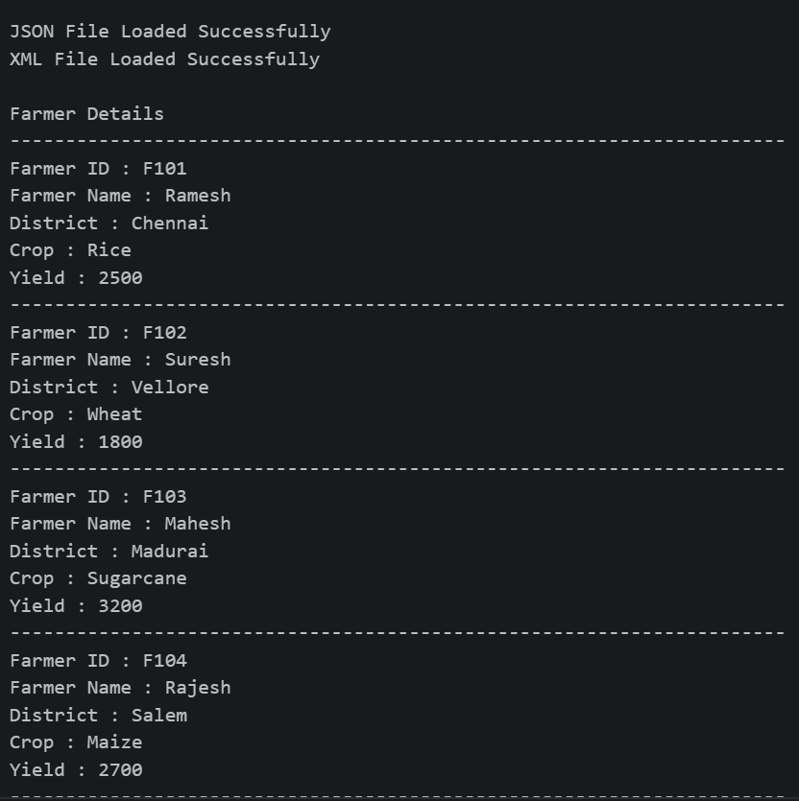
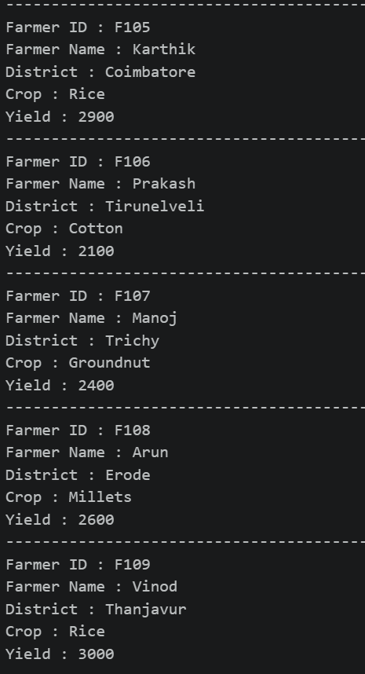
Output:

