ITA0612 -ACTIVITY-1

ChatGPT said:
1. Predicting Diabetic Retinopathy Using Machine Learning
Problem Statement
A hospital has collected medical records of diabetic patients over the past 10 years. The goal is to predict whether a patient is at risk of developing diabetic retinopathy within the next year.

Type of Learning
Supervised Learning (Classification)
Reason:
- The dataset contains labeled data (At Risk = Yes/No).
- The model learns from past examples to predict future outcomes.

Suitable Algorithm
- Random Forest (Recommended)
- Decision Tree
- Logistic Regression
- XGBoost
Best Choice: Random Forest
Reason:
- Handles large datasets well.
- High accuracy.
- Reduces overfitting.
- Works with both numerical and categorical data.

Features Required
- Age
- Gender
- Blood Sugar Level (HbA1c)
- Blood Pressure
- Duration of Diabetes
- BMI
- Cholesterol Level
- Smoking Status
- Family History
- Previous Eye Examination Results

Target Variable
Diabetic Retinopathy
- Yes
- No

Evaluation Metrics
- Accuracy
- Precision
- Recall
- F1-Score
- ROC-AUC
- Confusion Matrix

Workflow
Medical Records
↓
Data Preprocessing
↓
Feature Selection
↓
Train Random Forest Model
↓
Prediction
↓
Evaluate Accuracy

Conclusion
A Random Forest Classifier is suitable because it provides high accuracy, handles complex medical data, and predicts whether a patient is at risk of diabetic retinopathy.

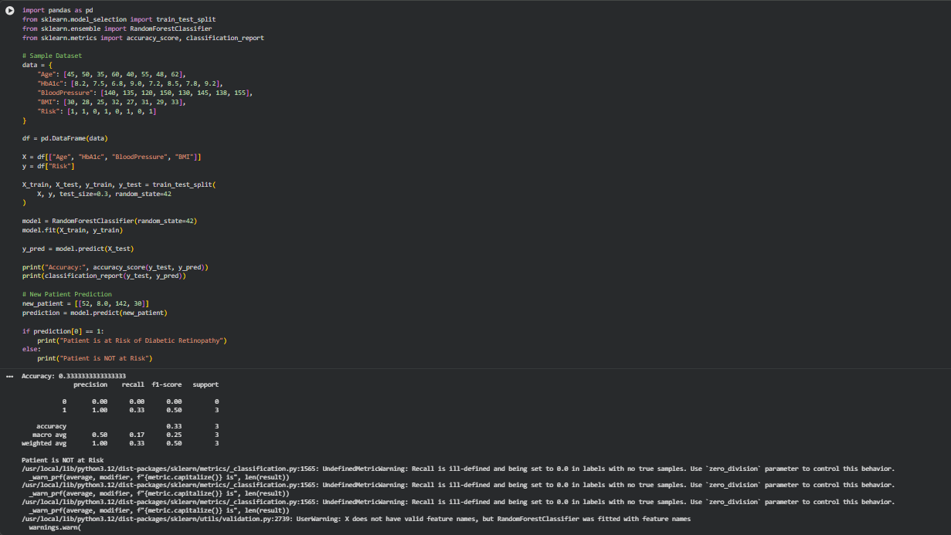

2. Customer Churn Prediction
Problem Statement
An online shopping company wants to identify customers who are likely to stop using its platform.

Type of Learning
Supervised Learning (Classification)
Reason:
- Historical data contains labels:
  - Churn
  - Not Churn

Suitable Algorithm
- Logistic Regression
- Decision Tree
- Random Forest
- XGBoost
Best Choice: Random Forest
Reason:
- High prediction accuracy.
- Handles missing values.
- Works well with customer behavior data.

Features Required
- Customer Age
- Gender
- Purchase Frequency
- Total Purchases
- Average Order Value
- Last Purchase Date
- Customer Rating
- Number of Complaints
- Membership Type
- Discount Usage

Target Variable
Customer Churn
- Yes
- No

Evaluation Metrics
- Accuracy
- Precision
- Recall
- F1-Score
- ROC-AUC
- Confusion Matrix

Workflow
Customer Data
↓
Data Cleaning
↓
Feature Selection
↓
Random Forest Model
↓
Predict Churn
↓
Retention Strategy

Conclusion
A Random Forest Classifier can accurately identify customers likely to churn, enabling the company to provide personalized offers and improve customer retention.

3. Fraud Detection in Banking
Problem Statement
A bank processes millions of transactions every day and wants to detect fraudulent transactions in real time while minimizing false alarms.

Type of Learning
Supervised Learning (Binary Classification)
Reason:
- Transactions are labeled as:
  - Fraud
  - Genuine

Suitable Algorithm
- Random Forest
- XGBoost
- Gradient Boosting
- Neural Network
Best Choice: XGBoost (Extreme Gradient Boosting)
Justification
- Very high accuracy.
- Fast prediction for real-time detection.
- Handles imbalanced datasets effectively.
- Reduces false positives and false negatives.
- Widely used in banking and fraud detection systems.

Features Required
- Transaction Amount
- Transaction Time
- Customer Location
- Merchant ID
- Device ID
- IP Address
- Number of Daily Transactions
- Previous Fraud History
- Payment Method
- Account Balance

Target Variable
Fraud
- Fraud
- Genuine

Evaluation Metrics
- Precision
- Recall
- F1-Score
- ROC-AUC
- Confusion Matrix
- False Positive Rate (FPR)

Workflow
Transaction Data
↓
Data Preprocessing
↓
Feature Engineering
↓
Train XGBoost Model
↓
Real-Time Fraud Detection
↓
Alert Bank

Conclusion
XGBoost is the preferred algorithm because it offers high accuracy, fast prediction speed, handles large and imbalanced datasets effectively, and minimizes false alarms, making it well-suited for real-time fraud detection.


