ITA0612-CO5-AT1
1. Combining Two Large Pandas DataFrames
Suppose we have:
- transactions.csv → Customer ID, Transaction ID, Amount, Date
- demographics.csv → Customer ID, Age, Gender, City, Income
The main goal is to combine them without duplicate customer IDs, while preserving valid records and maintaining a correct index.
Step 1: Load the Data
import pandas as pd

transactions = pd.read_csv("transactions.csv")
demographics = pd.read_csv("demographics.csv")

print(transactions.head())
print(demographics.head())
For very large files, use techniques such as:
transactions = pd.read_csv("transactions.csv", usecols=[
"CustomerID", "TransactionID", "Amount", "Date"
])
usecols avoids loading unnecessary columns and reduces memory usage.

Step 2: Check Customer IDs
First check whether the ID columns contain missing or duplicate values.
print(transactions["CustomerID"].isna().sum())
print(demographics["CustomerID"].isna().sum())

print(transactions["CustomerID"].duplicated().sum())
print(demographics["CustomerID"].duplicated().sum())
If the demographic table should contain one record per customer, remove duplicate IDs:
demographics = demographics.drop_duplicates(
subset="CustomerID",
keep="first"
)
For transactions, duplicate Customer IDs may actually be valid because one customer can have multiple transactions. Therefore, do not automatically remove duplicates from the transaction table.

Step 3: Standardize Customer IDs
Sometimes one file contains IDs as integers and another as strings.
transactions["CustomerID"] = transactions["CustomerID"].astype(str).str.strip()
demographics["CustomerID"] = demographics["CustomerID"].astype(str).str.strip()
Now both DataFrames use the same format.

Step 4: Merge the DataFrames
If we want to preserve all valid transaction records, use a left join:
merged = transactions.merge(
demographics,
on="CustomerID",
how="left",
validate="many_to_one"
)
validate="many_to_one" is particularly useful because it checks that:
- many transactions can belong to one customer
- each customer has only one demographic record
If the demographic table contains duplicate customer IDs, Pandas will raise an error instead of silently creating incorrect duplicate rows.

Step 5: Check Missing Customer Information
missing_demo = merged[merged["Age"].isna()]

print(missing_demo)
Find customers present in transactions but missing from demographics:
missing_ids = transactions[
~transactions["CustomerID"].isin(demographics["CustomerID"])
]

print(missing_ids)
This helps identify mismatched records.

Step 6: Validate Duplicate Customer Records
If the requirement is no duplicate customer IDs in the final customer-level DataFrame, check:
duplicates = demographics[
demographics["CustomerID"].duplicated(keep=False)
]

print(duplicates)
For a transaction-level DataFrame, repeated Customer IDs are expected. Instead, check whether the merge unexpectedly multiplied rows:
print("Transactions before merge:", len(transactions))
print("Rows after merge:", len(merged))
For a many-to-one merge, the merged DataFrame should not have more rows than the transaction DataFrame.

Step 7: Grouping for Validation
We can count transactions for each customer:
customer_summary = merged.groupby("CustomerID").agg(
Transaction_Count=("TransactionID", "count"),
Total_Amount=("Amount", "sum")
).reset_index()

print(customer_summary.head())
This helps verify that transaction information has been combined correctly.

Step 8: Sorting and Resetting Index
Sort by Customer ID and transaction date:
merged = merged.sort_values(
by=["CustomerID", "Date"]
).reset_index(drop=True)
Now the index becomes:
0
1
2
3
...
Check the final structure:
print(merged.info())
print(merged.head())

Debugging Mismatched or Missing Entries
Problem | Debugging Method
Missing Customer IDs | isna()
Duplicate IDs | duplicated()
IDs have spaces | .str.strip()
Different ID types | .astype(str)
Customers missing from another file | .isin()
Unexpected extra rows | Compare len() before/after merge
Incorrect merge | Use validate="many_to_one"
Wrong ordering | sort_values()
Incorrect index | reset_index(drop=True)
Final validation
print("Duplicate demographic IDs:",
demographics["CustomerID"].duplicated().sum())

print("Missing IDs:",
merged["CustomerID"].isna().sum())

print("Final rows:", len(merged))

print(merged.sort_values("CustomerID").head())
Conclusion: Use merge() with an appropriate join type, standardize IDs before merging, validate uniqueness using duplicated() and groupby(), use validate to catch incorrect relationships, and finish with sort_values() and reset_index().
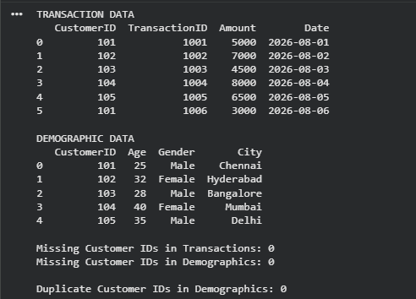
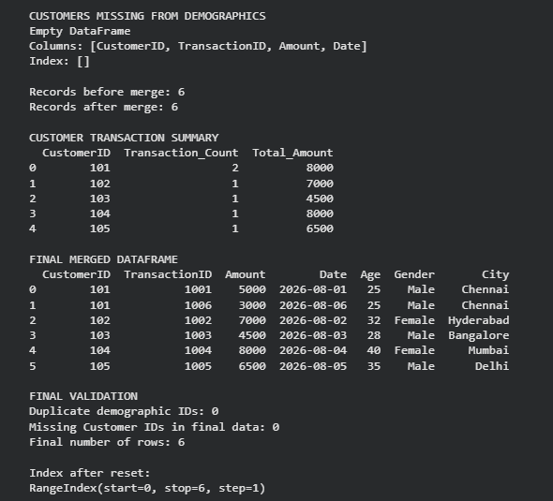

2. Complete Pandas Data Analysis Pipeline
A complete pipeline can be represented as:
Files → Loading → Cleaning → Processing → Filtering → Grouping → Sorting → Visualization → Results
Step 1: Import Libraries
import pandas as pd
import matplotlib.pyplot as plt
import glob
import os

Step 2: Find Multiple Data Files
Suppose several CSV files are stored in a data folder:
files = glob.glob("data/*.csv")

print("Files found:", files)

Step 3: Efficiently Read the Files
dataframes = []

for file in files:
try:
df = pd.read_csv(file)
dataframes.append(df)
print(file, "loaded successfully")

except Exception as e:
print("Error reading", file, ":", e)
Combine all successfully loaded files:
data = pd.concat(
dataframes,
ignore_index=True
)
ignore_index=True creates a consistent index.

Step 4: Inspect the Data
print(data.head())
print(data.shape)
print(data.info())
print(data.isnull().sum())
Check duplicate records:
print("Duplicate rows:", data.duplicated().sum())

Step 5: Clean the Data
Remove completely duplicated records:
data = data.drop_duplicates()
Remove unnecessary spaces from column names:
data.columns = data.columns.str.strip()
Convert data types where required:
data["Date"] = pd.to_datetime(
data["Date"],
errors="coerce"
)

data["Amount"] = pd.to_numeric(
data["Amount"],
errors="coerce"
)
errors="coerce" converts invalid values into NaN, allowing us to identify them.

Step 6: Handle Missing Values
Check missing values:
print(data.isnull().sum())
For example:
data["Amount"] = data["Amount"].fillna(
data["Amount"].median()
)
Or remove records where essential information is missing:
data = data.dropna(subset=["CustomerID"])

Step 7: Apply User-Defined Filtering
For example, find transactions above ₹10,000:
filtered = data[data["Amount"] > 10000]
Multiple conditions can be used:
filtered = data[
(data["Amount"] > 10000) &
(data["Category"] == "Electronics")
]
A user-defined condition can also be stored in a variable:
minimum_amount = 10000

filtered = data[
data["Amount"] >= minimum_amount
]

Step 8: Group and Aggregate
Calculate total sales by category:
category_sales = data.groupby("Category")["Amount"].sum()
For multiple statistics:
summary = data.groupby("Category").agg(
Total_Sales=("Amount", "sum"),
Average_Sales=("Amount", "mean"),
Number_of_Transactions=("Amount", "count")
).reset_index()

Step 9: Sort the Results
Sort categories by total sales:
summary = summary.sort_values(
by="Total_Sales",
ascending=False
)

print(summary)

Step 10: Generate Visualizations
Bar Chart
plt.figure(figsize=(8, 5))

plt.bar(
summary["Category"],
summary["Total_Sales"]
)

plt.xlabel("Category")
plt.ylabel("Total Sales")
plt.title("Sales by Category")
plt.xticks(rotation=45)

plt.tight_layout()
plt.show()
Line Chart
For sales over time:
monthly_sales = data.groupby(
data["Date"].dt.to_period("M")
)["Amount"].sum()

monthly_sales.plot(kind="line")

plt.xlabel("Month")
plt.ylabel("Sales")
plt.title("Monthly Sales Trend")
plt.tight_layout()
plt.show()

Optimization Techniques
1. Read only required columns
df = pd.read_csv(
"data.csv",
usecols=["CustomerID", "Category", "Amount", "Date"]
)
2. Specify data types
df = pd.read_csv(
"data.csv",
dtype={
"CustomerID": "string",
"Category": "string"
}
)
3. Process large files in chunks
for chunk in pd.read_csv("large_file.csv", chunksize=50000):
# Process each chunk
print(chunk.shape)
This prevents the entire large file from being loaded into memory.
4. Avoid unnecessary loops
Prefer Pandas operations such as:
data.groupby("Category")["Amount"].sum()
instead of manually looping through every row.

Debugging Corrupted or Inconsistent Files
Problem 1: Corrupted CSV
try:
df = pd.read_csv("data.csv")
except Exception as e:
print("File could not be loaded:", e)
Problem 2: Different column names
For example:
Customer_ID
Customer ID
customer_id
Standardize them:
data.columns = (
data.columns
.str.strip()
.str.lower()
.str.replace(" ", "_")
)
Now they become consistent.
Problem 3: Invalid numeric values
data["Amount"] = pd.to_numeric(
data["Amount"],
errors="coerce"
)

print(data[data["Amount"].isna()])
Problem 4: Invalid dates
data["Date"] = pd.to_datetime(
data["Date"],
errors="coerce"
)

print(data[data["Date"].isna()])
Problem 5: Unexpected categories
print(data["Category"].unique())
This helps identify spelling inconsistencies such as:
Electronics
electronics
Electronic
They can be standardized using:
data["Category"] = data["Category"].str.strip().str.title()

Complete Pipeline Flow
Multiple CSV Files
↓
File Validation
↓
Pandas read_csv()
↓
Data Concatenation
↓
Data Cleaning
↙ ↓ ↘
Missing Duplicates Data Types
Values ↓ ↓
↘ Processing ↙
↓
User Filtering
↓
Grouping & Aggregation
↓
Sorting
↓
Visualization
↙ ↘
Bar Chart Line Chart
↓
Final Results
Overall conclusion
The first problem is solved mainly using merge(), ID validation, duplicated(), groupby(), sort_values(), and reset_index().
The second problem follows a complete ETL-style Pandas pipeline: efficiently load multiple files, clean inconsistent data, filter according to user requirements, aggregate with groupby(), sort the results, and visualize important patterns using Matplotlib. Error handling, data-type conversion, missing-value checks, and duplicate detection make the pipeline more reliable.
