ITA0612-CO5-AT2

1. Pseudocode Algorithm: Data Cleaning and Transformation on Time-Series Data
ALGORITHM: TimeSeries_Data_Cleaning_And_Transformation

INPUT:
Time-series dataset D
Time column T
Value columns V
Required resampling interval R
Outlier threshold K

OUTPUT:
Cleaned and transformed time-series dataset C

BEGIN

1. LOAD DATA
Read dataset D
Identify time column T and value columns V

2. CONVERT TIME COLUMN
Convert T into standard DateTime format
If any timestamp cannot be converted:
Mark the corresponding record as invalid

3. FILTER INVALID ENTRIES
Remove records where:
- Timestamp is missing
- Timestamp is invalid
- Required values are invalid
Keep only valid records

4. INDEX BY TIME
Set T as the time index of dataset D

5. ENSURE CHRONOLOGICAL CONSISTENCY
Sort dataset by timestamp in ascending order

If duplicate timestamps exist:
Group records having the same timestamp
Aggregate their values using mean/sum/first
Keep one record for each timestamp

6. DETECT MISSING TIMESTAMPS
Determine the minimum and maximum timestamp
Generate a complete timestamp sequence
using the required time frequency

Compare the generated timestamps with existing timestamps
Identify missing timestamps

7. INSERT MISSING TIMESTAMPS
Reindex the dataset using the complete timestamp sequence
Missing timestamps will contain NULL/NaN values

8. HANDLE MISSING VALUES
FOR each numerical value column V:
Identify missing values

IF missing values are between two valid observations:
Interpolate values using time-based interpolation

ELSE IF missing values occur at the beginning or end:
Use forward-fill/backward-fill only when appropriate
Otherwise remove the remaining invalid records

9. REMOVE OUTLIERS
FOR each numerical value column V:

Calculate statistical limits
lower_limit = Q1 - K × IQR
upper_limit = Q3 + K × IQR

FOR each value:
IF value < lower_limit OR value > upper_limit:
Mark value as an outlier

Replace/remove marked outliers according to the requirement

10. RESAMPLE DATA
Resample the cleaned time-series data at fixed interval R

FOR each numerical column:
Calculate appropriate aggregate such as:
Mean, Sum, Minimum, Maximum, or Median

11. FINAL VALIDATION
Check that:
- All timestamps are valid
- Data is chronologically ordered
- No duplicate timestamps exist
- Required values contain no unexpected missing values
- Outliers have been handled
- Data follows the required time interval

12. RETURN RESULT
Store the cleaned and transformed dataset as C

RETURN C
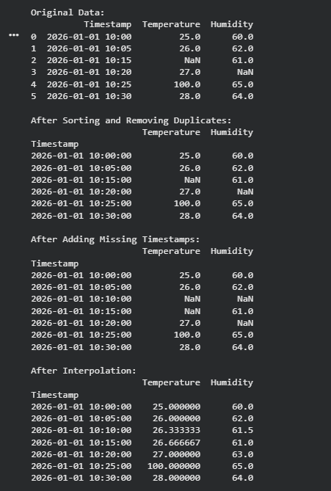
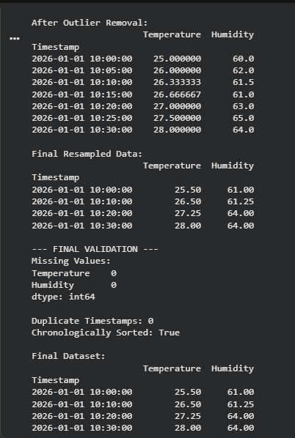

2. Pseudocode Algorithm: Feature Selection
ALGORITHM: Feature_Selection

INPUT:
Dataset D
Target variable Y
Correlation threshold CT
Feature significance threshold ST

OUTPUT:
Selected feature dataset F

BEGIN

1. LOAD DATASET
Read dataset D
Separate:
X = Input features
Y = Target variable

2. REMOVE INVALID FEATURES
Check for:
- Missing values
- Constant-value features
- Duplicate features
- Non-numeric or invalid attributes

Remove features that are completely invalid or useless

3. HANDLE MISSING VALUES
FOR each feature in X:
IF missing values exist:
Replace using mean/median/mode
OR use another suitable imputation method

4. NORMALIZE FEATURES
FOR each numerical feature X:

Calculate:
mean = average(X)
standard_deviation = std(X)

Normalize:
X_normalized = (X - mean) / standard_deviation

Store normalized dataset X_norm

5. CALCULATE FEATURE CORRELATION
Calculate correlation matrix between all features

FOR each pair of features (Fi, Fj):
Calculate correlation coefficient C

6. REMOVE REDUNDANT FEATURES
FOR each pair of features:

IF |C| >= CT:
Features are highly correlated

Compare their relevance to target Y

Keep the feature with higher relevance
Remove the less useful/redundant feature

7. MEASURE FEATURE RELEVANCE
FOR each remaining feature Fi:

Calculate relationship between Fi and target Y

Examples:
Correlation
Mutual Information
Chi-Square
ANOVA
Statistical significance

8. THRESHOLD-BASED FILTERING
FOR each feature Fi:

IF relevance_score(Fi) >= ST:
Keep Fi

ELSE:
Remove Fi

9. CREATE SELECTED FEATURE SET
Combine all retained features

F = Selected features + Target Y

10. VALIDATE FEATURE SELECTION
Split dataset into:
Training data
Validation/Test data

Train the chosen model using:
a) Original feature set
b) Selected feature set

Compare:
Accuracy
Precision
Recall
F1-score
RMSE/MAE for regression
Training time

11. CHECK DIMENSIONALITY REDUCTION
Calculate:
Original number of features
Final number of features

IF model performance improves or remains acceptable:
Accept selected features

ELSE:
Adjust CT and ST
Repeat feature selection

12. RETURN RESULT
Return selected feature dataset F

END
