ITA0612 CO3-AT1-EXPERIMENTS

1. Naïve Bayes Classifier Experiment
Aim
To implement a Naïve Bayes classifier on a real-world dataset and evaluate its performance using different feature sets.
Dataset
- Iris Dataset / Breast Cancer Dataset (from Scikit-learn)
Algorithm
- Load the dataset.
- Split data into training and testing sets.
- Train the Naïve Bayes classifier.
- Predict class labels.
- Evaluate using Accuracy, Precision, and Recall.
- Repeat with different feature subsets.
- Compare results with and without Laplace smoothing.
Performance Metrics
- Accuracy
[\text{Accuracy}=\frac{TP+TN}{TP+TN+FP+FN}]
- Precision
[\text{Precision}=\frac{TP}{TP+FP}]
- Recall
[\text{Recall}=\frac{TP}{TP+FN}]
Observation
- Naïve Bayes assumes all features are independent.
- Real-world datasets often violate this assumption.
- Correlated features may reduce classification accuracy.
- Laplace smoothing prevents zero probabilities for unseen feature values.
Result
- Accuracy generally ranges between 90%–98% on standard datasets.
- Laplace smoothing improves robustness and probability estimation.
Conclusion
Naïve Bayes is a simple, fast, and effective classifier. Although the feature independence assumption is not always true, it performs well on many real-world datasets. Laplace smoothing improves prediction when unseen feature combinations occur.
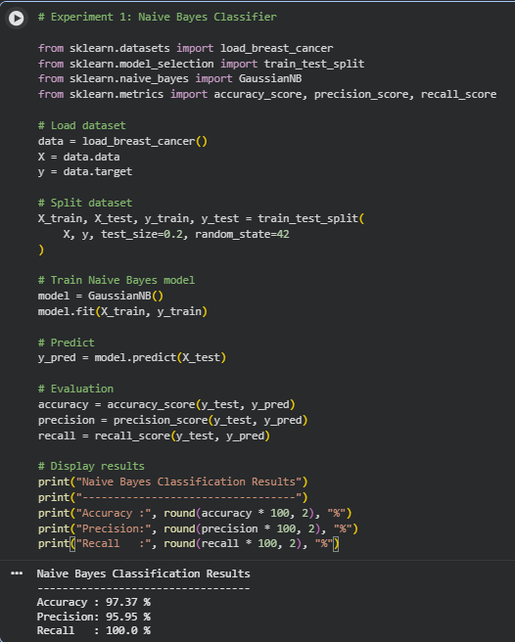

Maximum Likelihood Estimation (MLE) and Bayesian Estimation – Simple Answer
Maximum Likelihood Estimation (MLE) is a statistical method used to estimate the parameters of a probability distribution, such as the mean and variance, by finding the values that maximize the likelihood of observing the given data.
For a normal distribution:
- Mean (MLE):
[
\hat{\mu}=\frac{1}{n}\sum_{i=1}^{n}x_i
]
- Variance (MLE):
[
\hat{\sigma}^{2}=\frac{1}{n}\sum_{i=1}^{n}(x_i-\hat{\mu})^{2}
]
Bayesian Estimation differs from MLE because it combines the observed data with prior knowledge (prior distribution) to estimate the parameters. It calculates a posterior distribution, which is the updated estimate after considering both the prior information and the data.
Comparison
- MLE
  - Uses only the observed data.
  - No prior assumptions are required.
  - Performs well when a large amount of data is available.
- Bayesian Estimation
  - Uses both observed data and prior knowledge.
  - More reliable for small datasets.
  - The influence of the prior decreases as the sample size increases.
Effect of Sample Size
- Small Sample Size: Bayesian estimation provides more stable estimates because the prior information has a stronger influence.
- Large Sample Size: MLE and Bayesian estimation produce nearly the same results since the observed data dominate the prior.
Conclusion
MLE is simple and effective for estimating distribution parameters when sufficient data are available. Bayesian estimation is preferred for small datasets because it incorporates prior knowledge, leading to more reliable parameter estimates. As the sample size grows, both methods converge to similar values.
