Users
Admin:

Schools:
School1
Bus1
Bus driver
Bus no
Trips
Trip 1
Student1
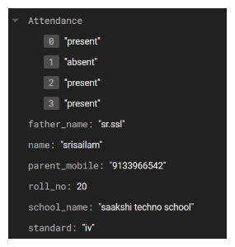
Student2
Same
Trip 2
Student 1: data
Student 2: data
Bus2
Same structure
Address
No of buses
School name
School2: same structure

