Road Traffic Extension Output Screens

In object detection no algorithm is better than YOLO so we have used Single Shot Detection algorithm (SSD) as existing algorithm and YOLO as the extension algorithm and while seeing output we can see YOLO is far better than existing SSD algorithm. There are many existing object detections algorithms are available such as RCNN, Faster RCNN, Semantic Segmentation and many more but no one is better than YOLO.

To run project double click on ‘run.bat’ file to get below screen

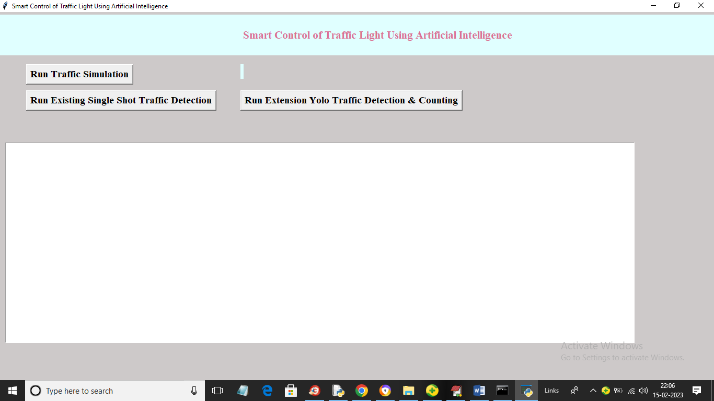

In above screen click on ‘Run Existing Single Shot Traffic Detection’ button to upload traffic video and then SSD algorithm will start detection from uploaded video

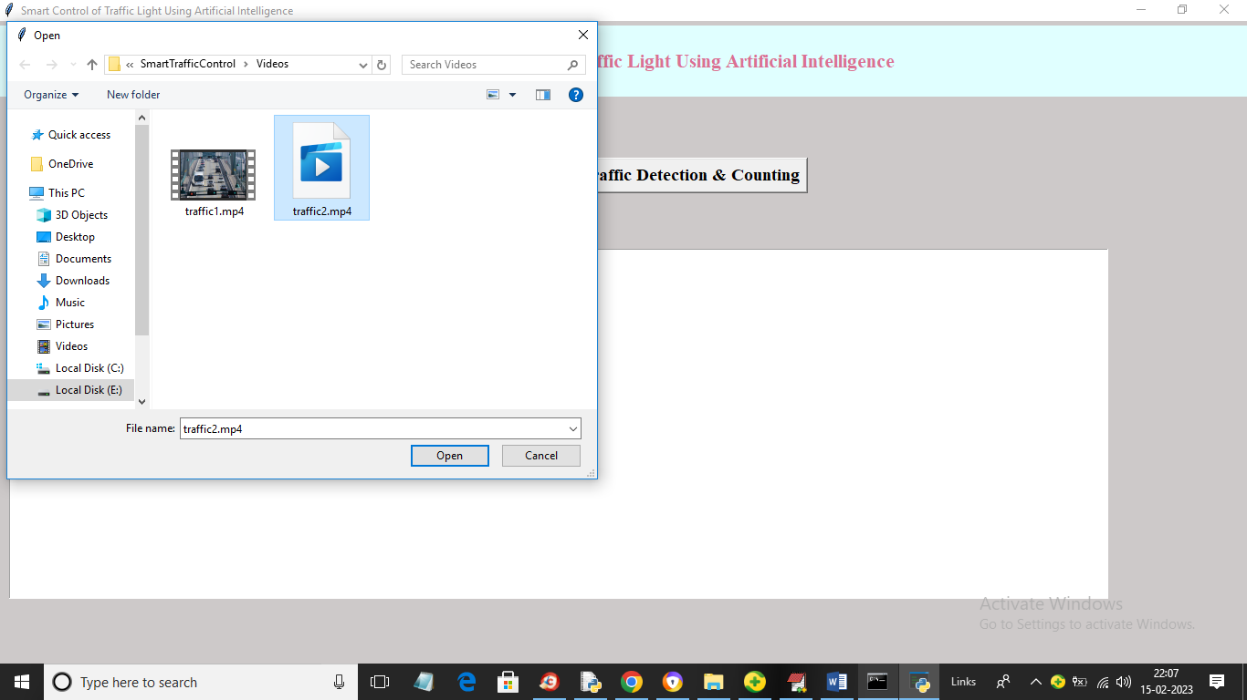

In above screen selecting and uploading ‘traffic2.mp4’ and then click on ‘Open’ button to load video and get below output

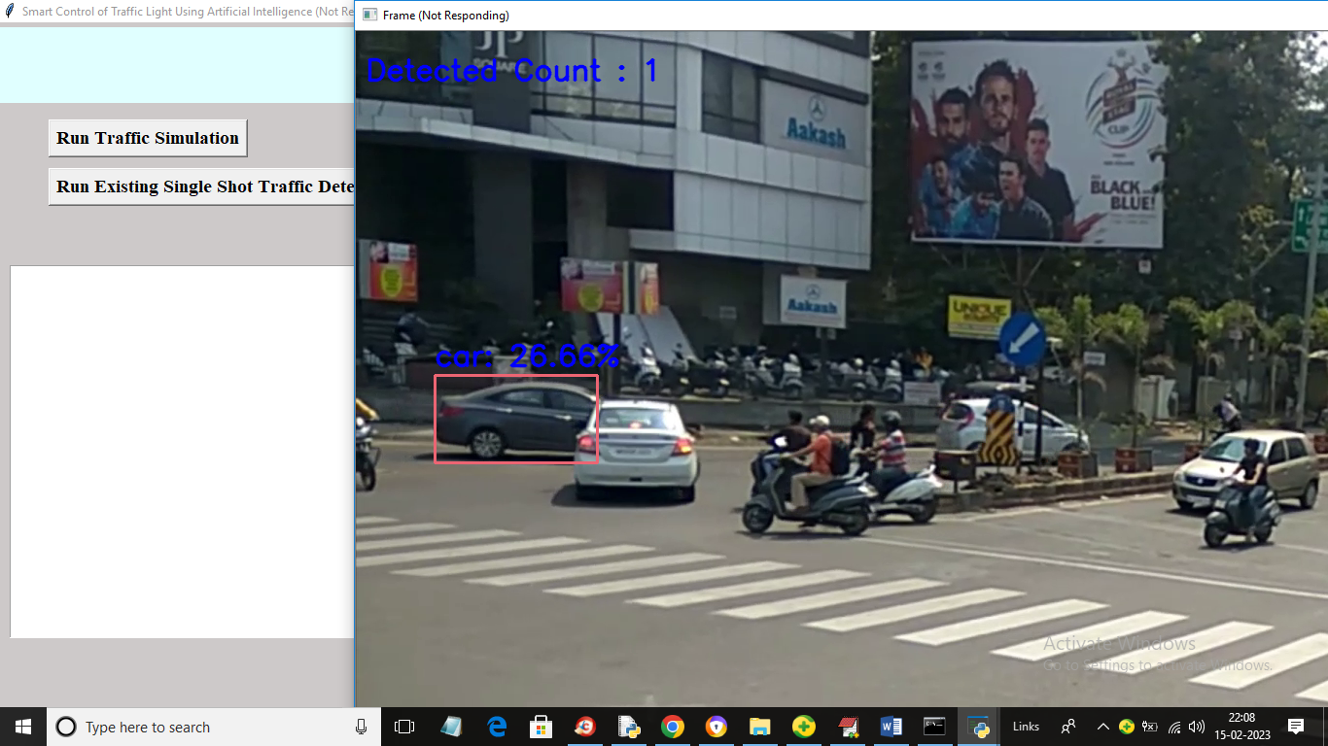

In above screen existing SSD detecting only one vehicle from the entire traffic

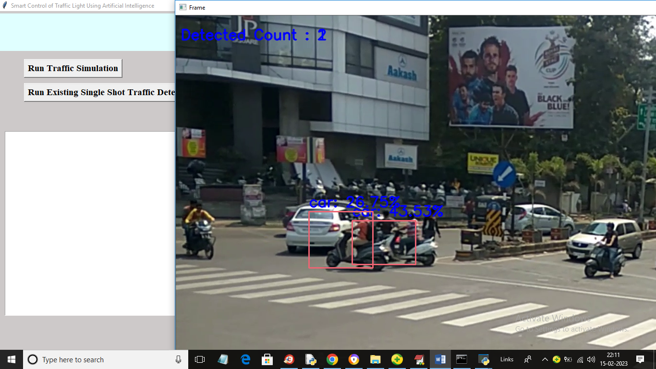

From above screens we can see that SSD is not good at traffic detection and now click on ‘Run Extension Yolo Traffic Detection & Counting’ button to upload video and get below output

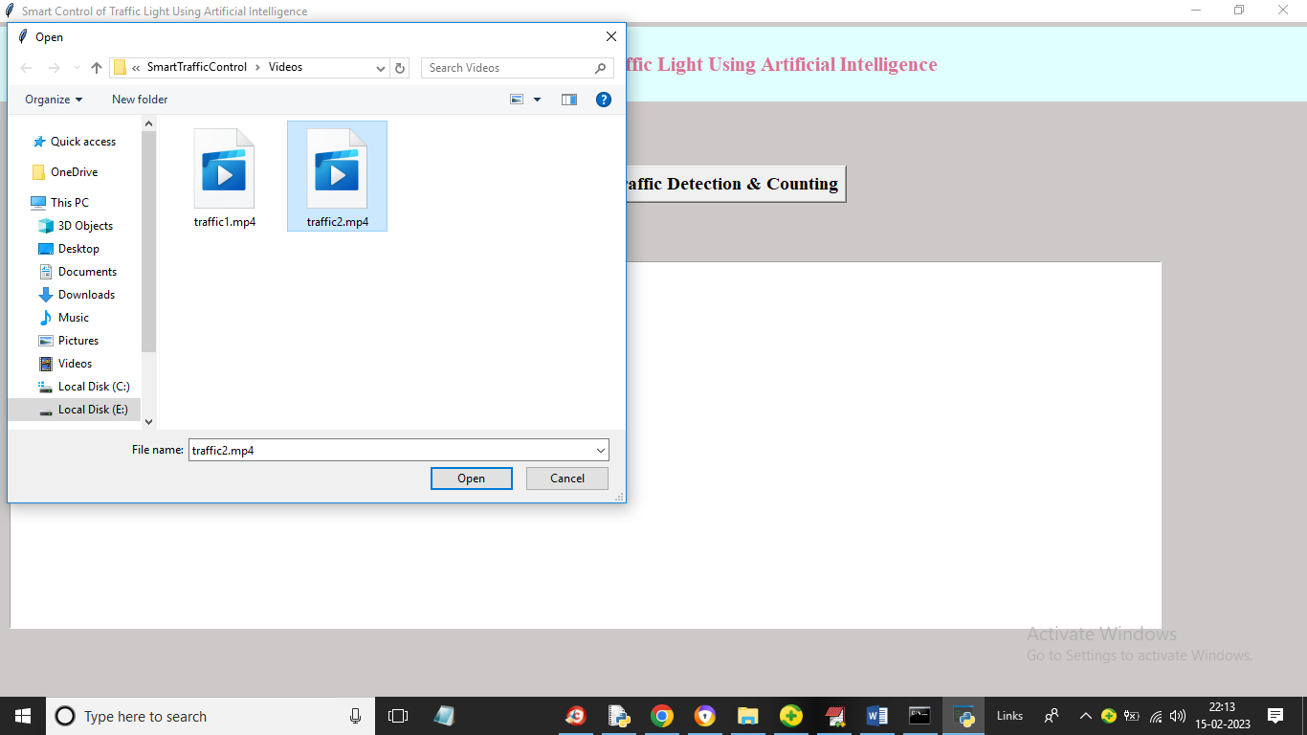

In above screen for YOLO also we are uploading traffic video and then click on ‘Open’ button to get below output

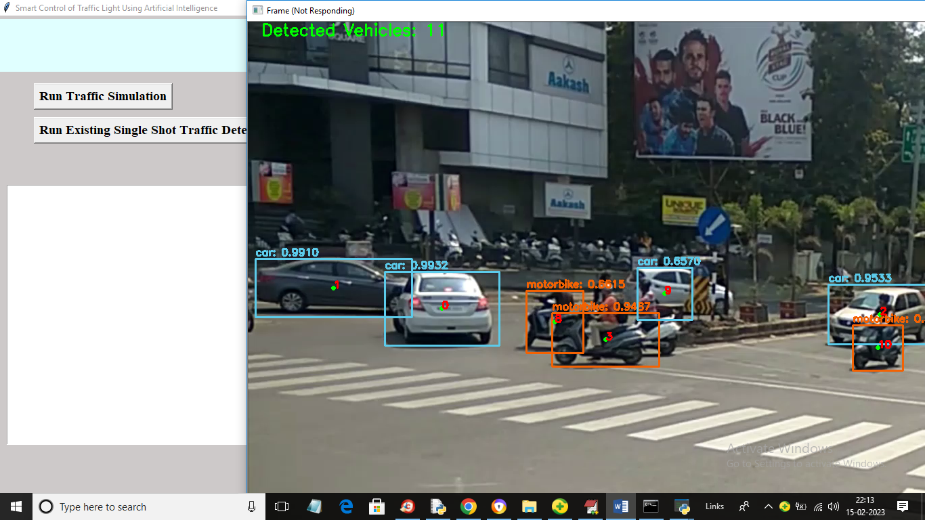

In above screen we can see YOLO able to detect and count all vehicles

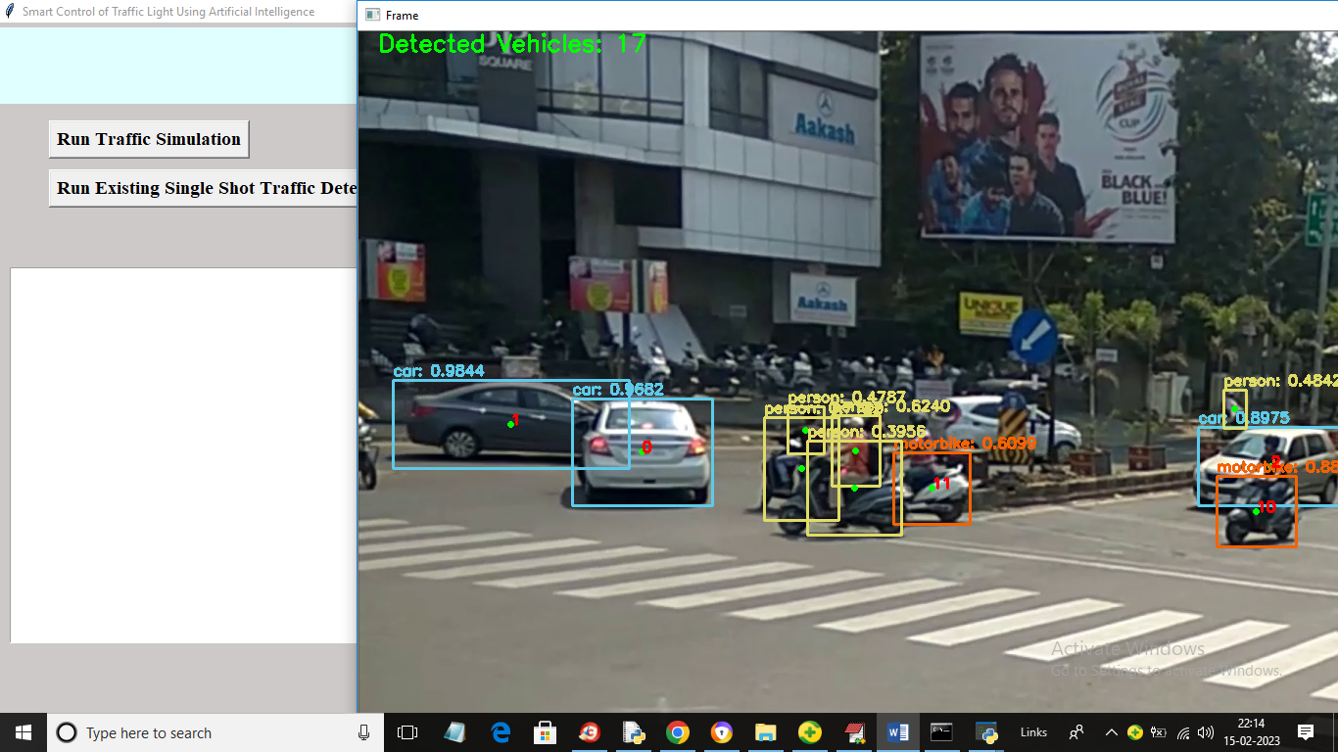

So from above screens it’s proven that YOLO is better than any other detection and classification algorithms