Mongodb active status:

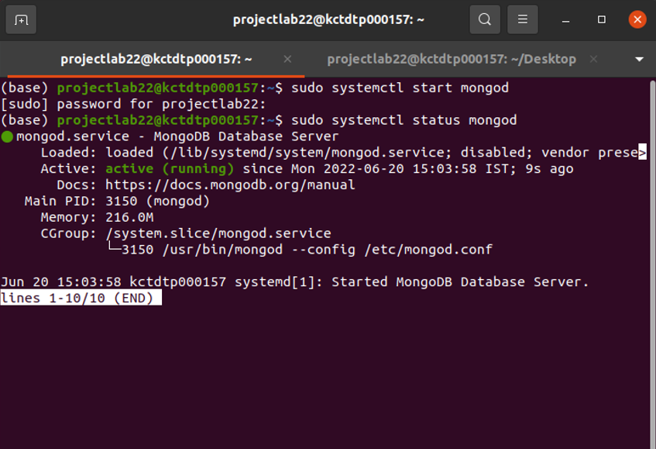

Nodejs status:

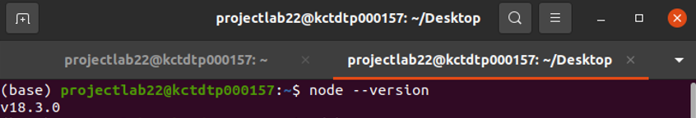

1.database creation

Database named mydb is created

var MongoClient = require('mongodb').MongoClient;

var url = "mongodb://localhost:27017/mydb";

MongoClient.connect(url, function(err, db) {

if (err) throw err;

console.log("Database created!");

db.close();

});

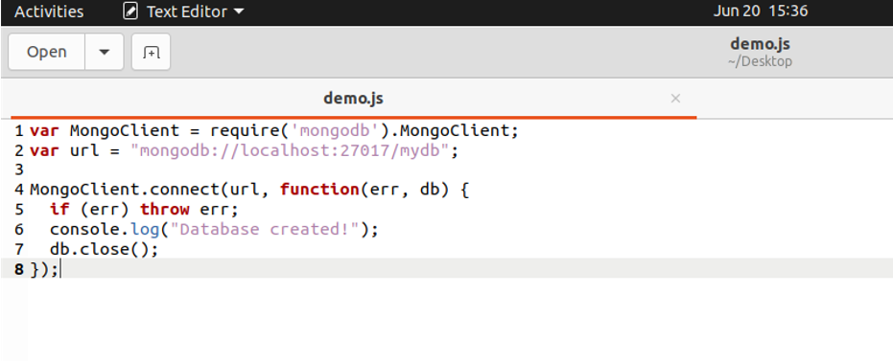

**OUTPUT:**

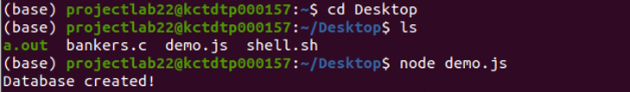

2.collection creation

var MongoClient = require('mongodb').MongoClient;

var url = "mongodb://localhost:27017/";

MongoClient.connect(url, function(err, db) {

if (err) throw err;

var dbo = db.db("mydb");

dbo.createCollection("customers", function(err, res) {

if (err) throw err;

console.log("Collection created!");

db.close();

});

});

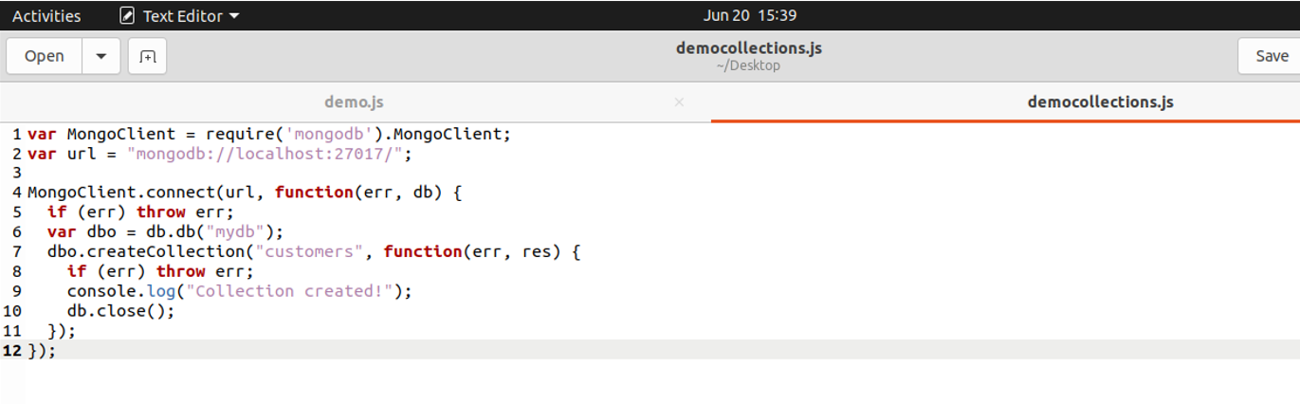

**OUTPUT:**

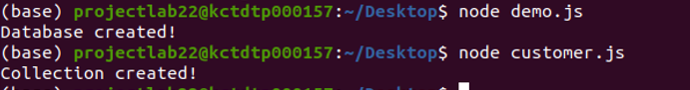

3.

a)insertion

insertOne() method:

var MongoClient = require('mongodb').MongoClient;

var url = "mongodb://localhost:27017/";

MongoClient.connect(url, function(err, db) {

if (err) throw err;

var dbo = db.db("mydb");

var myobj = { name: "Company Inc", address: "Highway 37" };

dbo.collection("customers").insertOne(myobj, function(err, res) {

if (err) throw err;

console.log("1 document inserted");

db.close();

});

});

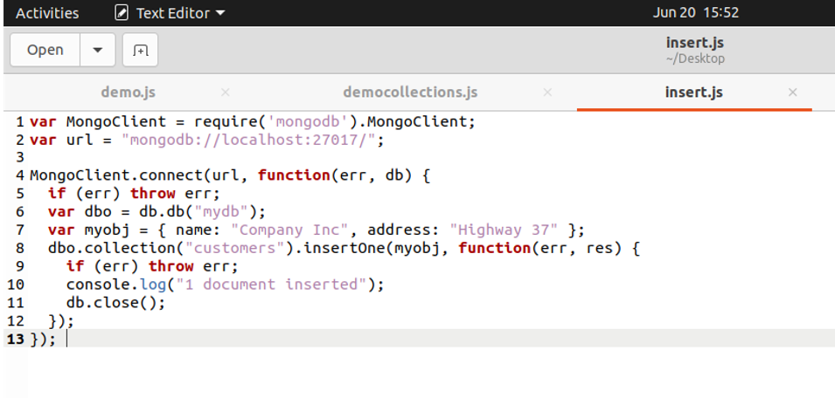

**OUTPUT:**

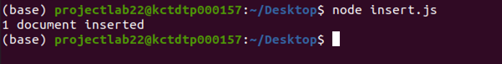

insertMany() method:

var MongoClient = require('mongodb').MongoClient;

var url = "mongodb://localhost:27017/";

MongoClient.connect(url, function(err, db) {

if (err) throw err;

var dbo = db.db("mydb");

var myobj = [

{ name: 'John', address: 'Highway 71'},

{ name: 'Peter', address: 'Lowstreet 4'},

{ name: 'Amy', address: 'Apple st 652'},

{ name: 'Hannah', address: 'Mountain 21'},

{ name: 'Michael', address: 'Valley 345'},

{ name: 'Sandy', address: 'Ocean blvd 2'},

{ name: 'Betty', address: 'Green Grass 1'},

{ name: 'Richard', address: 'Sky st 331'},

{ name: 'Susan', address: 'One way 98'},

{ name: 'Vicky', address: 'Yellow Garden 2'},

{ name: 'Ben', address: 'Park Lane 38'},

{ name: 'William', address: 'Central st 954'},

{ name: 'Chuck', address: 'Main Road 989'},

{ name: 'Viola', address: 'Sideway 1633'}

];

dbo.collection("customers").insertMany(myobj, function(err, res) {

if (err) throw err;

console.log("Number of documents inserted: " + res.insertedCount);

db.close();

});

});

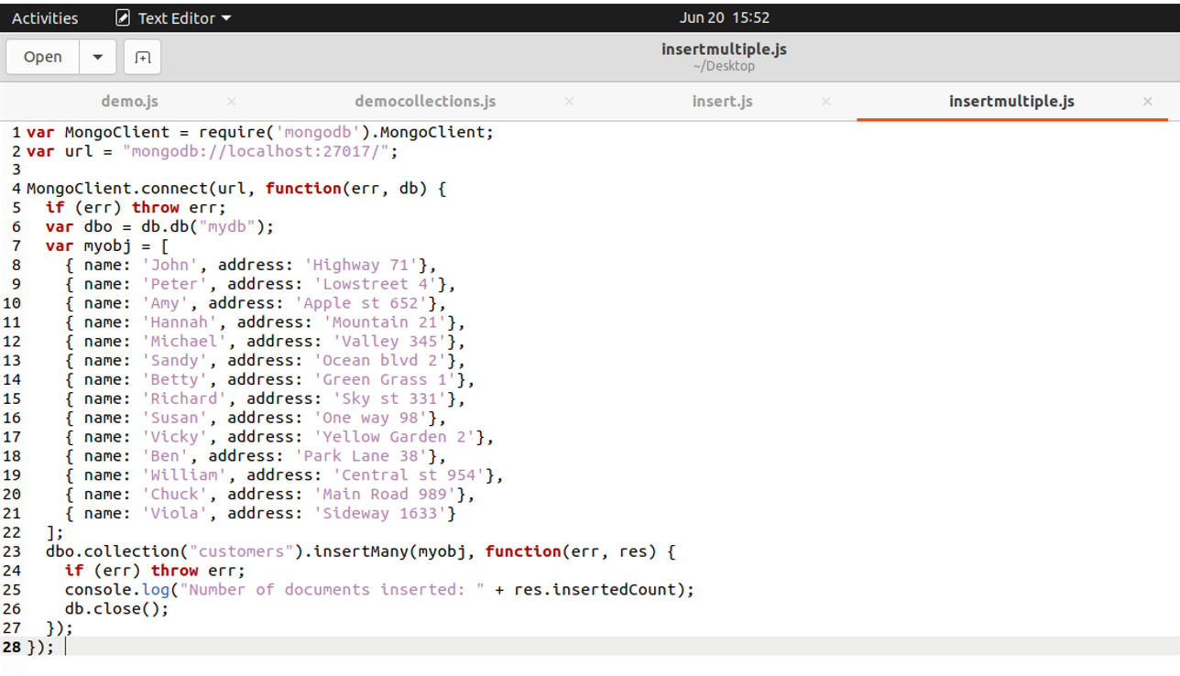

**OUTPUT:**



b)deletion

deleteOne() method:

Delete the document with the address "Mountain 21":

var MongoClient = require('mongodb').MongoClient;

var url = "mongodb://localhost:27017/";

MongoClient.connect(url, function(err, db) {

if (err) throw err;

var dbo = db.db("mydb");

var myquery = { address: 'Mountain 21' };

dbo.collection("customers").deleteOne(myquery, function(err, obj) {

if (err) throw err;

console.log("1 document deleted");

db.close();

});

});

**OUTPUT:**



deleteMany() method:

var MongoClient = require('mongodb').MongoClient;

var url = "mongodb://localhost:27017/";

MongoClient.connect(url, function(err, db) {

if (err) throw err;

var dbo = db.db("mydb");

var myquery = { address: /^O/ };

dbo.collection("customers").deleteMany(myquery, function(err, obj) {

if (err) throw err;

console.log(obj.result.n + " document(s) deleted");

db.close();

});

});

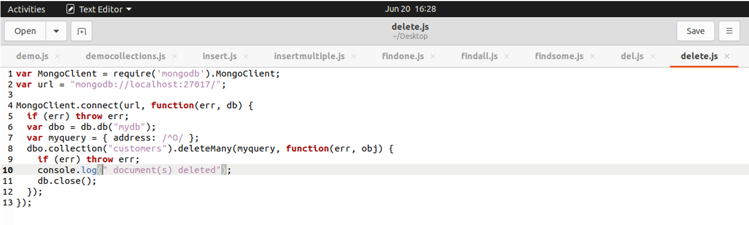

**OUTPUT:**



c)updation

updateOne() method :

var MongoClient = require('mongodb').MongoClient;

var url = "mongodb://127.0.0.1:27017/";

MongoClient.connect(url, function(err, db) {

if (err) throw err;

var dbo = db.db("mydb");

var myquery = { address: "Valley 345" };

var newvalues = { $set: {name: "Mickey", address: "Canyon 123" } };

dbo.collection("customers").updateOne(myquery, newvalues, function(err, res) {

if (err) throw err;

console.log("1 document updated");

db.close();

});

});

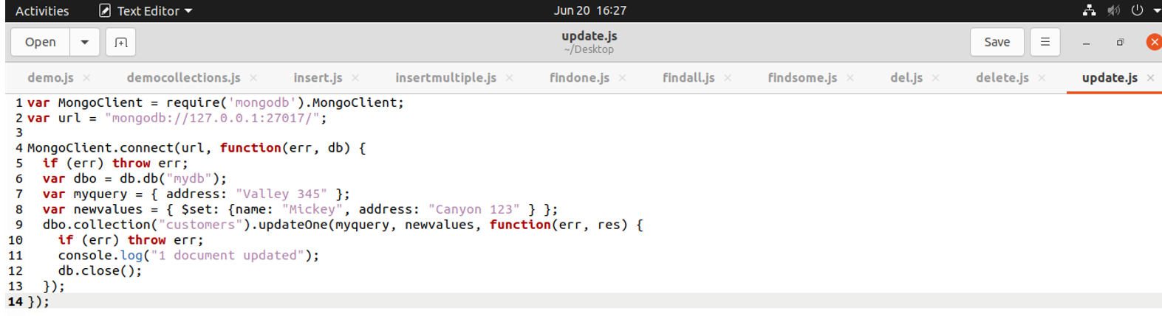

**OUTPUT:**



updateMany() method:

var MongoClient = require('mongodb').MongoClient;

var url = "mongodb://127.0.0.1:27017/";

MongoClient.connect(url, function(err, db) {

if (err) throw err;

var dbo = db.db("mydb");

var myquery = { address: /^S/ };

var newvalues = {$set: {name: "Minnie"} };

dbo.collection("customers").updateMany(myquery, newvalues, function(err, res) {

if (err) throw err;

console.log(res.result.nModified + " document(s) updated");

db.close();

});

});

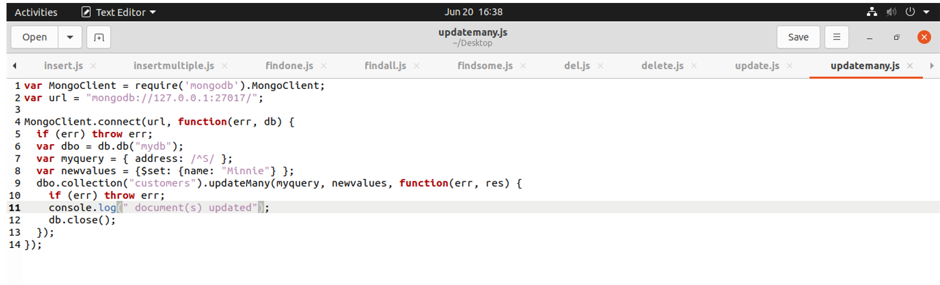

**OUTPUT:**



d)finding value

findOne() method:

var MongoClient = require('mongodb').MongoClient;

var url = "mongodb://localhost:27017/";

MongoClient.connect(url, function(err, db) {

if (err) throw err;

var dbo = db.db("mydb");

dbo.collection("customers").findOne({}, function(err, result) {

if (err) throw err;

console.log(result.name);

db.close();

});

});

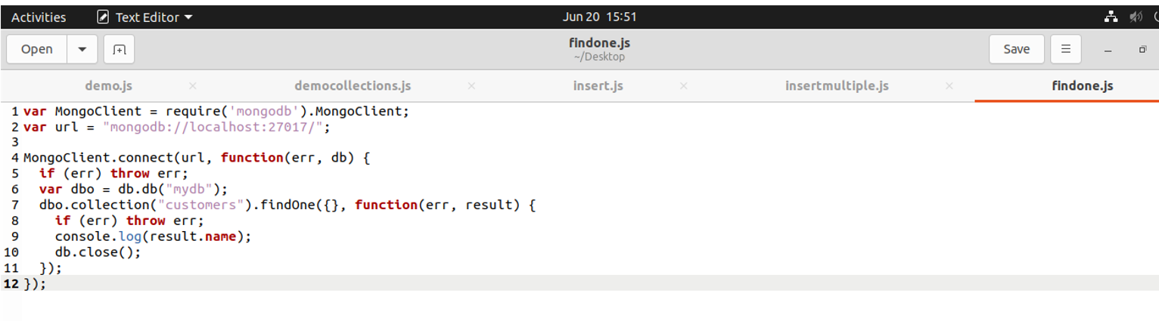

**OUTPUT:**



find() method:

var MongoClient = require('mongodb').MongoClient;

var url = "mongodb://localhost:27017/";

MongoClient.connect(url, function(err, db) {

if (err) throw err;

var dbo = db.db("mydb");

dbo.collection("customers").find({}).toArray(function(err, result) {

if (err) throw err;

console.log(result);

db.close();

});

});

**OUTPUT:**

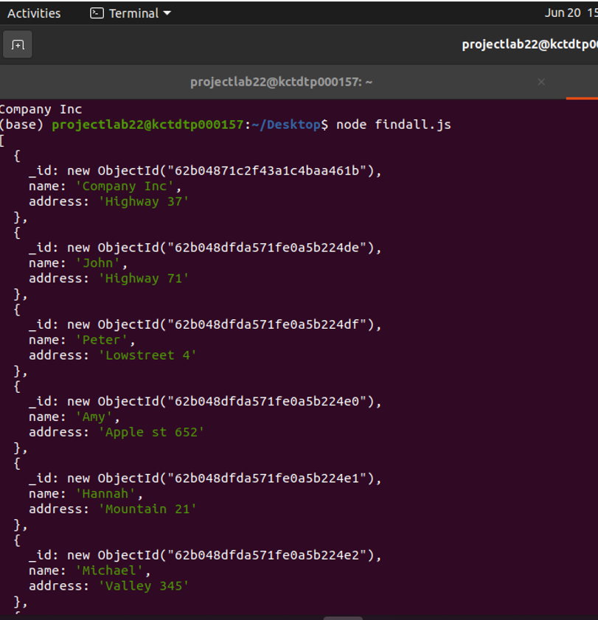

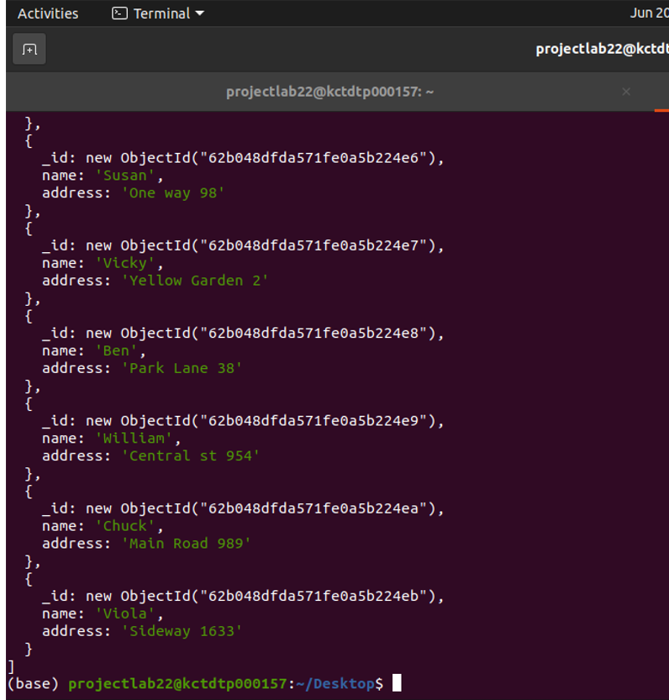

find() method:

var MongoClient = require('mongodb').MongoClient;

var url = "mongodb://localhost:27017/";

MongoClient.connect(url, function(err, db) {

if (err) throw err;

var dbo = db.db("mydb");

dbo.collection("customers").find({}, { projection: { _id: 0, name: 1, address: 1 } }).toArray(function(err, result) {

if (err) throw err;

console.log(result);

db.close();

});

});

**OUTPUT:**

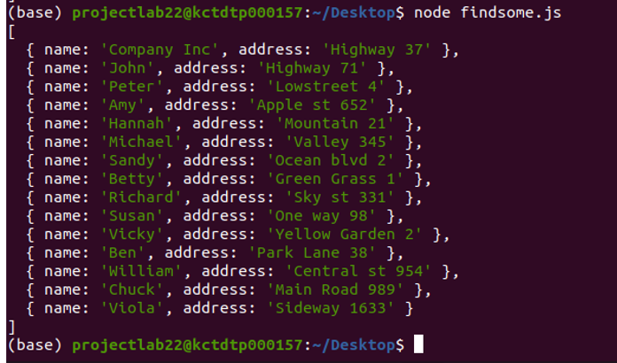

**<!DOCTYPE html>**

**<html lang="en">**

**<head>**

**<meta charset="UTF-8">**

**<meta http-equiv="X-UA-Compatible" content="IE=edge">**

**<meta name="viewport" content="width=device-width, initial-scale=1.0">**

**<title>Form Validation</title>**

**</head>**

**<body>**

**<form id="form_1">**

**Name:<br>**

**<input type="text" id="names"><br/></br>**

**Phone number:<br>**

**<input type="number" id="po_no"><br><br>**

**Password:<br>**

**<input type="password" id="password"><br><br>**

**Mail:<br>**

**<input type="text" id="mail"><br/></br>**

**<button type="button" onclick="allnumeric()">submit</button>**

**<input type="reset" value="Reset">**

**</form>**

**</body>**

**<script>**

**function allnumeric() {**

**var name=document.getElementById("names").value;**

**if (name==null || name==""){**

**alert("Name can't be blank");**

**return false;**

**}**

**var phone1 = document.getElementById("po_no").value;**

**let phone = parseInt(phone1);**

**if(phone<1111111111 || phone>9999999999){**

**alert("Please enter a valid number!");**

**return;**

**}**

**var InputValue = document.getElementById("password");**

**var passw=/^(?=.*\d)(?=.*[a-z])(?=.*[A-Z])(?=.*[^a-zA-Z0-9])(?!.*\s).{8,15}$/;**

**if(InputValue.value.match(passw))**

**{**

**}**

**else**

**{**

**alert('enter valid password');**

**return false;**

**}**

**var mail1 = document.getElementById("mail");**

**var mailformat = /^\w+([\.-]?\w+)*@\w+([\.-]?\w+)*(\.\w{2,3})+$/;**

**if(mail1.value.match(mailformat))**

**{**

**}**

**else**

**{**

**alert("You have entered an invalid email address!");**

**return false;**

**}**

**console.log("all crt");**

**}**

**</script>**

**</html>**

**MAINPAGE:**

**<html>**

**<head>**

**<title></title>**

**</head>**

**<style>**

**header{**

**width: 100%; height: 100vh;**

**background-color: white;**

**background-repeat: no-repeat;**

**background-size: cover;**

**}**

**nav{**

**width: 100%; height: 15vh;**

**background: blue;**

**display: flex; justify-content: space-between;**

**align-items: center;**

**}**

**nav .mainmenu{**

**width: 40%;**

**display: flex; justify-content: space-around;**

**}**

**nav .mainmenu a{**

**background: white;**

**width: 20%; height: 3vh;**

**text-align: center;**

**border: 2px solid black;**

**margin:10px;**

**padding:10px;**

**}**

**#sp {text-indent: 4em;}**

**</style>**

**<body>**

**<header>**

**<nav>**

**<div id="sp" class = "logo"><img onmouseover="bigimg(this)" onmouseout="smallimg(this)" src="F:/interiorhtmlcss/logo.jpg" width="50" height="50"></div>**

**<h2 style="font-weight:bold; color:white;">dgwudguwgyg khifheiugfu Decor studio</h2>**

**<div class = "mainmenu">**

**<a href="https://hackr.io/tutorials/learn-html-5">outlets</a>**

**<a href="https://hackr.io/tutorials/learn-html-5">order online</a>**

**<a href="https://hackr.io/tutorials/learn-html-5">Contact Us</a>**

**</div>**

**</nav>**

**<main>**

**<img src="F:/interiorhtml/4.jpg" width=1500 height=700>**

**<input type ="button" value = "view more">**

**</main>**

**</header>**

**</body>**

**<script>**

**function bigimg(x){**

**x.style.height="74px";**

**x.style.width="74px";**

**}**

**function smallimg(x){**

**x.style.height="50px";**

**x.style.width="50px";**

**}**

**</script>**

**</html>**

**FRAMES:**

**<html>**

**<head>**

**<title> Frames </title>**

**</head>**

**<frameset rows="20%,80%">**

**<frame src="https://miradorlife.com/category/blog/">**

**<frameset cols="40%,40%">**

**<frame src="page2.html">**

**<frame src="page1.html">**

**</frameset>**

**</frameset>**

**</html>**

**6 main:**

**#ab{**

**font-weight:bold;**

**color:red;**

**font-size:large;**

**}**

**section{**

**float: left;**

**width: 30%;**

**height: 500px; /* only for demonstration, should be removed */**

**background: #ccc;**

**padding: 20px;**

**}**

**aside {**

**float: left;**

**padding: 20px;**

**width: 70%;**

**background-color: #f1f1f1;**

**height: 500px; /* only for demonstration, should be removed */**

**}**

**</style>**

**<body>**

**<header>**

**<nav>**

**<div id="sp"><h2 style="color:white;">online-shopping</h2></div>**

**<div class="mainmenu">**

**<a href="#">Home</a>**

**<a href="#">Menu</a>**

**<a href="F:/iwp lab study/form javascript.html">Orders</a>**

**</div>**

**</nav>**

**</header>**

**<section>**

**<form id="ab" align="center">**

**View our stores:<br><br>**

**<select>**

**<option value="cbe">Cbe</option>**

**<option value="mum">Mumb</option>**

**<option value="ban">Bang</option>**

**<option value="hyd">Hyd</option>**

**</select>**

**</form>**

**</section>**

**<aside>**

**<marquee behavior="scroll" direction="up" scrollamount="2">**

**&nbsp;&nbsp;&nbsp;&nbsp;&nbsp;&nbsp;&nbsp;&nbsp;&nbsp;&nbsp;&nbsp;&nbsp;&nbsp;&nbsp;&nbsp;&nbsp;1.jkgfius<br><br>**

**&nbsp;&nbsp;&nbsp;&nbsp;&nbsp;&nbsp;&nbsp;&nbsp;&nbsp;&nbsp;&nbsp;&nbsp;&nbsp;&nbsp;&nbsp;&nbsp;2.hdiushfi<br><br>**

**&nbsp;&nbsp;&nbsp;&nbsp;&nbsp;&nbsp;&nbsp;&nbsp;&nbsp;&nbsp;&nbsp;&nbsp;&nbsp;&nbsp;&nbsp;&nbsp;3.ishisho<br><br>**

**&nbsp;&nbsp;&nbsp;&nbsp;&nbsp;&nbsp;&nbsp;&nbsp;&nbsp;&nbsp;&nbsp;&nbsp;&nbsp;&nbsp;&nbsp;&nbsp;4.jhiushfi<br><br>**

**</marquee>**

**</aside>**

**</body>**

**</html>**

**RANDOM IMAGE:**

**<html>**

**<head>**

**<title> Random Image Generator </title>**

**</head>**

**<script>**

**function getRandomImage() {**

**var randomImage = new Array();**

**randomImage[0] = "F:/interiorhtml/1.jpg";**

**randomImage[1] = "F:/interiorhtml/2.jpg";**

**randomImage[2] = "F:/interiorhtml/3.jpg";**

**randomImage[3] = "F:/interiorhtml/4.jpg";**

**randomImage[4] = "F:/interiorhtml/5.jpg";**

**randomImage[5] = "F:/interiorhtml/6.jpg";**

**var number = Math.floor(Math.random()*randomImage.length);**

**return document.getElementById("result").innerHTML = '<img src="'+randomImage[number]+'" width="500" height="500"/>';**

**</script>**

**<body>**

**<center><h2 style="color:green"> Random Image Generator </h2></center>**

**<h4> Click the button to generate and display random images on the webpage </h4>**

**<button onclick = "setInterval(getRandomImage, 2000)"> Generate Image </button>**

**<br> <br>**

**<span id="result" align="center"> </span>**

**</body>**

**</html>**