CHROMA: Colour Intelligence
Bridging Physical Colours and Digital Design

A PROJECT REPORT

Submitted by

BRANAYAGA A P | – | 241701010
SRISHA S | – | 241701056

In fulfilment for the course
GE23627 – DESIGN THINKING AND INNOVATION
for the degree of
BACHELOR OF ENGINEERING IN
COMPUTER SCIENCE AND DESIGN



RAJALAKSHMI ENGINEERING COLLEGE
THANDALAM, CHENNAI
OCTOBER 2026

ABSTRACT

Colour identification, comparison and visualization are essential in graphic design, fashion, interior design and other creative fields. However, transferring physical colours into digital workflows is often challenging due to lighting variations, subjective interpretation and disconnected colour-processing tools. CHROMA: Colour Intelligence – Bridging Physical Colours and Digital Design addresses these challenges through an integrated system consisting of CHROMAPOD, a portable colour-scanning device, and CHROMA Studio, its companion application. CHROMAPOD incorporates an ESP32 microcontroller, TCS34725 colour sensor, TFT display, rotary encoder, scan button, LED illumination and LiPo battery. It captures physical colours, performs comparisons using CIE76 (ΔE76) and communicates with the application through Bluetooth Low Energy (BLE). CHROMA Studio provides colour analysis, conversion between RGB, HEX, HSL, CMYK and LAB formats, image matching using CIEDE2000 (ΔE00), colour visualization, library management and project organization. Its Visualize Colour feature enables users to select surfaces in photographs and preview scanned or saved colours while preserving visible shading and texture where possible. The prototype was evaluated using 16 printed RGB reference swatches, with five scans recorded for each colour. Following calibration refinement from firmware V13 to V14, the average RGB agreement with intended digital reference values improved from approximately 85% to 94.68%. As ordinary printed swatches were used, this percentage represents agreement with intended RGB values rather than certified colour accuracy. The completed system demonstrates a practical approach to connecting physical colour sensing with digital colour analysis, matching and visualization.

ACKNOWLEDGEMENT

Initially, we thank the Almighty for being with us through every walk of our lives and showering His blessings throughout the endeavour to complete this report. Our sincere thanks to our Chairman Mr. S. Meganathan, B.E., F.I.E., our Vice Chairman Mr. Abhay Shankar Meganathan, B.E., M.S., and our respected Chairperson Dr. (Mrs.) Thangam Meganathan, Ph.D., for providing us with the requisite infrastructure and facilities at their esteemed institution.

Our sincere thanks to Dr. S. N. Murugesan, M.E., Ph.D., our beloved Principal, for his kind support and the facilities provided to complete our project work successfully. We express our sincere thanks to Dr. S. Vinodh Kumar, Ph.D., Professor and Head of the Department of Computer Science and Design, for his valuable guidance and encouragement throughout the project. We convey our heartfelt gratitude to our internal project guide, Dr. P. Revathy, Professor, Department of Computer Science and Design, for her continuous guidance, constructive suggestions and valuable support during the development of our project. We also thank the faculty members, our families and friends for their encouragement and support.

BRANAYAGA A P (241701010)
SRISHA S (241701056)

TABLE OF CONTENTS

S.NO | TITLE | PAGE.NO
1 | INTRODUCTION | 1
2 | LITERATURE SURVEY | 7
3 | SYSTEM DESIGN | 13
4 | HARDWARE IMPLEMENTATION | 24
5 | SOFTWARE IMPLEMENTATION | 32
6 | METHODOLOGY AND ALGORITHMS | 40
7 | TESTING AND RESULTS | 46
8 | CONCLUSION AND FUTURE SCOPE | 53
 | REFERENCES | 56

LIST OF FIGURES

FIGURE NO. | TITLE | PAGE.NO
3.1 | Overall system architecture of CHROMA | 16
3.2 | Overall system flow diagram | 17
3.3 | Use case diagram of CHROMA | 18
3.4 | Activity diagram for the CHROMAPOD scanning workflow | 20
3.5 | Sequence diagram for BLE-based image matching | 21
3.6 | BLE communication and data-flow diagram | 22
4.1 | CHROMAPOD working hardware prototype | 25
4.2 | CHROMAPOD hardware connection diagram | 30
5.1 | CHROMA Studio application home screen | 34
5.2 | Image Match interface and result display | 36
5.3 | Visualize Colour original and recoloured preview | 38
7.1 | CHROMA Colour Test Sheet containing 16 RGB reference colours | 47
7.2 | Colour-wise RGB agreement for 16 printed reference colours using V14 | 50
7.3 | Comparison of overall RGB agreement between firmware V13 and V14 | 50
LIST OF TABLES

TABLE NO. | TITLE | PAGE.NO
2.1 | Comparative Analysis of Existing Colour Identification Systems | 10
4.1 | Pin Configuration and Hardware Connections of CHROMAPOD | 28

LIST OF ABBREVIATIONS

S.NO | ABBREVIATION | EXPANSION
1 | ADC | Analog-to-Digital Converter
2 | BLE | Bluetooth Low Energy
3 | CIE | International Commission on Illumination
4 | CIELAB | CIE L*a*b* Colour Space
5 | CMYK | Cyan, Magenta, Yellow and Key (Black)
6 | ESP32 | Espressif Systems 32-bit Microcontroller
7 | GPIO | General-Purpose Input/Output
8 | HEX | Hexadecimal
9 | HSL | Hue, Saturation and Lightness
10 | I²C | Inter-Integrated Circuit
11 | LED | Light-Emitting Diode
12 | LiPo | Lithium-Polymer
13 | PCB | Printed Circuit Board
14 | RGB | Red, Green and Blue
15 | RGBC | Red, Green, Blue and Clear
16 | SPI | Serial Peripheral Interface
17 | TFT | Thin-Film Transistor
18 | USB | Universal Serial Bus
19 | ΔE76 | CIE 1976 Colour Difference
20 | ΔE00 | CIEDE2000 Colour Difference

INTRODUCTION

1.1 General

Colour plays an important role in graphic design, fashion, interior design, printing and digital media. Designers frequently use colours obtained from physical objects and materials, but transferring these colours into digital formats can be challenging. Conventional methods rely on visual estimation, photographic sampling or specialized instruments, which may be affected by lighting conditions, measurement consistency and accessibility.

CHROMA: Colour Intelligence – Bridging Physical Colours and Digital Design addresses this challenge through an integrated system consisting of CHROMAPOD, a portable colour-scanning device, and CHROMA Studio, its companion application. The system combines physical colour acquisition, numerical comparison, colour conversion, image matching, visualization and digital colour management through Bluetooth Low Energy (BLE) communication.

1.2 Background

Digital design workflows require accurate and convenient methods of identifying and reusing physical colour references. Manual colour selection is subjective, while camera-based extraction may be influenced by exposure, white balance and surrounding illumination. Dedicated colour-measurement instruments offer an alternative but may be less accessible for educational and everyday design applications.

Advancements in embedded systems enable compact colour-sensing solutions using microcontrollers and optical sensors. The ESP32 supports sensor interfacing, processing and wireless communication, while the TCS34725 provides red, green, blue and clear-channel measurements. With suitable calibration, these readings can be converted into digital colour estimates. CHROMA integrates these technologies with a companion application to provide a connected physical–digital workflow.

1.3 Problem Statement

Transferring colours from physical surfaces into digital environments remains challenging because their appearance varies with illumination, material properties and observation conditions. Manual RGB or HEX estimation can produce inconsistent results, while camera-based sampling introduces additional variations through image processing.

Furthermore, users often depend on separate applications for colour identification, conversion, comparison, visualization and reference storage. This fragmented workflow requires repeated manual transfer of colour information. CHROMA addresses the need for an integrated system that combines physical colour acquisition with digital analysis, image-based matching, surface visualization and colour management.

1.4 Motivation

The motivation behind CHROMA is to simplify the process of acquiring and reusing real-world colours in creative applications. Students and designers frequently need to reproduce colours from fabrics, printed materials, painted surfaces and everyday objects. Performing these activities through multiple tools can be time-consuming and inconvenient.

CHROMA was developed to connect a portable physical colour scanner with a digital application capable of analysing, comparing, converting and visualizing colours. The project also provides an opportunity to integrate embedded hardware, sensor calibration, wireless communication, colour-science algorithms and interactive application development into a functional prototype.

1.5 Objectives

The primary objective of CHROMA is to develop an integrated physical and digital colour analysis system that enables users to capture, compare, convert, visualize and manage colours conveniently.

The specific objectives are:
- To acquire physical colour measurements using the TCS34725 sensor and ESP32 microcontroller.
- To process sensor readings through calibration and display the resulting digital colour information.
- To perform physical colour comparison using the CIE76 colour-difference method.
- To establish bidirectional Bluetooth Low Energy communication between CHROMAPOD and CHROMA Studio.
- To support colour conversion, CIEDE2000 image matching, surface visualization and colour-reference management.
- To evaluate calibration performance and measurement consistency using repeated scans of printed RGB reference colours.

1.6 Scope and Limitations

The scope of CHROMA includes embedded hardware development, firmware programming, BLE communication, companion application development and experimental colour evaluation. CHROMAPOD incorporates an ESP32-WROOM-32, TCS34725 sensor, TFT display, rotary encoder, scan button, LED illumination and LiPo battery. It supports SCAN, COMPARE and IMAGE MATCH modes. CHROMA Studio provides Scan, Compare, Convert, Image Match, Visualize Colour, Library and Projects functionality through a mobile-compatible interface.

The system has limitations related to sensor characteristics, illumination, surface reflectivity and calibration conditions. The TCS34725 does not measure complete spectral information, and the experimental evaluation uses ordinary printed RGB references rather than certified colour standards. Consequently, reported agreement values do not represent laboratory-certified accuracy. Image-based visualization also provides an approximate preview rather than an exact prediction of physical material appearance.

1.7 Existing System

Existing colour-identification methods include manual comparison, smartphone colour-picking applications, specialized colour-measurement instruments and digital design software. Manual methods depend on visual judgment, while smartphone-based techniques extract colour values from photographs and can be affected by camera settings and illumination.

Dedicated measurement instruments provide more controlled acquisition but may involve additional cost or specialized procedures. Digital design applications offer extensive colour manipulation and management functions but generally require physical references to be acquired separately. These approaches provide useful individual capabilities but may lack the connected physical–digital workflow addressed by CHROMA.

1.8 Limitations of Existing Approaches

Conventional colour workflows face limitations related to measurement consistency, accessibility and the separation of physical acquisition from digital processing. Visual estimation is subjective, camera-based extraction depends on capture conditions, and specialized instruments may require additional resources or technical knowledge.

Users may also need multiple tools to identify, convert, compare, visualize and organize colours. Repeatedly transferring colour information between applications can reduce workflow efficiency. CHROMA addresses these limitations by integrating the relevant functions within a connected hardware and software system.

1.9 Proposed CHROMA System

CHROMA consists of two interconnected components: CHROMAPOD and CHROMA Studio. CHROMAPOD uses the TCS34725 sensor to acquire physical colour measurements, which are processed by the ESP32 through calibration and conversion procedures. A TFT display presents results, while the rotary encoder and scan button provide user interaction. The battery-powered device supports SCAN, COMPARE and IMAGE MATCH modes.

CHROMA Studio extends these capabilities through RGB, HEX, HSL, CMYK and LAB colour representations, image matching using CIEDE2000, surface recolouring, Library and Projects. Bluetooth Low Energy enables scanned colour values to be transmitted to the application and image-matching results to be returned to CHROMAPOD. This integration establishes a connected workflow between physical colour sensing and digital design operations.

1.10 Advantages and Applications

The primary advantage of CHROMA is the integration of physical colour sensing with digital analysis, comparison, conversion, visualization and reference management. The portable hardware enables direct acquisition of physical colours, while BLE communication reduces manual data transfer. Numerical colour-difference calculations support systematic comparison, and the application allows colours to be saved and reused across projects.

CHROMA has potential applications in graphic design, fashion, textiles, interior design, digital art and design education. Users can collect colour references, compare material shades, create digital palettes and preview selected colours on photographed surfaces. Although the prototype does not replace certified colour-measurement instruments, it demonstrates an accessible approach to connecting embedded sensing technologies with creative digital workflows.
LITERATURE SURVEY

2.1 Introduction

Colour sensing and analysis involve technologies for identifying, representing, comparing and modifying colours in physical and digital environments. Existing methods include optical sensors, camera-based colour extraction, colour-space conversion, numerical colour-difference calculations and image-processing techniques. Each method offers different advantages depending on accuracy requirements, operating conditions and application needs.

This literature survey examines research in colour science, optical sensing and digital visualization, along with existing commercial colour-identification systems. The study provides a theoretical foundation for developing CHROMA, an integrated physical and digital colour-analysis system.

2.2 Review of Related Research

Colour science provides mathematical methods for representing and comparing colours. The CIELAB colour space represents colours through lightness (L*) and chromatic coordinates (a* and b*). CIE76 calculates the Euclidean distance between two colours in this space, although equal numerical distances do not always correspond to equal perceived differences.

Luo, Cui and Rigg developed the CIEDE2000 colour-difference formula to improve the relationship between numerical measurements and human colour perception [1]. Sharma, Wu and Dalal subsequently examined its implementation and provided supplementary test data for validating calculations [2]. These studies support the comparison techniques used in CHROMA, where CHROMAPOD applies CIE76 and CHROMA Studio uses CIEDE2000 for image matching.

Research in digital image processing also provides approaches for modifying colours while preserving visual characteristics. Reinhard et al. investigated transferring colour characteristics between images [3], while Welsh et al. studied image colourization using luminance and texture information [4]. These studies provide background for CHROMA Studio's Visualize Colour feature, which applies selected colours to photographed surfaces while attempting to preserve shading and texture.

2.3 Existing Colour-Sensing Technologies

Optical colour sensors measure incident or reflected light through different spectral response channels and generate numerical colour information. Compact RGB sensors are suitable for embedded applications because of their small size, configurable measurement settings and straightforward microcontroller interfacing.

The TCS34725 provides red, green, blue and clear-channel measurements using an I²C interface, with configurable integration time and gain [5]. However, its raw values depend on illumination, surface reflectivity, sensor positioning and the device's spectral response. Calibration is therefore necessary to obtain meaningful digital colour estimates.

Other colour-measurement technologies include tristimulus colorimeters and spectrophotometers, which support more specialized measurement requirements. Unlike spectrophotometers, compact RGB sensors cannot obtain complete spectral reflectance information. CHROMAPOD therefore uses the TCS34725 as a practical sensing solution for a portable prototype rather than as a replacement for laboratory-grade colour-measurement instruments.

2.4 Colour Comparison and Visualization Methods

Colour comparison determines the difference between two colour references using numerical models. Direct RGB comparison is straightforward but does not correspond directly to human colour perception. CIE76 calculates distance within CIELAB, while CIEDE2000 introduces adjustments involving lightness, chroma and hue to improve perceptual correspondence.

Digital colour visualization involves modifying selected regions of an image while retaining relevant visual characteristics. Directly replacing pixel values may remove shading, texture and brightness variation. More useful recolouring methods attempt to preserve these details while applying a selected colour.

CHROMA applies CIE76 for hardware-based comparison and CIEDE2000 for image-based matching. Its Visualize Colour feature enables users to select photographed surfaces, apply colours and compare original and modified results. The generated preview is an image-based approximation rather than an exact prediction of physical material appearance.

2.5 Existing Colour Identification and Matching Systems

Several commercial products provide physical colour measurement or digital colour-management capabilities.

Nix Mini 3 is a portable colour sensor that connects to the Nix Toolkit mobile application. It enables users to scan physical surfaces, obtain digital colour values, identify matching paint colours and save or share scanned colour references [7]. It is designed for practical colour identification in applications such as painting, interior design and graphic design.

Datacolor ColorReader is a portable colour-measurement device that communicates with a companion application through Bluetooth. It provides digital colour values, paint matching, colour libraries and palette management. Supported representations include CIELAB, RGB and HEX, with additional colour models and numerical difference information available on certain models [8].

Pantone Connect is a digital colour-management platform that provides access to Pantone colour libraries, palette creation, image-based colour extraction and conversion between RGB, HEX, CMYK and LAB formats [9]. It also supports integration with compatible Adobe design workflows. Unlike standalone portable scanning devices, its principal emphasis is digital colour selection and colour-management operations.

These systems demonstrate the availability of established solutions for colour measurement and digital design. CHROMA combines an independently developed physical scanner with embedded colour comparison, BLE communication, image-based matching, surface-colour visualization and project-based colour organization.

Table 2.1 Comparative Analysis of Existing Colour Identification Systems
System | Primary Function | Key Features
Nix Mini 3 | Physical colour identification | Portable scanning, digital colour values, paint matching
Datacolor ColorReader | Colour measurement and matching | Bluetooth scanning, colour comparison, palette management
Pantone Connect | Digital colour management | Colour libraries, format conversion, image-based colour extraction

2.6 Comparative Analysis

Existing colour-identification systems provide different capabilities depending on their intended applications. Nix Mini 3 and Datacolor ColorReader focus on portable physical colour acquisition and matching, while Pantone Connect emphasizes digital colour libraries and design workflows. These products demonstrate that physical sensing, colour conversion and digital colour management are established technologies.

CHROMA integrates selected capabilities through CHROMAPOD and CHROMA Studio. CHROMAPOD acquires physical colours, processes calibrated RGB values and performs CIE76 comparison. CHROMA Studio supports colour conversion, CIEDE2000 image matching, surface recolouring and reference management. Bidirectional BLE communication connects the physical and digital components.

The main contribution of CHROMA is the integration of these functions into a custom-developed prototype. The project does not claim superior measurement accuracy over established commercial colour instruments, but demonstrates an accessible implementation of interconnected colour-analysis technologies.

2.7 Research Gap

Existing research and commercial systems provide established solutions for optical sensing, numerical colour comparison, image processing and digital colour management. However, these capabilities may be distributed across different devices or applications, requiring users to transfer colour information between separate workflows.

CHROMA addresses this practical integration opportunity by developing a portable colour scanner and companion application that combine acquisition, calibration, comparison, wireless communication, colour conversion, image matching, visualization and reference management. Its contribution lies in integrating established techniques within a connected hardware–software system.

The project also evaluates calibration refinement using repeated measurements of printed reference colours. This provides evidence of improved agreement with intended digital RGB values while recognizing the limitations of the sensor, printed references and measurement conditions.

SYSTEM DESIGN

3.1 General

System design establishes the architecture, components and communication mechanisms required for integrating physical colour sensing with digital colour processing. CHROMA consists of two interconnected components: CHROMAPOD, a portable colour-scanning device, and CHROMA Studio, its companion application. CHROMAPOD uses the TCS34725 sensor and ESP32 microcontroller to acquire and process physical colour measurements, while a TFT display, rotary encoder and scan button provide user interaction. CHROMA Studio extends these capabilities through colour comparison, conversion, image matching, visualization and reference management. Bluetooth Low Energy (BLE) enables communication between both components, allowing scanned colour information and application-generated results to be exchanged within a connected workflow.

3.2 Requirement Analysis

The primary requirement of CHROMA is to capture colour information from physical surfaces, process the measurements and make the resulting digital values available for further operations. The hardware must support optical sensing, calibrated colour processing, local display, physical controls and battery-powered operation. Consistent sensor positioning and illumination are necessary to reduce variations during acquisition. The application must receive colour information from CHROMAPOD and support conversion, numerical comparison, image-based matching, surface visualization and storage of colour references. The system must also support bidirectional BLE communication for operations involving both hardware and software. These requirements are categorized into functional requirements, which define the operations performed, and non-functional requirements, which address usability, responsiveness, reliability, portability and maintainability.

3.3 Functional and Non-Functional Requirements

The requirements of CHROMA are divided into functional and non-functional categories to ensure that the developed system provides the necessary capabilities while maintaining practical operating characteristics.

3.3.1 Functional Requirements

CHROMAPOD must acquire red, green, blue and clear-channel measurements through the TCS34725, process the readings using calibration procedures and display the resulting digital colour information on its TFT screen. The rotary encoder must support menu navigation, while the scan button initiates colour acquisition. SCAN mode captures physical colours, COMPARE mode evaluates two measured colours using the CIE76 colour-difference algorithm, and IMAGE MATCH supports interaction with CHROMA Studio through BLE. The companion application must provide Scan, Compare, Convert, Image Match, Visualize Colour, Library and Projects functionality. It must support RGB, HEX, HSL, CMYK and LAB representations, image-based matching using CIEDE2000, surface recolouring and digital reference management. Bidirectional communication must allow scanned values to reach the application and image-matching results to return to CHROMAPOD.

3.3.2 Non-Functional Requirements

The non-functional requirements focus on usability, portability, reliability and maintainability. CHROMAPOD must provide a compact interface with understandable mode selection, readable measurement results and rechargeable battery-powered operation. The application should maintain consistent navigation and responsive interaction across supported mobile interfaces. Repeated scans should produce reasonably consistent results under similar measurement conditions, although illumination and material characteristics may introduce variations. BLE communication must account for connection availability, while the modular separation of firmware, sensing, communication and application features should support testing, troubleshooting and future improvements. The system is designed for practical colour-analysis assistance rather than certified laboratory-grade measurement.

3.4 Overall System Architecture

CHROMA follows a connected hardware–software architecture consisting of physical colour acquisition, embedded processing, wireless communication and digital application modules. When the user initiates a scan, light reflected from the selected surface reaches the TCS34725 sensor, which produces raw red, green, blue and clear-channel measurements. The ESP32 receives these values through I²C and applies calibration and colour-conversion procedures. The processed result is displayed on the TFT screen and can be used for local comparison or transferred to CHROMA Studio through BLE. The device interface is controlled using the rotary encoder and scan button, while its rechargeable battery supports portable operation.

CHROMA Studio receives physical colour information and provides additional processing functions. In IMAGE MATCH, the application compares a scanned colour with a colour selected from a digital image using CIEDE2000 and returns the result to CHROMAPOD through BLE. Other functions, including conversion, visualization, Library and Projects, operate within the application's digital environment. This architecture assigns direct optical sensing and local interaction to the hardware while reserving image processing and broader colour-management functions for the companion application.
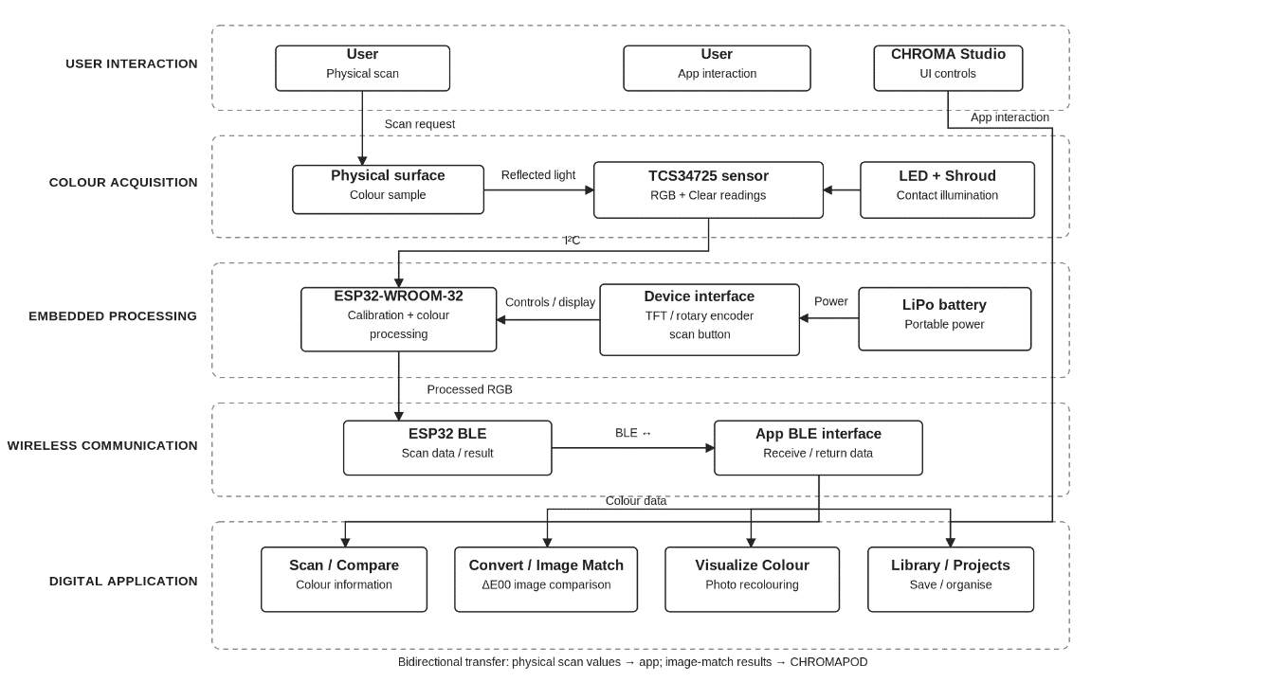
Figure 3.1 Overall system architecture of CHROMA

3.5 Hardware–Software Integration

Hardware–software integration enables colour measurements acquired by CHROMAPOD to be used within CHROMA Studio. The ESP32 coordinates sensor acquisition, calibration, display updates and communication through BLE. During connected scanning operations, processed RGB and related colour information are transmitted to the application, where they can be converted, compared, visualized or saved. The device continues to support local scanning and comparison without depending on continuous application connectivity, while features requiring digital-image processing use the companion software.

The IMAGE MATCH workflow demonstrates bidirectional integration. CHROMAPOD acquires a physical colour reference and sends it to CHROMA Studio, where the user selects a target colour from an image. The application performs the CIEDE2000 calculation and transmits the matching result back to the ESP32 for display. This arrangement enables both components to operate together while maintaining separate responsibilities for physical sensing and digital processing.
3.6 System Flow Diagram

The CHROMA workflow begins when the user powers on CHROMAPOD and selects SCAN, COMPARE or IMAGE MATCH using the rotary encoder. In SCAN mode, the sensor acquires reflected-light measurements, the ESP32 processes the raw readings through calibration and conversion, and the result is displayed on the TFT screen. If BLE is connected, the colour information can also be transferred to CHROMA Studio for further operations. COMPARE mode collects a reference and sample colour before calculating their CIE76 difference, while IMAGE MATCH sends a scanned colour to the application for comparison with a colour selected from a digital image. The result is then returned through BLE and displayed on the hardware. Application-only features such as colour conversion, surface visualization and reference organization operate independently when a physical scan is not required.

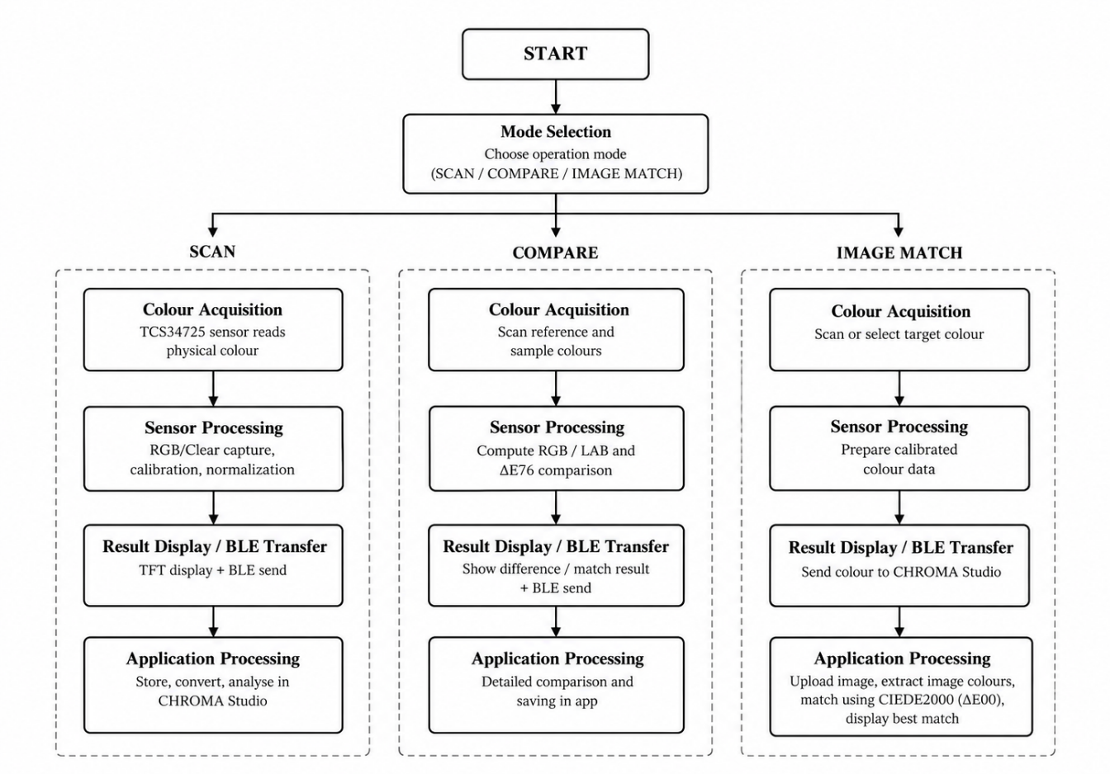
Figure 3.2 Overall system flow diagram
3.7 Use Case Diagram

The use case diagram represents the interactions between the user and the CHROMA system. Through CHROMAPOD, the user can select an operating mode, scan a physical colour, compare two scanned references and initiate image matching. The device provides measurement information and comparison results through its TFT display. Through CHROMA Studio, the user can establish a BLE connection, view scanned values, perform colour conversion, compare colours, select reference colours from images, visualize colours on photographed surfaces and organize saved references using Library and Projects. The use case diagram groups these functions within the CHROMA system boundary, illustrating the relationship between physical interaction and digital application operations.

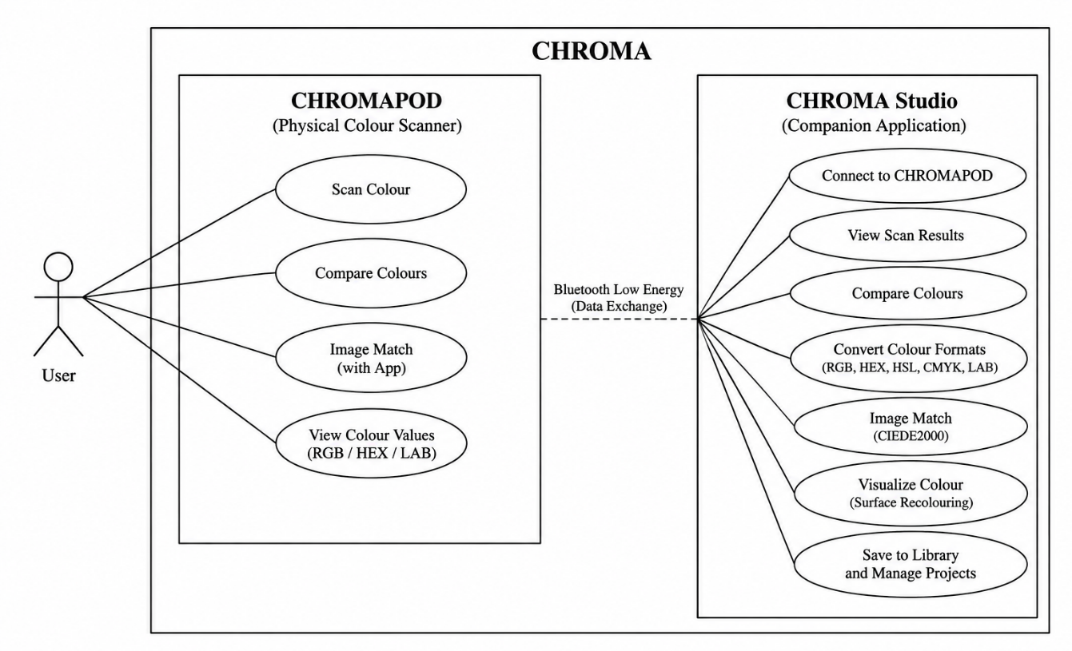
Figure 3.3 Use case diagram of CHROMA

3.8 Activity and Sequence Diagrams

Activity and sequence diagrams describe the operational flow and communication between CHROMAPOD and CHROMA Studio. The activity diagram focuses on the steps involved in acquiring and processing colour measurements, while the sequence diagram illustrates how information is exchanged between the user, hardware, BLE interface and application.

3.8.1 Activity Diagram

An activity diagram describes the sequence of operations and decisions that occur during a particular workflow. For CHROMA, the scanning activity begins when the user selects SCAN and initiates measurement. The system obtains the TCS34725 readings and processes the values through the ESP32 firmware. The result is displayed on the TFT screen, after which the user may initiate another scan or use the colour information within the connected application. A decision involving BLE connection status determines whether the acquired data can be transferred to CHROMA Studio. This representation helps explain how the system progresses from physical interaction to data acquisition, processing and output.

Additional activities occur when the user selects COMPARE or IMAGE MATCH. In COMPARE, two colour references are collected before calculating and displaying their numerical difference. In IMAGE MATCH, the application participates in the operation by providing a digital-image colour reference and calculating a matching result. For Visualize Colour, the activity begins with image selection, continues through surface selection and target-colour application, and concludes with the original and recoloured preview. These activities may be represented separately when necessary to avoid combining several distinct workflows into one overly complex diagram.

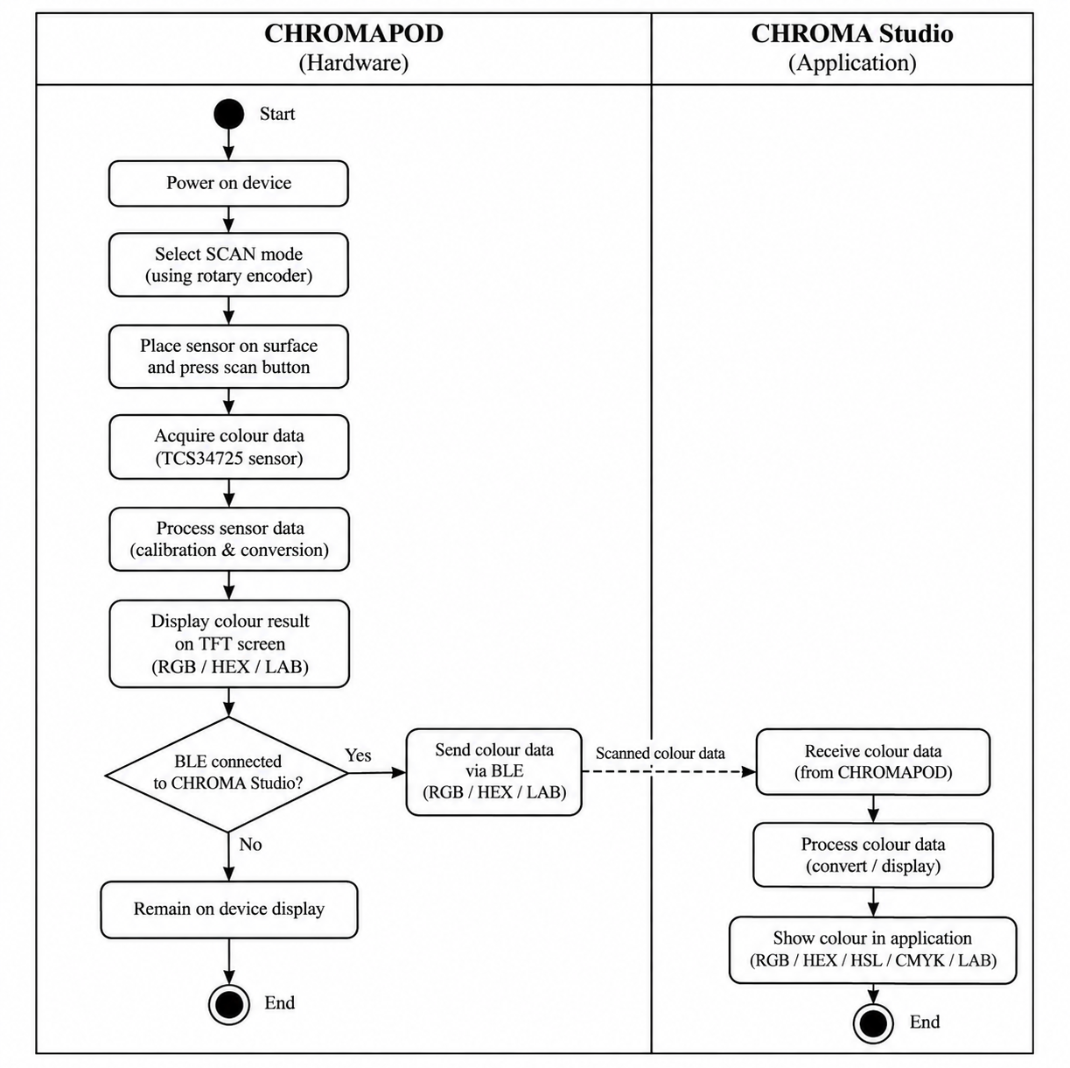
Figure 3.4 Activity diagram for the CHROMAPOD scanning workflow

3.8.2 Sequence Diagram

A sequence diagram illustrates the exchange of information between components in the order in which communication occurs. In CHROMA, the important participating elements are the user, CHROMAPOD's sensing and processing functions, the BLE communication interface and CHROMA Studio. During a connected scanning operation, the user initiates the scan, the colour sensor provides measurements to the ESP32, and the firmware processes the readings. The hardware interface displays the colour result, while the communication layer provides the scan information to the connected application. The sequence representation makes the responsibilities and timing order of these interactions easier to understand.

The IMAGE MATCH workflow requires communication in both directions. CHROMAPOD supplies the physical colour information, while CHROMA Studio handles digital-image colour selection and matching calculations. After evaluating the selected colours, the application returns the resulting match information through BLE for display on the device. The sequence diagram demonstrates that the colour-matching calculation is carried out at the application level, while CHROMAPOD provides the physical measurement and result display. This separation is useful for explaining why the application and hardware can share information without performing exactly the same processing operations.

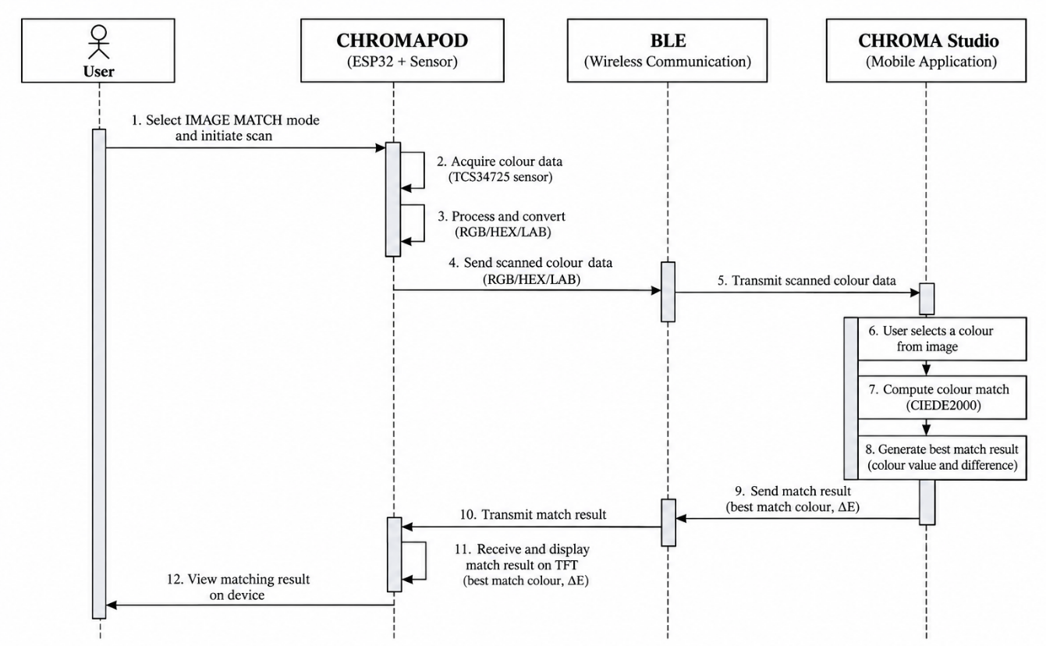
Figure 3.5 Sequence diagram for BLE-based image matching

3.9 BLE Communication and Data Flow

Bluetooth Low Energy provides the wireless communication mechanism between CHROMAPOD and CHROMA Studio. BLE is suitable for the exchange of relatively small amounts of information between a portable embedded device and a compatible application. Within the CHROMA architecture, the ESP32 provides the hardware-side BLE functionality, while CHROMA Studio acts as the digital communication interface. During a connected session, the system exchanges colour-related values and operation results required by the selected functionality. Communication is used for integration rather than as a replacement for the device's local sensing and display capabilities.

The data exchanged during a scan includes the processed colour values generated by the firmware and related measurement information. The application's BLE interface receives these values and makes them available to the relevant application features. For IMAGE MATCH, data must also travel from CHROMA Studio back to CHROMAPOD after the image-based comparison is completed. The communication design therefore supports both the transfer of physical measurement information and the return of application-computed results. The successful use of this workflow depends on the device and application being connected, so connection state forms an important part of user interaction and testing.
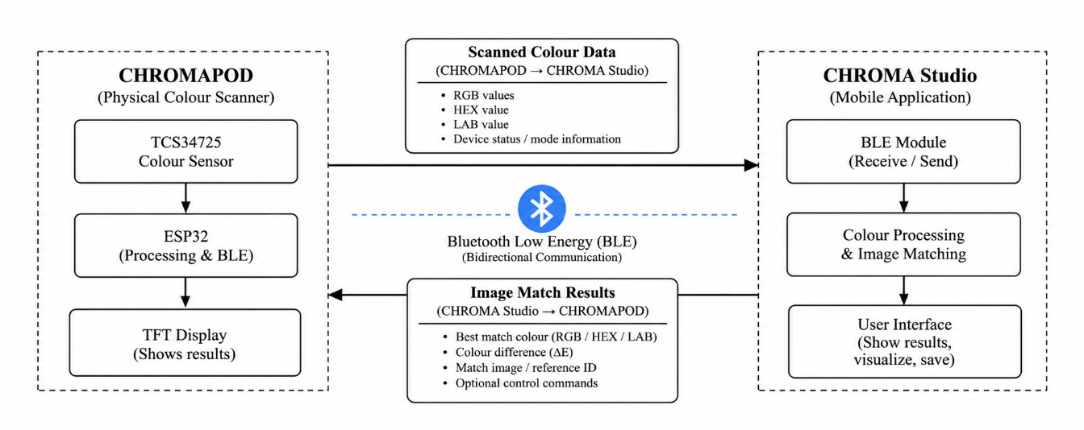
Figure 3.6 BLE communication and data-flow diagram
3.10 Module Design

CHROMA is organized into hardware and software modules according to their responsibilities. The colour-acquisition module uses the TCS34725 and its illumination arrangement to obtain sensor readings. The embedded processing module performs calibration, colour conversion, numerical comparison and mode control through the ESP32 firmware. The user-interface module consists of the TFT display, rotary encoder and scan button, while the BLE communication module handles wireless data exchange. These modules collectively form CHROMAPOD and enable portable physical colour acquisition and local interaction.

The software modules within CHROMA Studio include Scan, Compare, Convert, Image Match, Visualize Colour, Library and Projects. Scan handles received colour information, while Compare and Convert support numerical analysis and colour representation. Image Match performs CIEDE2000 comparison using a digitally selected reference, and Visualize Colour enables surface selection and recolouring. Library and Projects provide storage and organization of colour references. The modular design supports the integration of established colour-processing functions while allowing individual components to be maintained and improved without unnecessarily affecting unrelated operations.
HARDWARE IMPLEMENTATION

4.1 CHROMAPOD Hardware Overview

CHROMAPOD is the physical colour-scanning component of the CHROMA system, developed to acquire colour information from real-world surfaces and communicate the results to a digital environment. The hardware is built around the ESP32-WROOM-32 microcontroller and TCS34725 RGB colour sensor, supported by a 1.8-inch ST7735 TFT display, KY-040 rotary encoder, dedicated scan button and rechargeable lithium-polymer (LiPo) battery. The TCS34725 measures red, green, blue and clear-channel responses from reflected light, while the ESP32 processes these measurements through calibration and colour-conversion procedures to generate digital colour estimates. An illumination LED integrated into the sensor module, together with a surrounding sensor shroud, helps reduce the influence of ambient lighting during acquisition. The TFT display provides immediate visual feedback, and the rotary encoder and scan button enable users to navigate the device interface and initiate measurements. The rechargeable power system supports standalone operation, making CHROMAPOD suitable for acquiring colours directly from physical objects, printed materials and other accessible surfaces.

The device supports three primary operating modes: SCAN, COMPARE and IMAGE MATCH. SCAN mode captures a physical colour and displays its digital representation, including relevant numerical colour information. COMPARE mode allows two physical colours to be measured and evaluated using the CIE76 colour-difference algorithm, providing a numerical indication of their similarity. IMAGE MATCH integrates CHROMAPOD with the CHROMA Studio companion application through Bluetooth Low Energy (BLE), enabling a scanned physical colour to be compared with a reference selected from a digital image. The application performs the image-based comparison using CIEDE2000 and returns the result to CHROMAPOD for display. By combining embedded sensing, local processing, physical controls, wireless communication and battery-powered operation, the completed prototype demonstrates a functional connection between physical colour acquisition and digital colour analysis.

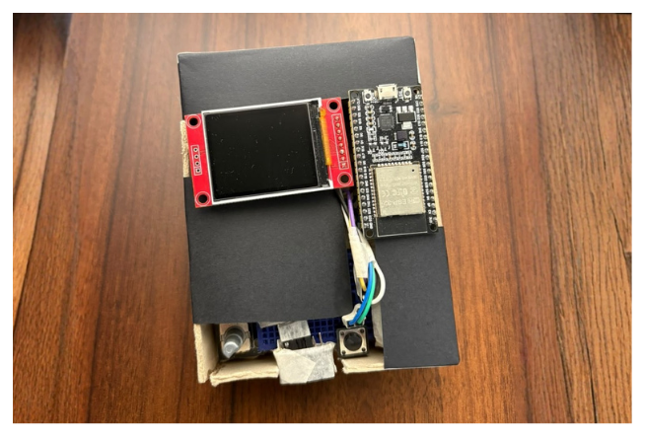
Figure 4.1 CHROMAPOD working hardware prototype

4.2 ESP32-WROOM-32 Microcontroller

The ESP32-WROOM-32 serves as the central processing and communication unit of CHROMAPOD. It provides General-Purpose Input/Output (GPIO), Inter-Integrated Circuit (I²C), Serial Peripheral Interface (SPI) and Bluetooth connectivity, enabling coordination between the colour sensor, display, input controls and companion application. The microcontroller receives red, green, blue and clear-channel measurements from the TCS34725 and processes them through firmware-based calibration and colour conversion to generate digital colour estimates. It also manages the rotary encoder, scan button, display updates and operating modes. Through BLE, the ESP32 transmits scanned colour information to CHROMA Studio and receives image-matching results for presentation on the TFT screen.

4.3 TCS34725 RGB Colour Sensor

The TCS34725 is a digital colour sensor that measures red, green, blue and clear-channel responses to reflected light. It includes optical filtering with infrared rejection and communicates with the ESP32 through the I²C interface. The sensor supports configurable integration time and gain, allowing its acquisition settings to be adjusted according to measurement conditions. In CHROMAPOD, the sensor's SDA and SCL connections use ESP32 GPIO21 and GPIO22, respectively. During scanning, reflected light from the selected surface produces raw colour-channel readings that are transmitted to the microcontroller. These readings undergo calibration to estimate digital RGB values because raw sensor responses are influenced by illumination, surface reflectivity and sensor positioning.

4.4 ST7735 TFT Display

The 1.8-inch ST7735 Thin-Film Transistor (TFT) display provides the primary visual interface for CHROMAPOD. It communicates with the ESP32 using SPI and displays operating modes, colour swatches, numerical colour values and comparison results. In SCAN mode, the screen presents the captured colour and its digital representation; in COMPARE mode, it displays the calculated colour difference; and in IMAGE MATCH, it presents the result received from CHROMA Studio. The display is connected through GPIO18 for SPI clock, GPIO23 for data, GPIO27 for chip selection, GPIO26 for data/command control and GPIO25 for reset. Its power and backlight connections use the regulated 3.3V supply from the ESP32 development board.

4.5 KY-040 Rotary Encoder and Scan Button

The KY-040 rotary encoder provides physical navigation and selection controls for CHROMAPOD. Its rotational signals allow the user to move through operating modes and menu options, while its integrated push switch supports selection and confirmation. The encoder uses GPIO33 for CLK, GPIO14 for DT and GPIO13 for its push-switch input. A separate momentary scan button is connected to GPIO32 and GND using the firmware's internal pull-up configuration. This arrangement separates menu navigation from colour acquisition, allowing the user to select the required function and initiate measurements without relying on a touchscreen.

4.6 LED Illumination and Sensor Shroud

Consistent illumination is essential for reliable colour acquisition because the TCS34725 measures light reflected from the selected surface. CHROMAPOD uses the illumination LED integrated into the TCS34725 sensor module rather than a separately wired external LED. The LED provides light for the measurement region, while the surrounding sensor shroud reduces interference from ambient illumination and helps maintain consistent contact with the scanned surface. Together, these features support more repeatable measurements under similar conditions. However, variations in surface texture, reflectivity and positioning may still influence the recorded colour values.

4.7 LiPo Battery and Power System

CHROMAPOD uses a rechargeable 3.7V lithium-polymer battery to support portable operation without a continuous USB connection. The battery is connected to a charging/protection module through its B+ and B− terminals. The module's output supplies a 5V voltage regulation stage, which delivers regulated power to the ESP32 development board through its VIN and GND connections. The ESP32 then provides a regulated 3.3V supply to the TCS34725 sensor, ST7735 TFT display and rotary encoder.

The implemented power arrangement supports the operation of the sensing, processing, display, control and BLE communication components. The completed prototype has been successfully operated using this battery-powered configuration, demonstrating standalone functionality for portable colour-scanning applications.

4.8 Circuit Connections and Assembly

The CHROMAPOD circuit integrates the ESP32, TCS34725 sensor, ST7735 TFT display, KY-040 rotary encoder, scan button and rechargeable power system. The TCS34725 communicates through I²C using GPIO21 and GPIO22, while the display uses SPI connections through GPIO18, GPIO23, GPIO27, GPIO26 and GPIO25. The rotary encoder is connected through GPIO33, GPIO14 and GPIO13, and the dedicated scan button uses GPIO32. The sensor, display and encoder receive 3.3V power from the ESP32, with shared ground connections. Battery power is supplied through the charging/protection module and 5V regulation stage to the ESP32 VIN connection.

The hardware components are integrated through firmware that coordinates colour acquisition, processing, display output, menu navigation and wireless communication. Table 4.1 presents the implemented pin configuration, while Figure 4.2 illustrates the hardware connections.

Table 4.1 Pin Configuration and Hardware Connections of CHROMAPOD
Component | Pin | Connected to ESP32 Pin | Purpose
TCS34725 Colour Sensor | VCC | 3V3 | Power supply
TCS34725 Colour Sensor | GND | GND | Ground
TCS34725 Colour Sensor | SDA | GPIO21 | I²C data
TCS34725 Colour Sensor | SCL | GPIO22 | I²C clock
TCS34725 Colour Sensor | INT | Not connected | Interrupt unused
Rotary Encoder (KY-040) | VCC | 3V3 | Power supply
Rotary Encoder (KY-040) | GND | GND | Ground
Rotary Encoder (KY-040) | CLK | GPIO33 | Encoder clock signal
Rotary Encoder (KY-040) | DT | GPIO14 | Encoder data signal
Rotary Encoder (KY-040) | SW | GPIO13 | Encoder push-switch input
Scan Button | IN | GPIO32 | Scan input signal
Scan Button | GND | GND | Ground
ST7735 TFT Display (1.8 inch) | VCC | 3V3 | Power supply
ST7735 TFT Display (1.8 inch) | GND | GND | Ground
ST7735 TFT Display (1.8 inch) | SCK | GPIO18 | SPI clock
ST7735 TFT Display (1.8 inch) | MOSI | GPIO23 | SPI data
ST7735 TFT Display (1.8 inch) | CS | GPIO27 | Chip select
ST7735 TFT Display (1.8 inch) | DC | GPIO26 | Data/command control
ST7735 TFT Display (1.8 inch) | RST | GPIO25 | Display reset
ST7735 TFT Display (1.8 inch) | BL/LED | 3V3 | Backlight supply
LiPo Battery (3.7 V) | Positive (+) | Charging module B+ | Battery positive
LiPo Battery (3.7 V) | Negative (−) | Charging module B− | Battery negative
Battery Charging / Power Module | OUT+ | 5V regulation stage input (+) | Positive power output
Battery Charging / Power Module | OUT− | 5V regulation stage input (−) | Ground output
5V Regulation Stage | 5V OUT | ESP32 5V (VIN) | Regulated 5V supply
5V Regulation Stage | GND | ESP32 GND | Common ground

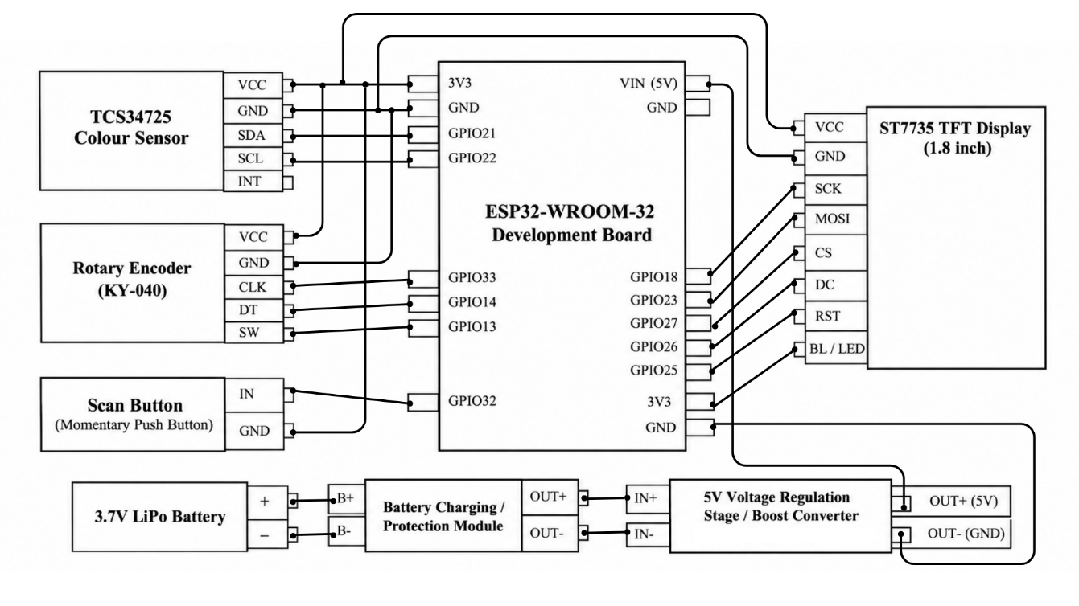
Figure 4.2 CHROMAPOD hardware connection diagram

4.9 Working Hardware Prototype

The completed CHROMAPOD prototype demonstrates the integration of physical colour sensing, embedded processing, user interaction and BLE communication within a portable device. The TCS34725 acquires colour-channel measurements, which are processed by the ESP32 to generate calibrated digital RGB values. The TFT display presents the resulting information, while the rotary encoder and scan button enable users to navigate modes and initiate measurements. The rechargeable battery, charging/protection module and regulated power supply support standalone operation. CHROMAPOD also communicates with CHROMA Studio for connected functions, including IMAGE MATCH.

The working prototype was evaluated using a printed reference sheet containing 16 RGB colours, with repeated scans collected to examine calibration performance and output consistency. The evaluation compared firmware Versions 13 and 14, with the detailed methodology and results presented in Chapters 6 and 7. The successfully assembled hardware establishes the physical foundation of the integrated CHROMA system.
SOFTWARE IMPLEMENTATION

5.1 Software Architecture and Technology Stack

The software architecture of CHROMA integrates embedded firmware, wireless communication and digital colour-processing functions within a connected hardware–software system. It consists of two primary components: the firmware running on CHROMAPOD and the CHROMA Studio companion application. The ESP32 firmware manages colour acquisition through the TCS34725 sensor, calibration, colour conversion, TFT display updates, rotary encoder input and Bluetooth Low Energy (BLE) communication. CHROMA Studio provides a user-friendly interface for colour analysis, comparison, conversion, image matching, surface visualization and reference management. The separation of these responsibilities allows CHROMAPOD to perform essential scanning and comparison operations independently while supporting advanced digital processing through the application.

The firmware is developed using the Arduino programming environment for the ESP32 platform, with libraries supporting sensor communication, display rendering and BLE functionality. CHROMA Studio is implemented as a responsive web-based application and packaged for Android using Capacitor, enabling mobile-oriented interaction and communication with the physical device. The software follows a modular architecture in which colour acquisition, embedded processing, communication and application-level functions operate as interconnected components, improving maintainability and supporting future development.

5.2 ESP32 Firmware and Device Interface

The ESP32 firmware controls the operation of CHROMAPOD by coordinating the colour sensor, TFT display, rotary encoder, scan button and BLE interface. During initialization, the firmware configures the required communication interfaces, prepares the display and establishes the operating states. The rotary encoder supports menu navigation and selection, while the dedicated scan button initiates colour acquisition. Raw red, green, blue and clear-channel measurements obtained from the TCS34725 are processed through calibration and conversion procedures before being displayed or used in numerical calculations. The firmware maintains the selected operating mode and updates the device interface according to user input.

CHROMAPOD provides three operating modes: SCAN, COMPARE and IMAGE MATCH. SCAN captures a physical colour and displays its digital representation, while COMPARE acquires two colour references and calculates their difference using CIE76. IMAGE MATCH exchanges information with CHROMA Studio through BLE, enabling comparison between a scanned physical colour and a reference selected from a digital image. The firmware handles the transmission of processed colour values and reception of application-generated results. Its final calibration version also incorporates refinements to the colour-processing procedure while preserving the implemented operating modes.

5.3 CHROMA Studio Companion Application

CHROMA Studio is the digital companion application developed to extend the capabilities of CHROMAPOD beyond physical colour acquisition. It provides seven major functional areas: Scan, Compare, Convert, Image Match, Visualize Colour, Library and Projects. These features allow users to examine scanned colours, perform numerical comparisons, convert between colour representations, select reference colours from images, preview colour changes on photographed surfaces and organize saved colour references. The application uses a responsive interface to support mobile-oriented interaction while maintaining a consistent workflow across its different functions.

Through BLE communication, CHROMA Studio receives processed colour information from CHROMAPOD and makes it available for further analysis and reuse. Users can work with captured colours across different features without repeatedly entering the same values. For example, a scanned colour may be converted into another format, compared with a reference, used for image matching or saved in a project. This integration establishes CHROMA Studio as the digital analysis and colour-management component of the overall system.

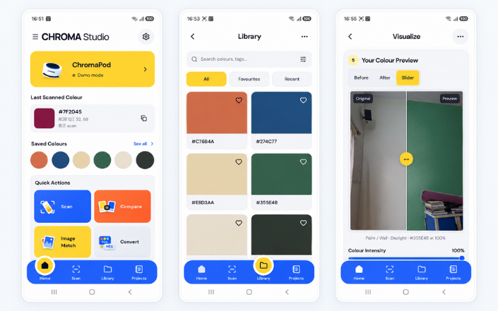
Figure 5.1 CHROMA Studio application home screen

5.4 SCAN and COMPARE

The SCAN feature enables users to acquire colour information from physical surfaces through CHROMAPOD. When a scan is initiated, the TCS34725 measures reflected light and generates raw RGBC values, which are processed by the ESP32 using the implemented calibration procedure. The resulting digital colour information is displayed on the TFT screen and can be transmitted to CHROMA Studio when a BLE connection is established. The acquired colour can subsequently be used in conversion, comparison, visualization and reference-management operations within the application.

The COMPARE feature evaluates the similarity between two colour references using numerical colour-difference calculations. On CHROMAPOD, the user scans a reference colour followed by a sample colour, after which the firmware converts both into CIELAB coordinates and calculates their CIE76 difference (ΔE76). CHROMA Studio also supports colour comparison through its digital interface. These operations provide a systematic method of examining colour differences, although the interpretation of the results depends on the input measurements and the limitations of the chosen comparison method.

5.5 CONVERT

The CONVERT feature allows users to represent a selected colour in different digital formats, including RGB, HEX, HSL, CMYK and CIELAB. RGB expresses colour through red, green and blue channel values, while HEX provides hexadecimal notation commonly used in web development. HSL represents hue, saturation and lightness, offering an intuitive format for colour adjustment. CMYK is associated with subtractive colour representation in printing, while CIELAB describes colours through lightness and chromatic coordinates. These representations are useful across graphic design, interface development, printing and colour-analysis workflows.

Within CHROMA Studio, users can convert scanned, selected or saved colours without manually performing mathematical calculations or switching between separate conversion tools. The application displays the corresponding numerical values and supports their reuse in other features. However, conversions between colour models depend on their mathematical assumptions and do not guarantee identical physical colour appearance across different displays, printers or materials.

5.6 IMAGE MATCH

IMAGE MATCH connects physical colour sensing with digital-image colour analysis. CHROMAPOD first captures a colour from a physical surface and transmits its processed RGB values to CHROMA Studio through BLE. The user then selects a reference colour from an uploaded image, and the application converts the relevant colour values into a suitable representation for calculating their difference using CIEDE2000 (ΔE00). This algorithm considers variations in perceived lightness, chroma and hue, providing a numerical indication of similarity between the physical and digital colour references.

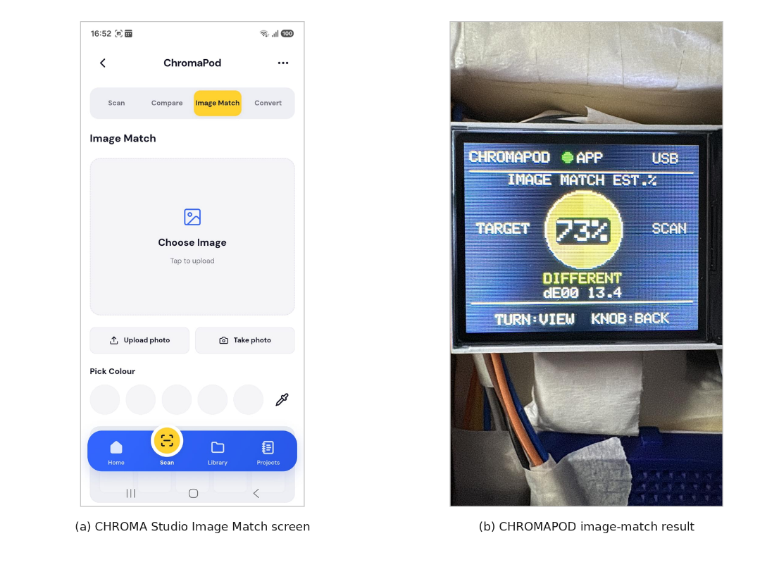
The application performs the image-based comparison and sends the result back to CHROMAPOD through BLE. The ESP32 receives the relevant colour information and calculated difference, validates the incoming message and updates the TFT display. This bidirectional workflow enables CHROMAPOD to participate in image matching without performing image processing directly on the microcontroller, demonstrating the integration of embedded colour acquisition and application-level analysis.
Figure 5.2 Image Match interface and result display
5.7 VISUALIZE COLOUR

Visualize Colour is one of the key features of CHROMA Studio, designed to help users preview colour changes on selected surfaces within photographs before making physical modifications. The user can upload an existing image or capture a new photograph and identify the region to be recoloured using automatic or manual selection tools. The Auto Select option simplifies surface identification, while Brush and Eraser controls allow users to refine the selected region for greater precision. The application also provides material categories such as wall or paint, fabric, wood, plastic, metal and ceramic, allowing users to explore colour changes across different types of surfaces. Once the required region is selected, a scanned, saved or custom colour can be applied to generate a modified preview. This workflow is particularly useful for interior design, fashion, product visualization and other creative applications where comparing colour alternatives is important.

The recolouring process modifies the selected region while attempting to preserve the original photograph's visible shading, brightness variations and surface texture. This helps maintain a more natural appearance instead of replacing the selected area with a uniform colour. The application provides Before, After and Slider viewing modes, enabling users to examine the original photograph, view the modified result and compare both appearances interactively. An intensity control allows the strength of the applied colour to be adjusted according to the user's preference, while the selected colour can be changed to explore multiple design combinations. The feature integrates with CHROMA Studio's colour library, allowing previously scanned or saved references to be reused during visualization. However, the generated preview remains an image-based approximation rather than an exact physical simulation, since the final appearance of a material depends on lighting conditions, camera characteristics, surface reflectivity and other environmental factors.
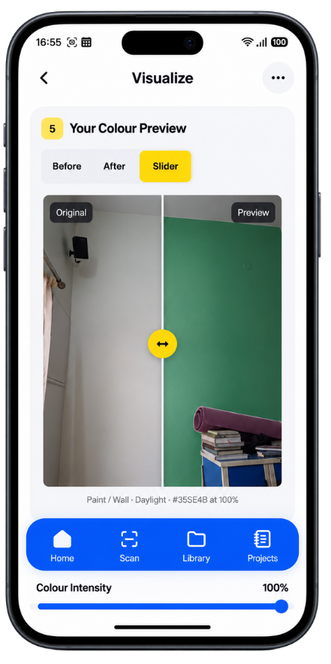
Figure 5.3 Visualize Colour original and recoloured preview

5.8 LIBRARY and PROJECTS

The LIBRARY feature provides a centralized location for storing and reusing colour references acquired through physical scanning, digital images or manual selection. Users can access saved colours for subsequent conversion, comparison, image matching or visualization without repeating the original acquisition process. This improves continuity between colour-related operations and reduces the need to maintain separate records outside the application.

The PROJECTS feature enables users to organize saved colours according to specific assignments, design activities or creative tasks. Multiple colour references can be grouped within individual projects, making them easier to retrieve and manage. Together, Library and Projects extend CHROMA Studio beyond immediate colour-processing operations by supporting organized reference storage and reuse across different design workflows.

5.9 BLE Integration and Android Application

Bluetooth Low Energy establishes wireless communication between the ESP32-based CHROMAPOD device and CHROMA Studio. The firmware provides BLE services and characteristics for exchanging colour information with the companion application. During scanning, the device can transmit processed RGB values and associated sensor information, including the clear-channel reading. Connected comparison operations exchange the required reference and result information according to the implemented message formats. The application receives these values and makes them available to the relevant features without requiring manual data entry.

In IMAGE MATCH, CHROMA Studio performs the digital-image comparison and returns the selected reference colour and calculated ΔE00 value through BLE. The ESP32 processes the received result and presents it on the TFT display. The system also distinguishes connected and disconnected states to manage operations requiring wireless communication. CHROMA Studio is packaged for Android using Capacitor, allowing its responsive web interface to operate as a mobile application while supporting integration with CHROMAPOD. The completed software demonstrates a connected workflow between embedded colour sensing, digital analysis, image visualization and reference management.
METHODOLOGY AND ALGORITHMS

6.1 Colour Acquisition Workflow

CHROMAPOD acquires physical colour information using the TCS34725 sensor interfaced with the ESP32 microcontroller. When the user initiates a scan, the sensor captures red, green, blue and clear (RGBC) channel readings from light reflected by the selected surface. Five consecutive sensor measurements are averaged to reduce short-term measurement noise before applying calibration and colour-conversion procedures. The processed result is displayed on the ST7735 TFT screen and can be transmitted to CHROMA Studio through Bluetooth Low Energy (BLE) when a connection is established. The same acquisition process supports SCAN, COMPARE and IMAGE MATCH operations, while consistent sensor placement and illumination help minimize variations between measurements.

Mean channel value:
x̄ = (x₁ + x₂ + x₃ + x₄ + x₅) / 5

6.2 Sensor Calibration Procedure

Sensor calibration converts raw RGBC measurements into normalized values suitable for digital colour estimation. Black and white references are recorded under the selected scanning conditions, and each channel is normalized using its corresponding reference levels. This process compensates for baseline readings and differences in channel response, allowing the black reference to approach zero and the white reference to approach one. The evaluated V13 calibration profile used black RGBC values of (71.10, 49.80, 28.70, 150.10) and white RGBC values of (715.067, 557.133, 328.600, 1617.867). Because these references depend on the sensor, printed material and illumination conditions, the resulting calibration profile is specific to the experimental setup. Profiles with nearly identical black and white levels must be rejected to prevent unstable calculations.

Channel normalization:
nₓ = max(0, min(1, (x − Bₓ) / (Wₓ − Bₓ)))

Where x represents the measured channel value, Bₓ is its black reference and Wₓ is its white reference.

6.3 Raw Sensor Data Processing

After normalization, the sensor readings are processed differently for approximately neutral and chromatic colours. A near-neutral colour is identified when the difference between the maximum and minimum normalized RGB channels is below 0.04. For these measurements, the normalized clear channel determines grey intensity using a calibrated tone exponent of 0.544, with additional handling near black to reduce unwanted colour casts. Chromatic colours are processed using a calibrated 3 × 3 correction matrix that adjusts the normalized RGB channels before the values are limited to the valid output range. The correction matrix is derived empirically for the selected reference conditions and does not represent an absolute spectral measurement.

Neutral colour condition:
max(nᵣ, nᵍ, nᵦ) − min(nᵣ, nᵍ, nᵦ) < 0.04

Neutral tone correction:
t = (n꜀)⁰·⁵⁴⁴
Chromatic colour correction:
[r′, g′, b′]ᵀ = M × [nᵣ, nᵍ, nᵦ]ᵀ
Where M represents the calibrated 3 × 3 correction matrix.

6.4 RGB and Colour Space Conversion

The corrected linear RGB values are converted into the standard sRGB representation using a piecewise transfer function. Each channel is limited to the range from zero to one, transformed and scaled to an 8-bit value between 0 and 255. The resulting RGB values can also be expressed as hexadecimal colour codes for use in digital design applications. For numerical colour comparison, sRGB values are linearized and converted into XYZ coordinates, followed by CIELAB coordinates consisting of L*, a* and b*. These conversions enable scanned colours to be represented digitally and compared using perceptual colour-difference methods.

sRGB transfer function:
sRGB(c) = 12.92c, for c ≤ 0.0031308
sRGB(c) = 1.055c^(1/2.4) − 0.055, for c > 0.0031308

Final 8-bit channel value:
RGB₈ = round(255 × sRGB(c))

6.5 CIE76 Colour Difference (ΔE76)

The CIE76 colour-difference algorithm is used for physical-to-physical colour comparison on CHROMAPOD. In COMPARE mode, the user scans a reference colour followed by a second sample colour. Both values are converted into CIELAB coordinates, and their Euclidean distance is calculated using the differences between their lightness and chromatic components. A smaller ΔE76 value indicates closer numerical similarity within the CIELAB colour space. The device also presents descriptive comparison information and an estimated match percentage, although this percentage is intended for user-interface interpretation rather than as a standardized measure of perceptual equality.

CIE76 colour difference:
ΔE76 = √[(L₁* − L₂*)² + (a₁* − a₂*)² + (b₁* − b₂*)²]

Displayed match estimate:
Match (%) = clamp(round(100 − 2 × ΔE76), 0, 100)

6.6 CIEDE2000 Image Matching (ΔE00)

CIEDE2000 is used within CHROMA Studio to compare a physically scanned colour with a reference selected from a digital image. Unlike CIE76, which calculates a direct Euclidean distance, CIEDE2000 incorporates corrections for differences in lightness, chroma and hue to provide improved correspondence with human colour perception. During IMAGE MATCH, CHROMAPOD transmits the scanned colour to the application through BLE. The application obtains the selected image colour, performs the CIEDE2000 calculation and returns the reference RGB values and calculated difference to the hardware for display. CIE76 and CIEDE2000 use different mathematical approaches, so their numerical results should not be interpreted as equivalent measurements.

CIEDE2000 colour difference:

ΔE00 = √[(ΔL′/(kL SL))² + (ΔC′/(kC SC))² + (ΔH′/(kH SH))² +
RT(ΔC′/(kC SC))(ΔH′/(kH SH))]

Where ΔL′, ΔC′ and ΔH′ represent adjusted lightness, chroma and hue differences; SL, SC and SH are weighting functions; kL, kC and kH are parametric factors; and RT is the rotation term.
6.7 Surface Selection and Colour Visualization

The Visualize Colour module allows users to apply scanned, saved or manually selected colours to specific regions of photographs. The user uploads or captures an image and identifies the desired surface using Auto Select, with Brush and Eraser tools available for refining the selected region. Material categories such as wall or paint, fabric, wood, plastic, metal and ceramic provide different visualization contexts. Once the target colour is selected, the application modifies the chosen region while preserving the unselected portions of the original image and attempting to retain visible shading, brightness variation and surface texture. Before, After and Slider views allow the original and recoloured appearances to be compared, while an intensity control adjusts the strength of the applied effect. The output serves as a design preview rather than a physically exact simulation of material appearance under real-world lighting conditions.

6.8 RGB Agreement Calculation

RGB agreement is used to evaluate the numerical similarity between the intended digital reference colours and the values reported by CHROMAPOD during testing. The absolute differences between the corresponding red, green and blue channels are summed and normalized by the maximum possible combined difference of 765. The result is expressed as a percentage, with 100% indicating identical eight-bit RGB values. The overall agreement is obtained by averaging the individual measurements across the experimental dataset. This metric supports comparison between firmware calibration versions but is distinct from CIE76 and CIEDE2000 perceptual colour-difference calculations. Since the reference colours were printed on ordinary paper rather than measured using certified instruments, the resulting agreement percentage does not represent laboratory-certified colour accuracy.

RGB agreement:
Agreement (%) = 100 × [1 − (|R₁ − R₂| + |G₁ − G₂| + |B₁ − B₂|) / 765]

Mean RGB agreement:
Mean agreement (%) = (Σ Agreementᵢ) / N

Where N represents the total number of recorded scans.

TESTING AND RESULTS

7.1 Testing Strategy

Testing and evaluation were conducted to assess the functionality, calibration performance and measurement consistency of the developed CHROMA system. The evaluation focused on physical colour acquisition through CHROMAPOD, numerical agreement between measured and intended RGB values, and integration with the CHROMA Studio application. The primary experiment involved 16 printed RGB reference colours tested using firmware Versions 13 and 14. Five complete scans were recorded for each colour under the respective test conditions, producing 80 measurements per version. The resulting RGB values were compared with the intended digital references using the agreement formula described in Chapter 6. Repeated measurements were also examined to observe short-term variation, while functional testing covered the hardware's SCAN, COMPARE and IMAGE MATCH modes and the major features of CHROMA Studio. This approach provided both numerical and functional evidence of system performance.

7.2 Experimental Setup

The experimental setup consisted of the CHROMAPOD hardware prototype, a printed CHROMA Colour Test Sheet and a computer used for firmware development and serial-data observation. CHROMAPOD incorporated the ESP32-WROOM-32 microcontroller, TCS34725 colour sensor, TFT display, rotary encoder, scan button and rechargeable LiPo battery. Colour measurements were obtained by positioning the sensor against each printed reference patch and initiating scans through the device interface. The illumination LED integrated into the sensor module and the surrounding shroud helped maintain consistent measurement conditions. Serial output was recorded to examine the acquired RGBC readings and the processed RGB values. The procedure was performed using the V13 calibration profile and repeated following the V14 refinement. Since ordinary printed references were used rather than certified colour standards, the experiment evaluated agreement with intended digital RGB codes rather than absolute colourimetric accuracy.

7.3 Sixteen-Colour Reference Sheet

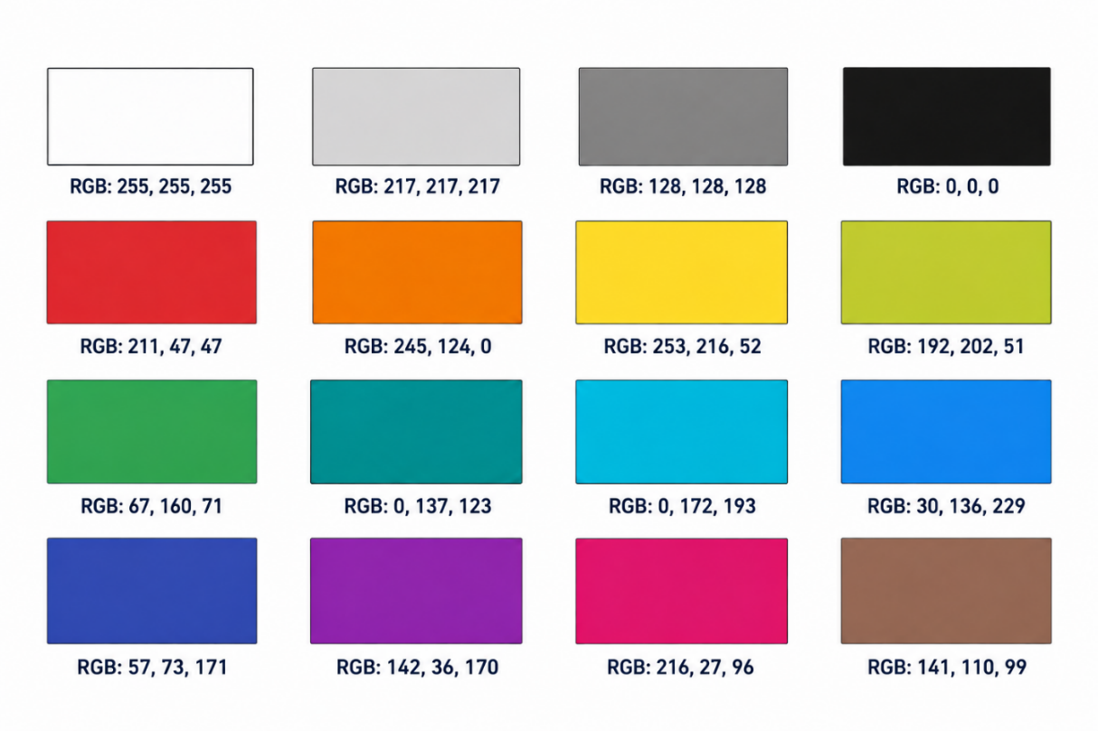
The CHROMA Colour Test Sheet consisted of 16 printed colour patches arranged in a four-by-four grid, with each patch labelled using its intended RGB value. The reference colours included four neutral shades—white, light grey, mid grey and black—and twelve chromatic shades: red, orange, yellow, lime, green, teal, cyan, blue, indigo, purple, pink and brown. This selection provided a range of brightness levels and colour characteristics for examining the scanner's response. Neutral patches were useful for evaluating black and white calibration and grey reproduction, while chromatic patches helped identify channel imbalances and colour-dependent variations. Although the printed sheet provided a practical reference for development and evaluation, the physical appearance of each patch depended on the printer, ink, paper and illumination conditions. Therefore, the intended RGB codes were treated as comparison references rather than certified physical colour measurements.
Figure 7.1 CHROMA Colour Test Sheet containing 16 RGB reference colours
7.4 Five-Scan Measurement Procedure

Each reference colour was evaluated through five complete scanning operations. For each scan, CHROMAPOD acquired multiple RGBC sensor samples and averaged them before applying the selected firmware calibration procedure to generate an RGB output. The five recorded results for each colour included the averaged sensor-channel measurements and the processed RGB values. The same procedure was used for V13 and V14, producing 80 scan records for each firmware version. The recorded RGB values were compared with the intended digital reference codes to calculate individual agreement percentages, which were then averaged for each colour and across the complete dataset. The measurements were also examined for minimum, maximum and range values to assess short-term variation. While this procedure provided an initial indication of consistency, more extensive repeatability evaluation would require independent physical references and repeated sessions under controlled conditions.

7.5 V13 Baseline Results

Following several earlier firmware development iterations, Version 13 (V13) was selected as the baseline for the documented experimental evaluation. Based on the colour deviations observed during V13 testing, targeted calibration refinements were introduced in Version 14 (V14). The V13 results demonstrated that CHROMAPOD could distinguish the printed reference colours, but noticeable differences remained between several measured RGB outputs and their intended values. For example, the five mid-grey measurements were (145,145,145), (144,144,144), (144,144,144), (143,143,143) and (143,143,143), compared with the intended value of (128,128,128). Black measurements ranged from (16,16,16) to (27,27,27), whereas white consistently produced (255,255,255). Several chromatic colours, particularly red, blue, teal and indigo, also exhibited substantial channel differences. The overall average RGB agreement calculated from the V13 dataset was 85.02%, indicating that further calibration refinement was required to obtain closer agreement with the selected digital reference values. These results established the baseline for evaluating subsequent calibration improvements rather than providing evidence of certified colour-measurement accuracy.

7.6 V14 Calibration Results

Firmware Version 14 introduced calibration refinements involving updated black and white normalization, chromatic correction and separate processing of approximately neutral colours. The revised firmware was evaluated using the same 16-colour reference sheet, with five complete scans recorded for each colour. The results showed improved agreement across most of the evaluated references, particularly neutral shades and chromatic colours that had exhibited larger differences under V13. The five mid-grey measurements were (127,127,127), (125,125,125), (124,124,124), (124,124,124) and (122,122,122), compared with the intended value of (128,128,128). All five black measurements produced (0,0,0), while white consistently produced (255,255,255). Light grey measurements ranged from (208,208,208) to (213,213,213), compared with the intended value of (217,217,217). The overall average RGB agreement increased to 94.68%, demonstrating closer numerical agreement with the selected reference codes under the experimental conditions, without establishing laboratory-certified colour accuracy.

7.7 Comparative Performance Analysis

The performance of V13 and V14 was compared using the mean RGB agreement calculated across the five scans of each reference colour. The overall agreement increased from 85.02% in V13 to 94.68% in V14, representing an improvement of 9.66 percentage points. This indicates that the calibration refinements reduced average channel-wise differences between the processed scanner outputs and the intended RGB reference codes. For V14, colour-wise agreements were 94.14% for red, 91.58% for orange, 92.47% for yellow, 98.61% for lime, 92.73% for green, 92.86% for teal, 94.54% for cyan, 90.43% for blue, 87.56% for indigo, 95.35% for purple, 95.14% for pink and 93.52% for brown. The neutral references achieved 100% for white, 97.33% for light grey, 98.59% for mid grey and 100% for black. Indigo produced the lowest V14 agreement, showing that calibration performance varied across the evaluated colours.

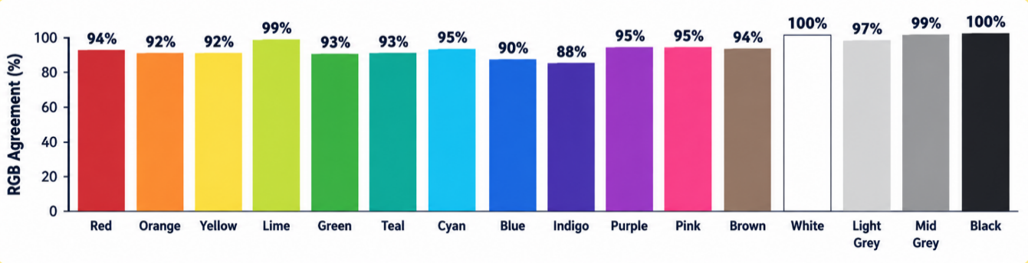
Figure 7.2 Colour-wise RGB agreement for 16 printed reference colours using V14

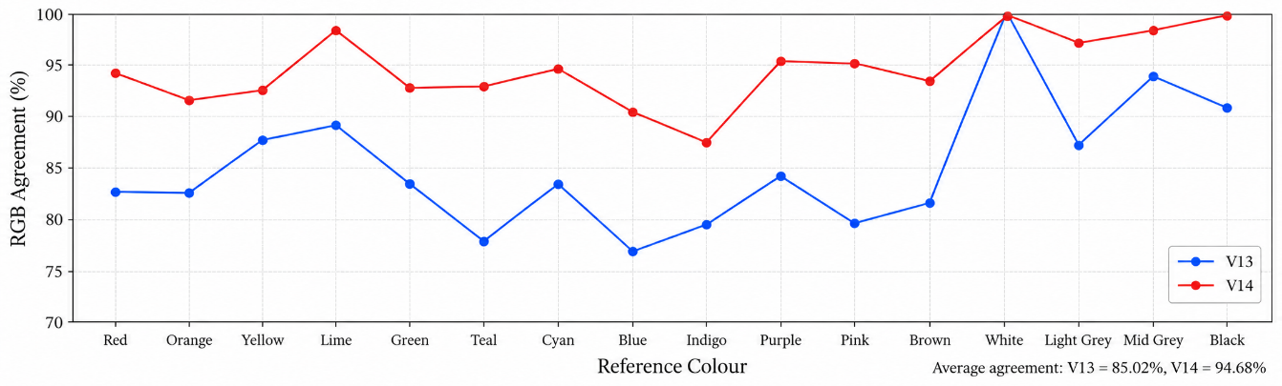
Figure 7.3 Comparison of overall RGB agreement between firmware V13 and V14

An important limitation of this comparison is that the printed reference sheet was also used during calibration development, with some colours contributing to the calibration-fitting process. Consequently, the V14 results do not represent fully independent validation. Nevertheless, the comparison provides evidence of improved agreement with the selected references and establishes a basis for further evaluation using independently measured colour samples.

7.8 Repeatability Observations

Repeatability was examined using five complete scans of each reference colour under similar measurement conditions. The V14 results showed relatively small variations for several colours. Mid-grey values ranged from 122 to 127 across the RGB channels, while light grey ranged from 208 to 213, giving a range of five digital levels in both cases. Lime produced red-channel values from 196 to 199, green-channel values from 196 to 200 and blue-channel values from 49 to 52. However, consistency varied between colours and channels, with pink showing green-channel values from 0 to 11 and indigo showing red-channel values from 8 to 16. White and black produced identical processed RGB values across their five scans, although output clipping and calibration behaviour may contribute to these results. Therefore, identical digital outputs do not necessarily indicate identical raw sensor readings. The observations support an initial assessment of short-term consistency, but broader testing across multiple sessions, surfaces and lighting conditions is required to evaluate long-term repeatability.

7.9 Functional and Integration Testing

Functional testing was performed to verify the major operations of CHROMAPOD and CHROMA Studio. Hardware testing included colour acquisition, TFT display updates, rotary encoder navigation, scan-button operation and CIE76-based colour comparison. BLE integration was examined through IMAGE MATCH, where a physically scanned colour was transmitted to CHROMA Studio, compared with a digital-image reference and returned to CHROMAPOD for display. The companion application's Scan, Compare, Convert, Image Match, Visualize Colour, Library and Projects functions were also examined through their respective user interfaces. The Visualize Colour feature was demonstrated by recolouring a selected wall region and comparing the original and modified appearances using the slider view. These observations confirm the operation of the major implemented modules and their integration, although they represent selected functional demonstrations rather than an exhaustive automated evaluation of every interface condition.

7.10 Limitations and Discussion

The experimental results demonstrate that CHROMA functions as an integrated physical and digital colour-analysis prototype, with calibration refinement improving average RGB agreement from 85.02% to 94.68%. Repeated measurements also provide useful observations about short-term output consistency. However, the experiment used ordinary printed A4 colour references, whose physical colours depend on printer characteristics, ink, paper and illumination rather than corresponding exactly to their intended digital RGB values. Because the printed samples were not independently measured with certified colour equipment, the reported agreement cannot be interpreted as absolute colourimetric accuracy. Furthermore, some reference colours contributed to calibration development, limiting the independence of the evaluation. Additional uncertainties arise from sensor positioning, ambient illumination, surface texture and reflectivity. Future testing should therefore include independently measured reference samples, additional materials, controlled lighting and repeated sessions to assess broader measurement performance and generalization.
CONCLUSION AND FUTURE SCOPE

8.1 Conclusion

CHROMA: Colour Intelligence – Bridging Physical Colours and Digital Design successfully demonstrates the development of an integrated physical and digital colour-analysis system consisting of CHROMAPOD and CHROMA Studio. CHROMAPOD combines an ESP32 microcontroller, TCS34725 colour sensor, TFT display, rotary encoder, scan button and rechargeable LiPo battery to support portable colour acquisition, numerical comparison and wireless communication. The companion application extends these capabilities through colour conversion, image matching, surface visualization, library management and project organization. Bluetooth Low Energy enables bidirectional communication between the device and application, establishing a connected workflow for transferring physical colour information into digital design operations. Experimental evaluation using 16 printed RGB reference colours, with five scans per colour, demonstrated an improvement in average RGB agreement from 85.02% in firmware V13 to 94.68% in V14, representing a gain of 9.66 percentage points. These findings demonstrate improved numerical agreement with the selected digital references, although the results do not represent certified colour accuracy.

8.2 Project Achievements

The major achievement of CHROMA is the successful integration of embedded colour sensing, calibrated processing and digital application functionality within a working prototype. CHROMAPOD supports SCAN, COMPARE and IMAGE MATCH modes, with CIE76 used for physical colour comparison and BLE communication enabling image-matching results to be returned from CHROMA Studio. The application provides seven functional areas: Scan, Compare, Convert, Image Match, Visualize Colour, Library and Projects. Its CIEDE2000-based image matching supports numerical comparison between physical and image-selected colours, while Visualize Colour enables users to recolour selected photographic surfaces while preserving visible shading and texture where possible. The completed system also supports storing and organizing colour references for future use. Calibration refinement and repeated scanning provided experimental evidence of improved output agreement, demonstrating the practical integration of hardware, firmware and software technologies.

8.3 Current Limitations

Although CHROMA operates as a functional prototype, its performance is influenced by sensor characteristics, illumination, measurement positioning and material properties. The TCS34725 measures broad colour-channel responses rather than complete spectral reflectance, limiting its suitability for laboratory-grade colour measurement. The experimental evaluation used ordinary printed colour references instead of certified physical standards, and some reference colours contributed to calibration development. Therefore, the reported RGB agreement values do not establish independent colourimetric accuracy. Similarly, the Visualize Colour feature produces an image-based approximation rather than an exact physical simulation, as real-world appearance depends on lighting, surface reflectivity and camera processing. The existing hardware is an assembled functional prototype, and further evaluation across different materials and operating conditions is necessary to establish broader measurement reliability.

8.4 Future Enhancements

Future development of CHROMA can focus on improving hardware compactness, portability and calibration procedures. A custom printed circuit board (PCB) could reduce wiring complexity and provide a more reliable arrangement of electronic components. A suitable 3D-printed enclosure could improve durability, ergonomics and sensor positioning during colour acquisition. Additionally, a guided calibration interface could allow users to recalibrate CHROMAPOD using reference colours without manually modifying firmware settings, improving convenience and measurement consistency.

CHROMA Studio could be enhanced through integration with professional design platforms such as Figma, Adobe Photoshop and Canva, enabling scanned colours and saved palettes to be transferred directly into digital design projects. Additional features such as colour harmony suggestions, automatic palette recommendations and improved project-sharing options could support creative workflows. Further refinements to surface-selection and recolouring methods could also improve the visual quality of colour previews across different materials.

Future experimental evaluation could incorporate independently measured colour standards, additional physical materials and controlled illumination conditions. Repeated scanning sessions under different operating conditions would help assess measurement accuracy, repeatability and calibration consistency more comprehensively. Alternative colour-correction techniques could also be investigated to improve performance across a wider range of colours and surfaces. These enhancements would build upon the existing functional prototype and support the development of CHROMA into a more reliable and versatile colour-analysis system.
REFERENCES

[1] Luo, M. R., Cui, G., and Rigg, B., “The Development of the CIE 2000 Colour-Difference Formula: CIEDE2000,” Color Research & Application, vol. 26, no. 5, pp. 340–350, 2001. DOI: 10.1002/col.1049.

[2] Sharma, G., Wu, W., and Dalal, E. N., “The CIEDE2000 Color-Difference Formula: Implementation Notes, Supplementary Test Data, and Mathematical Observations,” Color Research & Application, vol. 30, no. 1, pp. 21–30, 2005. DOI: 10.1002/col.20070.

[3] Reinhard, E., Ashikhmin, M., Gooch, B., and Shirley, P., “Color Transfer between Images,” IEEE Computer Graphics and Applications, vol. 21, no. 5, pp. 34–41, 2001. DOI: 10.1109/38.946629.

[4] Welsh, T., Ashikhmin, M., and Mueller, K., “Transferring Color to Greyscale Images,” ACM Transactions on Graphics, vol. 21, no. 3, pp. 277–280, 2002. DOI: 10.1145/566654.566576.

[5] ams AG, TCS3472 Color Light-to-Digital Converter with IR Filter, Technical Datasheet, 2012.

[6] International Organization for Standardization and International Commission on Illumination, ISO/CIE 11664-4:2019 — Colorimetry — Part 4: CIE 1976 L*a*b* colour space, 2019.

[7] Nix Sensor Ltd., “Nix Mini 3 Color Sensor and Nix Toolkit,” Official Product Documentation. Available: https://www.nixsensor.com/set-up-mini-3/

[8] Datacolor, “ColorReader Products and Features,” Official Product Documentation. Available: https://www.datacolor.com/colorreader/products/

[9] Pantone, “Pantone Connect Software Tier Comparison,” Official Product Documentation. Available: https://support.pantone.com/en/pantone-connect-software-tier-comparison

