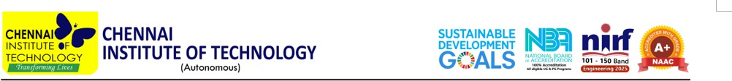

Department of Artificial Intelligence and Machine Learning &
Department of Computer Science and Business Systems

ISMLIA'26

INTERNATIONALSYMPOSIUMONMACHINELEARNINGANDITSINDUSTRIAL APPLICATIONS
25 September 2026, Friday| CIT Campus, Chennai,India

PROGRAMME

Time | Duration | Programme
08:30-09:30 | 60 min | Registration
INAUGURATION
09:30-09:33 | 3 min | Invocation (Prayer Song)
09:33-09:40 | 7 min | Lighting of Kuthuvilakku by Dignitaries
09:40-09:45 | 5 min | Welcome Address–Principal, CIT
09:45-09:50 | 5 min | Presidential Address-Chairman, CIT
09:50-09:55 | 3 min | Felicitation of Chief Guest and Speakers
09:55-10:05 | 10 min | Introduction of Guests - Prof. Sundramoorthy
10:05-10:15 | 10min | Inaugural Address - Dr. Kanchi Lakshmi Kiran
10:15-10:30 | 15 min | TeaBreak
TECHNICALSESSION-I
10:30-11:20 | 50 min | Lecture I - Dr.Raghuraj K Rao, MD & Head Technical Services, AKXA TECH Pvt. Ltd., Kolhapur
11:20-12:10 | 50 min | Lecture II - Dr. Kanchi Lakshmi Kiran, Senior VP, Regional Business Analytics, DBS, Singapore
POSTERSESSION
12:15-1:00 P.M | 45 min | Poster Presentation & Judging by Expert Panel
1:00-2:00 P.M | 60 min | Lunch
TECHNICALSESSION-II
2:00-2:50 P.M | 50 min | Lecture III - Prof. Ravindra Gudi, AI & ML Chair Professor & Deputy Director, IIT Bombay (Online Mode)
2:50-3:40 P.M | 50 min | Lecture IV -Dr. Vijaysai Prasad, JGM & Head, Water Technology Centre, L&T Constructions, Chennai
3:40-4:30 P.M | 50 min | Lecture V - Prof. Wu Zhe, Dept. of Chemical & Biomolecular Engineering, National University of Singapore
PANELDISCUSSION

Time | Duration | Programme
4:30-5:15 P.M | 45 min | Future of ML in Industry -Opportunities, Challenges & Roadmap
VALEDICTION & POSTER PRIZE DISTRIBUTION
5:15-5:20 P.M | 5 min | Valedictory Address and Concluding Remarks –HoD/AIML
5:20-5:25 P.M | 5 min | Poster Presentation Prize and Certificate Distribution
5:25-5:30 P.M | 5 min | Feedback
5:30-5:33 P.M | 3 min | Vote of Thanks – HoD/CSBS
5:33-5:35 P.M | 2 min | National Anthem

