AI-Assisted String Reversal Using GitHub Copilot
Name: N.Srishanth
Hall.No: 2303A51907
Batch : 12

Task 1: AI-Generated Logic Without Modularization
Scenario
A basic text-processing utility is developed for a messaging application.

Copilot Prompt Used
# write a code to reverse a string without using any functions
# accept user input for the string to be reversed
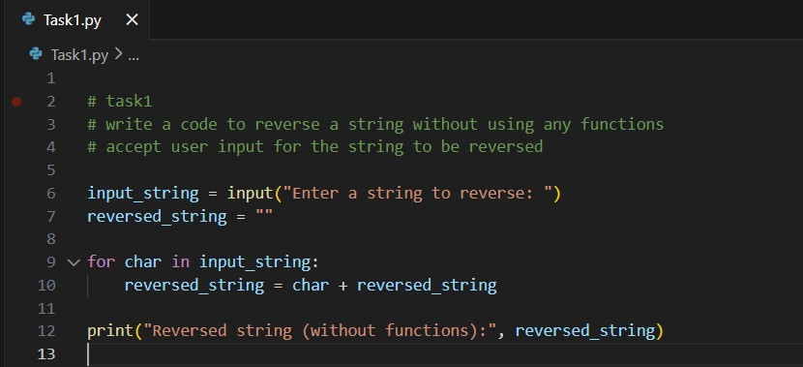

Sample Output
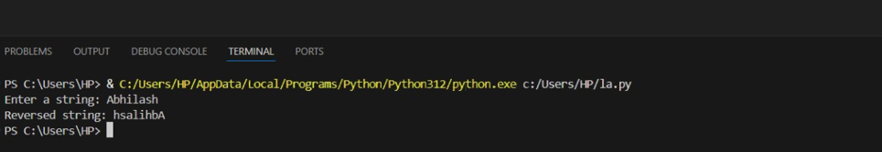

Explanation
The program reads user input and reverses the string using a loop without defining any functions. The logic is implemented directly in the main code.

Task 2: Efficiency & Logic Optimization
Scenario
The code is reviewed for readability and efficiency.

Copilot Prompt Used
#simplify this string reversal code and improve its performance
and readabilit y

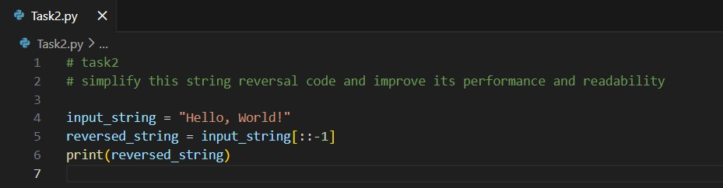

Sample Output

!dlrow ,olleH

Explanation
The slicing method simplifies the logic and removes unnecessary variables and loops.
The slicing method is faster in practice due to internal optimizations in Python.
Readability is significantly improved.

Task 3: Modular Design Using Functions
Scenario
The string reversal logic is reused in multiple parts of an application.

Copilot Prompt Used
# write code with function to reverse a string and comment each
line and function call and no sample input and output
Code
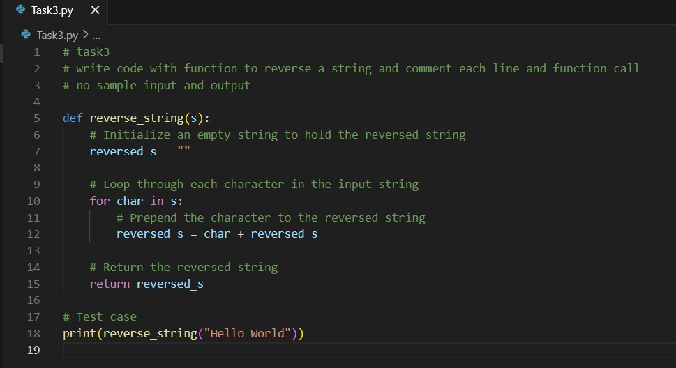
Sample Output
dlrow olleH

Explanation
Using a function improves reusability, readability, and maintainability. The logic can now be reused across different modules.

Task 4: Comparative Analysis – With vs Without Functions

Procedural vs Modular Approach With vs Without Functions

Copilot Prompt Used
#Create a Python program that prints a formatted comparison table showing the advantages of using functions over not using functions, and display a final recommendation.
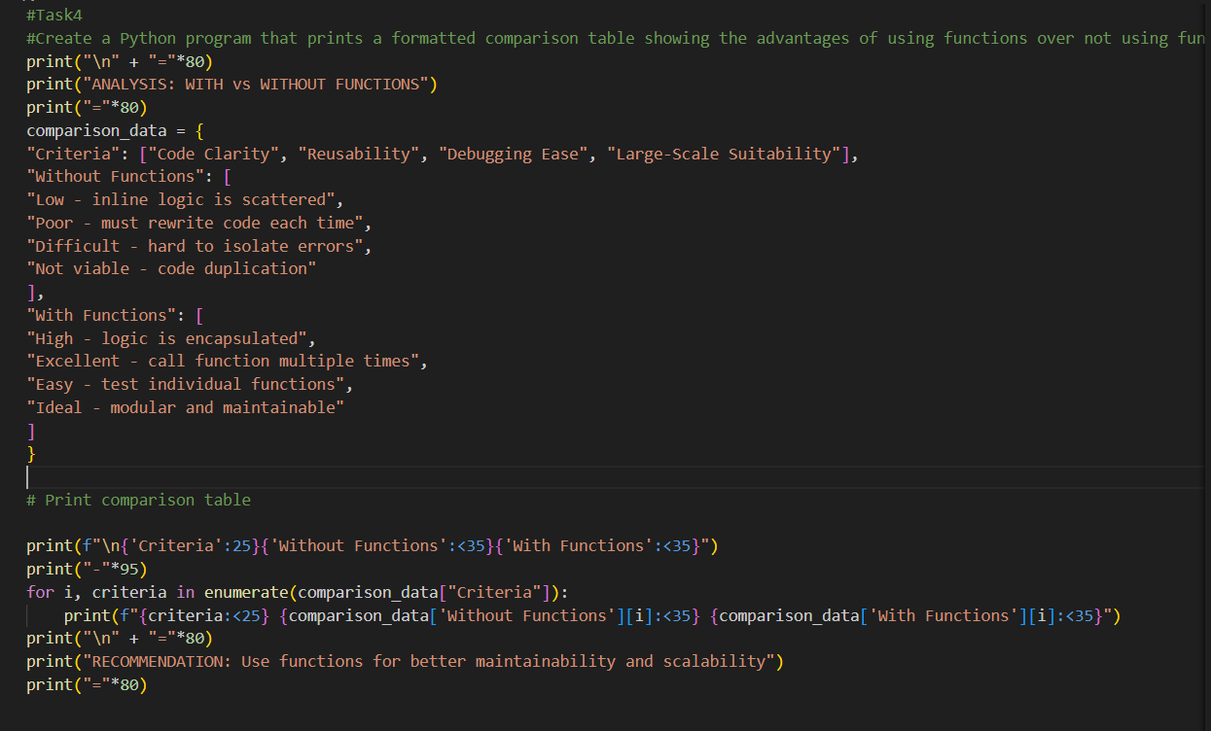

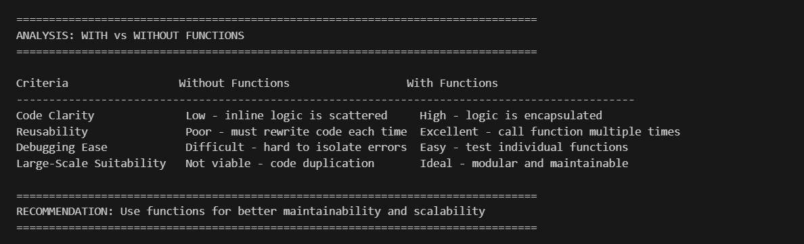Conclusion
Function-based design is preferred for large-scale applications due to better organization and reusability.

Task 5: Loop-Based vs Built-In String Reversal Copilot Prompt Use
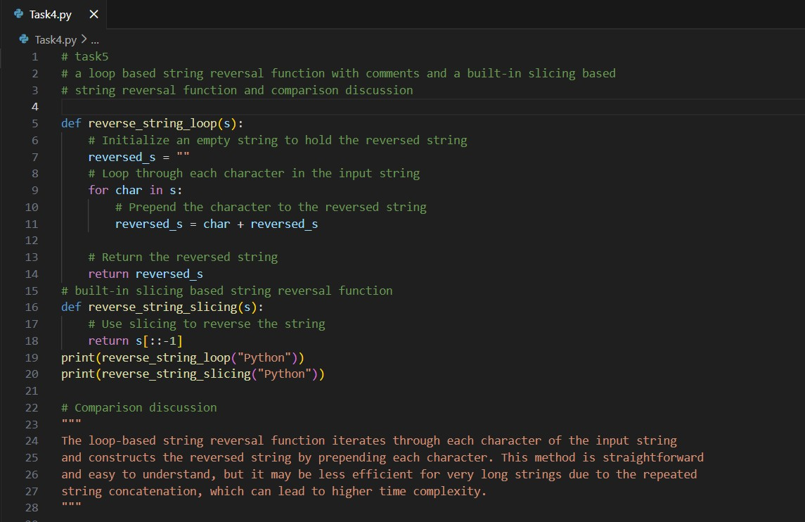
Output:
nohtyp
nohtyp

Comparison Discussion
The loop-based approach reverses the string by checking each character one by one. It helps beginners understand how string reversal works.
The slicing-based approach uses Python’s built-in feature to reverse the string. It is shorter and easier to read.
Both methods take the same amount of time, which is O(n), where n is the length of the string.
However, slicing works faster for large strings because it is optimized inside Python.
The loop-based method is good for learning, while the slicing method is better for real applications.

Conclusion
GitHub Copilot helped in writing, improving, and comparing different string reversal programs. Using functions and built-in features makes the code easier to read, faster, and better for large programs.

Declaration
All the code and explanations were created using GitHub Copilot and were checked manually to ensure correctness.

