AI ASSISTED CODING

LAB-4.1

Batch 12
N.Srishanth
2303A51907

Problem Statement 0:
A news aggregation platform wants to automatically categorize headlines into Politics, Sports, Technology, and Entertainment without training a machine learning model.
1. Prepare Sample Data
Collect 10 news headlines, each belonging to one of the four categories.
The 83rd Golden Globe Awards took place, with films like One Battle After Another, Hamnet, and Adolescence winning top honors.
Timothée Chalamet won his first Golden Globe for Best Actor in Marty Supreme and publicly thanked his partner, Kylie Jenner, who was present at the ceremony.
The song "Golden" from the animated film KPop Demon Hunters won Best Original Song, marking a first for a K-pop track at the Golden Globes.
Donald Trump has declared himself the "Acting President of Venezuela" following a U.S. military strike that captured Nicolas Maduro.
New U.S. Ambassador Sergio Gor has officially taken charge in New Delhi, inviting India to the "Pax Silica" initiative and signaling a potential visit from Trump in 2026 or 2027.
India Wins 1st ODI vs. NZ: India defeated New Zealand by 4 wickets in the series opener at Vadodara.
Virat Kohli Records: Kohli became the fastest player to reach 28,000 international runs, surpassing Sachin Tendulkar's record by 20 innings.
T20 World Cup Controversy: Tensions between the BCB and ICC continue; Pakistan has reportedly offered to host Bangladesh’s games for the upcoming tournament due to diplomatic friction with
India.
OpenAI and SoftBank are jointly investing $1 billion in SB Energy to expand data center and power infrastructure for their "Stargate" AI initiative.
Google is partnering with major retailers like Walmart and Shopify to integrate shopping features within its Gemini AI chatbot, aiming to transform the retail experience.
2. Zero-shot Prompting
Prompt:
"""Categorize these headlines
The 83rd Golden Globe Awards took place, with films like One Battle After Another, Hamnet, and Adolescence winning top honors.
Timothée Chalamet won his first Golden Globe for Best Actor in Marty Supreme and publicly thanked his partner, Kylie Jenner, who was present at the ceremony.
The song "Golden" from the animated film KPop Demon Hunters won Best Original Song, marking a first for a K-pop track at the Golden Globes.
Donald Trump has declared himself the "Acting President of Venezuela" following a U.S. military strike that captured Nicolas Maduro.
New U.S. Ambassador Sergio Gor has officially taken charge in New Delhi, inviting India to the "Pax Silica" initiative and signaling a potential visit from Trump in 2026 or 2027.
India Wins 1st ODI vs. NZ: India defeated New Zealand by 4 wickets in the series opener at Vadodara.
Virat Kohli Records: Kohli became the fastest player to reach 28,000 international runs, surpassing Sachin Tendulkar's record by 20 innings.
T20 World Cup Controversy: Tensions between the BCB and ICC continue; Pakistan has reportedly offered to host Bangladesh’s games for the upcoming tournament due to diplomatic friction with
India.
OpenAI and SoftBank are jointly investing $1 billion in SB Energy to expand data center and power infrastructure for their "Stargate" AI initiative.
Google is partnering with major retailers like Walmart and Shopify to integrate shopping features within its Gemini AI chatbot, aiming to transform the retail experience. into 'Entertainment', 'Politics', 'Sports', and 'Technology' categories."""
Given Code:
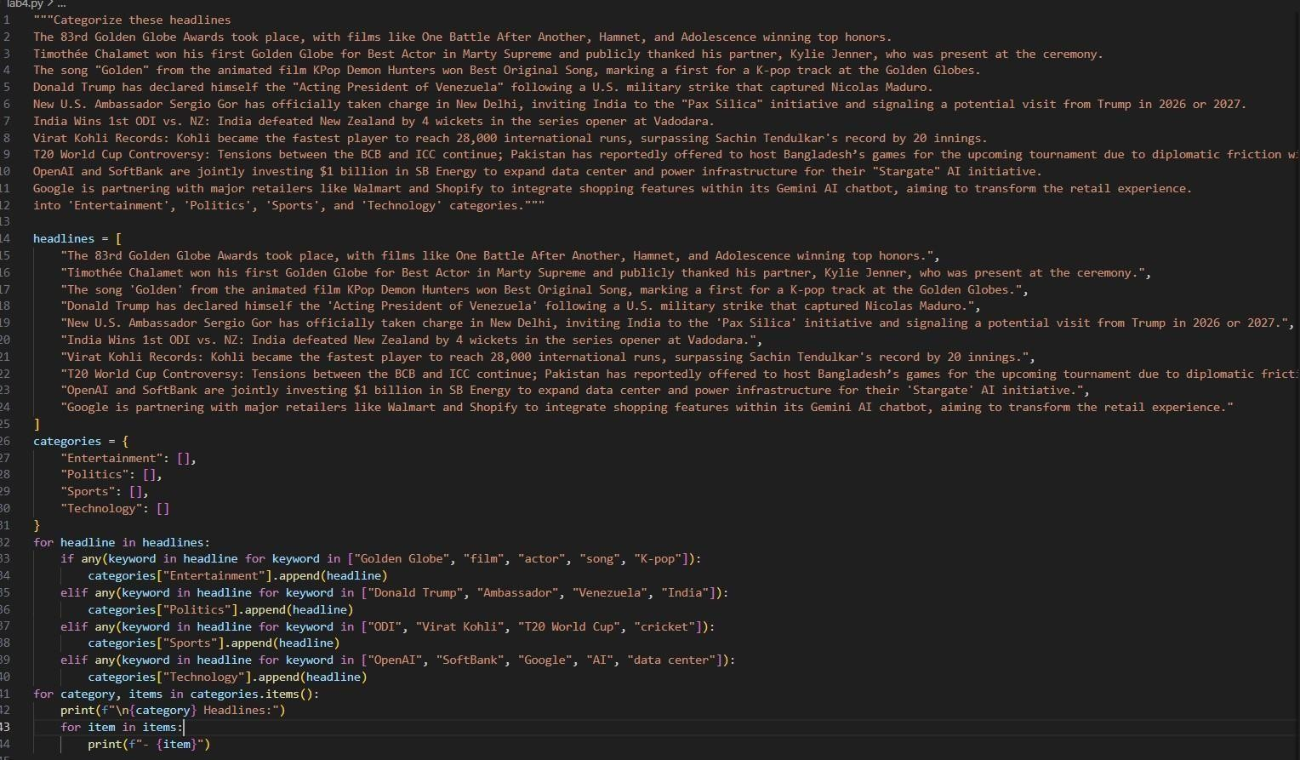
Output:
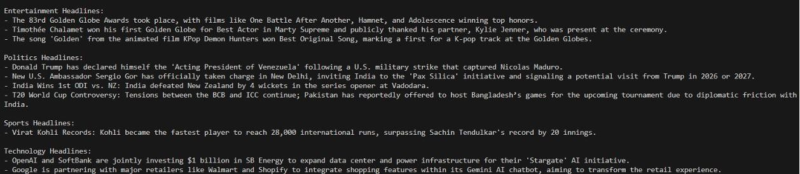

3. One-shot Prompting
Prompt:
"""Categorize these headlines
The 83rd Golden Globe Awards took place, with films like One Battle After Another, Hamnet, and Adolescence winning top honors.
Timothée Chalamet won his first Golden Globe for Best Actor in Marty Supreme and publicly thanked his partner, Kylie Jenner, who was present at the ceremony.
The song "Golden" from the animated film KPop Demon Hunters won Best Original Song, marking a first for a K-pop track at the Golden Globes.
Donald Trump has declared himself the "Acting President of Venezuela" following a U.S. military strike that captured Nicolas Maduro.
New U.S. Ambassador Sergio Gor has officially taken charge in New Delhi, inviting India to the "Pax Silica" initiative and signaling a potential visit from Trump in 2026 or 2027.
India Wins 1st ODI vs. NZ: India defeated New Zealand by 4 wickets in the series opener at Vadodara.
Virat Kohli Records: Kohli became the fastest player to reach 28,000 international runs, surpassing Sachin Tendulkar's record by 20 innings.
T20 World Cup Controversy: Tensions between the BCB and ICC continue; Pakistan has reportedly offered to host Bangladesh’s games for the upcoming tournament due to diplomatic friction with
India.
OpenAI and SoftBank are jointly investing $1 billion in SB Energy to expand data center and power infrastructure for their "Stargate" AI initiative.-Technology
Google is partnering with major retailers like Walmart and Shopify to integrate shopping features within its Gemini AI chatbot, aiming to transform the retail experience. into 'Entertainment', 'Politics', 'Sports', and 'Technology' categories."""
Given Code:

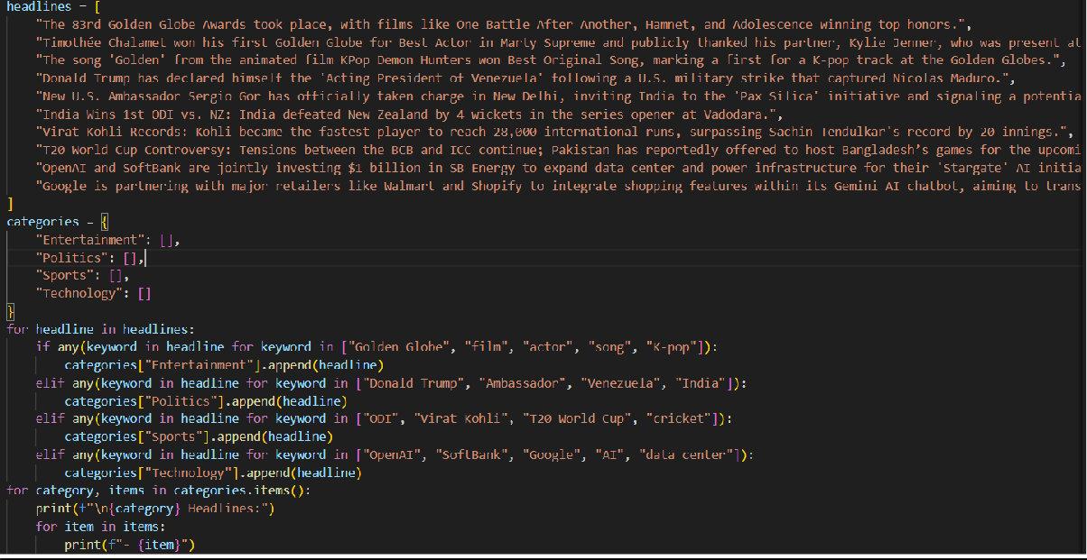
Output:
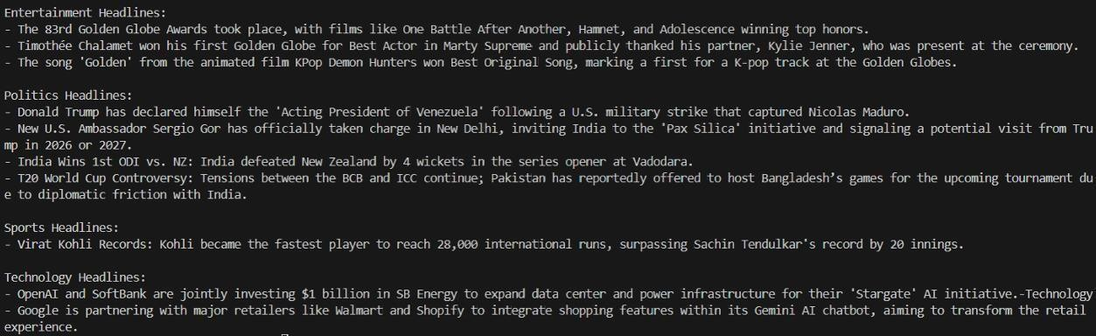

4. Few-shot Prompting
Prompt:
"""Categorize these headlines
The 83rd Golden Globe Awards took place, with films like One Battle After Another, Hamnet, and Adolescence winning top honors.-Entertainment
Timothée Chalamet won his first Golden Globe for Best Actor in Marty Supreme and publicly thanked his partner, Kylie Jenner, who was present at the ceremony.
The song "Golden" from the animated film KPop Demon Hunters won Best Original Song, marking a first for a K-pop track at the Golden Globes.
Donald Trump has declared himself the "Acting President of Venezuela" following a U.S. military strike that captured Nicolas Maduro.-Politics
New U.S. Ambassador Sergio Gor has officially taken charge in New Delhi, inviting India to the "Pax Silica" initiative and signaling a potential visit from Trump in 2026 or 2027.
India Wins 1st ODI vs. NZ: India defeated New Zealand by 4 wickets in the series opener at Vadodara.Sports
Virat Kohli Records: Kohli became the fastest player to reach 28,000 international runs, surpassing Sachin Tendulkar's record by 20 innings.
T20 World Cup Controversy: Tensions between the BCB and ICC continue; Pakistan has reportedly offered to host Bangladesh’s games for the upcoming tournament due to diplomatic friction with
India.
OpenAI and SoftBank are jointly investing $1 billion in SB Energy to expand data center and power infrastructure for their "Stargate" AI initiative.-Technology
Google is partnering with major retailers like Walmart and Shopify to integrate shopping features within its Gemini AI chatbot, aiming to transform the retail experience. into 'Entertainment', 'Politics', 'Sports', and 'Technology' categories."""
Given Code:

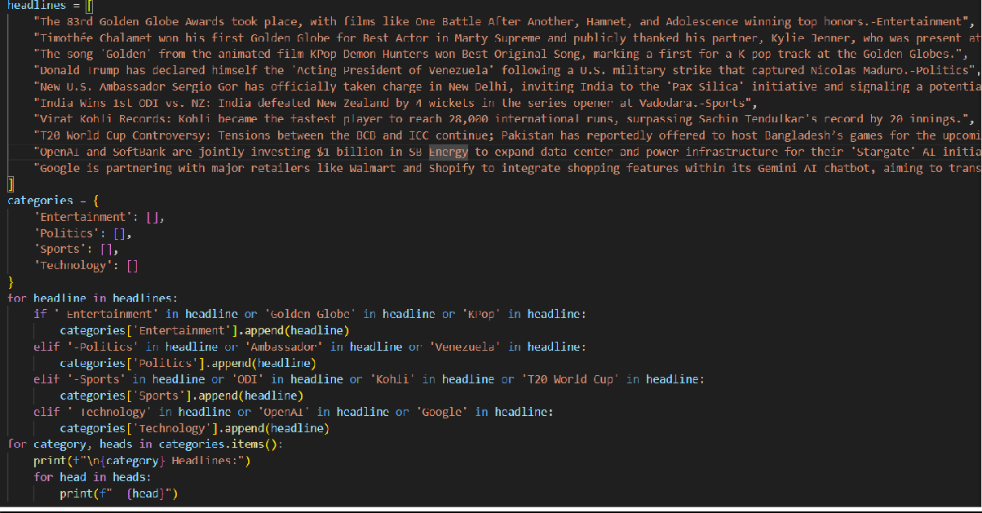
Output:
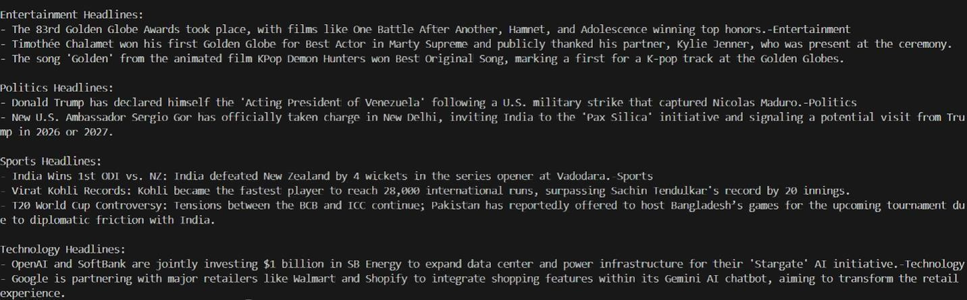

5. Evaluation
Zero-Shot: In zero shot the code classified using the keywords that are common in the headlines since there are no examples. So that’s why it confused 2 sports headline and classified it as politics.
One-Shot: In one shot also the ai got confused and did the same thing as above because I only gave one example
Few-Shot: In few shot I gave examples for 4 headlines and it understood the keywords and classified correctly.
Therefore, giving proper examples gives correct output. So, I think Few-shot is more efficient.
Customer Email Classification
A company receives a large number of customer emails every day and wants to automatically classify them into the following categories:
- Billing
- Technical Support
- Feedback
- Others
1. Zero-Shot Prompting:
Prompt:
"""Write code to categorize the following emails into Billing, Technical Support,Feedback, Others
Subject: Question Regarding Recent Invoice
Hello,
I hope you are doing well. I am writing to ask for clarification regarding my recent invoice. There are a few charges listed that I do not fully understand, and I would appreciate it if you could provide more details.
Please let me know if you need any additional information from my side. I look forward to your response.
Thank you for your assistance.
Best regards
Subject: Discrepancy Found on Billing Statement
Hello,
I am contacting you regarding a discrepancy I noticed on my latest billing statement. The amount charged does not seem to match my expected usage or plan.
Could you please review this and advise on how it can be corrected? I would appreciate your help in resolving this matter as soon as possible.
Thank you for your support.
Best regards
Subject: Request for Technical Assistance
Hello,
I am currently experiencing a technical issue with the service. The problem started recently and has been affecting my ability to use the platform as expected.
I would appreciate your guidance on how to resolve this issue or any troubleshooting steps I should follow. Please let me know if further details are required.
Thank you for your time and support.
Best regards
Subject: Feedback on Recent Experience Hello,
I wanted to take a moment to share my feedback regarding my recent experience with your service. Overall, I found it to be very helpful and easy to use.
I appreciate the effort your team puts into maintaining quality service, and I hope this feedback is useful for future improvements.
Thank you for your time.
Kind regards
Subject: General Inquiry
Hello,
I am writing to inquire about some general information related to your services. I was unable to find clear details on your website and would appreciate your guidance.
Please let me know the best way to proceed or if there is someone specific I should contact. Thank you in advance for your help.
Best regards """
Given Code:

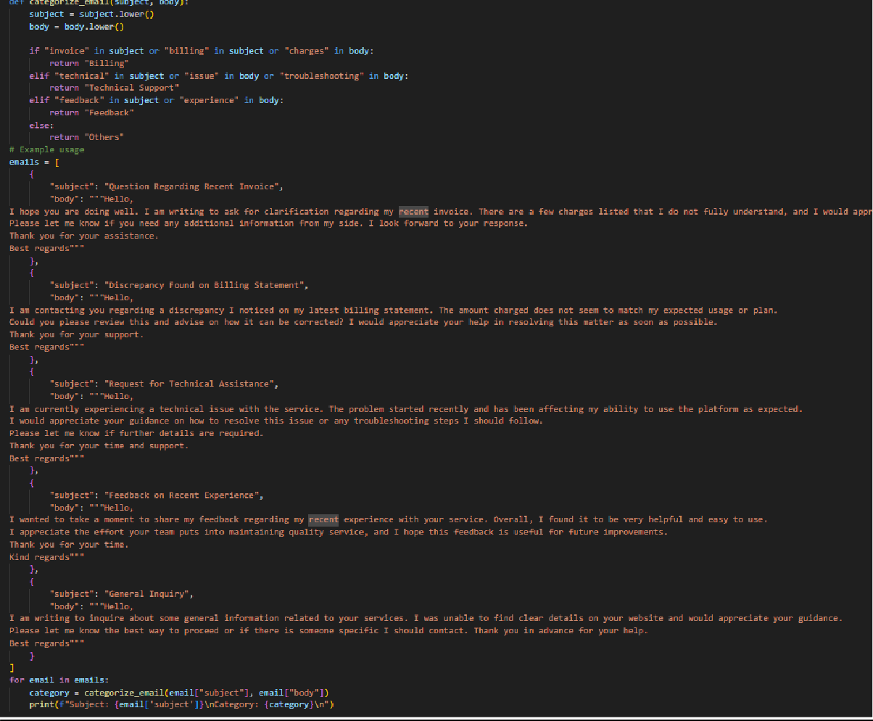
Output:
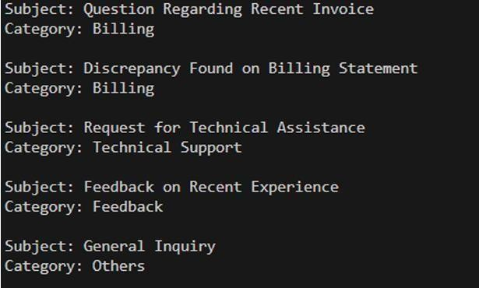

2. One-Shot Prompting:
Prompt:
"""Write code to categorize the following emails into Billing, Technical Support,Feedback, Others Subject: Question Regarding Recent Invoice
Hello,
I hope you are doing well. I am writing to ask for clarification regarding my recent invoice. There are a few charges listed that I do not fully understand, and I would appreciate it if you could provide more details.
Please let me know if you need any additional information from my side. I look forward to your response.
Thank you for your assistance.
Best regards-Billing
Subject: Discrepancy Found on Billing Statement
Hello,
I am contacting you regarding a discrepancy I noticed on my latest billing statement. The amount charged does not seem to match my expected usage or plan.
Could you please review this and advise on how it can be corrected? I would appreciate your help in resolving this matter as soon as possible.
Thank you for your support.
Best regards
Subject: Request for Technical Assistance
Hello,
I am currently experiencing a technical issue with the service. The problem started recently and has been affecting my ability to use the platform as expected.
I would appreciate your guidance on how to resolve this issue or any troubleshooting steps I should follow. Please let me know if further details are required.
Thank you for your time and support.
Best regards
Subject: Feedback on Recent Experience Hello,
I wanted to take a moment to share my feedback regarding my recent experience with your service. Overall, I found it to be very helpful and easy to use.
I appreciate the effort your team puts into maintaining quality service, and I hope this feedback is useful for future improvements.
Thank you for your time.
Kind regards
Subject: General Inquiry
Hello,
I am writing to inquire about some general information related to your services. I was unable to find clear details on your website and would appreciate your guidance.
Please let me know the best way to proceed or if there is someone specific I should contact. Thank you in advance for your help.
Best regards """
Given Code:

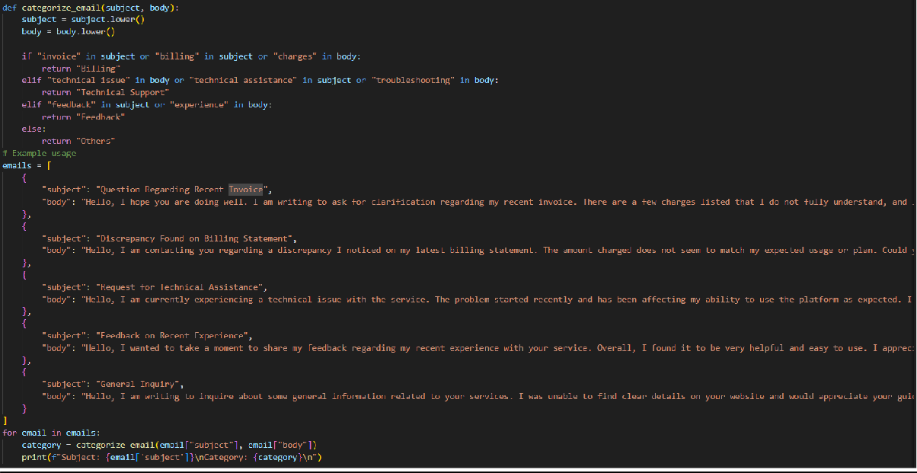
Output:
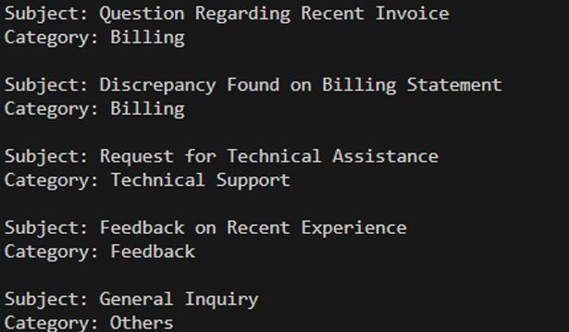

3. Few-Shot Prompting:
Prompt:
"""Write code to categorize the following emails into Billing, Technical Support,Feedback, Others
Subject: Question Regarding Recent Invoice
Hello,
I hope you are doing well. I am writing to ask for clarification regarding my recent invoice. There are a few charges listed that I do not fully understand, and I would appreciate it if you could provide more details.
Please let me know if you need any additional information from my side. I look forward to your response.
Thank you for your assistance.
Best regards-Billing
Subject: Discrepancy Found on Billing Statement
Hello,
I am contacting you regarding a discrepancy I noticed on my latest billing statement. The amount charged does not seem to match my expected usage or plan.
Could you please review this and advise on how it can be corrected? I would appreciate your help in resolving this matter as soon as possible.
Thank you for your support.
Best regards
Subject: Request for Technical Assistance
Hello,
I am currently experiencing a technical issue with the service. The problem started recently and has been affecting my ability to use the platform as expected.
I would appreciate your guidance on how to resolve this issue or any troubleshooting steps I should follow. Please let me know if further details are required.
Thank you for your time and support.
Best regards-Technical Support
Subject: Feedback on Recent Experience Hello,
I wanted to take a moment to share my feedback regarding my recent experience with your service. Overall, I found it to be very helpful and easy to use.
I appreciate the effort your team puts into maintaining quality service, and I hope this feedback is useful for future improvements.
Thank you for your time.
Kind regards-Feedback
Subject: General Inquiry
Hello,
I am writing to inquire about some general information related to your services. I was unable to find clear details on your website and would appreciate your guidance.
Please let me know the best way to proceed or if there is someone specific I should contact. Thank you in advance for your help.
Best regards """
Given Code:

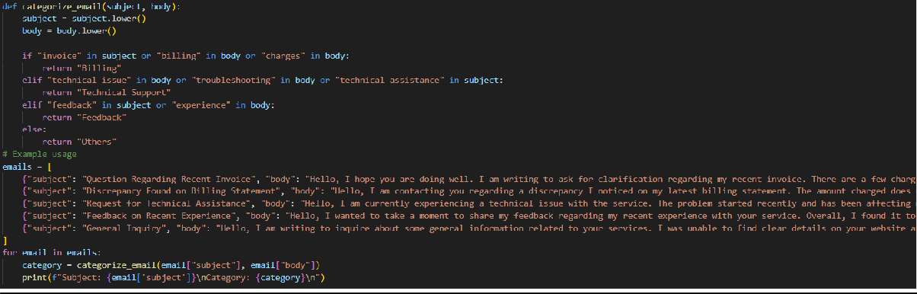
Output:
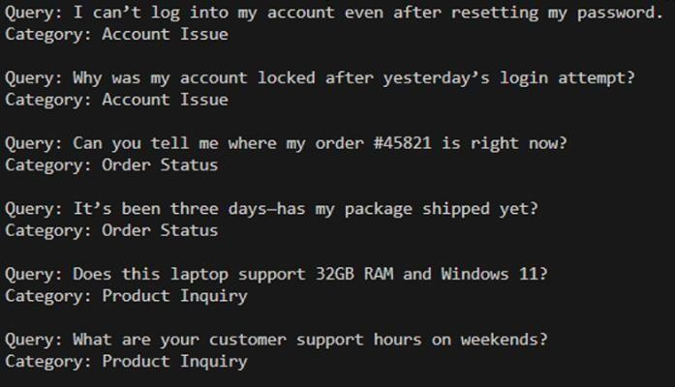

Intent Classification for Chatbot Queries
A company wants to deploy a chatbot to handle customer queries. Each query must be classified into one of the following intents: Account Issue, Order Status, Product Inquiry, or General Question using prompt engineering techniques.
1. Zero-Shot Prompting:
Prompt:
"""Write a code to classify a user query into categories-Account Issue, Order Status, Product Inquiry, or General Question using prompt engineering techniques.
I can’t log into my account even after resetting my password.
Why was my account locked after yesterday’s login attempt?
Can you tell me where my order #45821 is right now? It’s been three days—has my package shipped yet? Does this laptop support 32GB RAM and Windows 11? What are your customer support hours on weekends?
"""
Given Code:

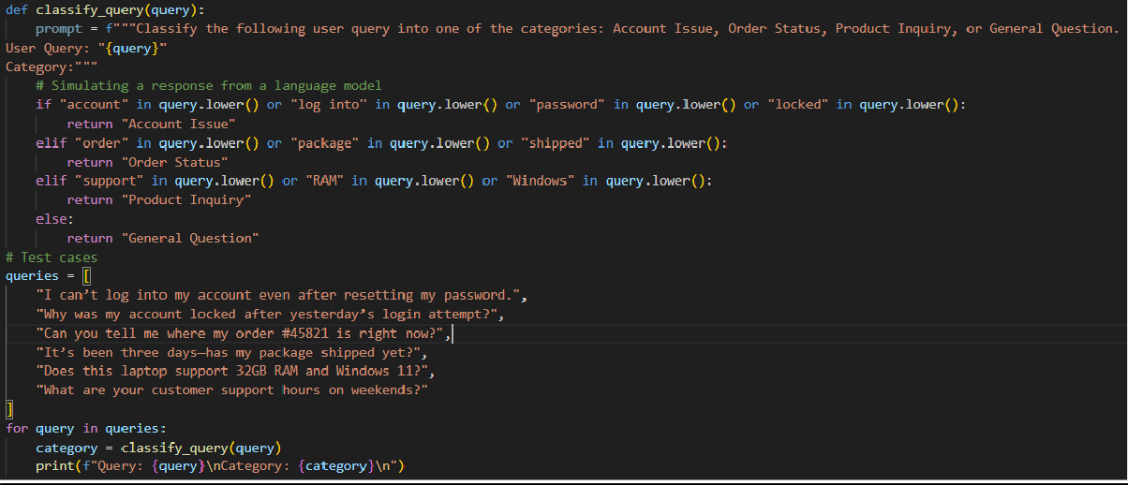
Output:
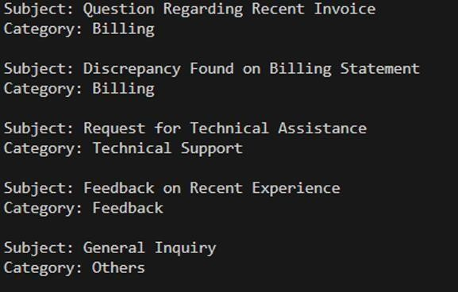

2. One-Shot Prompting:
Prompt:
"""Write a code to classify a user query into categories-Account Issue, Order Status, Product Inquiry, or General Question using prompt engineering techniques.
I can’t log into my account even after resetting my password.-Account Issue
Why was my account locked after yesterday’s login attempt?
Can you tell me where my order #45821 is right now? It’s been three days—has my package shipped yet? Does this laptop support 32GB RAM and Windows 11? What are your customer support hours on weekends?
"""
Given Code:

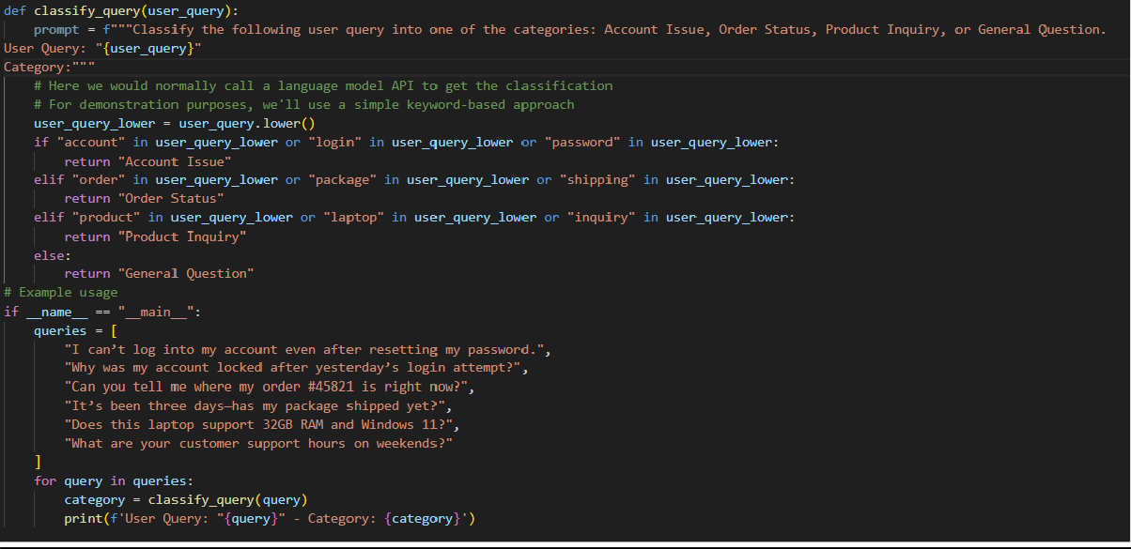
Output:
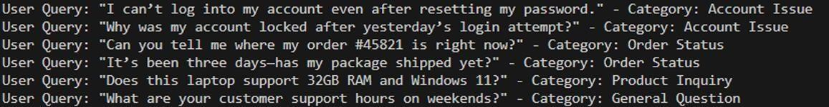

Student Feedback Analysis
A university collects student feedback and wants to categorize comments as Positive, Negative, or Neutral.
1. Zero-Shot Prompting:
Prompt:
"""Write a python code to categorize the feedback of university students into positive, negative, and neutral
The professor explained concepts clearly, and the course materials were very helpful.
I really enjoyed this class—assignments were engaging and relevant to real-world scenarios.
The teaching staff was supportive and always available to answer questions.
The lectures felt disorganized, and it was hard to understand what was expected.
Grading took too long, and feedback on assignments was minimal.
The course workload was overwhelming compared to the credit hours.
The course covered the topics listed in the syllabus.
Lectures were held twice a week, and attendance was mandatory.
The class used a mix of exams, quizzes, and assignments for evaluation. """
Given Code:

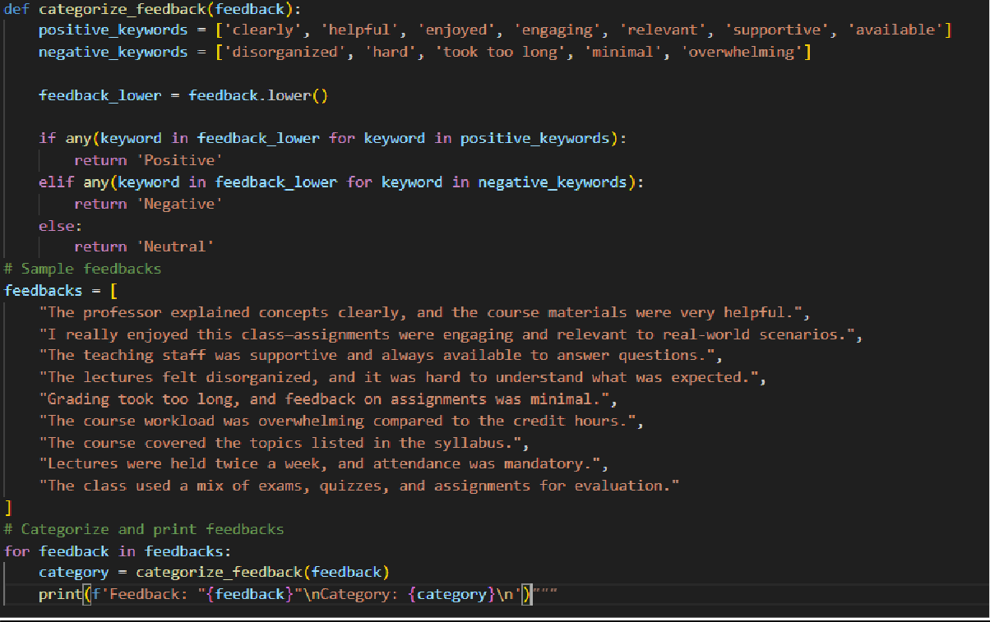
Output:
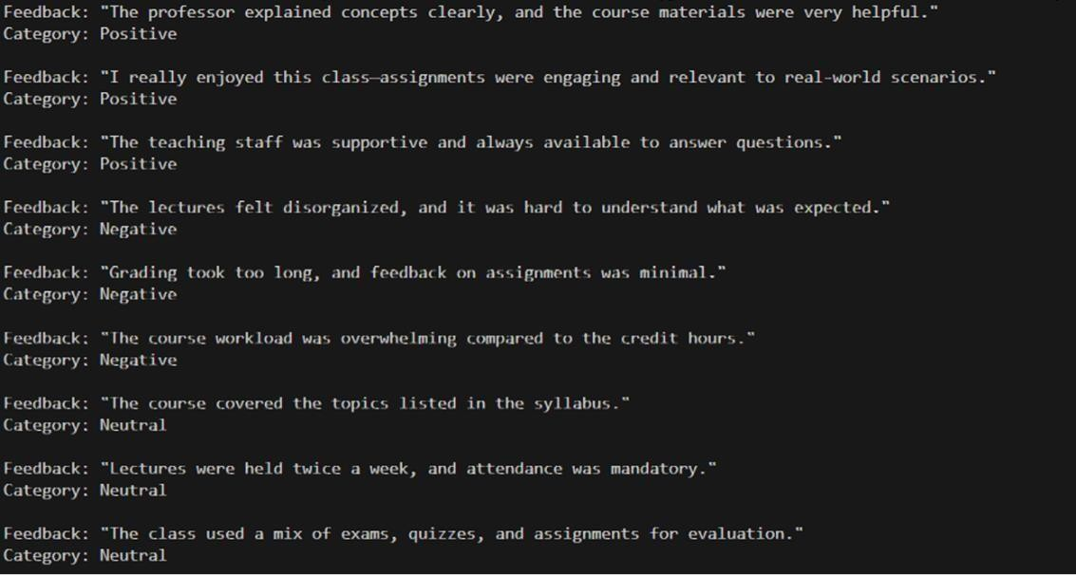

2. One-Shot Prompting:
Prompt:
"""Write a python code to categorize the feedback of university students into positive, negative, and neutral
The professor explained concepts clearly, and the course materials were very helpful.-Positive I really enjoyed this class—assignments were engaging and relevant to real-world scenarios.
The teaching staff was supportive and always available to answer questions.
The lectures felt disorganized, and it was hard to understand what was expected.
Grading took too long, and feedback on assignments was minimal.
The course workload was overwhelming compared to the credit hours.
The course covered the topics listed in the syllabus.
Lectures were held twice a week, and attendance was mandatory. The class used a mix of exams, quizzes, and assignments for evaluation. """
Given Code:

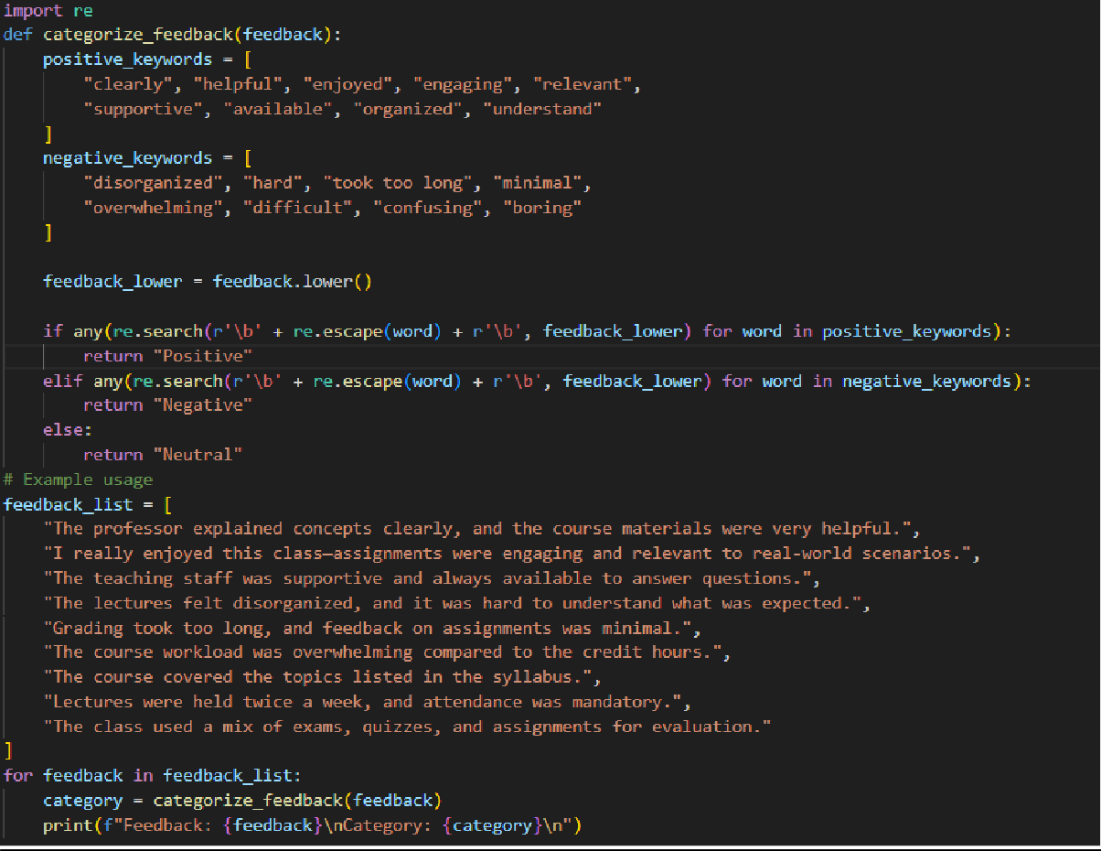
Output:
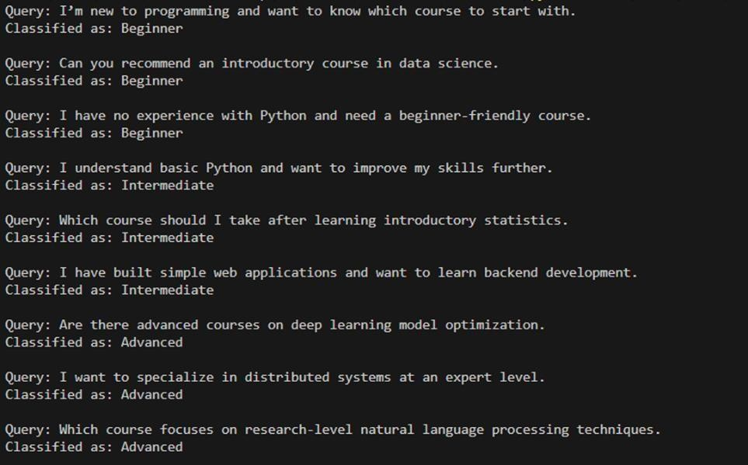

Course Recommendation System
An online learning platform wants to recommend courses by
classifying learner queries into Beginner, Intermediate, or Advanced
levels.
1. Zero-Shot Prompting:
Prompt:
"""Write a python code to classify the learner queries into beginner, intermediate, or advanced levels
I’m new to programming and want to know which course to start with.
Can you recommend an introductory course in data science.
I have no experience with Python and need a beginner-friendly course.
I understand basic Python and want to improve my skills further.
Which course should I take after learning introductory statistics.
I have built simple web applications and want to learn backend development.
Are there advanced courses on deep learning model optimization.
I want to specialize in distributed systems at an expert level.
Which course focuses on research-level natural language processing techniques. """
Given Code:
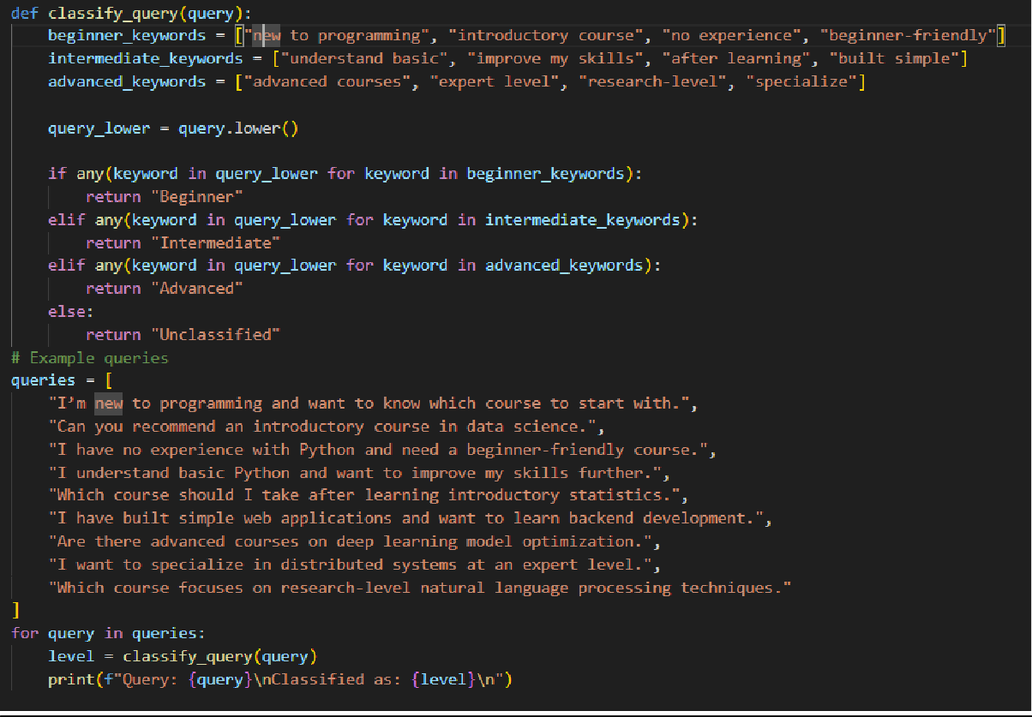
Output:
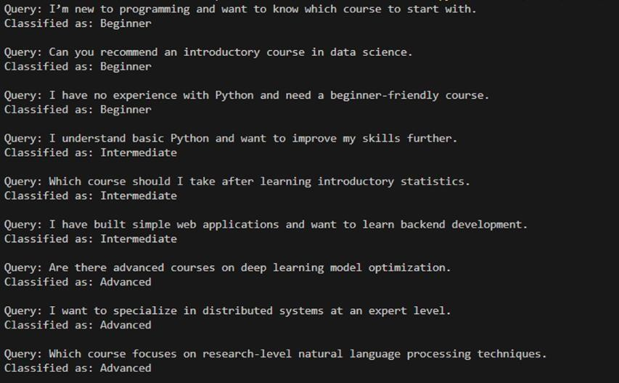

2. One-Shot Prompting:
Prompt:
"""Write a python code to classify the learner queries into beginner, intermediate, or advanced levels
I’m new to programming and want to know which course to start with.-> Beginner
Can you recommend an introductory course in data science.
I have no experience with Python and need a beginner-friendly course.
I understand basic Python and want to improve my skills further.
Which course should I take after learning introductory statistics.
I have built simple web applications and want to learn backend development.
Are there advanced courses on deep learning model optimization.
I want to specialize in distributed systems at an expert level.
Which course focuses on research-level natural language processing techniques.
"""
Given Code:

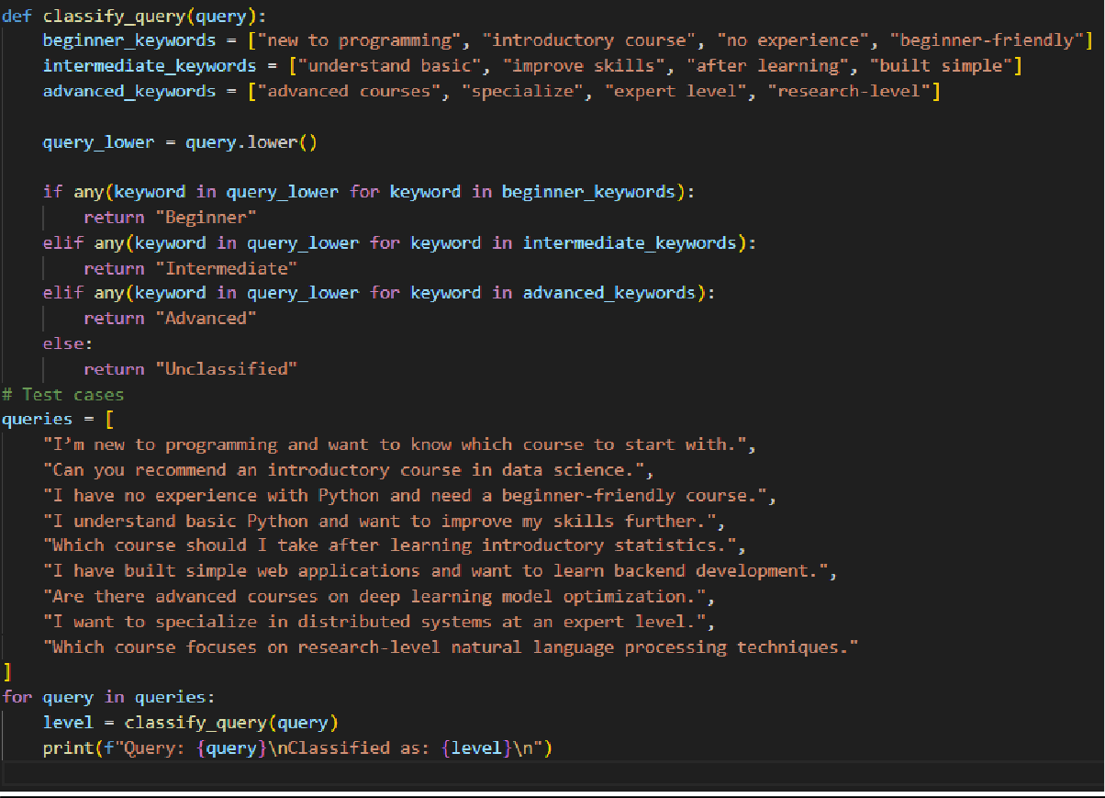
Output:
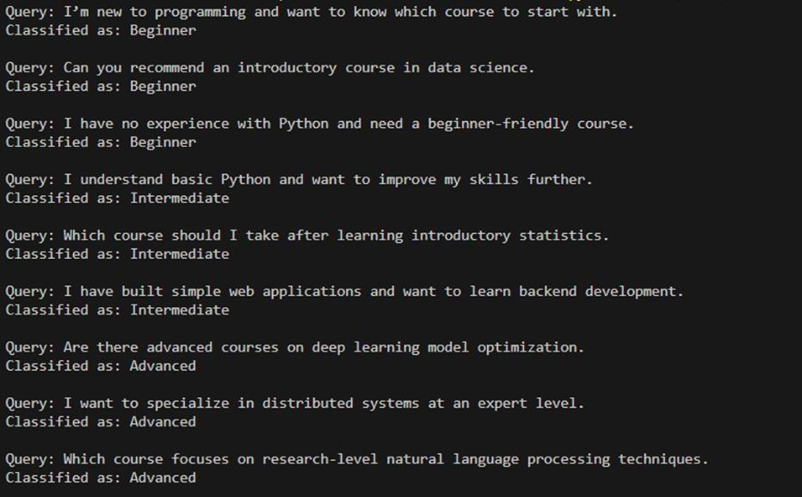

3. Few-Shot Prompting:
Prompt:
"""Write a python code to classify the learner queries into beginner, intermediate, or advanced levels
I’m new to programming and want to know which course to start with.-> Beginner
Can you recommend an introductory course in data science.
I have no experience with Python and need a beginner-friendly course.
I understand basic Python and want to improve my skills further.
Which course should I take after learning introductory statistics.-> Intermediate
I have built simple web applications and want to learn backend development.
Are there advanced courses on deep learning model optimization.
I want to specialize in distributed systems at an expert level.-> Advanced
Which course focuses on research-level natural language processing techniques. """ Given Code:
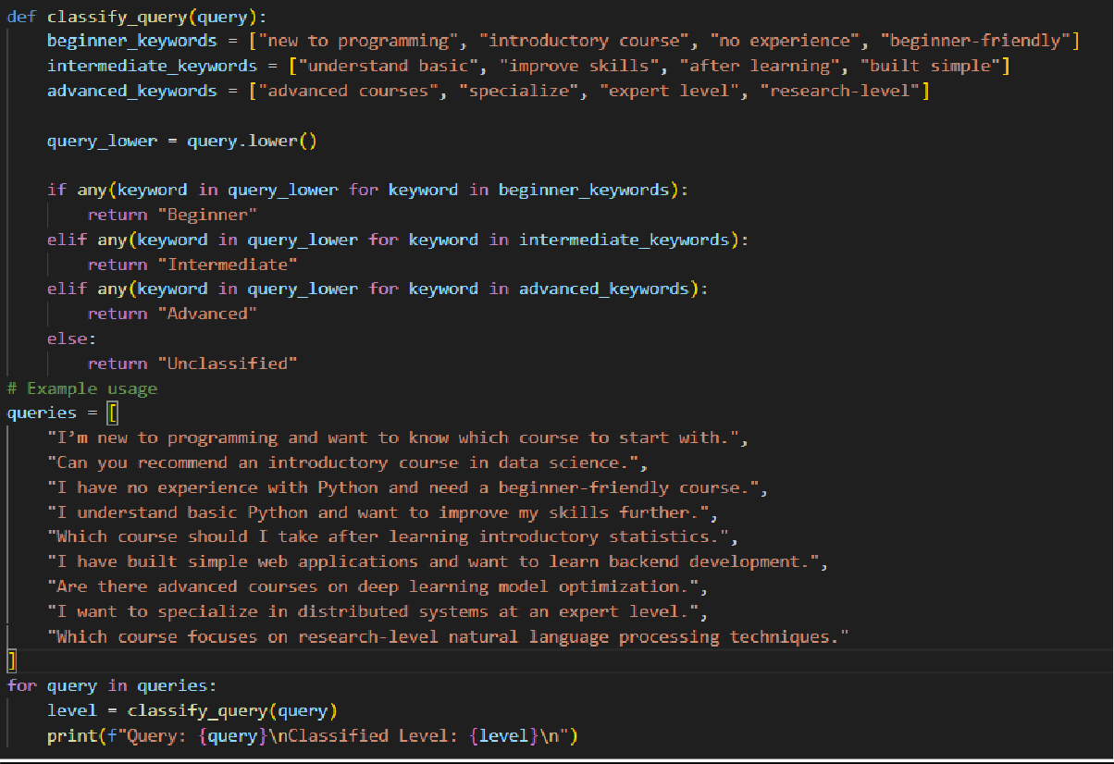
Output:
