AI ASSISTED CODING LAB - 7.5

N.Srishanth
2303A51907
BATCH-12

Task 1 (Mutable Default Argument – Function Bug)
Task: Analyze given code where a mutable default argument causes unexpected behavior. Use AI to fix it. # Bug: Mutable default argument def add_item(item, items=[]):
items.append(item) return
items print(add_item(1)) print(add_item(2))
Expected Output: Corrected function avoids shared list bug.

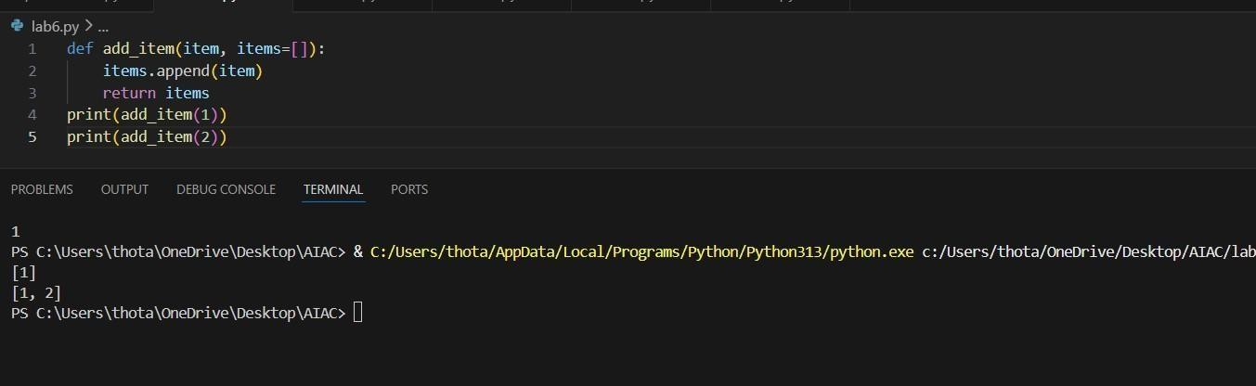

Task 2 (Floating-Point Precision Error)
Task: Analyze given code where floating-point comparison fails. Use AI to correct with tolerance. # Bug: Floating point precision issue
def check_sum(): return (0.1 + 0.2)
== 0.3 print(check_sum())
Expected Output: Corrected function
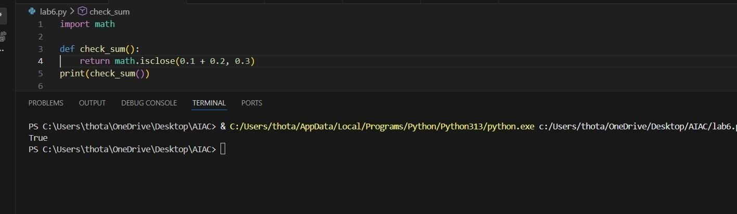

Task 3 (Recursion Error – Missing Base Case)
Task: Analyze given code where recursion runs infinitely due to missing base case. Use AI to fix. # Bug: No base case def countdown(n): print(n) return countdown(n-1) countdown(5)
Expected Output : Correct recursion with stopping condition
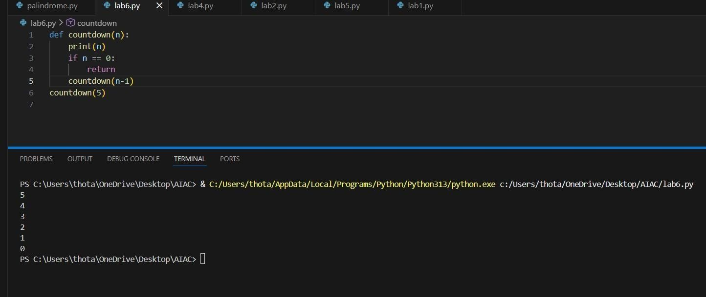

Task 4 (Dictionary Key Error)
Task: Analyze given code where a missing dictionary key causes error. Use AI to fix it.
# Bug: Accessing non-existing key def get_value(): data = {"a": 1, "b":
2} return data["c"] print(get_value())
Expected Output: Corrected with .get() or error handling.
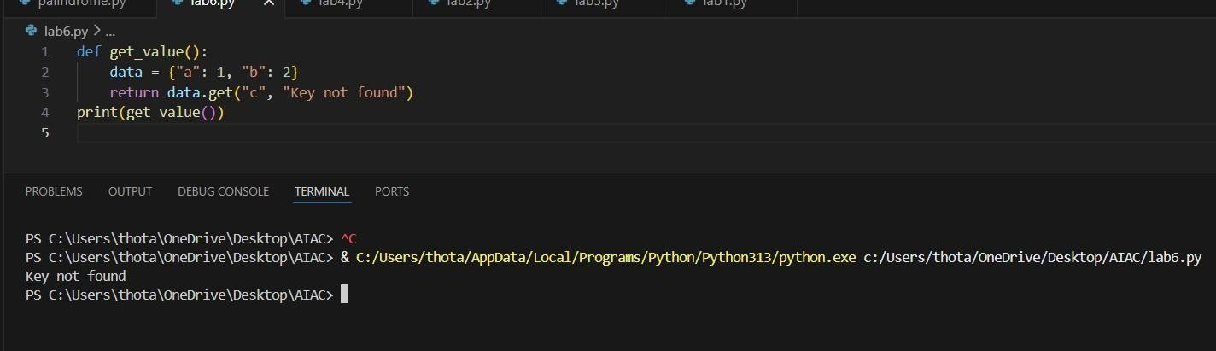

Task 5 (Infinite Loop – Wrong Condition)
Task: Analyze given code where loop never ends. Use AI to detect and fix it.
# Bug: Infinite loop def loop_example():
i = 0 while i < 5: print(i)
Expected Output: Corrected loop increments i.
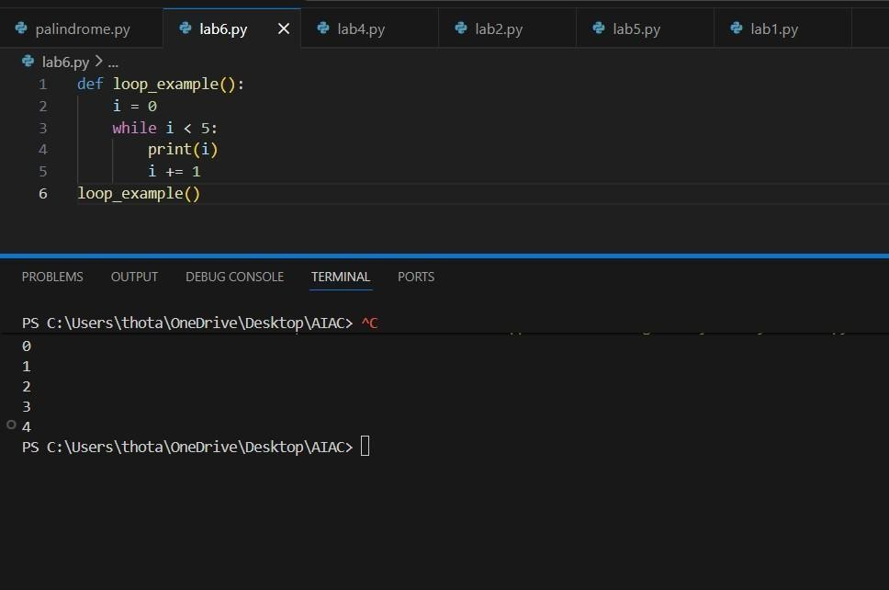

Task 6 (Unpacking Error – Wrong Variables)
Task: Analyze given code where tuple unpacking fails. Use AI to fix it.
# Bug: Wrong unpacking
a, b = (1, 2, 3)
Expected Output: Correct unpacking or using _ for extra values.
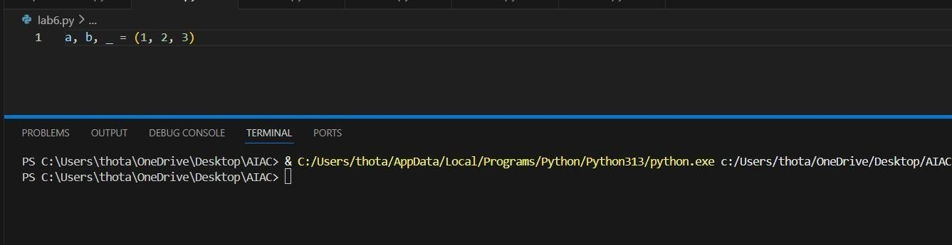

Task 7 (Mixed Indentation – Tabs vs Spaces)
Task: Analyze given code where mixed indentation breaks execution. Use AI to fix it. # Bug: Mixed indentation def func(): x = 5 y = 10 return x+y
Expected Output : Consistent indentation applied.
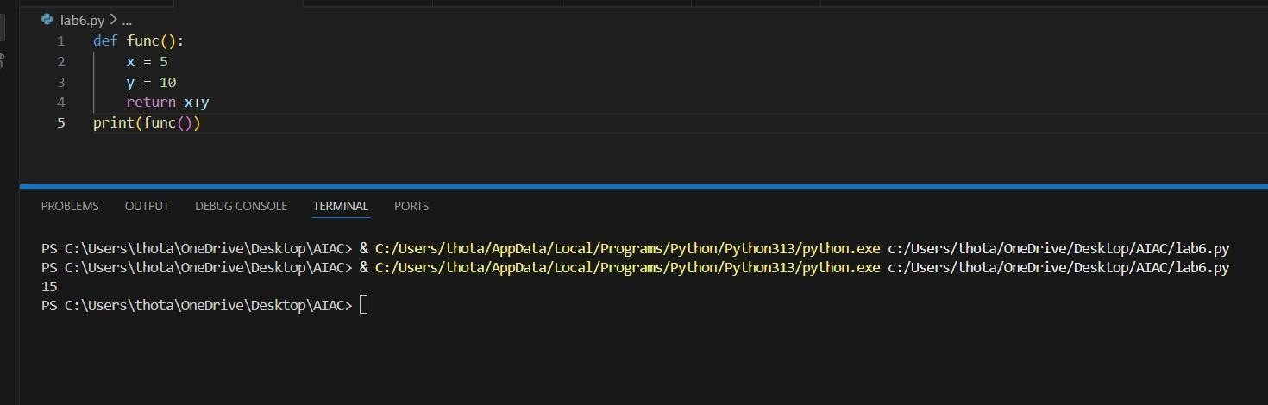

Task 8 (Import Error – Wrong Module Usage)
Task: Analyze given code with incorrect import. Use AI to fix.
# Bug: Wrong import import maths print(maths.sqrt(16)) Expected Output: Corrected to import math
