Lab Assignment-6.5
N.Srishanth
2303A51907
Batch-12

Task Description #1 (AI-Based Code Completion for Conditional Eligibility Check)
Task: Use an AI tool to generate eligibility logic.
Prompt: Generate Python code to check voting eligibility based on age and citizenship.
Code:
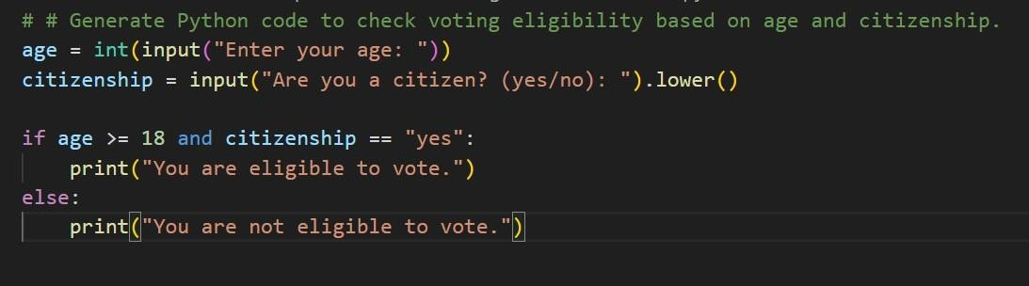
Output:
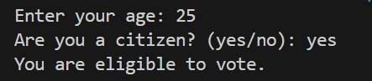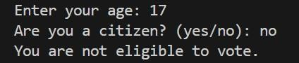

Explaination: This code checks if a person is eligible to vote. It first asks the user to enter their age and whether they are a citizen. If the user is 18 or older and answers "yes" to being a citizen, the program prints that they are eligible to vote. Otherwise, it tells them they are not eligible. The code uses simple input prompts and a conditional statement to make the decision.

Task Description #2(AI-Based Code Completion for Loop-Based String Processing)
Task: Use an AI tool to process strings using loops.
Prompt: Generate Python code to count vowels and consonants in a string using a loop.
Code:
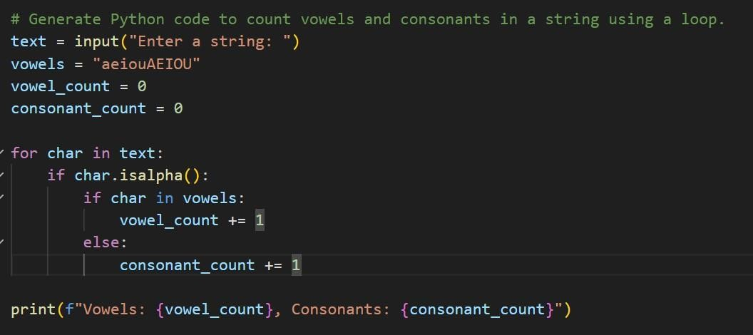
Output:
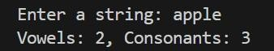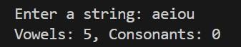
Explaination:This code counts the number of vowels and consonants in a userprovided string. It first asks the user to enter any text. Then, for each character in the string, it checks if the character is a letter. If it is, the code determines whether it is a vowel or a consonant and updates the respective count. Finally, it prints out the total number of vowels and consonants found in the input.

Task Description #3 (AI-Assisted Code Completion Reflection Task) Task: Use an AI tool to generate a complete program using classes, loops, and conditionals.
Prompt: Generate a Python program for a library management system using classes, loops, and conditional statements.
Code:
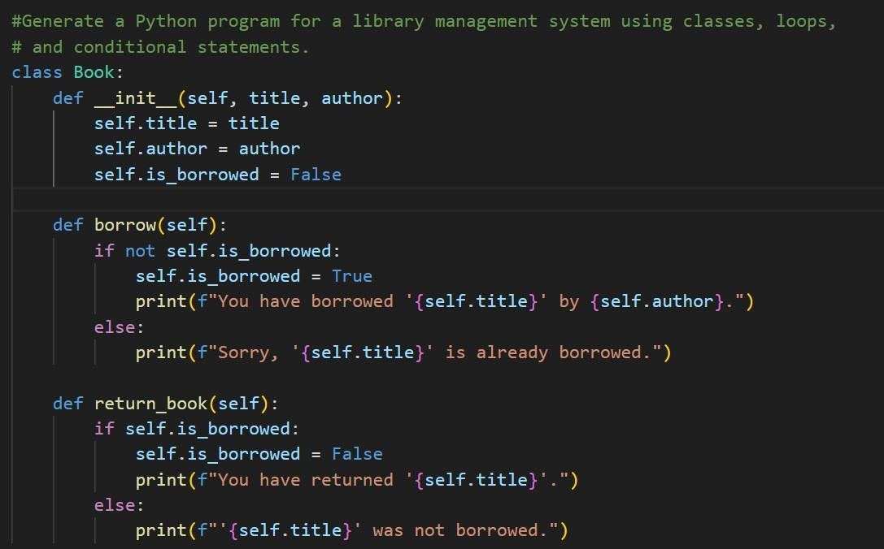
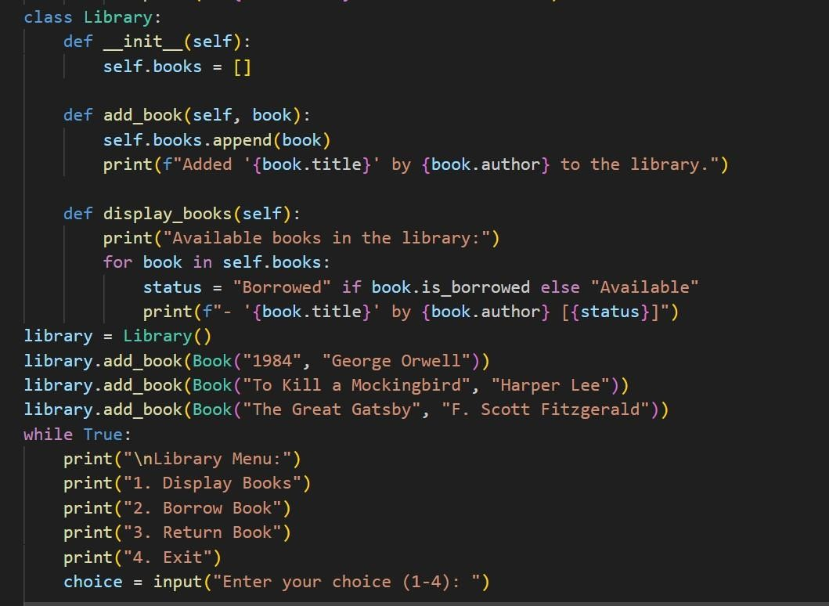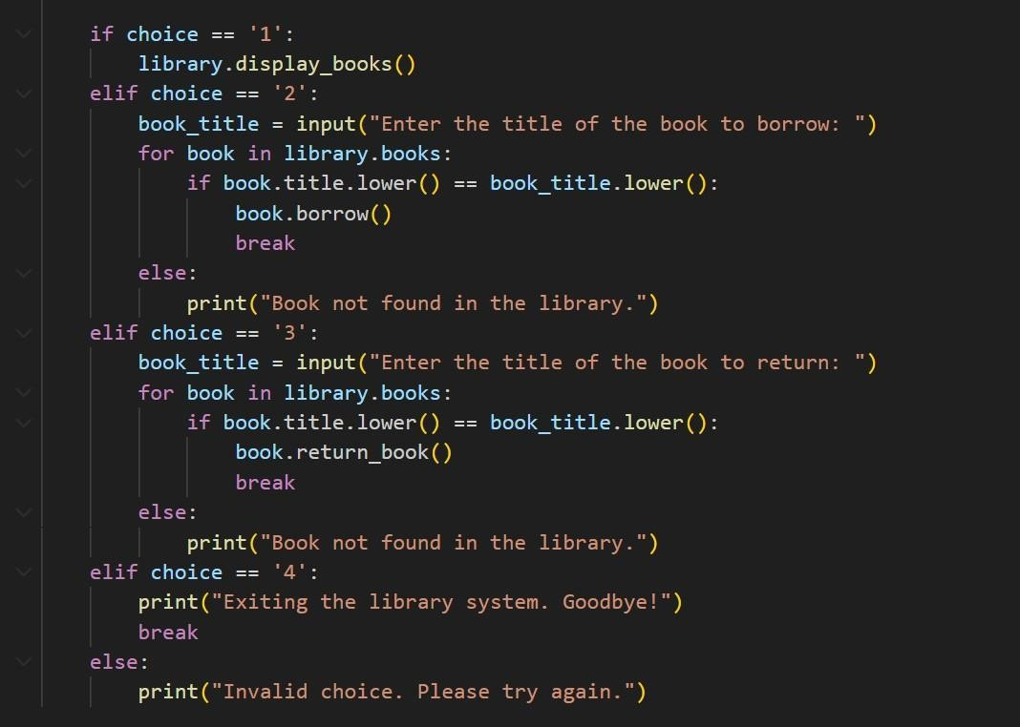

Output:
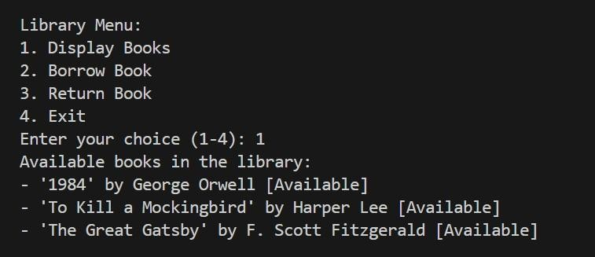
Explaination: This section uses classes to represent books and a library. Users can add books, display available books, borrow, and return books through a menu-driven loop.
Each part uses input prompts, conditionals, and loops to interact with the user and process their responses. The code demonstrates basic Python programming concepts in practical scenarios.

Task Description #4 (AI-Assisted Code Completion for Class- Based Attendance System)
Task: Use an AI tool to generate an attendance management class.
Prompt: Generate a Python class to mark and display student attendance using loops.
Code:
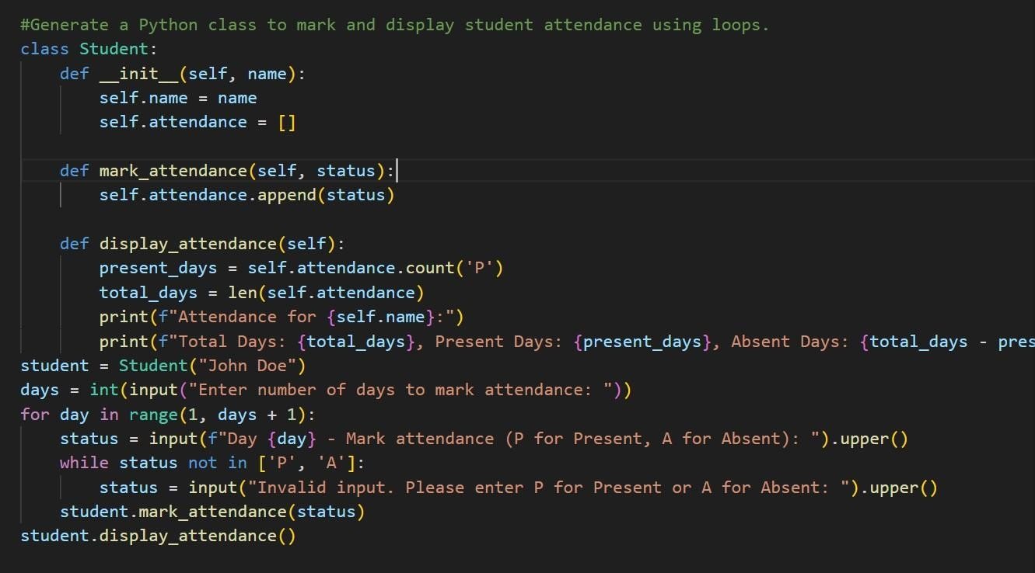
Output:
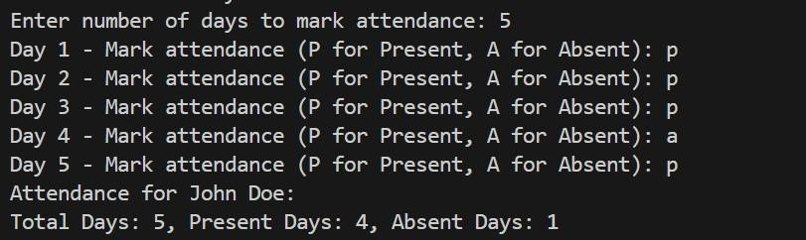

Explaination: This code defines a simple student attendance tracker. It creates a Student class that stores the student's name and a list of their attendance records. The user is asked how many days to mark attendance, then for each day, they enter 'P' for present or 'A' for absent. The program ensures only valid inputs are accepted. After all days are marked, it displays the total days, number of presents, and absents for the student.

Task Description #5 (AI-Based Code Completion for Conditional Menu Navigation)
Task: Use an AI tool to complete a navigation menu.
Prompt: Generate a Python program using loops and conditionals to simulate an ATM menu.

Code:
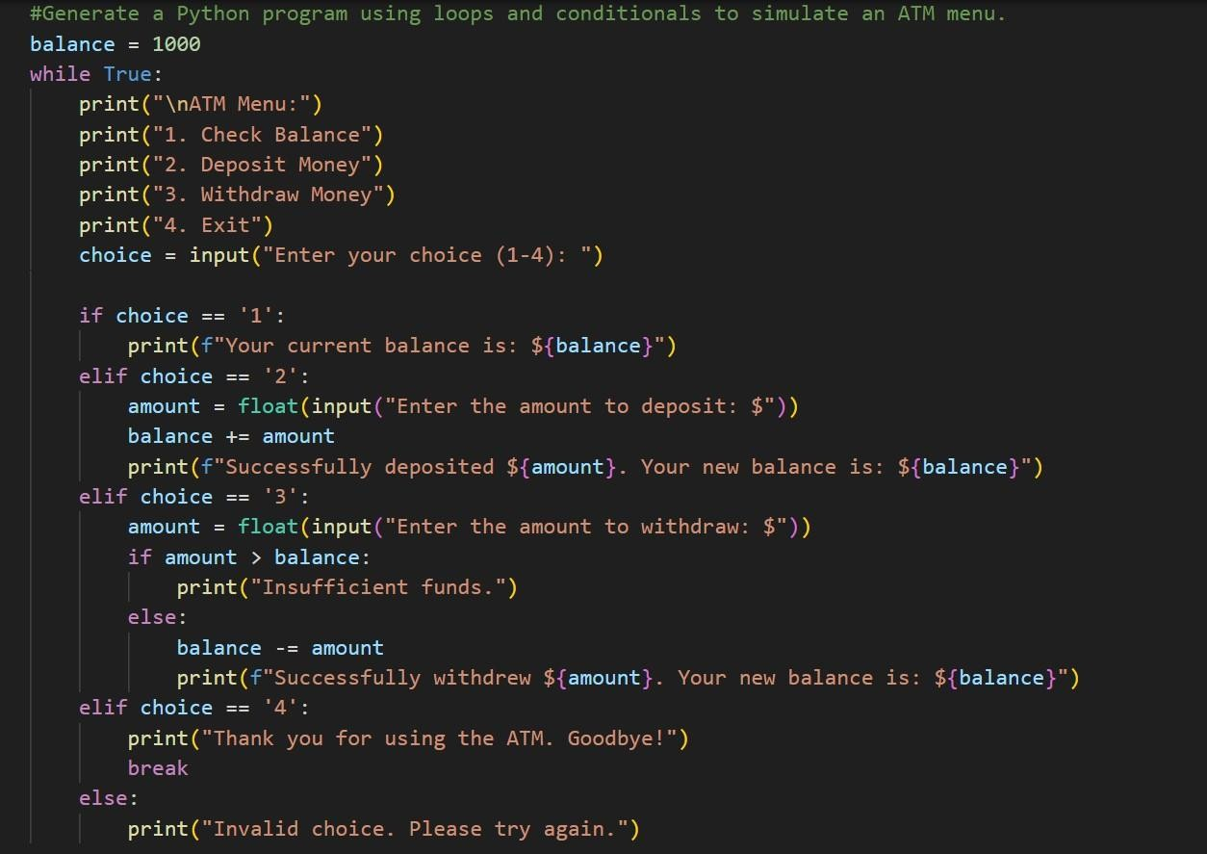

Output:
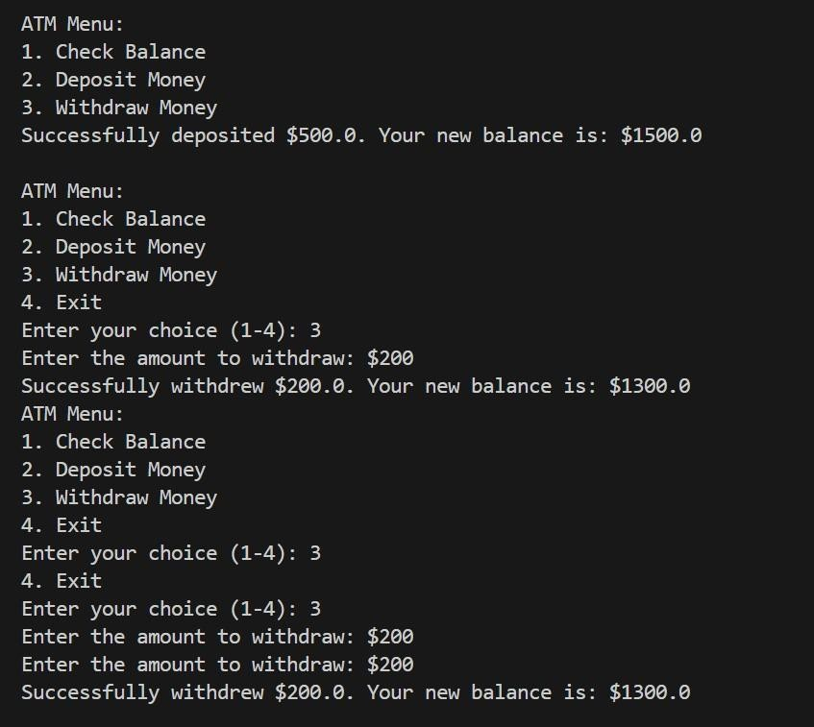
Explaination: This code simulates a simple ATM system. It starts with a balance of $1000 and repeatedly shows a menu with options to check balance, deposit money, withdraw money, or exit. The user selects an option by entering a number. Deposits increase the balance, and withdrawals decrease it if there are enough funds; otherwise, it warns about insufficient funds. The loop continues until the user chooses to exit.

