NOWCAST BULLETIN
TELANGANA
BULLETIN DATE  2026-09-21 | TIME OF ISSUE  19:17:50 | VALID UP TO  22:17:50

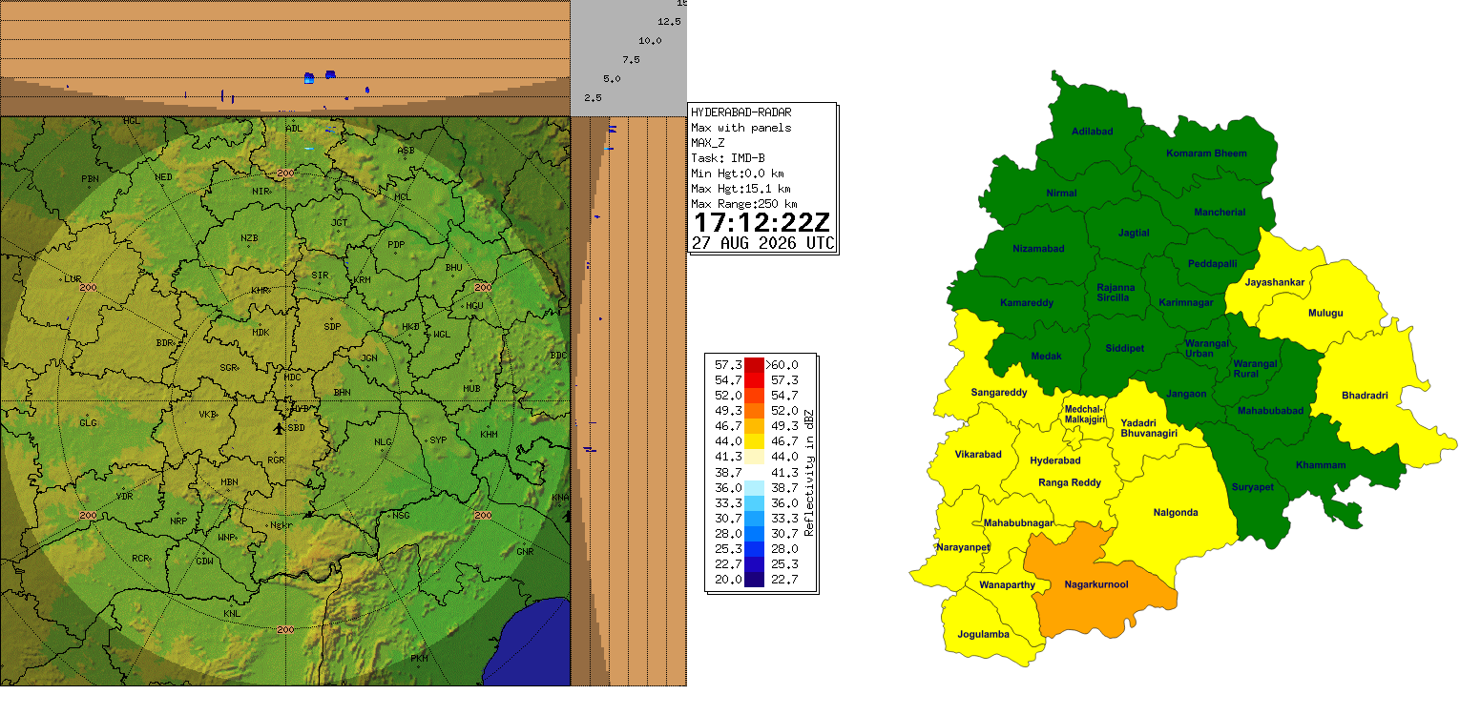
________________________________________________________________
Source: India Meteorological Department | Telangana nowcast products

