SMART INDIA HACKATHON 2026 • PROBLEM STATEMENT SIH26177
JEEVAN-AIR
Aerial Intelligence & Rescue — Prototype Specification & System Workflow Guide
Team | TEAM ZYNTAX
Problem Statement / Sponsor | SIH26177 / Qualcomm Inc
Category & Theme | Hardware / Robotics and Drones
Deliverable Type | Software Prototype Technical Specification & System Workflow Guide

[IMPORTANT CURRENT STATUS] PHYSICAL HARDWARE DISCLAIMER: The physical drone does NOT exist yet. The current JEEVAN-AIR deliverable is a functional Ground Control Station (GCS) software and rescue intelligence prototype. All drone telemetry, GPS positions, optical camera feeds, and thermal readings are mathematically simulated in software. No simulated data is described as real hardware data.

PART A — SOFTWARE PROTOTYPE

1. Prototype Overview
CLASSIFICATION: [IMPLEMENTED PROTOTYPE]
• Purpose: Provide search-and-rescue mission commanders with an autonomous aerial command interface that transforms raw sensor streams into prioritized, explainable victim triage and safe ground access corridors.
• What the User Sees: A responsive, dark-themed tactical dashboard featuring 11 navigation modules (Dashboard, Mission Control, Live Search, Detections, Hazards, Search Map, Alerts, Mission History, System Status, System Architecture, and HW Integration).
• How the Software Handles It: Executes as a single-page React 18 / TypeScript application on Vite (Port 5180), maintaining reactive state synced to the SimulationDataProvider via an event bus.

2. Current Prototype Status
CLASSIFICATION: [IMPLEMENTED (SOFTWARE) / SIMULATED (DATA)]
• Purpose: Establish verified software and decision-making logic before investing in physical drone assembly and flight controller wiring.
• What the User Sees: Live dashboard with active telemetry counters, simulated 3D GPS lock badges, synthetic camera overlays, real-time alert notifications, and multi-modal AI benchmark counters.
• How the Software Handles It: All flight movements step along a 10-waypoint lawn-mower route across sectors A1–C3. Incident injections simulate victim detections, second-look reviews, and hazard discoveries in real time.

3. Dashboard Overview
CLASSIFICATION: [IMPLEMENTED]
• Purpose: Surface critical operational intelligence on a single high-contrast screen without cognitive overload during high-stress rescue sorties.
• What the User Sees: Top mission statistics (surveyed sectors, identified survivors, elapsed time), active mission objective banner, controls bar, camera feed viewport, tactical sector map, drone telemetry card, alerts stream, AI diagnostic panel, and rescue priority queue.
• How the Software Handles It: MissionContext.tsx subscribes to the active data provider (createDataProvider() factory), updating all child components whenever position steps, new victims are localized, or hazard buffers expand.

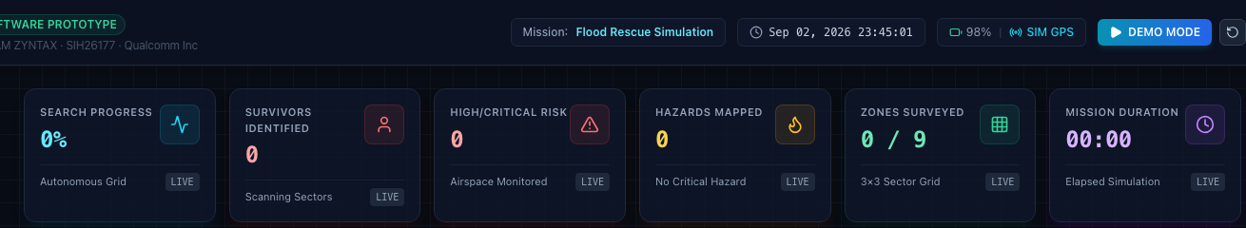
[SOFTWARE PROTOTYPE] Header & Mission Progress Stat Cards

4. Main Dashboard View
CLASSIFICATION: [IMPLEMENTED]
• Purpose: Consolidate drone status, camera imagery, and ground safe corridors in a synchronized dual-column operational layout.
• What the User Sees: Left 7-column layout displaying the live camera feed with HUD overlays and the 3x3 tactical GIS map. Right 5-column layout displaying drone flight gauges and the real-time alert feed.
• How the Software Handles It: Rendered via DashboardPage.tsx. Adapts smoothly to desktop and field command tablet displays.

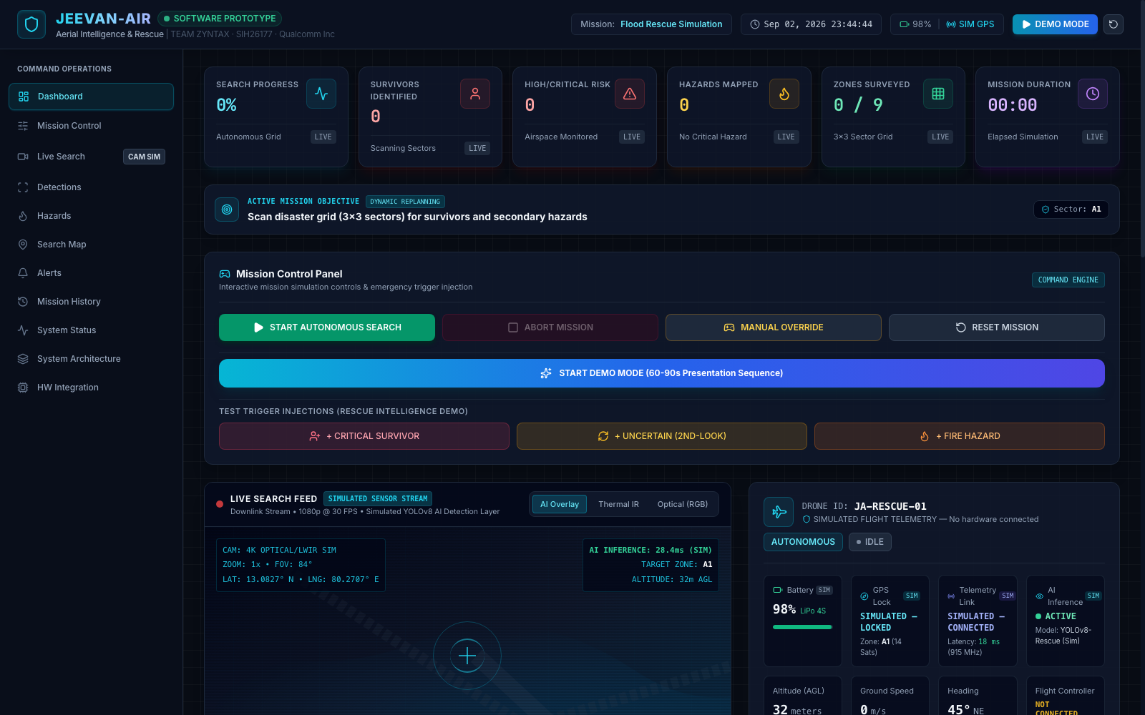
[SOFTWARE PROTOTYPE] Main Ground Control Station Command Center (Full View)

5. Simulated Drone Telemetry
CLASSIFICATION: [SIMULATED DATA]
• Purpose: Model the physical dynamics and flight performance of a medium-lift SAR quadcopter.
• What the User Sees: Drone ID JA-RESCUE-01, Altitude (32m AGL), Ground Speed (0 to 3.5 m/s), Heading (45 deg NE), Battery (98% discharging at 0.05%/s), Estimated Flight Time (~22 min), and Comms Link (94% RSSI).
• How the Software Handles It: Calculated in SimulationDataProvider.ts using kinematic position interpolation between waypoints. Battery decrements based on motor hover and forward transit energy profiles.

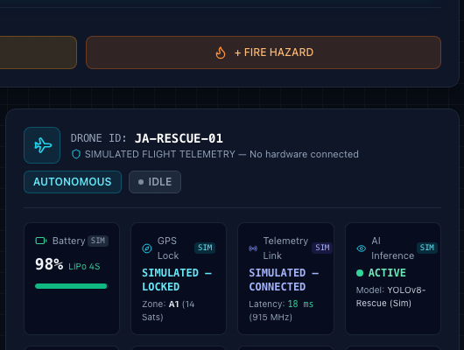
[SOFTWARE PROTOTYPE] Simulated Drone Telemetry Gauges & Communication State

6. Simulated GPS & Satellite Fix
CLASSIFICATION: [SIMULATED DATA]
• Purpose: Simulate high-precision geospatial localization in a realistic disaster operations theater.
• What the User Sees: GPS Fix badge: SIMULATED — LOCKED (3D FIX, 14 Satellites, HDOP 1.1). Coordinates centered on Chennai disaster zone (13.0827 deg N, 80.2707 deg E) across sectors A1 to C3.
• How the Software Handles It: Generates WGS-84 decimal degree coordinates matching the drone's position on the sector grid. Formatted to conform to future u-blox NEO-M9N GNSS NMEA/UBX payloads.

7. Survivor Detection Interface
CLASSIFICATION: [IMPLEMENTED (PIPELINE) / SIMULATED (FRAMES)]
• Purpose: Localize individuals on the ground using optical silhouette detection reinforced by thermal body heat verification.
• What the User Sees: Multi-spectral bounding boxes over victim positions, optical confidence (e.g. 94%), thermal confidence (e.g. 91%), biometric temperature readout (e.g. 36.8 C), condition badges (CRITICAL, STABLE, UNCERTAIN), and priority ranks (#1, #2).
• How the Software Handles It: YoloVisionProvider extracts candidate silhouettes; ThermalProcessingProvider evaluates radiometric heat matrices (35.5 C to 38.2 C); MultiModalFusionEngine correlates both using spatial IoU (>= 0.20 threshold).

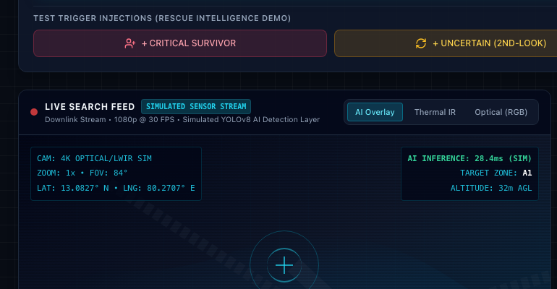
[SOFTWARE PROTOTYPE] Multi-Spectral Camera Feed Viewport (Optical, Thermal & AI Overlays)

8. Hazard Detection Interface
CLASSIFICATION: [IMPLEMENTED (INTERFACE) / SIMULATED (INCIDENTS)]
• Purpose: Identify environmental dangers that threaten victims or block ground rescue personnel.
• What the User Sees: Pulsing red circular danger rings on the tactical map showing hazard positions and radii (35m to 50m). Detailed hazard ledger on HazardsPage.tsx tracking Fire, Flood, Smoke, Debris, and Chemical Leaks.
• How the Software Handles It: HazardDetectionProvider.ts classifies threats based on thermal combustion thresholds (> 60 C for fire), optical water reflection heuristics (flood), and surface roughness variances (debris).

9. Explainable Risk Assessment
CLASSIFICATION: [IMPLEMENTED]
• Purpose: Calculate an objective, non-medical urgency score (0–100) with explicit human-readable reasons.
• What the User Sees: Explainable Decision Card displaying Risk Score (e.g. 88 / 100), Severity Level (CRITICAL), and bulleted reasons: 'No movement detected: high risk of entrapment', 'Extreme proximity to critical threat: Fire (~32m)'.
• How the Software Handles It: rescueIntelligence.ts evaluates 5 weighted factors: Movement (0–30 pts), Condition (0–25 pts), Thermal Heat Confirmation (0–15 pts), Hazard Proximity (0–20 pts), and Terrain Accessibility (0–10 pts).

10. Rescue Prioritization Queue
CLASSIFICATION: [IMPLEMENTED]
• Purpose: Deliver an actionable triage queue so rescue commanders know exactly which survivor to extract first.
• What the User Sees: Rescue Priority Panel showing survivors ranked sequentially: Priority #1 (Most Urgent), Priority #2, Priority #3... with priority badges on map icons and detection modals.
• How the Software Handles It: prioritizeSurvivors() filters out rejected false positives, sorts active candidates by descending riskScore, resolves ties via sensor confidence, and assigns ordinal ranks.

11. Autonomous Second-Look Verification
CLASSIFICATION: [IMPLEMENTED]
• Purpose: Eliminate optical false positives (shadows, blankets, debris) before ground resources are dispatched.
• What the User Sees: Ambiguous detections marked 'VERIFICATION NEEDED (POSSIBLE)' with an active 'REQUEST SECOND LOOK' button. Status updates to 'IN PROGRESS' and resolves to either 'VERIFIED' (green) or 'REJECTED' (grayed out).
• How the Software Handles It: executeSecondLookResolution() simulates multi-spectral re-examination: confirms candidates if optical confidence >= 65% or thermal heat is detected (boosting confidence >= 88%), or rejects false positives.

12. Safe-Access Ground Guidance
CLASSIFICATION: [IMPLEMENTED]
• Purpose: Synthesize safe foot navigation paths for ground rescue teams avoiding deadly hazard sectors.
• What the User Sees: Tactical Map displays an emerald dashed corridor with step markers ('Ingress Step #1', 'Step #2'...). Safe Route Card displays distance (e.g. 280m), walking time (4.2 min @ 1.1 m/s), avoided hazards, and terrain warnings.
• How the Software Handles It: calculateSafeRoute() runs A* pathfinding over the 3x3 sector graph, marking sectors with active critical hazards as impassable obstacles and calculating the shortest safe corridor from base (A1).

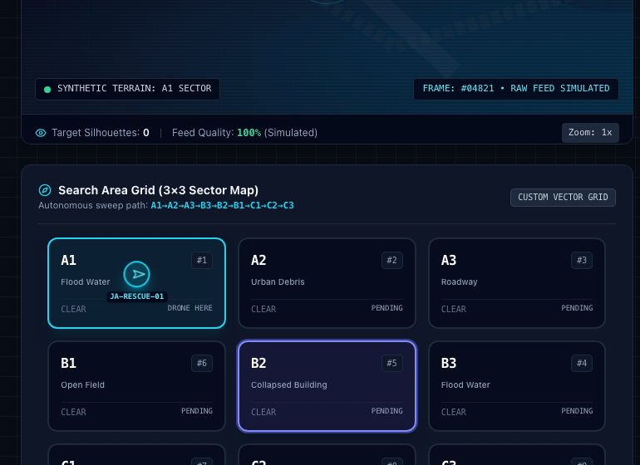
[SOFTWARE PROTOTYPE] Tactical 3x3 GIS Sector Map with Drone Flight Track & Ground Safe Corridor

13. Dynamic Mission Replanning
CLASSIFICATION: [IMPLEMENTED]
• Purpose: Automatically adapt drone search objectives upon discovering high-risk victims or advancing threats.
• What the User Sees: Mission Objective Banner updates from 'AUTONOMOUS SWEEP: Sector Grid A1–C3' to 'PRIORITY REPLAN: Monitor & guide responder approach to Survivor in Sector B2'. Timeline logs the replanning event.
• How the Software Handles It: SimulationDataProvider detects critical incidents and overrides the default sweep goal, logging chronological audit entries to DecisionTimeline.tsx.

14. Real-Time Alerts Feed
CLASSIFICATION: [IMPLEMENTED]
• Purpose: Alert commanders immediately to high-priority events requiring tactical action.
• What the User Sees: Alert cards tagged with severity (CRITICAL, HIGH, MEDIUM, LOW), title, message, and quick-action buttons ('VERIFY', 'DISMISS'). Unverified badge counter in the sidebar.
• How the Software Handles It: Alerts are published whenever a survivor is localized, risk is elevated, or a hazard expands. Tracks lifecycle from UNREAD to REQUIRES_VERIFICATION to VERIFIED.

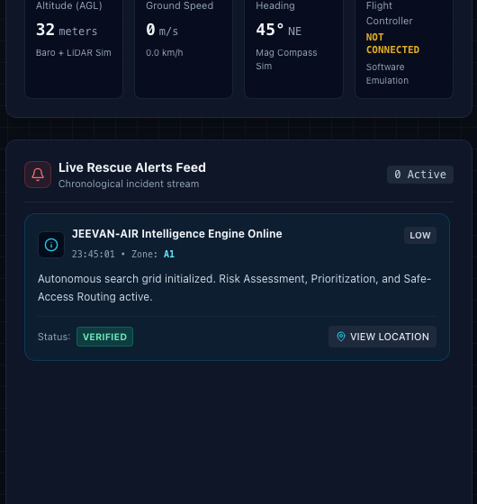
[SOFTWARE PROTOTYPE] Real-Time Incident Alert Feed with Urgency Badges

15. Disaster Geospatial Map
CLASSIFICATION: [IMPLEMENTED]
• Purpose: Provide complete situational awareness across the 3x3 operational grid.
• What the User Sees: Interactive GIS grid showing drone flight track (cyan), drone position icon with heading, detected survivors (orange icons with rank badges), active hazards (red danger rings), and ground safe corridor (emerald).
• How the Software Handles It: Rendered via SearchMap.tsx with SVG path overlays, sector centroid markers, and click-to-inspect sector inspectors.

16. Drone Status Display
CLASSIFICATION: [IMPLEMENTED]
• Purpose: Display flight health and controller readiness for the operator.
• What the User Sees: Flight Mode (AUTONOMOUS), Flight Controller (NOT CONNECTED — SIMULATED ROUTE), AI Status (ACTIVE), Battery gauge, Altitude AGL, Speed, Heading dial, and Comms Status.
• How the Software Handles It: DroneStatusCard.tsx renders live gauges based on the DroneStatus model. Clearly flags that flight control is software-simulated.

17. Connectivity Status
CLASSIFICATION: [SIMULATED]
• Purpose: Simulate radio datalink health and emergency fail-safe behaviors.
• What the User Sees: Header and telemetry card show 'SIMULATED — CONNECTED', 'DEGRADED', or 'DISCONNECTED'. Degraded mode warns of simulated packet latency; disconnected mode triggers RTL advisory.
• How the Software Handles It: setConnectivity() method on SimulationDataProvider emulates signal degradation and datalink drops for command resilience testing.

18. Current Technology Stack
CLASSIFICATION: [IMPLEMENTED]
• Purpose: Build on modern, maintainable, strictly typed web technologies.
• What the User Sees: React 18.3.1, TypeScript 5.6.3, Tailwind CSS 3.4.14, Vite 5.4.8, Lucide React 1.16.0, Node.js v22.6.0 on macOS Darwin ARM64. Port 5180.
• How the Software Handles It: Strict type safety with isolatedModules enabled. Production build compiles clean in 1.4s with 355 kB bundle size.

19. Current Limitations
CLASSIFICATION: [CURRENT LIMITATION]
• Purpose: Explicitly acknowledge prototype boundaries in accordance with hackathon evaluation standards.
• What the User Sees: 1. Physical drone airframe and motors absent; 2. Optical/thermal cameras absent; 3. Live MAVLink radio link absent; 4. Coarse 3x3 sector grid; 5. In-browser CPU inference.
• How the Software Handles It: All software is engineered with clean abstraction boundaries so that hardware procurement in Phase 4 requires zero UI rewrites.

PART B — SYSTEM WORKFLOW
The complete operational intelligence workflow of JEEVAN-AIR bridges raw aerial sensing and ground rescue execution:
DISASTER EVENT &longrightarrow; DRONE DEPLOYMENT &longrightarrow; AREA SEARCH &longrightarrow; RGB + THERMAL INPUT &longrightarrow; AI DETECTION &longrightarrow; VERIFY (2ND-LOOK) &longrightarrow; HAZARD CONTEXT &longrightarrow; RISK ASSESSMENT &longrightarrow; RESCUE PRIORITY &longrightarrow; SAFE-ACCESS GUIDANCE &longrightarrow; RESPONDER ALERT &longrightarrow; MISSION UPDATE

Current Software Workflow vs. Future Hardware Workflow
CURRENT SOFTWARE WORKFLOW [PROTOTYPE] | FUTURE PHYSICAL DRONE WORKFLOW [PLANNED]
1. SIMULATED DATA GENERATOR  (SimulationDataProvider.ts)  ↓  2. IDataAdapter INTERFACE CONTRACT  (providerFactory.ts)  ↓  3. COMMON DATA MODEL  (types/common.ts)  ↓  4. RESCUE INTELLIGENCE ENGINE  (Risk, Priority, Safe Route)  ↓  5. MISSION CONTEXT & GCS DASHBOARD  (React 18 / Tailwind CSS) | 1. PHYSICAL DRONE AIRFRAME  (Pixhawk 6C Autopilot / MAVLink 2.0)  ↓  2. SENSORS (Sony RGB + FLIR LWIR)  ↓  3. ONBOARD EDGE COMPUTE  (NVIDIA Jetson Orin Nano / YOLOv8)  ↓  4. JEEVAN-AIR EDGE BRIDGE  (Python FastAPI WebSocket @ 10 Hz)  ↓  5. HardwareDataProvider.ts  ↓  6. GCS DASHBOARD (Unchanged UI)

1. End-to-End System Workflow
Disaster Incident Detected -> GCS Commands Autonomous Search -> UAV Sweeps Sectors A1-C3 -> Dual-Camera Video Streams -> Edge AI Infers Humans & Hazards -> Multi-Modal Fusion Engine -> Rescue Intelligence Evaluates Risk -> Priority Queue Ranked -> Safe Ingress Corridor Synthesized -> Ground Team Alerted.

2. Survivor Detection Workflow
RGB Optical Silhouette Extracted -> Thermal LWIR Radiometric Heat Measured -> Spatial IoU Bounding Box Overlap Calculated -> Case A (Dual Match: Fused Confidence Boosted, Status VERIFIED) | Case B (Optical Only: Discounted, Condition UNCERTAIN, Triggers 2nd-Look) | Case C (Thermal Only: Rubble Occlusion, Condition CRITICAL).

3. Hazard Detection Workflow
Thermal Hotspot Scan (> 60 C) / Optical Edge Contrast Analysis -> Threat Classified (Fire, Flood, Smoke, Debris) -> GPS Centroid & Danger Radius (35m-50m) Calculated -> Spatial Hazard Buffer Established -> Threat Added to Disaster GIS Map & Alert Stream.

4. Rescue Priority Workflow
All Active Survivors Gathered -> Filter Out False-Positive Rejected Targets -> Compute Multi-Factor Risk Score (0-100) -> Primary Sort Descending Risk Score -> Secondary Sort Descending Fused Confidence -> Assign Ordinal Priority Ranks (#1, #2, #3) -> Update Dashboard Priority Queue.

5. Second-Look Verification Workflow
Target Detected with Low Confidence (< 75%) or Unconfirmed Thermal Heat -> Verification Status set to POSSIBLE -> Operator or Autonomous Logic Clicks REQUEST SECOND LOOK -> Status set to IN_PROGRESS -> Drone Retargets / Executes Multi-Spectral Re-examination -> Status upgraded to VERIFIED or relegated to REJECTED.

6. Safe-Access Guidance Workflow
Victim Localized in Target Sector -> Load 3x3 Sector Graph -> Mark Sectors with Active Critical Threats (Fire/Chemical) as IMPASSABLE Obstacles -> Apply Travel Cost Penalties to High Hazard Sectors -> Run A* Shortest Path from Staging Base (A1) -> Generate Step-by-Step Waypoints, Distance & Walking Time @ 1.1 m/s.

7. Dynamic Mission Replanning Workflow
Drone Executing Standard Lawn-Mower Sweep -> Incident Event Triggered (CRITICAL Survivor / Fire Proximity) -> Mission Replanning Engine Interrupts Default Objective -> Dynamic Mission Banner Updates -> Flight Route Retargeted to Target Sector -> Chronological Event Logged to Decision Timeline.

8. Future Hardware Integration Workflow
Procure Pixhawk 6C, u-blox GNSS, Jetson Orin Nano & FLIR Boson -> Connect Pixhawk UART to Jetson -> Deploy JeevanAir Edge Bridge (FastAPI) -> In src/hardware/config.ts set SIMULATION_MODE = false -> providerFactory.ts Instantiates HardwareDataProvider -> Dashboard Operates on Real Drone with Zero UI Modifications.

Logical ER Data Model Architecture
The logical entity-relationship architecture below represents all software data structures currently active in the prototype and provides the formal schema for future persistent storage (PostgreSQL/PostGIS):

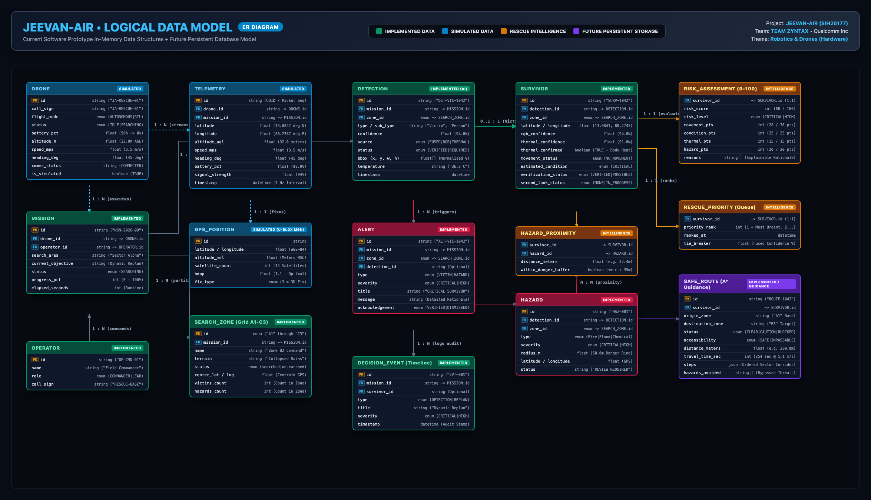
[LOGICAL DATA MODEL] JEEVAN-AIR Logical ER Data Model — 15 Entities Across 5 Pillars

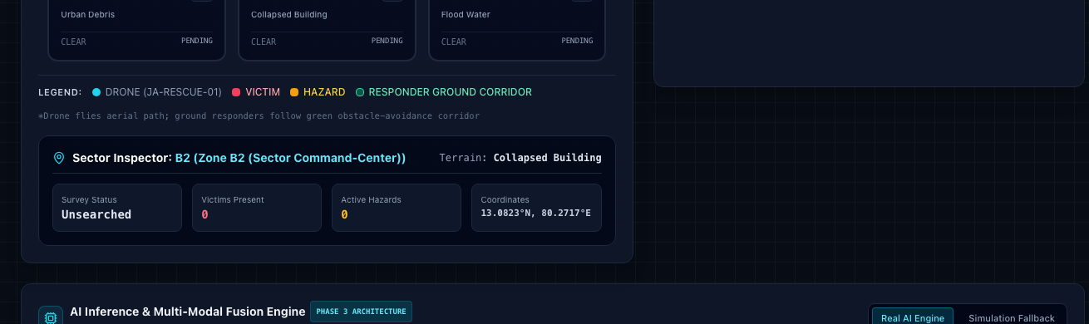
[SOFTWARE PROTOTYPE] Live AI Inference & Multi-Modal Fusion Diagnostic Panel with Measured Latency

Summary: System Workflow Validation Status
Workflow Module | Validation Mechanism | Current Engineering Status
End-to-End Decision Chain | Automated regression suite (test:all) | 85 / 85 PASSED (100%)
Multi-Factor Risk Scoring | 24 assertions in rescueIntelligence.test.ts | VERIFIED IN CODE
Priority Queue Ranking | Descending risk sort with confidence tie-breaker | VERIFIED IN CODE
A* Safe Ground Routing | Graph pathfinder bypassing active fire hazard | VERIFIED IN CODE
Second-Look Resolution | Dual-spectral recheck confirming genuine/debris | VERIFIED IN CODE
Multi-Modal IoU Fusion | 61 assertions in aiPipeline.test.ts | VERIFIED IN CODE
AI Latency Benchmarking | Measured in milliseconds via performance.now() | VERIFIED IN CODE
Hardware Provider Switch | providerFactory.ts reading SIMULATION_MODE | READY FOR PHASE 4

