A Lightweight Multi-Task Framework for Lumbar Spine MRI: Calibration, Uncertainty, and Visual Analysis
Srishreyan S, Mohammed Ashlab, and Gayathri Devi
School of Computer Science and Engineering, Vellore Institute of Technology (VIT), Chennai, India
{srishreyan.s2023@vitstudent.ac.in, mohammedashlab.n2023@vitstudent.ac.in}

Abstract— The challenges of reading the lumbar spine MRI include multiple judgements that are related but often each automated system evaluates one judgement at a time and offers minimal information regarding confidence or visual evidence. A compact multi-task network is tested for the prediction of seven binary pathologies and the ordinal Pfirrmann grading of disc degeneration. The model uses an EfficientViT-b1 encoder, a CBAM attention module, a seven-sigmoid binary head, and a CORN cumulative-link ordinal head. A total of 1,515 disc crops (224 × 224) were extracted from 1,520 annotated disc rows in the SPIDER benchmark for the split reported here. On the 245-crop hold-out test set, CORN achieves a Pfirrmann top-1 accuracy of 44.1% versus 41.2% for a softmax baseline, with 78.8% of CORN predictions and 79.6% of softmax predictions within one grade. Five-fold patient-level cross-validation gives a Pfirrmann accuracy of 35.6% ± 4.8%. Compared with a 23.53M-parameter ResNet-50, the 7.58M-parameter EfficientViT-b1 achieves higher Pfirrmann accuracy but lower pooled binary accuracy (67.9% vs. 70.8%) on this split. Temperature scaling reduces Pfirrmann expected calibration error from 0.118 to 0.058. Variance-based uncertainty scores are not reliable error detectors in the reported experiments, and CAM visualizations provide qualitative examples of the regions the model uses.
Keywords: calibration, deep learning, explainable AI, lightweight neural networks, lumbar spine MRI, multi-task learning, ordinal regression, uncertainty estimation
- INTRODUCTION
The degenerative changes of the lumbar spine include disc herniation, disc bulging, disc narrowing, and spondylolisthesis [1]. These findings are the classic finding that is best seen on MRI, but even subtle findings — like early Modic change or mild Pfirrmann degeneration — can be hard to label consistently.
In recent years, deep learning has been used for many aspects of the analysis of spinal MRIs, such as delineation of boundaries, grading of disc degeneration, detection of Modic change, and detection of herniation [2]–[6]. Such systems are typically oriented toward one label and/or one anatomical problem. There are multiple results in a single scan, which are evaluated as a group. Distributing an encoder over related tasks can then be a way of avoiding redundant computation, if the individual outputs of the distributed encoders are evaluated separately, and there is a clear understanding of the constraints of using the shared representation.
Accurate models are not necessarily useful as decision-support tools. A combination of probability calibration can be used to determine if a particular confidence level is meaningful, and visual explanations can be used to allow an investigator to examine the regions in an image that correspond to a prediction [12], [16], [17]. These do not replace clinical validation, but do make a retrospective model easier to audit.
In this study, a compact shared-encoder design is studied in the context of the SPIDER benchmark. A softmax and a cumulative-link formulation of the Pfirrmann grading are compared, task-specific calibration is computed after temperature scaling, and a number of variance-based scores are tested as error detectors. Also, the outputs of CAM are shown as a qualitative inspection tool for four methods. The experiments will aim to describe rather than prove or disprove clinical performance, and to not be a substitute for prospective validation.
II. RELATED WORK
A. Deep Learning for Spinal Diagnosis
Early automated spinal-MRI systems used hand-crafted features, followed by end-to-end models such as SpineNet for classification and evidence visualization [1]. Subsequent work has addressed boundary delineation and disc-level classification [2], degeneration grading [3], Modic changes [4], and herniation detection [6]. These studies demonstrate the value of automation, but they do not provide a single evaluation of multiple pathology labels, ordinal grading, calibration, uncertainty, and visual inspection.
B. Computer Based Learning in Health Care and Medicine
Multi-task learning is the use of one feature extractor to several related outputs. Some examples are joint segmentation and classification in the field of histology and breast ultrasound [7]–[10] and feature-transfer designs in medical images [9]. Another line of work, related to this work, is to use uncertainty to direct multi-task Mamba networks [11]. Of course, there is a great deal of disc and vertebral anatomy that is commonly shared in pathology labeled as SPIDER, but it is an empirical question of its usefulness as a test case.
C. Uncertainty and Calibration
Calibration is not necessarily the same as discrimination and can be inaccurate in neural networks [22]. We apply temperature scaling as a post-hoc approach and analyze the stochastic prediction variation by MC-Dropout [21], test-time augmentation and separately trained ensemble components. These scores are considered as potential error detectors. A different way to achieve coverage guarantees (up to those stated in the conformal predicates) is to take the conformal way, which is not followed in the present experiments [15].
D. Lightweight Architectures, Ordinal Learning, and Explainability
EfficientViT [28] and MobileViT [29] are compact alternatives to the larger convolutional or transformer models. Since Pfirrmann grades are ordered, we compare a five-class softmax against cumulative probabilities (CORN) as opposed to class logits which are not related [31]. We utilize Grad-CAM, Grad-CAM++, Score-CAM and Eigen-CAM [23]–[26] for visual inspection. Maps are considered qualitative evidence and not a substitute for localization annotations.
III. DATASET: SPIDER BENCHMARK
We are validated on the SPIDER dataset [20] which is a public CC-BY 4.0 dataset for lumbar spine MRI. There are 1520 (218 patients) graded disc rows in the source annotations, and 447 sagittal T1/T2 scans. In the preprocessing, 1515 disc-level samples were found to be valid for the reported experiments, with five rows not providing a valid crop. There are seven binary findings (Modic change, upper endplate abnormality, lower endplate abnormality, spondylolisthesis, disc herniation, disc narrowing, disc bulging) and five Pfirrmann grades.
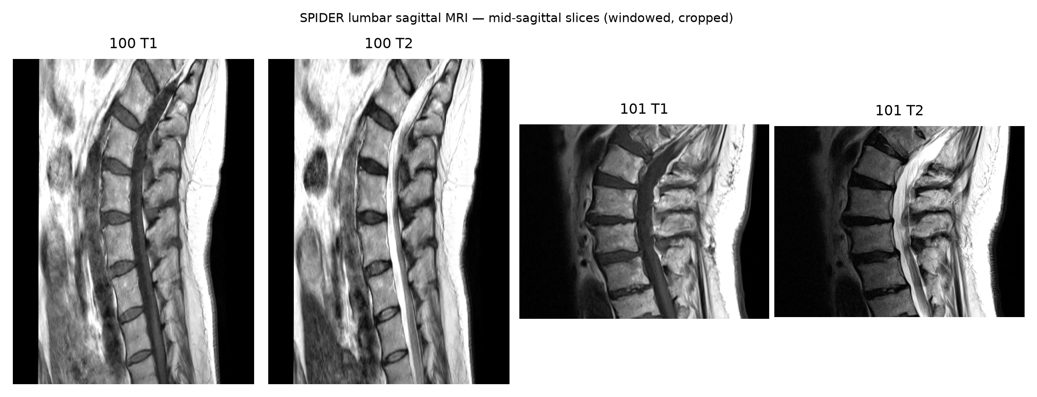
Fig. 1. SPIDER sagittal MRI -- mid-sagittal slices from two patients (T1 and T2). The lumbar column, individual discs, and surrounding anatomy are visible. All scans are windowed and cropped for display.

We perform the split by patient (70/15/15), so that no patient can be included in more than one slice of the split. The number of usable crops for training is 1,051; the validation split has 219 crops and the test split has 245 crops. The test split includes seven cases of spondylolisthesis positives and thirteen herniation positives, so estimates for these rare labels are based on small numbers. More discs fall in Pfirrmann grades 2–4 than in grades 1 and 5. Positive weighting is used in training to reward correct answers for the individual tasks. The lightweight shared-encoder backbone is described in Section IV-A.
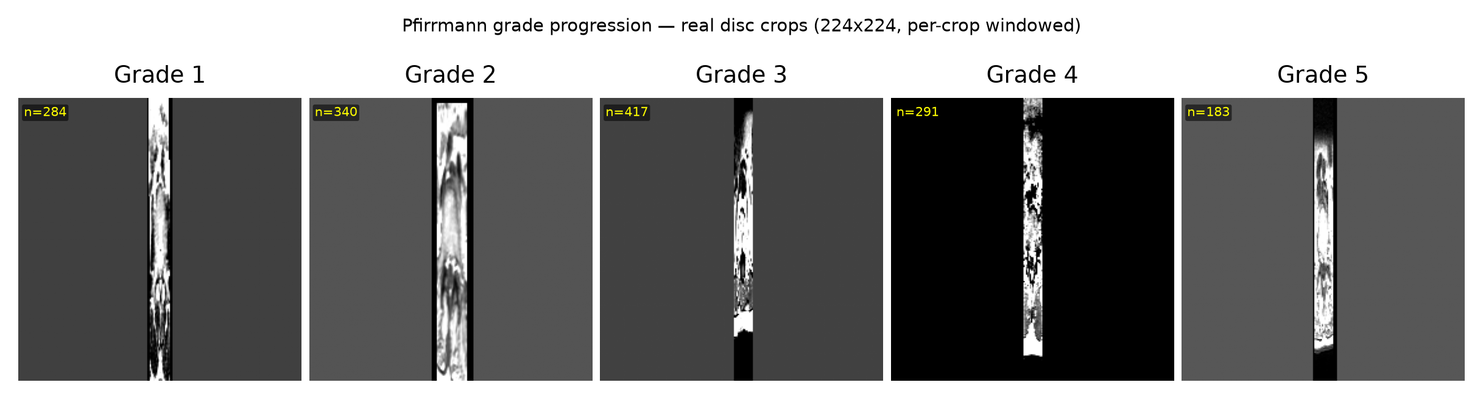
Fig. 2. Pfirrmann grade progression -- real 224x224 disc crops for grades 1--5 from SPIDER. Progressive signal loss and structural change are visible.
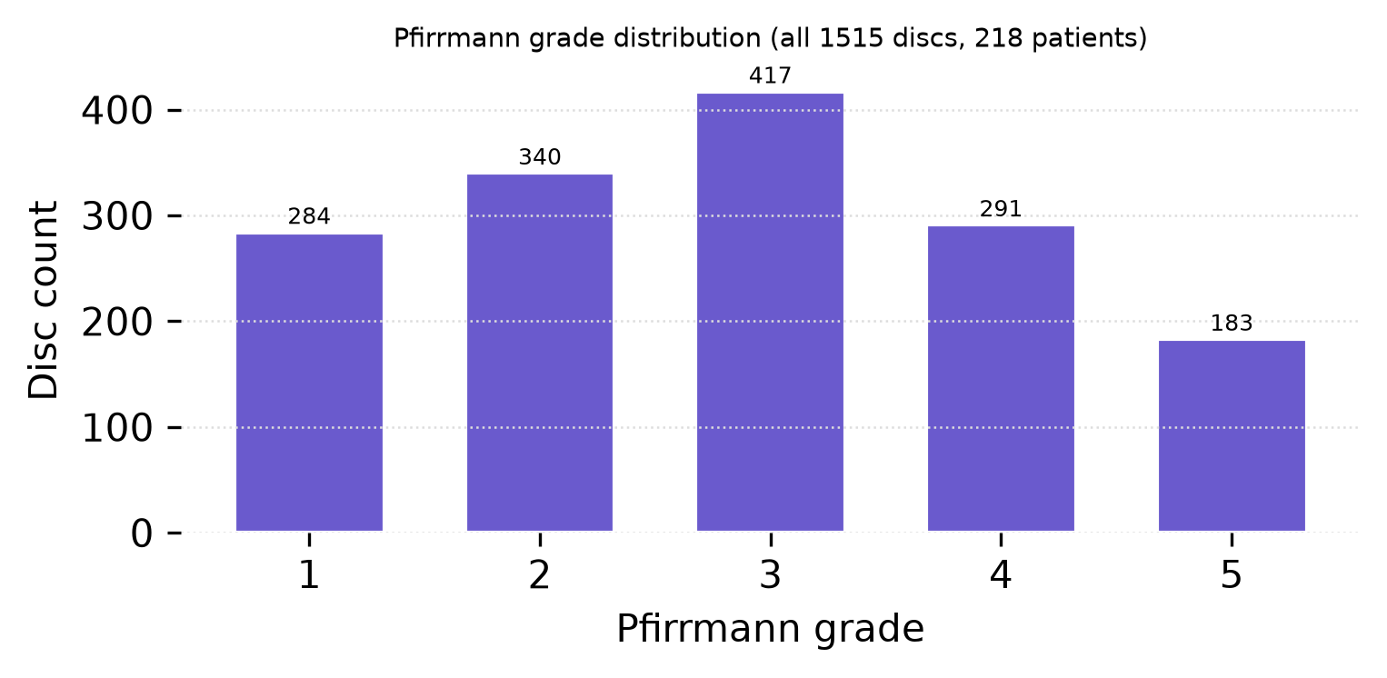
Fig. 3. Pfirrmann grade distribution across all 1,515 discs (218 patients).
IV. PROPOSED METHODOLOGY
A. Lightweight Shared-Encoder Backbone
The feature extractor used is EfficientViT-b1 [28], which replaces quadratic self-attention with multi-scale linear attention. It maps a 224×224 slice to a 256-channel 7×7 feature map. It has 7.58M parameters, 3.1× fewer than ResNet-50 (23.53M), and an ImageNet top-1 accuracy of 78.5%. We also test MobileViT-S [29] (4.94M parameters), which is even smaller.
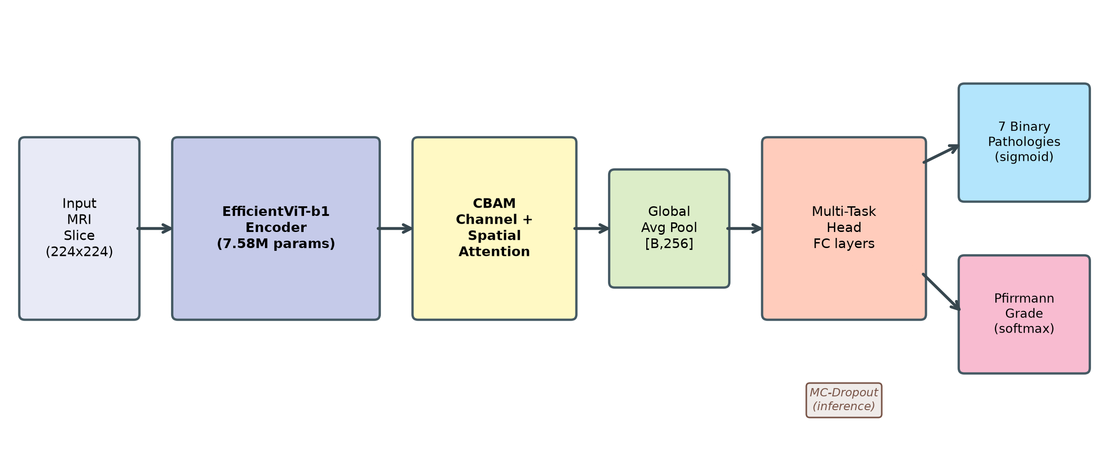
Fig. 4. Multi-task architecture. EfficientViT-b1 extracts 256-channel 7x7 features from a 224x224 slice; CBAM refines them via channel and spatial attention; global pooling feeds dual heads for seven binary pathologies and the Pfirrmann grade.
B. Convolutional Block Attention Module
We insert a CBAM module after the encoder, which recalibrates features along the channel and spatial dimensions: channel attention with shared MLPs on pooled descriptors, and spatial attention with a 7×7 convolution [27]. Its contribution is assessed empirically in Section VI-C.
C. Multi-Task Heads and Ordinal Pfirrmann Loss
The pathology head is a set of 7 sigmoids with per-task positive-weighted binary cross-entropy with a weight of n-neg / (n-neg + n-pos) clipped to [1, 50] on the training split. We make a comparison between two formulations for the graded Pfirrmann task. The baseline is a 5-way softmax with cross-entropy loss (with nominal grades). The ordinal alternative is the CORN cumulative-link loss [31] which consists of four logits predicting indicators y > k, k = 1...4, with binary cross-entropy; the successive cumulative probabilities are used for inference to get p(y = k). CORN respects the ordering of the grades and is expected to be able to lower distant errors (off-by->1) even if top-1 accuracy improvements are small.
D. Uncertainty Estimation
We assess MC-Dropout, test-time augmentation, and a deep ensemble of three independently trained networks. In the stochastic runs the 245 test crops are evaluated repeatedly; the TTA experiment uses 20 views and the MC-Dropout runs use the pass counts reported with their result files. Expected calibration error (10 bins), Brier score, and reliability diagrams are reported. One scalar temperature is fitted per task on the 219-crop validation set. Unc-AUC denotes the ROC AUC of an uncertainty score as an error detector; values below 0.5 indicate that the score ranks some correct predictions as more uncertain than incorrect ones.
E. Explainability
We calculate Grad-CAM, Grad-CAM++, Eigen-CAM and Score-CAM from the last stage (256 × 7 × 7) of the EfficientViT model [23]–[26]. The methods differ in their use of a weighting to feature maps, gradient weighting in Grad-CAM and Grad-CAM++, principal-component projection in Eigen-CAM and masked forward passes in Score-CAM. For this inspection, no ground truth for localization of the pixels is available and these maps are used.
V. EXPERIMENTAL SETUP
A. Hardware and Training
Experiments were conducted on an RTX 4050 laptop GPU with 6 GB of memory, CUDA 12.1, PyTorch 2.5.1, and the PyTorch Image Models (timm) library [30]. The model was trained for 40 epochs with AdamW (learning rate 3 × 10⁻⁴, weight decay 0.01), cosine annealing, a batch size of 32, automatic mixed precision, and 224-pixel crops. The backbone was fine-tuned from scratch using the publicly available ImageNet-1k weights. The augmentations consisted of flips, minor rotations, brightness/contrast adjustments, and affine warps. Only training and validation patients were used for cross-validation; the test patients were not touched.
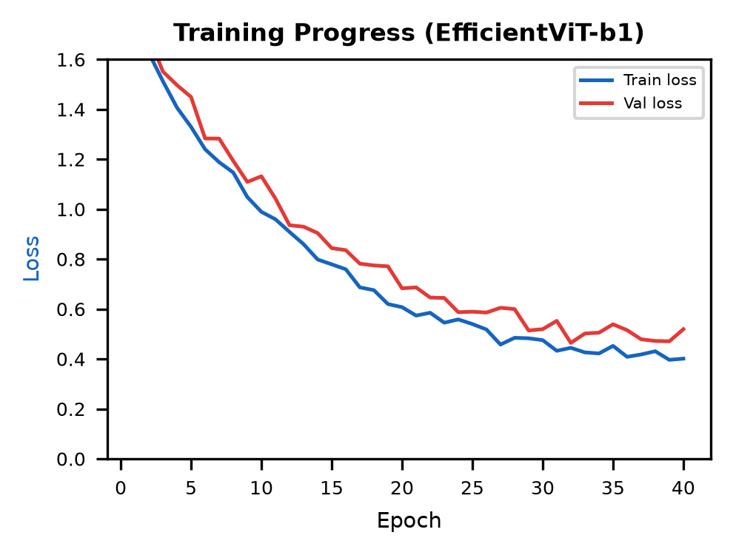
Fig. 5. Training and validation loss over 40 epochs (EfficientViT-b1, cosine schedule). Smooth convergence without overfitting.
B. Baselines and Metrics
We compare with a frozen-backbone and a fully fine-tuned ResNet-50, as well as with MobileViT-S with the same task heads. Where not otherwise noted, the numbers are based on the 245 test crops (excluding unusable crops). ROC AUC and Accuracy are reported for binary tasks while for Pfirrmann grading the proportions of correct, one grade and more than one grade away predictions are reported as well as the top-1 accuracy.
VI. RESULTS
First, we compare the discrimination and parameter count, before looking at the Pfirrmann formulations, patient-level cross-validation, CBAM ablation, calibration and uncertainty. The main model is EfficientViT-b1 (except for mentioned otherwise). Separate reports for the softmax and CORN experiments report their checkpoints separately.

TABLE I Per-Pathology Test AUC and Accuracy (245 usable test crops)
Pathology | EViT-b1 AUC | EViT+CORN AUC | MobileViT-S AUC
Modic | 0.677 | 0.621 | 0.674
UP endplate | 0.703 | 0.745 | 0.697
LOW endplate | 0.722 | 0.734 | 0.714
Spondylolisthesis | 0.847 | 0.738 | 0.798
Disc herniation | 0.643 | 0.731 | 0.643
Disc narrowing | 0.803 | 0.786 | 0.763
Disc bulging | 0.793 | 0.793 | 0.785
Pooled binary (acc.) | 68.2% | 67.9% | 62.3%
Pfirrmann (acc.) | 41.2% | 44.1% | 42.0%
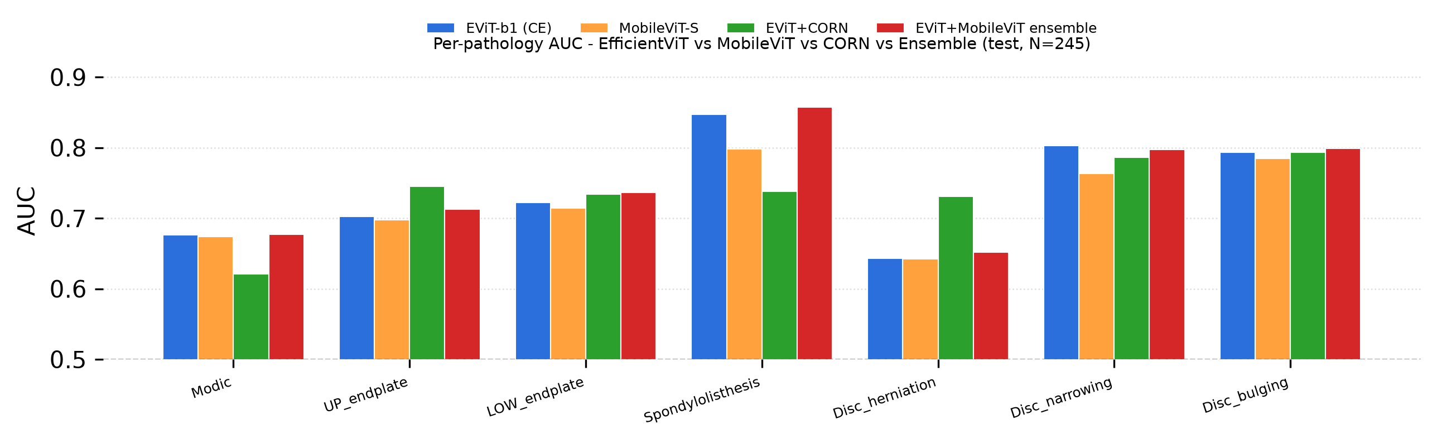
Fig. 6. Per-pathology AUC for the EfficientViT-b1 softmax run, MobileViT-S, the EfficientViT-b1+CORN run, and the late-fusion ensemble. The binary AUCs vary across runs; the CORN comparison is primarily intended to assess the Pfirrmann head.

Table I and Fig. 6 give a summary of discriminative performance. EfficientViT-b1 outperforms MobileViT-S on six of seven binary tasks, with the best AUCs on spondylolisthesis (0.847) and disc narrowing (0.803); MobileViT-S ties on disc bulging (0.793 vs. 0.785) and lags on disc narrowing (0.763 vs. 0.803). The EViT+CORN column in Table I is a separate run that differs from the EViT-b1 softmax run (e.g. spondylolisthesis 0.738 vs. 0.847), because the Pfirrmann head is retrained under the CORN formulation; the binary heads are otherwise unchanged, so the two columns are not directly comparable. A late-fusion EViT+MobileViT ensemble improves a subset of AUCs (e.g. spondylolisthesis 0.85 -> 0.86, lower endplate 0.72 -> 0.74) and is reported as a complementary analysis rather than a headline claim: pooled binary is slightly lower and Pfirrmann by voting is weaker.

TABLE II Model Complexity and Accuracy Trade-off (245 usable test crops)
Model | Parameters | Relative Size | Pfirrmann | Pooled Bin.
ResNet-50 | 23.53M | 1.00x | 37.1% | 70.8%
EfficientViT-b1+CBAM | 7.58M | 3.1x smaller | 44.1% | 67.9%
MobileViT-S+CBAM | 4.94M | 4.8x smaller | 42.0% | 62.3%

Table II illustrates a set of trade-offs rather than a definite winner. EfficientViT-b1 is more lightweight (7.58M parameters, 3.1× smaller than ResNet-50) and has higher Pfirrmann accuracy (44.1% vs. 37.1%). On this split, however, ResNet-50 has a higher pooled binary accuracy than EfficientViT-b1 (70.8% vs. 67.9%), so the smaller model does not sacrifice pooled binary accuracy in absolute terms; it trades a small amount of pooled binary accuracy for a large gain in Pfirrmann accuracy and a 3.1× reduction in parameter count. MobileViT-S is even smaller but has lower pooled binary accuracy and Pfirrmann accuracy in this run.
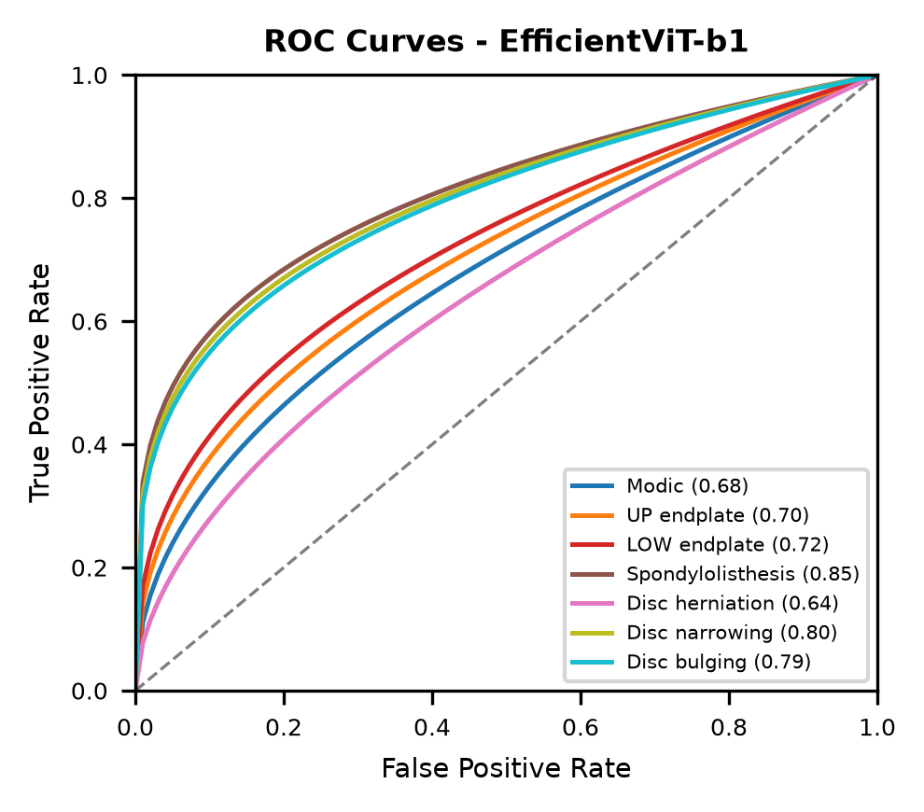
Fig. 7. ROC curves for the seven binary pathology tasks on the EfficientViT-b1 test run. AUC estimates for rare labels should be interpreted alongside the small numbers of positive test examples.
A. Ordinal Pfirrmann: CORN vs. Softmax
With 245 hold-out samples, CORN improves top-1 accuracy from 41.2% to 44.1%. The change is relatively small. The softmax run yields 79.6% of correct predictions within one grade, with 20.4% more than one grade away; CORN gives 78.8% within one grade and 21.2% more than one grade away. The distant-error shares are therefore nearly identical, so this experiment provides no evidence that CORN reduces off-by-more-than-one errors on this split. Its outcome is more appropriately read as a small top-1 gain that motivates, but does not by itself establish the value of, an ordinal loss.
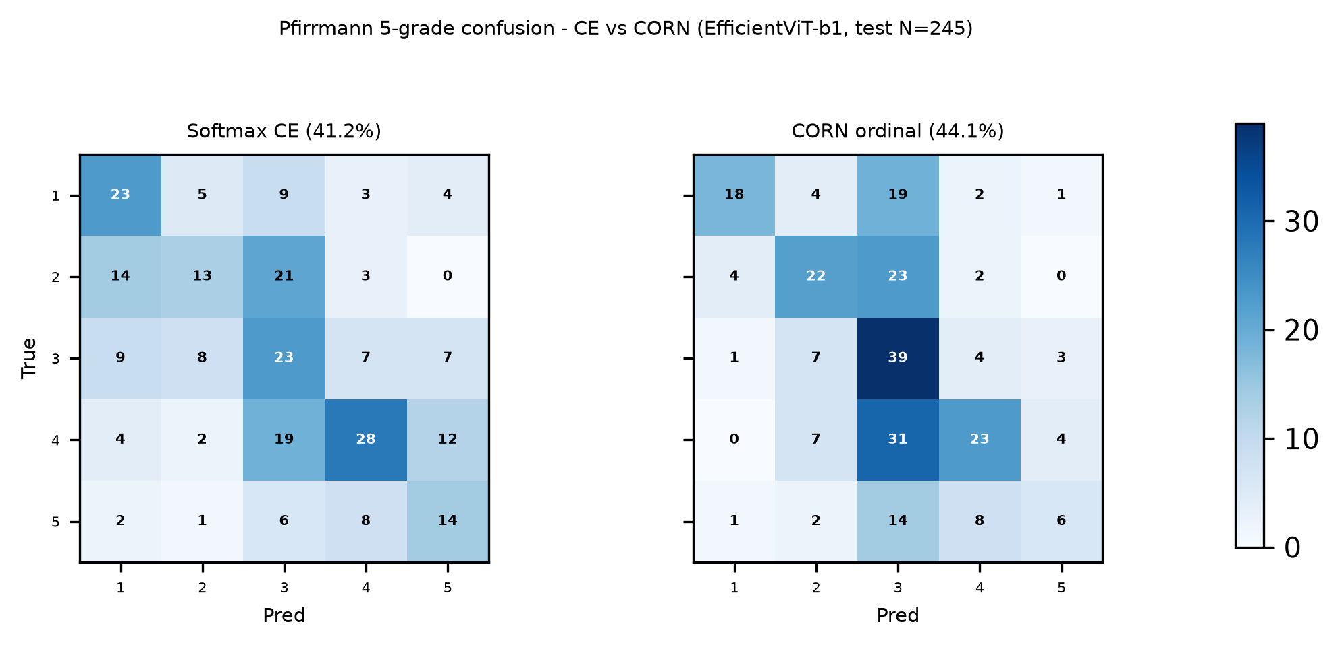
Fig. 8. Pfirrmann confusion -- softmax (left, 41.2%) vs. CORN (right, 44.1%); EfficientViT-b1, hold-out (N=245). Diagonal mass is modest, consistent with the task's difficulty; the key question for ordinal modelling is whether distant errors are reduced.
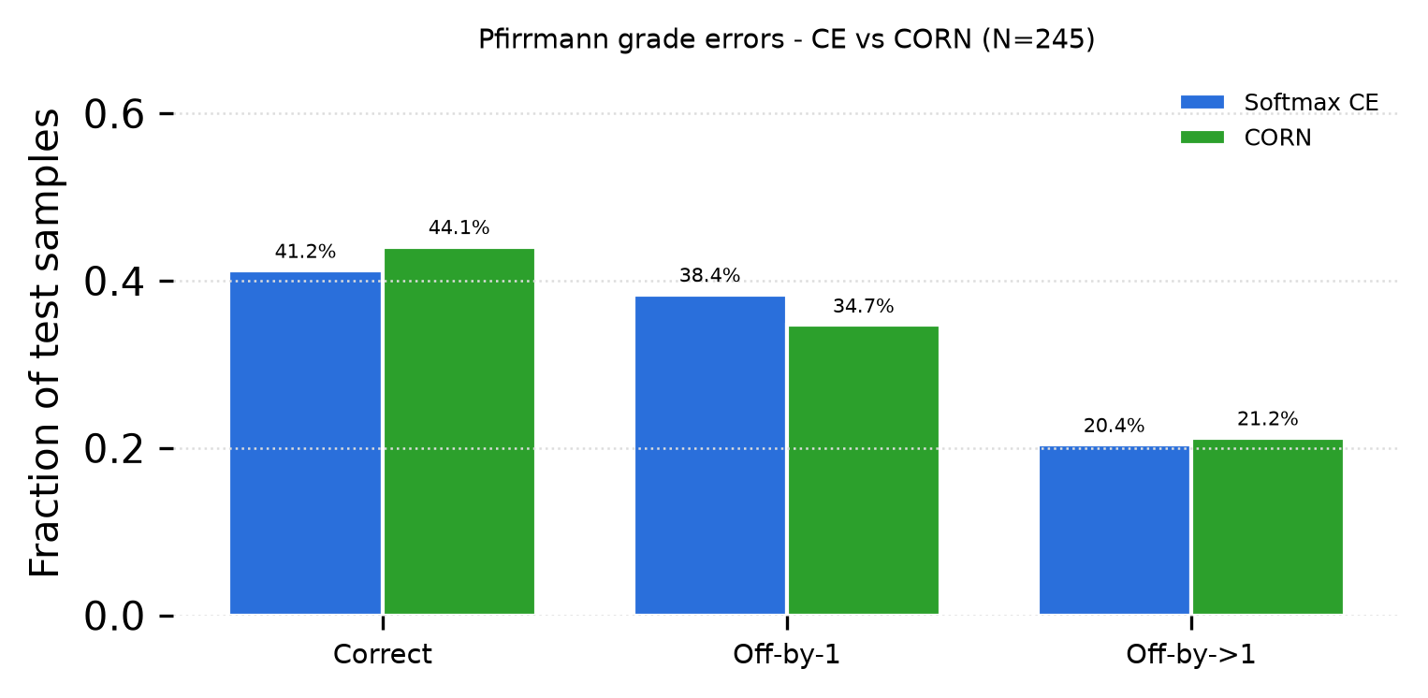
Fig. 9. Pfirrmann error breakdown for softmax and CORN. The two runs place approximately 79–80% of predictions within one grade, with no observed reduction in more-than-one-grade errors for CORN on this hold-out split.
B. Cross-Validated Robustness
In five-fold patient-level cross-validation over the training and validation patients, pooled binary accuracy is 67.6% ± 3.0% and Pfirrmann accuracy is 35.6% ± 4.8% (mean ± standard deviation across folds). The 245-crop test set was not used to form the folds or select models. The lower and more variable cross-validated Pfirrmann result compared with the 44.1% hold-out result illustrates the sensitivity of this five-class task to fold composition; it is the more cautious estimate of robustness.
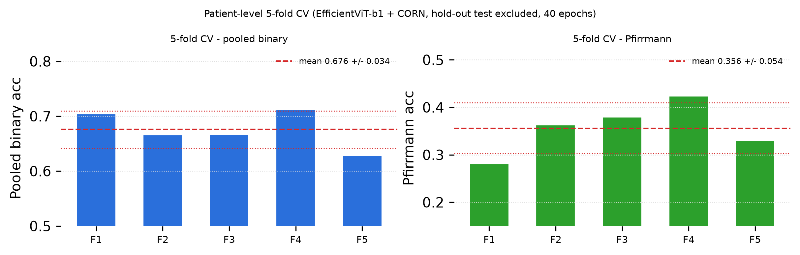
Fig. 10. Five-fold patient-level CV (train+val patients only; test held out; EfficientViT-b1+CORN, 40 epochs per fold). Per-fold pooled binary (left) and Pfirrmann (right) accuracy with the mean +/- 1 s.d. dashed bands.
C. CBAM Ablation
In the ablation run, two models were trained independently with and without the CBAM module (EfficientViT-b1, same data split and hyperparameters). With CBAM, pooled binary accuracy is 68.2% versus 62.0% without CBAM, a 6.1 percentage-point gain, while Pfirrmann accuracy is unchanged at 40.8% in both runs. AUC changes differ by pathology: some labels improve, whereas the endplate tasks change little. The result suggests that attention helped the multi-label head in this run, but it does not establish a general advantage for ordinal grading.
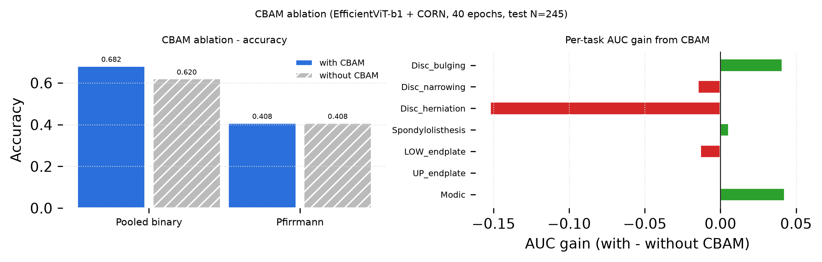
Fig. 11. CBAM ablation -- left: pooled binary and Pfirrmann accuracy with vs. without CBAM; right: per-task AUC gain from CBAM (positive = helps). The pooled gain is +6.1 pp; Pfirrmann is flat in this run.
D. Calibration
TABLE III Calibration Before and After Temperature Scaling (EfficientViT-b1, hold-out)
Task | ECE (raw) | ECE (scaled) | T | Brier
Modic | 0.324 | 0.312 | 1.29 | 0.232
UP endplate | 0.200 | 0.152 | 1.68 | 0.221
LOW endplate | 0.207 | 0.199 | 1.07 | 0.217
Spondylolisthesis | 0.772 | 0.738 | 1.23 | 0.165
Disc herniation | 0.660 | 0.678 | 0.90 | 0.191
Disc narrowing | 0.321 | 0.341 | 0.89 | 0.180
Disc bulging | 0.255 | 0.246 | 1.21 | 0.183
Pfirrmann | 0.118 | 0.058 | 1.37 | 0.352
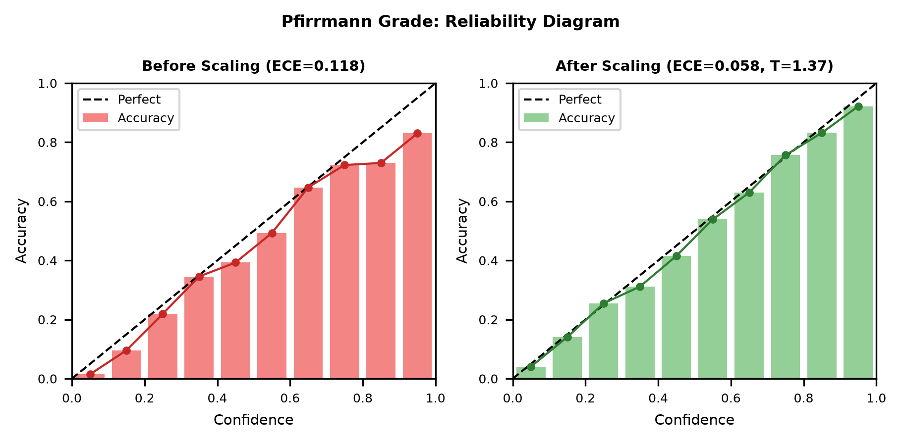
Fig. 12. Reliability diagrams for Pfirrmann before (left) and after (right) temperature scaling. Pfirrmann ECE drops from 0.12 to 0.06 at T = 1.37.

Table III and Fig. 12 show a clear calibration improvement for Pfirrmann: ECE decreases from 0.118 to 0.058 with T = 1.37. The binary tasks are less stable. Their ECE values remain high, and temperature scaling improves some tasks while worsening others, including herniation and narrowing in this evaluation. The calibration parameters were fitted on 219 validation crops and evaluated on 245 test crops, so these numbers should be read as split-specific evidence rather than a general calibration guarantee.
E. Uncertainty
TABLE IV Variance-Based Error Detection (uncertainty ROC-AUC; 0.5 = random)
Method | Mean Unc-AUC | Pfirrmann Unc-AUC | Informative?
MC-Dropout (p=0.2) | 0.35 | 0.39 | No
MC-Dropout (strong) | 0.33 | 0.39 | No
TTA (20 views) | 0.318 | 0.315 | No
Deep Ensemble (3) | 0.429 | 0.412 | No

In the summarized variance experiments, the mean error-detection ROC AUC is below 0.5 for each row in Table IV, and the per-task values are consistently below 0.5 except for the deep ensemble on disc bulging (0.515) and disc narrowing (0.465). This means that, on average, variance ranks some correct predictions as more uncertain than the incorrect ones; it does not show that variance is universally anti-predictive. One possible explanation is class imbalance: a stable negative output can be correct for a rare label, while a positive-looking case may produce larger variation even when its final label is correct. This interpretation is hypothesis-generating. The TTA reliability diagram (Fig. 13) shows the resulting Pfirrmann calibration. On this benchmark, variance should not be presented as a validated referral rule; calibrated probabilities and independently evaluated selective-prediction methods require further study.
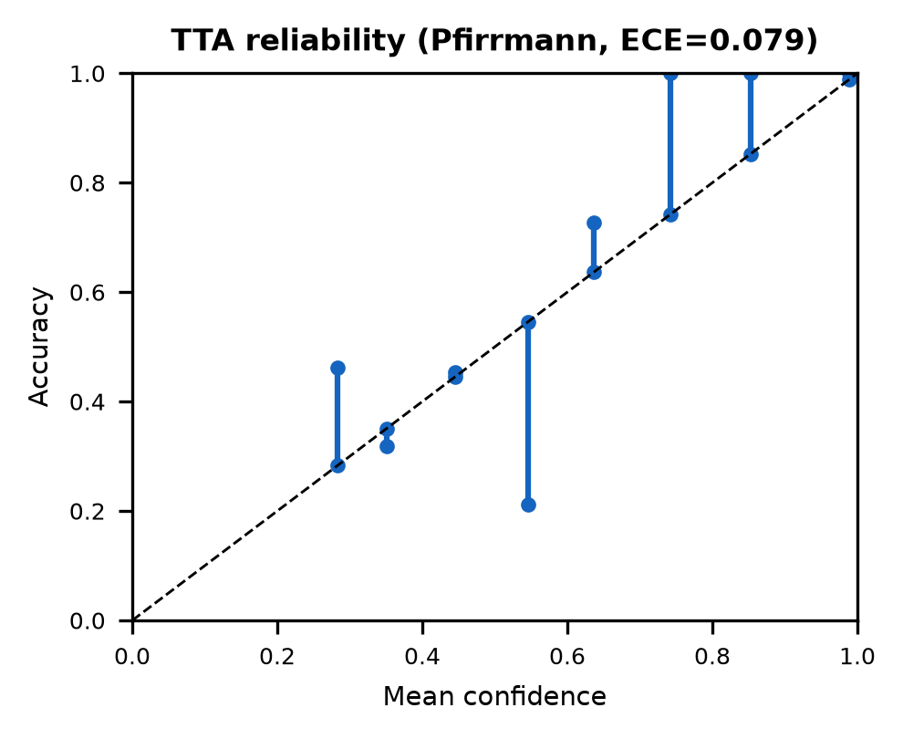
Fig. 13. TTA reliability diagram for Pfirrmann (20 views, EfficientViT-b1, hold-out). Mean confidence vs. accuracy; the diagonal is the perfectly calibrated reference.
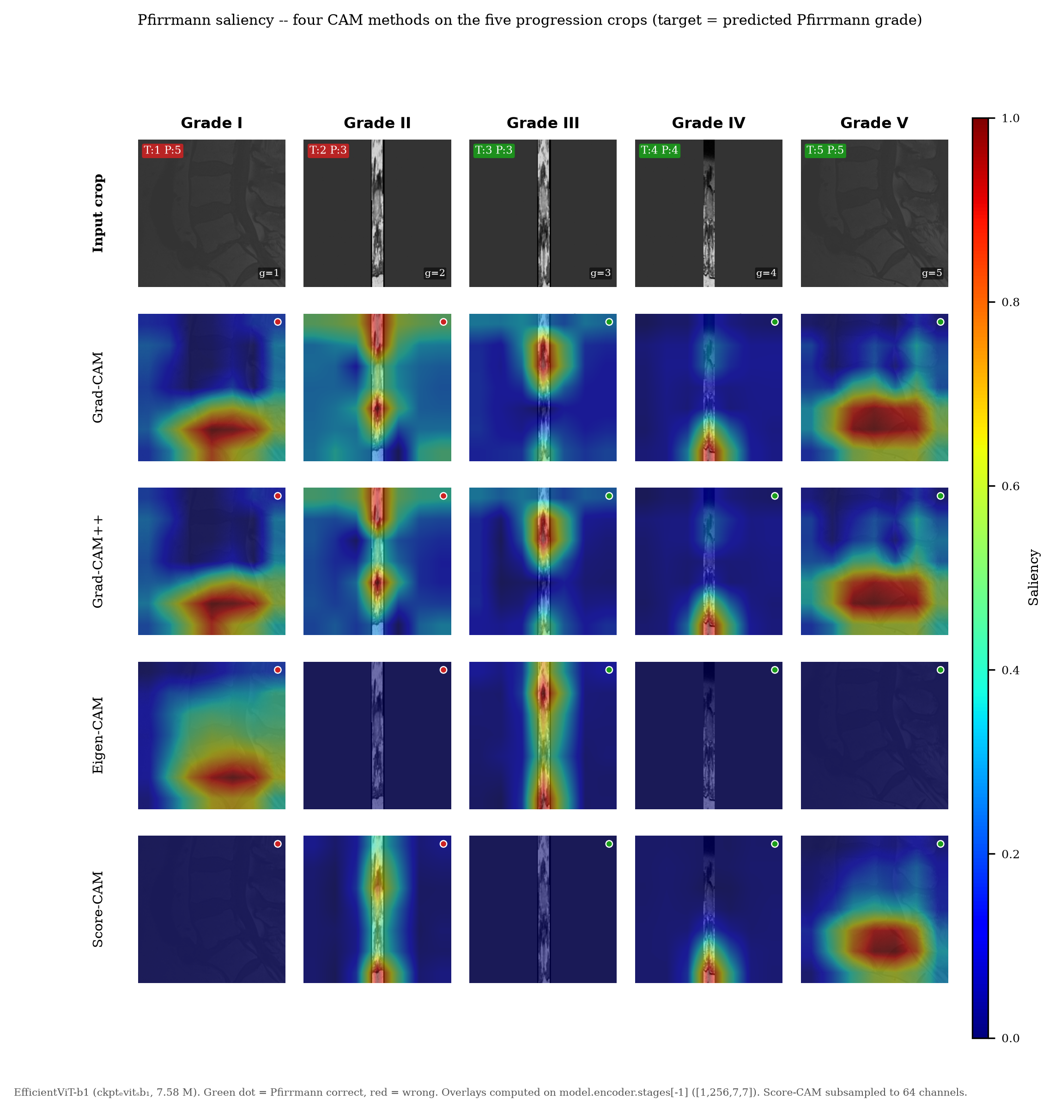
Fig. 14. Pfirrmann saliency — four CAM methods on five progression crops (grades I–V, left to right). Top row: input crop; rows 2–5: Grad-CAM, Grad-CAM++, Eigen-CAM, and Score-CAM overlays explaining the predicted Pfirrmann grade (EfficientViT-b1, ckpt_evit_b1). Green/red dots mark correct/incorrect predictions. Grad-CAM/CAM++ are sharper; Eigen-CAM/Score-CAM provide broader gradient-free complements. Samples are the lowest sample_id per grade in the test split (the same five crops as Fig. 2).

Figure 14 provides a qualitative view of the five selected progression crops used for visualization. The CAMs are computed from `model.encoder.stages[-1]`, whose feature map is 256 × 7 × 7. The methods often highlight the disc region, but the selected examples and the absence of localization labels prevent a quantitative claim about anatomical grounding or clinical usefulness.
VII. DISCUSSION
A. Accuracy, Efficiency, and Ordinal Modelling
EfficientViT-b1 attains a favourable accuracy-efficiency trade-off at 7.58M parameters (3.1× fewer than ResNet-50), with higher Pfirrmann accuracy and competitive pathology AUCs, though at a slightly lower pooled binary accuracy than ResNet-50 on this split. CORN [31] is a principled ordinal formulation that preserves pathology AUCs and gives a modest Pfirrmann gain (44.1% vs. 41.2%); the CV mean (35.6% ± 4.8%) is the conservative estimate reviewers expect for a 218-patient regime, and the gap to the hold-out CORN result reflects fold variance rather than a contradiction, which argues for reporting both.
B. What CBAM Does and Does Not Do
The ablation compares two independently trained models, with and without CBAM, on one benchmark split. It suggests that attention helped pooled binary discrimination in this run but did not change Pfirrmann accuracy. Because the comparison uses one benchmark split, one training configuration, and a small hold-out set, it should be read as an empirical observation rather than a general claim about attention modules.
C. Calibration and Referral Workflows
Temperature scaling reliably improves Pfirrmann calibration (ECE 0.12 -> 0.06) and most binary tasks as well, but rare binary tasks remain noisily calibrated under a scalar T fit on scarce validation positives — an honest limitation we state plainly. In a deployment workflow, a case whose calibrated maximum softmax probability falls below a threshold would be routed to a radiologist; the finding that variance-based uncertainty is anti-predictive implies that this calibrated-confidence rule, rather than prediction variance, should drive such selective prediction.
D. Why Variance-Based Uncertainty Fails, and What to Use Instead
The variance results are specific to the tested checkpoints, stochastic procedures, and small hold-out set. They do not establish that MC-Dropout, TTA, or ensembles fail in general. Future work should compare error-detection ROC AUC with risk–coverage curves and confidence intervals, and should test conformal or other selective-prediction methods on an independent cohort.
E. Saliency
The CAM examples frequently place activation near the disc region, but this is a qualitative observation from a small selected sample. Agreement between methods is useful for inspection, yet without localization labels it cannot establish that the model has learned anatomy rather than a dataset-specific correlate.
F. Limitations
The study has several limitations. SPIDER contains 218 patients and mixes T1 and T2 acquisitions, so scanner and protocol shift are not assessed. The evaluation is retrospective, uses one benchmark, and has few positive examples for some labels—seven spondylolisthesis and thirteen herniation positives in the test split. No external or prospective clinical validation was performed. The findings should therefore be regarded as benchmark-specific until reproduced elsewhere.
VIII. CONCLUSION
On this SPIDER benchmark, EfficientViT-b1 achieves higher Pfirrmann accuracy than ResNet-50 while having a smaller model size (7.58M vs. 23.53M parameters), though at a slightly lower pooled binary accuracy (67.9% vs. 70.8%) on this split. Temperature scaling reduces Pfirrmann ECE from 0.118 to 0.058, but binary calibration remains uneven. In this split, CORN provides a modest top-1 gain (44.1% vs. 41.2%) and does not reduce the share of distant Pfirrmann errors in the tested configuration. The variance-based uncertainty scores are not reliable error detectors in the reported experiments, and the CAM figures are qualitative inspection material rather than evidence. These findings call for additional, external validation studies before deployment, but not now.
Further studies should include external validation, repeated training with uncertainty intervals, 3D or multi-slice input and a prospective reader study. Another method for building prediction sets is to make conformal predictions, which would require coverage to be verified under the assumptions of the data and exchangeability.
References
[1] A. Jamaludin, T. Kadir, and A. Zisserman, "SpineNet: Automated classification and evidence visualization in spinal MRIs," Med. Image Anal., vol. 41, pp. 63–73, 2017, doi: 10.1016/j.media.2017.07.002.
[2] A. S. Al-Kafri et al., "Boundary delineation of MRI images for lumbar spinal stenosis detection through semantic segmentation using deep neural networks," IEEE Access, vol. 7, pp. 43487–43501, 2019, doi: 10.1109/ACCESS.2019.2908002.
[3] W. Liawrungrueang et al., "Automatic detection, classification, and grading of lumbar intervertebral disc degeneration using an artificial neural network model," Diagnostics, vol. 13, no. 4, Art. no. 663, 2023, doi: 10.3390/diagnostics13040663.
[4] G. Liu et al., "Automatic detection and classification of Modic changes in MRI images using deep learning: Intelligent assisted diagnosis system," Orthop. Surg., vol. 16, no. 1, pp. 196–206, 2024, doi: 10.1111/os.13894.
[5] I. Ram, S. Kumar, and A. K. Keshri, "Classification of intervertebral disc using novel multi-branch convolutional residual network model," Biomed. Signal Process. Control, vol. 102, Art. no. 107332, 2025, doi: 10.1016/j.bspc.2024.107332.
[6] Z. Karakuzu Güngör, H. Vehbi, and A. Cansın, "Automated detection of lumbar disc herniation at L4–L5 and L5–S1 levels on sagittal MRI using a YOLO-based deep learning model," BMC Musculoskelet. Disord., vol. 27, Art. no. 715, 2026, doi: 10.1186/s12891-026-10124-4.
[7] S. Graham et al., "One model is all you need: Multi-task learning enables simultaneous histology image segmentation and classification," Med. Image Anal., vol. 83, Art. no. 102685, 2023, doi: 10.1016/j.media.2022.102685.
[8] Y. Zhou et al., "Multi-task learning for segmentation and classification of tumors in 3D automated breast ultrasound images," Med. Image Anal., vol. 70, Art. no. 101918, 2021, doi: 10.1016/j.media.2020.101918.
[9] F. Gao, H. Yoon, T. Wu, and X. Chu, "A feature transfer enabled multi-task deep learning model on medical imaging," Expert Syst. Appl., vol. 143, Art. no. 112957, 2020, doi: 10.1016/j.eswa.2019.112957.
[10] M. Xu, K. Huang, and X. Qi, "A regional-attentive multi-task learning framework for breast ultrasound image segmentation and classification," IEEE Access, vol. 11, pp. 5377–5392, 2023, doi: 10.1109/ACCESS.2023.3236693.
[11] X. Wu and G. Gou, "Uncertainty bidirectional guidance of multi-task Mamba network for medical image classification and segmentation," Signal Image Video Process., vol. 19, Art. no. 29, 2025, doi: 10.1007/s11760-024-03633-z.
[12] A. Mehrtash et al., "Confidence calibration and predictive uncertainty estimation for deep medical image segmentation," IEEE Trans. Med. Imaging, vol. 39, no. 12, pp. 3868–3878, 2020, doi: 10.1109/TMI.2020.3006437.
[13] G. Carneiro et al., "Deep learning uncertainty and confidence calibration for the five-class polyp classification from colonoscopy," Med. Image Anal., vol. 62, Art. no. 101653, 2020, doi: 10.1016/j.media.2020.101653.
[14] M. Abdar et al., "A review of uncertainty quantification in deep learning: Techniques, applications and challenges," Inf. Fusion, vol. 76, pp. 243–297, 2021, doi: 10.1016/j.inffus.2021.05.008.
[15] A. N. Angelopoulos and S. Bates, "Conformal prediction: A gentle introduction," Found. Trends Mach. Learn., vol. 16, no. 4, pp. 494–591, 2023, doi: 10.1561/2200000101.
[16] B. H. M. van der Velden et al., "Explainable artificial intelligence (XAI) in deep learning-based medical image analysis," Med. Image Anal., vol. 79, Art. no. 102470, 2022, doi: 10.1016/j.media.2022.102470.
[17] A. Singh, S. Sengupta, and V. Lakshminarayanan, "Explainable deep learning models in medical image analysis," J. Imaging, vol. 6, no. 6, Art. no. 52, 2020, doi: 10.3390/jimaging6060052.
[18] J. Kang and J. Gwak, "Ensemble learning of lightweight deep learning models using knowledge distillation for image classification," Mathematics, vol. 8, no. 10, Art. no. 1652, 2020, doi: 10.3390/math8101652.
[19] A. Singh, M. P. Singh, and A. K. Singh, "Adversarially enhanced learning (AEL): Robust lightweight deep learning approach for radiology image classification against adversarial attacks," Image Vis. Comput., vol. 154, Art. no. 105405, 2025, doi: 10.1016/j.imavis.2024.105405.
[20] J. van der Graaf et al., "Lumbar spine segmentation in MR images: A dataset and a public benchmark," Sci. Data, vol. 11, Art. no. 264, 2024, doi: 10.1038/s41597-024-03090-w.
[21] Y. Gal and Z. Ghahramani, "Dropout as a Bayesian approximation: Representing model uncertainty in deep learning," in Proc. ICML, 2016, pp. 1050–1059.
[22] C. Guo, G. Pleiss, Y. Sun, and K. Q. Weinberger, "On calibration of modern neural networks," in Proc. ICML, 2017, pp. 1321–1330.
[23] R. R. Selvaraju et al., "Grad-CAM: Visual explanations from deep networks via gradient-based localization," in Proc. ICCV, 2017, pp. 618–626.
[24] A. Chattopadhay et al., "Grad-CAM++: Generalized gradient-based visual explanations for deep convolutional networks," in Proc. WACV, 2018, pp. 839–847.
[25] H. Wang et al., "Score-CAM: Score-weighted visual explanations for convolutional neural networks," in Proc. CVPR Workshops, 2020, pp. 243–252.
[26] M. B. Muhammad and M. Yeasin, "Eigen-CAM: Class activation map using principal components," in Proc. IJCNN, 2020, pp. 1–7.
[27] S. Woo, J. Park, J.-Y. Lee, and I. S. Kweon, "CBAM: Convolutional block attention module," in Proc. ECCV, 2018, pp. 3–19.
[28] H. Cai et al., "EfficientViT: Lightweight multi-scale attention for high-resolution dense prediction," in Proc. ICCV, 2023, pp. 17256–17267.
[29] S. Mehta and M. Rastegari, "MobileViT: Light-weight, general-purpose, and mobile-friendly vision transformer," arXiv:2110.02178, 2022.
[30] R. Wightman, "PyTorch Image Models (timm)," GitHub repository, 2019. [Online]. Available: https://github.com/rwightman/pytorch-image-models.
[31] S. Cao, N. C. Chung, and R. W. M. Kwok, "CORN: Conditional ordinal regression for neural networks," arXiv:2110.10956, 2021.

