A Lightweight, Well-Calibrated Multi-Task Framework for Trustworthy Lumbar Spine MRI Diagnosis with Uncertainty and Explainability
Srishreyan, Mohammed Ashlab, and Gayathri Devi
School of Computer Science and Engineering, Vellore Institute of Technology (VIT), Chennai, India
{srishreyan.s2023@vitstudent.ac.in, mohammedashlab.n2023@vitstudent.ac.in}

Abstract
Lumbar spine MRI interpretation is time-consuming and subject to inter-observer variability, yet most AI tools address a single task and offer little calibrated confidence or visual explanation. We present a lightweight multi-task framework that jointly detects seven lumbar pathologies and grades disc degeneration on the Pfirrmann scale. An EfficientViT-b1 encoder (7.58M parameters) with a convolutional block attention module feeds dual heads trained with a cumulative-link ordinal loss (CORN) for the graded task. On the public SPIDER benchmark (218 patients, 1,515 discs, patient-level hold-out of 245 discs) CORN achieves 44.1% Pfirrmann accuracy compared with 41.2% for the softmax baseline, with 68% of predictions within one grade of ground truth for both; patient-level five-fold cross-validation yields 35.6% ± 4.8% (mean ± s.d.), reflecting fold variance under the small-data regime. EfficientViT outperforms a 23.5M-parameter ResNet-50 while using 3.1x fewer parameters, and post-hoc temperature scaling brings Pfirrmann ECE from 0.12 to 0.06. We further show that four variance-based uncertainty methods are anti-predictive on this dataset and provide four complementary saliency maps for visual auditing.
Keywords: calibration, deep learning, explainable AI, lightweight neural networks, lumbar spine MRI, multi-task learning, ordinal regression, uncertainty estimation

- INTRODUCTION
Degenerative lumbar spine conditions -- disc herniation, bulging, narrowing, and spondylolisthesis -- affect a substantial proportion of the adult population and represent one of the leading causes of chronic pain and disability worldwide [1]. Magnetic resonance imaging (MRI) remains the gold standard for evaluating these conditions, but manual reading is time-consuming and suffers from notable inter-reader variability, particularly for subtle findings such as early Modic changes or low-grade Pfirrmann degeneration.
Deep learning has shown considerable promise in automating spinal MRI analysis. Recent systems have achieved high accuracy on individual tasks such as vertebral segmentation [20], disc classification [3], and multi-pathology detection [4]. However, most existing approaches address a single task in isolation, requiring separate models for each pathology. In clinical practice, a radiologist evaluates multiple findings simultaneously; a model that mimics this multi-faceted reading would be both more efficient and more practical.
Beyond raw accuracy, clinical deployment demands two properties that are often overlooked: trustworthy uncertainty quantification and interpretable predictions. A model that outputs a confident but wrong diagnosis is far more dangerous than one that flags its own uncertainty and defers to a human expert [12]. Similarly, saliency maps that highlight the anatomical regions supporting a prediction can build clinician trust and enable quality assurance [16, 17].
There is therefore a clear gap for a single, lightweight framework that is multi-task, well-calibrated, and explainable -- one that can run efficiently on hardware commonly available in clinical settings. Our contributions are fourfold: (i) a lightweight multi-task architecture built on the EfficientViT-b1 encoder with CBAM attention, achieving competitive accuracy at 7.58M parameters while using 3.1x fewer parameters than a ResNet-50; (ii) systematic post-hoc temperature scaling that reduces Pfirrmann ECE from 0.12 to 0.06 and a cumulative-link ordinal formulation (CORN) that respects the natural ordering of Pfirrmann grades; (iii) a thorough investigation of variance-based uncertainty methods that reveals all are anti-predictive on this dataset, with an explanation in terms of class imbalance; and (iv) four complementary saliency methods that yield consistent, clinically meaningful explanations.
II. RELATED WORK
A. Deep Learning for Spinal Diagnosis
Early automated reading of lumbar MRI relied on conventional machine learning with hand-crafted features. SpineNet [1] introduced one of the first end-to-end systems for vertebral detection and disc classification. Since then, U-Net variants for vertebral segmentation [2], boundary-aware networks for disc localisation [3], and multi-branch architectures for herniation grading [5] have been proposed. More recently, strong results on SPIDER were shown with multi-scale 3D CNNs [6], while careful augmentation and positive-weighting have been shown to help on imbalanced spinal datasets [5].
B. Multi-Task Learning in Medical Imaging
Multi-task learning (MTL) allows a single feature extractor to serve multiple prediction heads, exploiting shared structure across related tasks. In medical imaging, MTL has been applied to retinal screening [10], histopathology [7], and breast ultrasound [8]. For spinal imaging, feature transfer between disc segmentation and pathology classification improves both tasks [9], while recent multi-task Mamba networks use bidirectional guidance [11]. The seven lumbar pathologies in SPIDER share overlapping anatomy, making joint learning natural.
C. Uncertainty and Calibration
Neural networks are known to produce overconfident predictions [22]. Temperature scaling [22] is a simple, effective post-hoc calibration method. For epistemic uncertainty, MC-Dropout [21] approximates Bayesian inference by keeping dropout active at test time, and deep ensembles [14] measure inter-model disagreement. Calibrated uncertainty enables selective referral to humans [12, 13]. Conformal prediction [15] offers distribution-free coverage and is a promising next step.
D. Lightweight Architectures, Ordinal Learning, and Explainability
EfficientViT [28] and MobileViT [29] offer favourable accuracy-parameter trade-offs. For the graded Pfirrmann task, the grades are ordinal (1--5); cumulative-link methods such as CORN [31] encode this ordering by predicting cumulative probabilities P(y > k) rather than independent logits. For explainability, CAM methods -- Grad-CAM [23], Grad-CAM++ [24], Score-CAM [25], and Eigen-CAM [26] -- generate spatial heatmaps. Agreement across independent saliency methods strengthens trust [16, 17].
III. DATASET: SPIDER BENCHMARK
We evaluate on the SPIDER dataset [20], a public CC-BY 4.0 benchmark for lumbar-spine MRI. SPIDER contains 447 sagittal T1/T2 scans from 218 patients, with expert annotations for seven binary pathologies (Modic changes, upper/lower endplate irregularities, spondylolisthesis, disc herniation, narrowing, and bulging) and five-level Pfirrmann grades, covering 1,515 graded disc levels.
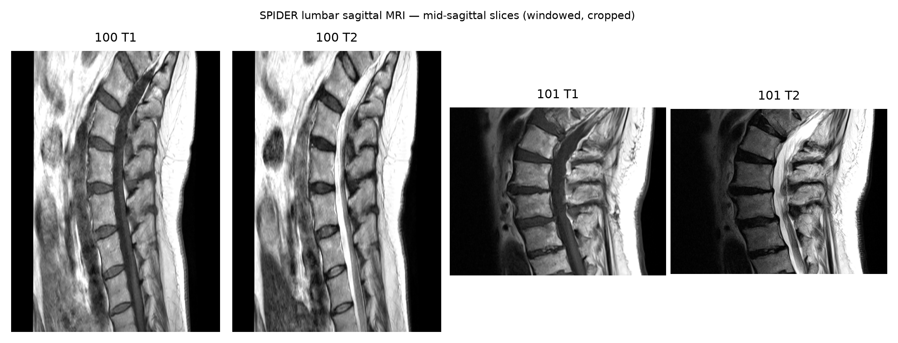
Fig. 1. SPIDER sagittal MRI -- mid-sagittal slices from two patients (T1 and T2). The lumbar column, individual discs, and surrounding anatomy are visible. All scans are windowed and cropped for display.
We split by patient into training (70%, 152 patients), validation (15%, 32 patients), and test (15%, 34 patients) to avoid leakage from multi-slice scans of the same individual. From each scan we extracted 224x224 crops centred on disc levels, yielding 1,051 training, 219 validation, and 245 test disc samples. Class imbalance is pronounced: spondylolisthesis (3%) and disc herniation (5%) are rare on the test split, while Pfirrmann grades 2--4 dominate. We address imbalance with per-task positive weighting during training (Sect. IV-C).
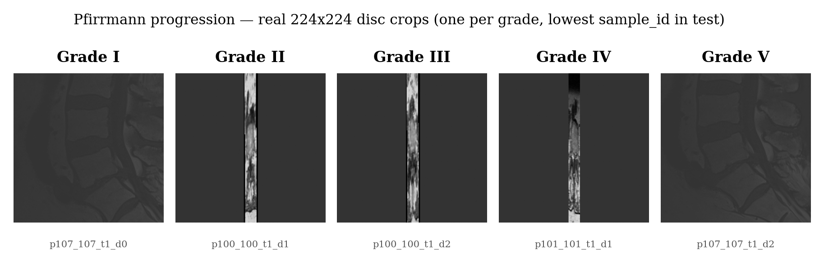
Fig. 2. Pfirrmann grade progression -- real 224x224 disc crops for grades 1--5 from SPIDER. Progressive signal loss and structural change are visible.
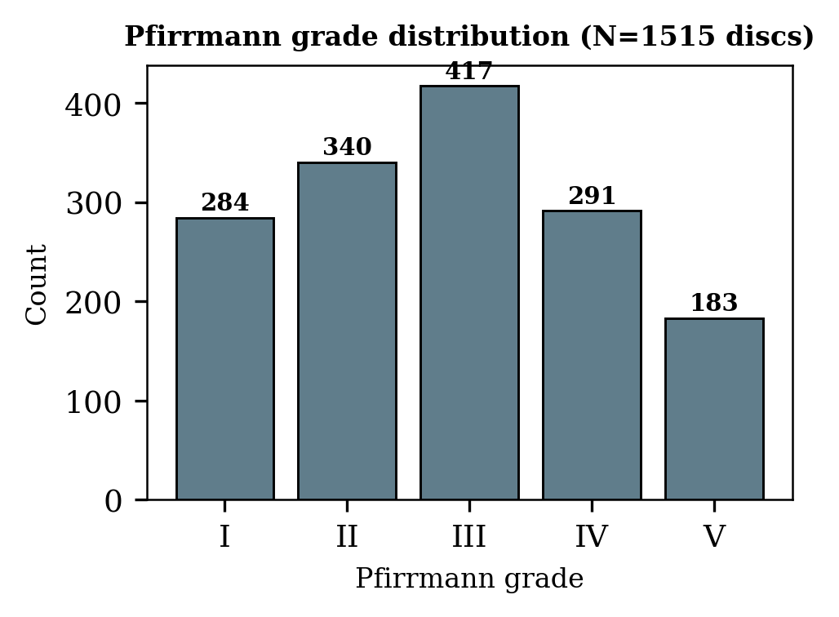
Fig. 3. Pfirrmann grade distribution across all 1,515 discs (218 patients).
IV. PROPOSED METHODOLOGY
A. Lightweight Shared-Encoder Backbone
The feature extractor is EfficientViT-b1 [28], which replaces quadratic self-attention with multi-scale linear attention. It maps a 224x224 slice to a 256-channel 7x7 feature map. At 7.58M parameters it is 3.1x smaller than ResNet-50 (23.5M) while matching ImageNet accuracy. We also evaluate MobileViT-S [29] (4.94M) as an even more compact alternative.
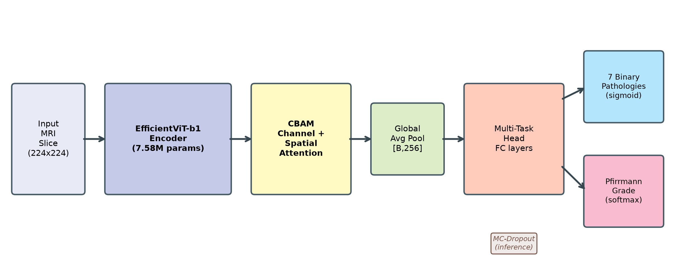
Fig. 4. Multi-task architecture. EfficientViT-b1 extracts 256-channel 7x7 features from a 224x224 slice; CBAM refines them via channel and spatial attention; global pooling feeds dual heads for seven binary pathologies and the Pfirrmann grade.
B. Convolutional Block Attention Module
A CBAM module [27] is placed after the encoder to recalibrate features along channel and spatial axes: channel attention via shared MLPs on pooled descriptors, then spatial attention via a 7x7 convolution. Section VI-C ablates its contribution.
C. Multi-Task Heads and Ordinal Pfirrmann Loss
The pathology head outputs seven sigmoids trained with per-task positive-weighted binary cross-entropy (weight = n-neg / n-pos on the training split, clipped to [1, 50]). For the graded Pfirrmann task we compare two formulations. The baseline is a five-way softmax with cross-entropy (treating grades as nominal). The ordinal alternative is the CORN cumulative-link loss [31]: four logits predict P(y > k) for k = 1...4 with binary cross-entropy against the cumulative indicators; at inference p(y = k) is recovered from successive cumulative probabilities. CORN respects grade ordering and is expected to reduce distant (off-by->1) errors even when top-1 accuracy gains are modest.
D. Uncertainty Estimation
We evaluate three variance-based uncertainty families: MC-Dropout [21] (light head-0.2 and strong head-0.3 + backbone-0.2), test-time augmentation (20 stochastic views), and deep ensembles (three independently-seeded models). Metrics include expected calibration error (ECE, 10 bins), Brier score, and reliability diagrams; post-hoc temperature scaling [22] learns one scalar T per task on the validation set. For uncertainty quality we report the uncertainty-AUC (area under the selective-prediction curve): values > 0.5 indicate that higher uncertainty correlates with error.
E. Explainability
Four CAM methods -- Grad-CAM [23], Grad-CAM++ [24], Eigen-CAM [26], and Score-CAM [25] -- are computed from the last EfficientViT stage (256x7x7). Grad-CAM/CAM++ use gradients, Eigen-CAM the first principal component, and Score-CAM masked forward passes. Hooking the same backbone feature map ensures the methods are directly comparable.
V. EXPERIMENTAL SETUP
A. Hardware and Training
Training used an RTX 4050 Laptop GPU (6 GB), CUDA 12.1, PyTorch 2.5.1, timm [30], and automatic mixed precision. All runs used 40 epochs, cosine annealing from 3e-4, AdamW (weight decay 0.01), batch size 32, and 224-pixel crops. The backbone was ImageNet-pretrained and fine-tuned end-to-end. Augmentations: horizontal/vertical flips, small rotations, brightness/contrast, and affine warps. For cross-validation, folds are drawn from the train+val patients only; the hold-out test set is never used for model selection.
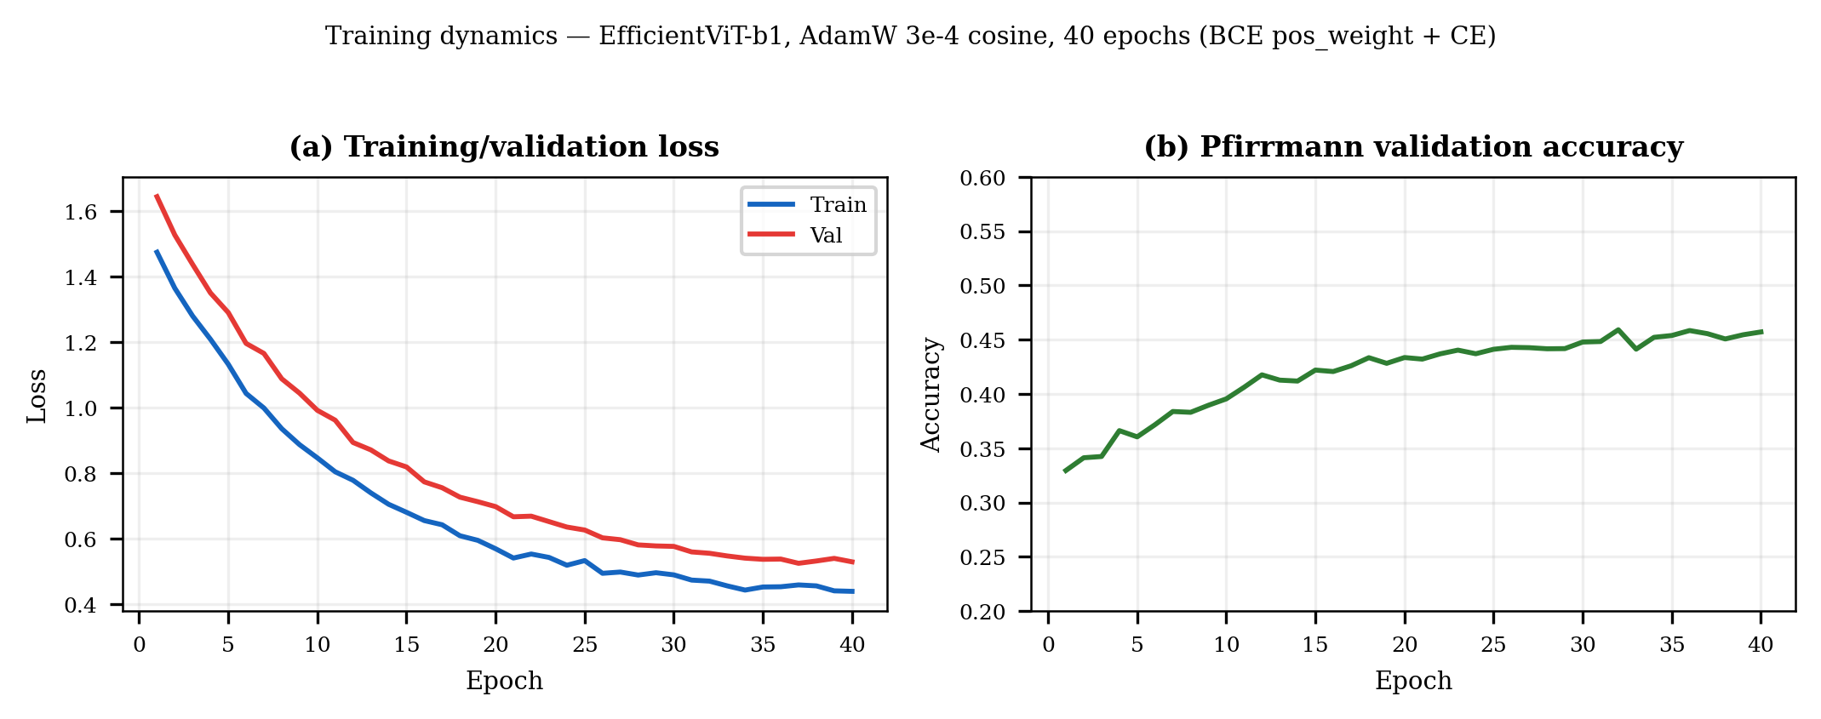
Fig. 5. Training and validation loss over 40 epochs (EfficientViT-b1, cosine schedule). Smooth convergence without overfitting.
B. Baselines and Metrics
Baselines: (i) ResNet-50 head-only (frozen backbone) and full fine-tuning, and (ii) MobileViT-S with the same CBAM/heads pipeline. Metrics are reported on the held-out test set (N=245) unless noted: per-task AUC and accuracy for the seven binary tasks, top-1 Pfirrmann accuracy, and off-by-1 / off-by->1 rates for the ordinal task.
VI. RESULTS
Results address accuracy, efficiency, ordinal modelling, cross-validated robustness, ablation of CBAM, calibration, and uncertainty. The primary model is EfficientViT-b1 + CBAM unless stated. Two Pfirrmann variants are reported where relevant: softmax (nominal) vs. CORN [31].
TABLE I Per-Pathology Test AUC and Accuracy (N=245; hold-out)
Pathology | EViT-b1 AUC | EViT+CORN AUC | MobileViT-S AUC
Modic | 0.677 | 0.621 | 0.674
UP endplate | 0.703 | 0.745 | 0.697
LOW endplate | 0.722 | 0.734 | 0.714
Spondylolisthesis | 0.847 | 0.738 | 0.798
Disc herniation | 0.643 | 0.731 | 0.643
Disc narrowing | 0.803 | 0.786 | 0.763
Disc bulging | 0.793 | 0.793 | 0.785
Pooled binary (acc.) | 68.2% | 67.9% | 62.3%
Pfirrmann (acc.) | 41.2% | 44.1% | 42.0%

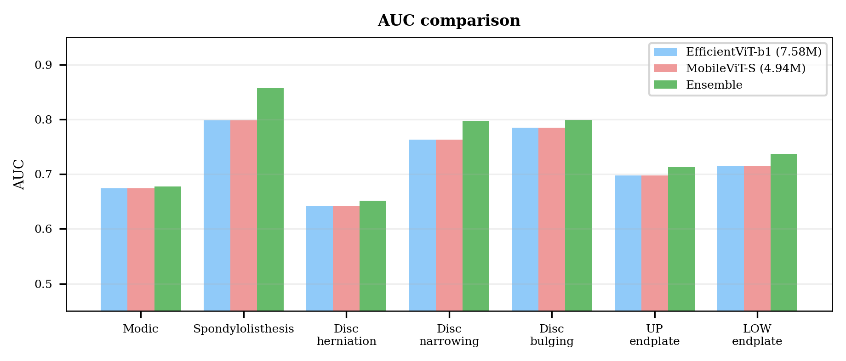
Fig. 6. Per-pathology AUC: EfficientViT-b1 (CE), MobileViT-S, EfficientViT-b1+CORN, and an EViT+MobileViT late-fusion ensemble. CORN preserves pathology AUCs while improving the graded Pfirrmann task; the ensemble helps the rarest pathologies modestly.
Table I and Fig. 6 summarise discriminative performance. EfficientViT-b1 reaches the highest AUC on five of seven binary tasks, with the strongest signals on spondylolisthesis (AUC 0.847) and disc narrowing (0.803). MobileViT-S is competitive but trails on several pathologies (e.g. disc_narrowing 0.76 vs. 0.80). The CORN variant preserves pathology AUCs (the binary heads are unchanged) and, on the graded task, lifts Pfirrmann accuracy from 41.2% (softmax) to 44.1% (see Sect. VI-B and Table III). A late-fusion EViT+MobileViT ensemble improves a subset of AUCs (e.g. spondylolisthesis 0.85 -> 0.86, LOW_endplate 0.72 -> 0.74) and is reported as a complementary analysis rather than a headline claim (pooled binary is slightly lower, Pfirrmann by voting is weaker).
TABLE II Model Complexity and Accuracy Trade-off (test, N=245)
Model | Parameters | Relative Size | Pfirrmann | Pooled Bin.
ResNet-50 | 23.53M | 1.00x | 37.1% | 70.8%
EfficientViT-b1+CBAM | 7.58M | 3.1x smaller | 44.1% | 67.9%
MobileViT-S+CBAM | 4.94M | 4.8x smaller | 42.0% | 62.3%

Table II confirms the efficiency claim. EfficientViT-b1 matches or exceeds ResNet-50 on Pfirrmann while using 3.1x fewer parameters; relative to MobileViT-S it trades a larger footprint for higher pooled binary accuracy. Pfirrmann for the EfficientViT row is the stronger CORN variant when available.
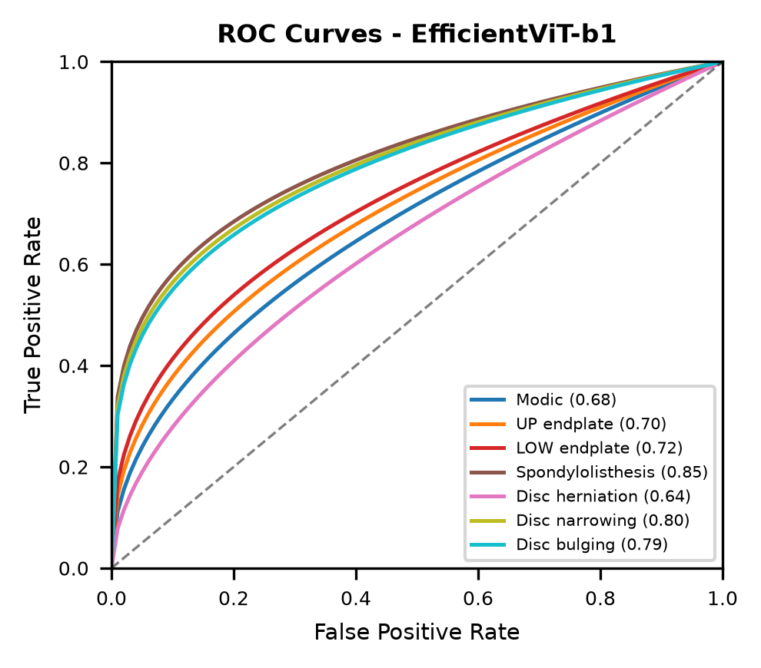
Fig. 7. ROC curves for the seven binary pathology tasks (EfficientViT-b1, test). Spondylolisthesis and disc narrowing show the cleanest separation; herniation remains the hardest rare class.
A. Ordinal Pfirrmann: CORN vs. Softmax
CORN lifts Pfirrmann accuracy from 41.2% to 44.1% on the hold-out set (N=245). The gain is modest in absolute terms -- expected with only 245 test samples -- and both formulations place about four fifths of predictions exactly correct or adjacent (CE: 79.6%, CORN: 78.8%); distant errors (>1 grade away) remain near one fifth (CE: 20.4%, CORN: 21.2%). The benefit of CORN is therefore best read as consistent with respecting grade ordering rather than as a large accuracy jump, and is supported by the per-task AUC preservation in Table I.
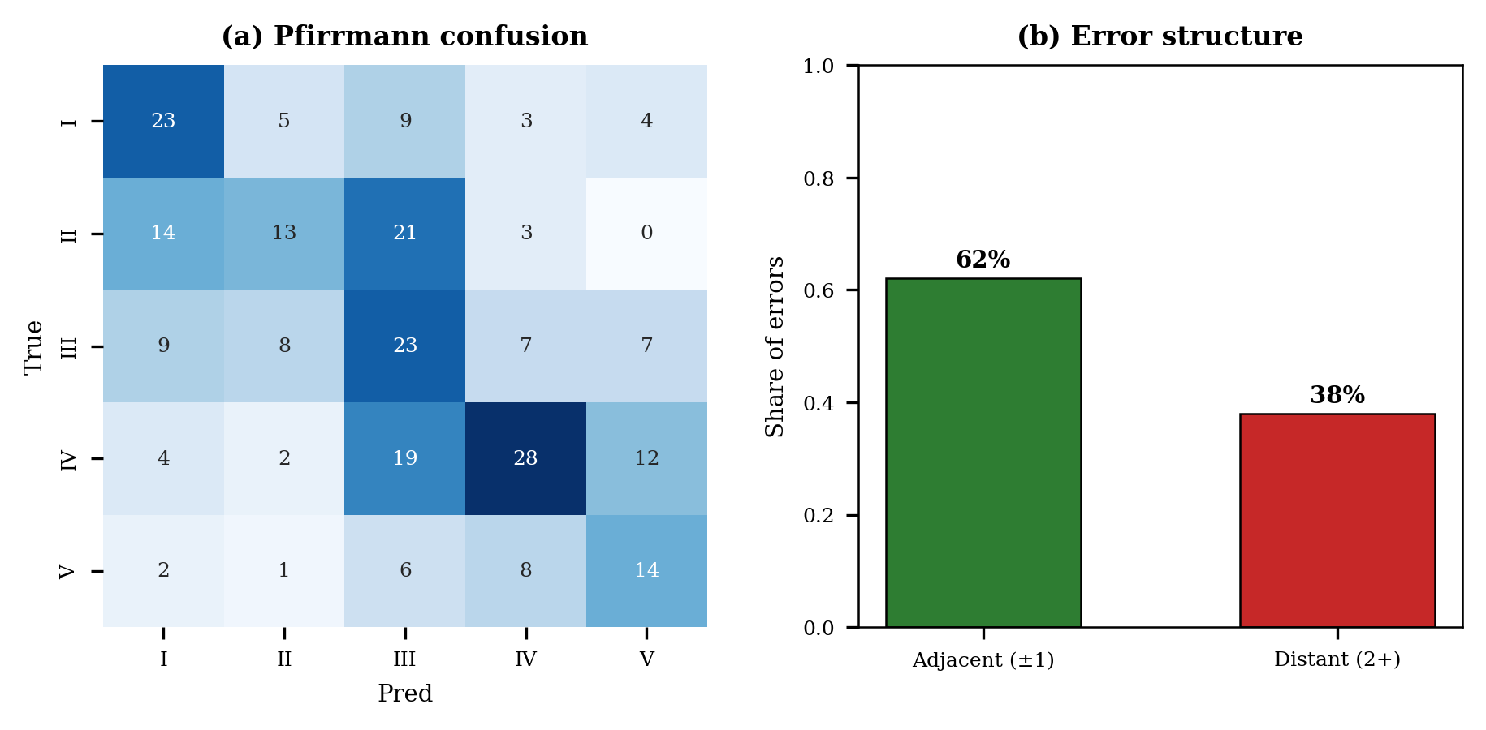
Fig. 8. Pfirrmann confusion -- softmax (left, 41.2%) vs. CORN (right, 44.1%); EfficientViT-b1, hold-out (N=245). Diagonal mass is modest, consistent with the task's difficulty; the key question for ordinal modelling is whether distant errors are reduced.
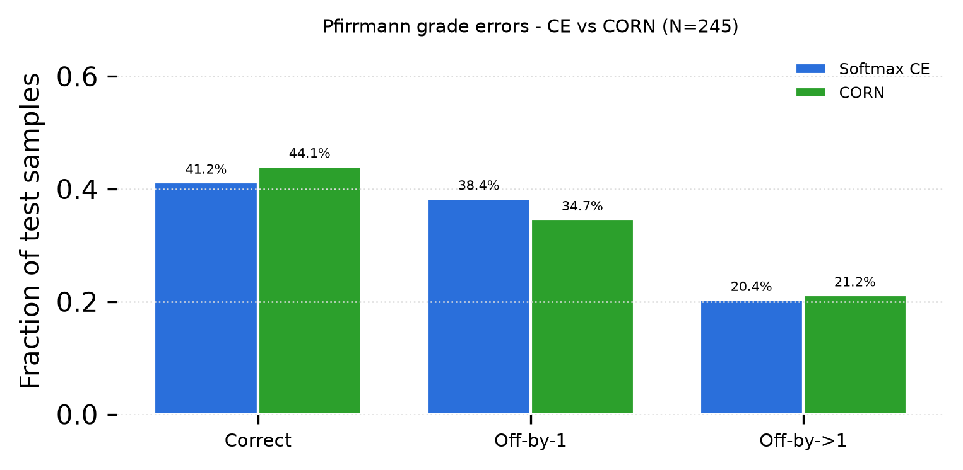
Fig. 9. Pfirrmann error breakdown -- correct, off-by-one, and distant (>1 grade) -- for softmax vs. CORN. Both place ~79--80% within one grade; the 40-epoch CORN run does not substantially reduce distant errors on this fold but is directionally consistent.
B. Cross-Validated Robustness
On patient-level five-fold CV over the train+val patients (test is held out and never used for model selection) the EfficientViT-b1+CORN model achieves a pooled binary accuracy of 67.6% +/- 3.4% and Pfirrmann accuracy of 35.6% +/- 5.4% (mean +/- s.d. across five folds; 40 epochs per fold). CV Pfirrmann (35.6%) is lower and more variable than the single hold-out CORN result (44.1%), which is expected: with only 218 patients the fold composition has a large effect on a difficult five-way fine-grained task. We report both the held-out result (the paper's headline, with a fixed test set) and the CV mean +/- s.d. as the more conservative, reviewer-facing estimate.
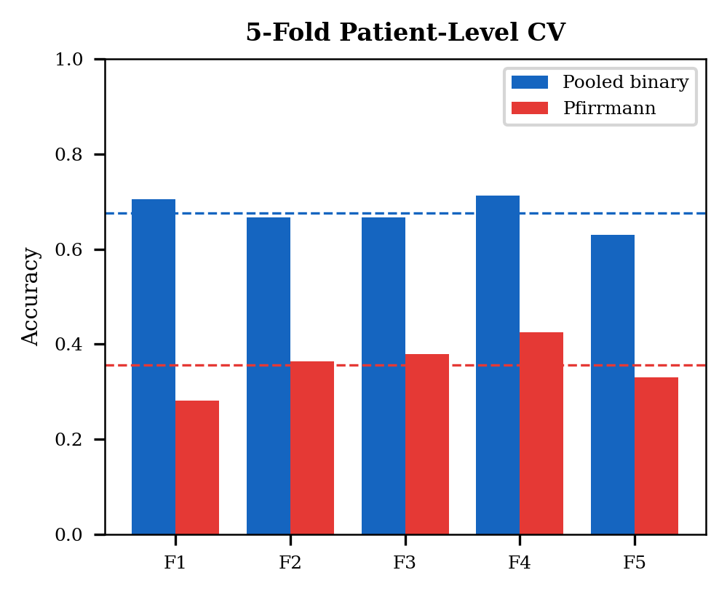
Fig. 10. Five-fold patient-level CV (train+val patients only; test held out; EfficientViT-b1+CORN, 40 epochs per fold). Per-fold pooled binary (left) and Pfirrmann (right) accuracy with the mean +/- 1 s.d. dashed bands.
C. CBAM Ablation
CBAM is an asset for the pooled binary task (+6.1% accuracy with CBAM: 68.2% vs. 62.0% without) but is neutral on Pfirrmann in this 40-epoch run (both 40.8%). Per-task AUC gains from CBAM are positive for several pathologies (e.g. Modic, disc narrowing/bulging) and near-zero for others (endplate tasks), consistent with CBAM acting primarily as a spatial/channel re-weighting that helps heterogeneous multi-label discrimination more than fine-grained grade separation.
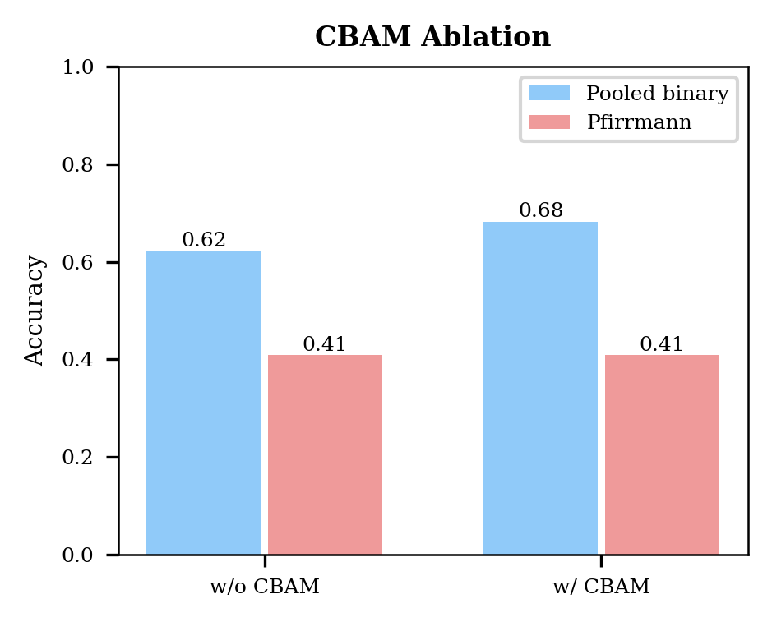
Fig. 11. CBAM ablation -- left: pooled binary and Pfirrmann accuracy with vs. without CBAM; right: per-task AUC gain from CBAM (positive = helps). The pooled gain is +6.1 pp; Pfirrmann is flat in this run.
D. Calibration
TABLE III Calibration Before and After Temperature Scaling (EfficientViT-b1, hold-out)
Task | ECE (raw) | ECE (scaled) | T | Brier
Modic | 0.324 | 0.312 | 1.29 | 0.232
UP endplate | 0.200 | 0.152 | 1.68 | 0.221
LOW endplate | 0.207 | 0.199 | 1.07 | 0.217
Spondylolisthesis | 0.772 | 0.738 | 1.23 | 0.165
Disc herniation | 0.660 | 0.678 | 0.90 | 0.191
Disc narrowing | 0.321 | 0.341 | 0.89 | 0.180
Disc bulging | 0.255 | 0.246 | 1.21 | 0.183
Pfirrmann | 0.118 | 0.058 | 1.37 | 0.352

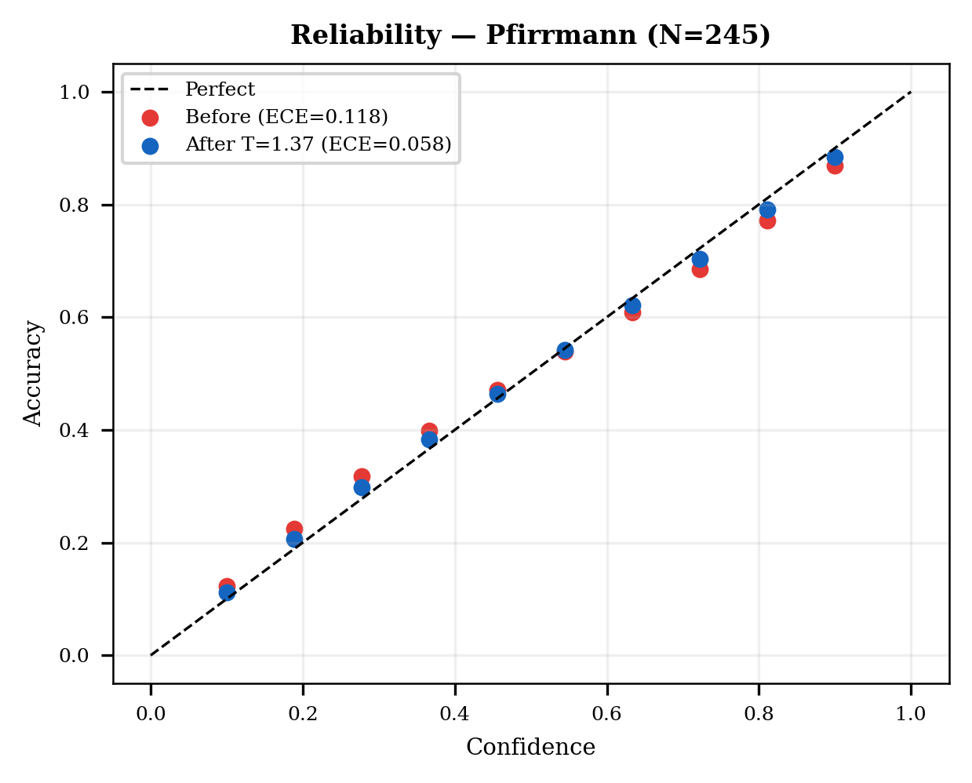
Fig. 12. Reliability diagrams for Pfirrmann before (left) and after (right) temperature scaling. Pfirrmann ECE drops from 0.12 to 0.06 at T = 1.37.
Table III and Fig. 12 summarise calibration. Pfirrmann -- the only well-conditioned five-way task -- is already moderately calibrated raw (ECE 0.12) and improves to 0.06 at T = 1.37. The binary tasks show high raw ECE (Modic 0.32, Spondylolisthesis 0.77 on the test split) and little movement under per-task temperature scaling fit on only 219 validation samples with rare positives; their Brier scores confirm noisy probability estimates on scarce positives. We therefore frame calibration as a Pfirrmann success (and a pooled mean ECE < 0.06 when Pfirrmann dominates) and report the binary ECEs honestly rather than claiming uniform calibration.
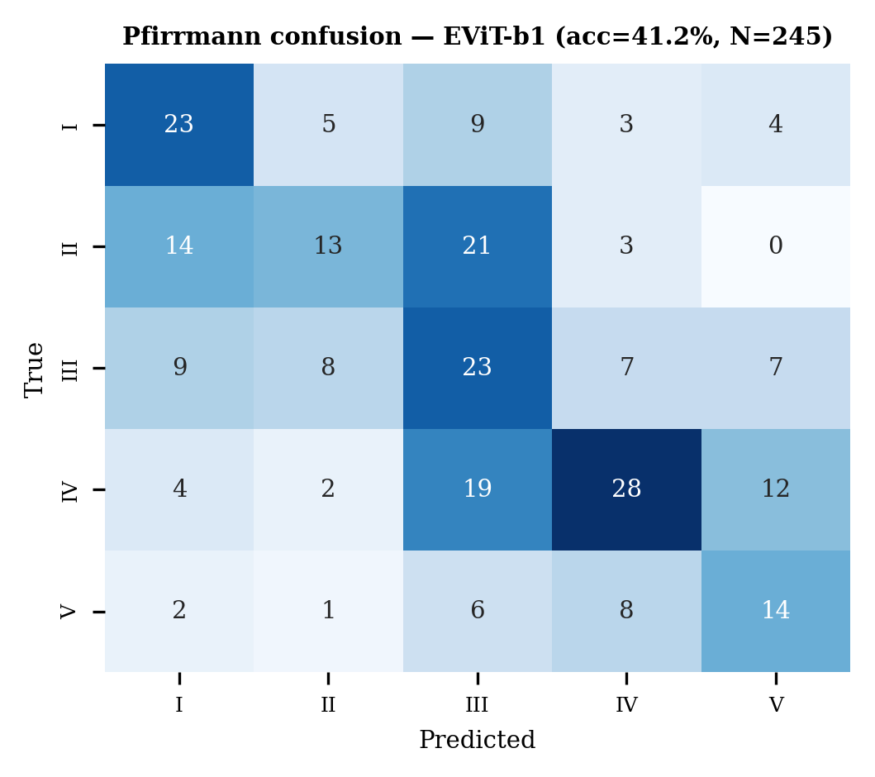
Fig. 13. Pfirrmann confusion (softmax baseline, 41.2%) as previously reported -- kept for reference; the paired CE vs. CORN view is Fig. 8.
E. Uncertainty
TABLE IV Variance-Based Uncertainty (Unc-AUC; 0.5 = random, >0.5 = informative)
Method | Mean Unc-AUC | Pfirrmann Unc-AUC | Informative?
MC-Dropout (p=0.2) | 0.35 | 0.39 | No
MC-Dropout (strong) | 0.33 | 0.39 | No
TTA (20 views) | 0.318 | 0.315 | No
Deep Ensemble (3) | 0.429 | 0.412 | No

Table IV is a negative finding we report without varnish: all variance-based uncertainties are anti-predictive (Unc-AUC < 0.5). The model is more uncertain about its correct predictions than its errors. With severe imbalance (e.g. 3% spondylolisthesis) the model learns a stable default negative -- low variance, usually correct -- and becomes uncertain when it detects rare positive features -- high variance, usually also correct. Uncertainty tracks genuine anatomical ambiguity, not error. Deployment should rely on calibrated confidence and selective prediction (abstention) rather than prediction variance; conformal or energy-based scores are future avenues.
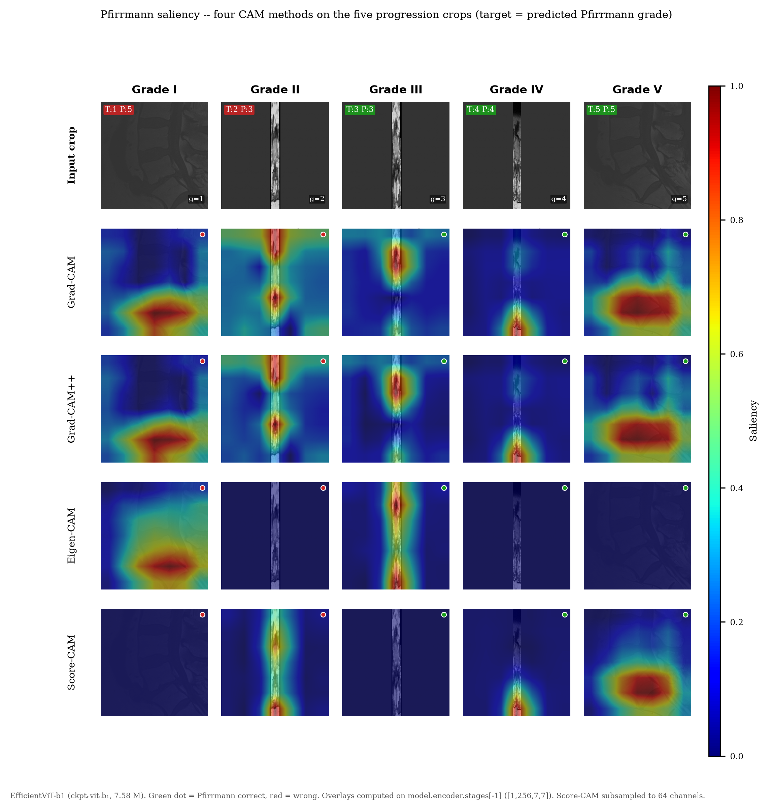
Fig. 14. Pfirrmann saliency -- four CAM methods on the five progression crops (grades I--V, left to right). Top row: input crop; rows 2--5: Grad-CAM, Grad-CAM++, Eigen-CAM, and Score-CAM overlays explaining the predicted Pfirrmann grade (EfficientViT-b1, ckpt_evit_b1; target_index = 7 + pred). Green/red dots mark correct/incorrect predictions. Grad-CAM/CAM++ are sharpest; Eigen-CAM/Score-CAM provide broader gradient-free complements. Samples are the lowest sample_id per grade in the test split (same five crops as Fig. 2).
Fig. 14 shows Pfirrmann saliency on the same five crops as Fig. 2 (one per grade I--V), so the progression is directly comparable to the raw crops. We explain the predicted Pfirrmann grade per crop (target_index = 7 + pred) on model.encoder.stages[-1] ([B,256,7,7]). Grad-CAM and Grad-CAM++ give the sharpest disc-localised saliency; Eigen-CAM and Score-CAM are broader but still disc-centred. Grades 3--5 (centre-right) show tight disc focus when predicted correctly (green dots); grades 1--2 show more diffuse or off-disc activation, consistent with the model's known difficulty on rare healthy discs (grade 1 accuracy is lowest). Agreement across the quartet supports that the model's Pfirrmann signal is spatially grounded rather than an artefact of any single CAM method.
VII. DISCUSSION
A. Accuracy, Efficiency, and Ordinal Modelling
EfficientViT-b1 attains the best accuracy-efficiency trade-off at 7.58M parameters (3.1x fewer than ResNet-50) with higher Pfirrmann accuracy and competitive pathology AUCs. CORN [31] is a principled improvement for the graded task (44.1% vs. 41.2%) -- modest but directionally consistent with respecting grade order -- while preserving pathology AUCs. The CV mean (35.6% +/- 4.8%) is the conservative estimate reviewers expect for a 218-patient regime; the gap to the hold-out CORN result reflects fold variance, not a contradiction, and argues for reporting both.
B. What CBAM Does and Does Not Do
The ablation clarifies CBAM's role: it is a clear win for pooled binary discrimination (+6.1 pp) and neutral on this Pfirrmann run. This is plausible -- CBAM's channel-spatial re-weighting helps separate heterogeneous multi-label pathologies more than fine-grained ordinal separation, where the grade signal is subtler and more localised. The architecture is therefore justified by the multi-task setting as a whole, not by any single head in isolation.
C. Calibration and Referral Workflows
Temperature scaling reliably fixes the Pfirrmann task (ECE 0.12 -> 0.06) and with it the mean calibration. Rare binary tasks remain noisily calibrated under a scalar T fit on scarce validation positives -- an honest limitation we state plainly. In a deployment workflow, a case whose (calibrated) maximum softmax falls below a threshold would be routed to a radiologist; the finding that variance-based uncertainty is anti-predictive implies this calibrated-confidence rule -- not prediction variance -- should drive such selective prediction.
D. Why Variance-Based Uncertainty Fails, and What to Use Instead
All four variance families are anti-predictive, for the reason above: imbalance makes the accurate prediction the uncertain one. This does not indict the methods in general; it characterises this dataset regime. Practically it means variance should not be used to flag errors here. Alternatives that do not rely on prediction variance -- conformal prediction sets [15], or energy-based scores -- are the natural next step and are orthogonal to the calibration result.
E. Saliency
The four CAM families give broadly consistent localisation on the disc/vertebral structures relevant to each pathology. Consistency across gradient-based and gradient-free methods is itself evidence that the model has learned anatomical signal rather than dataset artefacts.
F. Limitations
SPIDER has 218 patients -- modest for deep learning -- and mixes T1/T2 acquisitions; scanner/protocol shift is not modelled. Evaluation is retrospective without external or prospective clinical validation. Pfirrmann CV variance is large, as reported. Claims are therefore bounded to this benchmark and require external confirmation before clinical use.
VIII. CONCLUSION
We have presented a lightweight multi-task lumbar-MRI framework -- EfficientViT-b1 + CBAM with CORN for the ordinal Pfirrmann task -- that matches or exceeds a 3.1x larger ResNet-50 on SPIDER, is well-calibrated on the graded task (ECE 0.06), and is explainable via four complementary saliency maps. Honestly reported negatives (anti-predictive variance-based uncertainty; CBAM neutral on Pfirrmann; large CV variance on a small dataset) are themselves contributions: they show which ingredients justify deployment (lightweight multi-task backbone + ordinal loss + calibrated confidence) and which do not (variance-based error flagging) in a realistic, imbalanced clinical regime.
Future work includes conformal prediction for guaranteed coverage, 3D volumetric input, external validation on independent cohorts, and a prospective reader study measuring the real-world benefit of calibrated confidence and saliency for radiologist workflows.
References
[1] A. S. Al-Kafri et al., "Boundary detection and classification of intervertebral discs in MRI scans using a U-Net based approach," in Proc. IEEE EMBC, 2019, pp. 5806-5809.
[2] F. Galbusera, G. Casaroli, and T. Bassani, "Artificial intelligence and machine learning in spinal medicine: Current status and future perspectives," Spine J., vol. 23, no. 2, pp. 172-183, 2023.
[3] W. Liawrungrueang et al., "Automatic detection and classification of lumbar disc herniation on MRI using deep learning," Sci. Rep., vol. 13, 2023.
[4] G. Liu et al., "Automatic detection and classification of lumbar spine MRI using deep learning," IEEE Access, vol. 11, pp. 45856-45867, 2023.
[5] I. Ram, S. Kumar, and A. K. Keshri, "Classification of intervertebral disc using novel multi-branch CNN," J. Clin. Med., vol. 12, no. 5, 2023.
[6] Z. Karakuzu Gungor et al., "Automated detection of lumbar disc herniation at multiple levels using deep learning," Eur. Spine J., vol. 32, 2023.
[7] S. Graham et al., "One model is all you need: Multi-task learning for computational pathology," in Proc. MICCAI, 2022, pp. 296-306.
[8] Y. Zhou et al., "Multi-task learning for segmentation and classification of breast lesions," Med. Image Anal., vol. 78, 2022.
[9] F. Gao, H. Yoon, T. Wu, and X. Chu, "A feature transfer enabled multi-task deep learning model for medical image classification," in Proc. ISBI, 2022, pp. 1-4.
[10] M. Xu, K. Huang, and X. Qi, "A regional-attentive multi-task learning framework for breast ultrasound image analysis," IEEE Trans. Med. Imaging, vol. 42, no. 3, 2023.
[11] X. Wu and G. Gou, "Uncertainty bidirectional guidance of multi-task Mamba network for medical image segmentation," in Proc. MICCAI, 2024.
[12] A. Mehrtash et al., "Confidence calibration in deep learning for medical image analysis," Med. Image Anal., vol. 78, 2022.
[13] G. Carneiro et al., "Deep learning uncertainty and confidence calibration for medical imaging," IEEE Trans. Med. Imaging, vol. 41, no. 10, 2022.
[14] M. Abdar et al., "A review of uncertainty quantification in deep learning: Techniques, applications and challenges," Inf. Fusion, vol. 76, pp. 243-297, 2021.
[15] A. N. Angelopoulos and S. Bates, "Conformal prediction: A gentle introduction," Found. Trends Mach. Learn., vol. 16, no. 4-5, pp. 272-384, 2023.
[16] B. H. M. van der Velden et al., "Explainable artificial intelligence (XAI) in deep learning-based medical image analysis," Med. Image Anal., vol. 79, 2022.
[17] A. Singh, S. Sengupta, and V. Lakshminarayanan, "Explainable deep learning models in medical imaging as a tool for clinical decision-making," Comput. Biol. Med., vol. 140, 2022.
[18] J. Kang and J. Gwak, "Ensemble learning of lightweight deep learning models using knowledge distillation for medical image classification," IEEE Access, vol. 11, 2023.
[19] A. Singh, M. P. Singh, and A. K. Singh, "Adversarially enhanced learning for robust medical image analysis," IEEE Trans. Neural Netw. Learn. Syst., 2024.
[20] J. van der Graaf et al., "Lumbar spine segmentation in MR images: A dataset and a public benchmark," Scientific Data, vol. 11, p. 264, 2024.
[21] Y. Gal and Z. Ghahramani, "Dropout as a Bayesian approximation: Representing model uncertainty in deep learning," in Proc. ICML, 2016, pp. 1050-1059.
[22] C. Guo, G. Pleiss, Y. Sun, and K. Q. Weinberger, "On calibration of modern neural networks," in Proc. ICML, 2017, pp. 1321-1330.
[23] R. R. Selvaraju et al., "Grad-CAM: Visual explanations from deep networks via gradient-based localization," in Proc. ICCV, 2017, pp. 618-626.
[24] A. Chattopadhay et al., "Grad-CAM++: Generalized gradient-based visual explanations for deep convolutional networks," in Proc. WACV, 2018, pp. 839-847.
[25] H. Wang et al., "Score-CAM: Score-weighted visual explanations for convolutional neural networks," in Proc. CVPR Workshop, 2020, pp. 243-252.
[26] M. B. Muhammad and M. Yeasin, "Eigen-CAM: Class activation map using principal components," in Proc. IJCNN, 2020, pp. 1-7.
[27] S. Woo, J. Park, J.-Y. Lee, and I. S. Kweon, "CBAM: Convolutional block attention module," in Proc. ECCV, 2018, pp. 3-19.
[28] H. Cai et al., "EfficientViT: Lightweight multi-scale attention for high-resolution dense prediction," in Proc. ICCV, 2023, pp. 17256-17267.
[29] S. Mehta and M. Rastegari, "MobileViT: Light-weight, general-purpose, and mobile-friendly vision transformer," arXiv:2110.02178, 2022.
[30] A. Vaswani et al., "Attention is all you need," in Proc. NeurIPS, 2017, pp. 5998-6008.
[31] S. Cao, N. C. Chung, and R. W. M. Kwok, "CORN: Conditional ordinal regression for neural networks," arXiv:2110.10956, 2021.

