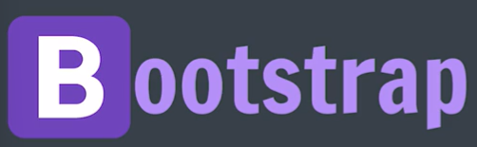
Bootstrap is a powerful, feature-packed frontend toolkit.
Build anything – from prototype to production – in minutes
Bootstrap is a CSS framework, a CSS toolkit.
There are many components which we use repetitively used like forms, navbar, cards, buttons, etc…. Bootstrap provides a toolkit of these components, which we can directly use.
No need to style from basics …

In terms of popularity, still pure CSS/Vanilla CSS comes at no. 1 and 2nd is Bootstrap.
Bootstrap is a CSS framework that uses Flexbox to make layouts easier to build and has various pre-built components.

Provides pre built CSS file that can attached with html file
getbootstrap.com
Bootstrap is mainly a CSS framework, but it also includes JavaScript components.

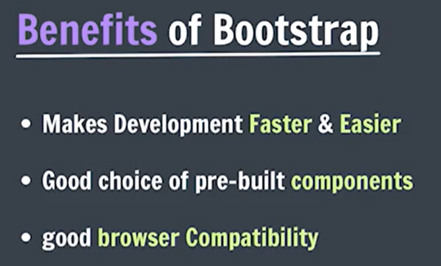
Provides already built in responsive components

Why CSS then?
Bootstrap don’t provide exactly what we are thinking and hence we need to customize it using our knowledge of CSS.
Ways to include Bootstrap in our project
- Download Bootstrap
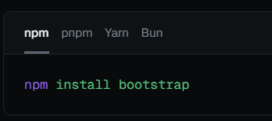

- Include CDN links: Include Bootstrap’s CSS and JavaScript files via CDN.
CDNs (Content Delivery Networks) are services that provides copies of libraries for your website.

CSS link goes inside <head>:
<link
href="https://cdn.jsdelivr.net/npm/bootstrap@5.3.5/dist/css/bootstrap.min.css"
rel="stylesheet"
/>

Add this Bootstrap JavaScript bundle just before the closing </body> tag:
<script src="https://cdn.jsdelivr.net/npm/bootstrap@5.3.5/dist/js/bootstrap.bundle.min.js">
</script>

If you include bootstrap file first and then some other CSS file , then that other CSS file will overwrite bootstrap file and vice versa.

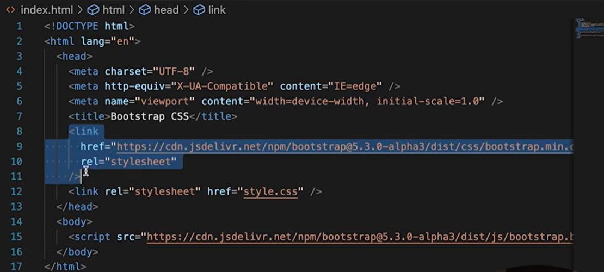

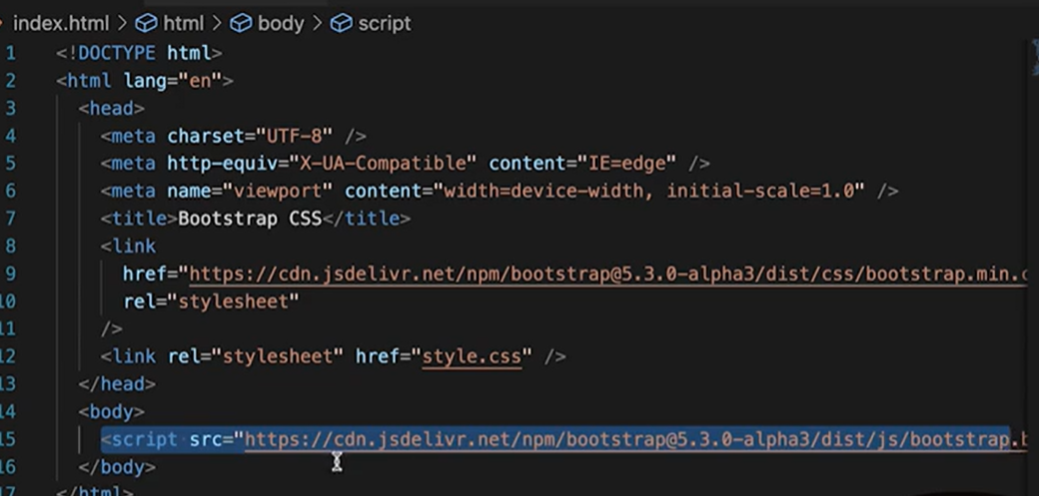

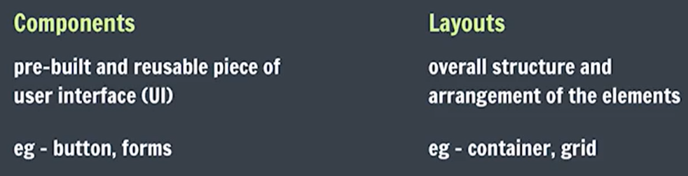

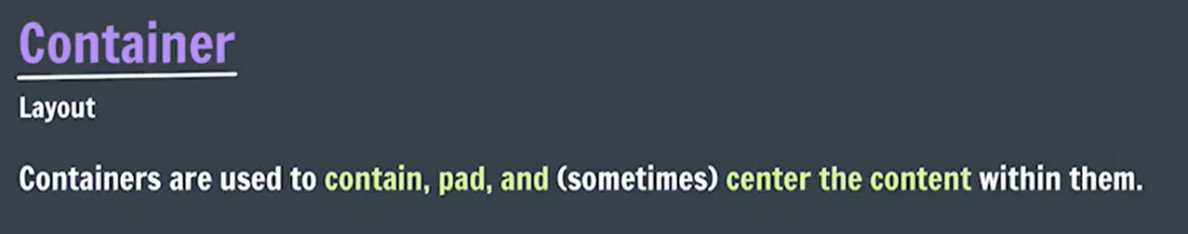
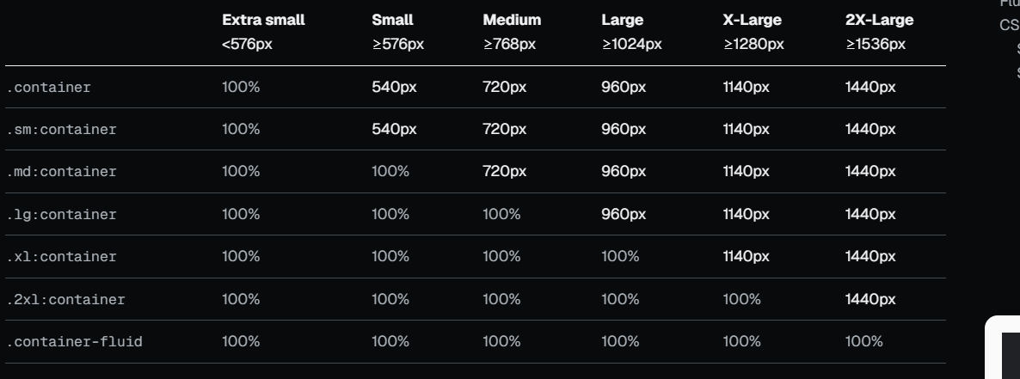

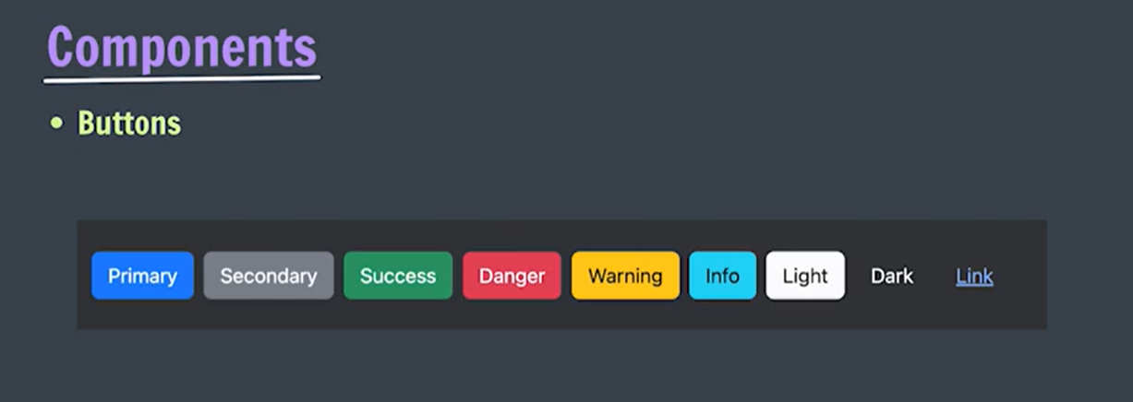
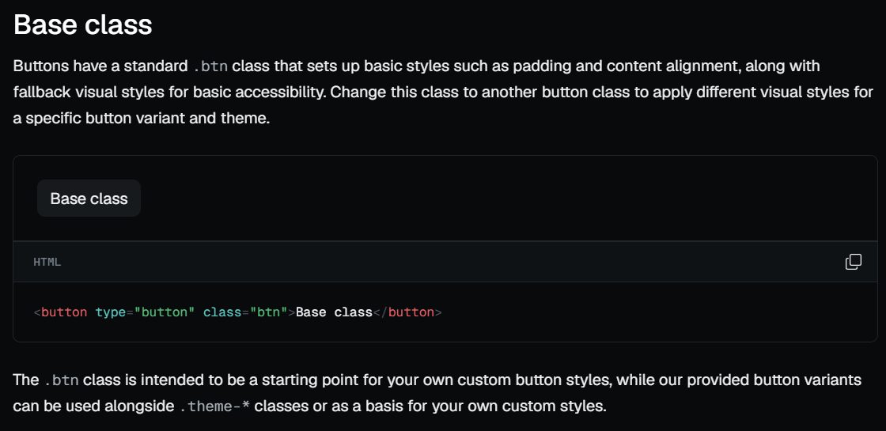
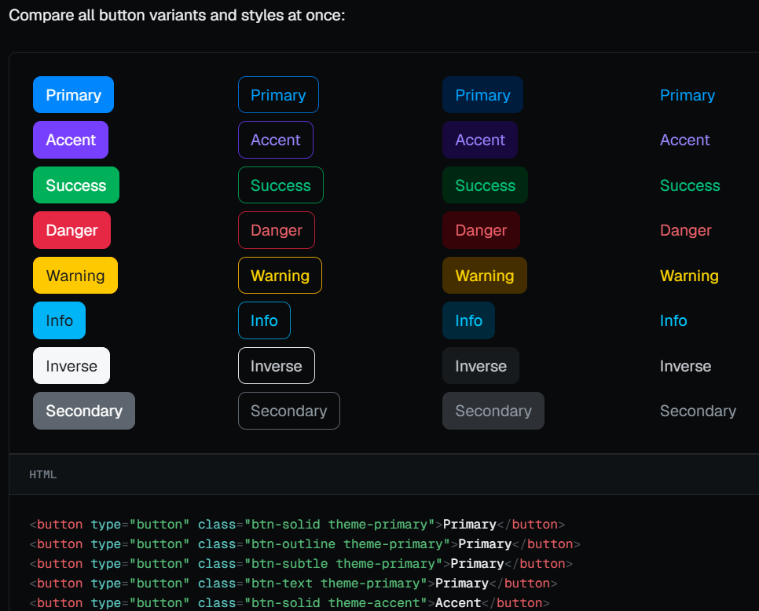

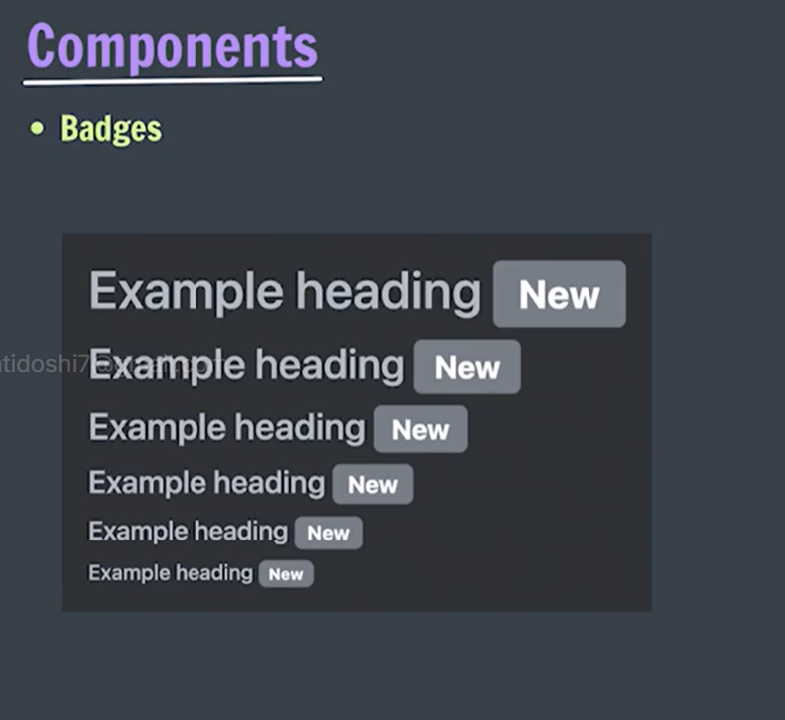
Small components for indicating status and counts, or labelling items.

Badges are tiny, static display components used for adding context to other elements. They can be used as part of navigation, buttons, and more to provide a counter or label. Badges scale to match the size of the immediate parent element by using relative font sizing and em units.

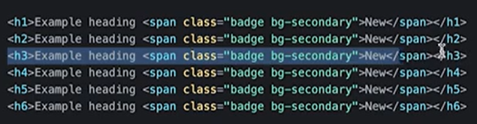

<button class="btn btn-primary theme-primary">Notifications <span class="badge bg-danger" style="border-radius: 50%;">4</span></button>

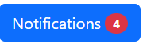

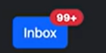

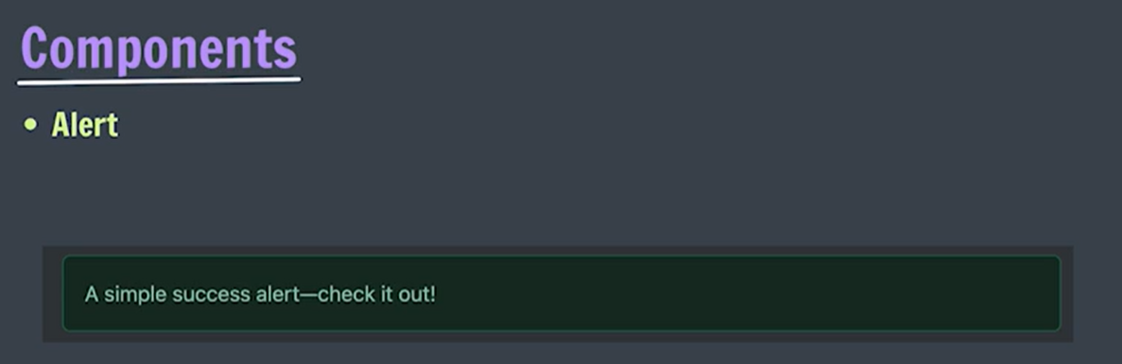
Alert: Provide contextual feedback messages for typical user actions with the handful of available and flexible alert messages.

Navbar
Create flexible, responsive navigation bars. Includes support for branding, navigation, and a built-in drawer for mobile.

