HTML 5
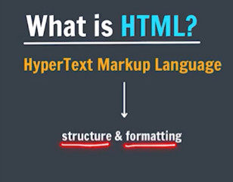
HTML tells formatting and structure of everything that is written on a website.
HTML decides what will be there on a web page and how it looks(the format), its representation.
HTML is a markup language, it is not a hardcoded programming language.
HTML is very simple.
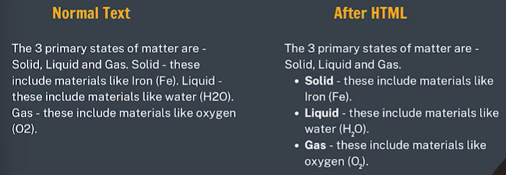
HTML tells the rules to our browsers (chrome, Firefox, safari. Etc) that how to present our plain text.

HTML creates a web page not a website
Website => a broader term, consists of backend, frontend, database etc
Webpage => a small page of website

Right click => view page source and inspect (temporary changes)

Paragraph Element (Every paragraph tag starts with a new line)
<p>Hello World </p>
<p>Srishti Doshi </p>
=>
Hello World
Srishti Doshi
<p/> => paragraph tag
<b/> => bold tag

If you give so much spaces inside a paragraph tag, html will ignore it and all content will be visible on a single line only.
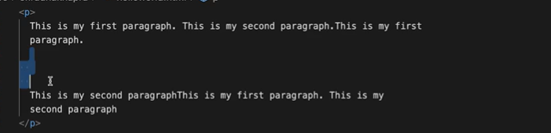

Nesting -> nested tags (tags inside tag)

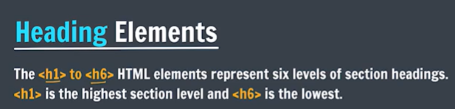
All heading tags have their default sizes.

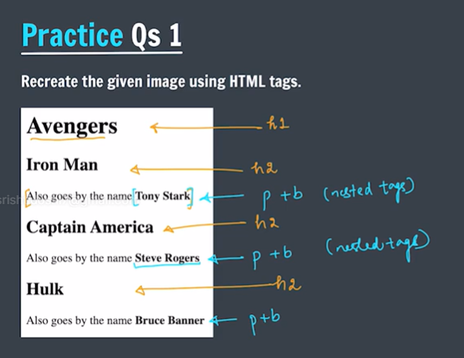
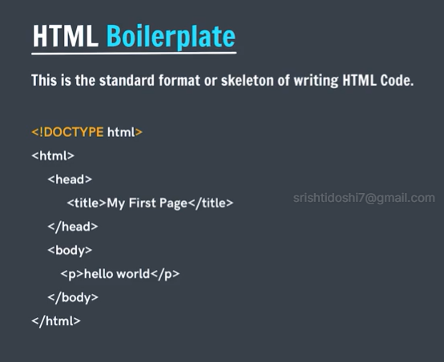
<!DOCTYPE html> => tells that we are using HTML5 (5th version of html)
<html> -> root tag
<head> -> head tag (meta info., extra info, meta data , CSS link, JS link)
<title> -> title tag ( name of page, displayed on tab not on website, should be very relevant)
<body> -> body tag (data that is actually displayed on website)
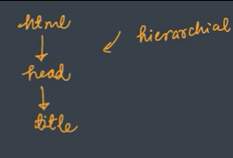

Shortcut: Boilerplate Code
Type and enter: ! (Called emmets (shortforms, preinstalled on code editors))
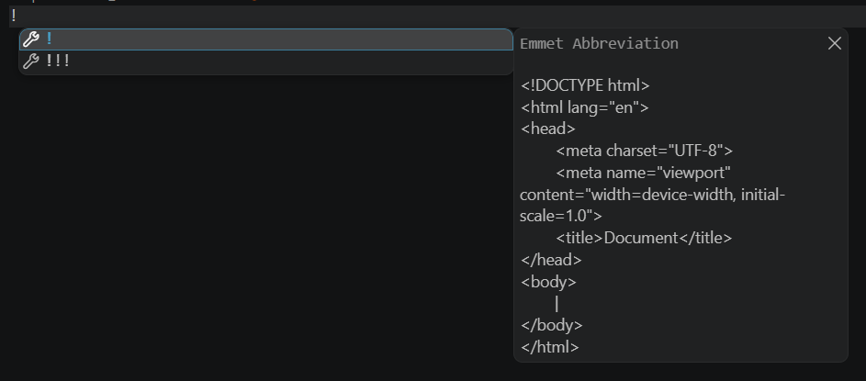
Boilerplate code:
<!DOCTYPE html>
<html lang = “en”>
<head>
<meta charset = “UTF-8”>
<meta name = “viewport” content = “width = device-width, initial-scale = 1.0”>
<title>Document</title>
</head>
<body>

</body>
</html>

Give proper spacing, tab space called indentation for proper reading

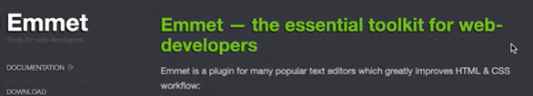
Visit emmet.io
https://docs.emmet.io/cheat-sheet/
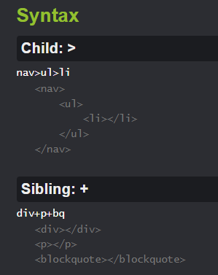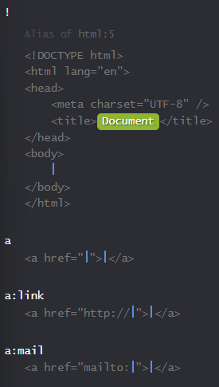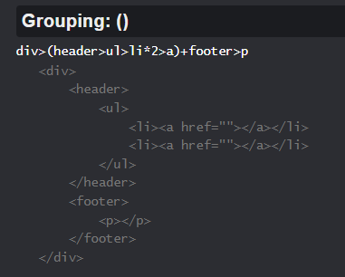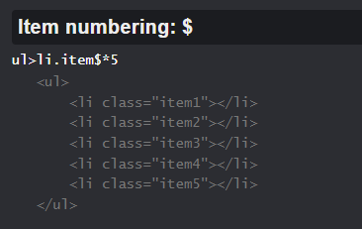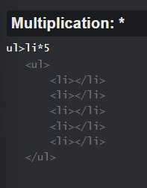
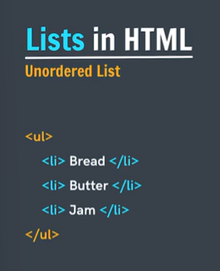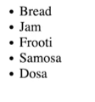
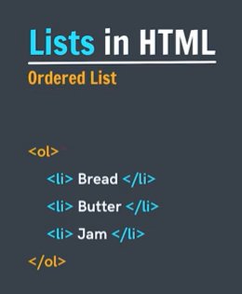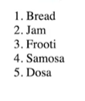
<li> tag for each item
<ol> tag for ordered list
  - <ol type = “circle”>
  - <ol type = “square”>
<ul> tag for unordered list
  - <ul type = “A”>
  - <ul type = ‘a’>
  - <ul type = “I”>

We can either use or “ “ or ‘ ‘ to define attributes in html tags
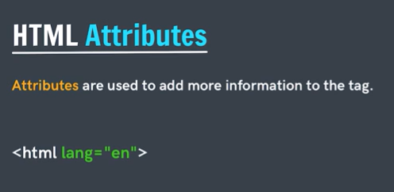

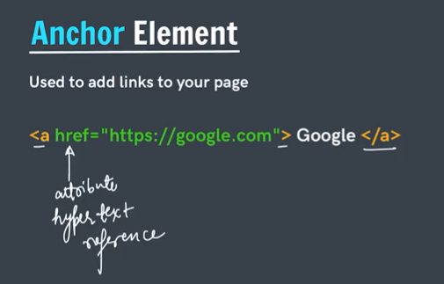
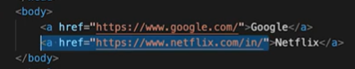

In href attribute, we can have two types of links
- Absolute Link => internet links, like for google, Netflix, written as it is on internet
- Relative Link => file links, one html page to another html page

Types of Tags
- Pair tag => <h1></h1> <p></p> <a></a>
- Single tag => <img> <br> <hr>
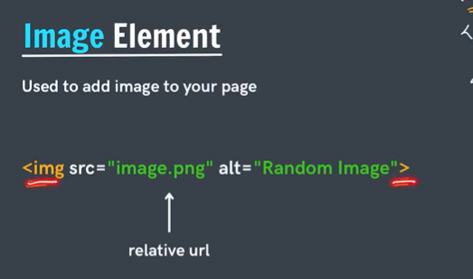
img tag is a single tag and hence no text can be written simply.
Alt attribute helps us write a an alternate text when img is not available/missing
To add internet image, we use internet url of that image, by copying its image address, but if that image on interent does not exist or move then we won’t see it on our webpage.
Relative url and image are more reliable

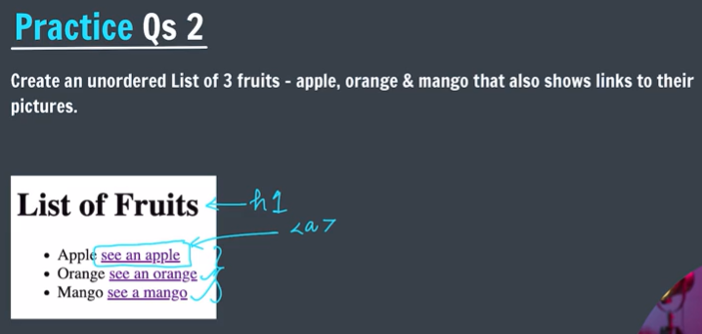
<!DOCTYPE html>
<html lang = “en”>
<head>
<meta charset = “UTF-8”>
<meta name = “viewport” content = “width = device-width, initial-scale = 1.0”>
<title>Fruits List</title>
</head>
<body>
<h1>List of Fruits</h1>
<ul>
<li>Apple <a href = “https://apple.com”>see an apple</a></li>
<li>Orange <a href = “https://orange.com”>see an orange</a></li>
<li>Mango <a href = “https://mango.com”>see an mango</a></li>
</ul>
</body>
</hml>
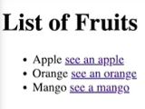

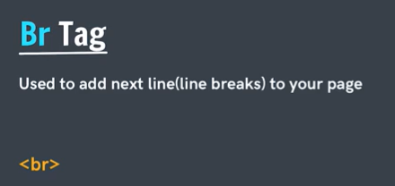
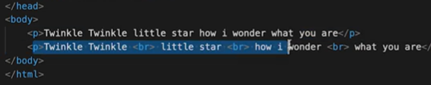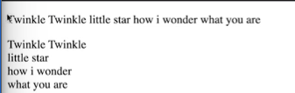

Hr Tag
HTML thematic break (horizontal rule) element
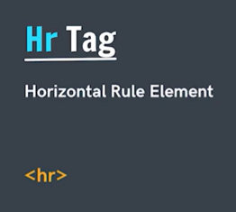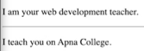

HTML Entities
HTML entities are special codes used in to display characters that might otherwise be interpreted as HTML syntax or are inconvenient to type
Character | HTML Entity | Meaning
< | &lt; | Less than
> | &gt; | Greater than
& | &amp; | Ampersand
" | &quot; | Double quotation mark
' | &apos; | Apostrophe
© | &copy; | Copyright
® | &reg; | Registered trademark
™ | &trade; | Trademark
non-breaking space | &nbsp; | Prevents a line break
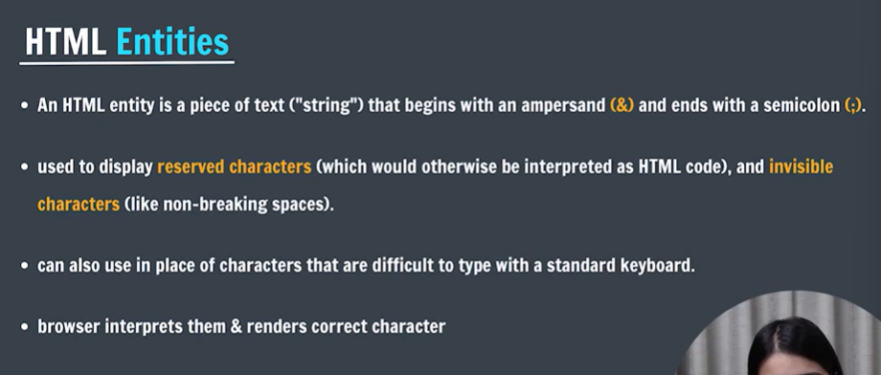
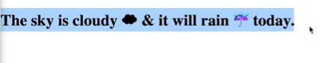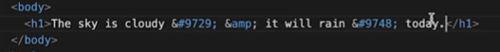
Html entity code / decimal code for required cloud symbol => #9748

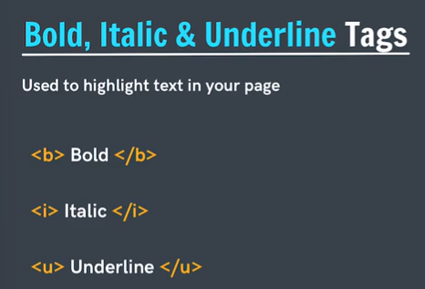
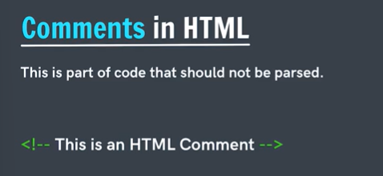
Vs Code shortcut trick for commenting : select , then ctrl + /

/ => forward slash
\ => backward slash

MDN => great resource for web developers

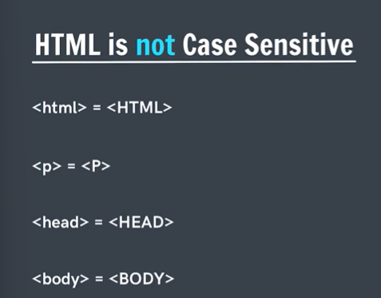

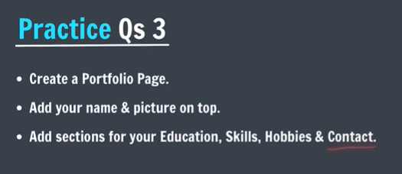

Name codes in html: search heart symbol in html on google => &hearts;

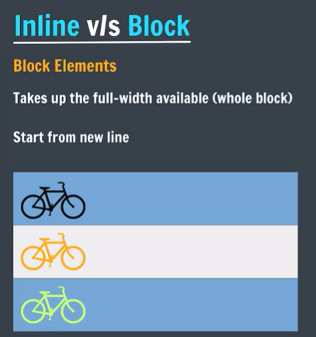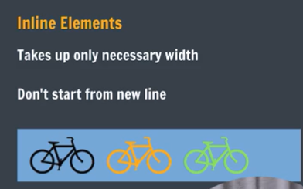

Heading Element -> block
Paragraph Element -> block
Anchor Tag -> inline
Image Element -> inline
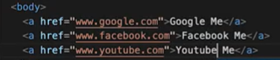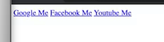

Element v/s Tag
Tag = the markup syntax
Element = the complete HTML structure

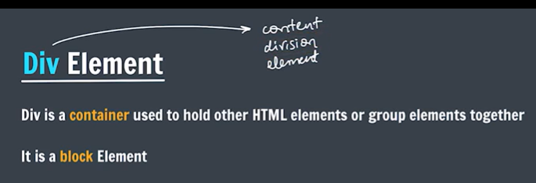
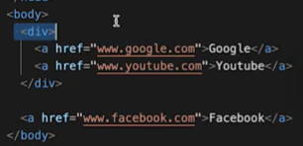

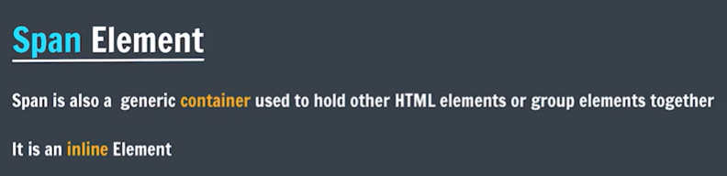
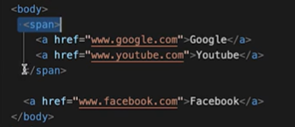

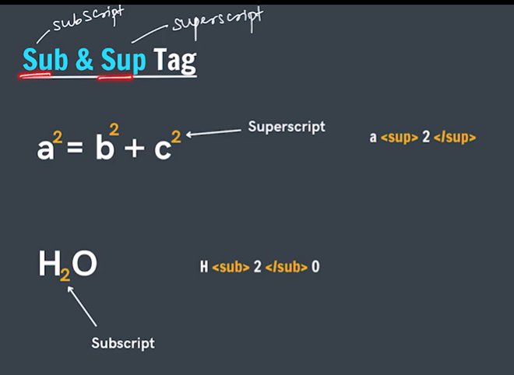
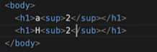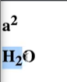
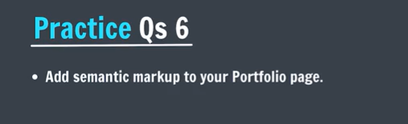

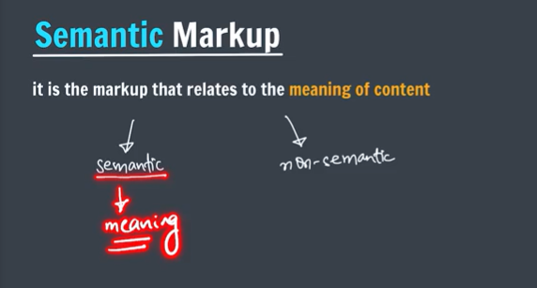
- Meaningful / more structured layout
- SEO friendly
- Readable / also better for screen readers
- Improves user experience UX
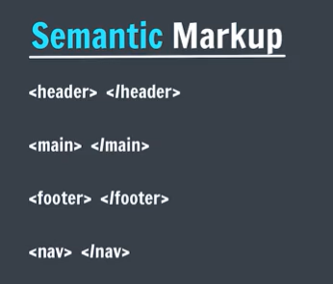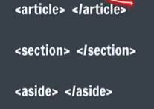
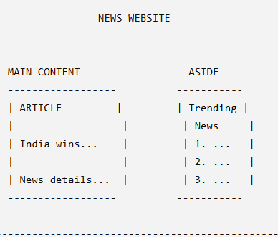

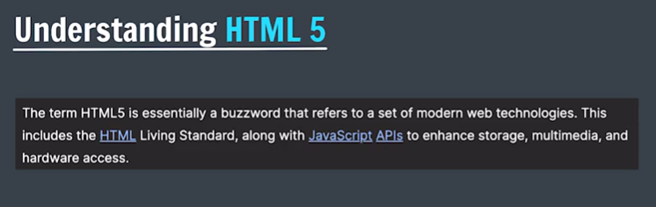
HTML 5 = new features/upgrades in HTML + other things/features that are not part of HTML
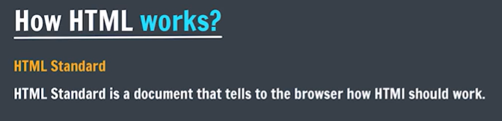
No need to install anything for html
HTML standard is also called living standard as it keeps updating and the browser works with newer versions
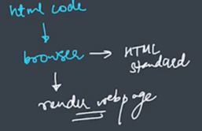

Video tag
The <video> tag is used to embed and play a video directly on a web page without needing an external video player.
<video src="video.mp4" controls></video>
Here:
- <video> → video element
- src="video.mp4" → location of the video
- controls → displays play, pause, volume, fullscreen controls

<video width="600" height="400" controls>
<source src="myvideo.mp4" type="video/mp4">
</video>

The <source> tag can provide different video formats:
<video controls>
<source src="video.mp4" type="video/mp4">
<source src="video.webm" type="video/webm">
</video>

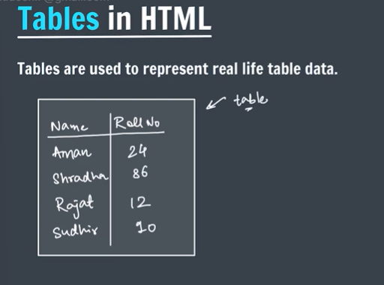
Attributes of Table :
- Row -> horizontal data line
- Column -> vertical data line

Table Header => Main row, consists headings, can be drawn anywhere but usually in 0th row
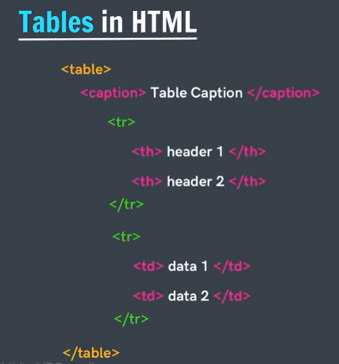
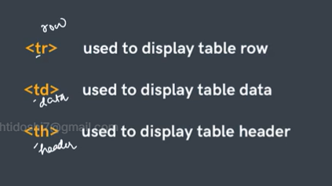
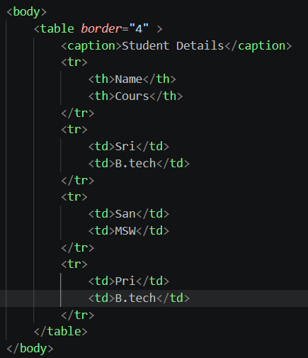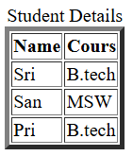
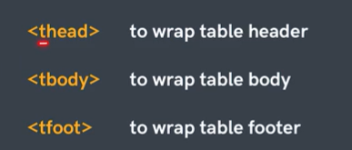
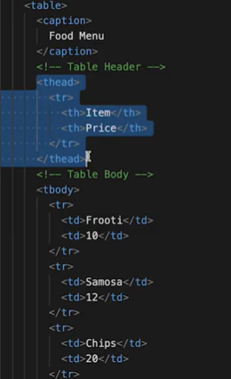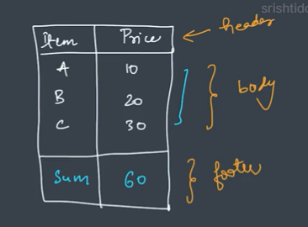

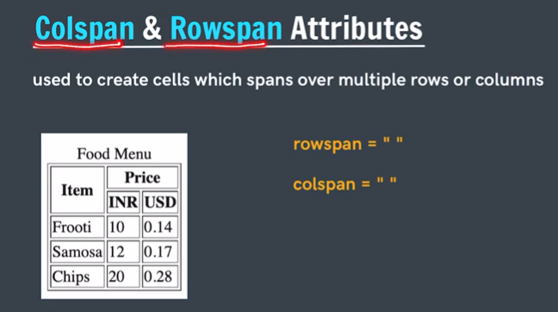
Span => refers to area , usually occupied by a cell ( 1 row and 1 column)
By Default every cell takes => 1 row, 1 column
Frooti => 1 row, 1 column <td> Frooti </td>
Price => 1 row, 2 columns <th colspan = “2”> Price </th>
Item => 2 row, 1 column <th rowspan = “2”> Item </th>

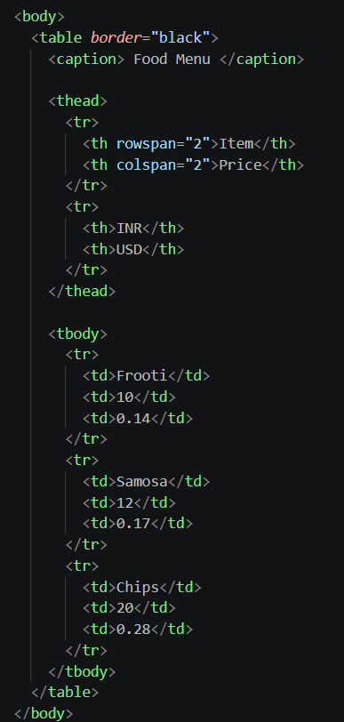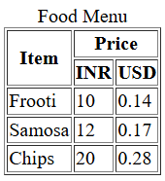

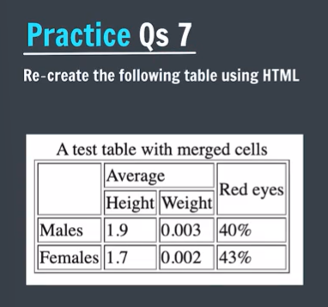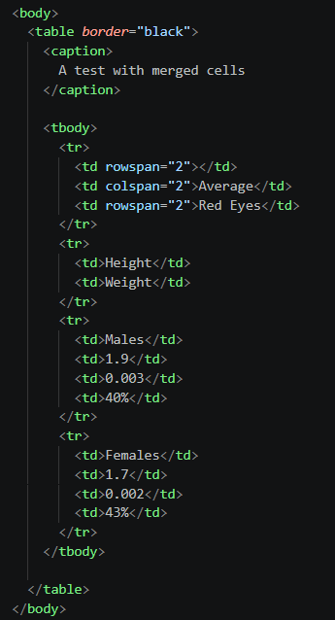

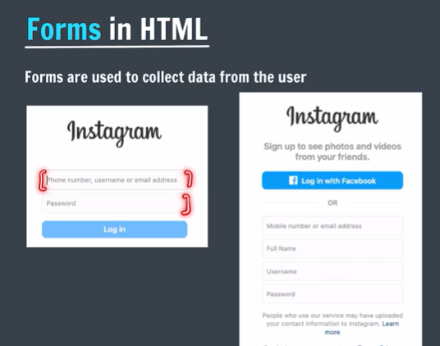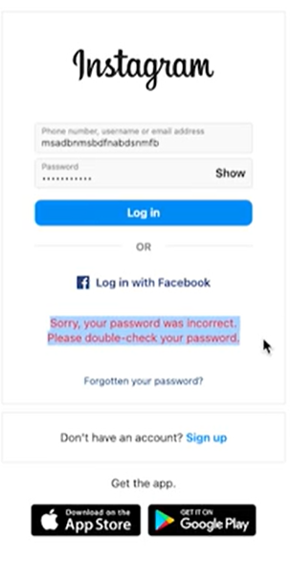
<form>
Content
</form>
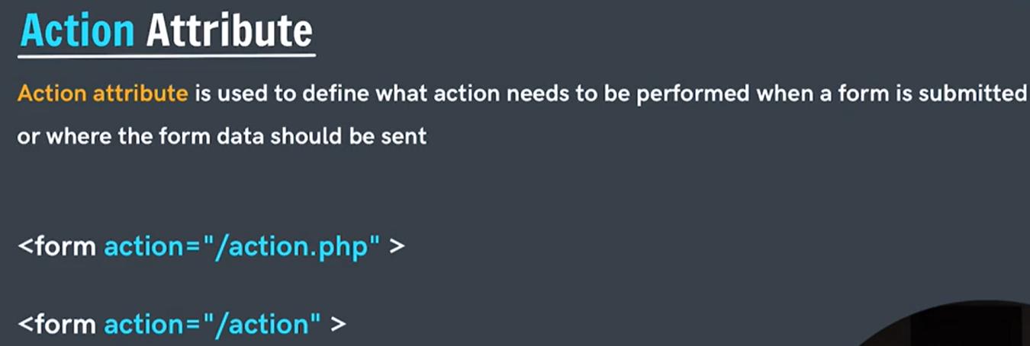
Action sends the data(like input data) to the url/location defined in action attribute.
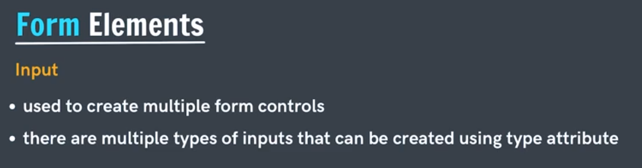
<input> is a single tag
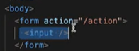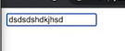
<input> creates a box in which anything (text, numbers etc) can be typed
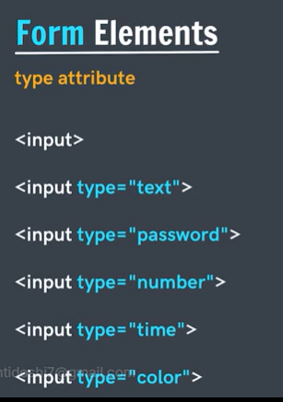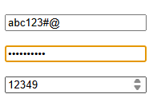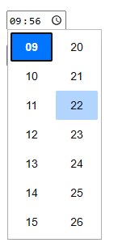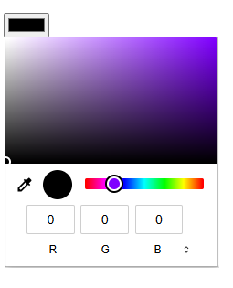
If type = “number”, then only numbers can be typed in input box.
There are so many types like email, date etc
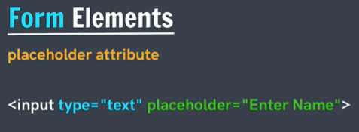
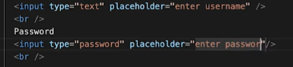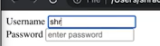

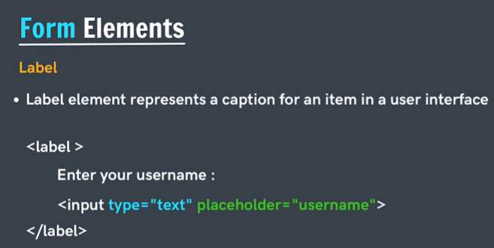
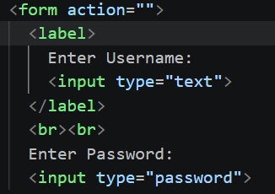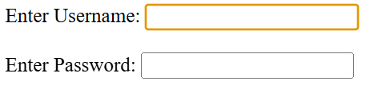
<Label> => connection between text( Enter Username )and input box, both acts as same entity
Now, when we click Enter Username and it triggers typing box, it gets highlighted.
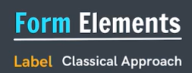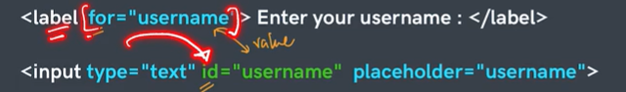
With the help of id we can connect it with a label.
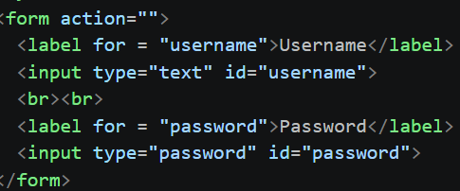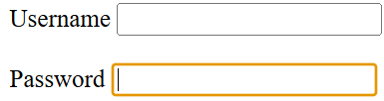

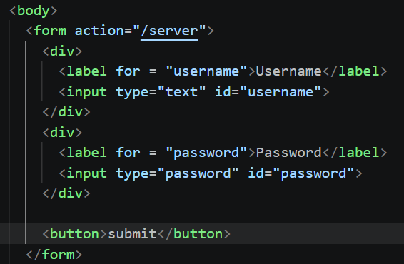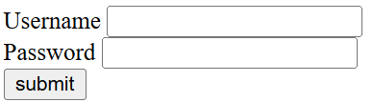
Click submit
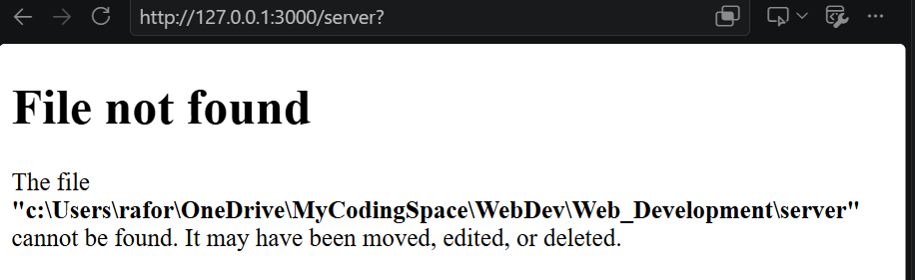
Button defined inside a form, then default behaviour of every button is to submit information to whatever place written in action.

But outside the form, no default behaviour you must define what should happen when you click a button.

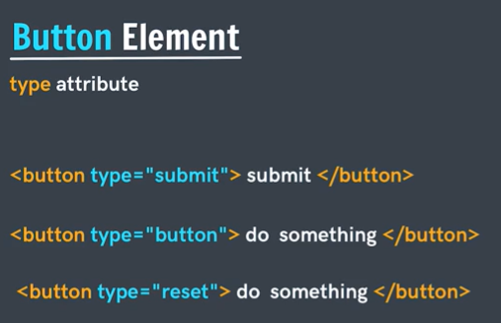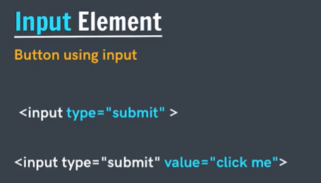
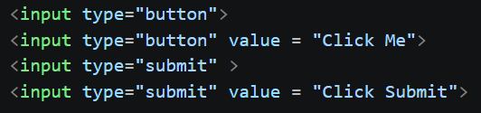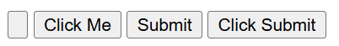

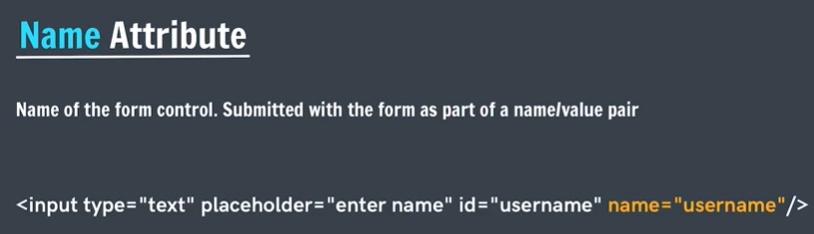
Name attribute is really useful when accessing the input data from backend.
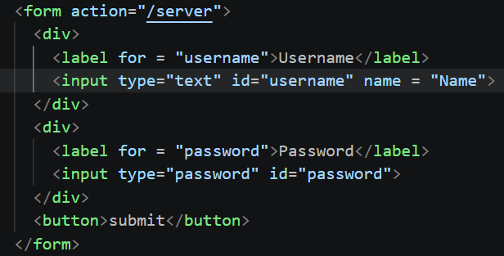
After clicking submit, we can see the data , name-value pair in url => not safe way
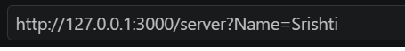

We can see this on google, youtube etc…
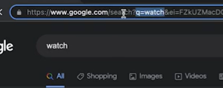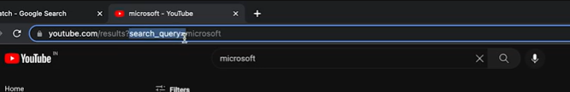

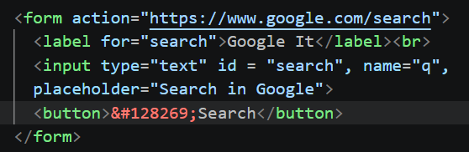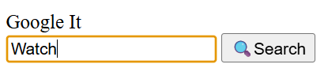
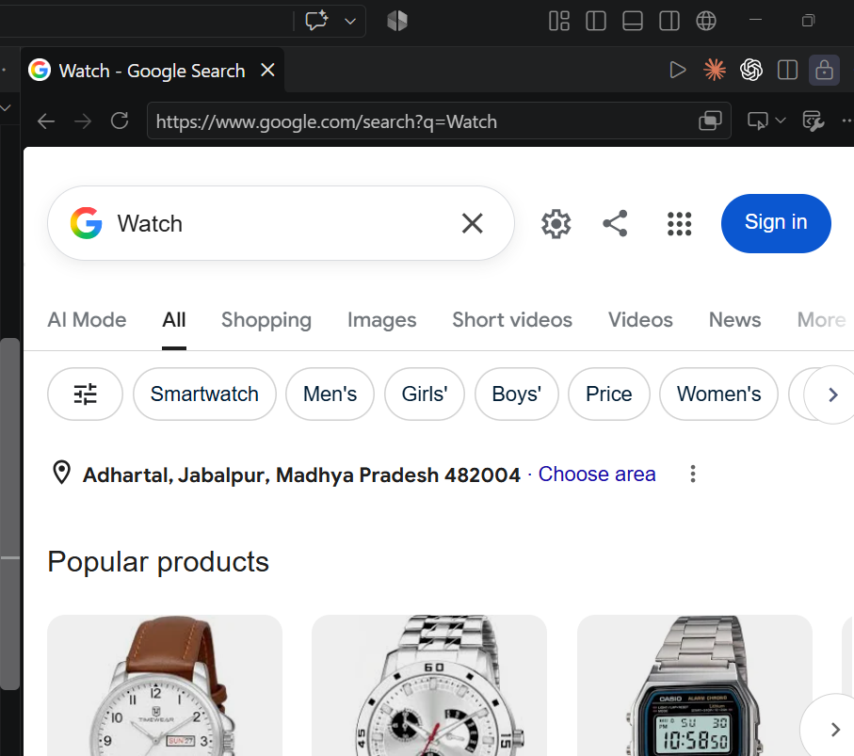

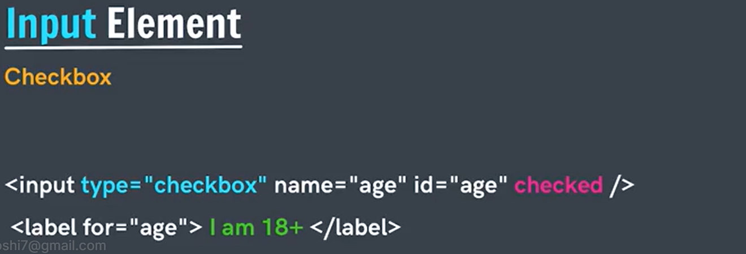
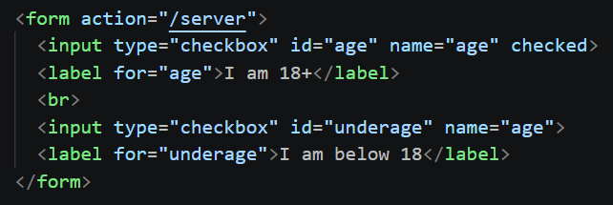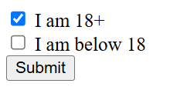
Multiple checkboxes can be selected in a group of checkboxes.
If we submit and checkbox is unticked then, nothing passes in url
But when ticked, then in URL on passes
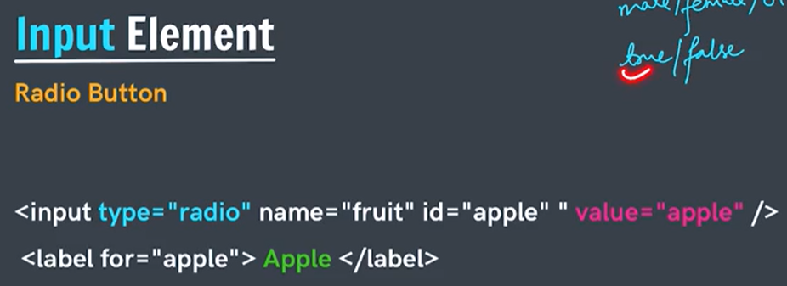
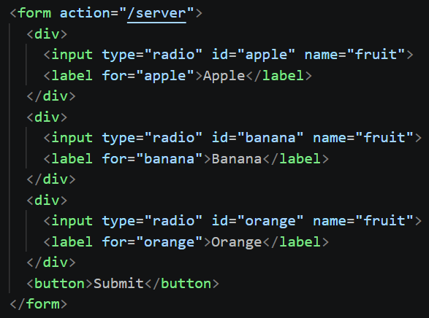
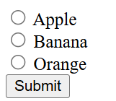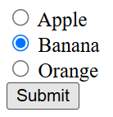
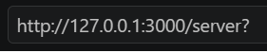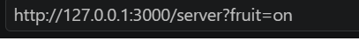

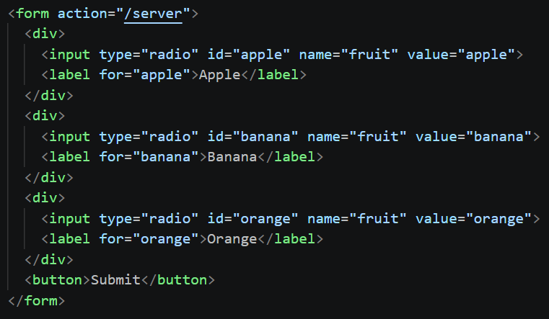
name and value Attributes
- Form data is sent in the form of name-value pairs: name=value.
- name attribute identifies the form field. Same name groups related form controls, such as radio buttons.
- value attribute specifies the data/value associated with the field.
Example:
<input type="radio" name="gender" value="male">
<input type="radio" name="gender" value="female">

Here, gender is the name, while male/female are the values.

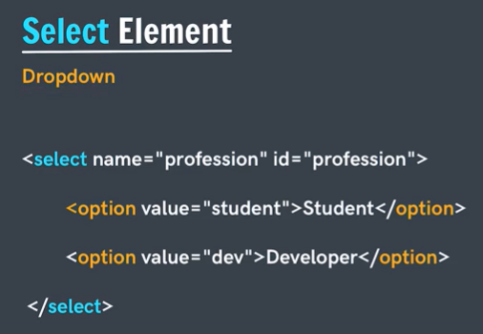
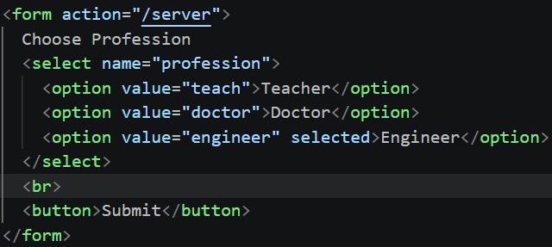
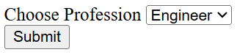

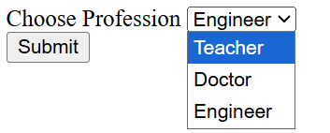

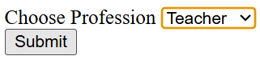

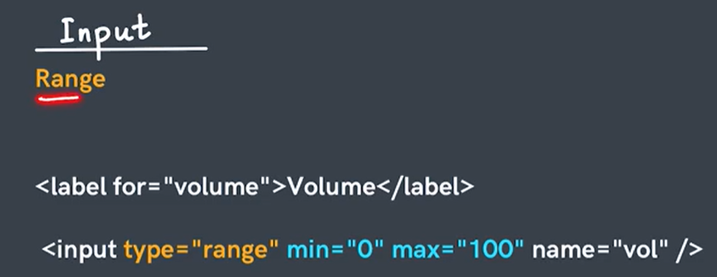

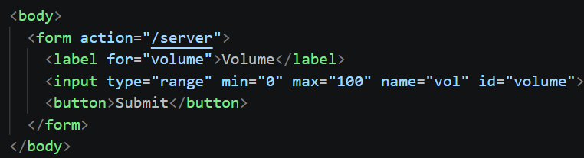
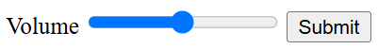

<input type="range" min="0" max="100" name="vol" id="vol" step="10" value="70">
value attribute sets the default value

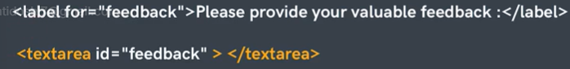
By default size of text area is 2 rows and 10 columns.
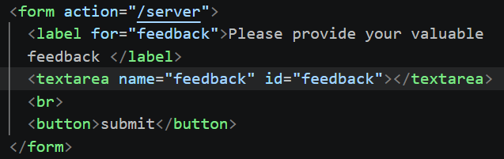
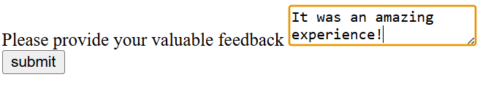
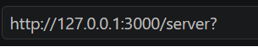

<textarea id="feedback" name="feedback"></textarea>

<textarea id="feedback" name="feedback" placeholder = “Write your comments here” rows="4" cols="15"></textarea>
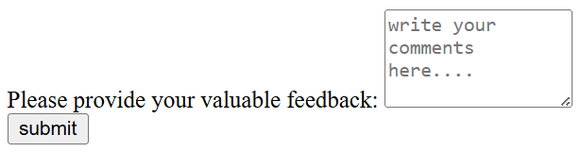

Practice Qs

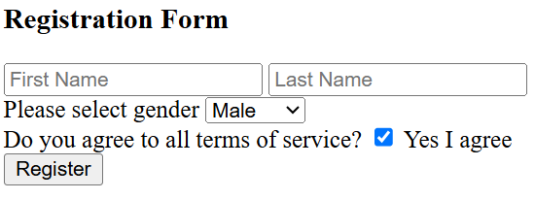
<body>
<h3>Registration Form</h3>
<form action="/server">
<div>
<input type="text" placeholder="First Name" name="first name">
<input type="text" placeholder="Last Name" name="last name">
</div>
<div>
<label for="gender">Please select gender</label>
<select name="gender" id="gender">
<option value="m">Male</option>
<option value="f">Female</option>
<option value="o">Other</option>
</select>
</div>
<div>
Do you agree to all terms of service?
<input id = "agree" type="checkbox" name="agree" checked>
<label for="agree">Yes I agree</label>
</div>
<button>Register</button>
</form>
</body>
http://127.0.0.1:3000/server?first+name=Sonu&last+name=Doshi&gender=f&agree=on
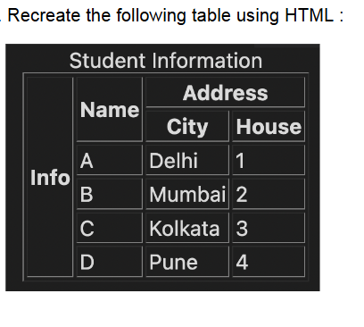
<body>
<table border="">
<caption>Student Information</caption>
<tr>
<th rowspan="6">Info</th>
<th rowspan="2">Name</th>
<th colspan="2">Address</th>
</tr>
<tr>
<th>City</th>
<th>House</th>
</tr>
<tr>
<td>A</td>
<td>Delhi</td>
<td>1</td>
</tr>
<tr>
<td>B</td>
<td>Mumbai</td>
<td>2</td>
</tr>
<tr>
<td>C</td>
<td>Kolkata</td>
<td>3</td>
</tr>
<tr>
<td>D</td>
<td>Pune</td>
<td>4</td>
</tr>
</table>
</body>

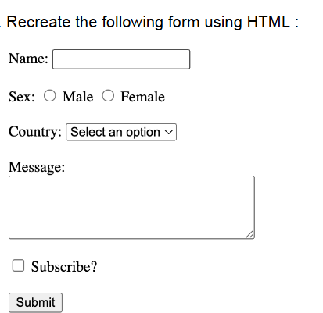

<body>
<form action="/server">
<div>
<label for="name">Name:</label>
<input type="text"name="name" id="name">
</div>
<br>
<div>
Sex:
<input type="radio" id="male" name="sex" value="male">
<label for="male">Male</label>
<input type="radio" id="female" name="sex" value="female">
<label for="female">Female</label>
</div>
<br>
<div>
<label for="country">Country</label>
<select name="country" id="country" placeholder = "Select an ption">
<option value="india">India</option>
<option value="canada">Canada</option>
<option value="australia">Australia</option>
<option value="newzealand">New Zealand</option>
<option value="russia">Russia</option>
<option value="america">America</option>
<option value="china">China</option>
<option value="bhutan">Bhutan</option>
<option value="germany">Germany</option>
<option value="japan">Japan</option>
<option value="britian">Britian</option>
</select>
</div>
<br>
<div>
<label for="msg">Message: </label>
<br>
<textarea name="msg" id="msg" rows="5" cols="35"></textarea>
</div>
<div>
<input id = "subscribe" type="checkbox" name="subscribe">
<label for="subscribe">Subscibe?</label>
</div>
<br>
<button>Submit</button>
</form>
</body>

http://127.0.0.1:3000/server?name=Sonu&sex=female&country=india&msg=Good+Day%21&subscribe=on

