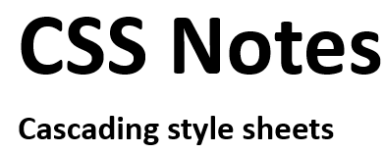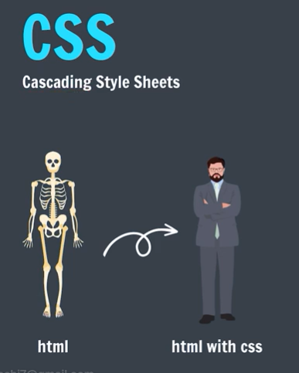
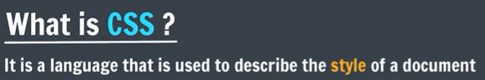
With CSS Without CSS
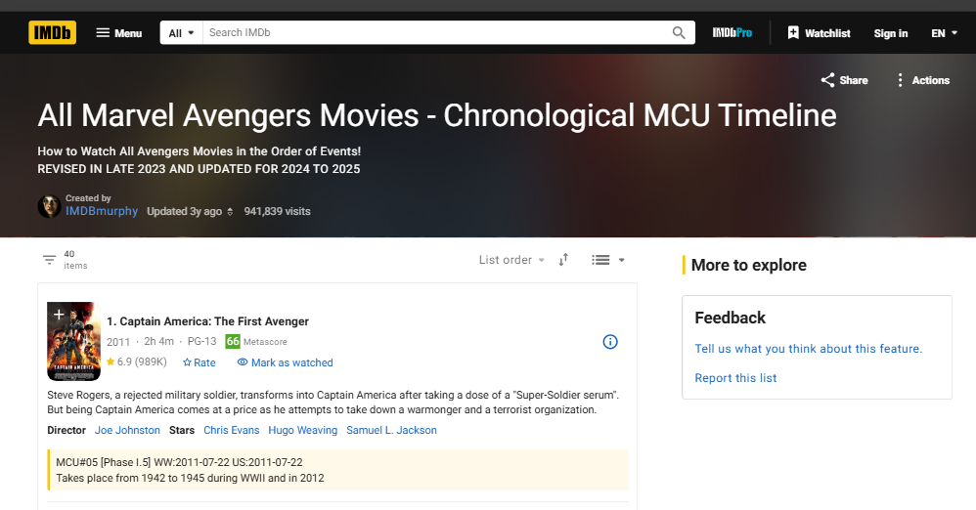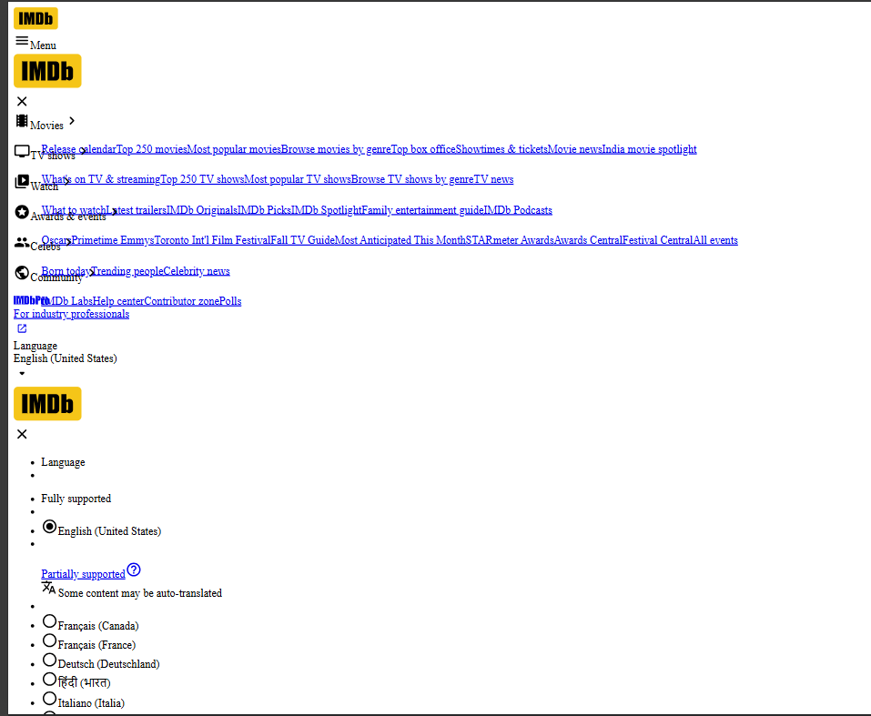


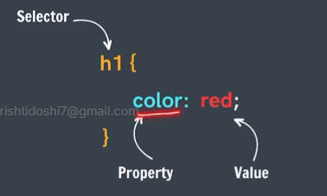

- Inline Styles (repeated copying for same type of elements)
- Using <style> tag (limited to only one document in which defined)
- External Stylesheet
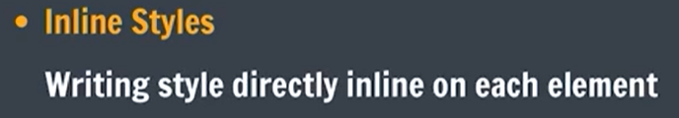
<h1 style = “color: red”>Hello!</h1>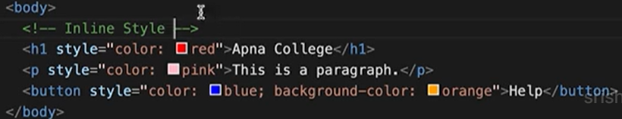 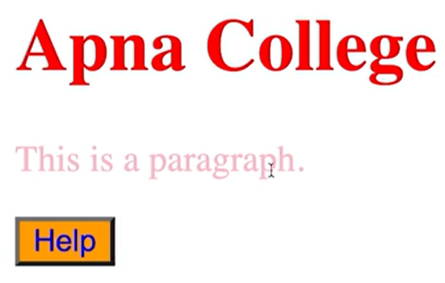

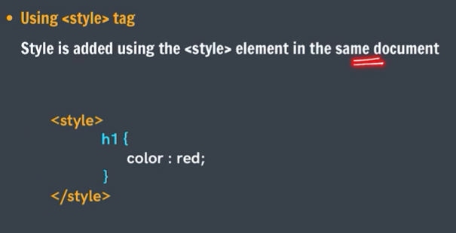
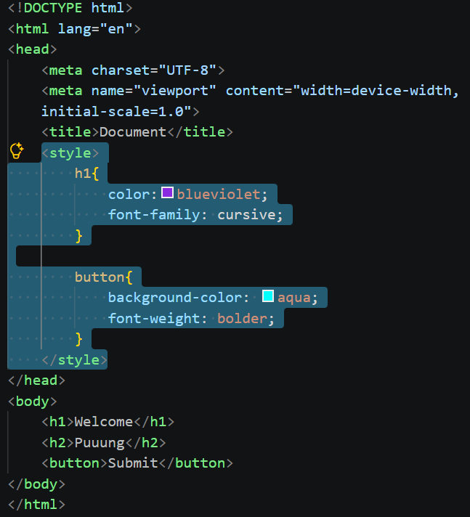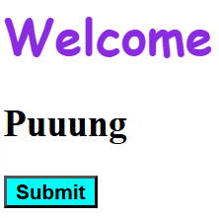
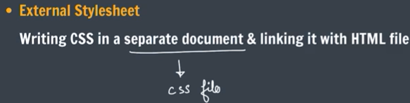
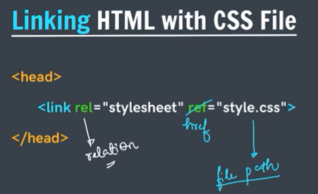
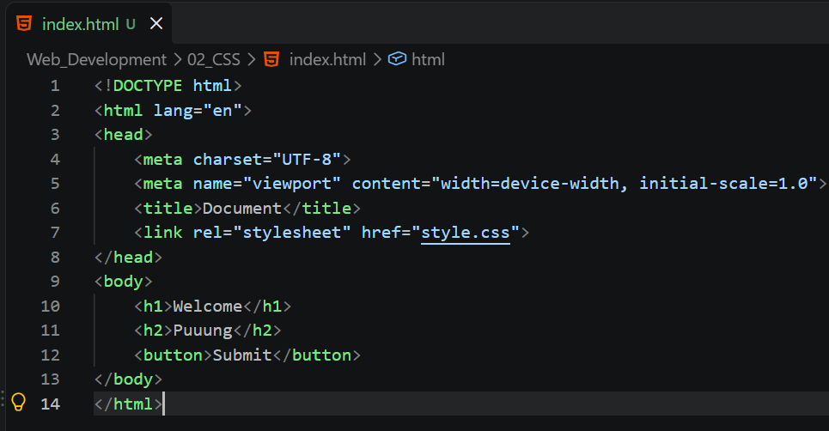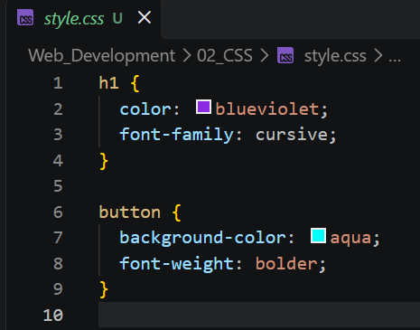

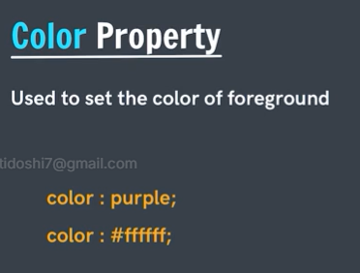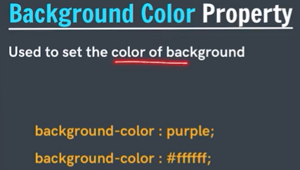
background : black;
background-color: black;
The above both works for bg color, but background is a large property which can be used for various things like bg image bg color etc.

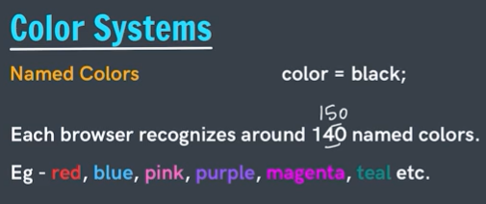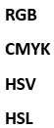
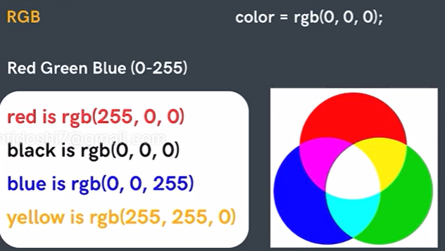
RGB colors are used in CSS, televisions, cameras….
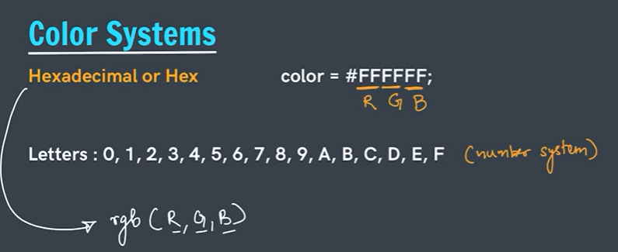
Hex => more compact
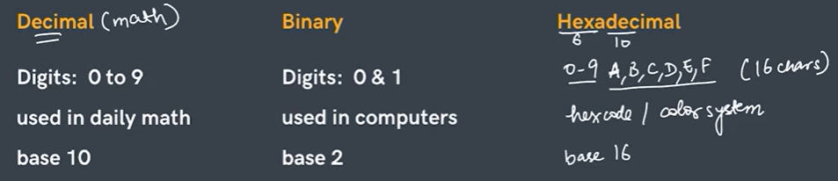
RGB => 0 - 255
HexCode => 00 - ff
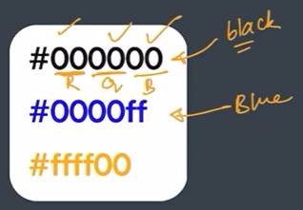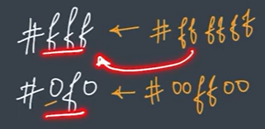
In case of identical pairs, we can write the 6 digit code in 3 digits => shorthand

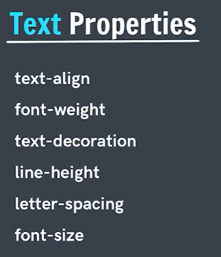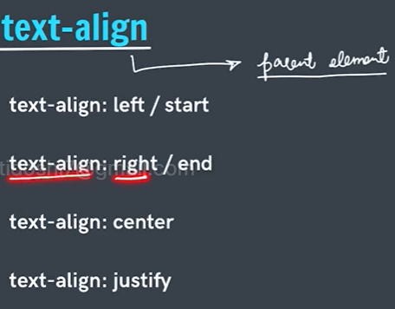
Text-align, here alignment is with respect to parent, not entire document.
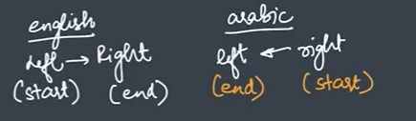
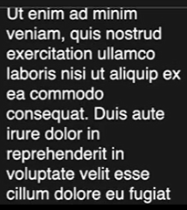 -- Justify --> 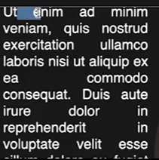
Justify add some spaces between words to make the horizontal and vertical boundary same.

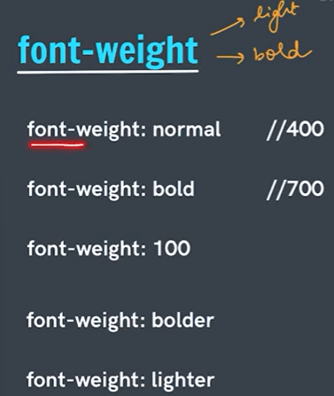 Range = 100 to 900
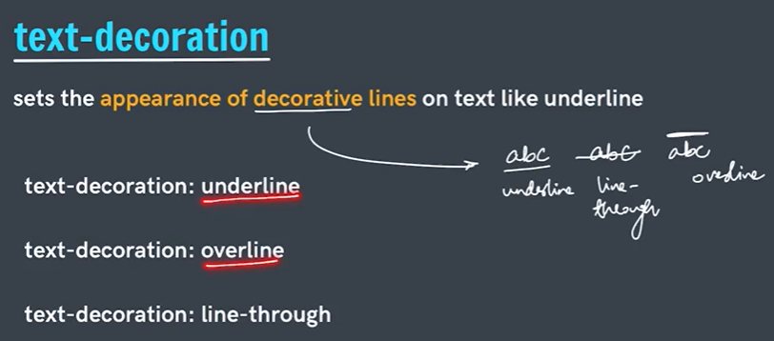
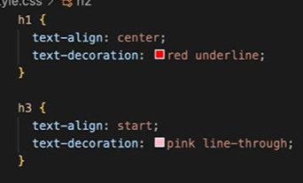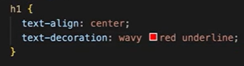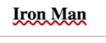
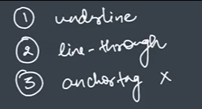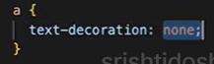
The main use case of text-decoration is used to remove the by default underline of anchor tag.

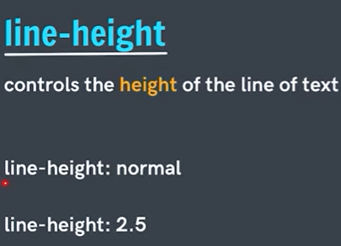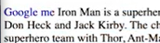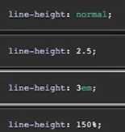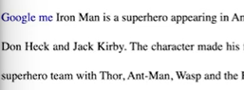

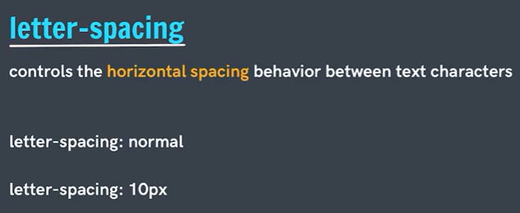
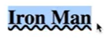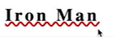
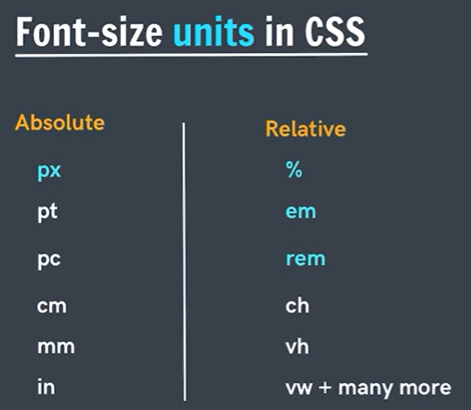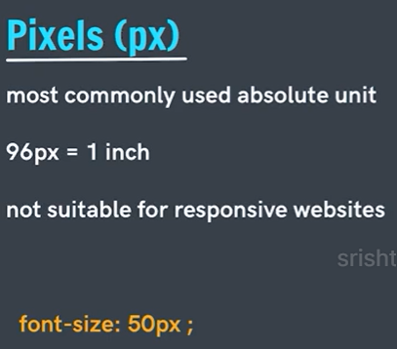
For responsive websites, we generally do not use pixels, we prefer relative units.
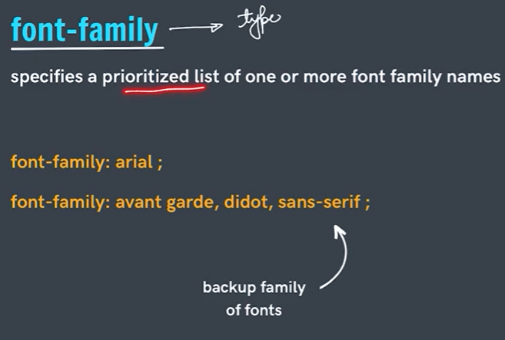 visit cssfontstack.com
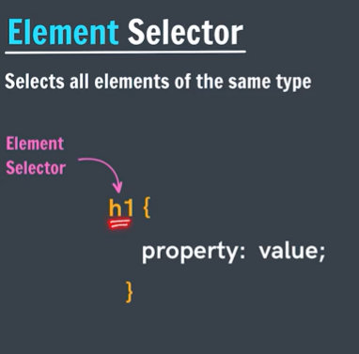 multiple elements can be selected using comma (,)
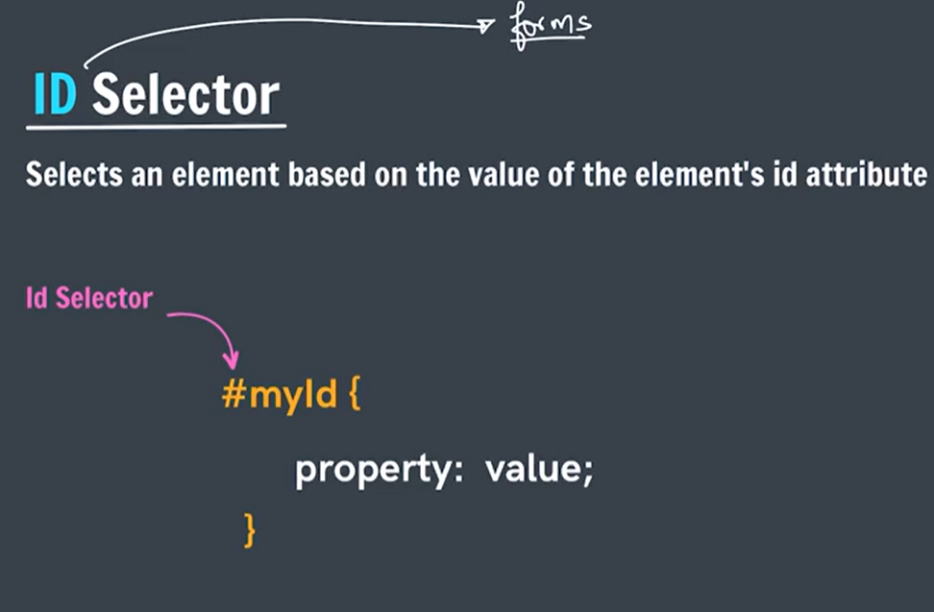
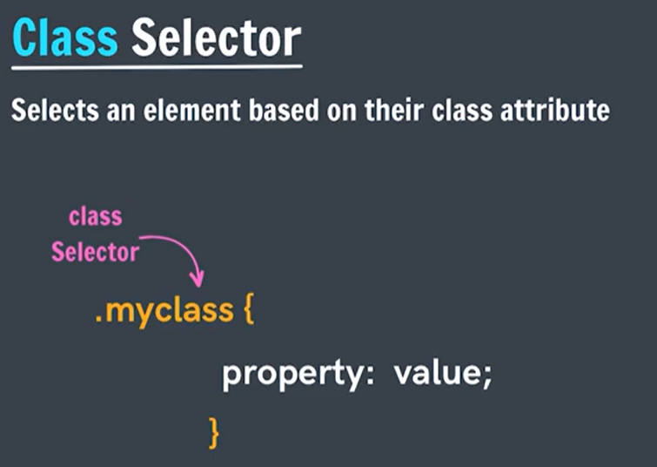
Id => must be unique
Class => not necessarily unique

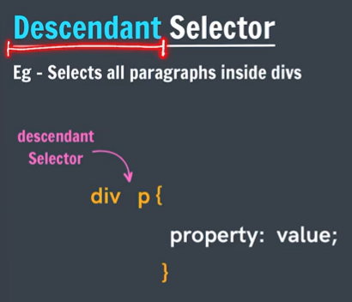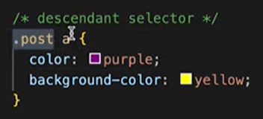
div element => p post class => a

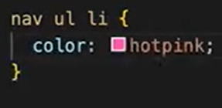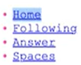
Nav element => ul list => li tag => color hotpint

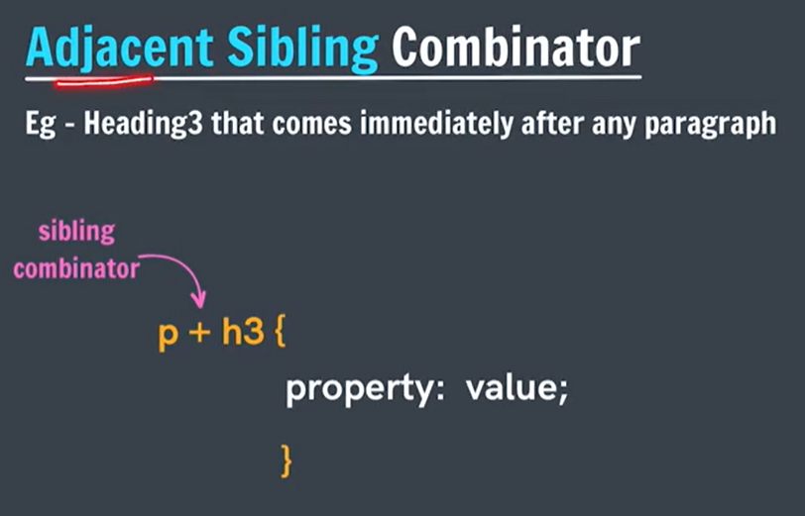
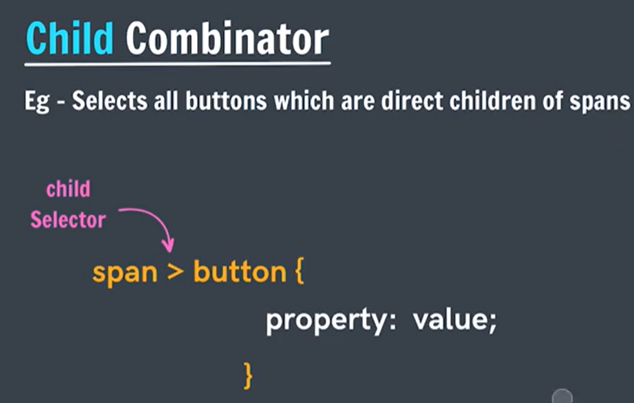
All buttons which are direct children of span, does not work for grandchildren

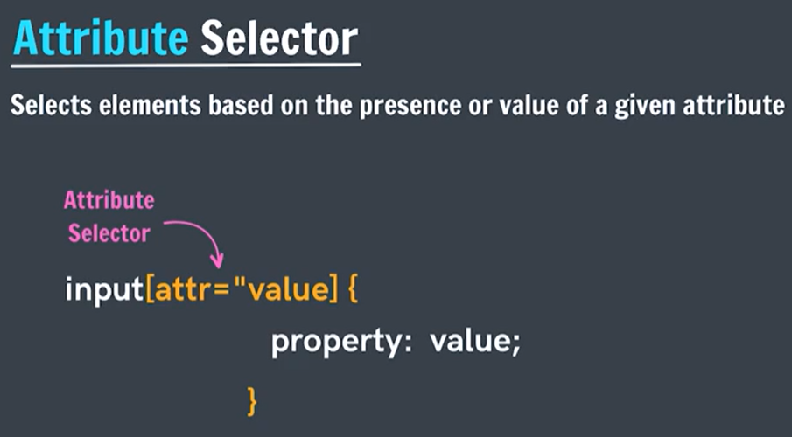
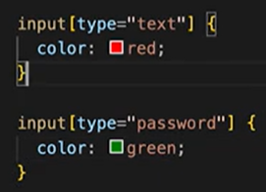
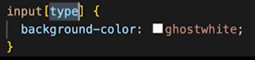 if there is any input with some type , then apply property

Practice Q) Set the color for paragraphs inside divs with the id “myId” to green.
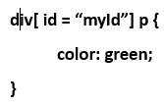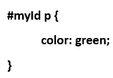
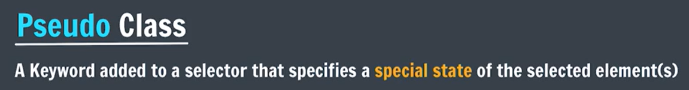
- hover => moving cursor on it
- active => clicking
- checked => usually used in radio and checkboxes when they are ticked/selected.
- nth-of-type => select nth elements
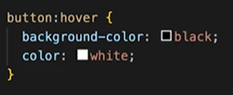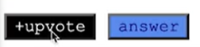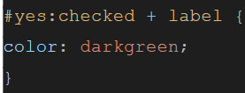
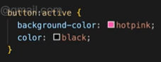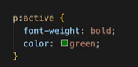
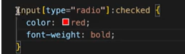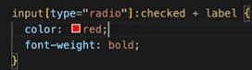

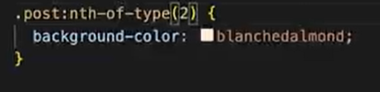 2nd post class
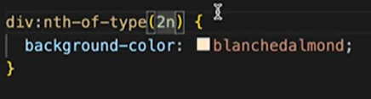 2n div: even no. div 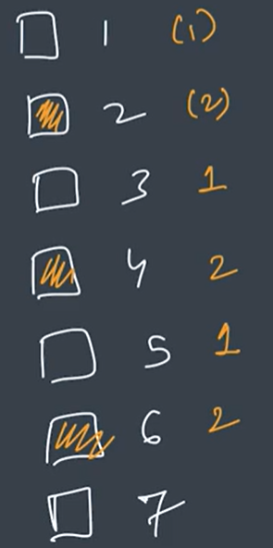

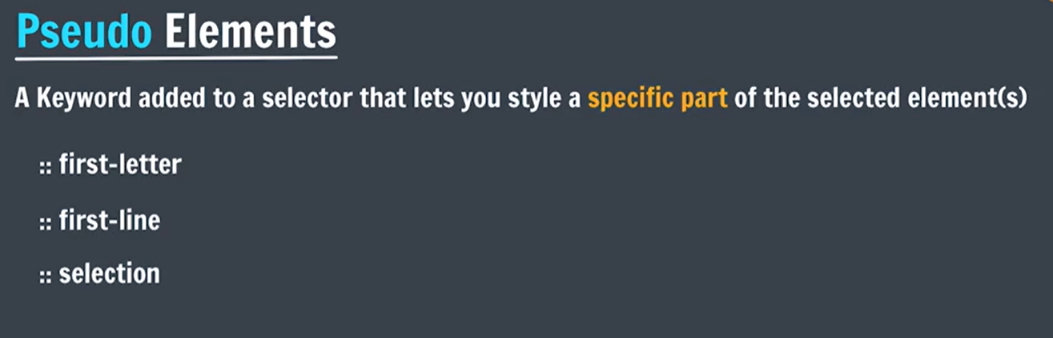
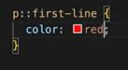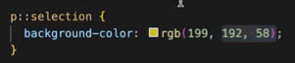

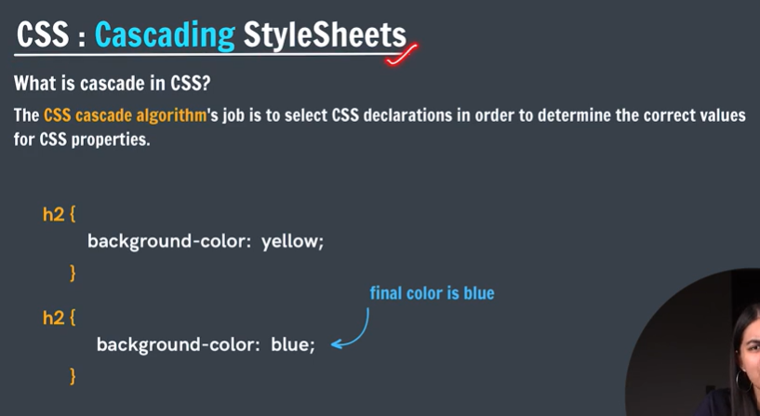
Cascading means when multiple CSS rules apply to the same element, the browser decides which rule should win.
Multiple rules → browser compares them → one final style is applied.
Both rules target the same <h2>.
👉 The second rule wins, so the text becomes blue.
This is because both selectors have the same specificity, so the rule written later wins.
Main factors in the cascade
Remember: I → S → O → L
- Importance —! important
- Specificity — which selector is more specific ( inline > id > class, pseudo-class, attribute > element , pseudo-element )
- Order — if specificity is equal, later rule wins
- Inheritance — some properties come from the parent

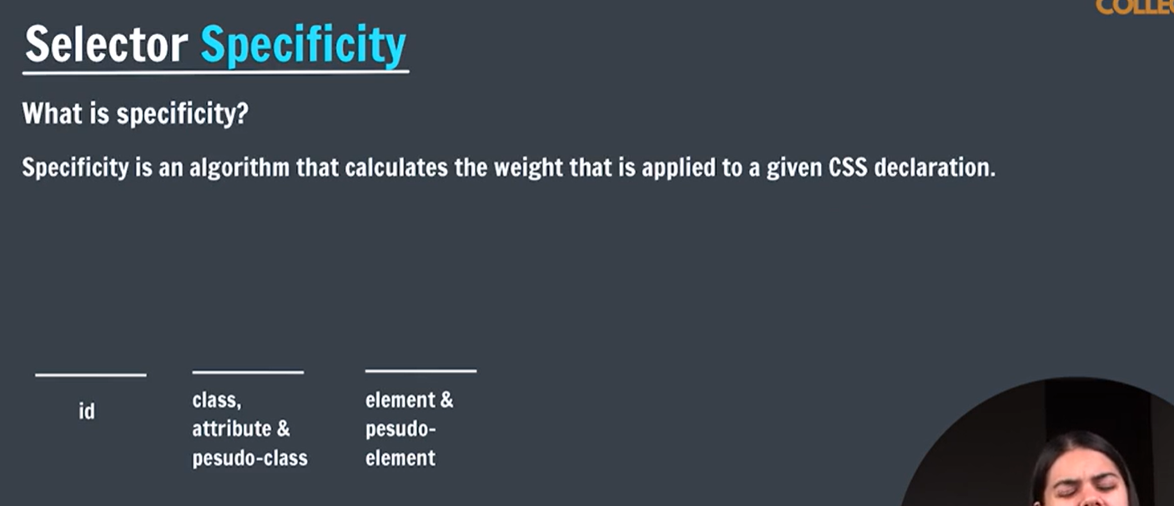
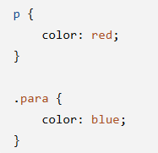
.para wins because a class selector is more specific than an element selector.
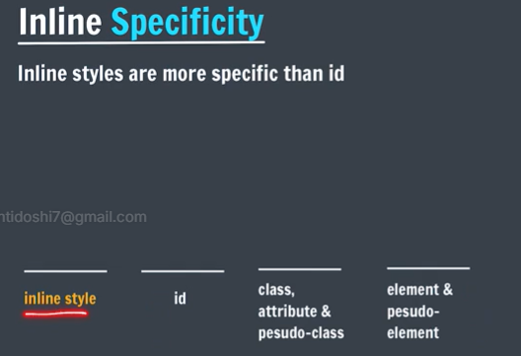
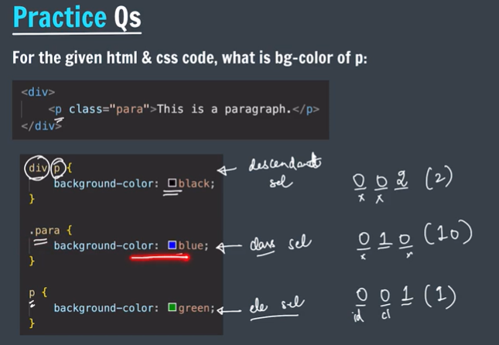
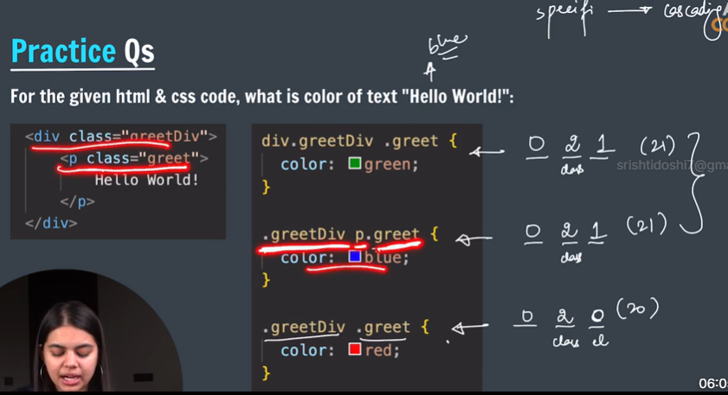

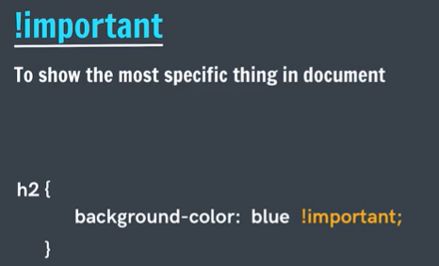
! important > inline
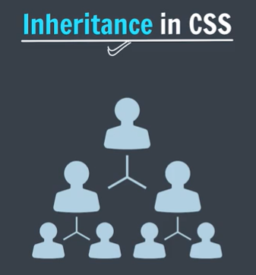
If we have div => p => ul => li
And we set div background as blue then p, ul, li will also inherit div’s property, resulting in bg blue.
So all elements tries inherit properties from their parents/ grandparents, upper layer if they do not have their own properties
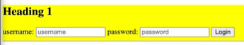
Except: Input boxes, buttons
To make this exception inherit 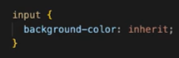

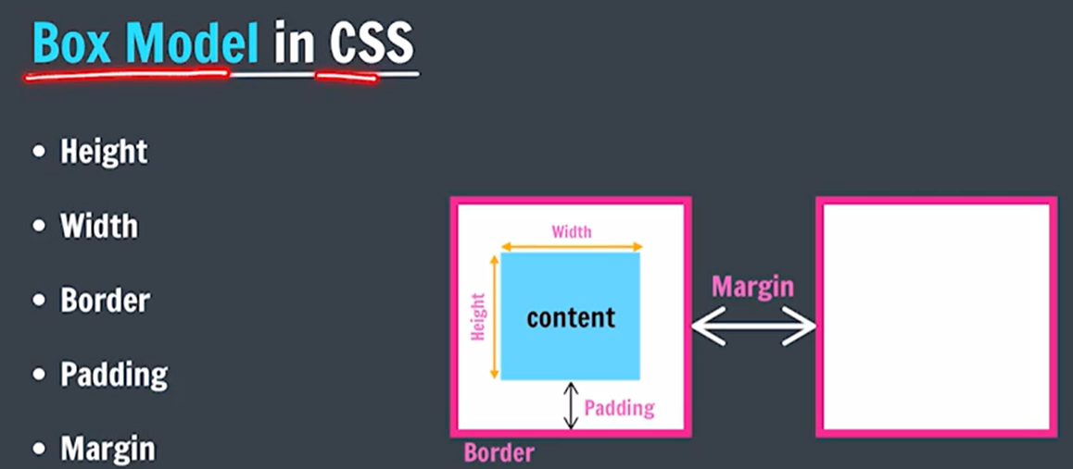
Whenever we inspect a website, every element can be analysed as a box, box of different colours, different colours also have meaning according to different browser.
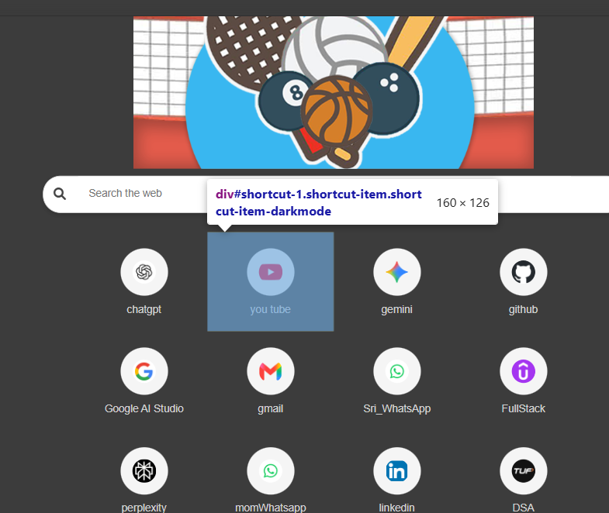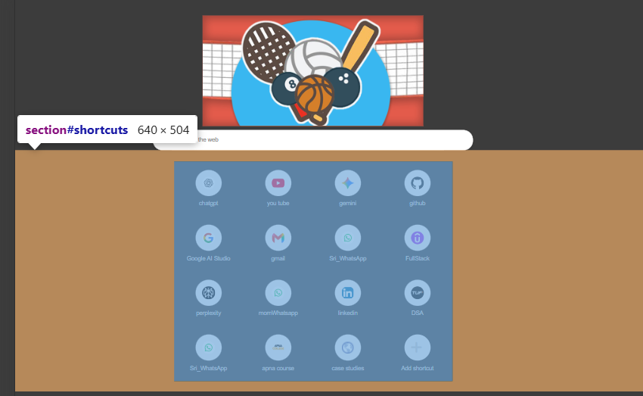
All elements in our browser looks in the form of boxes and this phenomenon is called as box model.
In CSS, on your webpage whatever you make: heading element, para, button, div, span etc, they will eventually be interpreted in the form of box structure by browser.
HTML Elements => box
Margin => distance between two box

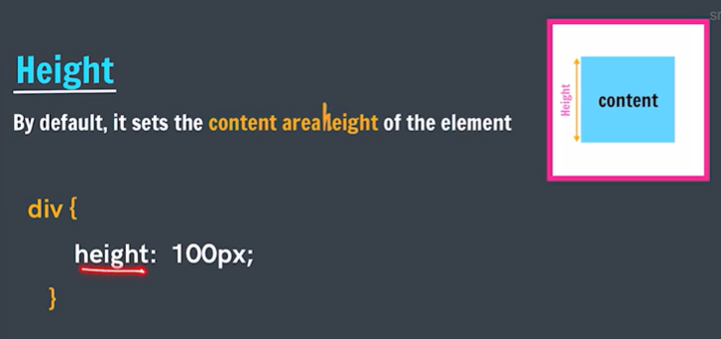
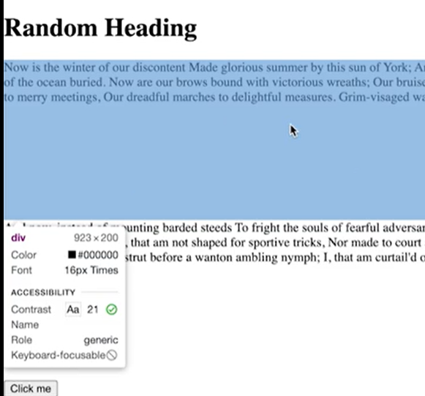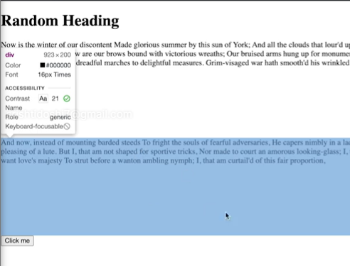
By default, if there is no content(text), then there is no height of div but when we set height then it gets height even when content is there or not.
If there is very little height, then it tries to fit everything in it 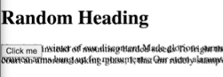

Height, width sets only for content area.
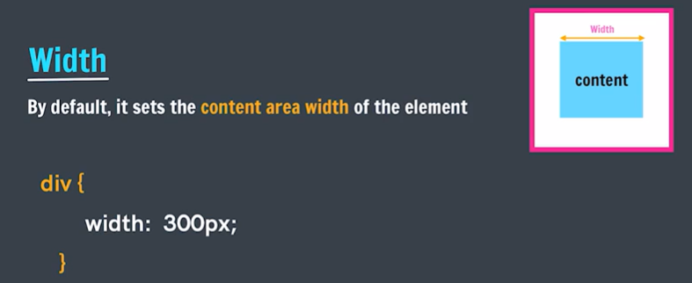
By default, width of div is full screen
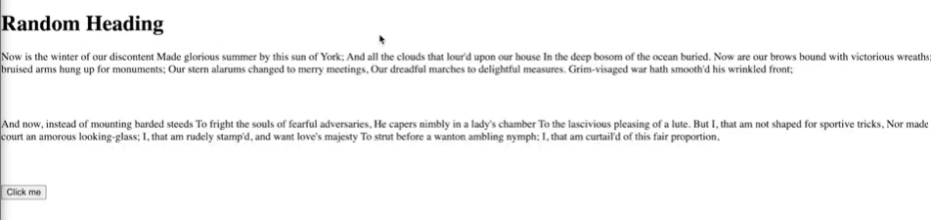

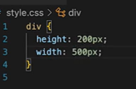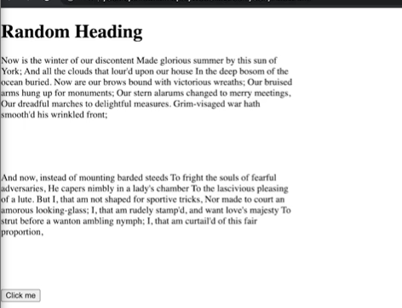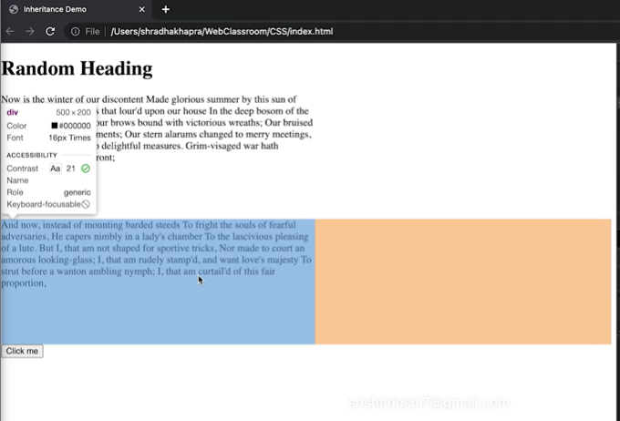

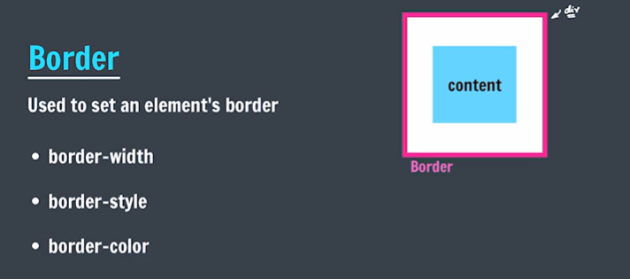
Border is set of element, not for content
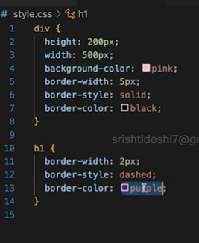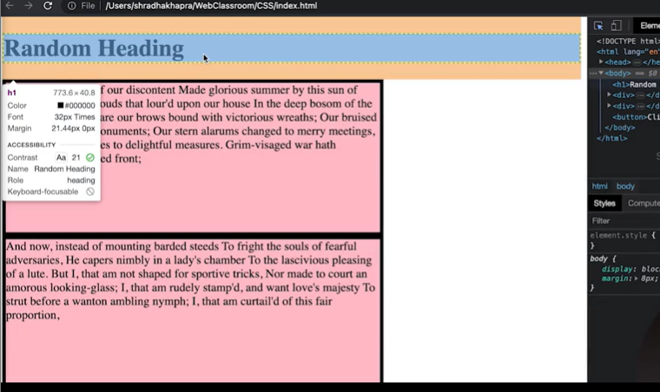
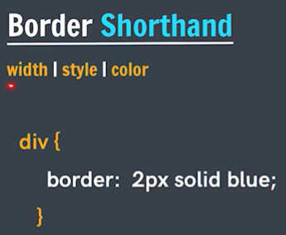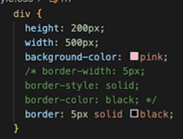
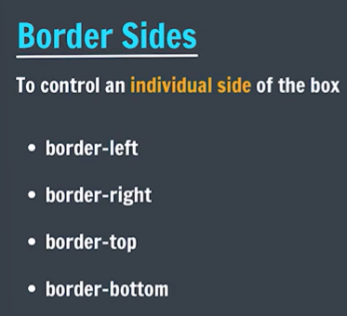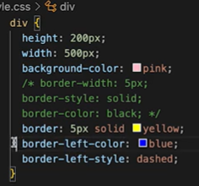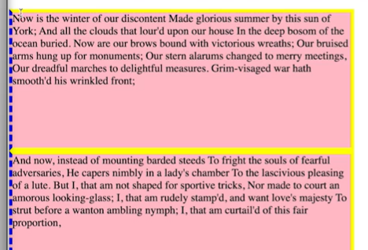
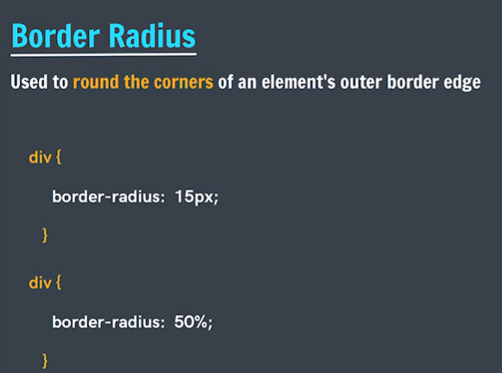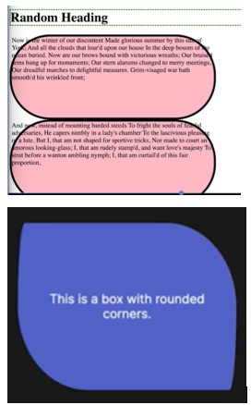

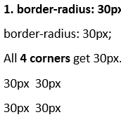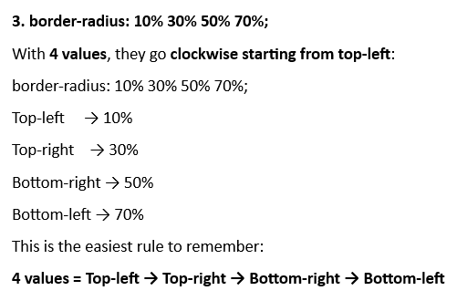
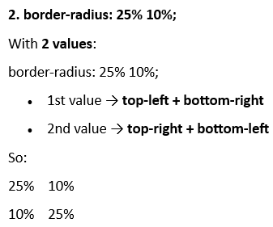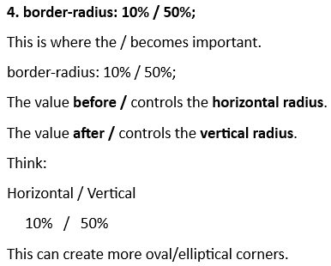
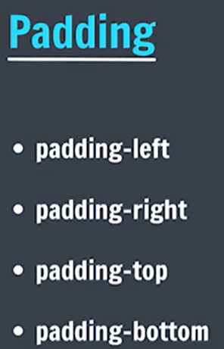
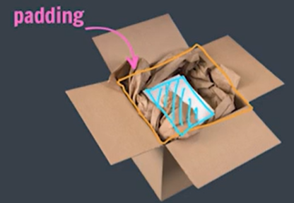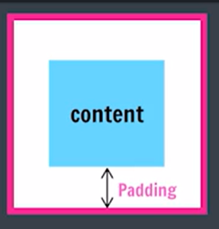
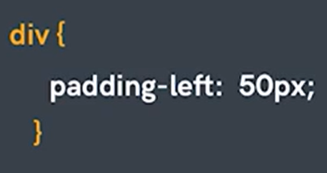

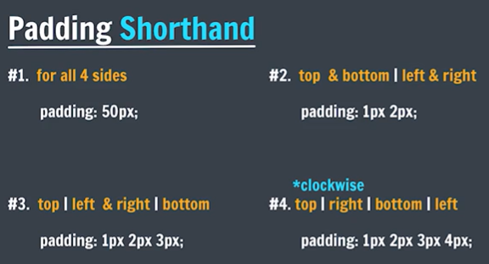
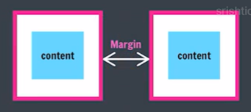

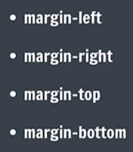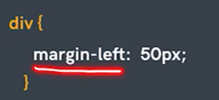

Dev Tools
Orange area => margin
Green area => padding
Blue area => content

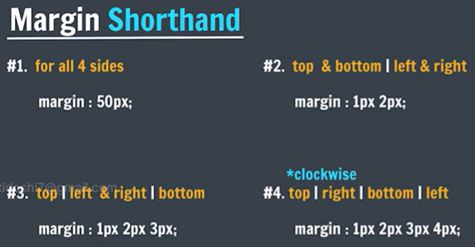
Heading element gets a default margin already.
We can remove it by setting margin: 0;

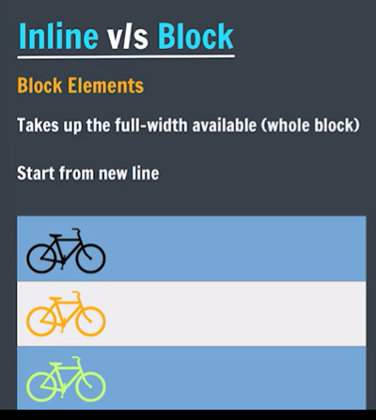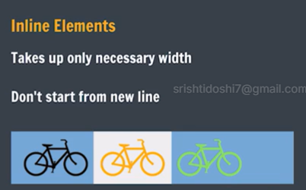

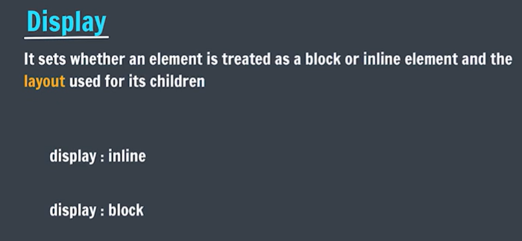
In span elements height and width does not get set, and margin get set only for left and right.
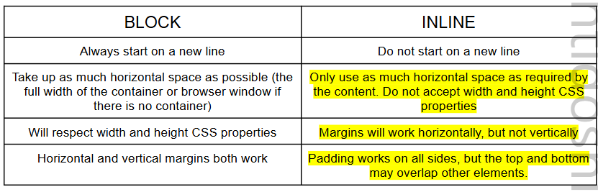

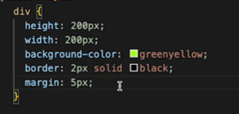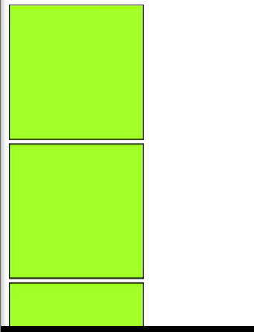

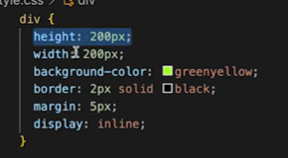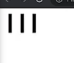

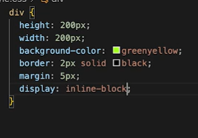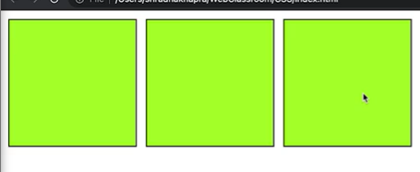

display: inline-block;
- style will be applied like block elements
- will behave like inline

display: none;
- will vanish , not visible/present on screen

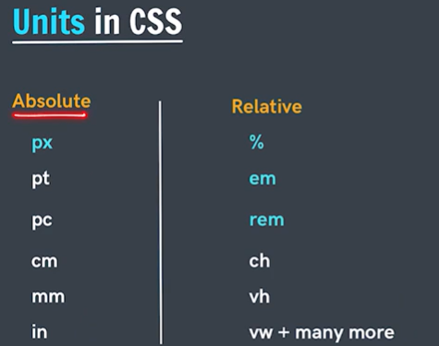
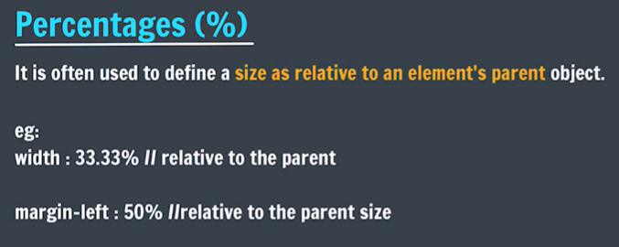
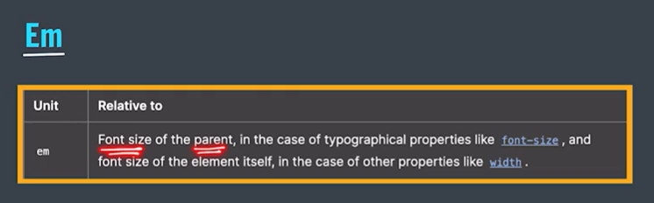
Parent => font size = 10px
Child => font size = 3 em => 3*10px = 30px

Child => padding = 1 em => 1 *30px = 30px ( padding is relative to child font size only)


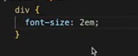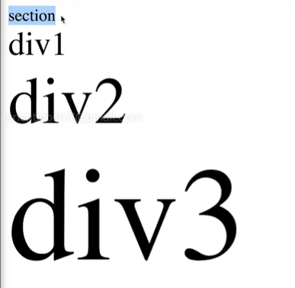

ems -> parent/root
rems -> root element
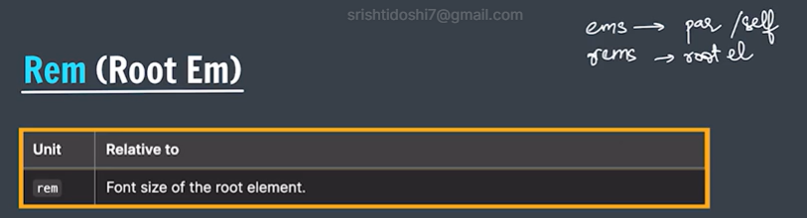
It is a CSS relative unit based on the font size of the root element (<html>).
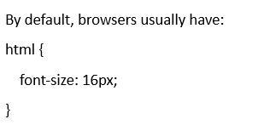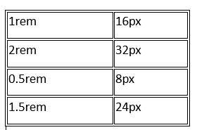
Practice Q
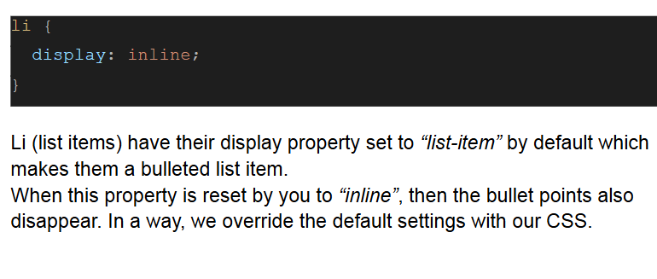

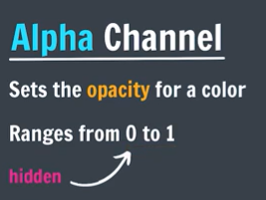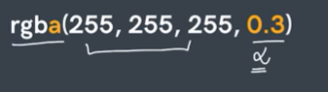
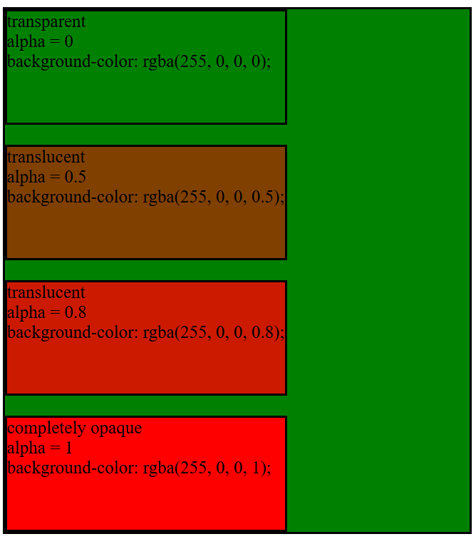
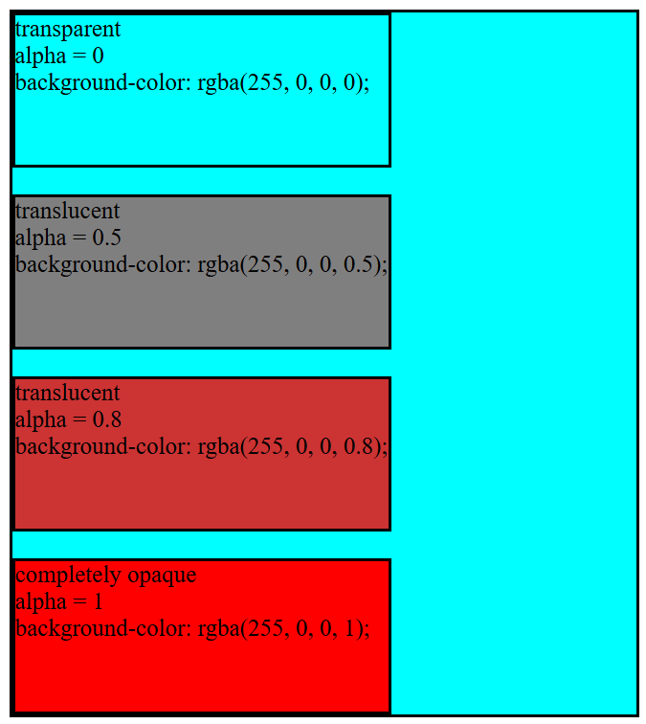

In hexadecimal code
Alpha value lies between 00 -> ff
- 00 => hidden
- Ff => visible
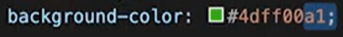
Alpha => decides opacity of colour => colour visibility
Opacity => decides opacity of full element => element visibility

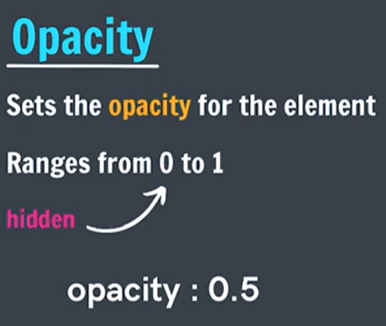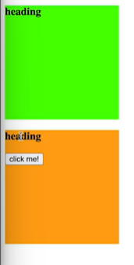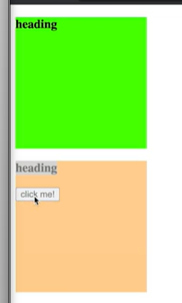
Here if a set opacity of orange box = 0, then full element (including heading and click me button) will not be visible (visibility = 0)
Opacity of element = 0.5 => translucent (full element, heading etc)
Opacity of element = 1 => fully visible (full element, heading etc)

CSS Transitions
Transitions enable you to define the transition between two states of an element.

For example: If I want that when my rectangle element is hovered, its shape gets converted into a circle. When one state of an element changes into another, then how it will transitions, slowly, immediately, after some delay etc properties at time of transition is defined by CSS transitions.
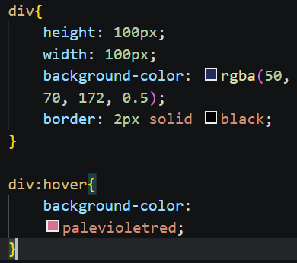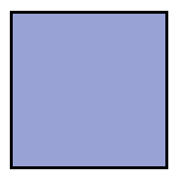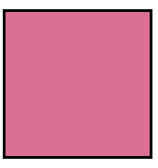
Right now as div is hovered, it immediately change color
For smooth, like fadein fade out experience, we will use transition: 1s;
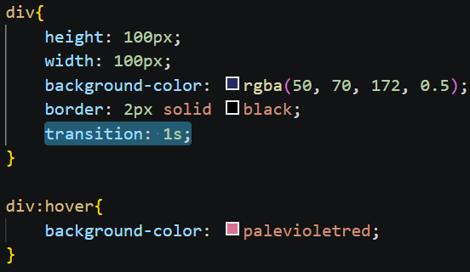
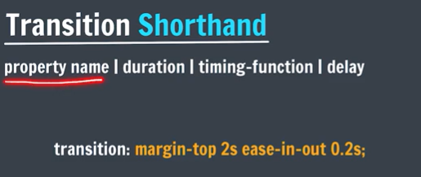
transition-delay : 1s => how much seconds later change will apppear => delay
transition-duration: 1s => time it takes to change from 1 state to another.

margin : 0 auto; => centers the div => margin-top: 0;
margin-right: auto;
margin-bottom: 0;
margin-left: auto;

transition-property => Which CSS property should transition
transition-duration => How long the transition takes
transition-timing-function => How the transition progresses
transition-delay => How long to wait before starting

1. transition-property
Specifies what property should change smoothly.
transition-property: background-color;
Multiple properties:
transition-property: background-color, width, color;

2. transition-duration
Specifies how much time the transition takes.
transition-duration: 1s;
or
transition-duration: 500ms;

3. transition-timing-function
Controls the speed pattern of the transition.
Common values:
ease
linear
ease-in
ease-out
ease-in-out
Example:
transition-timing-function: ease-in-out;
Easy way to remember:
- ease → starts slow, speeds up, slows down
- linear → constant speed
- ease-in → starts slowly
- ease-out → ends slowly
- ease-in-out → slow at both ends

4. transition-delay
Specifies how long to wait before the transition starts.
transition-delay: 2s;
So the transition waits 2 seconds and then begins.

Shorthand: transition
Instead of writing all four properties separately:
button {
transition-property: background-color;
transition-duration: 0.5s;
transition-timing-function: ease;
transition-delay: 0s;
}
Can write:
button {
transition: background-color 0.5s ease 0s;
}
⭐ Most commonly used
transition: all 0.3s ease;
This means:
all properties → 0.3 seconds → ease
Example:
.box {
width: 100px;
background-color: blue;
transition: all 0.5s ease;
}

.box:hover {
width: 200px;
background-color: red;
}
The width and background color will change smoothly on hover.
CSS transition is used to create a smooth change between two states of an element over a specified duration.
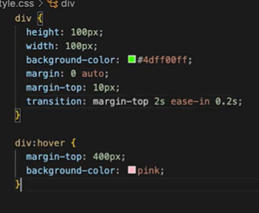
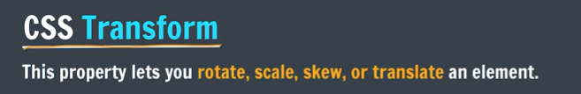
CSS transform Properties
The CSS transform property is used to move, rotate, resize, or skew an element without changing the normal document flow.
The main transform functions are:
Transform | Purpose | Example
translate() | Move element | transform: translate(50px, 20px);
translateX() | Move horizontally | transform: translateX(50px);
translateY() | Move vertically | transform: translateY(20px);
scale() | Increase/decrease size | transform: scale(1.5);
scaleX() | Change width | transform: scaleX(2);
scaleY() | Change height | transform: scaleY(2);
rotate() | Rotate element | transform: rotate(45deg);
skew() | Slant element | transform: skew(20deg);
skewX() | Slant horizontally | transform: skewX(20deg);
skewY() | Slant vertically | transform: skewY(20deg);

1. translate()
Moves an element from its original position.
.box {
transform: translate(50px, 20px);
}
- 50px → moves right
- 20px → moves down

2. translateX()
Moves left/right.
transform: translateX(100px);
Positive → right
Negative → left
transform: translateX(-50px);

3. translateY()
Moves up/down.
transform: translateY(50px);
Positive → down
Negative → up
transform: translateY(-50px);

4. scale()
Changes the size of an element.
transform: scale(2);
2 means 200% of original size.
transform: scale(0.5);
Means 50% of original size.
Can also use:
transform: scale(2, 1.5);
- X direction → 2×
- Y direction → 1.5×

5. rotate()
Rotates an element.
transform: rotate(45deg);
Example:
.box:hover {
transform: rotate(45deg);
}
Negative value rotates in the opposite direction:
transform: rotate(-45deg);

6. skew()
Slants/distorts an element.
transform: skew(20deg);
Or separately:
transform: skewX(20deg);
transform: skewY(20deg);

⭐ Multiple transforms
Multiple transform functions can be combined:
.box {
transform: translateX(50px) rotate(45deg) scale(1.5);
}
So the element is:
moved → rotated → enlarged

transform + transition
These are commonly used together for hover effects:
.box {
transition: transform 0.5s;
}

.box:hover {
transform: scale(1.2);
}
Now the box smoothly grows when hovered.


box-shadow: 2px 3px 10px green;
- 2px => x effect
- 3px => y effect
- 10px => blur radius, 0px => no blur, opaque solid shadow, 2px => less blur, 7px => more blur
- Green => colour of shadow
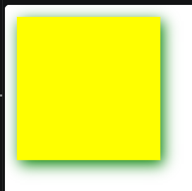
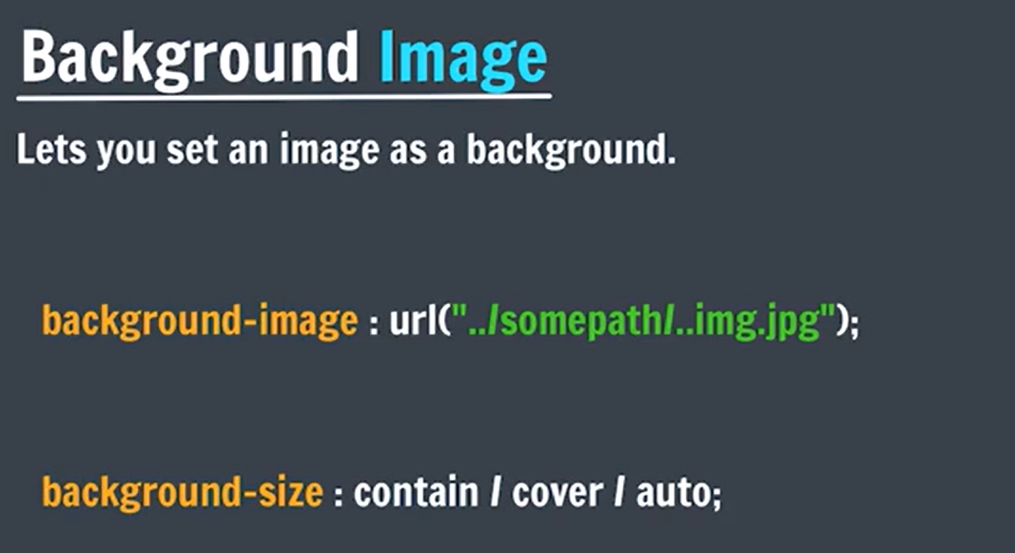
CSS background-image Property
The background-image property is used to set an image as the background of an HTML element.
Basic syntax
.box {
background-image: url("image.jpg");
}
Example:
<div class="box"></div>
.box {
width: 500px;
height: 300px;
background-image: url("flower.jpg");
}
The image will appear behind the content of the .box.

Important background properties
background-image is usually used with these properties:
Property | Purpose
background-image | Sets the background image
background-size | Controls image size
background-position | Controls image position
background-repeat | Controls repetition
background-attachment | Controls whether image scrolls
background | Shorthand for background properties

1. background-size
Most commonly:
background-size: cover;
cover → image covers the entire element, even if some part gets cropped.
background-size: contain;
contain → entire image is visible, but empty space may remain.

Imagine a photo inside a frame.
cover
Fill the frame completely.
📸 → 🖼️
- Image may be enlarged/reduced
- Entire box gets covered
- Image can be cropped
- No empty space

contain
Show the whole photo.
📸 → 🖼️
- Image may be enlarged/reduced
- Entire image is visible
- No cropping
- Empty space may remain

auto
Don't change the image's original size.
📸 → 🖼️
- Original image dimensions are maintained
- If image is bigger than box → part can be cropped
- If image is smaller → it remains small
- It doesn't try to fill the box

2. background-position
Controls where the image is positioned.
background-position: center;
Other examples:
background-position: top;
background-position: bottom;
background-position: left;
background-position: right;

3. background-repeat
By default, a small background image can repeat.
background-repeat: no-repeat;
Other values:
background-repeat: repeat;
background-repeat: repeat-x;
background-repeat: repeat-y;

⭐ Common practical example
.hero {
width: 100%;
height: 500px;

background-image: url("hero.jpg");
background-size: cover;
background-position: center;
background-repeat: no-repeat;
}
This creates a full-size hero/banner background.
Shortcut
All of these can also be written using the background shorthand:
.hero {
background: url("hero.jpg") center / cover no-repeat;
}

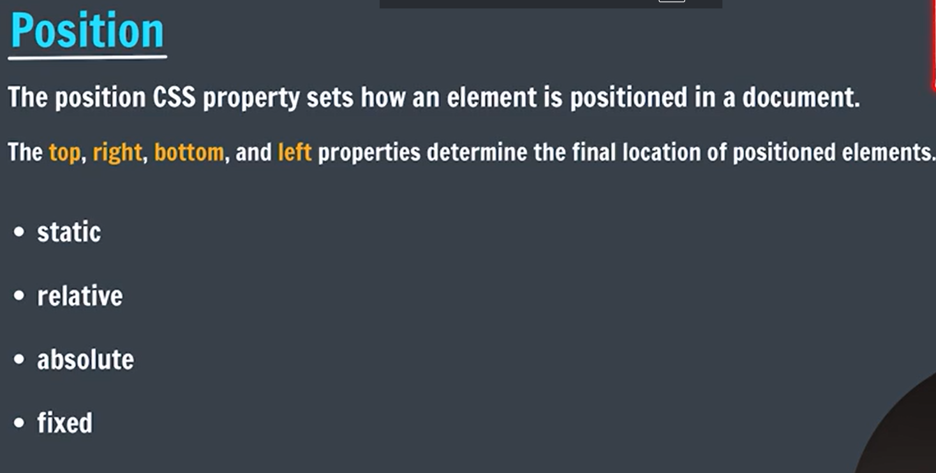
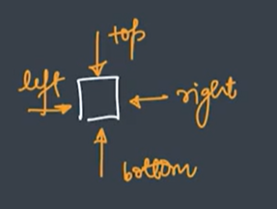
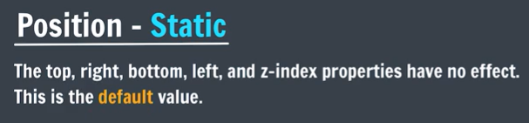
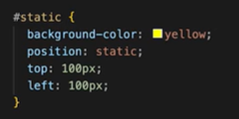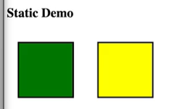
The yellow box has position: static and hence top: 100px and left: 100px doesn’t work.

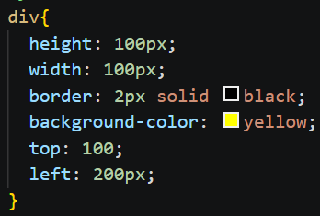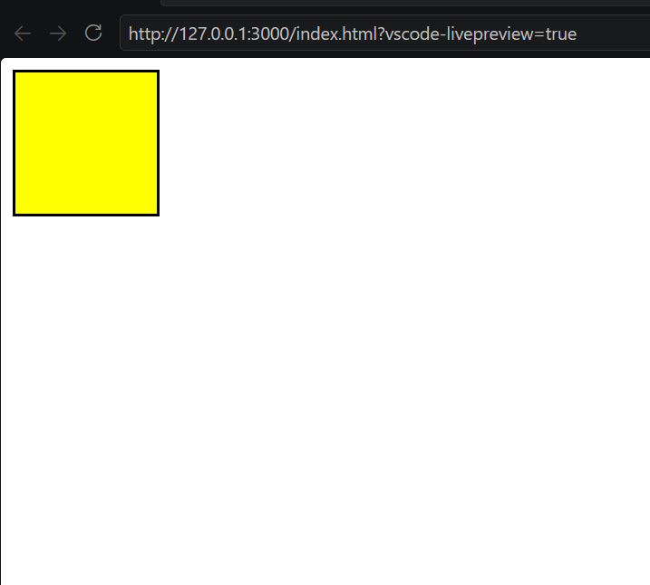
By default, position is static and hence top, left, etc doesn’t work.

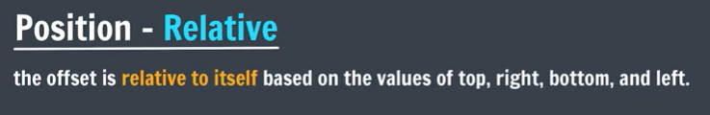
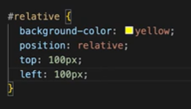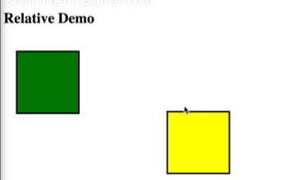
Here top: 100px, means offset of 100px from left.
The position is not relative to whole page it is relative to the centre of object itself

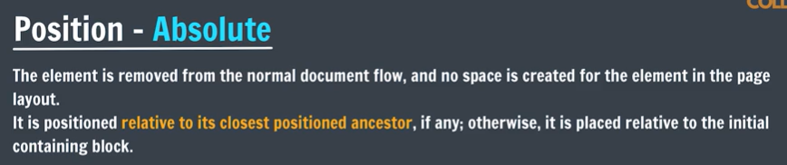
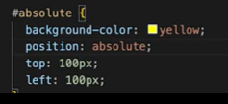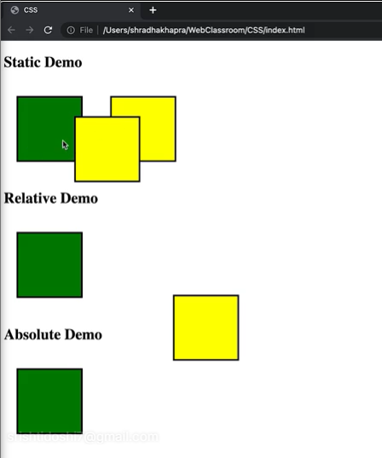

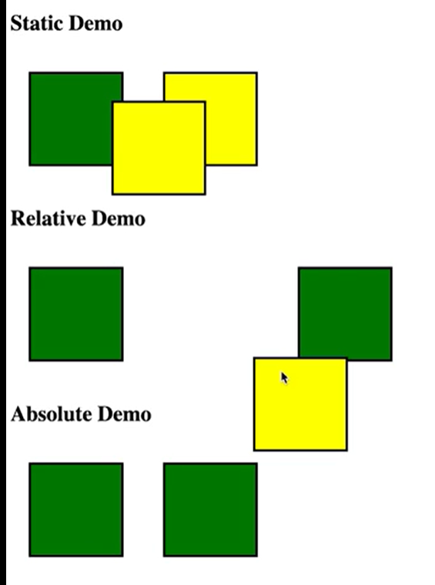
Here when we create 3rd Relative div box then it didn’t took space of 2nd div, as space is created for div whose position: relative
But when we create 3rd Absolute div box then it took the space of 2nd div, as no space is created for div whose position: relative
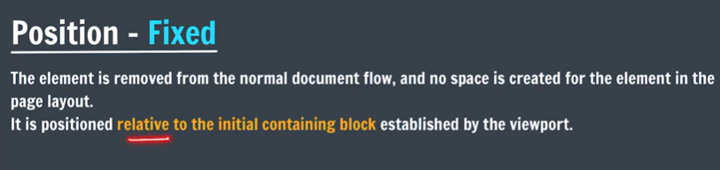
Fixed block will scroll with page, helpful in navbars
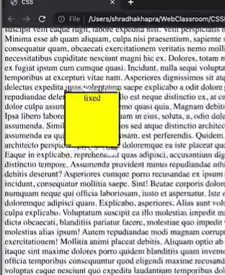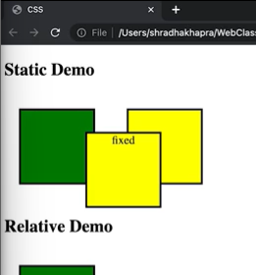

Position: sticky

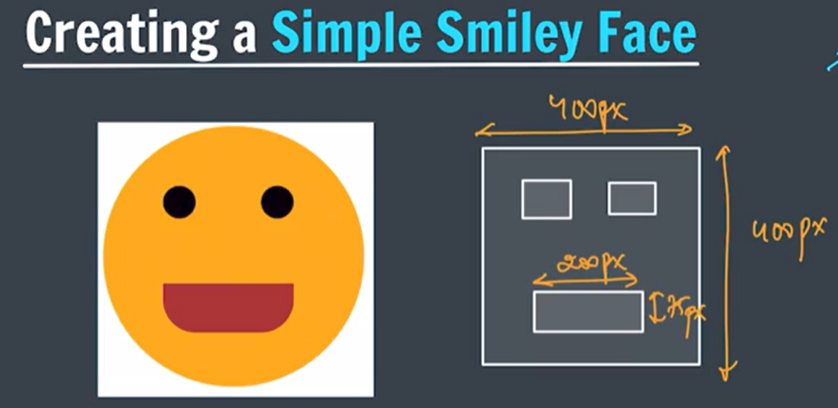

<!doctype html>
<html lang="en">
<head>
<meta charset="UTF-8" />
<meta name="viewport" content="width=device-width, initial-scale=1.0" />
<title>Document</title>
<style>
.face{
height: 400px;
width: 400px;
border-radius: 50%;
background-color: rgba(249, 167, 5, 0.575);
}

.mouth{
height: 75px;
width: 200px;
background-color: #ffa511;
border-radius: 0px 0px 50px 50px;
position: absolute;
top: 230px;
left: 100px;
}

.leftEye, .rightEye{
height: 50px;
width: 50px;
background-color: black;
border-radius: 50%;
position: absolute;
top: 80px;
left: 100px;
}

.rightEye{
left: 250px;
}
</style>
</head>
<body>
<div class="face">
<div class="mouth"></div>
<div class="leftEye"></div>
<div class="rightEye"></div>
</div>
</body>
</html>

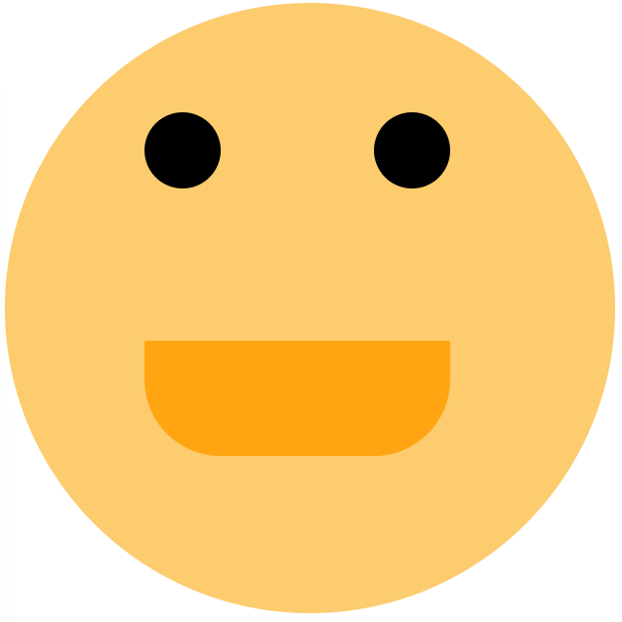

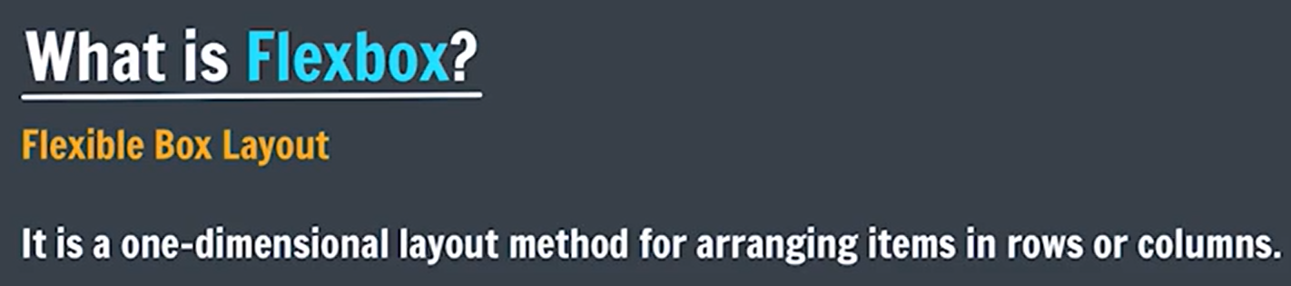
Flexible layout for different screen sizes => Flexbox => responsive
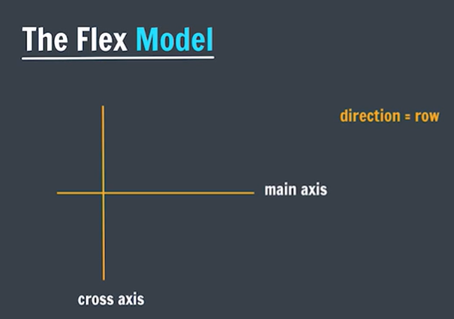
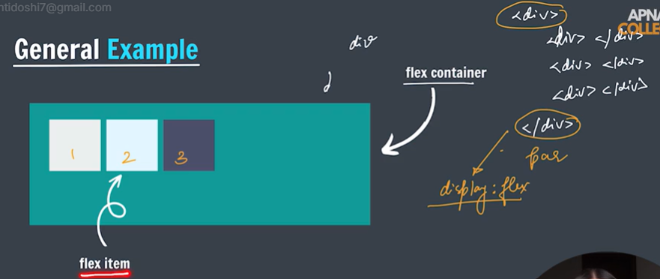
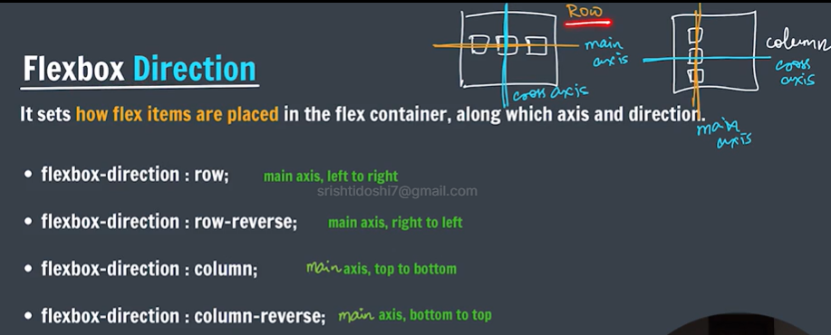
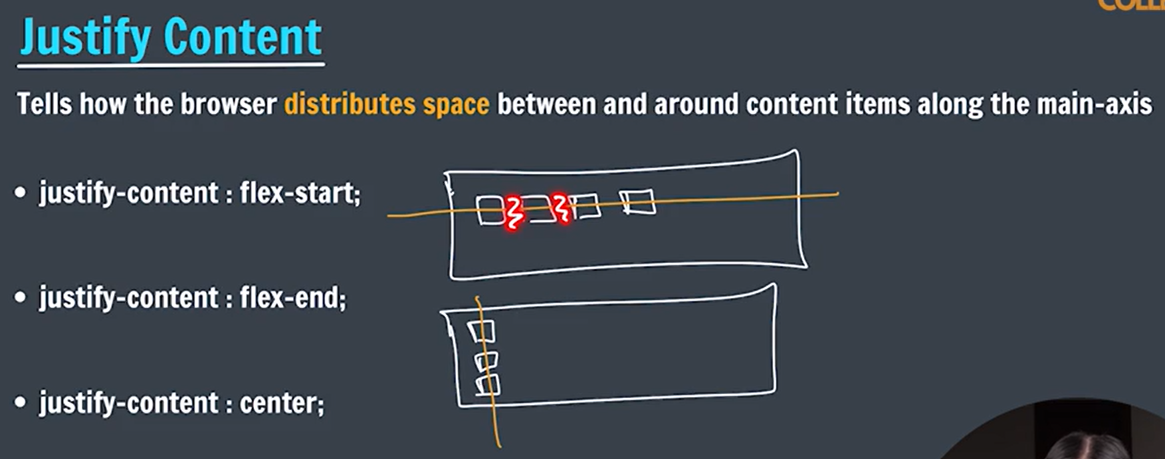
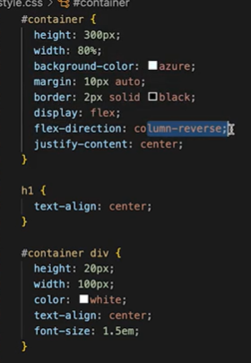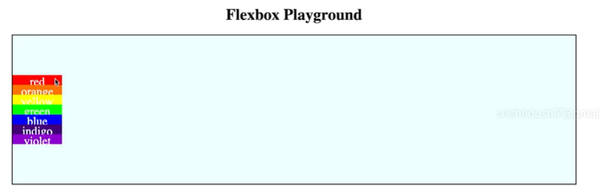
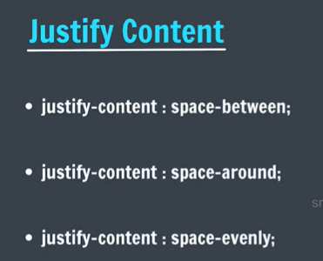
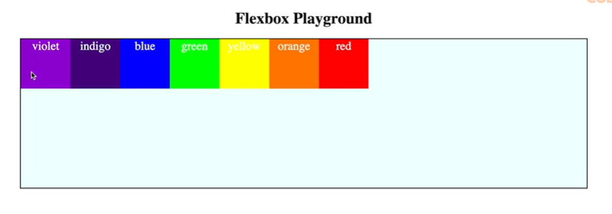
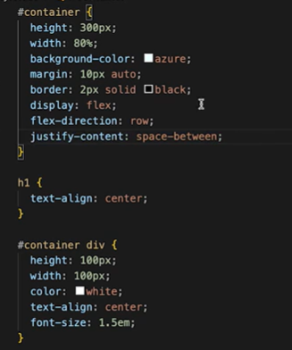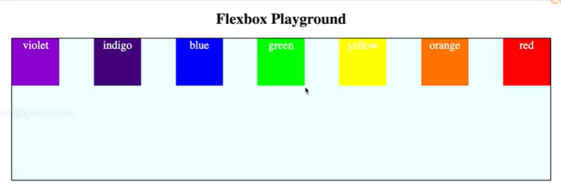

If we make a container of 100px and then put 5 elements in it each of 100px , => items overflow => then normally, the inner elements size will get decreased to fit in container’s single row. But to still fit in with required width, we use flex wrap, here elements move in next line
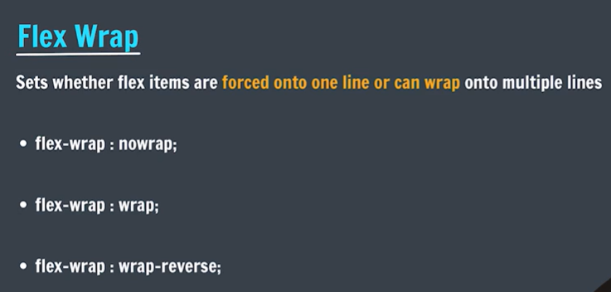
Flex-direction: row

flex-wrap: nowrap; => by default(inner elements size decreases to fit in)
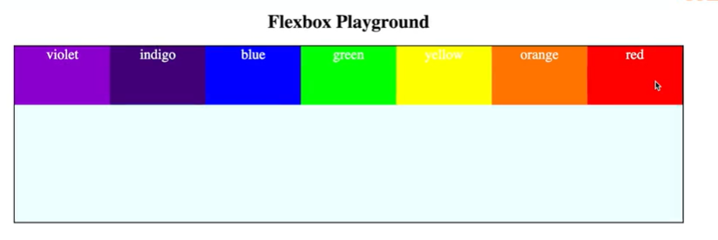

flex-wrap: wrap;
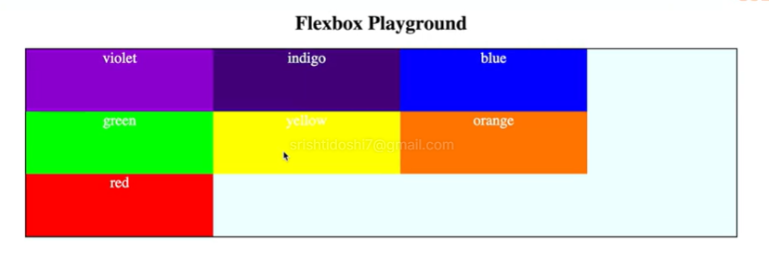

flex-wrap: wrap-reverse; (cross axis => reverse direction wrap
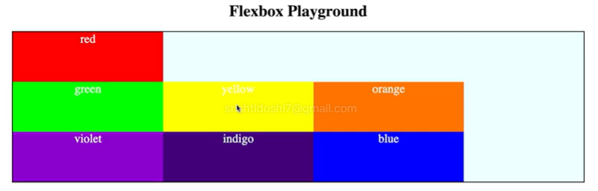

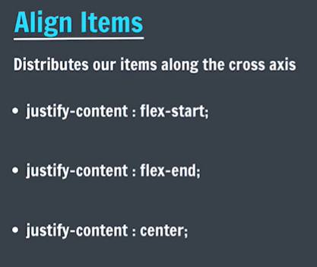

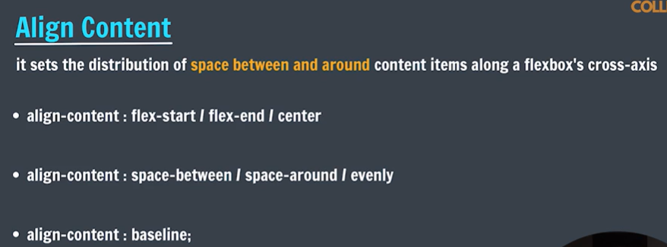

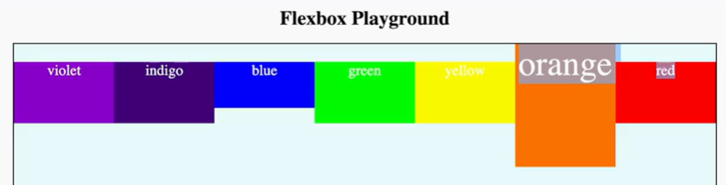

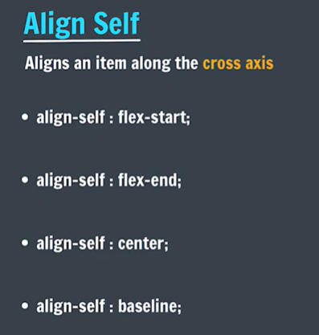
Align self behaves like align items
Align items => group
Align self => individual
Priority: Align-self > align-items
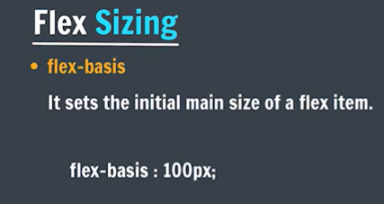

Main size of elements can be changed automatically (Grow/shrink) according to extra space present in container

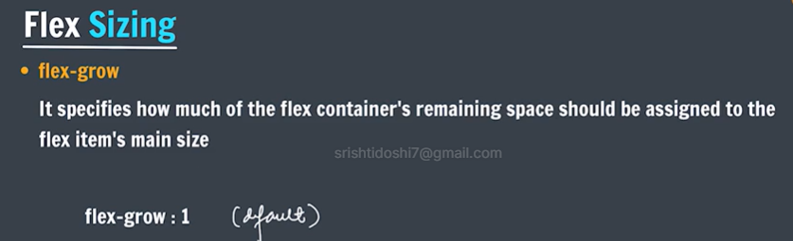
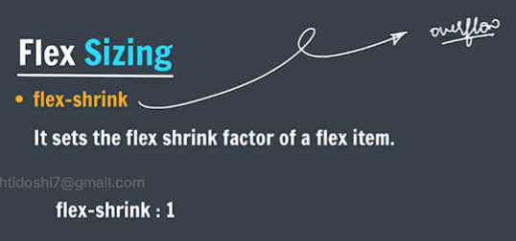

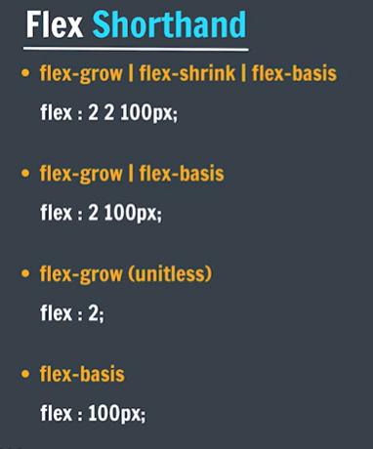
Try this game to understand flexbox:
https://codingfantasy.com/games/flexboxadventure/play

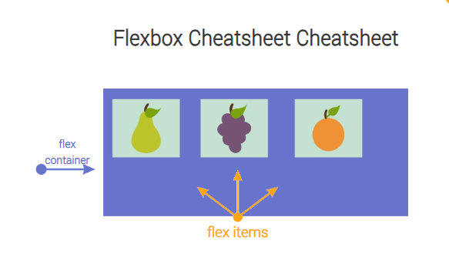

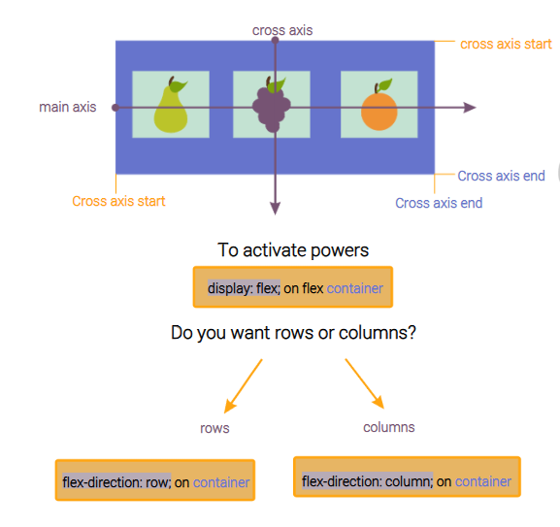
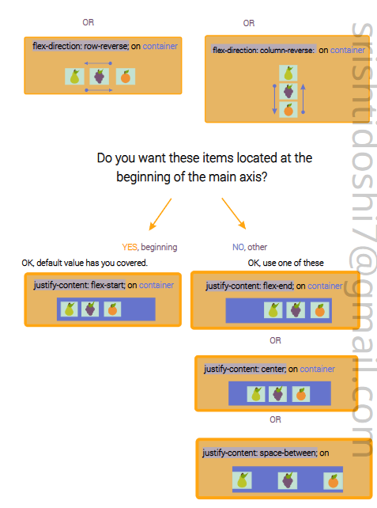

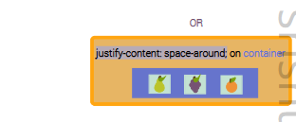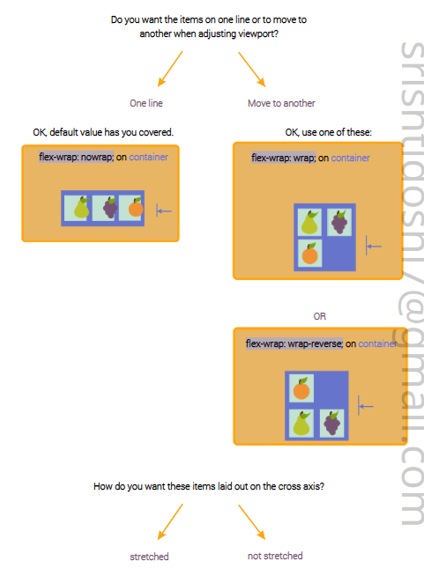

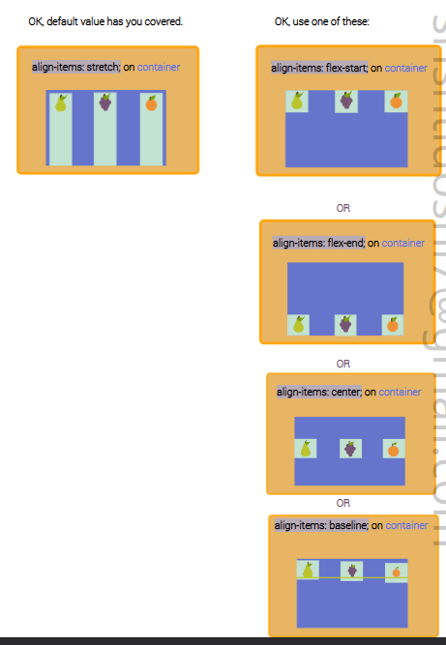

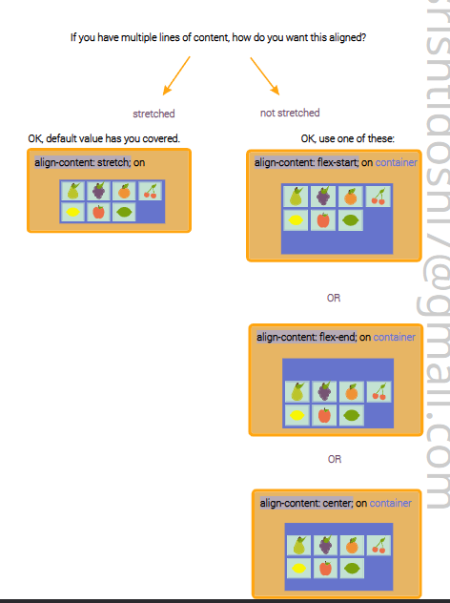

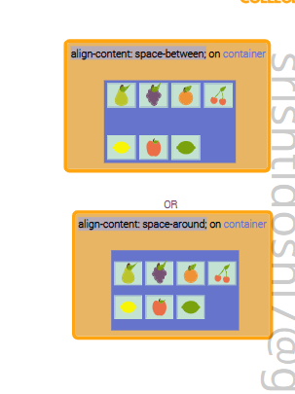

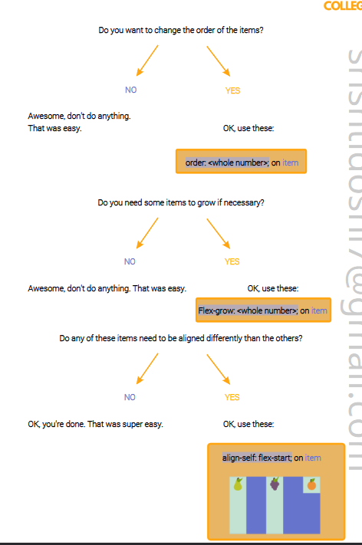

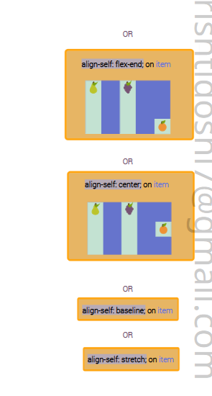

CSS Layout => helps in creating layout of elements but only in anyone one direction(horizontal/vertical)
CSS Grid => helps in creating layout of elements in 2D. => 2D layouts
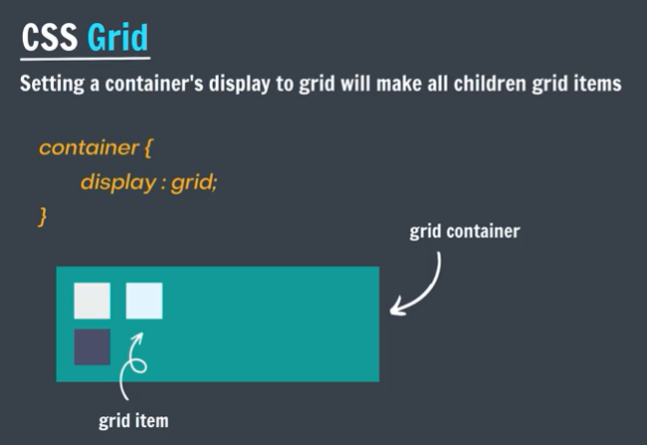

In grid container, only direct children are considered as grid item.
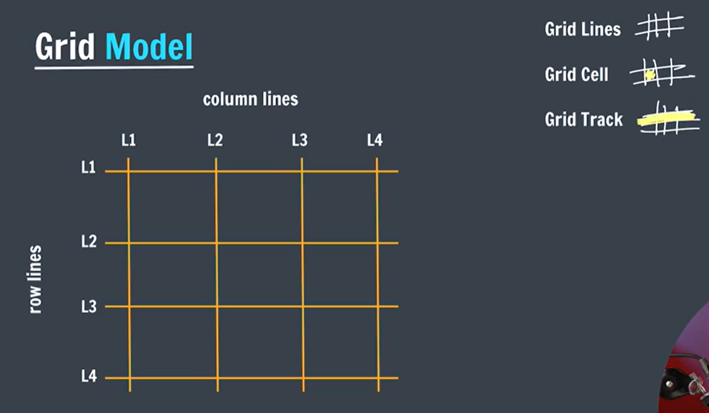
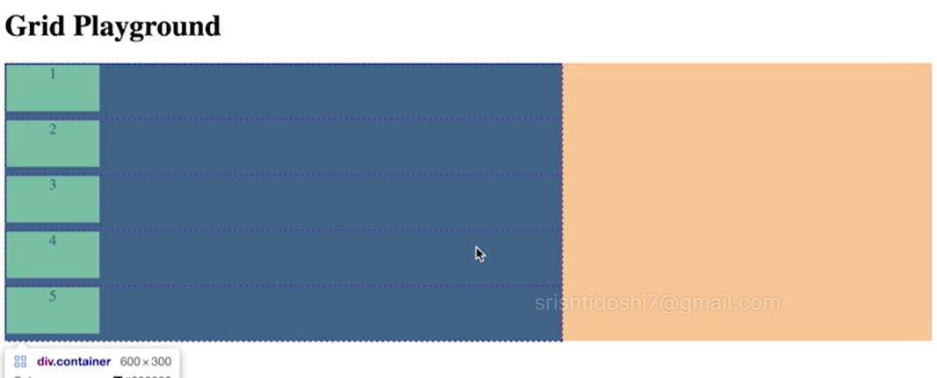
See the purple lines, these are grid lines

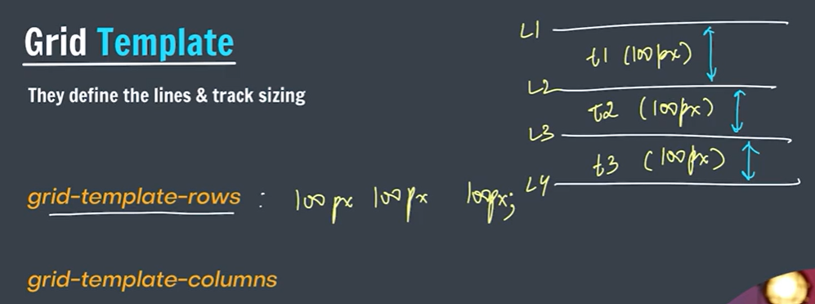
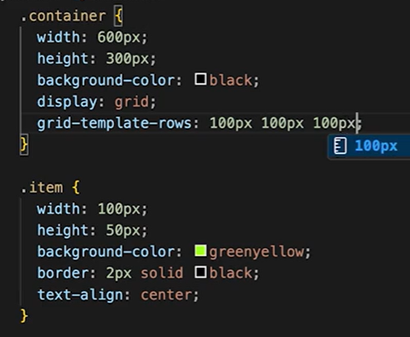
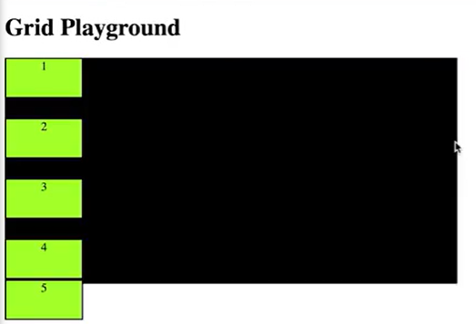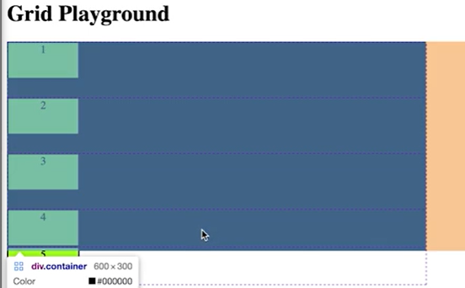

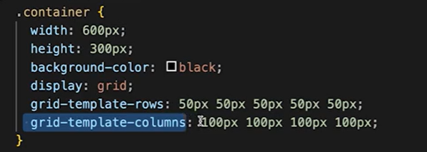

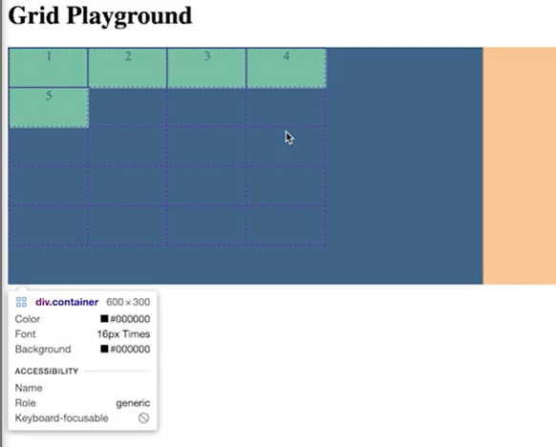
grid-template-rows: auto;
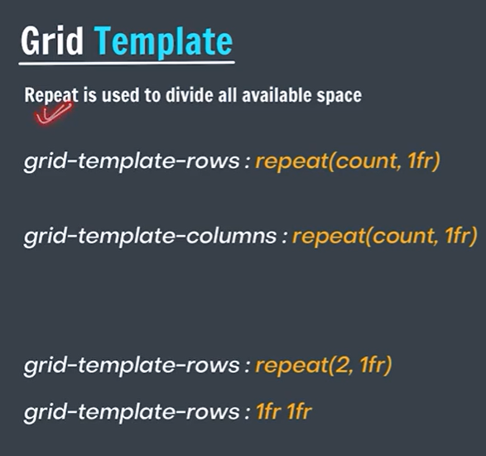
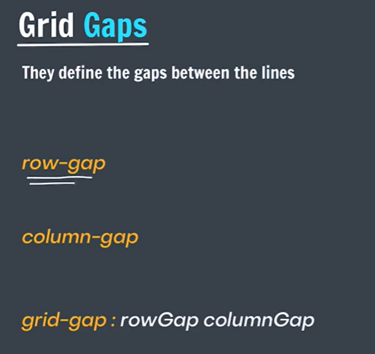
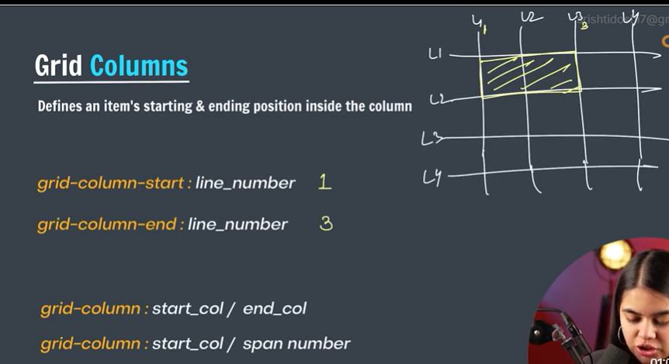

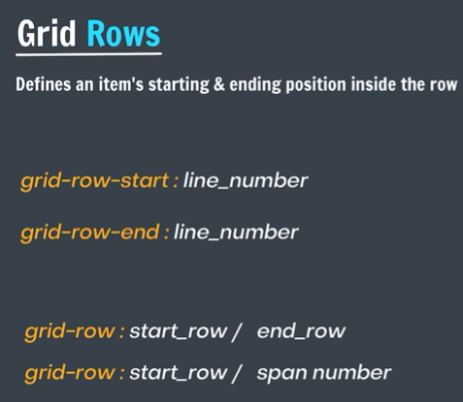
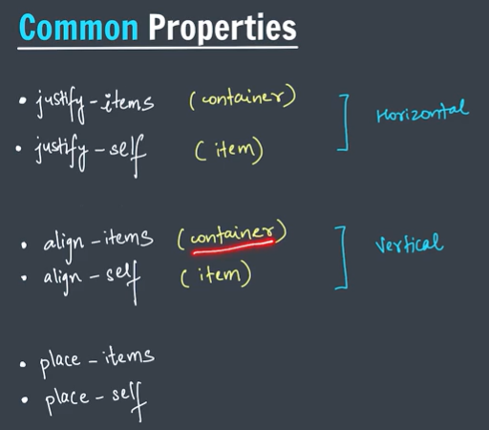

display: grid; If we set an element as grid, then it becomes a block element
display: inline-grid; If we set an element as inline-grid, then it becomes a iniline element

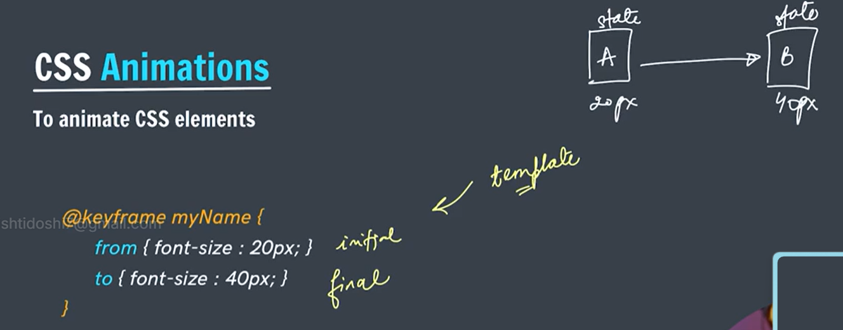
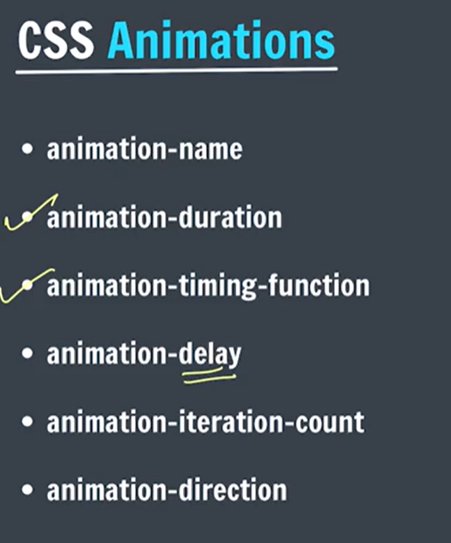

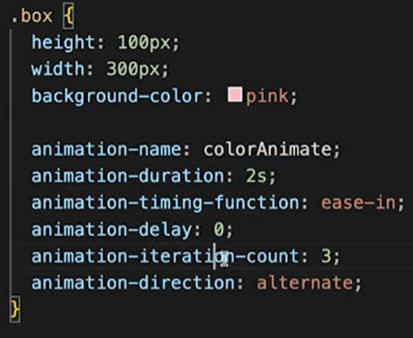

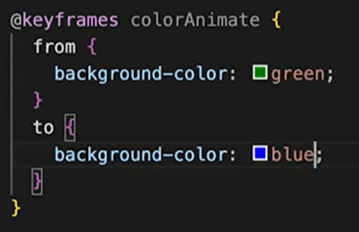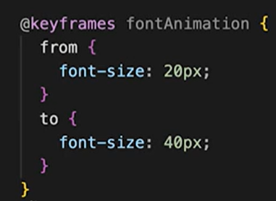

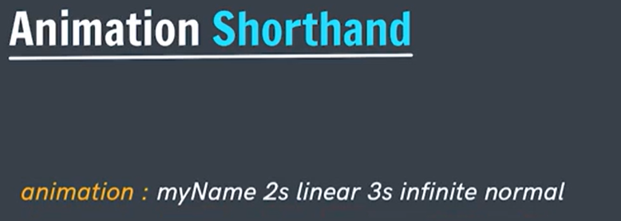

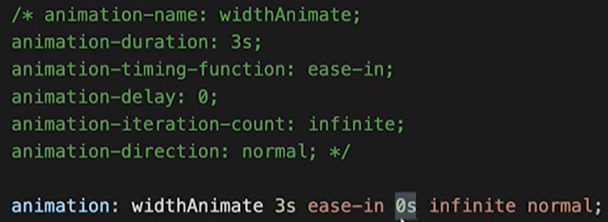
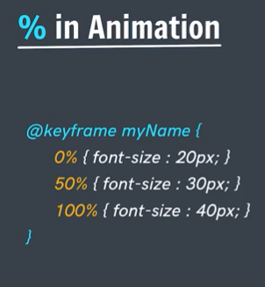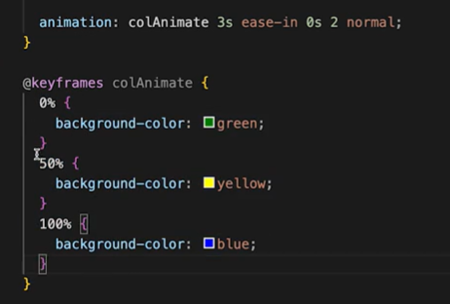

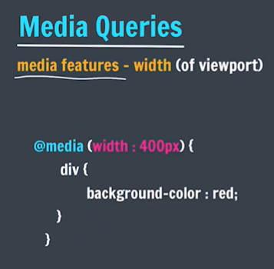
Every device/environment has its particular properties (width, height, orientation – portrait, landscape mode).
Due to these properties, the changes that comes are called media features.

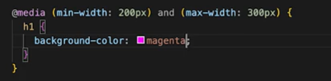
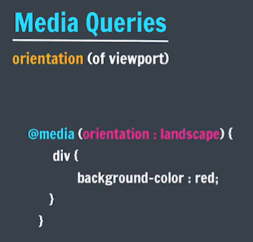
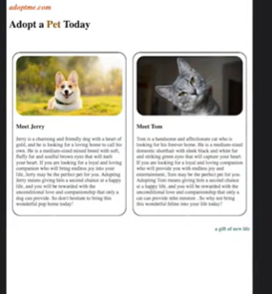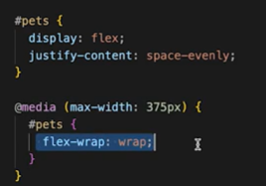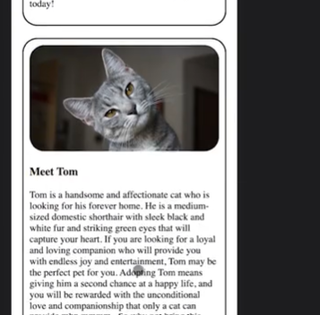

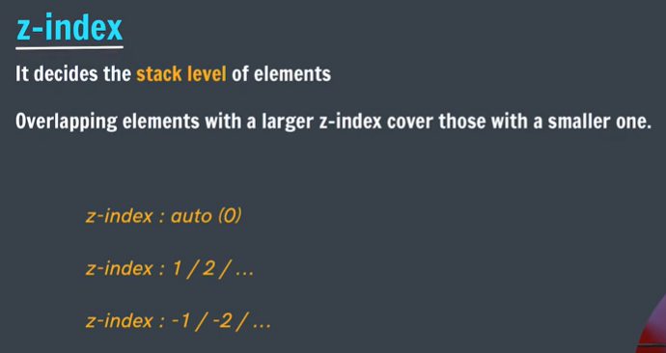
The element who has position: static or default, we cannot apply z index on it
It works with => position : relative or absolute etc..
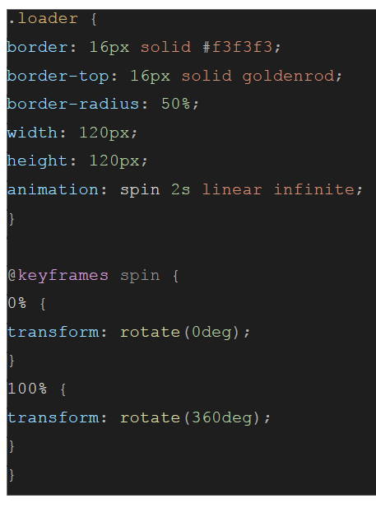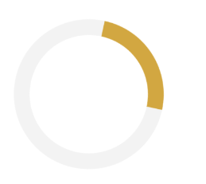


- Colour
- Typography (text style)

Consistency, colour consistency, not too crowded, empty spaces available is kind of good.

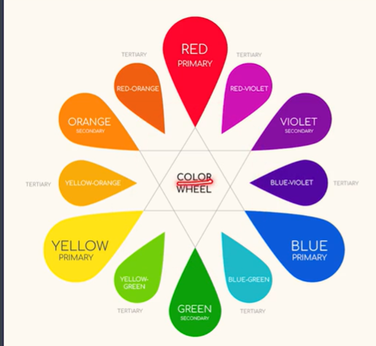

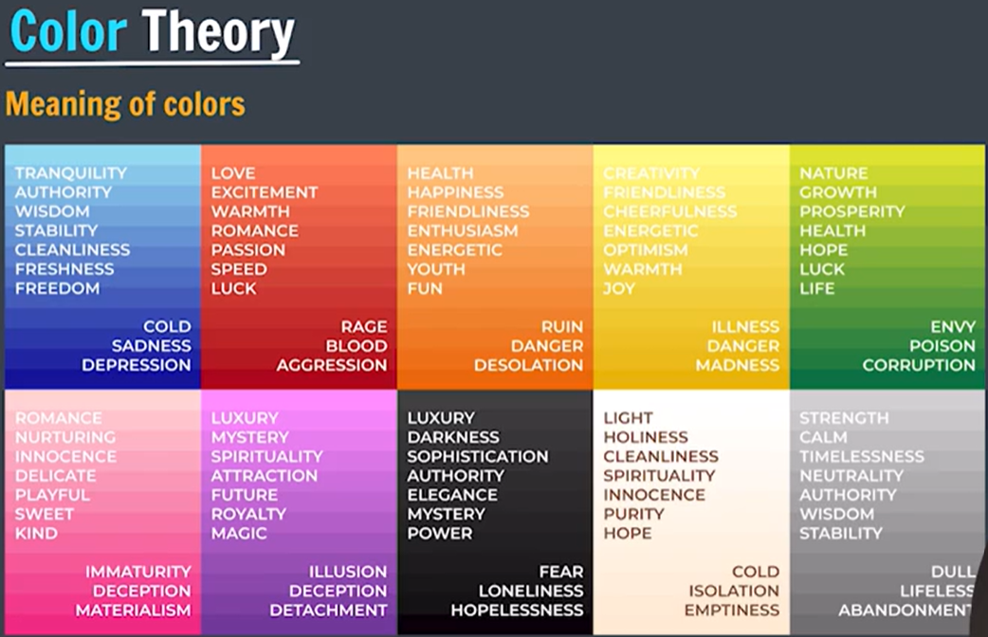
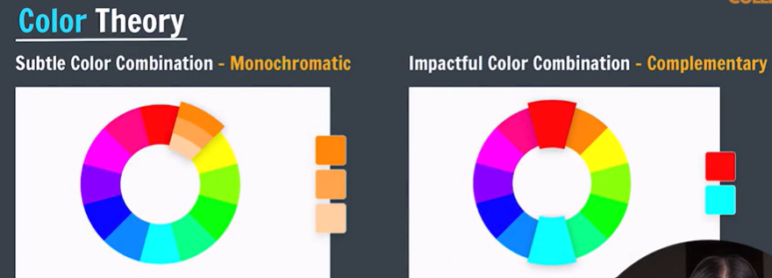

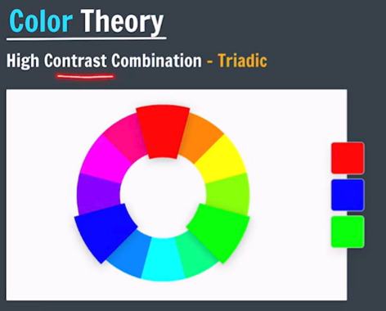

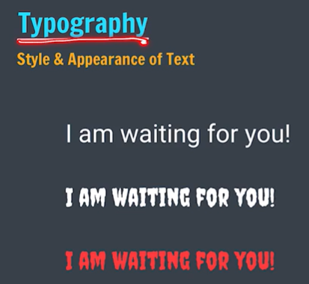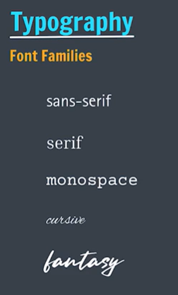
Try to use maximum only two fonts in one section, to avoid making it look messy.
 library of fonts 1513 fonts available

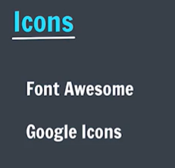 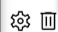 for font awesome icon links: cdnjs.com/libraries/font-awesome

