JAVASCRIPT .

Frontend components
- HTML (structure) => markup language
- CSS (styling) => styling language
- JavaScript (functionality) => programming language => logical coding

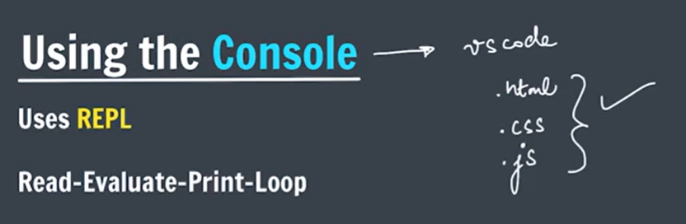
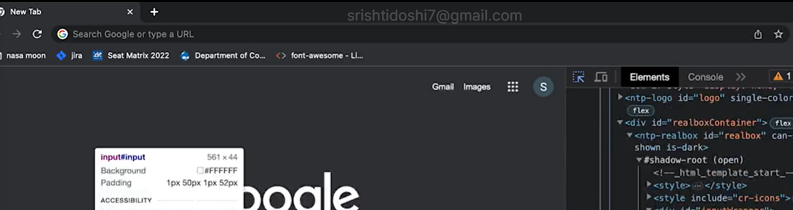
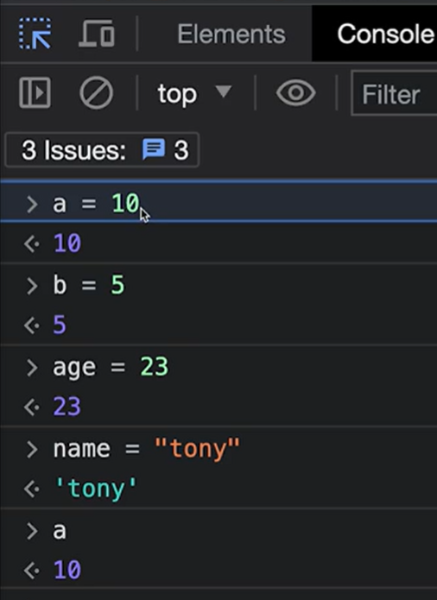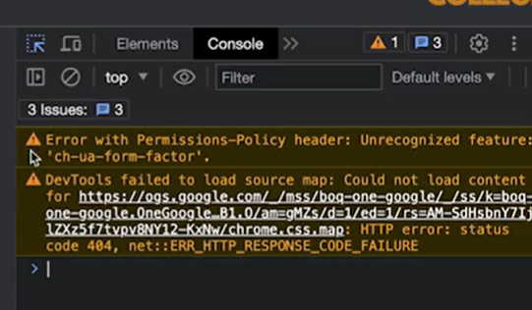
Ctrl +L => clear console

Variable => name of a storage location in memory.

Data Types in JS
- Number
- Boolean
- String
- Undefined
- Null
- Bigint
- Symbol
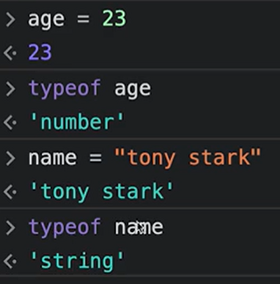
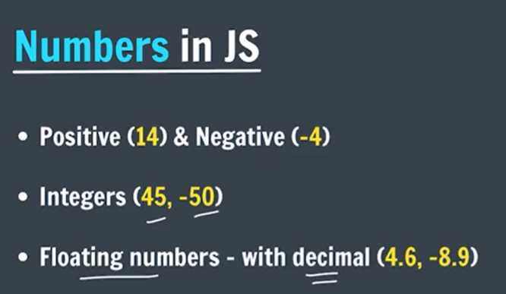
JS automatically detect datatype, no need to specifically state it.

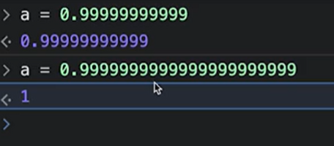
There is a limit at storing so many digits of decimal numbers in js, and when reaching the limit it automatically gets to nearest integer.

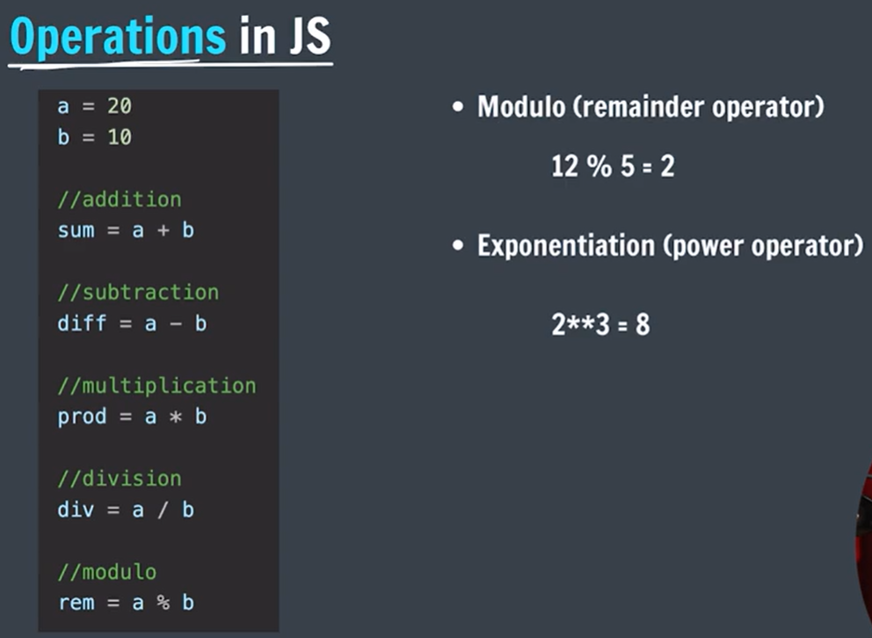
A, b => operands
+, - => operators

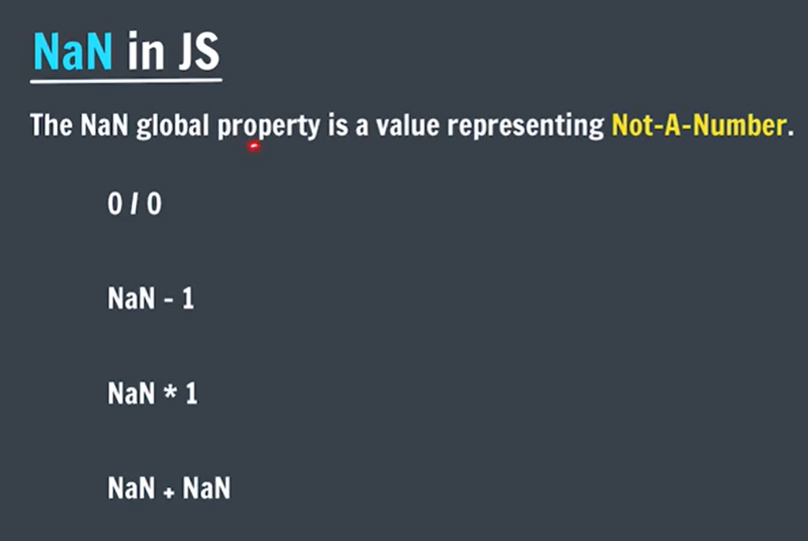
NaN is a number in js that represents a value that is not a number.
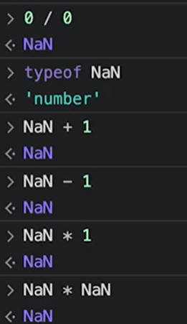
Performing any operation with NaN results in NaN.

Operator Precedence
This is the general order of solving an expression.
() > ** > *, /, % > +,-
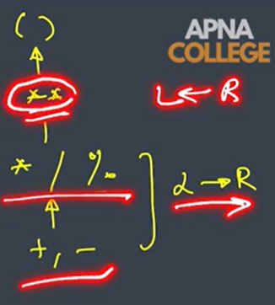

In JavaScript, *, /, %, +, and - have left-to-right associativity when operators have the same precedence.
20/5*2 => 4*2 => 8
But JavaScript uses ** for exponentiation, and it has right-to-left associativity.
2**3**2 => $2^{\left(3^{2}\right)}=2^{9}=512$

Keword => fixed meaning

let keyword => syntax of declaring variables

let age = 23;
age = age+1;

let cgpa;
cgpa = 8.9

let num1 = 2;
let num2 = 4;
let sum = num1+num2
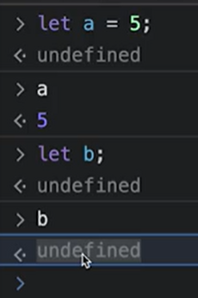
- Uninitialized: No value has been assigned to the variable.
- undefined: The value that JavaScript returns when a declared variable has no assigned value.

const Keyword => values of constants can’t be changed with re-assignment and they can’t be re-declared.
const year = 2025;
year = 2026 //error

const pi = 3.14

var keyword => old syntax of writing variables
different from let in terms of scope
var age = 23;
var cgpa = 8.9;

difference : let and var
Feature | var | let
Scope | Function-scoped | Block-scoped {}
Redeclaration in the same scope | Allowed | Not allowed
Reassignment | Allowed | Allowed
Hoisting | Hoisted and initialized with undefined | Hoisted but inaccessible before declaration (TDZ)
Global declaration | Becomes a property of window in a browser script | Does not become a property of window

Hoisting and undefined
With var:
console.log(a); // undefined
var a = 10;
JavaScript allows the access because var is hoisted and initialized with undefined.

With let:
console.log(b); // ReferenceError
let b = 10;
Although let is also hoisted, it remains in the Temporal Dead Zone (TDZ) until its declaration is executed.

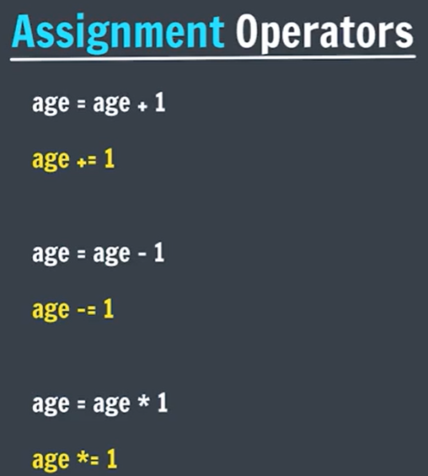

Binary operators(+, -,*) => needs two operands
Unary operators(++, --) => needs only one operand
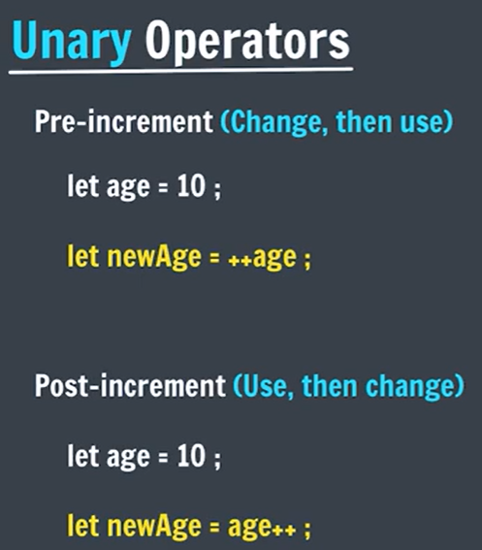

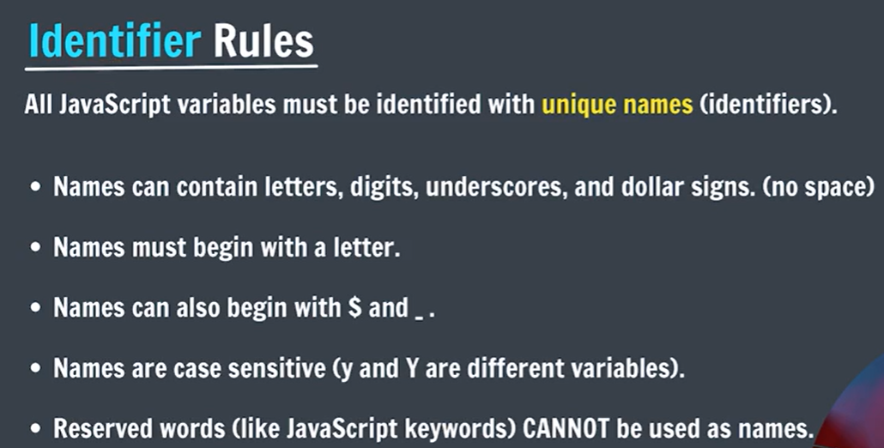

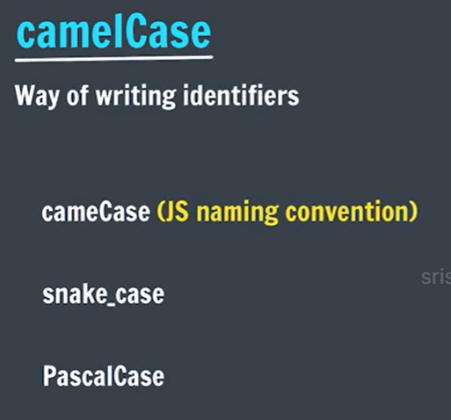

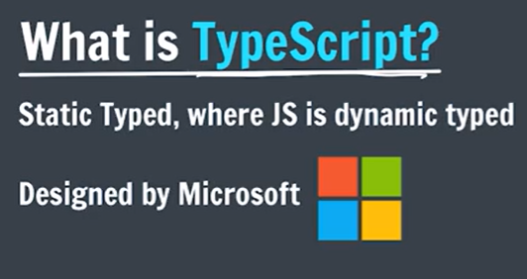
Js is dynamically typed that means type of a variable can be changed later.
Ts is strict version of Js that is statically typed that means type of a variable cannot be changed later

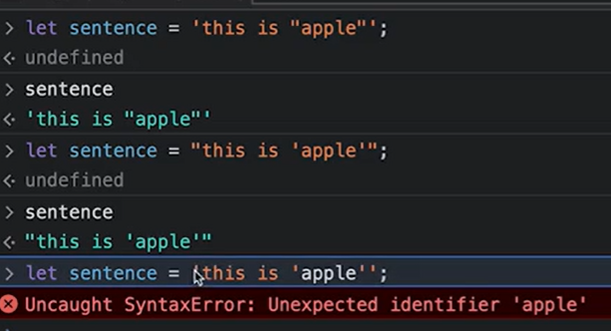.
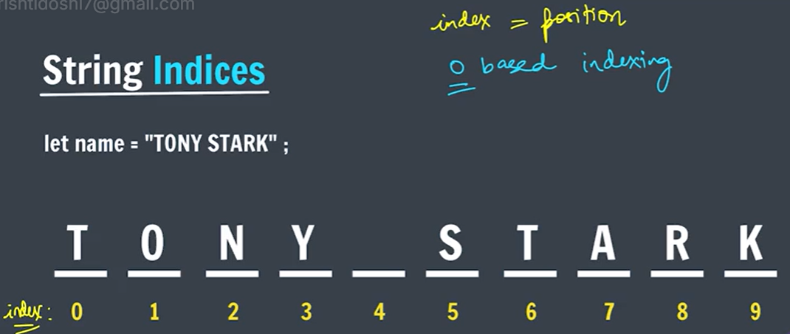

let name = “apple”;
name[0]; //a
name[100]; //undefined
name.length; //5
name[name.length-1]; //e
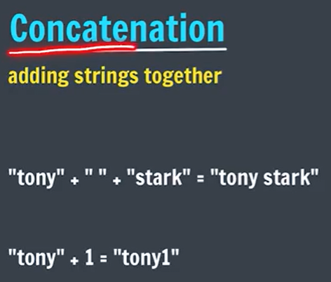
‘’sri” + 12 = ‘’sri12’’

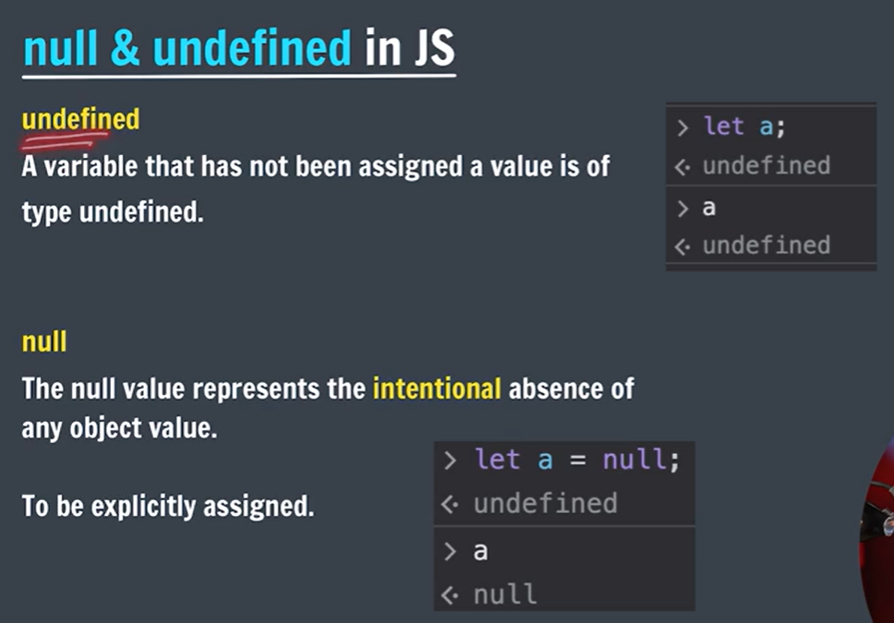

Semicolon is imp in js => not writing => error

console.log() => To write (log) a message on the console
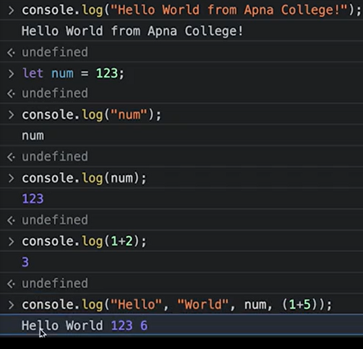
console.log() is used to display values or messages in the browser's console so that the output of JavaScript code can be checked.
console — a built-in object that provides access to the developer console.

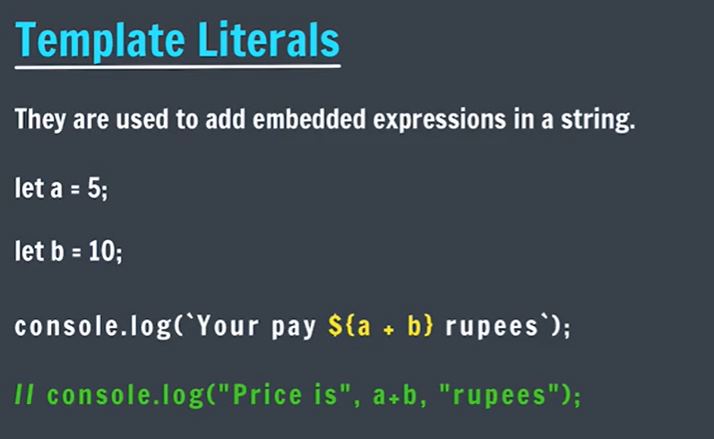
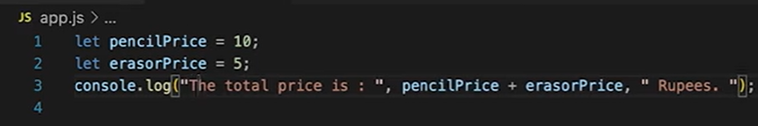
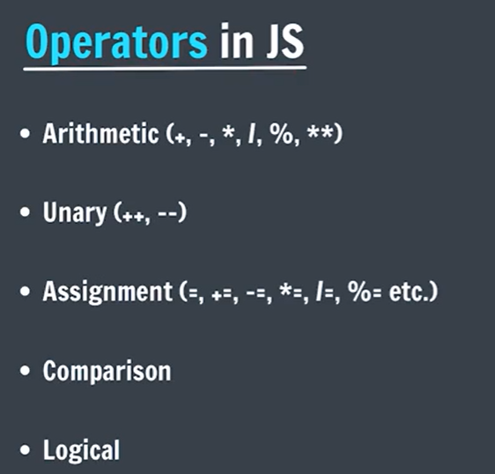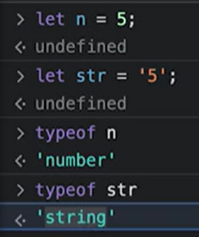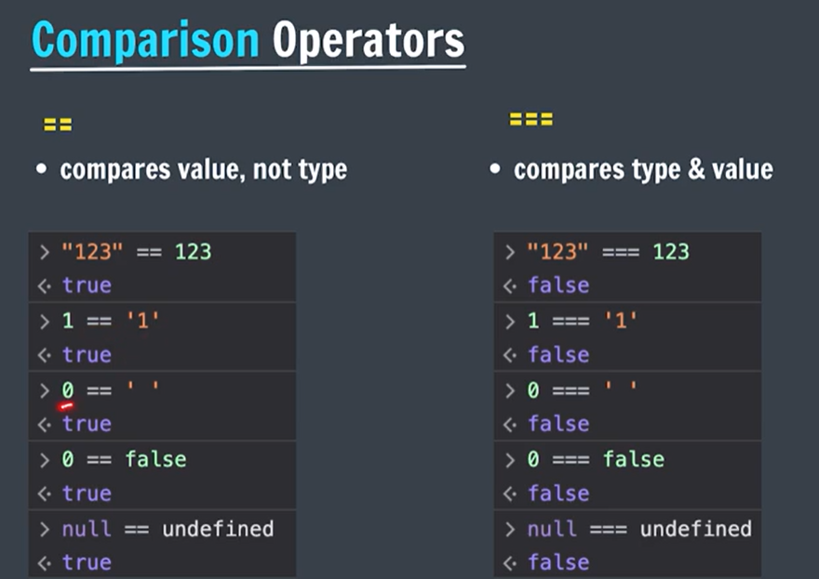
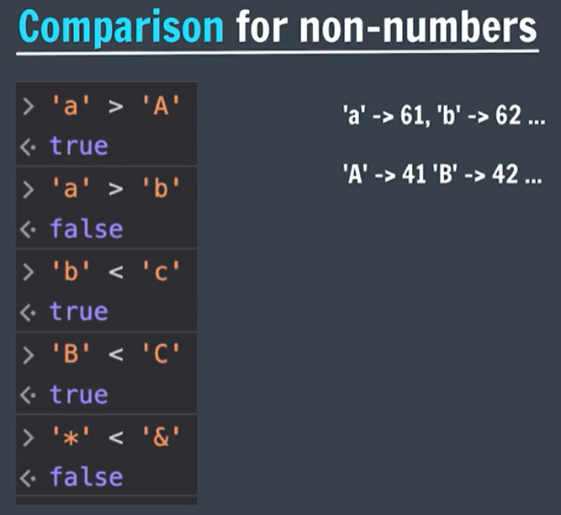
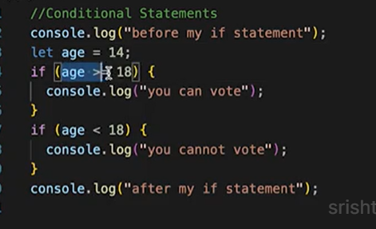
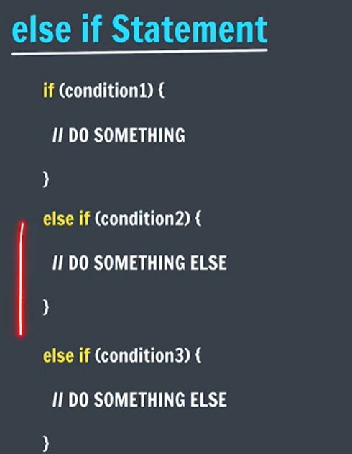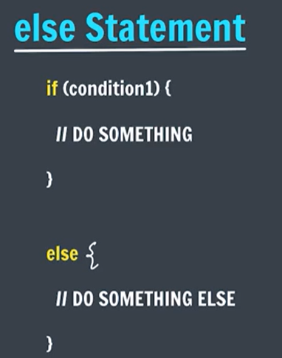

BODMAS => Bracket > *, / > +, -
Operation | Direction
Brackets | Innermost first
Orders (powers) | Right to Left (for chained powers)
Multiplication & Division | Left to Right
Addition & Subtraction | Left to Right

Str.length

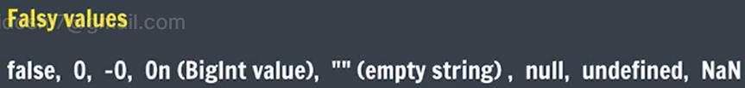

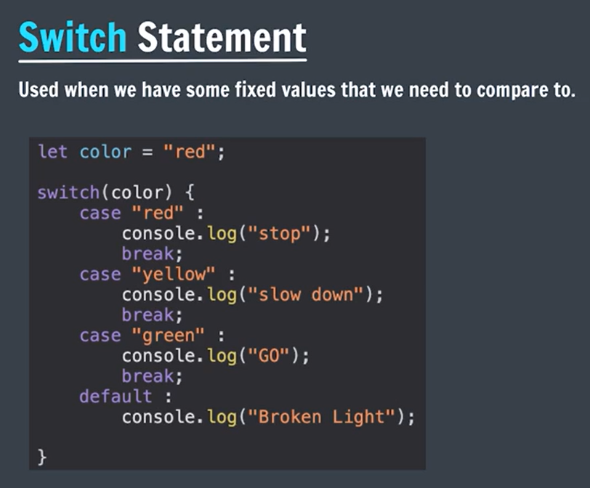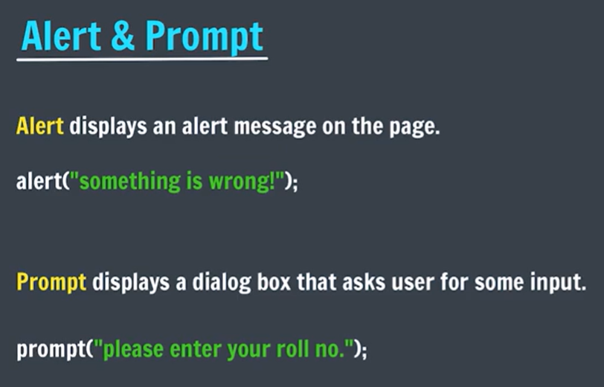

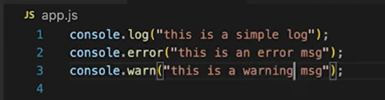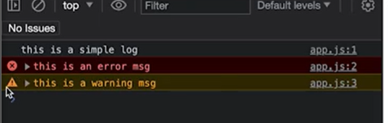

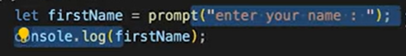

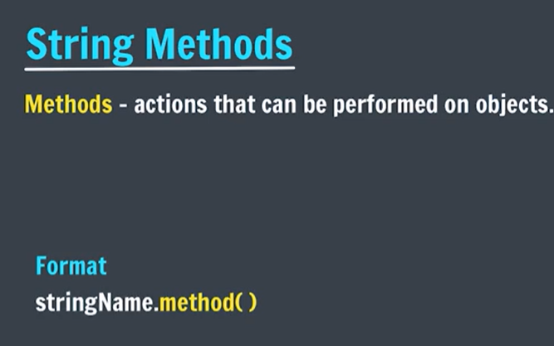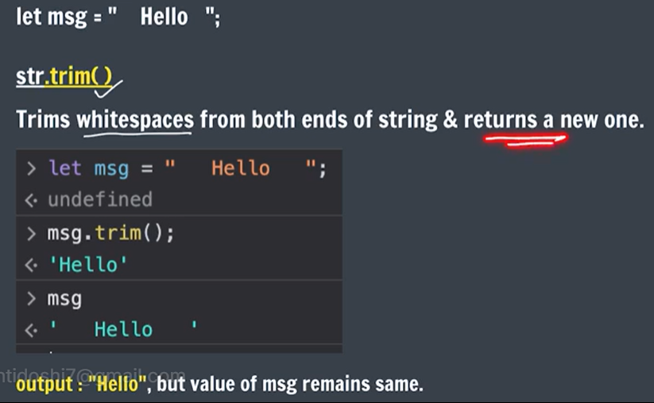

JavaScript strings are immutable
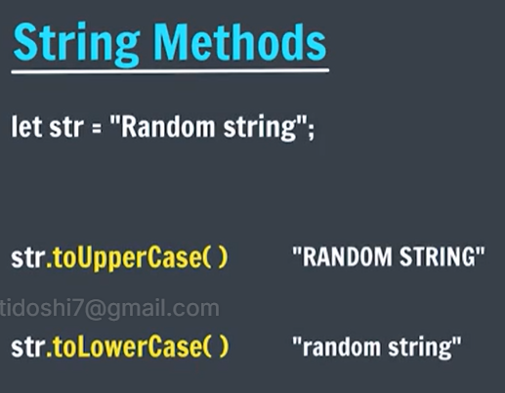

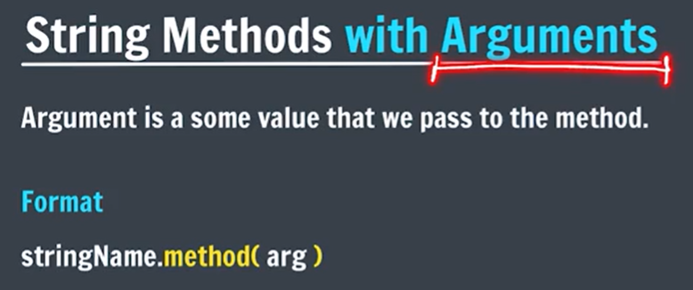
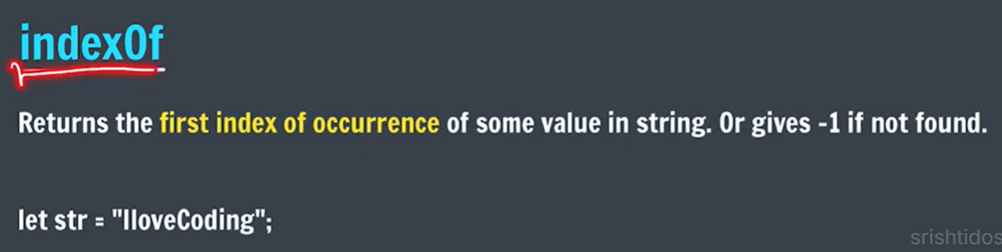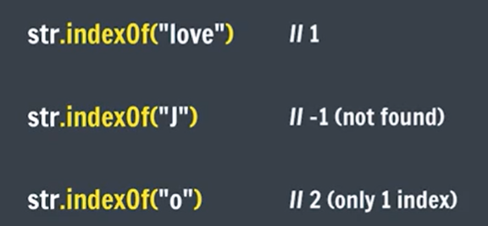

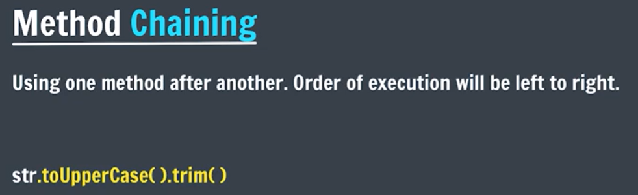

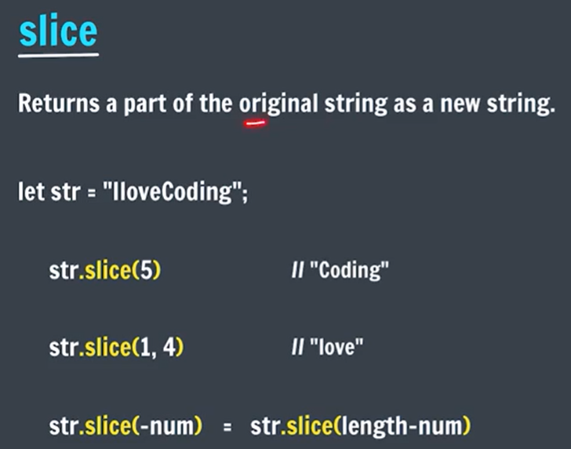

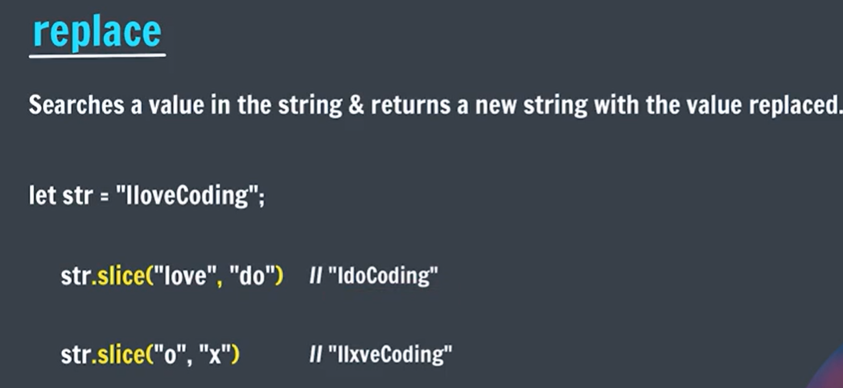
let name = “College”;
name.replace(‘l’, ‘t’); //Cotlege

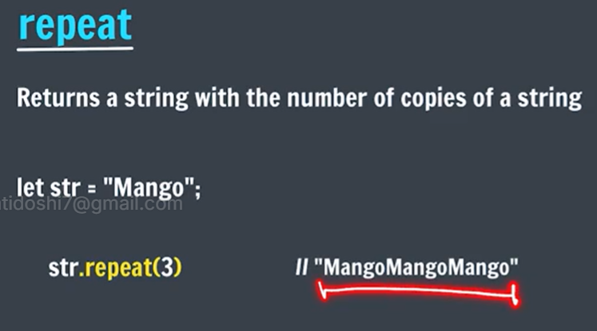
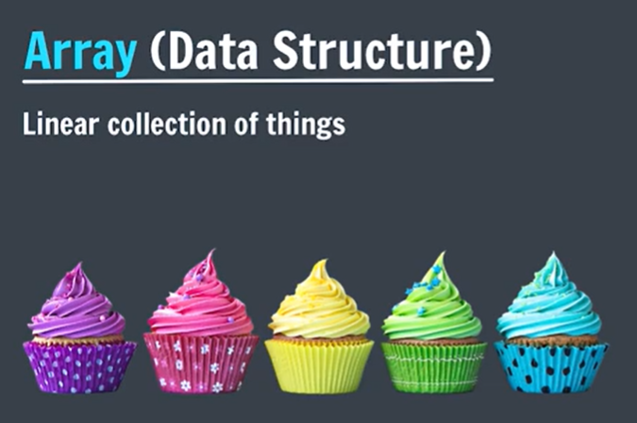
We may need different variables to store different elements.
But with the help of an array we can store different elements in a single array.

let student1 = “prince”;
let student2 = “tiku”;
and so on …

let students = [“prince”, “tiku”, “sonu”, “sahil”, “motu”];

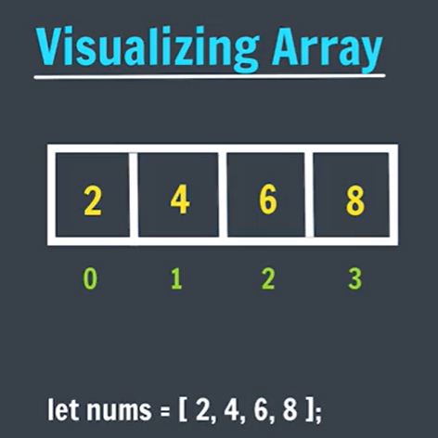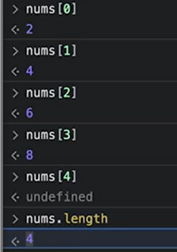

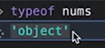

In C++ , java , the array consists elements of same data type.
Nut in JS , we can create array that can consists elements of different data types too

let info = [“sris”, 20, 90];
info[0] //sri
info[0][0] //s
info[0][1] //3
info[0].length //4

let empArr = [];
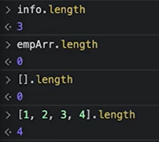

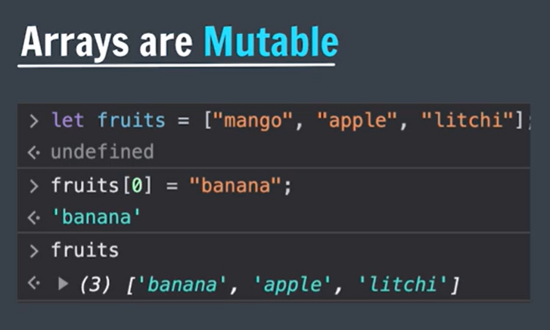
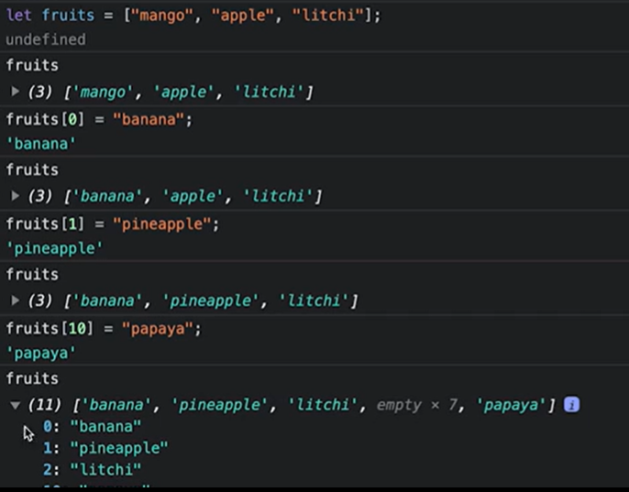
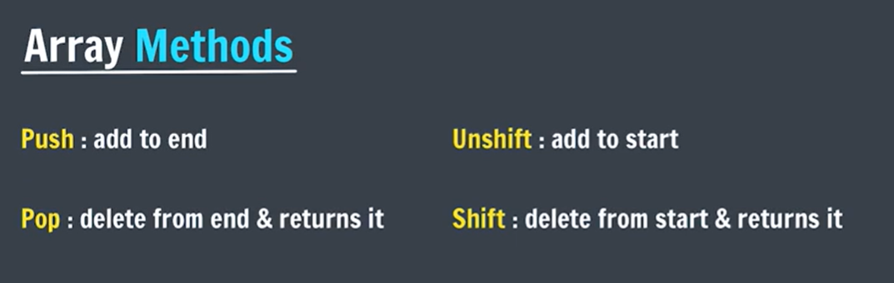
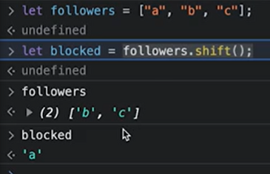

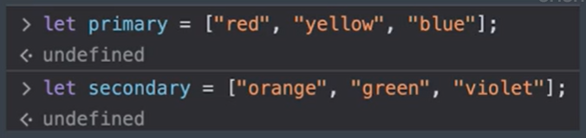
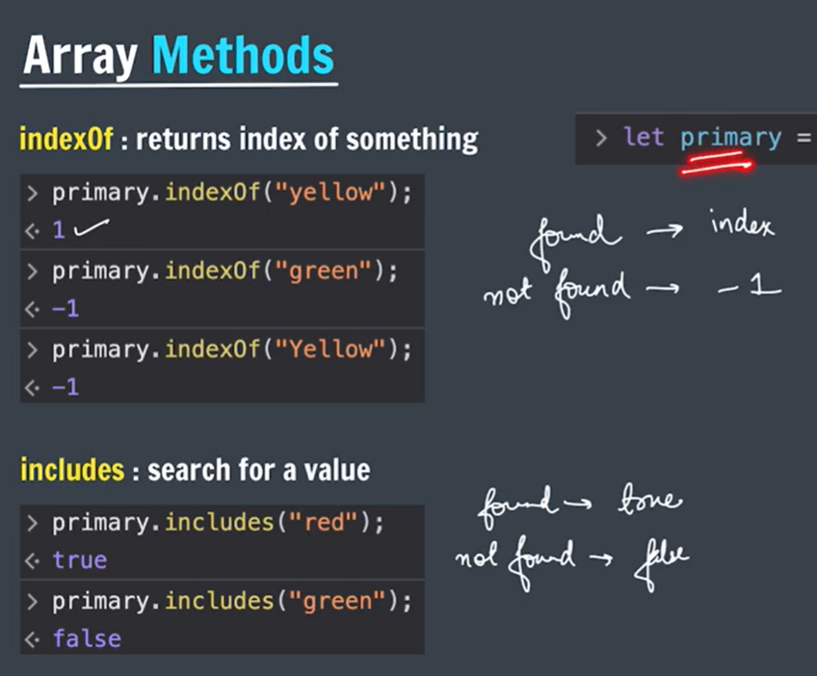
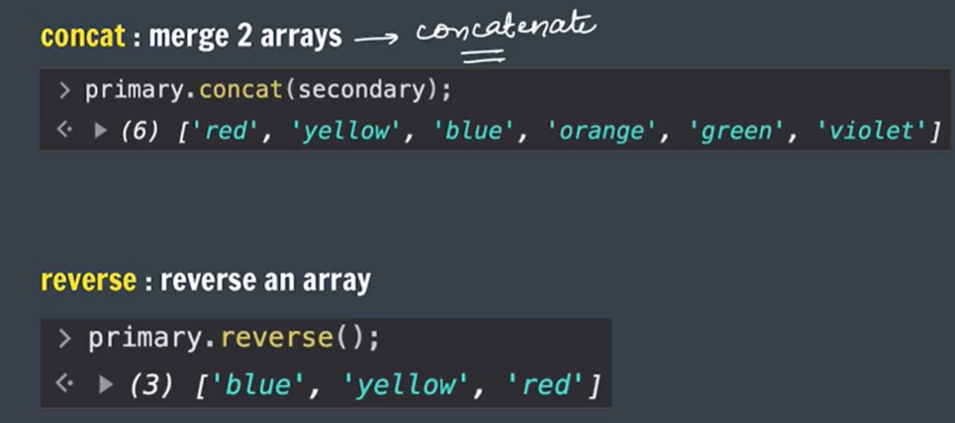
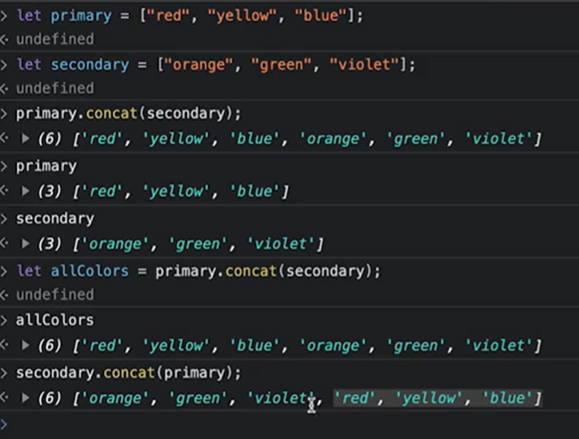
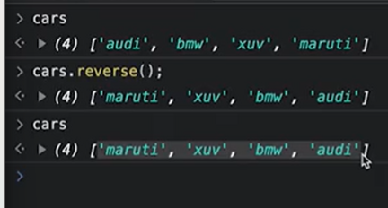

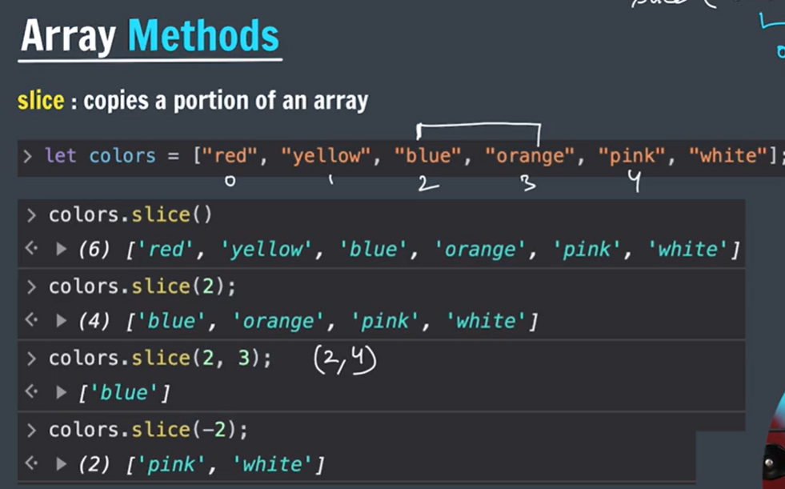

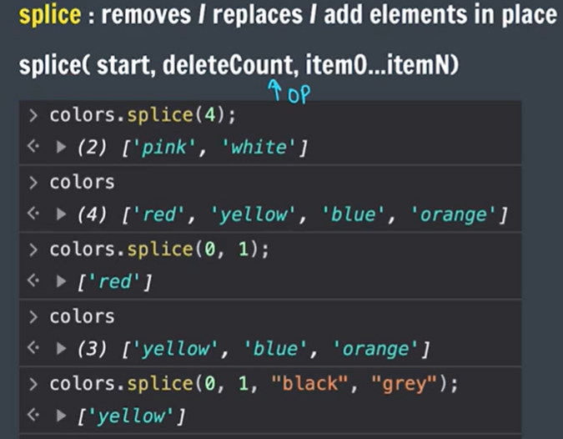
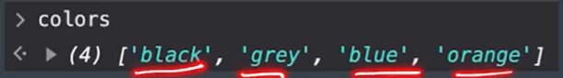
Slice returns a copy while splice changes original array
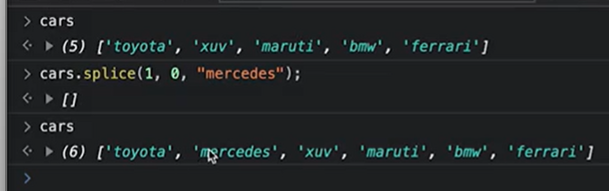

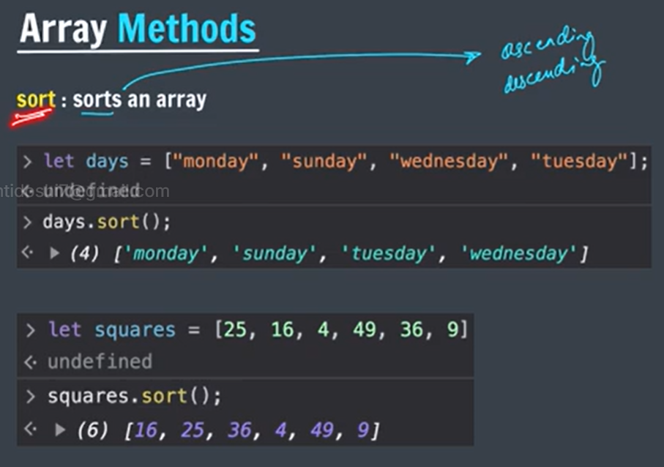

By default, sort() sorts an array by converting each array’s elements in string form and them arrange them in ascending order.
Hence, in case of numbers it provides a unexpected output.

arr.splice(0,1).splice(1,0,”june”); => wrong
splice returns deleted item array and hence no chaining can be done

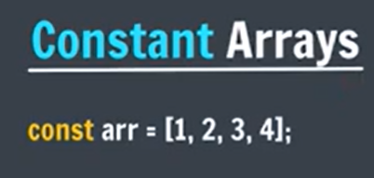
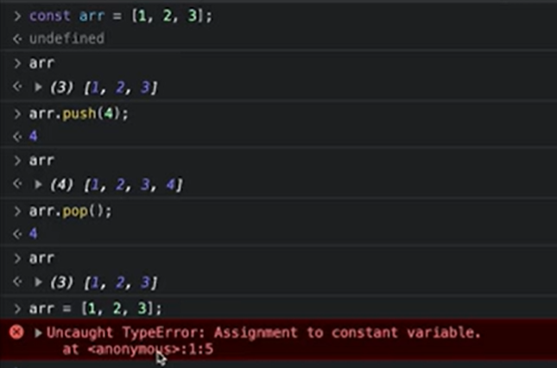4
Here array is not constant and hence operations on elements can be easily performed.
Here arr is constant, that means address of arr is constant.
Reference variable i.e arr is constant and it stores address. 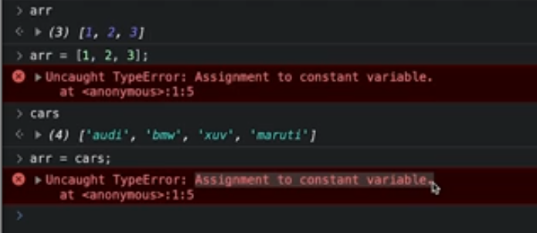

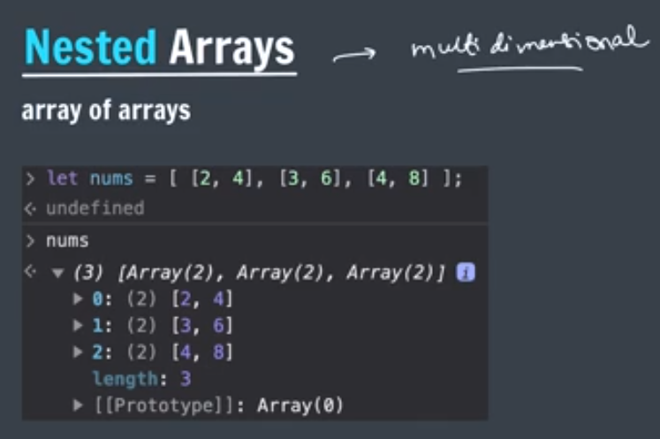
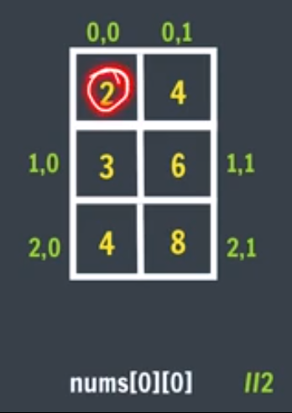

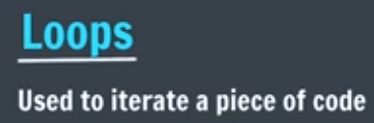
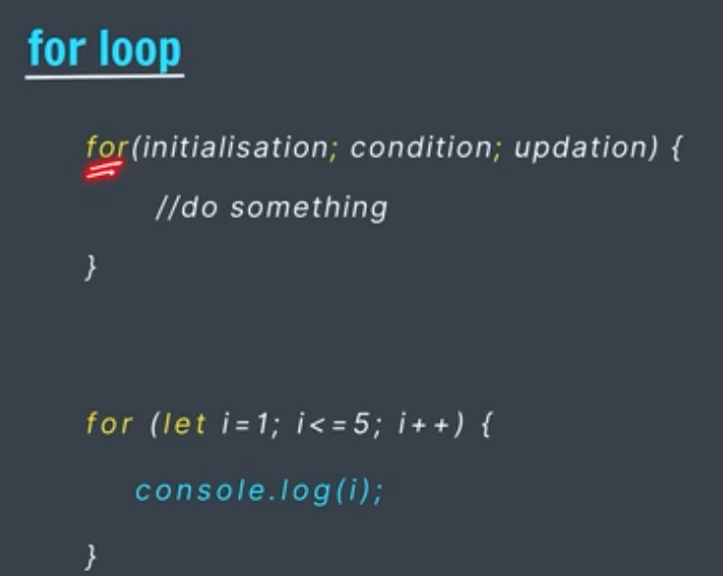

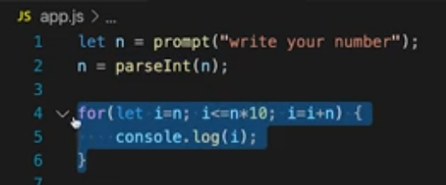
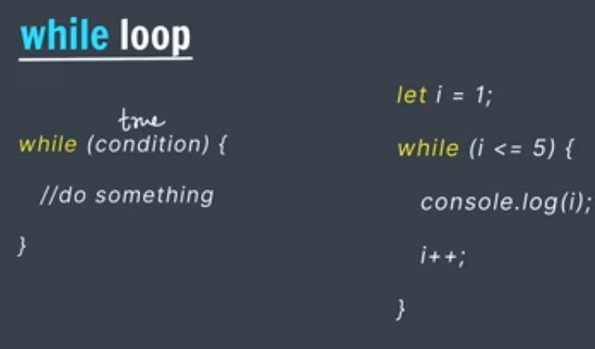

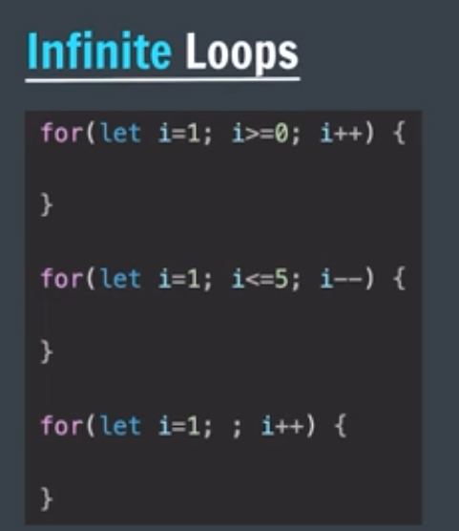

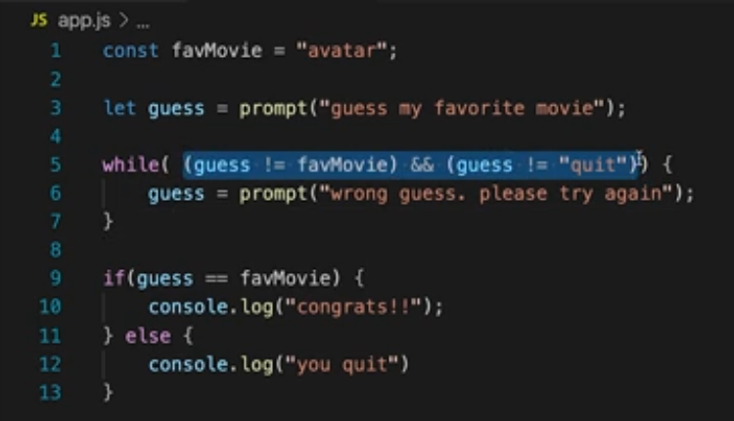

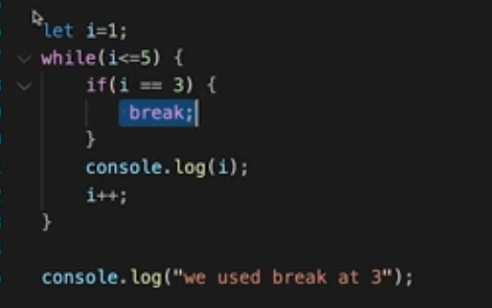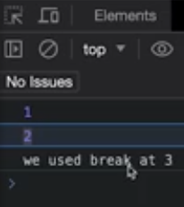

- .length → Property (no parentheses) => JavaScript
- .length() → Method (with parentheses) => Java

1. .length – Without parentheses
Used with strings and arrays in JavaScript.
For strings: let name = "Srishti";
console.log(name.length); // 7
It returns the number of characters in the string.
For arrays: let numbers = [10, 20, 30, 40];
console.log(numbers.length); // 4
It returns the number of elements in the array.

2. .length() – With parentheses
JavaScript strings and arrays do NOT have a built-in length() method.
However, other languages, such as Java, use:
String name = "Srishti";
System.out.println(name.length());



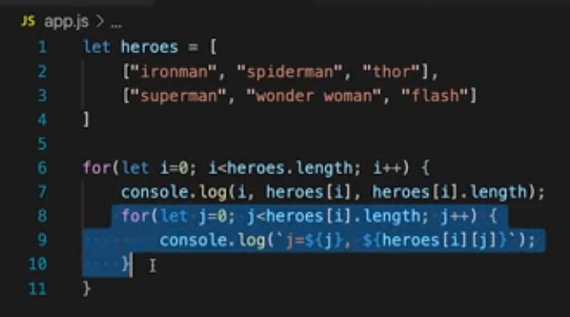
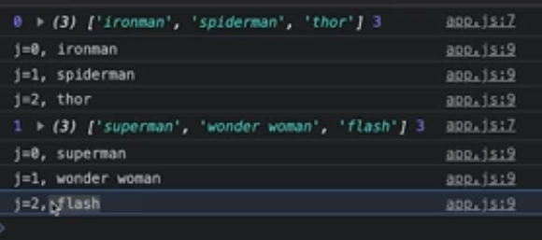

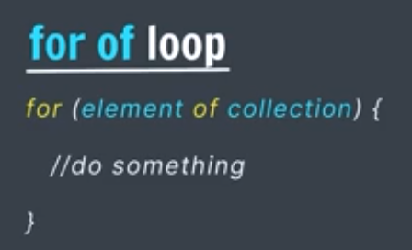
Recent in JS, Check compatibility, for of loop does not work with Internet Explporer.
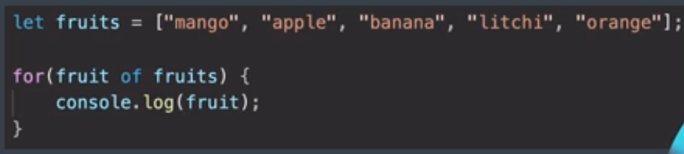
No counter variable needed, no initialization of variable
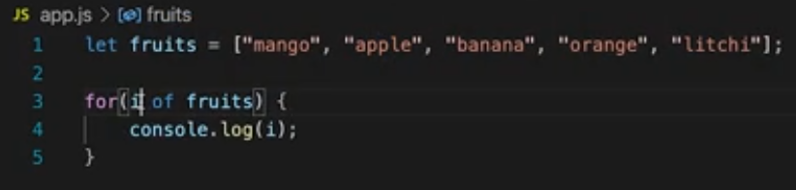

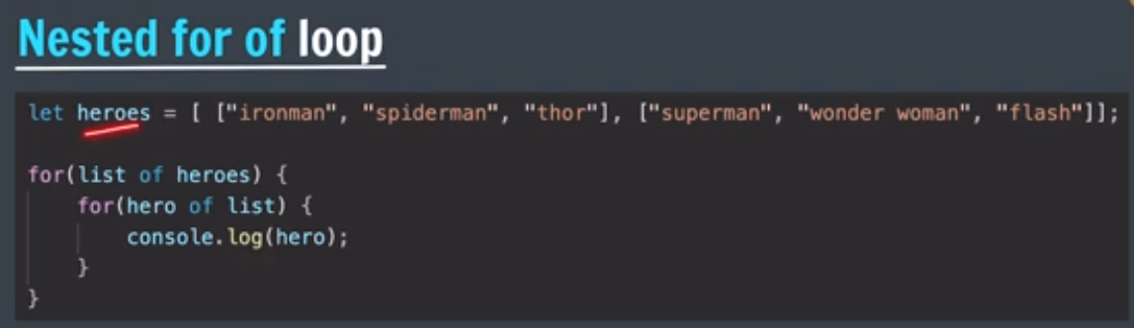

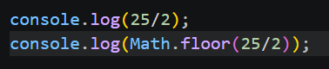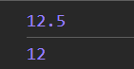

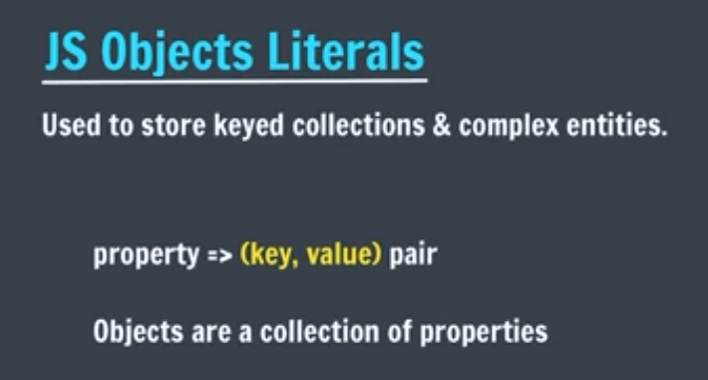

Object is a broader term in JS.
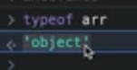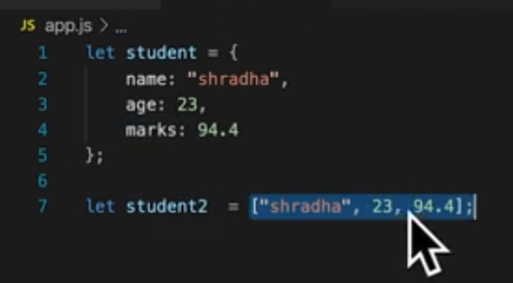

Object literal means creating an object type collection or data structure on our own.

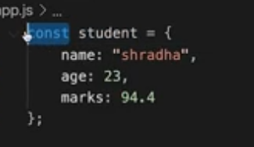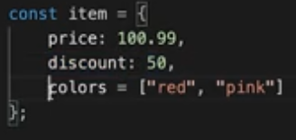
In JavaScript, making an object or array const means the reference cannot be reassigned, but the contents can still be modified.
Both arrays and objects follow the same rule.
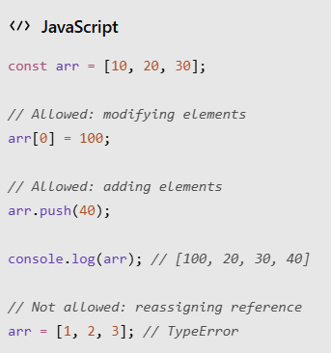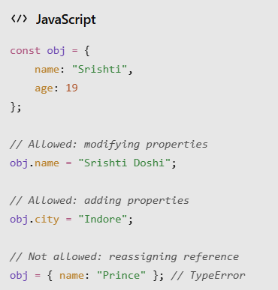

Understanding References
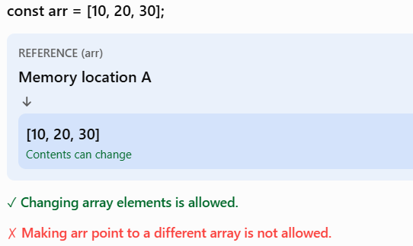

const does not make an object or array immutable. It only makes the variable binding immutable.

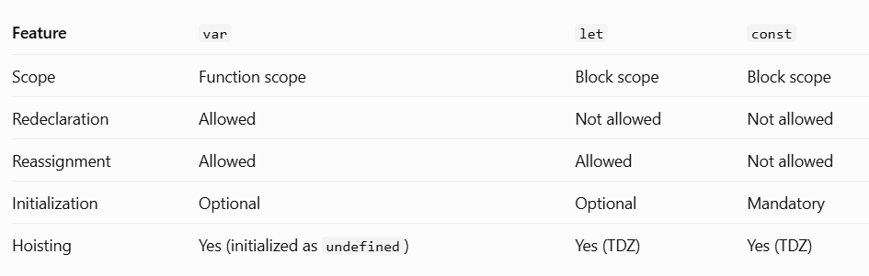

Hoisting
JavaScript processes variable declarations before executing the code.
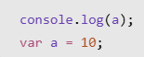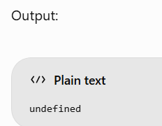

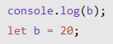

Similarly, const also produces a ReferenceError when accessed before initialization.
This happens because let and const remain in the Temporal Dead Zone (TDZ) until their declaration is initialized.


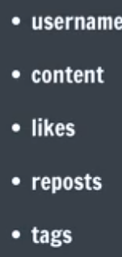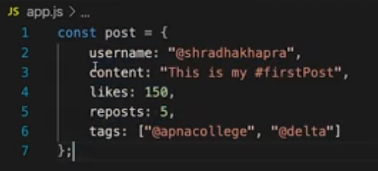

Accessing values
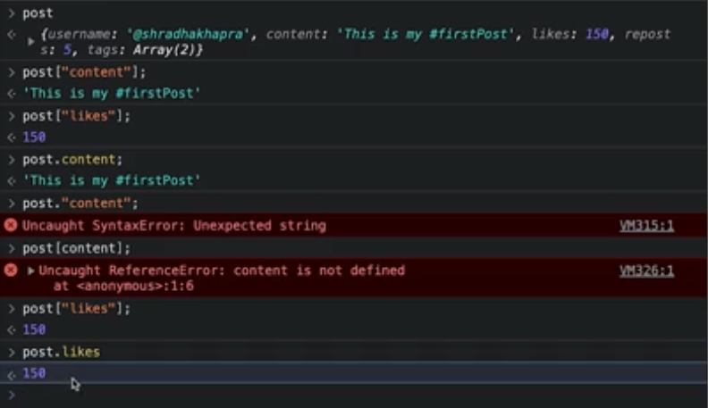
Advantage of [] over dot
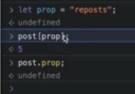

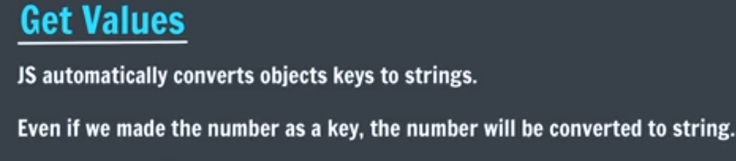
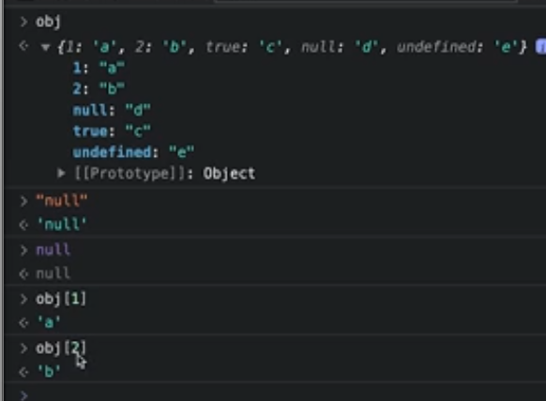

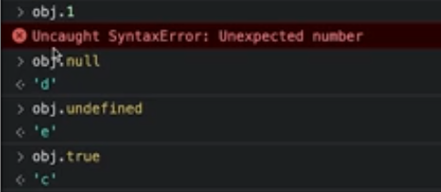
Dot method don’t automatically convert
JavaScript: Object Property Keys & Accessing Properties
1. Object Property Keys
In JavaScript, object property keys are generally converted into strings (except Symbol keys).
Example:
let obj = {
1: "hello",
null: "world",
undefined: "hd",
true: "fsf",
name: "Srishti"
};
JavaScript internally treats the keys approximately as:
{
"1": "hello",
"null": "world",
"undefined": "hd",
"true": "fsf",
"name": "Srishti"
}
Original key | Converted key
1 | "1"
null | "null"
undefined | "undefined"
true | "true"
2. Accessing Object Properties
JavaScript provides two ways to access object properties.
A. Dot Notation
Syntax:
obj.propertyName
Examples:
obj.name // "Srishti"
obj.null // "world"
obj.undefined // "hd"
Important: Dot notation expects a valid property identifier after the dot.
obj.1 // ❌ SyntaxError
obj."1" // ❌ SyntaxError
Reason: After the dot (.), JavaScript expects an IdentifierName, not a number or a quoted string.
B. Bracket Notation
Syntax:
obj["propertyName"]
Examples:
obj["1"] // "hello"
obj[1] // "hello"
obj["null"] // "world"
obj[null] // "world"
obj[undefined] // "hd"
obj[true] // "fsf"
Bracket notation accepts an expression inside []. JavaScript evaluates the expression and converts the result into a property key.
3. Dot Notation vs Bracket Notation
Dot notation | Bracket notation
obj.name | obj["name"]
obj.null | obj["null"]
obj.1 ❌ | obj[1] ✅
Direct property identifier | Accepts expressions
Cannot use dynamic variable keys | Supports dynamic variable keys
4. Dynamic Property Access
let key = "name";

console.log(obj.key); // undefined
console.log(obj[key]); // "Srishti"
Explanation:
- obj.key searches for a property literally named "key".
- obj[key] evaluates the variable key, which contains "name", and accesses obj.name.
Key Takeaways
- Object property keys are strings or Symbols.
- Other key types are converted into strings.
- Dot notation expects an IdentifierName after ..
- Bracket notation accepts expressions.
- Use bracket notation when accessing properties dynamically or when keys contain special characters or spaces.
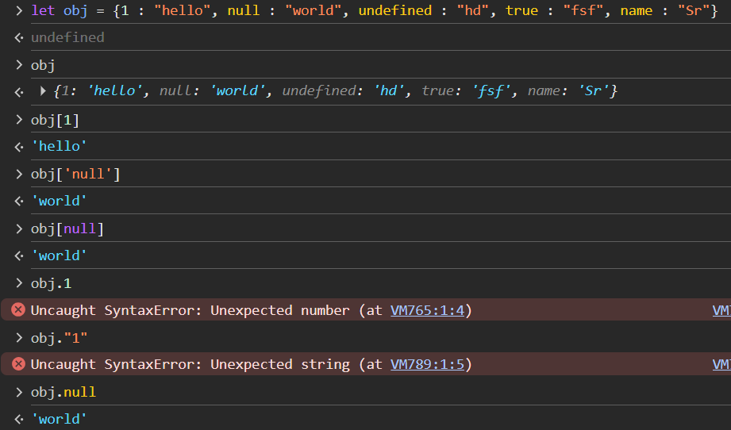

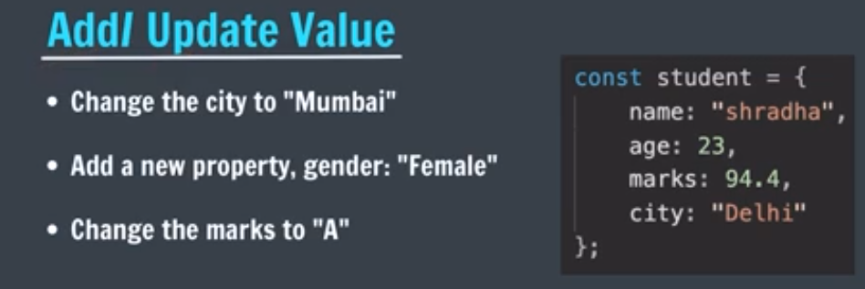
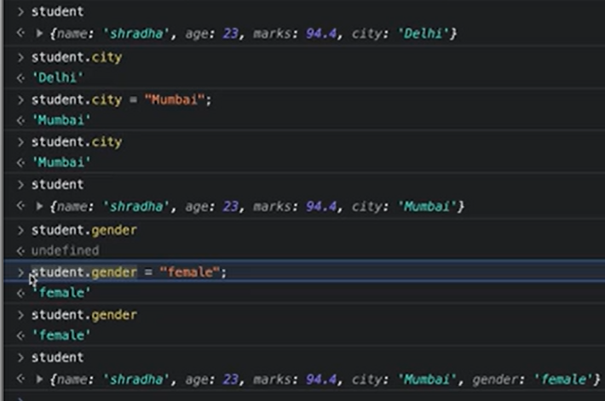
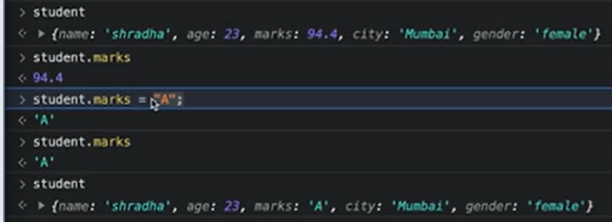
delete obj.key;
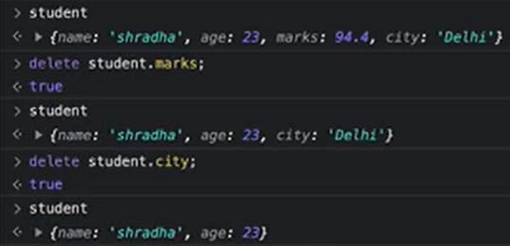

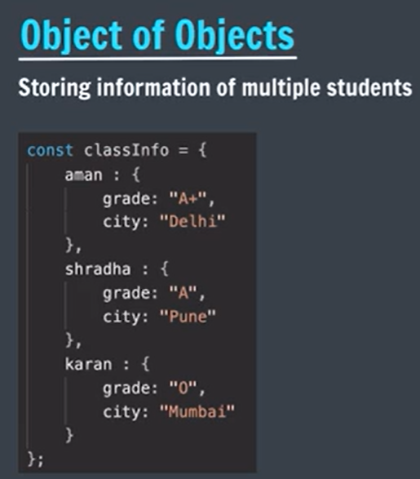
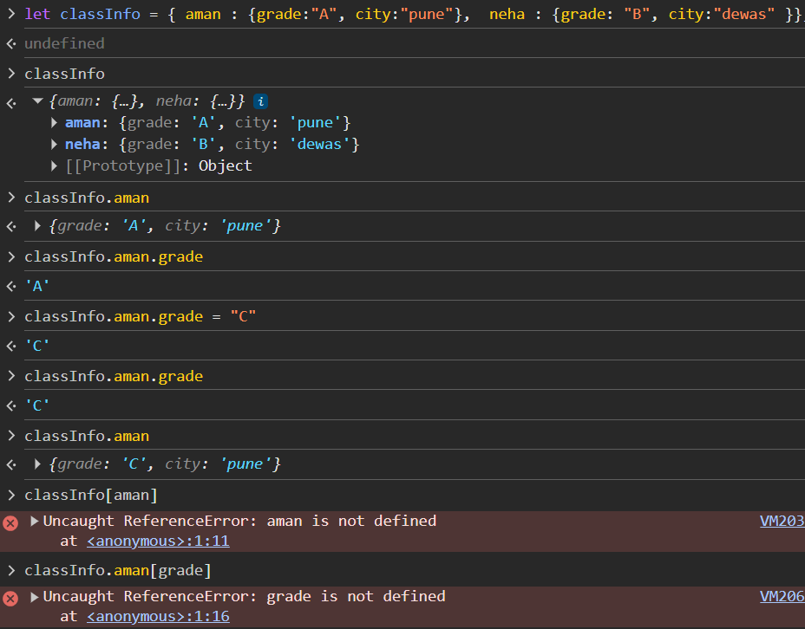
JavaScript treats aman inside the brackets as a variable, not as a string.
It tries to find a variable named aman.
Since no such variable has been declared, it throws: ReferenceError: aman is not defined
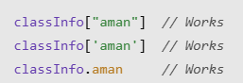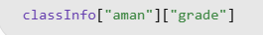
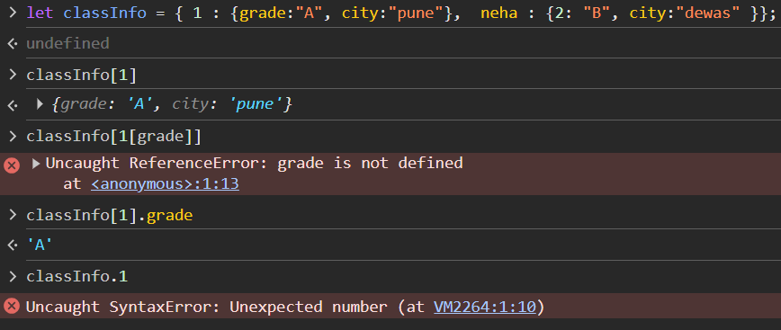

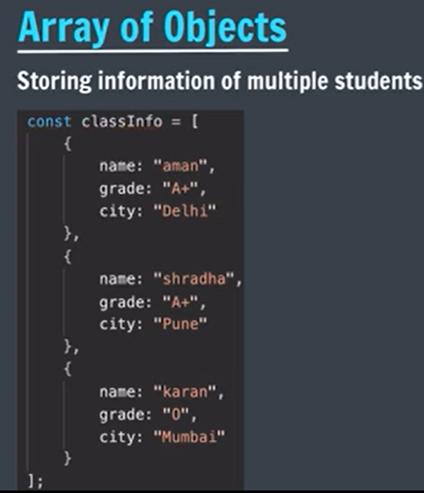
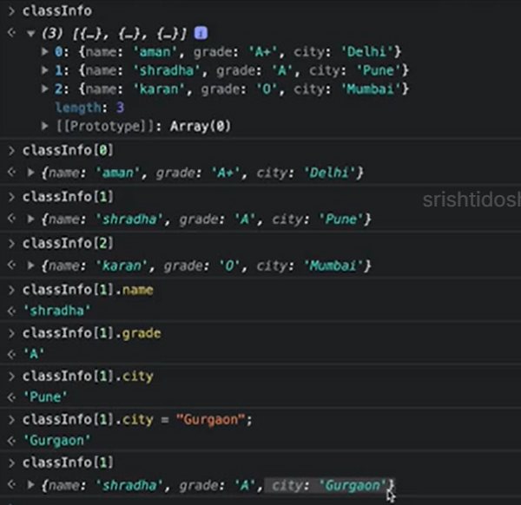
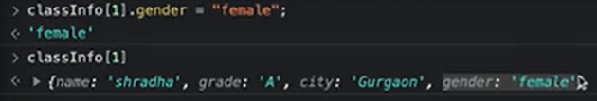

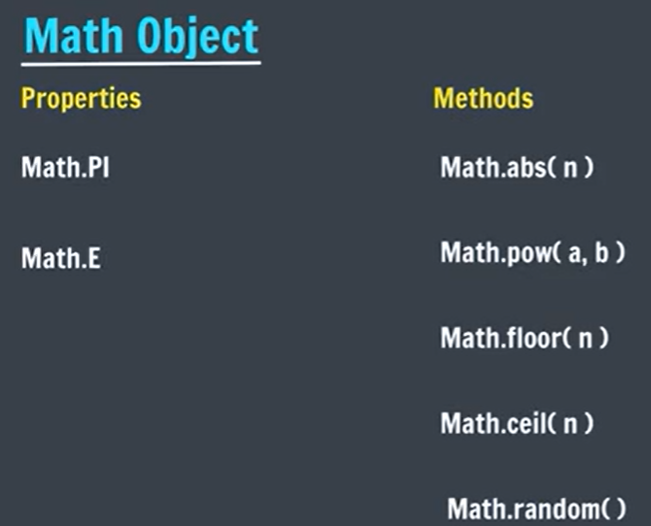
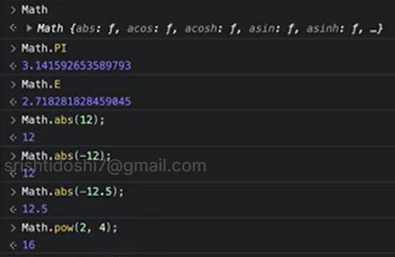
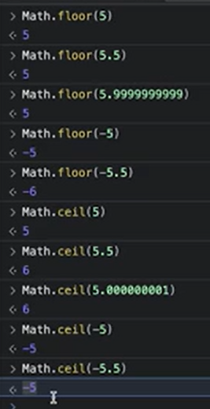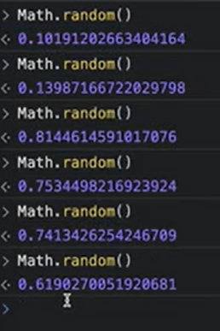
random() function gives value from 0 to 1, where 1 is exclusive.

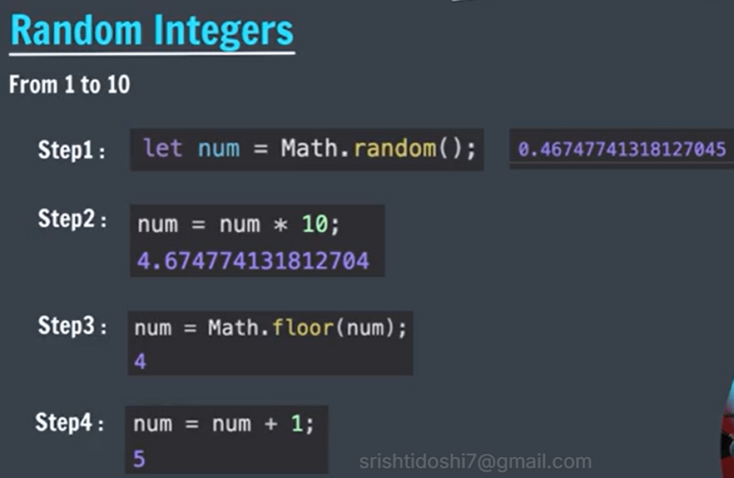
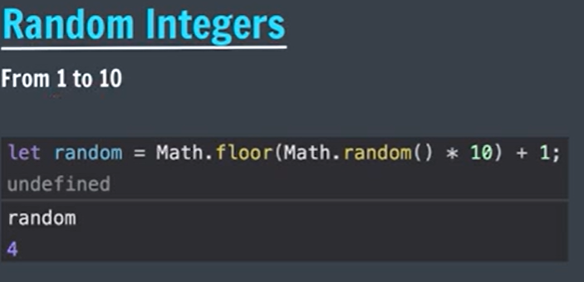

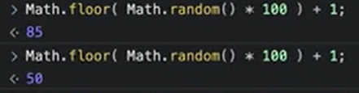

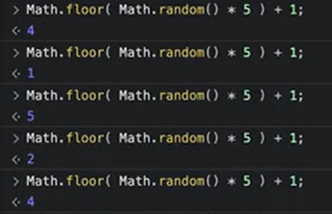

Generate a random number between 21 to 25.
Math.floor(Math.random()*5) + 21;
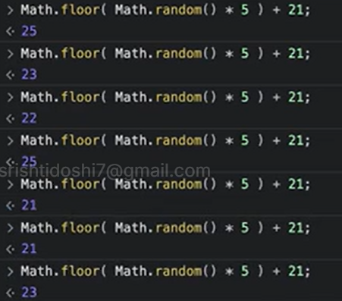

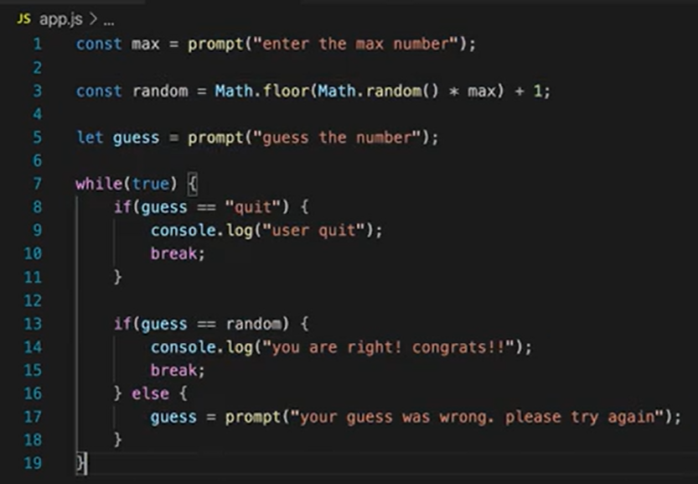
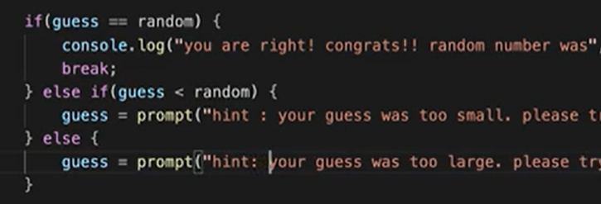

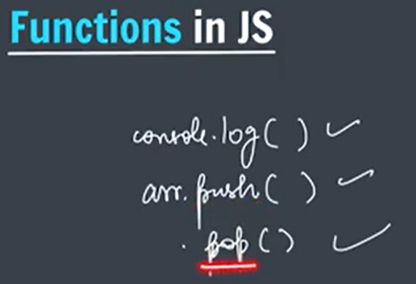
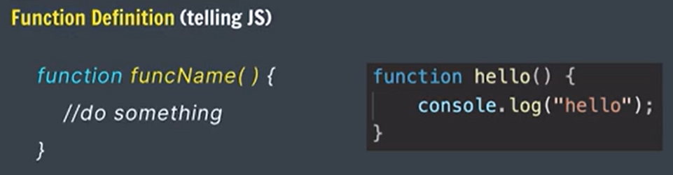
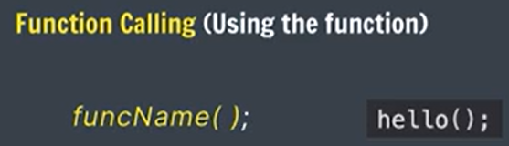
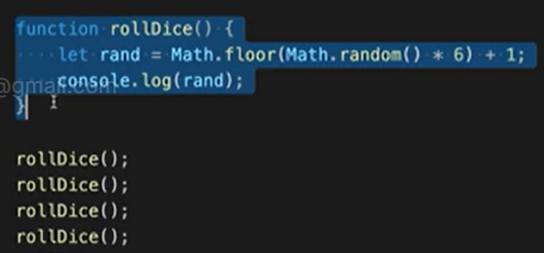


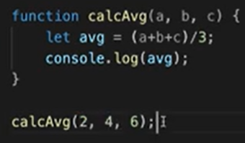
Parameters: a, b, c
Arhuments: 2, 4, 6

Test whether something is function or variable simply using console
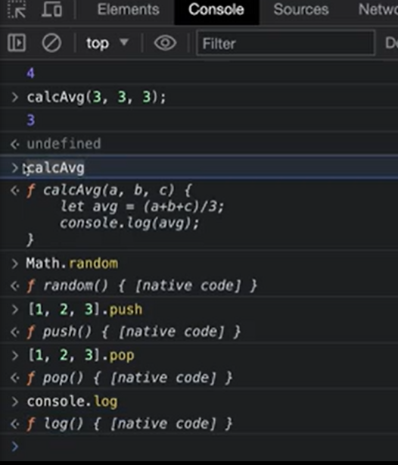

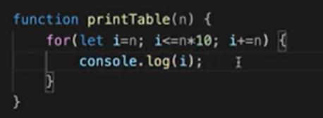
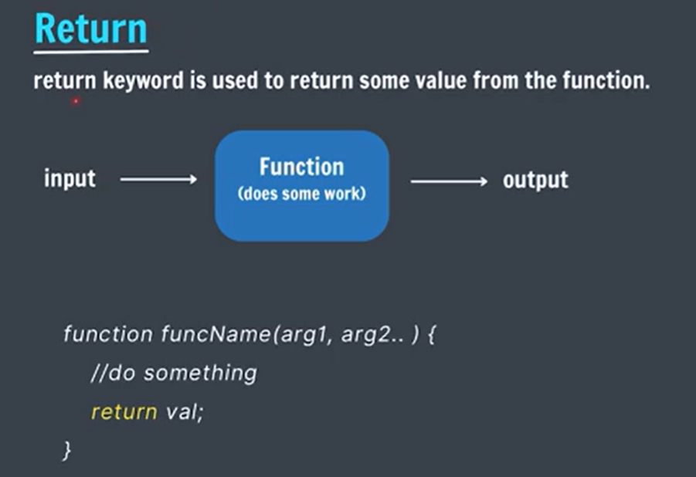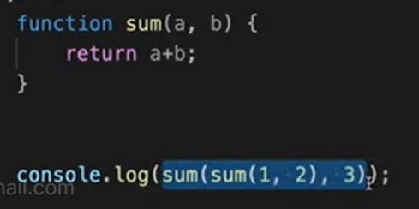

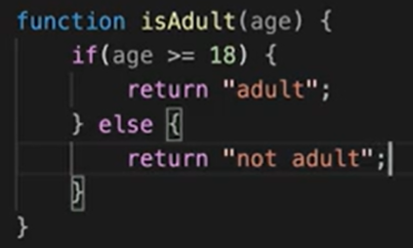

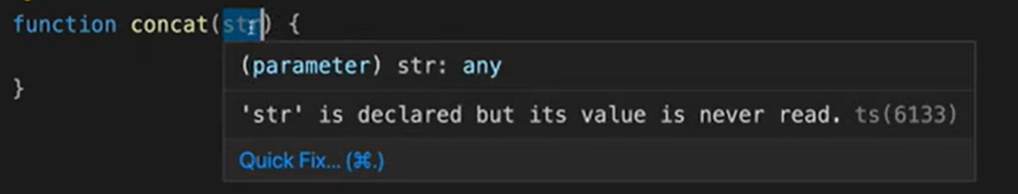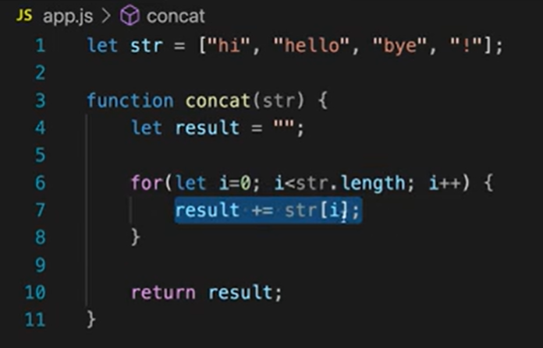

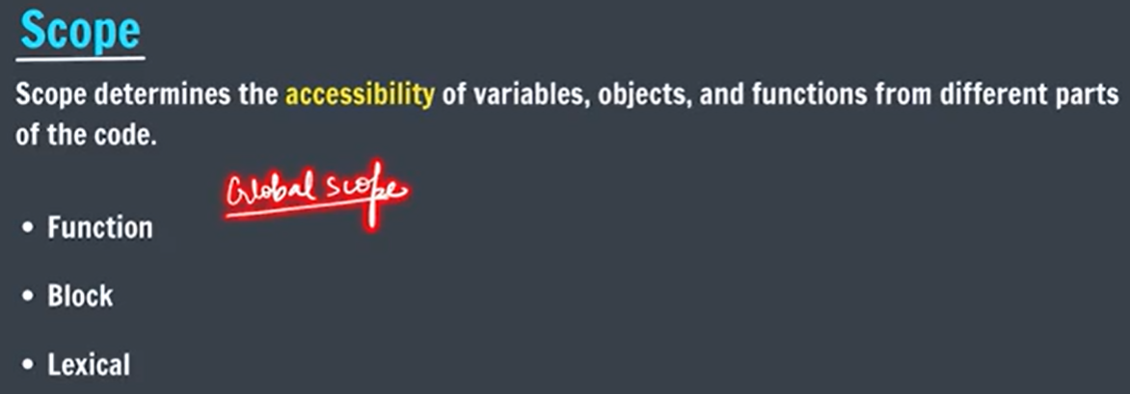
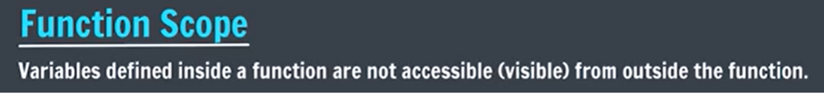
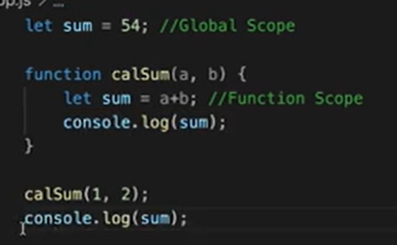
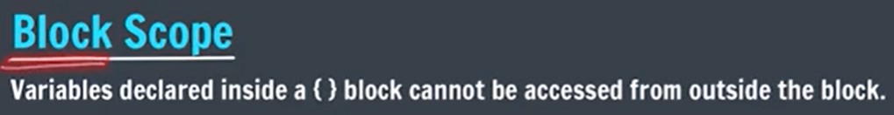
Before 2015 only var was there
In 2015, let and const are introduced
Block scope works only with let and const, not with var
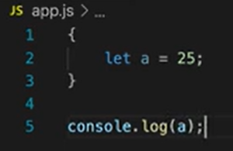 same for const
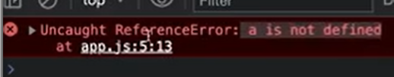
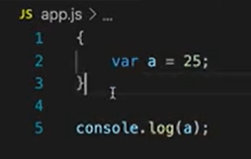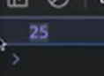
Block scope does not applied on var

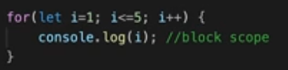

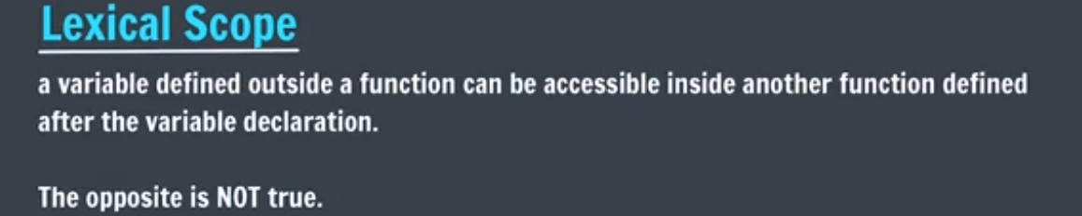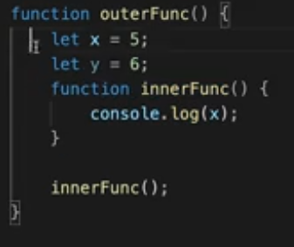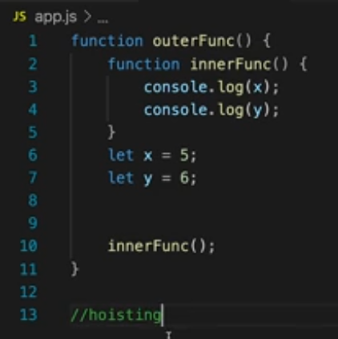

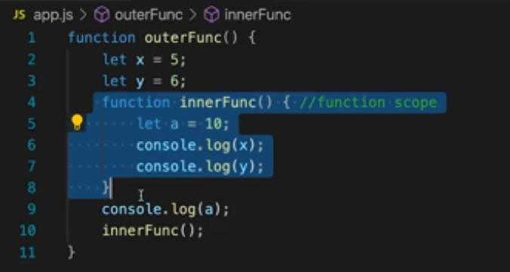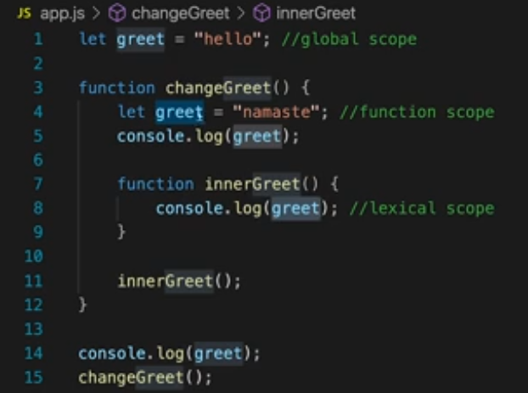

//nameless functions => called using variable name
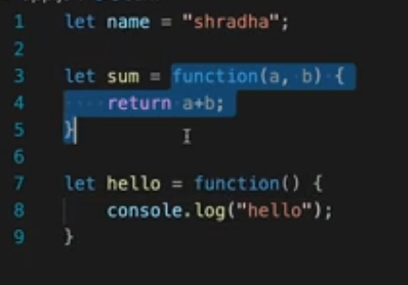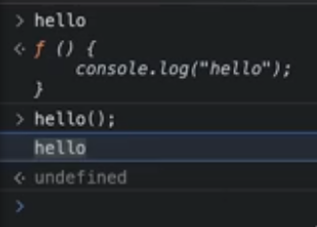

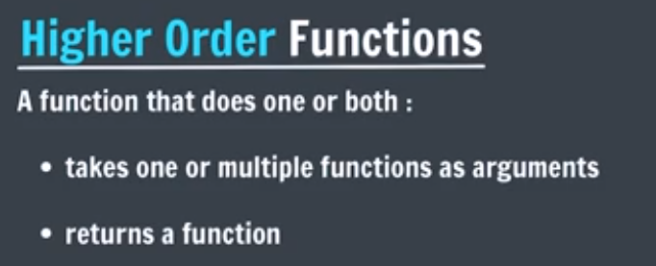
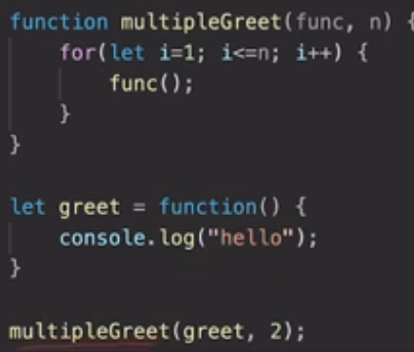
Here, multipleGreet is an higher order function

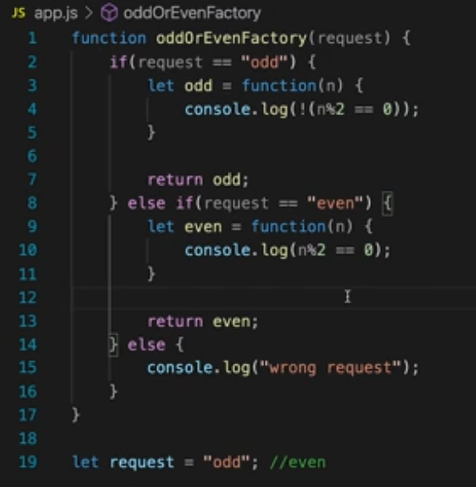
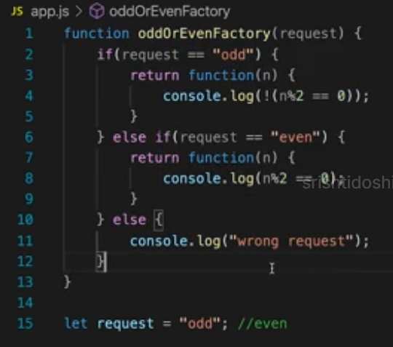
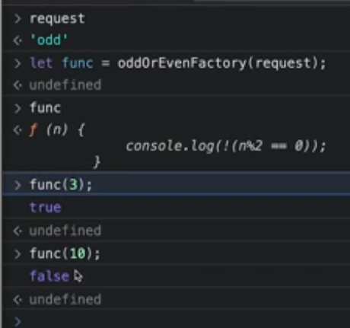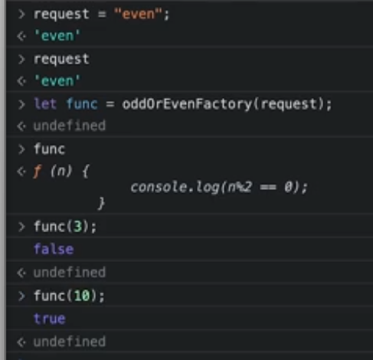

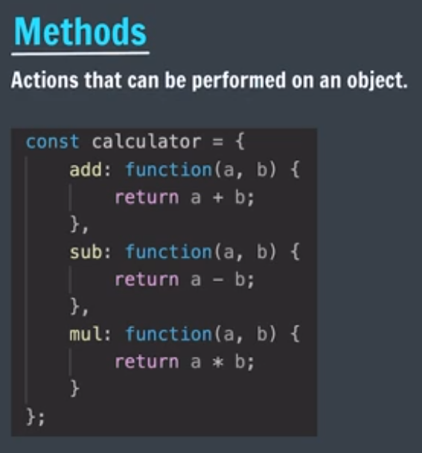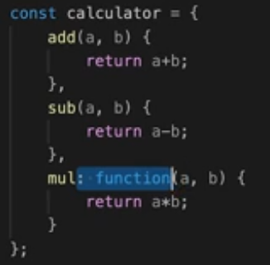
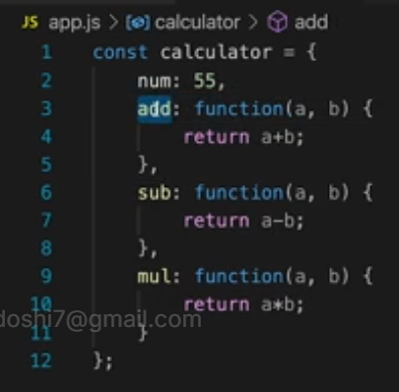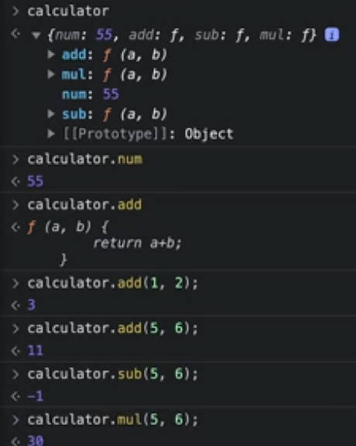
Functions for objects => methods

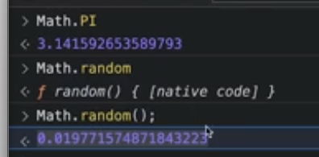

Arrays and strings are internally JS objects and hence they have so many built in methods
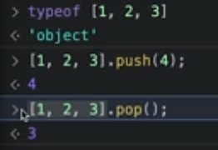

Practice
// Q1 Write a JavaScript function that returns array elements larger than a number.

let arr = [8, 9, 10, 1, 2, 3, 4, 5, 6, 7];
let num = 5;

//elements larger than a number num
function getElements(arr, num)
{
for(let i = 0; i < arr.length; i++)
{
if(arr[i] > num)
{
console.log(arr[i]);
}
}
}

getElements(arr, num); //8 9 10 6 7
console.log("");
getElements([1,2,3,4,5,6,7,8], 7); // 8

// Q2. Write a JavaScript function to extract unique characters from a string.
let s = "aabbabcd";

//function to get String with all unique characters
function getUniqueChar(str)
{
let ans = "";
for(let i = 0; i < str.length; i++)
{
let currChar = str[i];

if(ans.indexOf(currChar) == -1)
{
//if current char is not added, then add, else it is duplicate, no need to add.

ans += currChar;
}
}
return ans;
}

console.log(getUniqueChar(s)); //abcd
console.log(getUniqueChar("aaaa")); //a

// Example: str = “abcdabcdefgggh”
// ans = “abcdefgh”

// Qs3. Write a JavaScript function that accepts a list of country names as input and returns the longest country name as output.
// Example : country = ["Australia", "Germany", "United States of America"]
// output : "United States of America"

function longestName(country)
{
let largest = "";
for(let i = 0; i < country.length; i++)
{
if(country[i].length >= largest.length)
{
largest = country[i];
}
}

return largest;
}

console.log(longestName(["Australia", "Germany", "United States of America"]));
console.log(longestName(["India", "UK", "USA"]));

// Qs4. Write a JavaScript function to count the number of vowels in a String argument.

let str1 = "athiest";

function countVowels(str)
{
let count = 0;
for(let i = 0; i < str.length; i++)
{
if(str[i] == 'a' || str[i] == 'e' || str[i] == 'i' || str[i] == 'o' || str[i] == 'u')
{
count++;
}
}
return count;
}

console.log(countVowels(str1)); //3
console.log(countVowels("srishti")); //2
console.log(countVowels("sonu")); //2

// Qs5. Write a JavaScript function to generate a random number within a range (start, end)

function generateRandom(start, end)
{
let diff = end - start;
return Math.floor(Math.random() * diff) + start;
}

console.log(generateRandom(1,5));
console.log(generateRandom(10,15));
console.log(generateRandom(100,150));

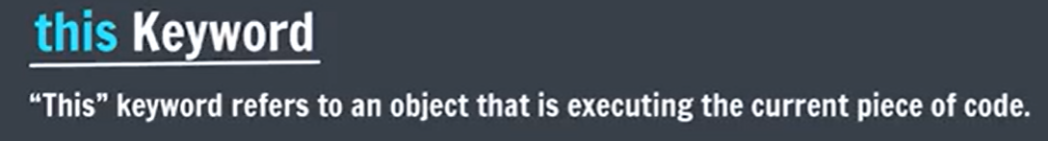
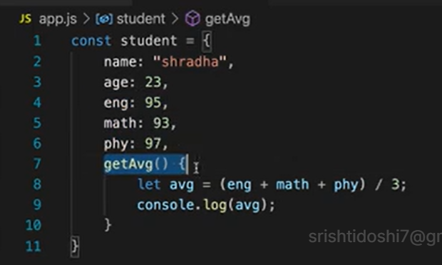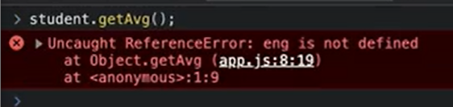

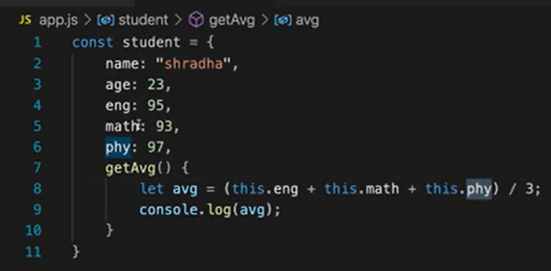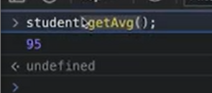
Here, this basically means calling object i.e. here student
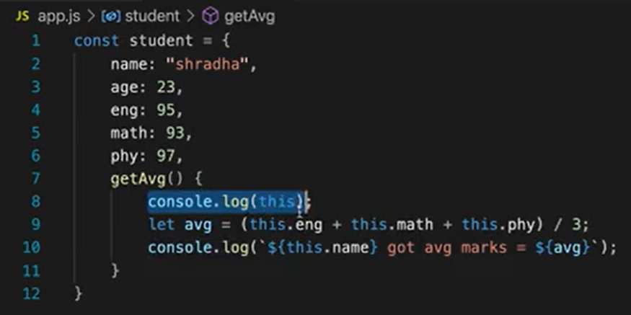
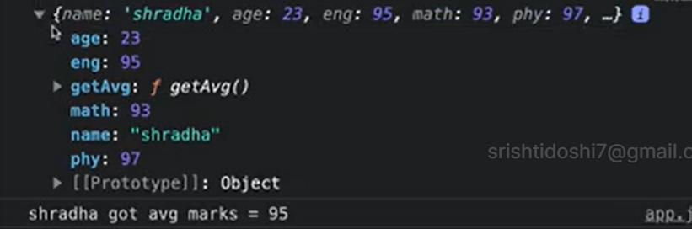

Now we created a function outside, now if we print value of this, we got a by default window object
This window object is responsible for creating browser window , when js runs, on higher level, every code comes under window object
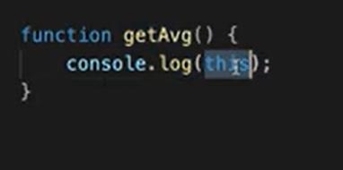
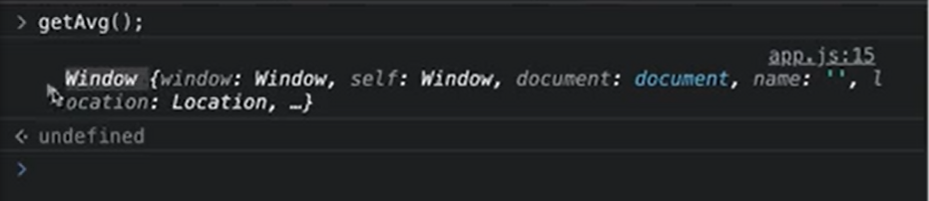
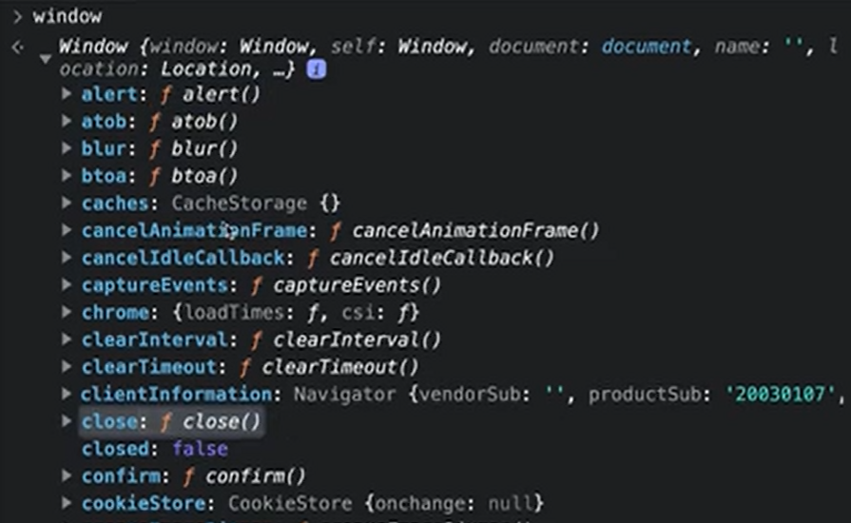

So when there is no object , then we always have a by default window object
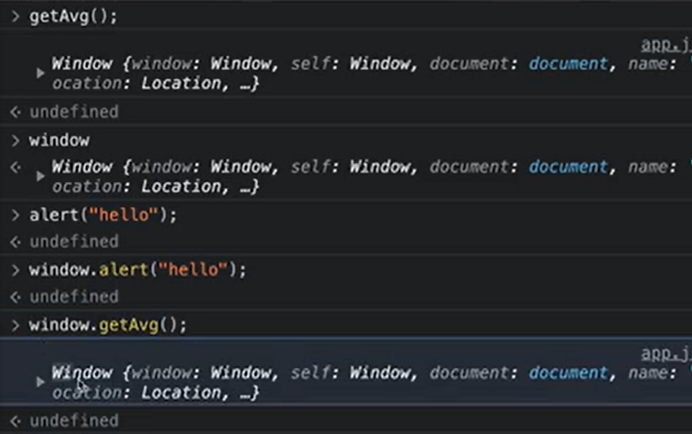
In this, window object ki value store hoti hai
By default, we use window object to call any method.

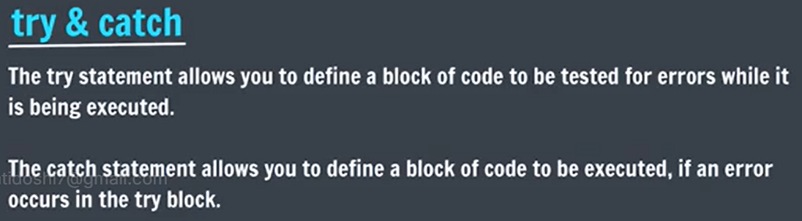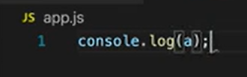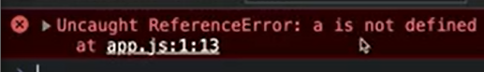
Due to single error, the remaining code also does not work, website crashes

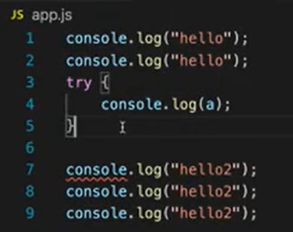 Never right try alone, always pair with catch

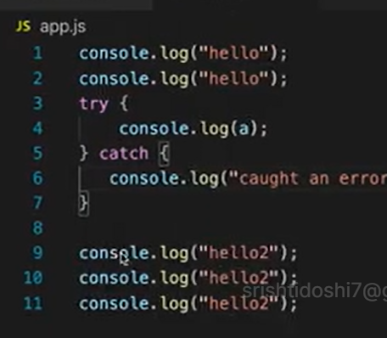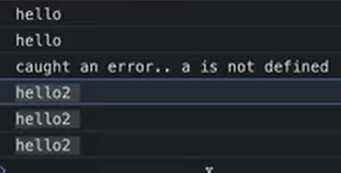

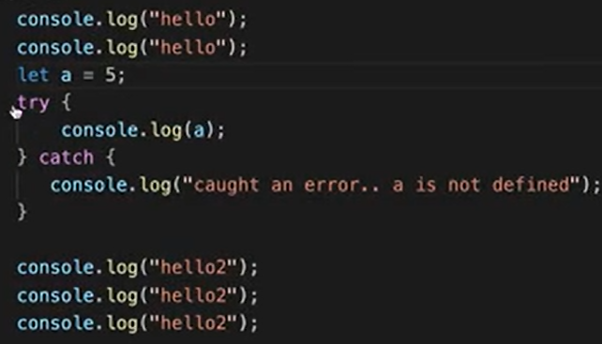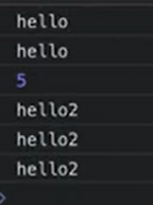

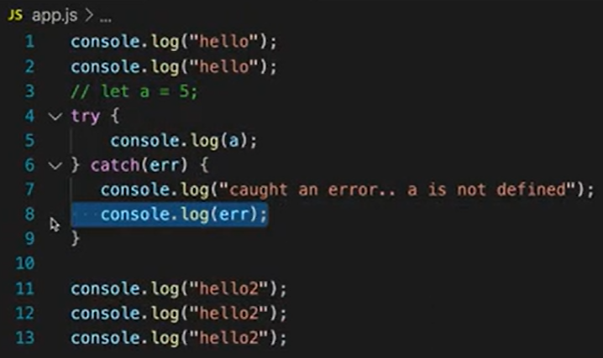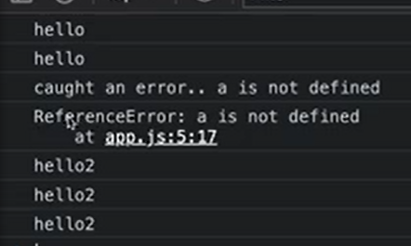

Miscellaneous Topics

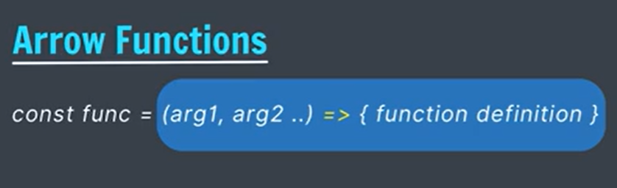
Usually we use arrow function as values
Here our arrow function becomes a value for func variable

Arrow functions are nameless functions, no function keyword used
Arrow functions are also used as a parameter in higher order functions

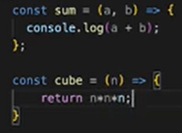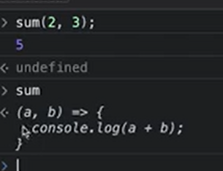

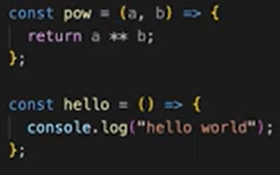

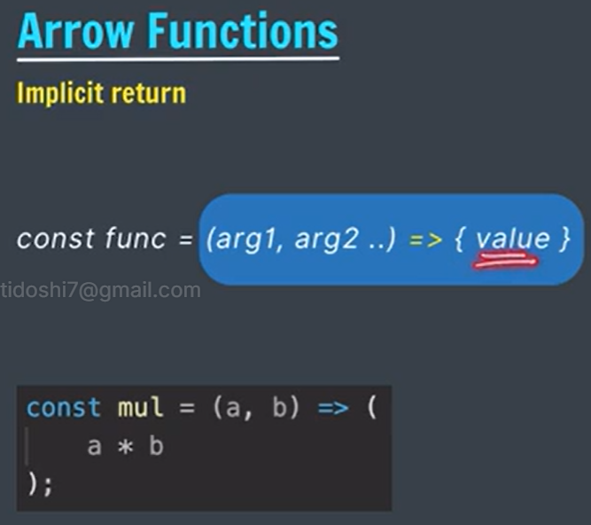 more compact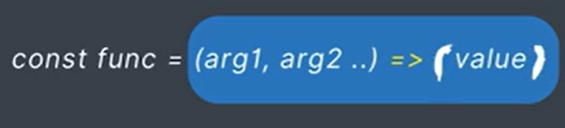
Notice the parenthesis () instead of curly places {}
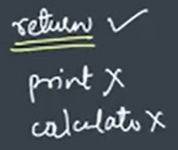

Parenthesis is optional, can be removed too 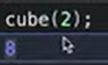

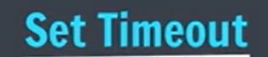
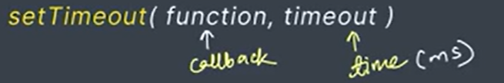
Inbuilt function of window object
Timeout tells the time after which callback or given function executes
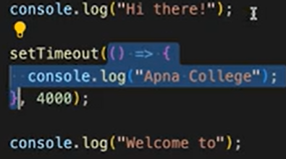
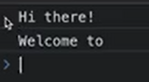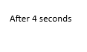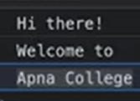
This does not stop the execution flow of remaining code.

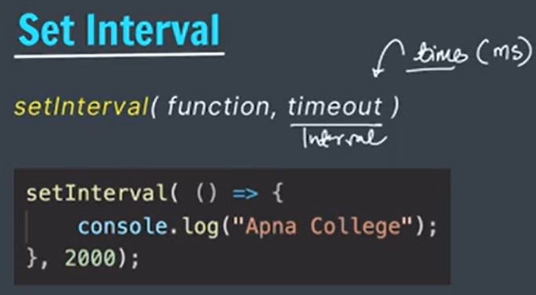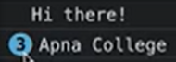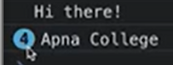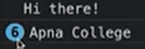
The above code prints “Apna college” after every 2 seconds

wait for time => exec the callback

 wait for time => exec the callback => wait for time => exec the callback => wait for time => exec the callback …

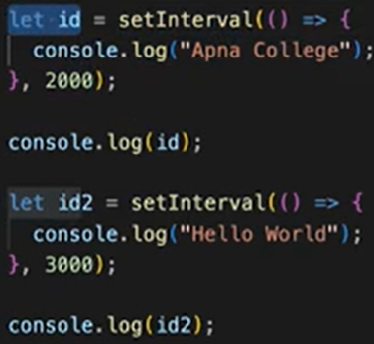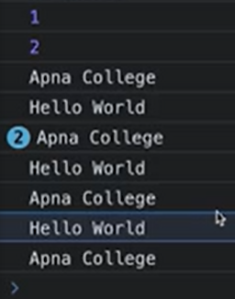

To stop the execution of setInterval, we use clearInterval(id)
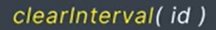
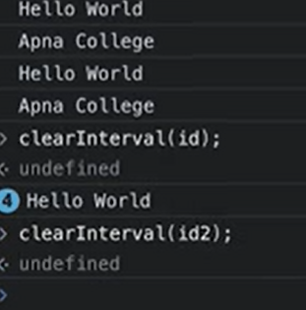


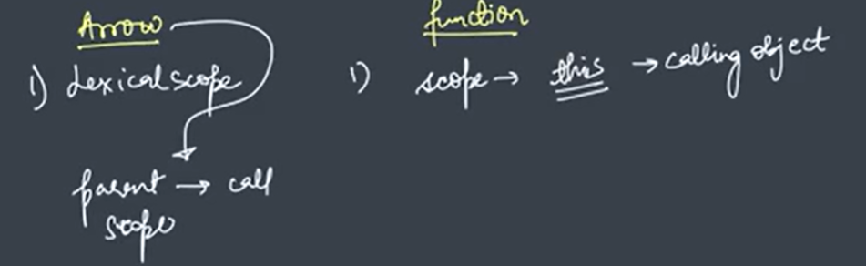

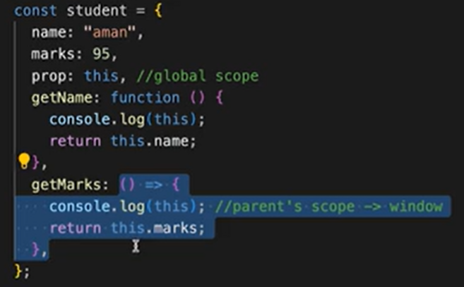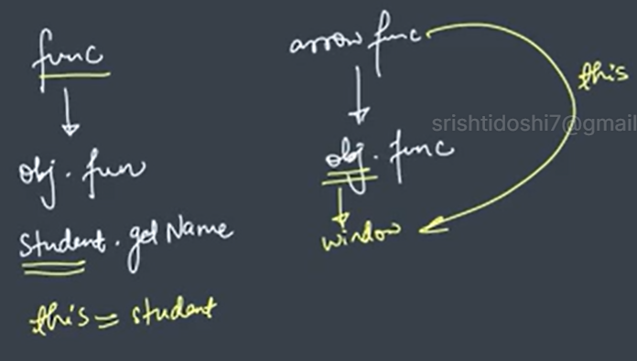
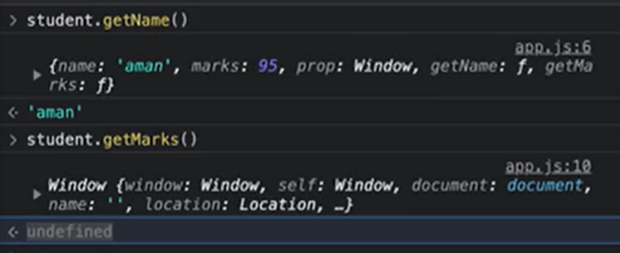

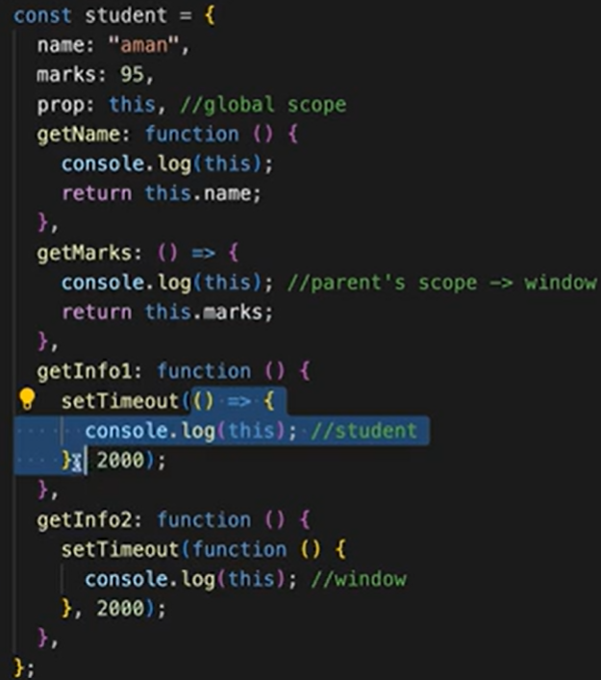
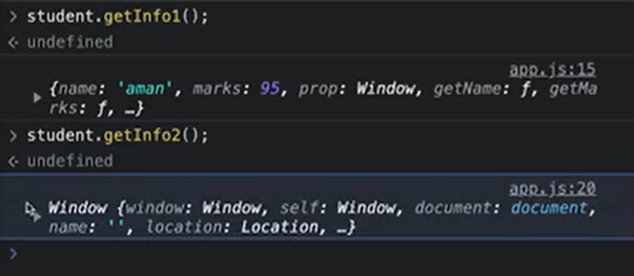
In getInfo2, setTimeout is called by window object and hence this value is window object
In getInfo1, setTimeout is also called by window object but its parent scope is student and the value of this is student object

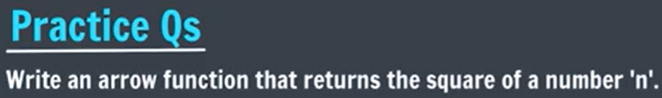
(n) => (n*n);


