**Name : Srishti Kumari**

**Roll : 22052602**

**Section : CSE-29**

**Assignment 4**

**Logistic Regression**

1. Use logistic regression to find decision boundary For the given database. Set your learning rate to 0.1 What is the cost function value and learning parameter value after convergence?

**Sol.** Final cost (alpha=0.1): 0.2291

Final parameters (theta): [ 0.32395465 2.38613663 -2.49462467]

2. Plot cost function v/s iteration graph for the model trained in question 1. Plot the line as shown here - https://pythonguides.com/matplotlib-plot-a-line/#Matplotlib_plot_a_line_chart

Do not use scatter plots for this.

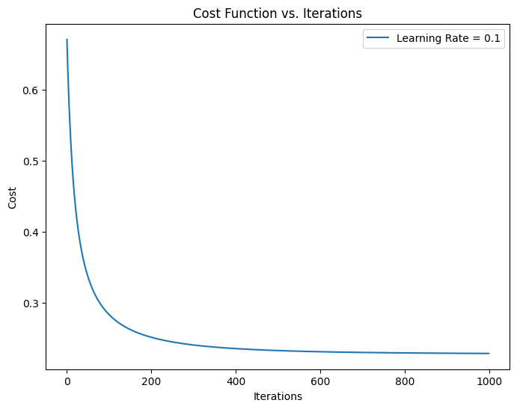

3. Plot the given dataset on a graph, use different colours for different classes and also show the decision boundary you obtained in question 1. Do not use scatter plot.

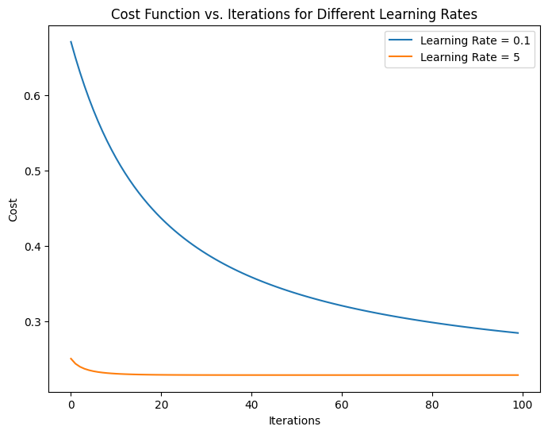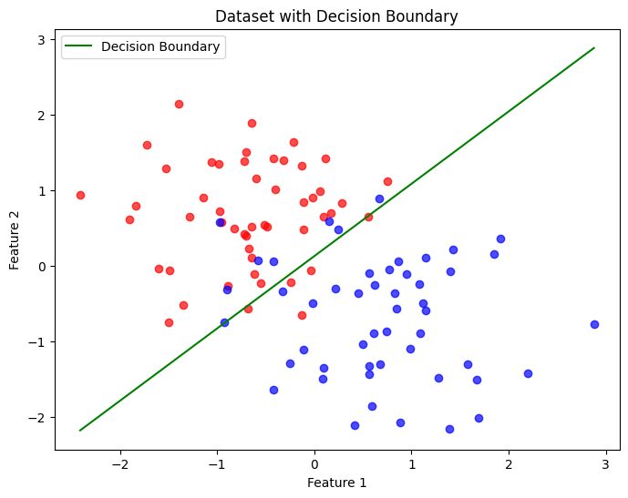

4. Train your model with a learning rate of 0.1 and 5. Plot the cost-function v/s iteration curve for both learning rates on the same graph. For this task, only train your model for 100 iterations.

5. Find the confusion matrix for your training dataset. Using the confusion matrix to calculate the accuracy, precision, recall, F1-score.

Confusion Matrix:

[[45 5]

[ 8 42]]

Accuracy: 0.8700

Precision: 0.8936

Recall: 0.8400

F1-Score: 0.8660