**ABSTRACT**

Personal Accident Insurance is a cover meant for compensation in case of an accident causing injury/ death to person/ persons by violent external means. Insurers pay compensation for death, permanent total disablement, permanent partial disablement (like loss of finger, etc.) and temporary total disablement (like fractures). The purpose of personal accident insurance is to pay fixed compensation for death or disablement resulting from accidental bodily injury. Insurers pay compensation for death, permanent total disablement, permanent partial disablement (like loss of finger, etc.) and temporary total disablement (like fractures). A personal accident policy gives financial relief to insured people if they sustain any injury/ death due to accidents.

Due to rapid industrialization, and more and more use of complex machinery, industrial accidents are more frequent. To cater to the varying and increasing needs, different forms of cover are available. Individuals are granted this cover under an individual personal accident insurance policy. For a group of individuals, the insurance companies have devised group personal accident insurance policies.

We all are aware of those enormous hospital bills one needs to pay in-case he/she faces an accident. Depending on the severity the bills are large enough to bankrupt anyone. So gone are those days, accident insurance helps you claim your insured sum so as to help you get rid of the difficulties you might face.

**1. INTRODUCTION**

The personal accident insurance policy is issued to cover the risk of accidents by external means resulting in the death or bodily injury. The bodily injury may result in to the permanent total disability or partial disability or temporary total disability. This policy can be issued to an individual or in group. The premium rates depend upon the person engaged in activities to earn his livelihood. The sum insured will depend upon the income of the person.

While minor accidents can indispose you temporarily, major ones can severely impact your life and well-being. A sound insurance plan to protect you from economic repercussions of having a mishap has become a necessity. The value of the human life is immeasurable, but with a view to providing some relief to the injured person or a dependent, insurance companies have devised this insurance policy. It refers to an insurance which offers compensation in the event of demise, bodily hurts, impairment or mutilation resulting from an event, such as a violent, hazardous, visible and external means. The types of events that are included in such insurance are rail, road, and air, injury because of collision or fall, burn injury, drowning etc. The policy guards your dependents (parents or family) from any economic repercussions if the unfortunate comes to pass. A person should purchase the policy that covers or provides reimbursements for all eventualities from short-term impairment to untimely demise, and safeguard the family’s future. Besides, online renewal of these plans is just a few clicks away.

**1.1 Objectives**

Develop a computerized application for personal insurance which will allow users to have different policies which they can claim on in case of bodily injuries. The focus of the project is on accuracy, usability, efficiency and effectiveness.

**1.2 Overall product perspective**

This project is initial version of personal insurance policy management. We have represented it as batch application. The online version of the project will allow the customers to take insurance policy, renew their policy and claim the insured amount.

**1.3 Software Interface**

|  |  |
| --- | --- |
| **Software used** | **Description** |
| Z/OS | Z/OS is a 64-bit operating system produced by IBM. |
| COBOL | COBOL is a compiled English-like computer programming language designed for business use. |
| JCL | JCL is the command language which is commonly used in Operating System in the IBM Mainframe computers. |
| VSAM (Files) | VSAM stands for Virtual Storage Access Method. VSAM is a file storage access method used in ZOS operating systems |

**1.4 Workflows of activities**

The activity diagram shows how the customer actually applies for insurance. First and foremost requirement is personal details of the customer who wants to have insurance based on which the premium amount is calculated for that particular person. Once the premium amount is generated there are different processes he/she needs to go through. The customer makes a payment of premium amount.

After a certain duration, policy renewal is required which will allow the customer to extend the insurance. Renewal also includes free health checkup and cumulative bonus in case the person doesn’t claim for 4 years continuously.

There are certain insurance policy decided by the insurance company. Those insurance policy decide what amount of acclamation needs to be fulfilled. A person can only claim if the notice is provided within 7 days the injure/accident. Now the expenses are checked against the insurance policy and the claim amount is payable.

We are using a master file from which we are extracting details of the person who is claiming for the insurance. Now since the person needs to renew thus we have used a renewal file whose variables are described below. The person need to pay the premium amount calculated based on the personal details. For this we have used another file named settlements and accounts. The final process includes claiming the insurance amount. Thus we have used a file which includes acclamation details. The insurance company needs to approve the acclaimed amount thus there is a file for approving the claim.

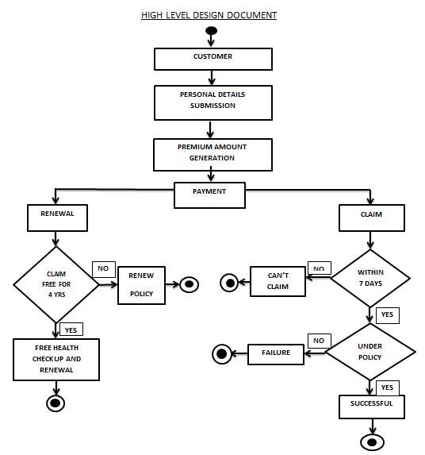

**­­1.5 Assumptions**

1. There is a customer details sequential file having data such as:-
   * Name
   * Age
   * Policy no
   * Existing disability etc.
2. There is a renewal sequential file having data such as:-

* policy no
* no of people
* applied date etc.

1. There is a claim request sequential file having data such as:-

* policy no
* policy plan
* name and address of hospital etc.

**2. KEY REQUIREMENTS**

Underwriting -:

The very first process of this project accepts the personal details and the policy details and premium amount is generated.

Details of the proposers are entered after which the insured’s personal details and sum insured are entered. The physical status such as existing disabilities is collected at the time of registration process. According to the given information the premium amount is calculated and discounts are also offered on the premium amount based on certain criteria such as family discount, special discount etc.

Renewal :

This module consists the renewal of the plan before expiration of the insurance plan. That is, you need to renew the policy plan before the expiration as to avail the facility.

* Within one month of the expiry of the policy, the policy can be renewed by the proposer.
* During renewal the number of persons covered under the policy can be increased or decreased and the existing insured’s personal details and sum insured is subject to change.
* The age of the insured should be automatically incremented during the renewal of the policy.
* Claim free renewals for 4 continuous years is subject to a free health checkup. A claim free renewal will also lead to the benefits of cumulative bonus.

Claims Process -:

Includes granting the claim to the insured person in case of any accident or injury, which is included in the policy plan.

- Claim Request file

In this file the insured person , who wants to claim the amount , will request for the same by giving the information mentioned in the requirements above for accessing the claim , failing in which , the claim won’t be granted

- Claim Grant File

This file is for the company use , it maintains the record of the claim granted such as name of the insured person to whom claim is granted ,grant date ,amount, mode of payment and other user details are entered

Settlements and accounts process:

This process takes care of premium payment. When the proposer pays premium amount, the amount is verified after which details like the mode of payment, cheque /DD No, cheque or DD Date and bank name and address are collected from the proposer

A file will be created to store this record every time a user buys a policy,

**3. Rough Implementation**

Fig 1 : Calculating the premium amount and writing in master file after reading from the personal file

Fig 2 : Renewal of the policy based on certain insurance rules

Fig 3 : Calculating the claim amount based on the claim application made by the customer.