Lesson: Force
Grade
Did I Do It Like an Architecht?
Did I Meet the Project Goals/Criteria? |  |  | Not  Yet | Starting  to | Yes!
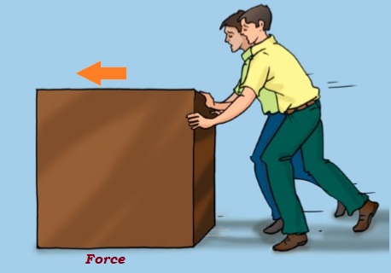 |  | I pushed the furniture as much I can with the help of my friend.
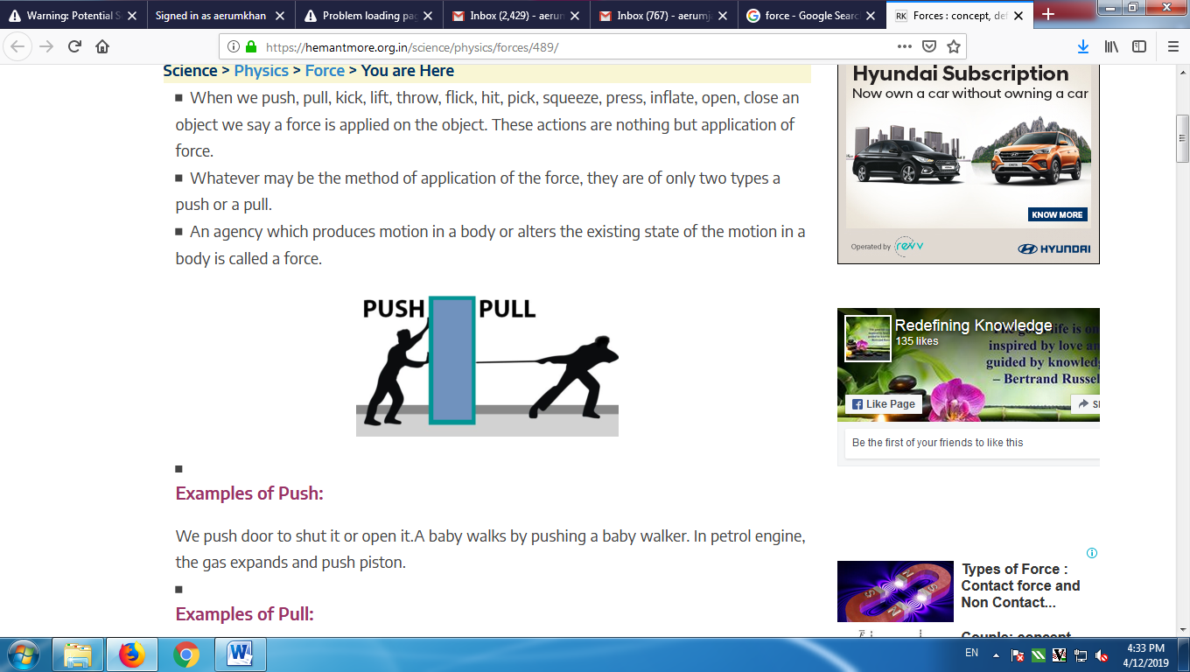 |  | I pushed as well as the furniture was pulled by my friend to complete the task of changing its position.
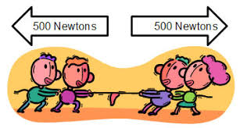 |  | I maximized the strength with my friend to win the game of Tug of War against the other group of students in my school.
Was I participating in the Class? |  |  | Not  Yet | Starting  to | Yes!
 |  | I asked thoughtful questions and defined more than one problem.
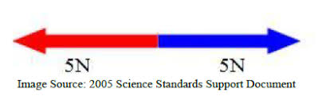 |  | I developed and used models that met all of the criteria.
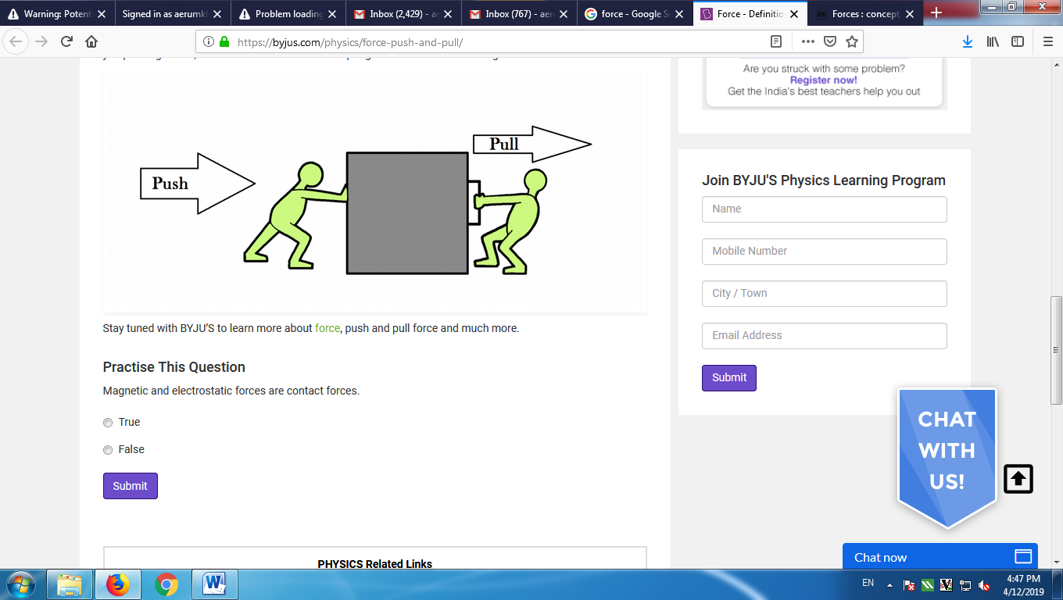 |  | I planned the design carefully and carried out the task of placing the furniture on the right place.
How did I work with my group members? |  |  | Not  Yet | Starting  to | Yes!
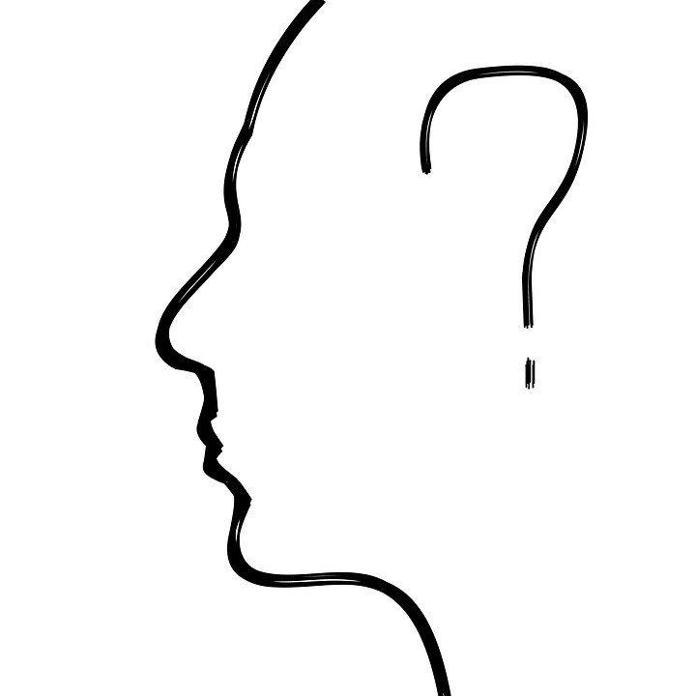 | I listened carefully to others’ ideas, asking their opinions. I took turns and made sure everyone was sharing.
 | I told others my ideas and I made sure I didn’t do all the talking.
 | I helped solve problems that came up in our group and was willing to compromise when things didn’t go my way.

Grade
Time to think about what I learned.
How did you use the exploration with materials to help you make your design? Think about the properties of the materials you used.

What would you do differently next time? How would you make your design even better?

What questions do you have about the process of planning, designing, testing, and redesigning?

