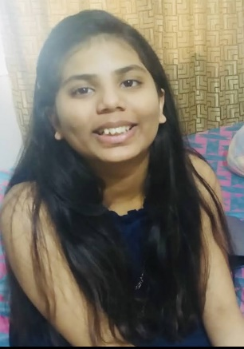

Srishti Chowdhary
High-achieving honors student

Objective
Resourceful and dedicated High School student with excellent analytical skills and demonstrated commitment. Strong organizational abilities with proven success managing multiple teams. Well-rounded and professional team player dedicated to continuing academic pursuits at a collegiate level in computer science or cybersecurity.

Education
Hamilton High School, Chandler AZ Expected Graduation May 2026
- GPA: 4.0
- Relevant Coursework: Ap Computer Science, Courses in game development, web development, app development, and python. Currently taking a course in ethical hacking.
- Honors & Awards: most well-behaved student award, Certified game developer, 3rd place reflections award in art, Global Finalist in Uber Global Hackathon, participation award in Model UN
- Positions of leadership: Leader for my team in the Uber Global Hackathon, Chosen for student-lead teaching.

Extracurriculars

- Hamilton Swim & Dive team
- Coding courses from Udemy
- Acrylic canvas painting
- Pencil sketching
- Dance

Skills

- Communication skills
- Excellent teamwork skills
- Adept in many technological aspects
- Hindi: Advanced
- English: Advanced

Contact info
- Instagram: https://www.instagram.com/srishti.chowdhary8/
- Phone Number: (602)-718-0610
- Email: srishtic0710@gmail.com
- GitHub links with all my codes: https://github.com/SrishtiC-008?tab=repositories
https://github.com/srishtic08?tab=repositories

