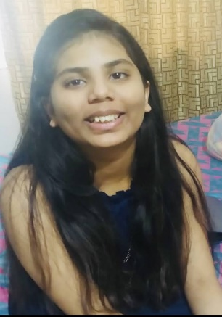

Srishti Chowdhary

High-achieving honors student

# Objective

Resourceful and dedicated High School student with excellent analytical skills and demonstrated commitment. Strong organizational abilities with proven success managing multiple teams. Well-rounded and professional team player dedicated to continuing academic pursuits at a collegiate level in computer science or cybersecurity.

# Education

**Hamilton High School, Chandler AZ** *Expected Graduation May 2026*

* **GPA**: 4.0
* **Relevant Coursework**: Ap Computer Science, Courses in game development, web development, app development, and python. Currently taking a course in ethical hacking.
* **Honors & Awards**: most well-behaved student award, Certified game developer, 3rd place reflections award in art, Global Finalist in Uber Global Hackathon, participation award in Model UN
* **Positions of leadership**: Leader for my team in the Uber Global Hackathon, Chosen for student-lead teaching.

# Extracurriculars

* Hamilton Swim & Dive team
* Coding courses from Udemy
* Acrylic canvas painting
* Pencil sketching
* Dance

# Skills

* Communication skills
* Excellent teamwork skills
* Adept in many technological aspects
* Hindi: Advanced
* English: Advanced

# Contact info

* Instagram: <https://www.instagram.com/srishti.chowdhary8/>
* Phone Number: (602)-718-0610
* Email: [srishtic0710@gmail.com](mailto:srishtic0710@gmail.com)
* GitHub links with all my codes: <https://github.com/SrishtiC-008?tab=repositories>

<https://github.com/srishtic08?tab=repositories>