**UNIVERSITY DEPARTMENT**

**RAJASTHAN TECHNICAL UNIVERSITY, KOTA**



**DEPARTMENT OF COMPUTER SCIENCE ENGINEERING**

**Synopsis on**

**TOPIC: SIGN LANGUAGE RECOGNITION**

**USING MACHINE LEARNING**

Submitted to: Supervisor:

**Dr. C.P. Gupta Dr. Harish Sharma**

**(Professor) (Associate Professor)**

Submitted by:

**Srishti Gupta (19/428)**

**Isha Bhargava (20/615)**

**1. Introduction:**

Various challenges are faced by people with speech and hearing impairments while communicating as they cannot adapt to the surrounding environment quickly and respond to other people.

Sign language is composed of a system of conventional gesture, mimic, hand sign and figure spelling, plus the use of hand position to represent letters of the alphabet.

Sign language is complex and is not be possible to be understood by majority of the public. It is impossible for people with speech impairment to learn spoken language; this means that it is a problem for hearing-impaired people both to communicate with other people who are not conversant with sign language and to communicate among themselves.

Human beings have adopted various methods to solve this challenge. For instance, human sign language translators are commonly used in public places and TV channels to communicate spoken messages in a form that people living with these disabilities can understand.

The main purpose is to provide speech and text output using hand gesture sign language without using any sensor for people with impairment.

1. **Problem Statement:**

In our progressive society, it is necessary to socialize with all people to whether for recreation or for a purpose. However, people who have a hearing impairment and/or a speech impairments need a different way to communicate other than vocal communication. They resort to sign language to communicate with each other.

But Sign Language requires a lot of training to be understood and learn and not every person may understand what the sign language gestures mean. Learning sign language is also time consuming as there are no effective, portable tool for recognizing sign language. Hearing or Speech disabled people who know Sign Language require a translator who also knows Sign Language to explain their thoughts to other people in an effective manner.

To help overcome these problems, this system helps hearing or speech impaired people to learn as well as translate their sign language.

1. **Issues and Solutions:**

a) Language barrier problem occurs for different regions.

Soln.- Can be solved using data of variety of regions here we’ll be using Indian Sign Language for its use in India.

b) In general model data set is taken from internet, which may not be very accurate in some cases.

Soln.- The proposed model is for real time use in which we can feed the data ourselves so that a particular person can also use his/her hand for feeding the data and training the model, which will provide high accuracy results for that particular case.

Issue a) can be solved using the Indian Sign Language defined below: 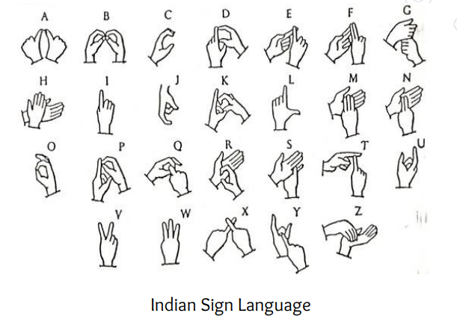

1. **Tools and Method Used:**

The proposed research experiment was aimed at developing an efficient machine learning model for accurate detection, decoding, and translation of sign language into a text message format using convolutional neural network.

We will use Open CV to acquire the image then we’ll colour convert it for it’s processing using other modules.

Jupyter notebook will be used for the coding in python language.

**5. Previous work done:** Built a hand gesture recognizer using Machine Learning Algorithms**.**

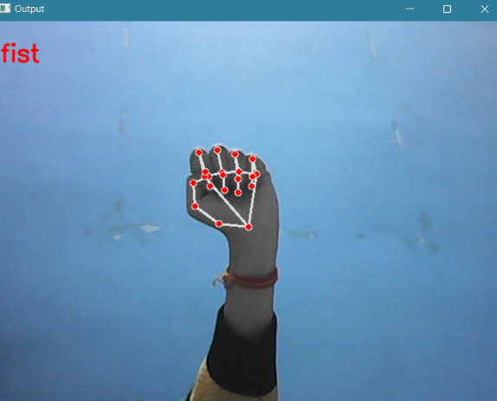 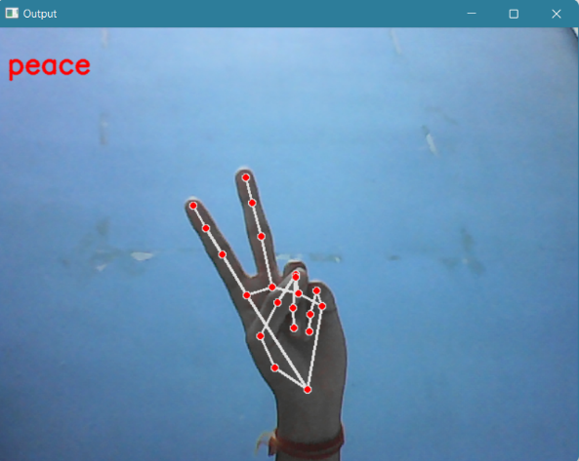

**6. Future Scope:**

In future work, proposed system can be developed and implemented using Raspberry Pi. Image Processing part should be improved so that System would be able to communicate in both directions i.e.it should be capable of converting normal language to sign language and vice versa. Moreover we will focus on converting the sequence of gestures into the speech which can be heard.

**Functional Requirements**

1. Creating the dataset : We will be having a live feed from the video cam and every frame that detects a hand in the ROI (region of interest) created will be saved in a directory that contains two folders train and test.
2. Calculate threshold value : We calculate the threshold value for every frame and determine the contours.
3. Training CNN : Now on the created data set we train a convolution neural network.
4. Predict the gesture : We create a bounding box for detecting the ROI and identify any foreground object.

**Conclusion**

We have developed an efficient machine learning model for the detection, understanding, and translation of Indian Sign Language to written text. The research was based on background information pointing out that this problem represents a significant communication gap between the speech-impaired and the general public.

**References**

1. Wang, Z.J.; Turko, R.; Shaikh, O.; Park, H.; Das, N.; Hohman, F. CNN Explainer: Learning Convolutional Neural Networks with Interactive Visualization. IEEE Trans. Vis. Comput. Graph. 2021, 27, 1396–1406.

2. R. Sharma et al. Recognition of Single Handed Sign Language Gestures using Contour Tracing descriptor. Proceedings of the World Congress on Engineering 2013 Vol. II, WCE 2013, July 3 - 5, 2013, London, U.K

3. R.Karthikeyan, C.Jothi Kumar, “Improved Reputation Systemfor Wireless Sensor Networks (WSNS) “, International Journal of Innovations in Scientific and Engineering Research (IJISER), Vol.1, no.3, pp.191-195, 2014.

4. M. Jeballi et al. Extension of Hidden Markov Model for Recognizing Large Vocabulary of Sign Language. International Journal of Artificial Intelligence & Applications 4(2); 35-42, 2013