

AI RESUME BULDER (API INTEGRATION)
PRESENTED BY (GROUP 12)
Shourya Sharma
Sristhi Sachdeva Sushant Singh
Soniya bhardwajh

AI Resume Builder Project

Project Overview
This project is an AI-powered Resume Builder web application that helps users create professional resumes easily. It uses modern frontend technologies and integrates AI features to generate content suggestions for resumes.

Objectives
- Simplify resume creation
- Provide AI-based suggestions
- Create professional templates
- Improve user experience with interactive UI

Technologies Used
- Frontend: React.js, HTML, CSS, JavaScript
- Backend: Node.js (optional)
- AI Integration: API-based content generation - Version Control: Git & GitHub

Features
- User-friendly interface
- Multiple resume templates
- AI-generated content suggestions
- Live preview of resume
- Download resume as PDF

Working
- User enters personal and professional details.
- AI suggests content for sections like summary and skills.
- User customizes the resume layout.
- Final resume is generated and can be downloaded.

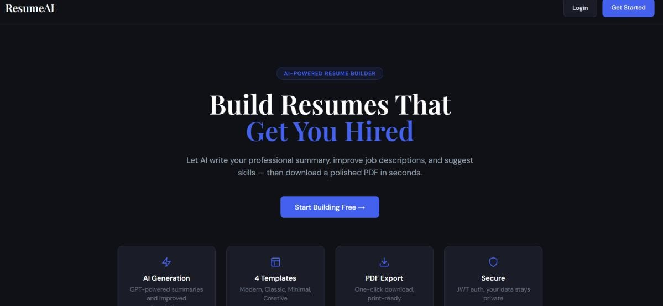

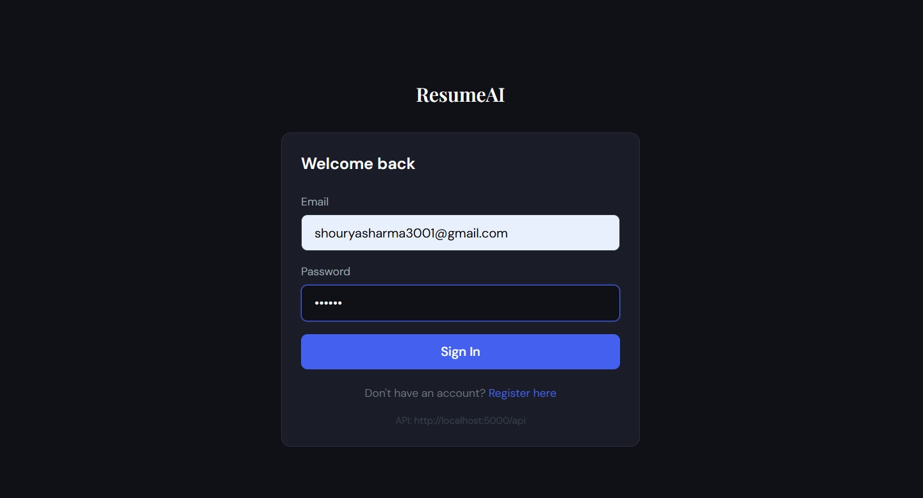

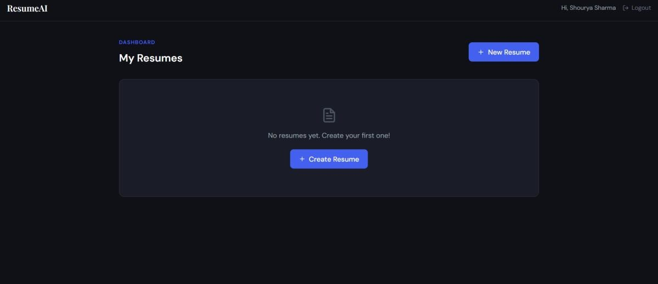

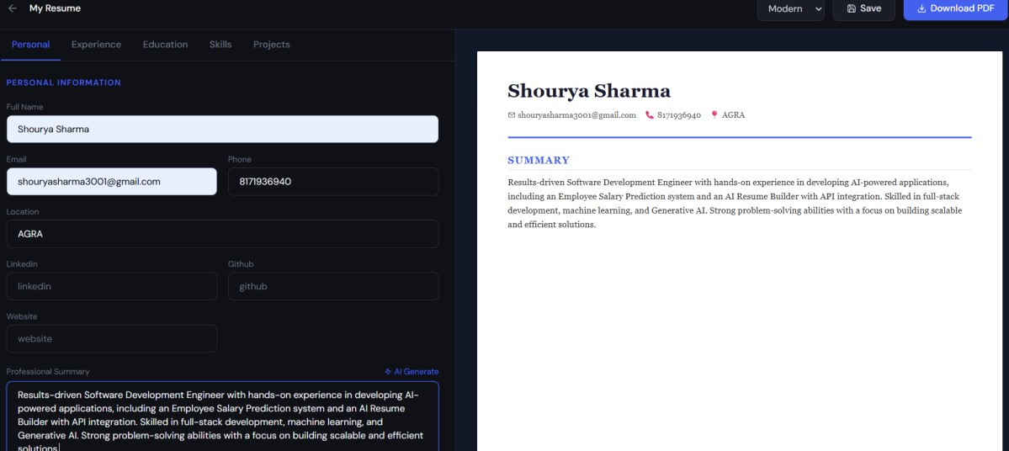

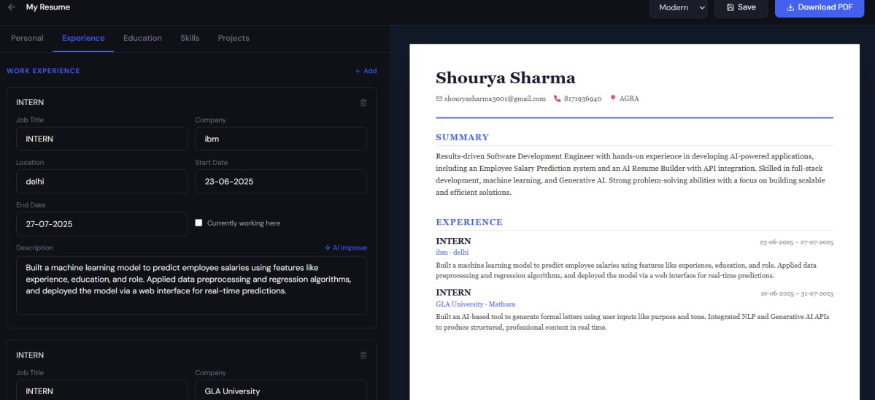

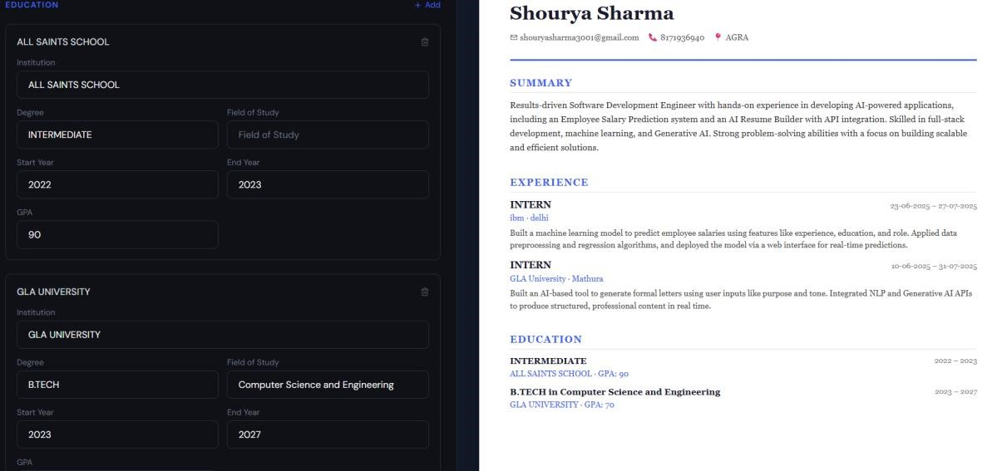

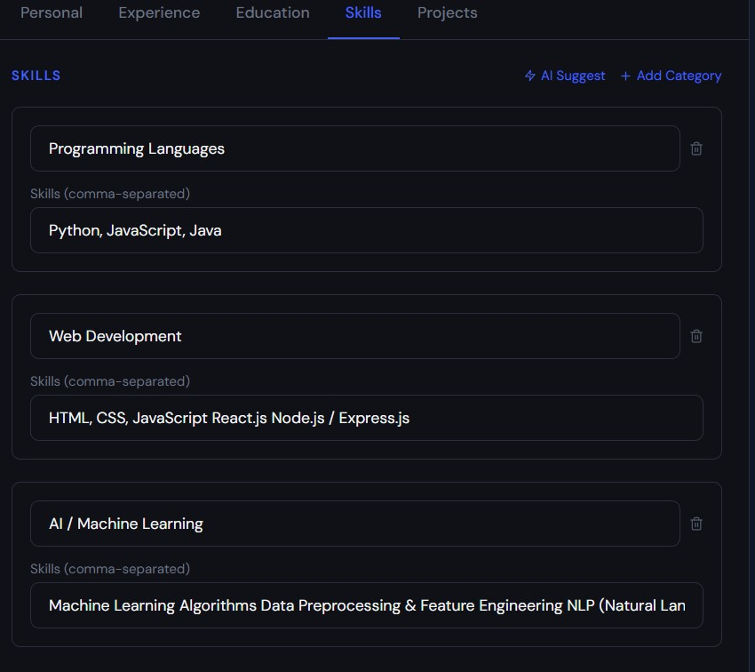

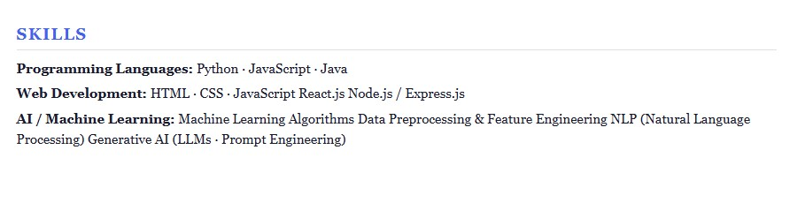

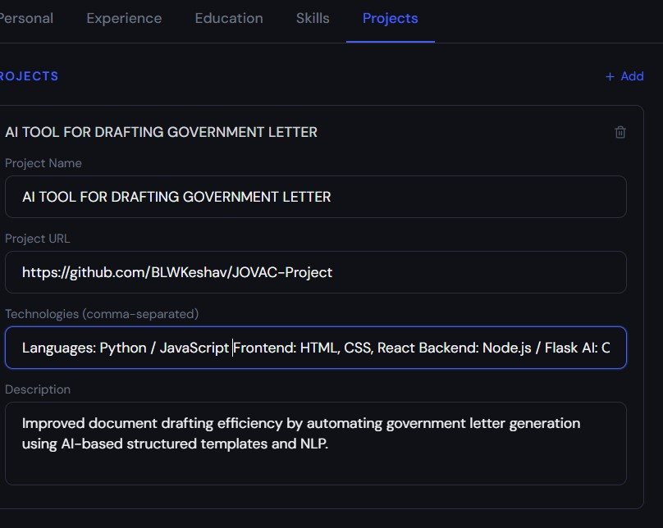

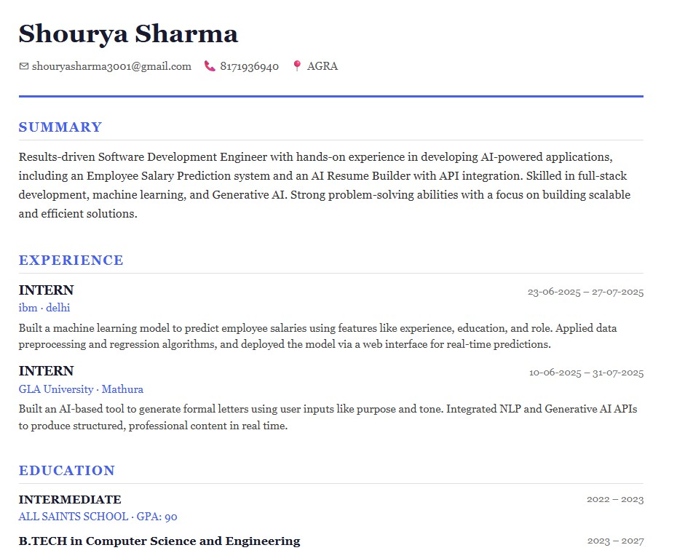

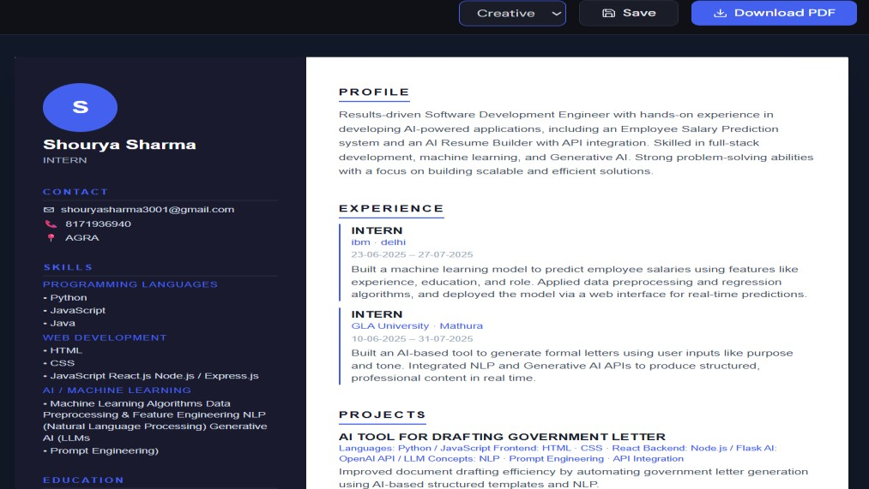

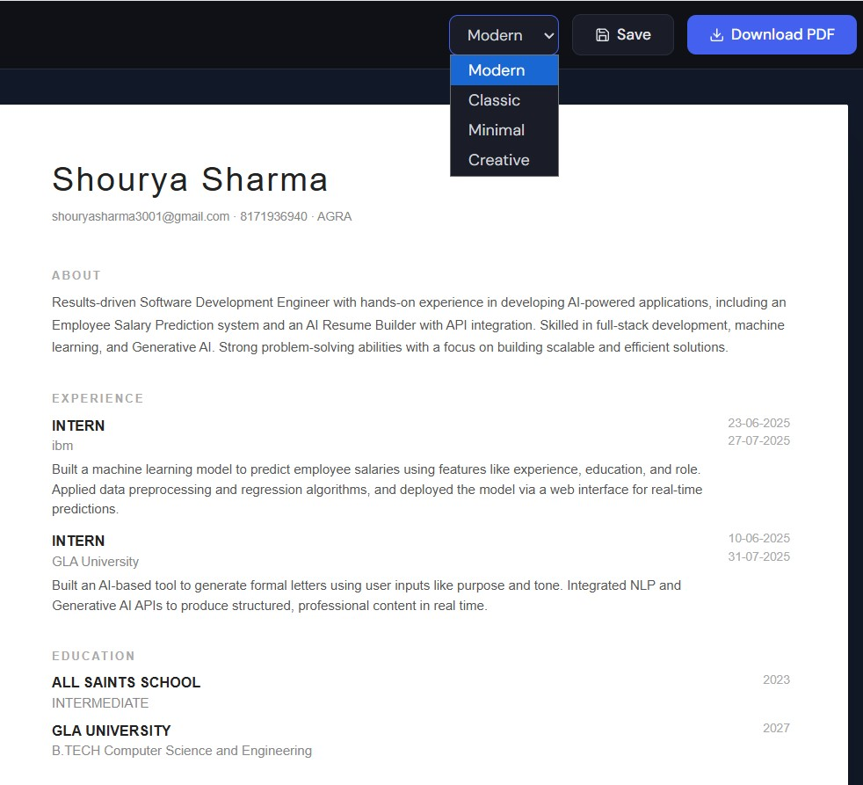

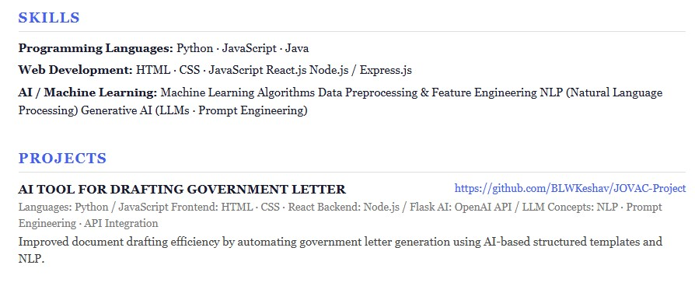

Conclusion
The AI Resume Builder makes resume creation faster, easier, and more efficient by combining user input with AI-powered suggestions.

