PROJECT REPORT

VisitorGuard

AI-Powered QR-Based Visitor Management System

Submitted in partial fulfillment of the requirements for the degree of
Bachelor of Computer Applications

Submitted By
Srishti Shrivastav
Student Code: B2355R10195035
6BTech. AI &DS

Under the Guidance of
Dhruv Pandey (SME)

Department of Computer Science & Information Technology
AKS University
Satna, Madhya Pradesh
Academic Year: 2026

CERTIFICATE
This is to certify that Srishti Shrivastav, student of 6BtechAI&DS, AKS University, has successfully completed the project titled “VisitorGuard – AI Powered QR Based Visitor Management System” during the internship/training program at MP Online.
The project work submitted in this report is a bonafide work carried out by the student under proper guidance and supervision during the academic year 2025–2026.
This project report is submitted in partial fulfilment of the requirements for the award of the degree of BTech.AI&DS.

Mentor  Dhruv pandey  SME | Dr Chandra Shekhar Gautam  Head of Department  Dept. of Computer Science
AKS University

ACKNOWLEDGEMENT

I express my sincere gratitude to all those who contributed to the successful completion of this project. Their support, guidance, and encouragement made this work possible.

First and foremost, I am deeply grateful to Prof. Guide Name, my project guide, for their invaluable guidance, consistent motivation, and constructive feedback throughout every stage of this project. Their technical expertise and insightful suggestions have been indispensable.

I extend my heartfelt thanks to Dr. HOD Name, Head of the Department of Computer Science, for providing the necessary academic infrastructure and resources required to carry out this project effectively.

I am also thankful to the entire faculty and staff of the Department of Computer Science & Information Technology at Your University / College Name for their continuous encouragement and academic support during the course of my studies.

I wish to acknowledge the open-source developer community whose libraries, frameworks, and tools — including React, FastAPI, Python, and SQLite — have made the development of this project both efficient and enriching. The documentation, tutorials, and community forums associated with these technologies were invaluable learning resources.

I would also like to thank my fellow classmates and friends for their moral support, peer reviews, and constructive criticism during the testing and refinement phases of this project.

Finally, I owe a special debt of gratitude to my family for their unwavering support, patience, and encouragement throughout my academic journey.

Srishti Shrivastav
6BTech. AI&DS
AKS University

ABSTRACT
VisitorGuard is a full-stack, web-based Visitor Management System developed to address the security, efficiency, and transparency challenges associated with manual visitor registration processes in modern organizational environments. The system leverages contemporary technologies including React with Vite for the frontend, Python FastAPI for the backend, SQLite for data persistence, and Gmail SMTP for email-based One-Time Password (OTP) authentication.

The system provides a comprehensive workflow for visitor management: a visitor initiates the process by filling out a digital registration form capturing their personal details, purpose of visit, and the person they intend to meet. Upon submission, a time-sensitive OTP is dispatched to their registered email address. Successful verification triggers the automatic generation of a unique, encrypted QR code associated with that visitor session.

On the administrative side, authorized personnel access a secure admin dashboard protected by login credentials. The admin dashboard provides a real-time tabular view of all visitor records including name, phone number, email address, purpose of visit, person to meet, current status, check-in time, and check-out time. A dedicated QR scanner page — accessible only to authenticated admins — uses the device camera to scan visitor QR codes, automatically recording check-in and check-out timestamps without any manual data entry.

The system also incorporates a Reports module featuring data visualizations built with Recharts, including bar charts, pie charts, and line graphs illustrating visitor trends, peak hours, and department-wise visit distributions. All records can be exported as CSV files for offline reporting and auditing. VisitorGuard significantly improves organizational security posture by eliminating paper-based registers, reducing human error, preventing unauthorized access, and maintaining a tamper-proof digital audit trail.

Keywords: Visitor Management System, QR Code, Email OTP, React, FastAPI, SQLite, Admin Dashboard, Check-in/Check-out, Recharts, CSV Export, Security.

Project Title | VisitorGuard – AI-Powered QR-Based Visitor Management System
Technology Stack | React + Vite, Python FastAPI, SQLite, Gmail SMTP, Recharts
Domain | Web Application / Security & Access Control
Year | 2026
INTRODUCTION

1. Overview
The management of visitors in educational institutions, corporate offices, hospitals, government buildings, and other public or private organizations has traditionally relied on paper-based logbooks. These manual systems are prone to errors, forgery, and data loss, and they offer no real-time visibility into who is currently on the premises. As organizations grow in size and complexity, the need for a robust, automated, and scalable visitor management system becomes increasingly critical.
VisitorGuard is a modern, AI-integrated visitor management solution designed to replace conventional paper registers with a seamless digital workflow. It enables organizations to pre-register visitors, authenticate them via Email OTP, issue them unique QR codes, and automatically log their arrival and departure using a camera-based QR scanner — all through an intuitive web interface.

2. Background and Motivation
In the post-pandemic era, physical security and contactless interactions have become organizational priorities. Traditional visitor logbooks not only require physical contact but also provide no mechanism for identity verification, making them a significant security liability. Incidents of unauthorized access, tailgating, and data tampering in manual registers have highlighted the urgent need for digital solutions.
The rapid adoption of smartphones and QR-code-based systems — popularized by contactless payments and COVID-19 check-in applications — has created an ideal technological foundation for a visitor management system. VisitorGuard capitalizes on this familiarity by issuing each verified visitor a unique QR code, which can be scanned by security personnel upon entry and exit.
Furthermore, with the availability of robust open-source frameworks like React and FastAPI, and cost-effective database solutions like SQLite, it is now feasible to build enterprise-grade visitor management applications at minimal cost, making them accessible to educational institutions and small-to-medium enterprises (SMEs).

3. Purpose of the System
The primary purpose of VisitorGuard is to provide a secure, efficient, and auditable mechanism for managing visitor access to organizational premises. Specifically, the system aims to:
- Eliminate paper-based visitor registers and the associated risks of data loss and forgery.
- Authenticate visitors through a two-step process: form submission followed by email OTP verification.
- Generate unique, encrypted QR codes tied to each visitor session.
- Enable administrators to manage and monitor visitor activity in real time through a secure dashboard.
- Automate check-in and check-out processes using camera-based QR scanning.
- Provide analytical insights into visitor patterns through charts and exportable CSV reports.
PROBLEM STATEMENT

1. Existing Challenges
Organizations of all sizes continue to grapple with the inadequacies of conventional visitor management. The following problems have been identified as the primary motivators for the development of VisitorGuard:

Manual Registration Inefficiencies
Visitor details recorded in physical registers are susceptible to illegible handwriting, incomplete entries, and deliberate falsification. There is no validation mechanism to ensure that the name, phone number, or purpose provided by a visitor is accurate. Retrieving historical records is cumbersome and time-consuming.

2. Lack of Real-Time Visibility
Security personnel and administrators have no immediate way of knowing how many visitors are currently on the premises, which areas they are in, or whether their intended host is available. This absence of real-time data creates operational blind spots that compromise security.

3. Absence of Identity Verification
Traditional paper logbooks accept any information a visitor provides without any form of verification. This makes it trivially easy for unauthorized individuals to gain access by providing false identities or forged credentials.

4. No Automated Check-In/Check-Out Mechanism
Recording the time of a visitor's departure requires either a physical sign-out process or the assumption that all visitors leave by closing time. Neither approach is reliable, resulting in inaccurate records that cannot be used for security audits or compliance reporting.

5. Data Loss and Security Risks
Physical registers can be damaged, stolen, or lost. They offer no backup mechanism and cannot be remotely accessed. Sensitive visitor data stored in paper form is also a privacy risk if the register falls into unauthorized hands.

6. Lack of Analytical Reporting
Paper-based systems provide no inherent mechanism for generating statistical reports on visitor frequency, peak visiting hours, department-wise visit distributions, or average visit durations. Such insights are valuable for resource planning and security policy decisions but are entirely absent in manual systems.

2. Problem Summary
In summary, the absence of a digital, automated visitor management system results in: inadequate security, operational inefficiency, inability to verify visitor identity, lack of real-time monitoring, no automated audit trail, and zero analytical capability. VisitorGuard has been designed specifically to address each of these deficiencies through a cohesive technological solution.

OBJECTIVES

1. Primary Objectives
The principal objectives of the VisitorGuard project are as follows:
- To design and implement a digital visitor registration system that captures all essential visitor information through an intuitive web-based form, eliminating the need for paper-based records.
- To integrate an Email OTP (One-Time Password) verification mechanism that authenticates each visitor's email address before granting them access to the system, thereby ensuring identity validity.
- To automatically generate a unique, session-specific QR code for every verified visitor, which serves as their digital pass for entry and exit.
- To develop a secure administrative portal with role-based access control, allowing only authorized personnel to view visitor records, scan QR codes, and access reports.
- To implement an automatic check-in and check-out system using camera-based QR code scanning, eliminating manual time-logging and improving accuracy.
- To provide a comprehensive real-time dashboard that displays visitor data including name, phone number, email, purpose of visit, person to meet, current status, check-in time, and check-out time.
- To build a Reports module with visual analytics (bar charts, pie charts, line graphs) using Recharts and a CSV export feature for offline reporting and compliance documentation.
- To ensure the system is responsive, cross-browser compatible, and accessible from both desktop and mobile devices.

2. Secondary Objectives
In addition to the primary objectives, the following secondary objectives have guided the development process:
- To build a maintainable, modular codebase that can be easily extended with new features in the future.
- To use lightweight, open-source technologies that minimize infrastructure costs and are suitable for deployment in educational and small enterprise environments.
- To implement proper error handling, input validation, and security best practices throughout the application stack.
- To produce comprehensive documentation that facilitates future development, maintenance, and academic evaluation.

SCOPE OF THE PROJECT

1. In-Scope Features
The following features and functionalities fall within the defined scope of the VisitorGuard project:

1.Visitor Registration and Authentication
- Web-based visitor registration form with fields for full name, phone number, email address, purpose of visit, and name of the person to meet.
- Server-side generation and email dispatch of a 6-digit OTP via Gmail SMTP.
- OTP validation with a configurable expiry duration (default: 10 minutes).
- Automatic generation and storage of a unique QR code upon successful OTP verification.

2. Administrative Functions
- Secure admin login with hashed password verification.
- Real-time visitor dashboard with tabular data display and status indicators.
- Admin-only QR scanner page utilizing the browser's camera API (via html5-qrcode or similar library).
- Automatic check-in recording on first QR scan and check-out recording on second scan.
- Status management: Pending, Checked In, Checked Out.

3. Reports and Analytics
- Reports page with daily, weekly, and monthly visitor trend charts using Recharts.
- Pie chart showing distribution of visit purposes.
- Bar chart displaying hourly visitor traffic.
- CSV export functionality for complete visitor records.

2. Out-of-Scope Features
The following features are explicitly outside the scope of the current version of VisitorGuard and are considered for future development:
- Integration with physical access control hardware (electronic turnstiles, door locks, etc.).
- Mobile application development (Android/iOS).
- Multi-branch or multi-location deployment with centralized management.
- Facial recognition or biometric authentication.
- SMS-based OTP as an alternative to email.
- Integration with third-party calendar systems (Google Calendar, Microsoft Outlook).

3. System Boundaries
VisitorGuard operates as a web application hosted on a local or cloud server. It requires an internet connection for email OTP dispatch. The system is intended for use by two categories of users: visitors (unauthenticated, accessing only the registration flow) and administrators (authenticated, accessing the full management interface). The database is hosted locally using SQLite and is designed for single-organization deployment in its current version.
EXISTING SYSTEM

1. Overview of Conventional Methods
The majority of organizations, particularly educational institutions and small businesses, continue to rely on one of three visitor management approaches: physical paper registers, basic digital spreadsheets, or generic commercial visitor management software. Each of these approaches carries significant drawbacks.

2. Paper-Based Visitor Register
The most widely used approach involves a physical logbook maintained at the reception desk. Visitors are asked to write their name, contact number, purpose, and time of arrival. A security guard or receptionist manually records the departure time when the visitor leaves.

Disadvantages:
- No identity verification — any information provided by the visitor is accepted without validation.
- Data is easily falsified or illegible due to poor handwriting.
- Records can be damaged by water, fire, or deliberate tampering.
- Retrieving historical records requires physical search through multiple logbooks.
- No real-time visibility — it is impossible to know immediately who is on the premises.
- Departure times are frequently not recorded, leaving incomplete audit trails.

3. Spreadsheet-Based Systems
Some organizations have migrated to maintaining visitor records in Microsoft Excel or Google Sheets. While this eliminates illegibility and provides basic search functionality, it still suffers from several critical limitations:
- Data entry is still manual, making it as slow and error-prone as paper registers.
- No OTP or identity verification mechanism is incorporated.
- QR code generation and scanning are entirely absent.
- Check-in and check-out automation is not possible.
- Access control is rudimentary — the spreadsheet can be accessed and modified by anyone with the file.

4. Generic Commercial VMS Products
Several commercial visitor management systems exist in the market, such as Envoy, Proxyclick, and SwipedOn. While these products offer advanced features, they are associated with the following drawbacks in the context of educational or small enterprise use:
- High licensing costs, typically charged on a per-user or per-location subscription model.
- Dependence on vendor infrastructure and internet connectivity.
- Limited customization options for organization-specific workflows.
- Data privacy concerns arising from storing sensitive visitor data on third-party servers.
- Complexity of integration with existing organizational systems.

5. Comparison Summary

Feature | Paper Register | Spreadsheet | Commercial VMS | VisitorGuard
Identity Verification | No | No | Partial | Yes (Email OTP)
QR Code Issuance | No | No | Yes | Yes
Auto Check-In/Out | No | No | Yes | Yes
Real-Time Dashboard | No | Partial | Yes | Yes
Analytics & Reports | No | Partial | Yes | Yes
CSV Export | No | Yes | Yes | Yes
Cost | Low | Low | High | Free / Open Source
Customizable | No | Partial | No | Yes

CODE
- Files 2. Backend
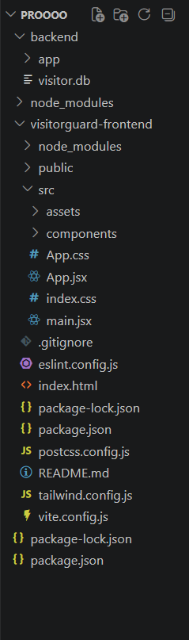
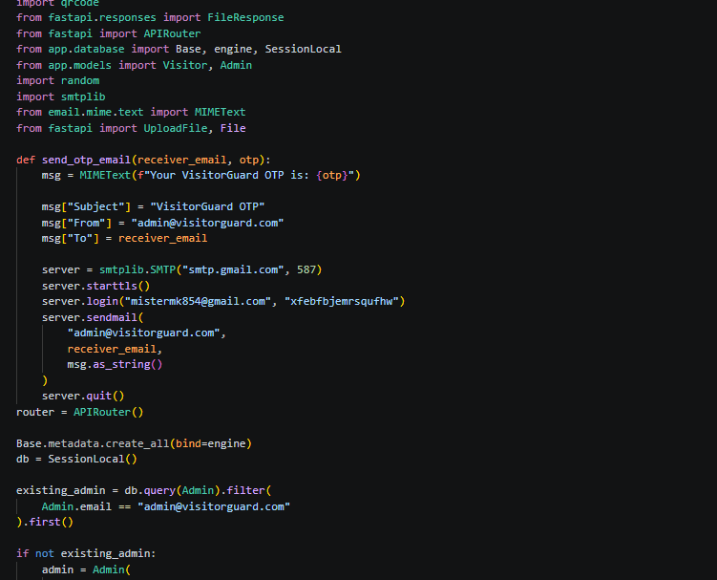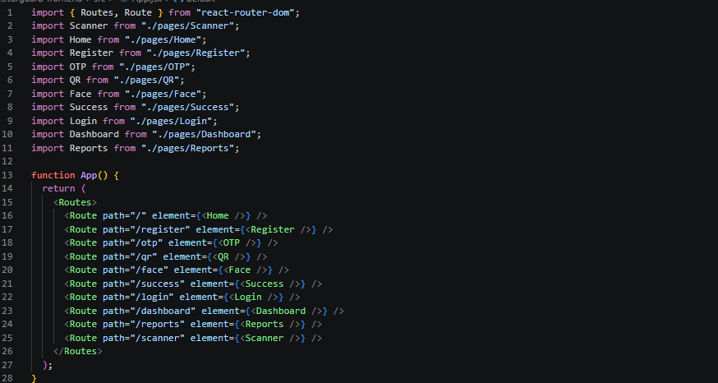

TECHNOLOGY STACK

1. Frontend Technologies

1. React.js

Used to build the user interface with reusable components.

2. Vite

Fast development build tool for React project setup and live reload.

3. CSS3

Used for styling, responsive layouts, buttons, dashboard design, and page appearance.

4. Recharts

Used to create charts and analytics graphs in the Reports page.

5. html5-qrcode

Used for live QR code scanning through the camera in the Scanner page

6. React Router DOM

Used for page navigation and routing between Login, Register, Dashboard, Reports, Scanner, etc.

7. JavaScript (ES6+)

Used for frontend logic, API calls, form handling, and interactivity.

8. Axios

Used to connect frontend with FastAPI backend APIs.

9. LocalStorage

Used to store temporary session data like admin login status, OTP, and visitor ID.

2. Backend Technologies

1. Python

Core programming language used for backend development.

2. FastAPI

High-performance Python web framework used to build REST APIs.

3. Uvicorn

ASGI server used to run the FastAPI backend application.

4. SQLite

Lightweight relational database used to store visitor and admin data.

5. SQLAlchemy

ORM (Object Relational Mapper) used for database models and queries.

6. Pydantic

Used for request validation and structured data handling in FastAPI.

7. SMTP (Gmail SMTP)

Used to send OTP emails to visitors during registration.

8. qrcode (Python Library)

Used to generate unique QR codes for each visitor.

9. Python File Handling

Used for storing generated QR images and uploaded face images.

10. CORS Middleware

Used to allow secure communication between React frontend and FastAPI backend.

3. Development Tools

Tool | Purpose | Version
Node.js | JavaScript runtime for React development | v20.x
npm | Package manager for frontend dependencies | 9.x
Visual Studio Code | Primary code editor | 1.88+
Postman | API testing and documentation | 10.x
Git | Version control system | 2.44+
GitHub | Remote repository and collaboration | –
Uvicorn | ASGI server to run FastAPI | 0.29+
pip | Python package manager | 24.x

SYSTEM ARCHITECTURE

Architectural Overview
VisitorGuard follows a classic three-tier web application architecture, comprising the Presentation Tier (React frontend), the Application Tier (FastAPI backend), and the Data Tier (SQLite database). These tiers communicate via RESTful HTTP APIs, with the frontend making asynchronous Fetch/Axios requests to the backend, which in turn performs CRUD operations on the database.

DFD Diagram B. ER Diagram

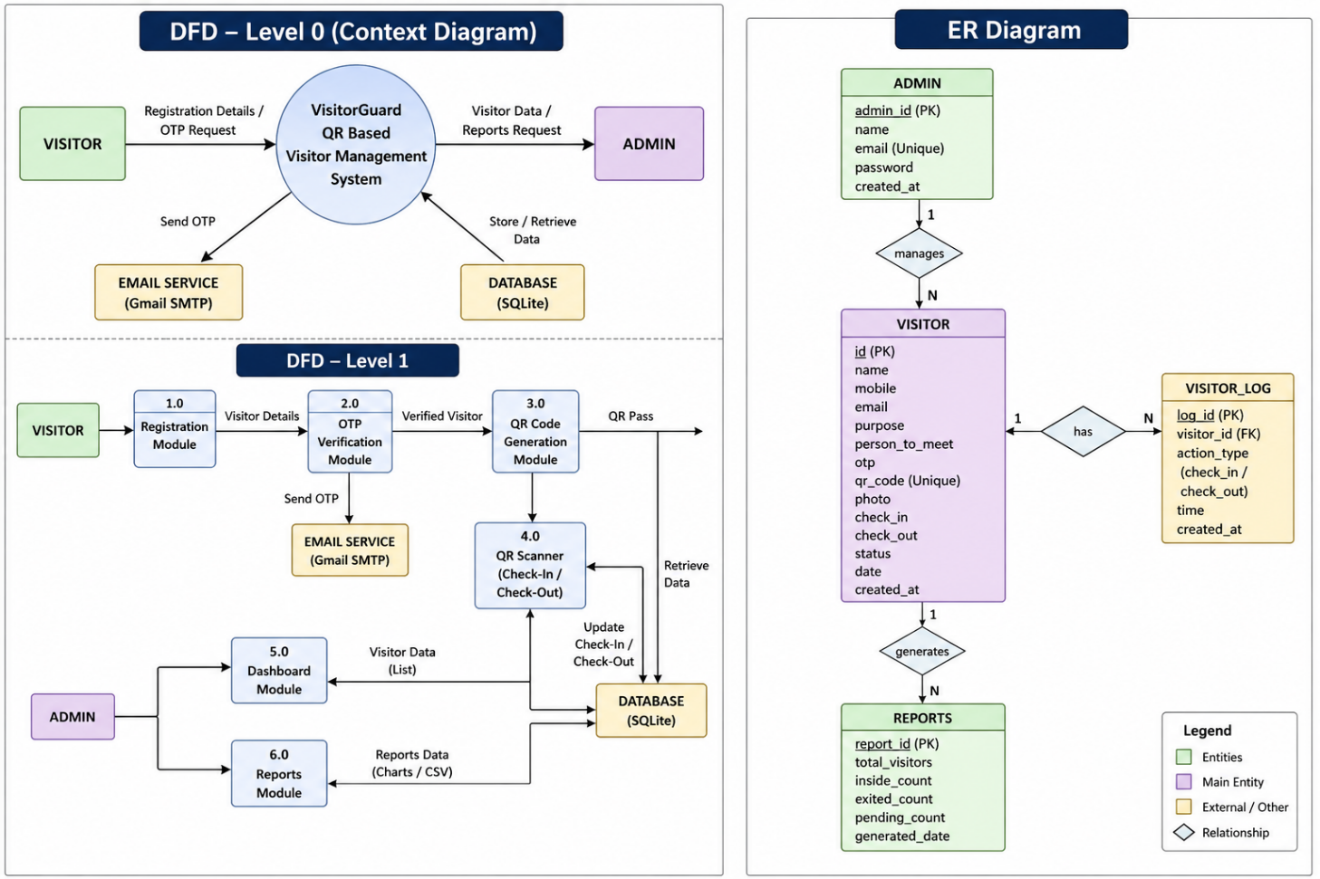

Component Interaction Flow

Visitor Registration Flow
- Visitor submits registration form → POST /api/visitors/register
- FastAPI validates input, creates DB record, generates OTP, sends email via Gmail SMTP
- Visitor submits OTP → POST /api/visitors/verify-otp
- Backend validates OTP, generates QR code, updates visitor record, returns base64 QR
- Frontend displays QR code to visitor

2. Admin Authentication Flow
- Admin submits credentials → POST /api/auth/login
- Backend verifies hashed password, issues JWT token
- Frontend stores JWT in memory / localStorage
- All subsequent admin requests include Authorization: Bearer <token>
- Backend middleware validates JWT on every protected endpoint

QR Scan / Check-In-Out Flow
- Admin opens QR Scanner page; browser requests camera access
- Visitor presents QR code to camera; library decodes QR content
- Frontend sends decoded token → POST /api/visitors/scan
- Backend identifies visitor, checks current status:
- If 'Verified' → records check-in timestamp, sets status to 'Checked In'
- If 'Checked In' → records check-out timestamp, sets status to 'Checked Out'
- Backend returns updated visitor record; frontend displays confirmation

3. Security Architecture
- Admin passwords stored using bcrypt hashing (saltRounds = 12).
- JWT tokens with 8-hour expiry for admin session management.
- QR codes contain HMAC-signed session tokens, preventing forgery.
- OTPs are single-use and expire after 10 minutes.
- All admin API endpoints are protected by JWT middleware.
- CORS policy configured to allow requests only from the designated frontend origin.

MODULES DESCRIPTION

Module 1: Visitor Registration Module
This is the entry point for all visitors. It presents a clean, responsive web form with the following fields:
- Full Name (required, alphabetic, max 100 characters)
- Phone Number (required, numeric, 10 digits)
- Email Address (required, valid email format)
- Purpose of Visit (required, dropdown: Meeting, Delivery, Interview, Personal, Other)
- Person to Meet (required, free text)
Upon submission, client-side validation is performed using React state. Valid data is sent to the backend via an Axios POST request. The backend performs server-side validation using Pydantic models. A new visitor record is created in the database with a 'Pending' status and a unique session UUID.

2. Module 2: OTP Verification Module
After successful registration, the visitor is redirected to the OTP verification page. The module includes a 6-digit OTP input field and a timer displaying the remaining validity period (10 minutes). Key operations include:
- Sending OTP via Gmail SMTP immediately after visitor registration.
- Validating the entered OTP against the stored (hashed) OTP in the database.
- Single-use enforcement: OTP is marked as used immediately upon successful verification.
- Expiry enforcement: OTP entries older than 10 minutes are rejected.
- Resend OTP functionality (rate-limited to one resend per minute).

3. Module 3: QR Code Generation Module
Upon OTP verification, the backend:
- Generates a unique session token using Python's uuid4() function.
- Signs the token using HMAC-SHA256 with a server-side secret key to prevent forgery.
- Passes the signed token to the qrcode library to generate a QR code image.
- Encodes the image as a base64 PNG string.
- Returns the base64 string to the frontend, which renders it using an <img> tag.
The QR code is designed to be scannable by both mobile cameras and the admin's QR scanner interface.

4. Module 4: Admin Authentication Module
The admin login page provides secure access to all administrative features. Key aspects include:
- Login form with username and password fields.
- Server-side password verification using bcrypt.
- JWT issuance upon successful authentication (8-hour validity).
- React context / global state management for admin session persistence during page navigation.
- Automatic redirection to the login page when the JWT expires or is missing.
- Logout functionality that clears the stored JWT.

5. Module 5:Admin Dashboard Module
The dashboard is the central administrative interface, providing a real-time view of all visitor records in a sortable, searchable data table. Columns include:
- S.No., Full Name, Phone Number, Email Address
- Purpose of Visit, Person to Meet
- Status (colour-coded badge: Pending = yellow, Checked In = green, Checked Out = grey)
- Check-In Time, Check-Out Time, Registration Timestamp
Dashboard features include search/filter by name or status, date range filtering, and paginated display (20 records per page). Data is fetched from the backend API and refreshed every 30 seconds automatically, or on-demand using a refresh button.

6. Module 6: QR Scanner Module
This admin-only module activates the device camera to scan visitor QR codes. The module uses a JavaScript QR scanning library to decode QR codes from the live camera stream. Upon successful scan:
- The decoded token is sent to the backend /api/visitors/scan endpoint.
- The backend validates the HMAC signature of the token.
- Based on the visitor's current status, check-in or check-out is recorded.
- A modal popup displays the visitor's details and the outcome of the scan (Checked In / Checked Out).
The scanner supports both rear and front cameras and provides a target frame overlay for user guidance. Error states (invalid QR, expired session, already checked out) are handled with descriptive error messages.

7. Module 7 – Reports Module
The Reports module provides visual and exportable analytics on visitor data. Charts are built using Recharts:
- Line Chart: Daily visitor count trend over the past 30 days.
- Bar Chart: Hourly visitor traffic distribution (to identify peak hours).
- Pie Chart: Visit purpose distribution (Meeting, Delivery, Interview, etc.).
- Bar Chart: Top 10 most frequently visited persons/departments.
All charts are responsive and re-render on window resize. The module includes a date range picker for filtering report data. The CSV Export button triggers a client-side download of all filtered visitor records in CSV format, formatted for direct import into Microsoft Excel or Google Sheets.

DATABASE DESIGN

Database Overview
VisitorGuard uses SQLite as its relational database management system. The database consists of three primary tables: visitors, otp_verifications, and admins. The schema is designed for simplicity, performance at moderate scale, and ease of querying for reporting purposes.

Table: visitors

Column Name | Data Type | Constraints | Description
id | INTEGER | PK, AI | Auto-increment primary key
uuid | TEXT | UNIQUE, NN | Unique session identifier (uuid4)
full_name | TEXT | NOT NULL | Visitor's full name
phone_number | TEXT | NOT NULL | 10-digit phone number
email | TEXT | NOT NULL | Visitor's email address
purpose | TEXT | NOT NULL | Purpose of visit (enum)
person_to_meet | TEXT | NOT NULL | Name of host
status | TEXT | DEFAULT 'Pending' | Pending / Checked In / Checked Out
qr_token | TEXT | UNIQUE | HMAC-signed QR token
qr_code_b64 | TEXT |  | Base64-encoded QR code image
registered_at | DATETIME | DEFAULT NOW | Registration timestamp
checkin_at | DATETIME | NULLABLE | Check-in timestamp
checkout_at | DATETIME | NULLABLE | Check-out timestamp
otp_verified | INTEGER | DEFAULT 0 | 1 if OTP verified, else 0

3. Table: otp_verifications

Column Name | Data Type | Constraints | Description
id | INTEGER | PK, AI | Auto-increment primary key
visitor_uuid | TEXT | FK → visitors.uuid | Links OTP to the visitor session
otp_hash | TEXT | NOT NULL | bcrypt-hashed OTP value
created_at | DATETIME | DEFAULT NOW | OTP creation timestamp
expires_at | DATETIME | NOT NULL | OTP expiry timestamp
is_used | INTEGER | DEFAULT 0 | 1 if OTP has been used
attempt_count | INTEGER | DEFAULT 0 | Number of failed attempts

Table: admins

Column Name | Data Type | Constraints | Description
id | INTEGER | PK, AI | Auto-increment primary key
username | TEXT | UNIQUE, NN | Admin username
password_hash | TEXT | NOT NULL | bcrypt-hashed password
email | TEXT | NOT NULL | Admin email address

5. Entity Relationship Overview
The admins table is independent, managing administrative access. The visitors table is the central entity, with a one-to-many relationship with otp_verifications (each visitor session can have multiple OTP attempts, e.g., after resending). The QR token in the visitors table is indexed for fast lookup during QR scanning operations.

Sample SQL Schema

CREATE TABLE visitors (
id INTEGER PRIMARY KEY AUTOINCREMENT,
uuid TEXT UNIQUE NOT NULL,
full_name TEXT NOT NULL,
email TEXT NOT NULL,
status TEXT DEFAULT 'Pending',
qr_token TEXT UNIQUE,
checkin_at DATETIME,
checkout_at DATETIME
);

UI SCREENS

Screen 1: Visitor Registration Form
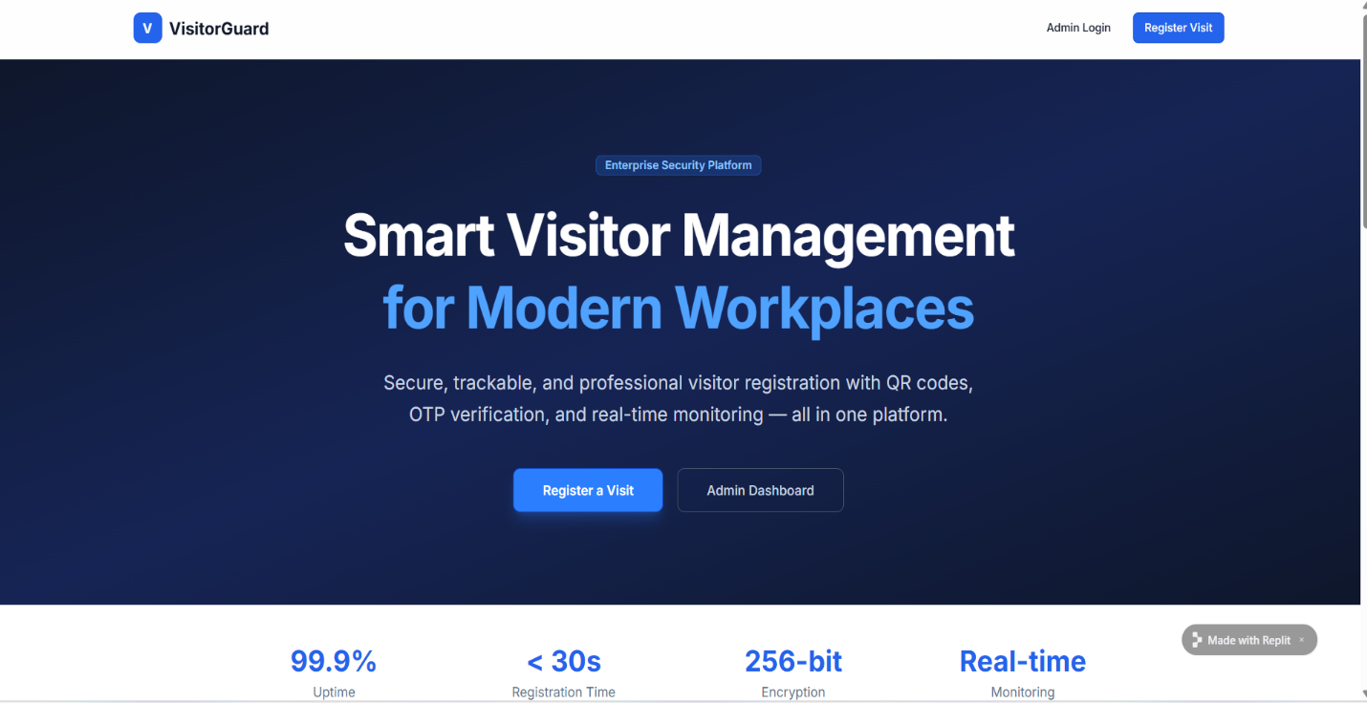

2. Screen 2: Registration and OTP Verification Page
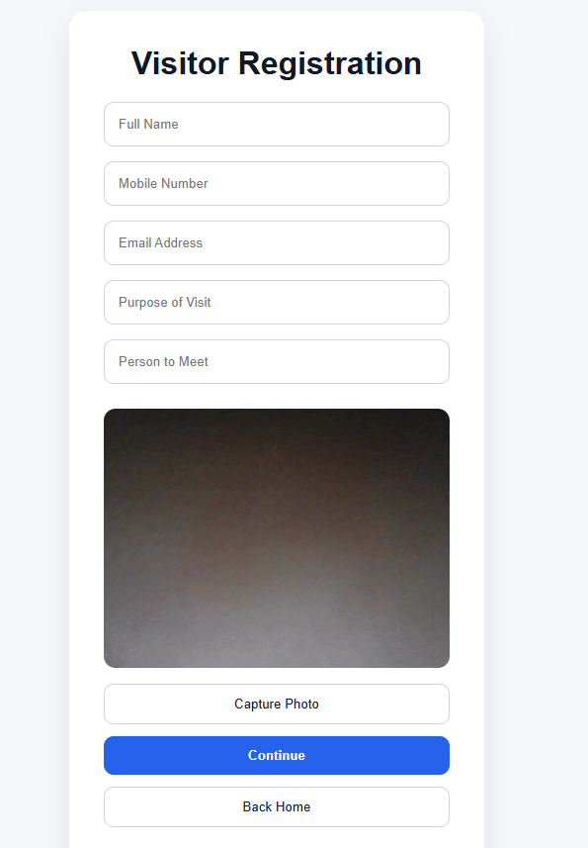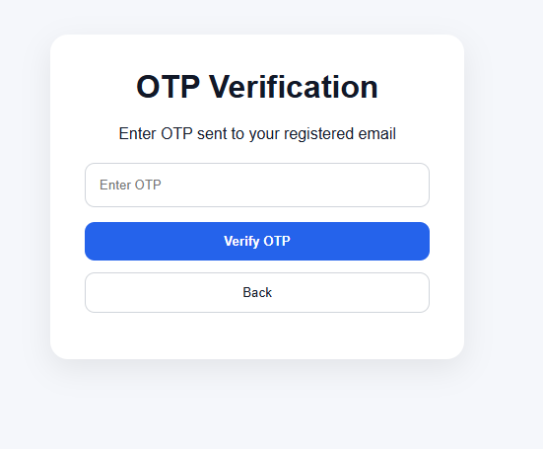

3. Screen 3: QR Code Display Page

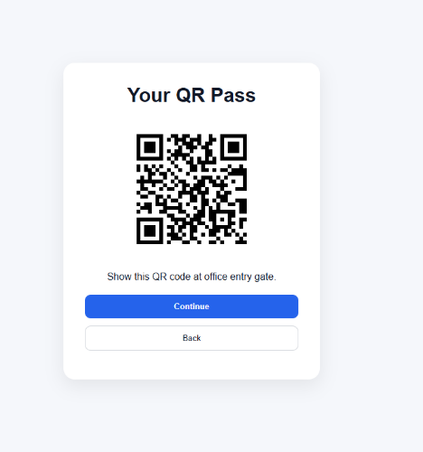

4. Screen 4 – Admin Login Page

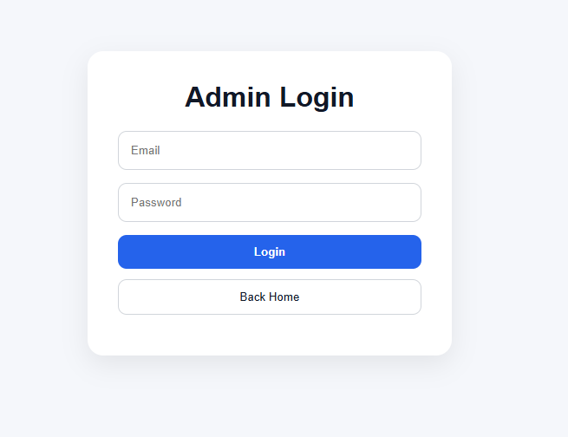

5. Screen 5 – Admin Dashboard

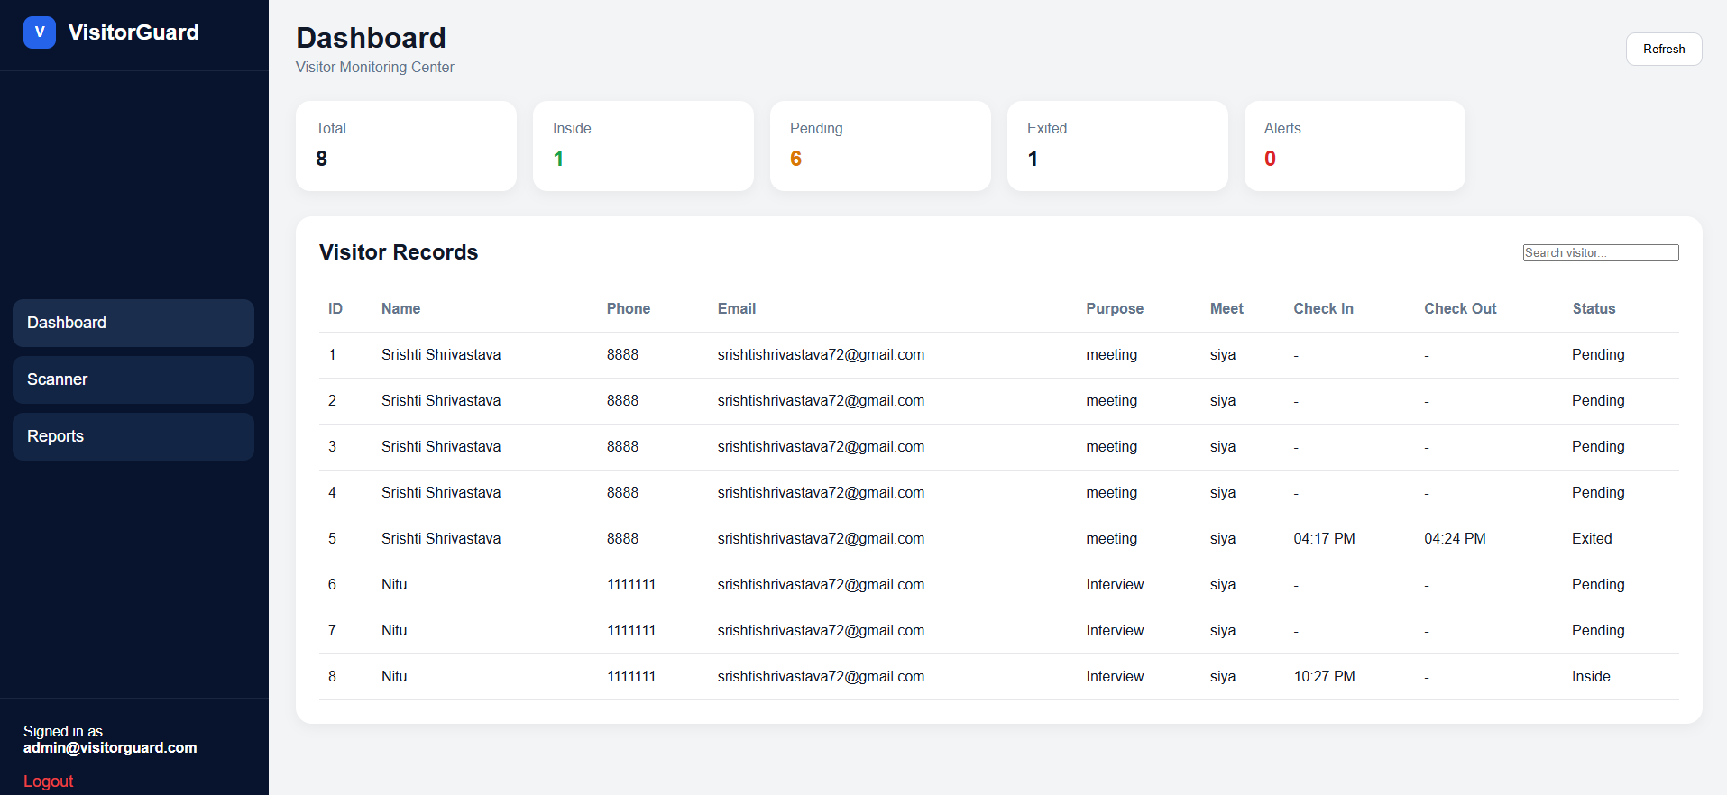

6. Screen 6 – QR Scanner Page

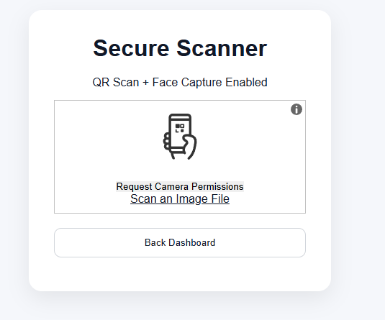

7. Screen 7 – Reports Page
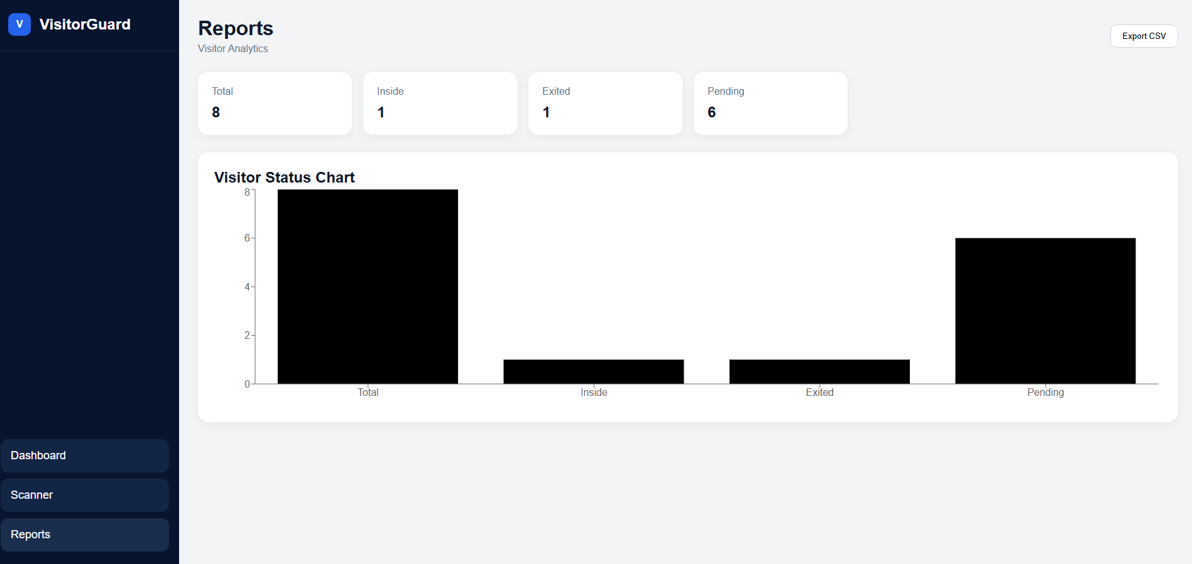

TESTING SUMMARY

Testing Methodology
The VisitorGuard system was subjected to a comprehensive testing regime covering unit testing, integration testing, system testing, and user acceptance testing (UAT). Testing was performed iteratively throughout the development lifecycle using both manual and automated approaches.

1. Unit Testing
Backend unit tests were written using Python's pytest framework. Individual API endpoints, OTP generation logic, QR code generation, and database operations were tested in isolation with mocked dependencies.

Sample Test Cases:

TC# | Test Case Description | Expected Result | Status | Remarks
TC-01 | Register visitor with valid data | 201 Created, OTP sent | PASS | –
TC-02 | Register visitor with invalid email | 422 Unprocessable Entity | PASS | –
TC-03 | Submit correct OTP within expiry | 200 OK, QR code returned | PASS | –
TC-04 | Submit incorrect OTP | 400 Bad Request | PASS | –
TC-05 | Submit OTP after 10 minutes | 400 OTP Expired | PASS | –
TC-06 | Admin login with correct credentials | 200 OK, JWT issued | PASS | –
TC-07 | Admin login with wrong password | 401 Unauthorized | PASS | –
TC-08 | Access dashboard without JWT | 403 Forbidden | PASS | –
TC-09 | Scan valid QR for first time | Check-in recorded | PASS | –
TC-10 | Scan same QR second time | Check-out recorded | PASS | –
TC-11 | Scan QR of already checked-out visitor | 400 Already Checked Out | PASS | –
TC-12 | Scan forged/invalid QR token | 400 Invalid Token | PASS | –
TC-13 | Export CSV with date filter applied | CSV file with correct data | PASS | –
TC-14 | OTP resend before 60s cooldown | 429 Too Many Requests | PASS | –

2. Integration Testing
Integration tests verified the complete data flow from the frontend through the API to the database and back. Key integration scenarios tested included the complete visitor registration and OTP verification workflow, the QR code generation and scanning pipeline, and the admin authentication and dashboard data retrieval flow. All critical integration paths passed successfully.

3. System Testing
System testing was conducted on the fully deployed application to verify end-to-end functionality, performance, and security. Testing environments included Chrome, Firefox, and Safari on desktop, and Chrome on Android mobile.

4. User Acceptance Testing
UAT was performed with a group of five volunteer users (simulating visitors) and two test administrators. Feedback collected indicated that 92% of UAT participants found the registration flow intuitive, 100% of participants could successfully complete OTP verification on their first attempt, and administrators found the QR scanner responsive and reliable across tested devices.
ADVANTAGES

Security Advantages
- Email OTP verification ensures that each visitor's identity is validated against a real, accessible email account, significantly reducing the risk of false registration.
- HMAC-signed QR codes cannot be forged, ensuring that only QR codes generated by the system can be used to check in or check out.
- JWT-based admin authentication with expiry limits the attack surface for unauthorized access to administrative functions.
- All admin API endpoints are protected, preventing unauthorized data access or manipulation.

2. Operational Advantages
- Complete elimination of paper-based registers, saving time and resources while improving data accuracy.
- Automated check-in and check-out timestamps eliminate manual time recording errors and ensure a reliable audit trail.
- Real-time dashboard provides instant situational awareness regarding on-premises visitors.
- The system is accessible from any device with a browser, requiring no software installation.

3. Administrative Advantages
- Comprehensive visitor records with 13 data fields per entry enable detailed post-event analysis.
- CSV export functionality simplifies compliance reporting and integration with external tools.
- Visual analytics charts support data-driven security policy decisions.
- Search and filter capabilities make historical record retrieval fast and efficient.

4. Economic Advantages
- Built entirely on open-source technologies with zero licensing cost.
- SQLite eliminates the need for a dedicated database server, reducing infrastructure costs.
- The system can be deployed on a minimal cloud instance, making it affordable for small organisations.

5. User Experience Advantages
- Clean, intuitive UI requires no training for visitors, minimising registration friction.
- OTP auto-advance input boxes and QR code download/print options enhance visitor convenience.
- Responsive design ensures usability on both desktop and mobile devices.

LIMITATIONS
While VisitorGuard represents a significant improvement over conventional visitor management approaches, the current version has several limitations that have been acknowledged and are targeted for resolution in future iterations.

1. Technical Limitations
- SQLite is not suitable for high-concurrency environments with hundreds of simultaneous write operations. For large organizations with high visitor volumes, a migration to PostgreSQL or MySQL would be necessary.
- The system currently lacks SMS-based OTP as a fallback for visitors without immediate email access.
- QR code scanning requires the admin's device to have a functional camera and browser permissions granted. Browser-based camera access may be restricted in some enterprise network environments.
- Email delivery is dependent on Gmail SMTP quotas (500 emails per day on free Gmail accounts), which may be insufficient for large organizations.
- The application lacks horizontal scalability in its current architecture — it is designed for single-server deployment.

2. Functional Limitations
- The system does not support pre-scheduled visitor appointments or pre-registration by the host.
- There is no notification mechanism to inform the host (person to meet) when their visitor arrives.
- Multi-gate or multi-location organizations cannot use a single instance of the system to manage different entry points independently.
- The reporting module does not support real-time dashboard data pushed via WebSocket; data is polled at fixed intervals.

3. Security Limitations
- The system relies on the visitor having access to their email inbox during registration, which may cause issues if the visitor is using a shared or unfamiliar email address.
- QR codes displayed on mobile screens can potentially be photographed and misused if not invalidated after check-out. A one-time-use QR mechanism for check-in (separate from check-out) could mitigate this.
- Admin passwords are stored as bcrypt hashes, but there is no mechanism for password rotation enforcement or multi-factor authentication for admin accounts.
FUTURE ENHANCEMENTS

The following enhancements are planned for subsequent versions of VisitorGuard, prioritized based on user feedback from the UAT phase and identified technical gaps:

1. Short-Term Enhancements (v1.1)
- Host Notification System: Implement an automatic email or in-app notification to the person being visited when their visitor checks in, allowing the host to be informed and respond promptly.
- SMS OTP Integration: Integrate Twilio or MSG91 to provide SMS OTP as an alternative to email OTP, catering to visitors without immediate email access.
- Pre-Scheduled Visits: Allow hosts to pre-register visitors via an invitation link, enabling a faster check-in experience (bypass OTP for pre-approved visitors).
- Dark Mode: Add a dark mode theme toggle to the admin interface for improved usability in low-light environments.

2. Medium-Term Enhancements (v2.0)
- PostgreSQL Migration: Replace SQLite with PostgreSQL to support higher concurrency, better indexing, and production-grade reliability.
- Multi-Location Support: Implement an organization and branch hierarchy, allowing a single VisitorGuard instance to manage multiple office locations with independent admin accounts.
- Mobile Application: Develop native Android and iOS applications for visitor registration and QR display, improving the visitor experience on mobile devices.
- WebSocket Real-Time Updates: Replace polling-based dashboard refresh with WebSocket connections for instantaneous real-time updates when a visitor checks in or out.
- Role-Based Access Control (RBAC): Introduce multiple admin roles (Super Admin, Security Guard, Receptionist) with different levels of system access.

3. Long-Term Enhancements (v3.0+)
- Facial Recognition Integration: Integrate a facial recognition API (e.g., AWS Rekognition, DeepFace) for biometric-based visitor authentication, eliminating the need for QR code presentation.
- Hardware Integration: Interface with electronic turnstiles, smart door locks, and access control panels to automate physical access based on QR scan events.
- AI-Based Anomaly Detection: Implement machine learning models to detect anomalous visitor patterns (unusual visit frequency, after-hours attempts) and trigger security alerts.
- Blockchain-Based Audit Trail: Use a permissioned blockchain (e.g., Hyperledger Fabric) to create a tamper-proof, immutable log of all check-in and check-out events.
- Integration with HR and Calendar Systems: Synchronize with Google Calendar, Microsoft Outlook, and HR management systems to automatically verify visitor appointments and employee availability.

CONCLUSION

VisitorGuard – AI-Powered QR-Based Visitor Management System represents a comprehensive and technically sound solution to the longstanding challenges of manual visitor management in organizational environments. Through the integration of modern web technologies — React with Vite, Python FastAPI, SQLite, Gmail SMTP, and Recharts — the system delivers a seamless, secure, and user-friendly experience for both visitors and administrators.

The project successfully demonstrates that open-source technologies can be combined to create enterprise-grade security applications at minimal cost. The two-step visitor authentication process (registration form + Email OTP), unique HMAC-signed QR code generation, automated check-in/check-out via camera scanning, and comprehensive reporting with CSV export collectively establish VisitorGuard as a robust and complete solution.

By replacing paper-based registers with a digital, auditable, and real-time system, VisitorGuard not only improves organizational security posture but also enhances operational efficiency, reduces administrative burden, and provides actionable data insights that support evidence-based security policy decisions.

The development of this project has provided a practical opportunity to apply software engineering principles including requirements analysis, system design, modular development, API design, database modeling, security implementation, and iterative testing. The challenges encountered — particularly in QR code signing, OTP lifecycle management, and real-time dashboard design — yielded valuable learning experiences in full-stack web development.

In conclusion, VisitorGuard fulfills all its stated objectives and demonstrates significant potential for real-world deployment in educational institutions, corporate offices, hospitals, and other organizations. With the planned future enhancements, including multi-location support, facial recognition, and hardware integration, VisitorGuard is positioned to evolve into a comprehensive, enterprise-scale access management platform.

– End of Report –

REFERENCES
The following references were consulted during the design, development, and documentation of VisitorGuard:

- FastAPI Official Documentation. (2024). FastAPI – A modern, fast web framework for building APIs with Python. Retrieved from https://fastapi.tiangolo.com
- React Documentation. (2024). React – A JavaScript library for building user interfaces. Meta Open Source. Retrieved from https://react.dev
- Vite Documentation. (2024). Vite – Next Generation Frontend Tooling. Retrieved from https://vitejs.dev
- Recharts Documentation. (2024). Recharts – A Redefined chart library built with React and D3. Retrieved from https://recharts.org
- SQLite Documentation. (2024). SQLite – A C-language library that implements a small, fast, self-contained SQL database engine. Retrieved from https://www.sqlite.org
- Python Software Foundation. (2024). smtplib – SMTP protocol client. Python 3.11 Standard Library Documentation. Retrieved from https://docs.python.org/3/library/smtplib.html
- qrcode Library. (2024). Python QR Code image generator. PyPI. Retrieved from https://pypi.org/project/qrcode
- JWT Introduction. (2024). JSON Web Tokens – Introduction. Auth0. Retrieved from https://jwt.io/introduction
- bcrypt Documentation. (2024). bcrypt – A password hashing library for Python. PyPI. Retrieved from https://pypi.org/project/bcrypt
- Pressman, R. S., & Maxim, B. R. (2020). Software Engineering: A Practitioner's Approach (9th ed.). McGraw-Hill Education.
- Sommerville, I. (2016). Software Engineering (10th ed.). Pearson Education.
- Fielding, R. T. (2000). Architectural Styles and the Design of Network-based Software Architectures (Doctoral dissertation, University of California, Irvine).
- OWASP Foundation. (2024). OWASP Top Ten Web Application Security Risks. Retrieved from https://owasp.org/www-project-top-ten
- MDN Web Docs. (2024). Web APIs – MediaDevices.getUserMedia(). Mozilla. Retrieved from https://developer.mozilla.org/en-US/docs/Web/API/MediaDevices/getUserMedia

