Title: Day 4 - Template Comparison & Agent Orchestration

1. Objective
The objective of Day 4 is to integrate all components of the system and enhance it with semantic comparison and AI-based suggestions.
2. Methodology
2.1 Vector Database
- Gold-standard clauses stored in ChromaDB
- Converted into embeddings using sentence transformers
- Enables semantic similarity search
2. Methodology
2.1 Vector Database
- Gold-standard clauses stored in ChromaDB
- Converted into embeddings using sentence transformers
- Enables semantic similarity search
2.3 Agent Orchestration
- A centralized agent coordinates:
  - Clause comparison
  - Risk analysis
  - Suggestion generation
2.4 LLM Integration
- LLM is used to:
  - Generate safer clause wording
  - Provide explanations in plain English
  - Suggest improvements
3. Output
The system produces:
- Clause classification
- Risk score
- Deviation detection
- Suggested improvements
- Explanation of risks

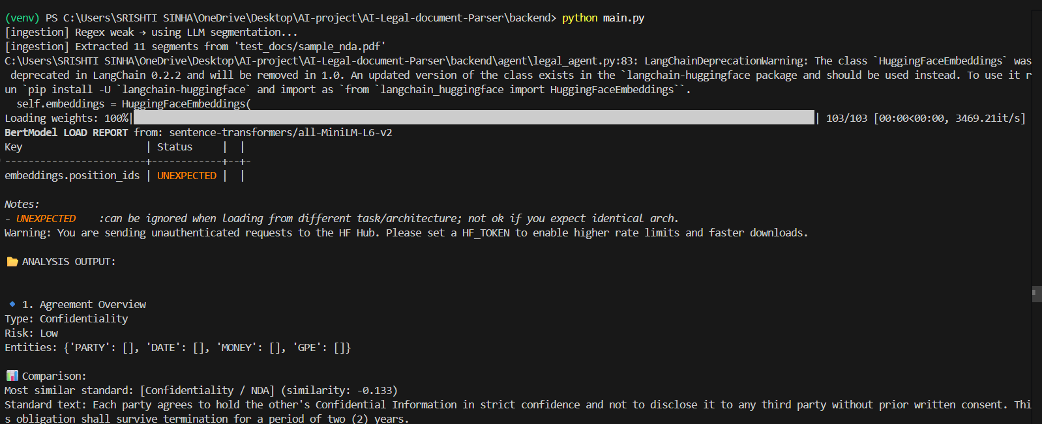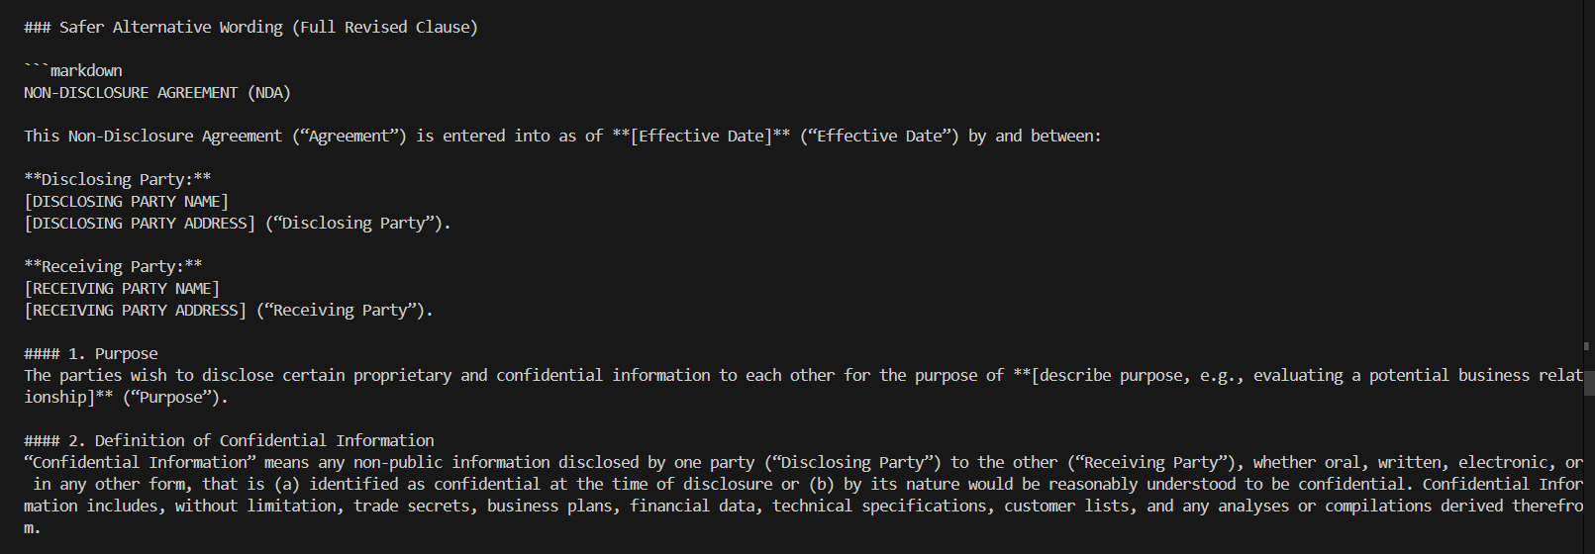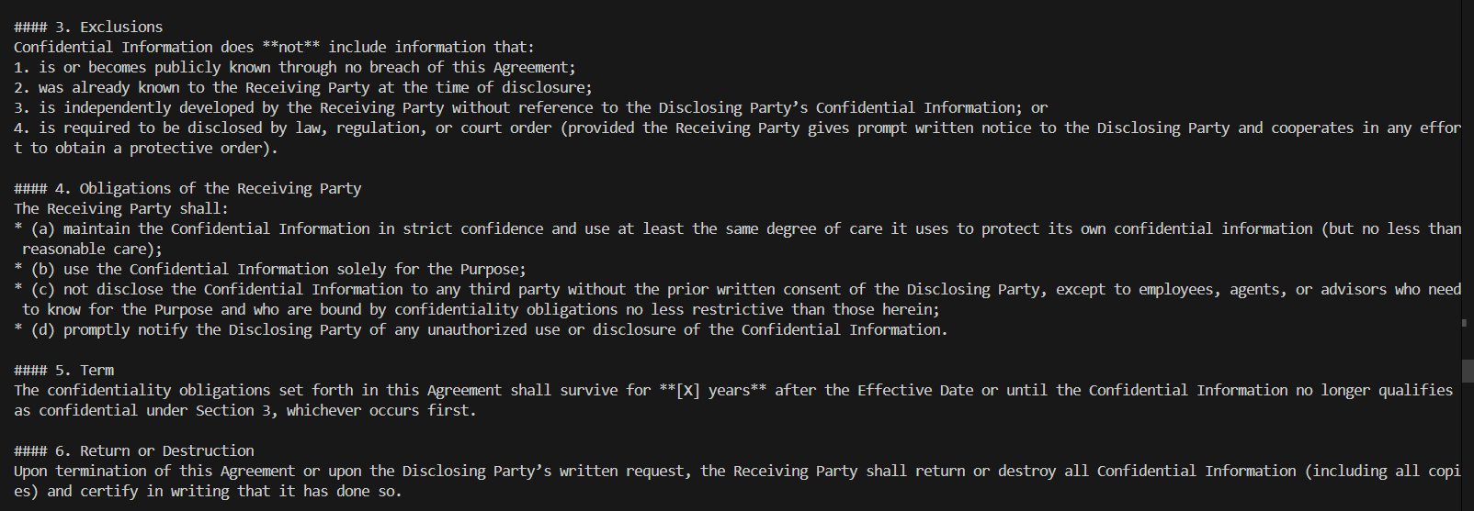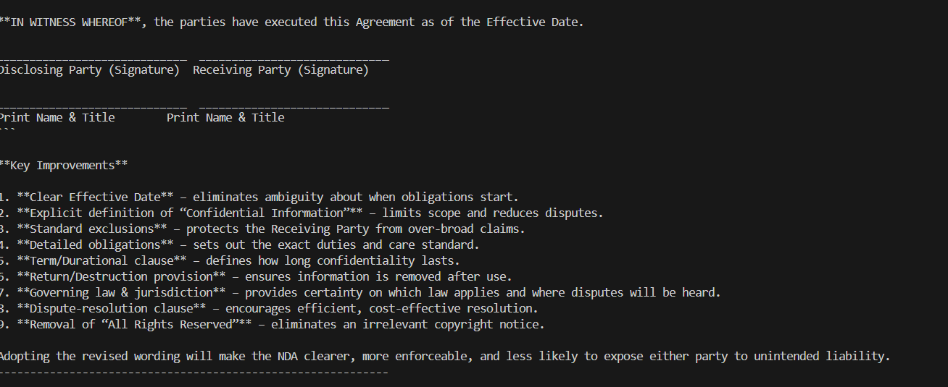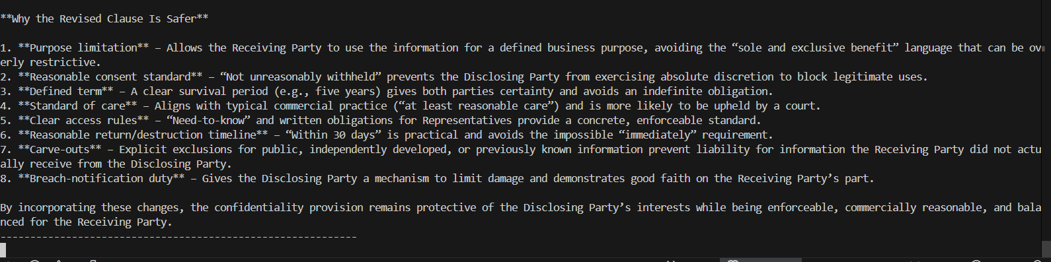

4. Key Achievements
- Implemented vector database for semantic search
- Built agent-based architecture
- Integrated LLM for intelligent suggestions
- Achieved end-to-end working pipeline

5. Conclusion
The system successfully demonstrates an intelligent legal document analysis pipeline combining NLP, vector search, and LLM capabilities.

