DAY – 2

Title - Skeleton Pipeline (Backend)
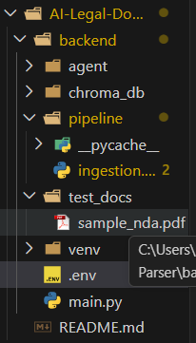
1. Objective
The objective of Day 2 is to implement a basic document ingestion pipeline capable of:
- Extracting text from PDF documents
- Segmenting the document into logical sections
- Demonstrating fallback to LLM-based parsing when rule-based methods fail
2. Approach
We designed a hybrid pipeline:
Step 1: PDF Text Extraction
- Tool: PyMuPDF (fitz)
- Extracts raw text from all pages of the NDA document
Step 2: Regex-Based Segmentation
- Identifies section headings using:
  - Numbered headings (e.g., 1. Definitions)
  - ALL CAPS headings
  - Section/Article formats
Step 3: LLM-Based Fallback
- If regex segmentation is insufficient:
  - Groq LLaMA model is used
  - Returns structured JSON of sections
3. System Flow
PDF → PyMuPDF Extraction → Regex Segmentation → LLM Fallback → Structured Output
4. Implementation Details
Technologies Used:
- Python
- PyMuPDF
- Regex (re module)
- OpenAI API (LLM fallback)

5. Output
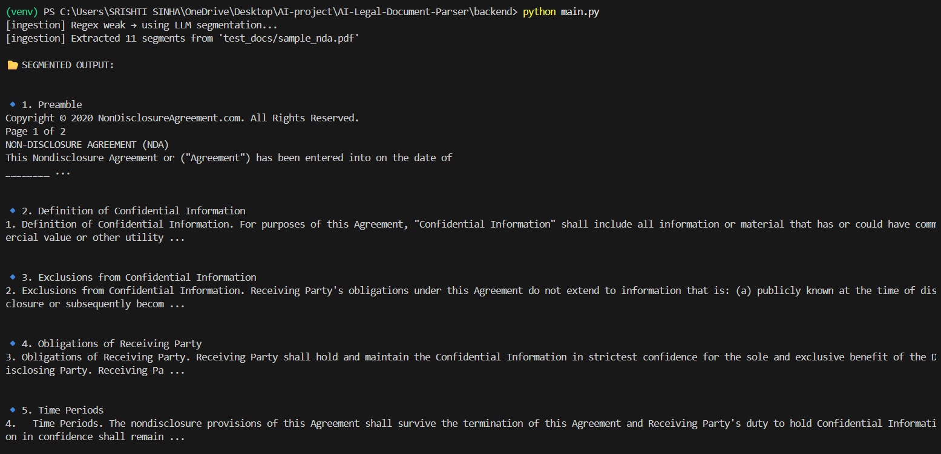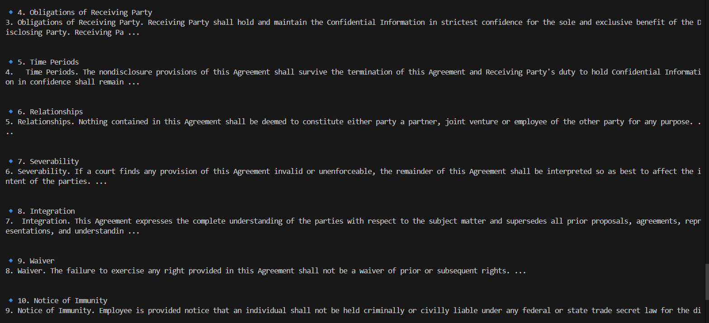
6. Key Achievements
- Successfully extracted text from PDF
- Segmented document into logical clauses
- Implemented hybrid parsing (regex + LLM)
7. Conclusion
The ingestion pipeline successfully demonstrates a scalable approach to legal document parsing by combining deterministic and AI-based methods.

