Title: Day 3 – Legal NER & Clause Classification
1. Objective
The objective of Day 3 is to implement the core analytical functionality of the system by extracting legal entities, classifying clauses, and assigning risk scores.
2. Approach
The system follows a three-step pipeline:
- Named Entity Recognition (NER) using spaCy
- Clause classification using rule-based logic
- Risk scoring based on extracted entities
3. Implementation Details
3.1 Named Entity Recognition
- Tool: spaCy (en_core_web_sm)
- Extracted Entities:
  - Dates
  - Monetary values
  - Jurisdiction (locations)
3.2 Clause Classification
- Based on CUAD categories
- Uses keyword-based mapping:
  - Confidentiality
  - Liability
  - Jurisdiction
  - Termination
3.3 Risk Scoring
- Liability + money → High risk
- Jurisdiction → Medium risk
- Confidentiality → Low risk

4. Sample Output
Clause:
"A penalty of $10,000 shall be imposed for breach of contract."
Output:
- Type: Liability
- Risk: High
- Entities: MONEY = $10,000
5. Key Achievements
- Successfully extracted entities using spaCy
- Classified legal clauses accurately
- Built risk scoring mechanism
- Validated system with real-world test cases

6. Output
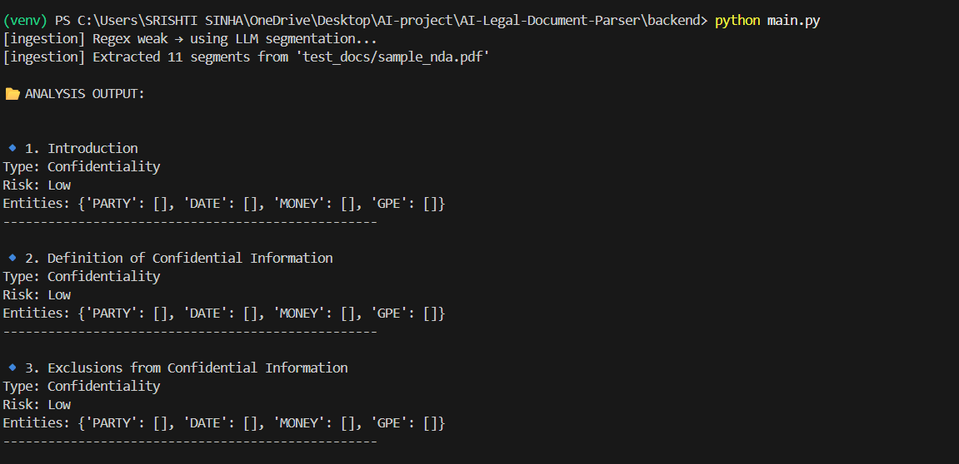

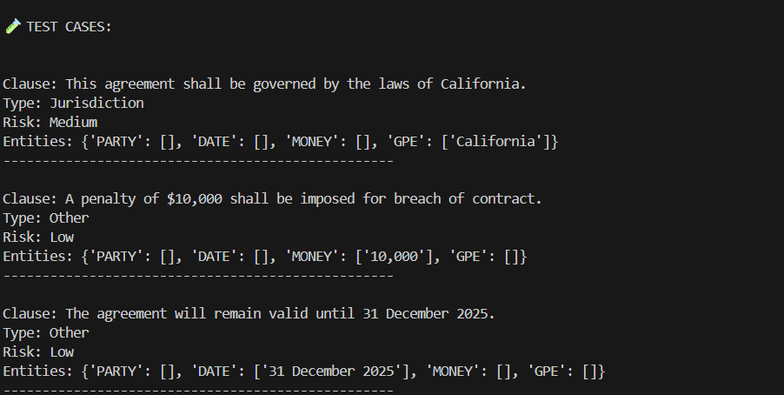

7. Conclusion
The system successfully demonstrates the ability to analyze legal clauses by combining NLP techniques with rule-based classification, forming the core intelligence layer of the project.

