Use Case and Design Specification View Edit Maps
Project – Property Rental Website

Author: Srishti Sureshkumar
Document Number: Use Case and Design Specification View Edit Maps V1.0
Document Version Number: Version V1.0 Last Modified: 3rd May 2020

Table of Contents

1. Name 2
1.1 Brief Description 2
1.2 Actor Description 2
1.3 Screen mock-up 2
2. Pre Conditions 2
3. Flow of Events 3
3.1 Basic Flow 3
4. Post Conditions 3
5. Sequence Diagram 3
6. Document Change History 3

Use Case Specification- sample

Name
Property Rental Website.

Brief Description
This use case describes the scenario where the user enters the site to sell/ rent/ buy a property.

Actor Description
Property Rental Site user

Screen mock-up

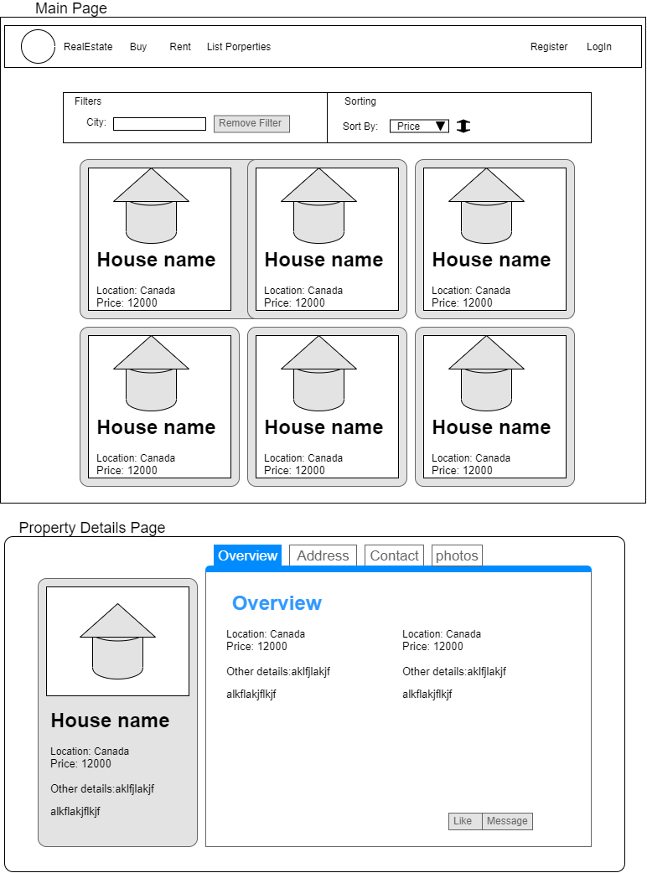

Pre Conditions
The user has opened the site on the web browser and the page is displayed to the user.

Flow of Events

Basic Flow
- The use case begins when the user enters to the main screen with ‘Buy’ screen as the default.
- The User can scroll through the properties listed on the screen and click on it if interested.
- The user can
  - register on to the site by clicking on ‘Register’ on the navigation bar if they are a new user
  - Can login with existing account.

- The user selects a particular property to view more details/contact information about the property by clicking on the popped up button on the property card.
- The system displays the details of that property.
- The user can
  - Go through the details about that property
  - Can view the images of the property (if available)
  - Can like or message the owner about his/her interest by clicking on the respective buttons.

- The user can upload a property for rent or sell (only for registered users)
  - By clicking on ‘List of properties’ in the navigation bar.
  - Then filling in the required details about the property in the displayed form.

Post Conditions
The SSIS maps for the selected module will be modified and persisted to the database for the current migration instance.

Sequence Diagram

Document Change History

Date | Author/Editor | Description of Change(s)
03/05/2020 | Srishti | Version 1.0
05/05/2020 | Srishti | Version 1.0 UI MockUp

