Customer Segmentation and Predictive Analytics
Assignment 7 | R Programming (ODD 2026-27)
K-Means and Hierarchical Clustering, PCA, and Supervised Prediction of High-Value Customers

Field | Details
Name | Srishti D Yadav
Roll Number | 23102C0014
Class | BE CMPN - C
Subject | R Programming (ODD 2026-27)
Dataset | UCI Online Retail - 541,909 transactions, Dec 2010 to Dec 2011
Environment | Python 3, Google Colab; pandas, scikit-learn, scipy, seaborn, Plotly
Customers analysed | 4,338 after cleaning
COs addressed | CO3, CO4, CO5, CO6
Note on language. The submission instructions for this laboratory specify Python in Google Colab, so the implementation is in Python rather than R.

Objective
An e-commerce company wants to understand its customers and improve its marketing decisions. Using historical online retail transaction data, this work identifies meaningful customer segments through unsupervised learning, and then builds supervised models to predict whether a customer belongs to the high-value segment. The end product is a set of segment profiles with targeted marketing recommendations attached to each.

Preprocessing
The raw file holds 541,909 transactions across eight attributes. Three problems had to be resolved before customer-level features could be built, and each required a decision rather than a default.
# | Step | Rows before | Rows after | Removed
1 | Remove cancellations (InvoiceNo starting with C) | 541,909 | 532,621 | 9,288
2 | Drop rows with no CustomerID | 532,621 | 397,924 | 134,697
3 | Remove invalid quantity or unit price | 397,924 | 397,884 | 40
4 | Remove duplicate rows | 397,884 | 392,692 | 5,192
The second step is by far the most consequential. 134,697 rows, 25.3% of the file, carry no customer identifier. These are guest checkouts, and because the entire analysis operates at customer level they cannot be attributed to anyone and must be removed. This is a real loss rather than a free operation: those transactions represent genuine revenue that is absent from every figure that follows, and any conclusion about total customer value understates the business by that amount.
Cancellations were removed because a return is not a purchase event. Retaining them would corrupt recency, since a customer's most recent activity could be a refund, and would corrupt frequency by counting a reversal as an interaction.
Final transactions : 392,692
Unique customers : 4,338
Date range : 2010-12-01 to 2011-12-09
Total revenue : 8,887,208.89

Customer-Level Feature Engineering
Transactions were aggregated to one row per customer using a snapshot date of 10 December 2011, one day after the last transaction, so that recency is never zero. The classical RFM triple was extended with four further features, because RFM alone cannot separate a customer who spends heavily across many small orders from one who spends the same in a single large order.
Feature | Definition | Purpose
Recency | Days since last purchase | How recently engaged
Frequency | Count of distinct invoices | How often they buy
Monetary | Total revenue | How much they are worth
TotalQuantity | Total items purchased | Volume, independent of price
UniqueProducts | Distinct StockCodes bought | Breadth of catalogue engagement
AvgOrderValue | Monetary / Frequency | Basket size per visit
PurchaseRate | Frequency / months of tenure | Rate, adjusted for how long they have been a customer
PurchaseRate exists because raw frequency penalises new customers. A customer who joined last month and bought twice is behaving very differently from one who bought twice across a full year, but Frequency records both as 2.

Outlier treatment and scaling
Every RFM variable is severely right-skewed. Most customers buy once and spend little, while a handful spend enormously, and K-Means minimises squared Euclidean distance, so without treatment a few extreme customers would dictate the entire cluster structure.
Feature | Skew before | Skew after log transform
Recency | 1.25 | -0.38
Frequency | 12.07 | 1.00
Monetary | 19.34 | 0.29
TotalQuantity | 20.38 | 0.02
UniqueProducts | 6.92 | -0.30
AvgOrderValue | 41.69 | 0.11
PurchaseRate | 7.27 | 1.16
The treatment was deliberately winsorising at the 1st and 99th percentiles rather than deleting outliers. This matters: the extreme spenders are precisely the high-value customers the second half of the assignment asks us to predict, so removing them as outliers would destroy the target before it could be modelled. Capping preserves the customer while limiting their leverage on the distance metric.
A log transform then compressed the remaining skew, reducing AvgOrderValue from 41.69 to 0.11 and Monetary from 19.34 to 0.29, so that clustering is driven by order-of-magnitude differences rather than by a few individuals. Standardisation was applied last, because K-Means is scale-sensitive and Monetary in pounds would otherwise dominate Recency in days purely through the size of its numbers.

Choosing the Number of Clusters
k | Inertia (WCSS) | % drop from previous k | Silhouette
2 | 18,008.3 | - | 0.3433
3 | 14,527.1 | 19.33 | 0.2477
4 | 12,734.1 | 12.34 | 0.2406
5 | 11,193.7 | 12.10 | 0.2264
6 | 10,236.0 | 8.56 | 0.2156
7 | 9,460.7 | 7.57 | 0.2100
8 | 8,829.1 | 6.68 | 0.2181
9 | 8,344.6 | 5.49 | 0.2083
10 | 7,988.4 | 4.27 | 0.1979
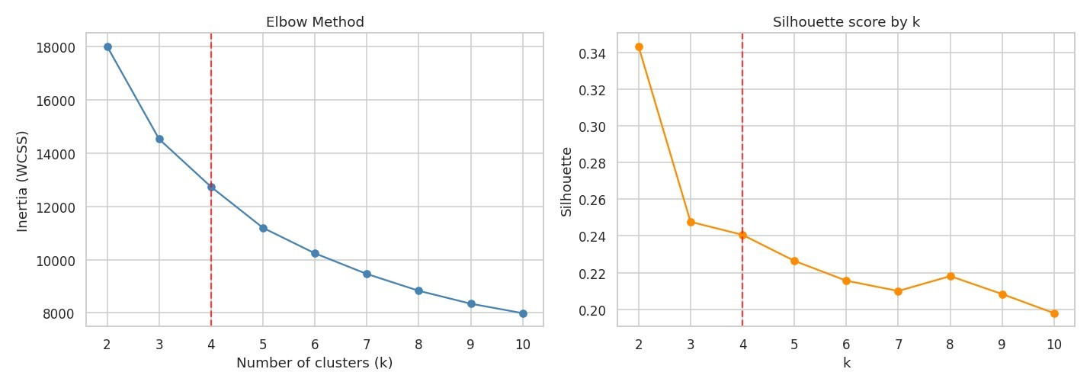
Figure 1. Elbow curve and silhouette score across k. The dashed line marks the chosen k = 4.

Why k = 4 and not k = 2
The two criteria disagree, and the disagreement has to be resolved by argument rather than by taking whichever number is largest. The silhouette peaks at k = 2 with 0.3433 and falls thereafter. Taken literally that would mean splitting 4,338 customers into two groups, which is statistically the cleanest partition and commercially close to useless: it distinguishes only good customers from bad ones, which is something the business already knows.
The inertia curve tells a different story. The percentage drop is 19.33% moving to k = 3 and 12.34% moving to k = 4, after which it falls to 8.56% and continues declining. The marginal return from each additional cluster therefore flattens around k = 4, which is the definition of the elbow.
k = 4 was chosen because it sits at that elbow, retains a silhouette of 0.2406 that is essentially identical to k = 3 at 0.2477, and produces four segments that map onto recognisable commercial categories. A silhouette in the 0.24 range indicates moderate rather than strong separation, which is honest for customer data: real customer behaviour lies on a continuum, and any partition of it imposes boundaries that the underlying data does not sharply provide.

K-Means and Hierarchical Clustering
Agglomerative clustering with Ward linkage was run for comparison. Ward was chosen because it minimises the increase in within-cluster variance at each merge, which is the same objective K-Means pursues, making the two methods directly comparable rather than merely both being clustering algorithms.
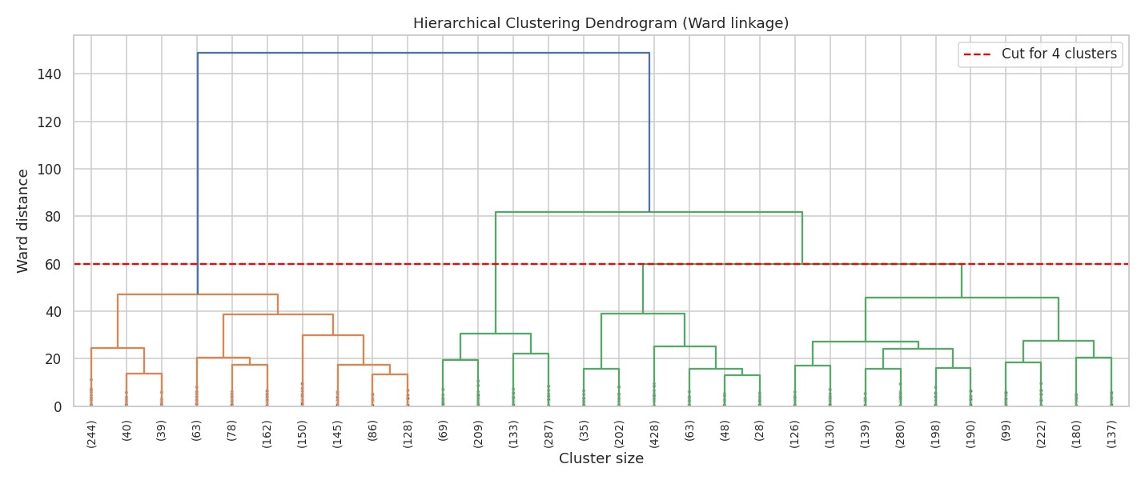
Figure 2. Ward dendrogram, last 30 merges. The red line marks the cut producing four clusters.
Method | Silhouette | Cluster sizes
K-Means | 0.2406 | 966 / 1,243 / 1,225 / 904
Hierarchical (Ward) | 0.1794 | 1,135 / 698 / 804 / 1,701
K-Means produced both the better silhouette, 0.2406 against 0.1794, and the more balanced partition. The hierarchical solution places 1,701 of 4,338 customers, 39%, into a single cluster, which limits its usefulness for targeting: a segment containing two fifths of the base is not a segment in any actionable sense.
The crosstabulation below shows where the methods agree. Cluster 3 under K-Means maps almost entirely onto hierarchical cluster 0, with 868 of 904 customers, so the high-value group is identified consistently by both. Agreement is weaker among the middle clusters, which is expected: those customers sit near the boundaries where the two algorithms' differing merge criteria produce different splits.
K-Means \ Hierarchical | H0 | H1 | H2 | H3
Cluster 0 | 115 | 56 | 24 | 771
Cluster 1 | 0 | 642 | 423 | 178
Cluster 2 | 152 | 0 | 357 | 716
Cluster 3 | 868 | 0 | 0 | 36
Per-customer silhouette analysis showed 136 customers, 3.1% of the base, with negative values, meaning they would sit better in a different cluster. That is a low proportion and indicates the K-Means partition is stable, with disagreement confined to a small boundary population.

Principal Component Analysis
Component | Explained variance | Cumulative
PC1 | 62.07 % | 62.07 %
PC2 | 18.41 % | 80.48 %
PC3 | 8.28 % | 88.76 %
PC4 | 5.78 % | 94.54 %
PC5 to PC7 | 5.46 % | 100.00 %
Two components capture 80.5% of the variance in seven features, so the 2D projection below is a fair representation rather than a heavy simplification.
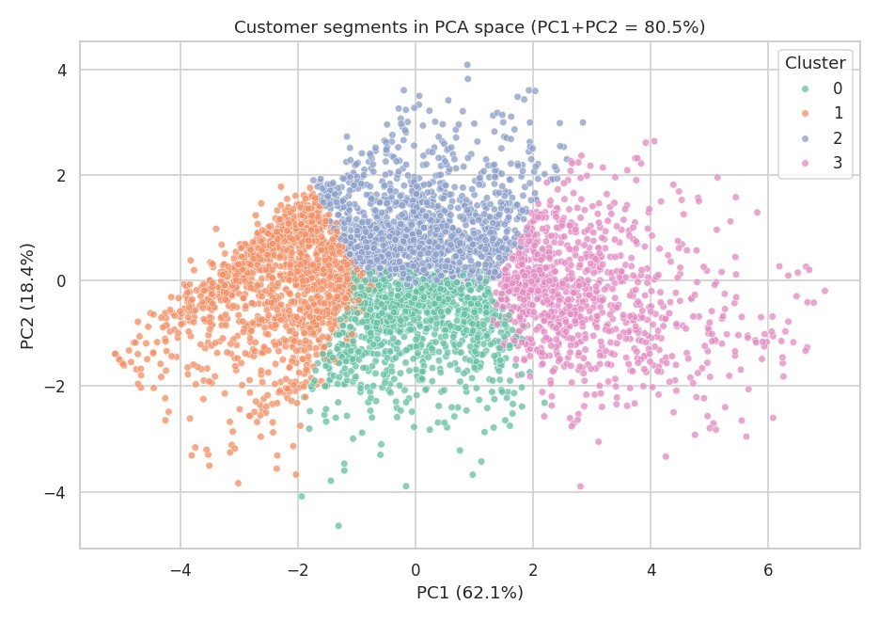
Figure 3. Customer segments projected onto the first two principal components.

What the components mean
A principal component is only useful if it can be interpreted, and the loadings make that possible.
Feature | PC1 | PC2 | PC3
Recency | -0.330 | 0.473 | -0.373
Frequency | 0.409 | -0.204 | -0.479
Monetary | 0.452 | 0.222 | -0.041
TotalQuantity | 0.443 | 0.206 | -0.068
UniqueProducts | 0.379 | 0.106 | -0.410
AvgOrderValue | 0.271 | 0.623 | 0.547
PurchaseRate | 0.325 | -0.493 | 0.396
PC1 loads positively on Monetary, TotalQuantity, Frequency and UniqueProducts, and negatively on Recency. It is therefore a single overall customer value axis: high PC1 means a customer who spends more, buys more often, buys more variety and bought recently. That one axis alone explains 62% of all variation, which is itself a finding: most of what distinguishes these customers is simply how valuable they are, not what kind of buyer they are.
PC2 separates two different routes to the same spend. It loads strongly positive on AvgOrderValue at 0.623 and Recency at 0.473, and strongly negative on PurchaseRate at -0.493. High PC2 describes a customer who buys rarely but in large baskets; low PC2 describes one who buys frequently in small amounts. This is exactly the distinction that RFM alone cannot make, and it justifies including the extra engineered features.

Cluster Profiling
Cluster | Recency | Freq | Monetary | AvgOrder | Customers | % base | % revenue
0 | 25.0 | 2.96 | 626 | 236 | 966 | 22.3 | 6.8
1 | 182.1 | 1.38 | 237 | 186 | 1,243 | 28.7 | 3.3
2 | 109.1 | 2.50 | 1,377 | 656 | 1,225 | 28.2 | 19.0
3 | 19.2 | 12.05 | 6,970 | 606 | 904 | 20.8 | 70.9
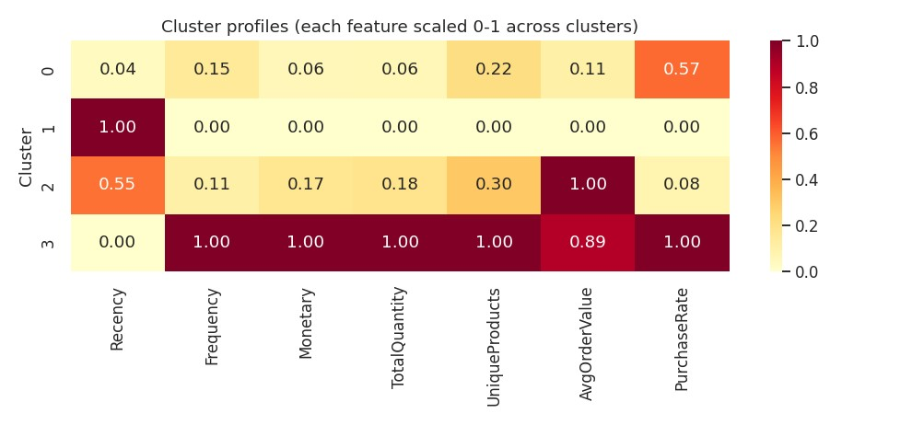
Figure 4. Cluster profiles with each feature scaled 0 to 1 across clusters.

Segment interpretation

Cluster 3 - Champions (20.8% of customers, 70.9% of revenue)
The defining finding of the entire analysis. 904 customers, one fifth of the base, generate 70.9% of all revenue. They buy 12.05 times on average against a base median far below that, spend 6,970 each, and bought 19 days ago. Their average order value of 606 is close to Cluster 2's 656, so what separates them is not basket size but frequency: they return four to five times as often.

Cluster 2 - Big Spenders, Infrequent (28.2% of customers, 19.0% of revenue)
The highest average order value in the dataset at 656, but only 2.50 purchases and a recency of 109 days. These customers spend substantially when they buy and then disappear for three to four months. They are the clearest commercial opportunity, because the value per transaction is already proven and only the frequency is missing.

Cluster 0 - Recent, Low Value (22.3% of customers, 6.8% of revenue)
Recency of 25 days is nearly as good as the Champions, but frequency is 2.96 and spend is 626. These are engaged customers who have not yet developed into high-value ones. Their good recency means the relationship is live and the window for development is open.

Cluster 1 - Lapsed (28.7% of customers, 3.3% of revenue)
The largest segment by headcount and the smallest by revenue. Recency of 182 days means the average member has not purchased in six months, frequency is 1.38, and spend is 237. Most bought once and never returned.

Supervised Prediction of High-Value Customers
Cluster 3 has the highest mean monetary value and was therefore designated the high-value segment: 904 customers, 20.8% of the base, holding 70.9% of revenue. Two classifiers were trained to predict membership from the seven engineered features, with a 75/25 stratified split preserving the class ratio in both halves.

An important caveat on interpretation
The target label was derived from the clustering, using the same seven features the classifiers then receive. The models are therefore learning to reproduce a boundary that K-Means had already drawn in that same feature space. Strong metrics here confirm that the high-value segment is cleanly separable; they do not demonstrate predictive power over anything external, and it would be wrong to present the accuracy figures below as evidence that the model can forecast customer value. A genuine predictive test would train on one time period and predict who becomes high-value in the next, which this design does not do.
The classes are also imbalanced by construction at roughly one to four, so accuracy alone would be misleading: a model predicting Standard for everyone would score 79.2%. Both models were fitted with balanced class weights, and precision, recall, F1 and ROC-AUC are all reported.

Results
Model | Accuracy | Precision | Recall | F1-Score | ROC-AUC
Random Forest | 0.9899 | 0.9909 | 0.9602 | 0.9753 | 0.9995
SVM (RBF) | 0.9641 | 0.8582 | 0.9912 | 0.9199 | 0.9962
Stratified 5-fold cross-validation confirmed the single-split result rather than relying on it: Random Forest scored 0.9584 F1 with a standard deviation of 0.0116, and SVM 0.9218 with 0.0129. The narrow spread on both indicates the split was not a lucky one.
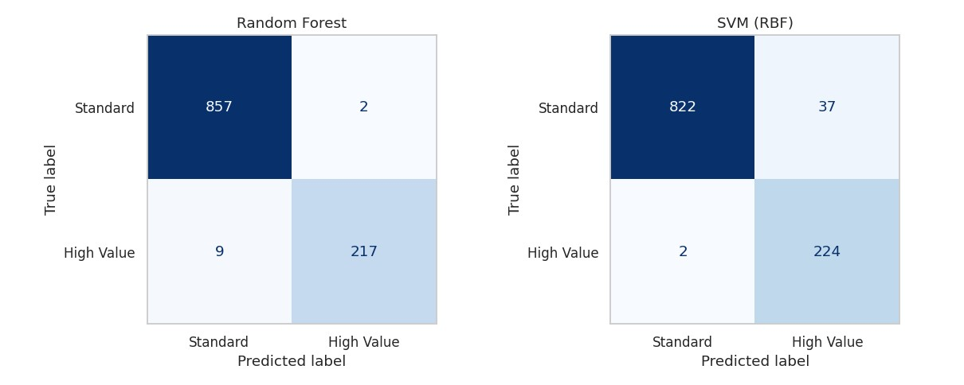
Figure 5. Confusion matrices on the 1,085-customer test set.

Reading the errors rather than the headline
The aggregate metrics favour Random Forest, but the error profiles differ in a way that matters commercially and that the headline numbers conceal.
Model | True neg | False pos | False neg | True pos
Random Forest | 857 | 2 | 9 | 217
SVM (RBF) | 822 | 37 | 2 | 224

Random Forest misses 9 high-value customers and wrongly flags 2. SVM misses only 2 but wrongly flags 37. These two error types are not equally expensive. A false negative is a customer worth roughly 6,970 who receives no retention effort, and if they lapse the loss is that full amount. A false positive is a standard customer who receives premium treatment they did not earn, costing the price of a discount or a loyalty perk.
On that asymmetry the SVM's error profile is arguably preferable despite its lower accuracy and F1: it misses 7 fewer high-value customers at the cost of 35 unnecessary perks. Whether that trade is worth making depends on the cost of the retention offer against the expected value of a retained Champion, which is a business decision rather than a modelling one. The relevant point is that F1 alone does not settle it, and selecting a model on F1 without examining the confusion matrix would have hidden the question entirely.
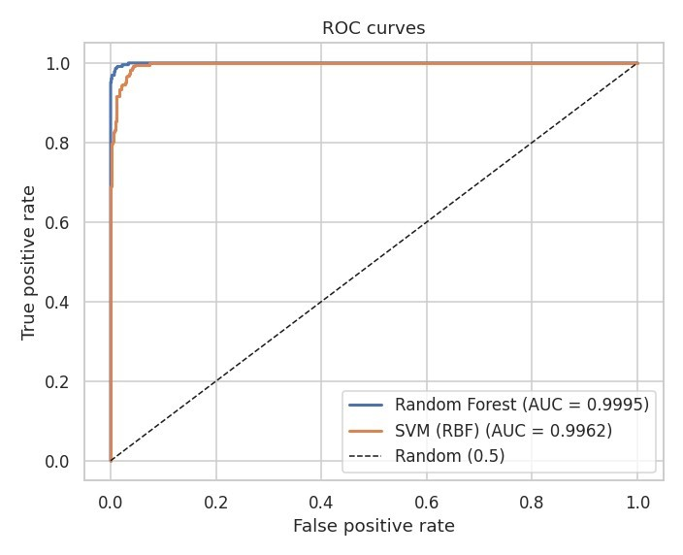
Figure 6. ROC curves. Both models separate the classes almost perfectly.
ROC-AUC of 0.9995 and 0.9962 confirms near-perfect separability, which is the expected consequence of the circularity described in section 8.1 rather than a surprising result.

Feature Importance
Feature | Gini importance | Permutation importance
Monetary | 0.2962 | 0.4583
Frequency | 0.2157 | 0.2044
TotalQuantity | 0.1813 | 0.1260
PurchaseRate | 0.1347 | 0.1305
UniqueProducts | 0.0846 | 0.0665
Recency | 0.0650 | 0.0856
AvgOrderValue | 0.0226 | -0.0001
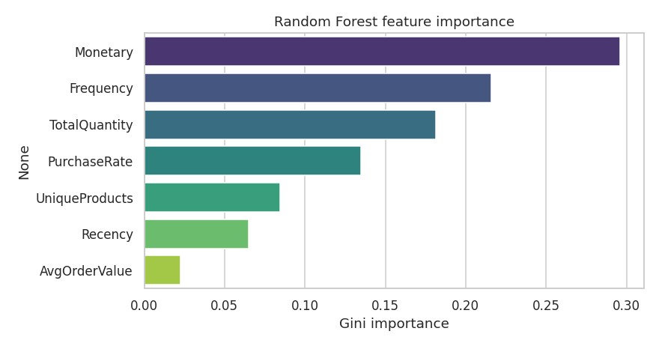
Figure 7. Random Forest Gini feature importance.
Both measures are reported because Gini importance is computed on training data and is biased toward features with many distinct values, while permutation importance measures the actual drop in F1 when a feature is shuffled on held-out data. The two agree on the ordering of the top four, which is reassuring.
Monetary dominates on both, and under permutation it is far more dominant at 0.4583 than Gini suggests at 0.2962. That is unsurprising given the target was defined by the cluster with the highest mean monetary value, and it is another symptom of the circularity noted earlier.
AvgOrderValue is the informative case. Its permutation importance is -0.0001, effectively zero and marginally negative, meaning shuffling it does not degrade the model at all. This does not make the feature useless in general: section 6.1 showed it as the dominant loading on PC2, separating frequent small buyers from occasional large ones. What it means is that this particular distinction is irrelevant to whether a customer is high-value, because Cluster 2 and Cluster 3 have almost identical average order values at 656 and 606. Basket size distinguishes buying styles; it does not distinguish the valuable from the rest.

Marketing Recommendations

Cluster 3, Champions - retain at almost any cost
904 customers carry 70.9% of revenue, so the risk concentration is extreme: losing a tenth of this segment costs more than losing the whole of Clusters 0 and 1 combined. Priority is retention, not acquisition. Dedicated account contact, early access to new stock, and a loyalty tier with meaningful benefits. Their recency of 19 days means they are currently active, so the correct posture is protective rather than remedial, and any lengthening of that recency should trigger immediate intervention.

Cluster 2, Big Spenders - the clearest growth opportunity
These 1,225 customers already spend 656 per order, nearly matching the Champions' 606, but buy only 2.50 times against 12.05. The gap is entirely frequency. Since willingness to spend is already proven, the intervention is about occasions rather than persuasion: replenishment reminders timed to their purchase cycle, seasonal campaigns, and subscription or standing-order options. Converting even a fraction of this segment toward Champion behaviour is the single highest-return action available, because the revenue per successful conversion is large and the segment is sizeable.

Cluster 0, Recent Low Value - develop while the window is open
Recency of 25 days is nearly as strong as the Champions', so these 966 customers are engaged; they simply have not developed yet at 2.96 purchases and 626 spend. Onboarding sequences, cross-category recommendations and a second or third purchase incentive. The step from occasional to habitual is where this segment's value lies, and their good recency means that step is currently achievable.

Cluster 1, Lapsed - reactivate selectively
1,243 customers, the largest segment by headcount, generating 3.3% of revenue. At 182 days recency and 1.38 purchases, most bought once and left. Win-back offers and a short survey to establish why. Crucially, spend here should be capped and measured, because the expected return per customer is low: this segment is worth a cheap automated campaign, not the discretionary budget that belongs with Clusters 2 and 3.

Conclusion
Four customer segments were identified from 4,338 customers using seven engineered features. K-Means at k = 4 outperformed Ward hierarchical clustering on both silhouette, 0.2406 against 0.1794, and balance, and the two methods agreed strongly on the high-value group, assigning 868 of 904 Champions identically. Two principal components captured 80.5% of the variance, with PC1 interpretable as an overall value axis and PC2 as a separation between frequent small buyers and occasional large ones.
The central finding is the concentration of revenue: 20.8% of customers account for 70.9% of turnover. The second, less obvious finding is that frequency rather than basket size is what separates the top segment. Clusters 2 and 3 have almost identical average order values, 656 and 606, but differ nearly fivefold in purchase frequency, 2.50 against 12.05. That points the marketing strategy squarely at purchase occasions rather than at upselling, and it is a conclusion that would have been invisible from Monetary alone.
Both classifiers separated the high-value segment almost perfectly, with Random Forest reaching 0.9753 F1 and 0.9995 ROC-AUC against SVM's 0.9199 and 0.9962. Random Forest is the better choice overall, not only for the higher scores but because its feature importances give marketing teams a usable explanation of why a customer was flagged, which the SVM cannot provide.

Limitations
The supervised step is circular. The high-value label came from the clustering, using the same features the models then received, so the near-perfect metrics measure separability of a boundary already drawn rather than genuine predictive skill. This is stated plainly because presenting 0.99 accuracy as a forecasting result would be misleading. A valid predictive design would train on one period and test against who becomes high-value in the next.
Removing the 134,697 rows without a CustomerID discarded 25.3% of all transactions. Those guest purchases carry real revenue that is absent from every figure in this report, and guest buying behaviour may differ systematically from registered behaviour rather than being a random sample of it.
The silhouette of 0.2406 indicates moderate rather than strong cluster separation. Customer behaviour is continuous, so the four segments are a useful imposed structure rather than naturally occurring groups with clean boundaries, and 136 customers already sit closer to a cluster other than their assigned one. Finally, the data covers a single year from one UK-based retailer whose customer base includes many wholesalers, so the segment shapes are specific to that market and period and should not be assumed to transfer.

