MINOR PROJECT REPORT
EVENT PLANNING\nBUDGET AND PROPOSAL
A spreadsheet-based planning and cost analysis project

STUDENT DETAILS | INFORMATION
Student Name | Srishti Shubham
UID | 26BCD10379
Section | 26BCD6B
Subject | Computing Aptitude
Project Event | Campus Carnival 2026
Submission Date | 2 November 2026

Submitted by\nSrishti Shubham\nUID: 26BCD10379\nSection: 26BCD6B
Submitted to\nFaculty name: Not specified
CHANDIGARH UNIVERSITY

1. Abstract
This project presents an event planning budget and proposal for a fictional college cultural event named Campus Carnival 2026. The proposed event is designed for approximately 300 students, faculty members, and invited guests. The plan covers the event purpose, target audience, programme flow, venue and logistics, technical arrangements, catering, decoration, entertainment, marketing, media coverage, safety, and operations.
Microsoft Excel is used as the main planning tool to organize item-wise costs, calculate planned totals, add a contingency reserve, estimate income, compare the funding requirement, track vendor quotations, schedule payments, and monitor milestones. A dashboard and charts summarize the planned budget by category. Microsoft Word is used for documentation, while Microsoft PowerPoint is used to communicate the proposal and its key findings.
The illustrative direct cost subtotal is ₹133,900. A 10% contingency reserve of ₹13,390 brings the total planned budget to ₹147,290. Expected income from ticket sales, a sample college contribution, sponsorship, and stall fees is ₹125,000, leaving an estimated funding gap of ₹22,290. All amounts and arrangements are fictional academic estimates and are not confirmed quotations or approvals.

Event Proposal Overview

Purpose
The purpose of Campus Carnival 2026 is to provide a planned campus gathering where students, faculty members, and invited guests can participate in cultural performances, games, food stalls, and shared activities. The proposal brings the programme, venue requirements, resources, costs, and funding plan together before any event commitment is made.

Target Audience
The proposed audience is approximately 300 people, including college students, faculty members, and invited guests. This number is a planning estimate and should be updated after registration or permission is confirmed.

Sample Event Agenda
Time | Activity | Coordination Requirement
9:00–9:30 AM | Registration and welcome | Registration desk, name tags and volunteers
9:30–10:00 AM | Opening and introduction | Host, sound system and stage
10:00 AM–12:00 PM | Cultural performances | Stage, microphones, lighting and programme team
12:00–1:00 PM | Food and activity stalls | Catering area, stall coordination and waste bins
1:00–2:30 PM | Games and audience activities | Game materials, prizes and volunteers
2:30–3:30 PM | Guest performance and closing | Performer, AV support and announcements
3:30–4:00 PM | Feedback and dispersal | Feedback collection and orderly exit

Venue and Logistics
The sample venue is the college auditorium and adjoining campus area, subject to approval and availability. The logistics plan includes seating and tables, registration materials, stage and audio-visual equipment, lighting, catering and drinking water, decoration, photography, transport of materials, first-aid supplies, volunteer coordination, cleaning, and waste management. A technical rehearsal and safety check are planned for the day before the event.

Planning Status
This is a draft academic proposal. The proposed date, venue, agenda, audience size, vendor estimates, income sources, and permissions must be confirmed by the institution and event team before implementation.

2. Demo and Code

Demonstration
The demonstration is provided in the accompanying Excel workbook. The workbook contains linked worksheets: Dashboard, Event Setup, Detailed Budget, Income Plan, Vendor Tracker, Payment Schedule, Event Timeline, and Read Me.
The Event Setup sheet stores the sample event assumptions. Detailed Budget records each cost item with quantity, unit, planned unit cost, planned total, actual cost, variance, and payment status. Income Plan estimates funding sources. Vendor Tracker compares sample quotations, Payment Schedule records payment milestones, and Event Timeline lists the planning tasks and owners. The Dashboard summarizes the figures and displays category charts.

Excel Formulas Used
Calculation | Formula / Logic | Purpose
Line-item total | =Quantity × Planned Unit Cost | Calculates each budget item.
Direct cost subtotal | =SUM(Planned Total range) | Adds all direct event expenses.
Contingency | =Direct Cost Subtotal × 10% | Provides a reserve for unexpected costs.
Total planned budget | =Subtotal + Contingency | Shows the overall estimated cost.
Expected income | =SUM(Expected Amount range) | Adds planned funding sources.
Funding gap | =Total Planned Budget − Expected Income | Shows the additional amount to be funded.
Category total | =SUMIF(Category range, Selected Category, Planned Total range) | Summarizes cost by category.
Lowest vendor quote | =MIN(Quote 1:Quote 3) | Identifies the lowest sample quotation.
The formulas are designed to update when quantities, unit costs, or expected income values are changed. The workbook is a planning model; actual costs and payments should be entered only when verified information becomes available.

3. Project Objectives
The main objective of the project is to prepare a structured and realistic-looking event proposal supported by a detailed, formula-driven budget in Microsoft Excel.
- Define the event concept, purpose, target audience, proposed date, and venue.
- Prepare an item-wise budget for venue, technical equipment, catering, decoration, entertainment, marketing, media, logistics, safety, and operations.
- Calculate quantities, unit costs, line totals, direct cost subtotal, contingency, and total planned budget.
- Estimate income from ticket sales, institutional contribution, sponsorship, and stall participation fees.
- Compare expected income with planned expenditure to identify the funding gap or surplus.
- Compare sample vendor quotations and maintain a record of payment milestones.
- Prepare a timeline with key tasks, target dates, responsible teams, and status.
- Present budget distribution and planning milestones through charts and a clear dashboard.
- Communicate the proposal, assumptions, limitations, and recommendations in a professional format.

4. Technologies Implemented
The project uses common productivity applications to create an integrated planning, calculation, and presentation workflow.

4.1 Microsoft Excel
Microsoft Excel is the primary tool used to build the event budget workbook. It stores the planning assumptions and item-wise costs, calculates totals using formulas, and summarizes the results in tables and charts.
- Data entry: records event details, categories, quantities, units, planned costs, actual costs, and income sources.
- Formulas: multiplication, SUM, SUMIF, MIN, and IF-based calculations support budget analysis.
- Cell references: connect the dashboard to the budget, setup, and income worksheets.
- Conditional formatting: highlights variances and helps identify budget items requiring attention.
- Charts: doughnut and bar charts show category-wise budget distribution and comparison.
- Data validation: dropdown lists support consistent payment and task status entries.
- Number formatting: displays amounts in Indian Rupees and dates in a readable format.

4.2 Microsoft Word
Microsoft Word is used to prepare the project report. It organizes the abstract, objectives, formulas, technologies, features, development process, findings, recommendations, and conclusion into a formal document.

4.3 Microsoft PowerPoint
Microsoft PowerPoint is used to present the event concept, planning requirements, budget summary, workflow, dashboard, timeline, recommendations, and conclusion through concise slides.

4.4 Sample Dataset
The project uses fictional sample estimates for a one-day college event with 300 expected attendees. The amounts are illustrative and do not represent actual supplier quotations, confirmed bookings, approved sponsorship, or a real event.

5. Project Features

5.1 Event Setup
The Event Setup worksheet records the event name, type, date, venue, expected attendance, ticket price, contingency rate, budget owner, and proposal status. These assumptions can be edited to model a different event.

5.2 Detailed Expense Tracking
The Detailed Budget worksheet divides expenditure into categories and records each item with its description, quantity, unit, planned unit cost, planned total, actual cost, variance, and payment status.

5.3 Automatic Budget Calculation
Each planned line total is calculated by multiplying quantity by unit cost. Excel then adds the direct costs, calculates a 10% contingency reserve, and displays the total planned budget.

5.4 Income and Funding Plan
The Income Plan estimates ticket sales, institutional contribution, sponsorship, and stall participation fees. The expected amounts are calculated from quantity and rate.

5.5 Funding Gap Analysis
The dashboard compares the total planned budget with expected income. A positive gap indicates that additional funding is required; a surplus indicates that expected income exceeds planned costs.

5.6 Vendor Quotation Comparison
The Vendor Tracker stores up to three sample quotations for selected services and calculates the lowest quote. Supplier details remain placeholders until real vendors are contacted.

5.7 Payment Schedule
The Payment Schedule records payment milestones, due dates, amounts due, amounts paid, outstanding balances, and payment status.

5.8 Event Timeline
The Event Timeline lists planning milestones, target dates, responsible teams, priorities, and status. This helps organize work before and after the event.

5.9 Visual Dashboard
The Dashboard displays the direct subtotal, contingency, total planned budget, expected income, funding gap, expected attendees, and estimated cost per attendee. Charts summarize category-wise costs.

5.10 Editable and Accessible Design
The workbook uses separate worksheets, clear headings, formatted tables, dropdowns, formulas, and charts. Sample inputs can be changed to update the planning calculations.

6. Development Process

6.1 Planning and Requirement Identification
The first step was to select a fictional college cultural event and identify the main planning requirements: event purpose, audience, programme, venue, equipment, catering, promotion, safety, and cost control.

6.2 Defining the Event Concept
Campus Carnival 2026 was selected as a one-day campus event with performances, games, food, and activity stalls. The sample plan assumes 300 attendees and a proposed date of 12 December 2026.

6.3 Preparing the Budget Dataset
A sample list of expense items was created and grouped into venue, technical, catering, decoration, entertainment, marketing, media, logistics, safety, and operations. Each item was assigned a quantity and illustrative unit cost.

6.4 Creating the Detailed Budget
The Detailed Budget worksheet was prepared to calculate line totals and direct costs. A 10% contingency reserve was added to account for unexpected expenses during event preparation.

6.5 Estimating Income
Potential funding sources were added, including ticket sales, a sample college contribution, sponsorship, and stall participation fees. These amounts are estimates and require confirmation.

6.6 Developing Supporting Trackers
Vendor quotation, payment schedule, and event timeline worksheets were added to organize procurement comparisons, payment milestones, responsibilities, and due dates.

6.7 Building the Dashboard and Charts
The Dashboard worksheet was linked to the other sheets. A doughnut chart and a bar chart were included to make category-wise budget distribution easier to interpret.

6.8 Testing and Verification
The calculations were reviewed using the sample quantities and unit costs. The direct cost subtotal, contingency, total budget, expected income, and funding gap were cross-checked.

6.9 Preparing the Report and Presentation
The report documents the purpose, formulas, objectives, tools, features, process, findings, and limitations. The presentation summarizes the proposal for a classroom demonstration.

7. Key Findings
The sample workbook produces the following estimates for Campus Carnival 2026:
Budget Indicator | Illustrative Result
Expected attendees | 300
Direct cost subtotal | ₹133,900
Contingency reserve (10%) | ₹13,390
Total planned budget | ₹147,290
Expected income | ₹125,000
Estimated funding gap | ₹22,290
Estimated cost per attendee | ₹490.97
The largest expense category is Catering at ₹49,300, because the sample estimate includes snacks and beverages for 300 attendees along with serving staff. Venue and Technical costs are also important parts of the proposed budget.
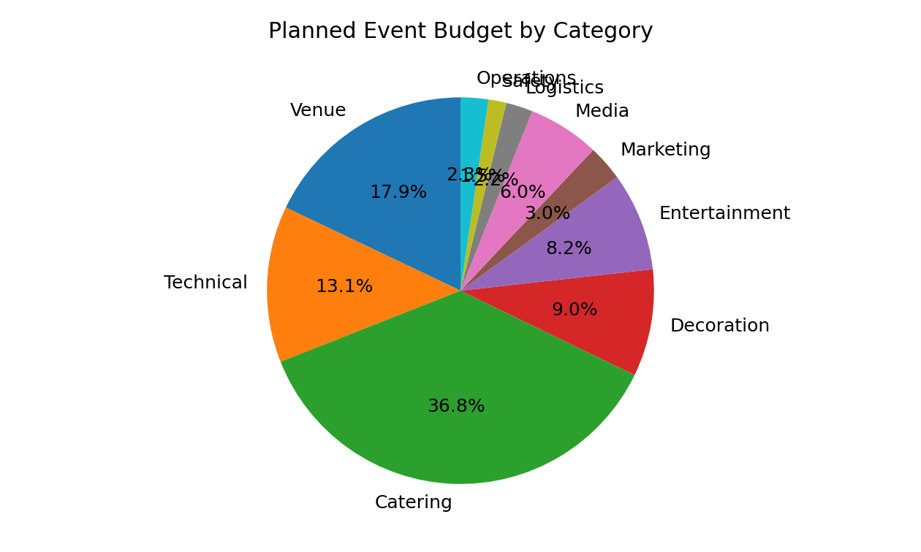
Figure 1: Planned event budget distribution by category.

7. Key Findings (continued)
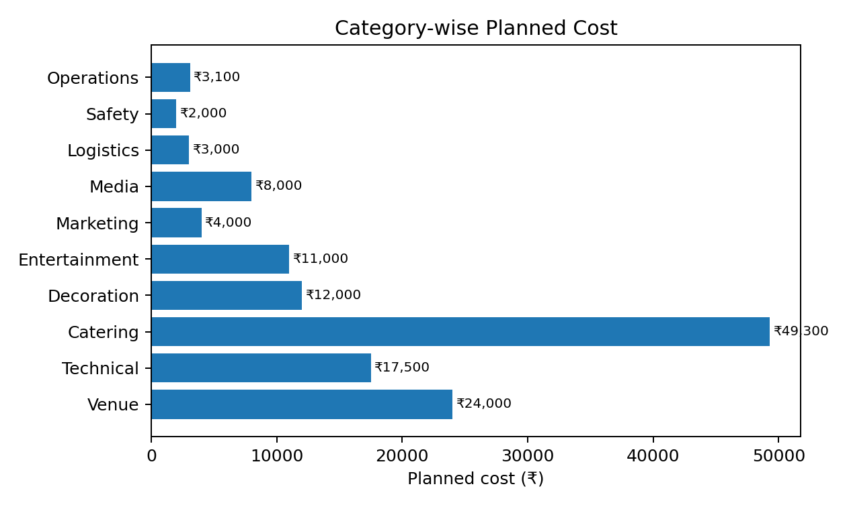
Figure 2: Comparison of planned cost across event categories.
The sample funding plan estimates ₹75,000 from ticket sales, ₹20,000 as a possible institutional contribution, ₹20,000 from two sample sponsors, and ₹10,000 from five activity stalls. These amounts total ₹1,25,000. Compared with the total planned budget of ₹1,47,290, the proposal has an estimated funding gap of ₹22,290.
The vendor tracker and payment schedule provide a framework for comparing supplier offers and tracking payments. Since the vendor names, quotations, and payment milestones are illustrative, they should be replaced with verified details before the proposal is used operationally.

8. Recommendations
- Obtain written approval for the event date, venue, audience size, and programme before making commitments.
- Collect at least three comparable quotations for major services such as catering, venue, sound, lighting, and decoration.
- Confirm the number of attendees before finalizing food, seating, registration materials, and other per-person costs.
- Maintain the contingency reserve and obtain approval before using it.
- Secure sponsorship and institutional contributions in writing instead of treating estimated income as confirmed funding.
- Use a payment schedule with clear milestones, due dates, receipts, and outstanding balances.
- Assign a responsible team member to every task and review the event timeline regularly.
- Prepare safety arrangements, first-aid support, crowd management, and an emergency contact plan.
- After the event, compare actual costs with the planned budget and document lessons for future events.

9. Conclusion
The Event Planning Budget and Proposal project demonstrates how Microsoft Excel can support the planning of a college event through structured data entry, formulas, budget comparisons, vendor tracking, payment scheduling, and data visualization. The workbook organizes the major requirements of a sample campus event and presents the estimated costs and funding sources in a clear format.
For the fictional Campus Carnival 2026, the direct cost subtotal is ₹133,900. After adding a 10% contingency reserve, the total planned budget becomes ₹147,290. The expected income is ₹125,000, resulting in an estimated funding gap of ₹22,290. These figures help demonstrate how a planner can identify financial requirements before an event is approved.
The project also shows the importance of planning beyond the budget itself. A successful event requires a clear programme, suitable venue, reliable suppliers, promotion, logistics, safety arrangements, payment control, and timely coordination among teams.
All event details and financial values in this project are fictional and intended for academic demonstration. The workbook does not confirm actual vendor availability, bookings, approvals, or sponsorship. In conclusion, the project provides a structured starting point for preparing, monitoring, and presenting an event proposal.

Appendix A: Budget Calculation Summary
Category | Planned Cost (₹)
Venue | ₹24,000
Technical | ₹17,500
Catering | ₹49,300
Decoration | ₹12,000
Entertainment | ₹11,000
Marketing | ₹4,000
Media | ₹8,000
Logistics | ₹3,000
Safety | ₹2,000
Operations | ₹3,100
Direct cost subtotal | ₹133,900
Contingency (10%) | ₹13,390
Total planned budget | ₹147,290

Appendix B: Core Formula Definitions
Term | Formula / Meaning
Line-item total | Quantity × Planned Unit Cost
Direct cost subtotal | Sum of all planned line-item totals
Contingency reserve | Direct cost subtotal × 10%
Total planned budget | Direct cost subtotal + contingency reserve
Expected income | Sum of all expected funding sources
Funding gap | Total planned budget − expected income
Estimated cost per attendee | Total planned budget ÷ expected attendees
Lowest quotation | Minimum of the three quotation values

Appendix C: Assumptions and Limitations
- The event is fictional and planned as a one-day campus cultural event.
- The expected attendance is 300 people and the ticket price is ₹250.
- All expense amounts, income sources, vendor names, quotations, and payment milestones are illustrative.
- No actual venue booking, supplier selection, sponsorship, or institutional approval is confirmed.
- Real event use requires verified quotations, permission, safety review, and updated attendance estimates.

Appendix D: Project File Structure
File | Purpose
Event_Planning_Budget_Proposal.xlsx | Formula-driven budget, income, vendor, payment, timeline, and dashboard workbook.
Event_Planning_Mini_Project_Report.docx | Written project documentation.
Event_Planning_Budget_Proposal_Presentation.pptx | Classroom presentation of the event proposal.

