BANK LOAN QUERY DOCUMENT
BANK LOAN REPORT |SUMMARY

1.Total loan application
select count(id)as Total_loan_apllication from financial_loan;
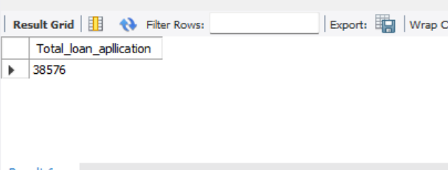
2.MTD loan application
SELECT COUNT(id) AS MTD_Total_loan_application
FROM financial_loan
WHERE issue_date BETWEEN '01-01-2021' AND '31-12-2021';
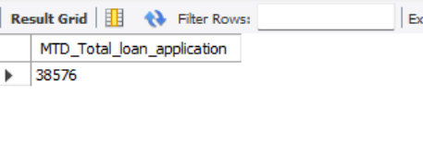
3.PMTD loan applications
SELECT COUNT(id) AS PMTD_Total_loan_application
FROM financial_loan
WHERE issue_date BETWEEN '01-11-2021' AND '30-11-2021';
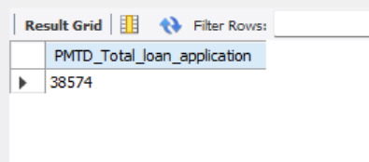
4.Total funded Amount select sum(loan_amount) AS Total_Funded_amount from financial_loan;
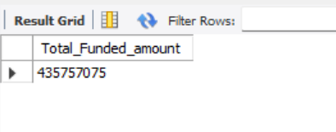
5.MTD total funded amount
SELECT SUM(loan_amount) AS mtd_Total_Funded_amount
FROM financial_loan
WHERE STR_TO_DATE(issue_date, '%d-%m-%Y') BETWEEN '2021-12-01' AND '2021-12-31';
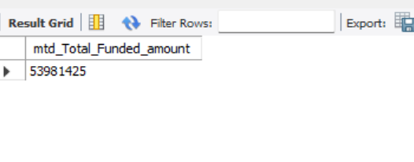
6.pmtd total funded amount
SELECT SUM(loan_amount) AS pmtd_Total_Funded_amount
FROM financial_loan
WHERE STR_TO_DATE(issue_date, '%d-%m-%Y') BETWEEN '2021-11-01' AND '2021-11-30';
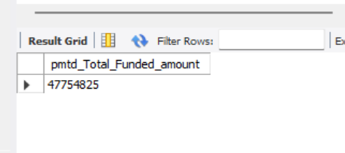
7. Total amount received
select sum(total_payment) as total_amount_received from financial_loan;
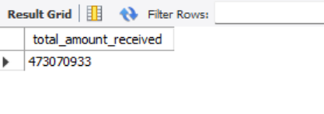
8. Mtd total amount received
select sum(total_payment) as mtd_total_amount_received from financial_loan
where str_to_date(issue_date ,' %d-%m-%Y') between '2021-12-01' and '2021-12-31';
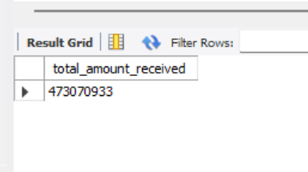
9. Pmtd total amount received
select sum(total_payment) as pmtd_total_amount_received from financial_loan
where str_to_date(issue_date ,' %d-%m-%Y') between '2021-11-01' and '2021-11-30';
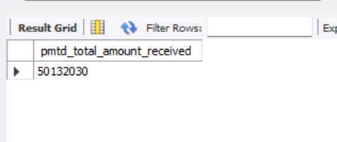
10 . Avg interest rate
select avg(int_rate)*100 As avg_interest_rate from financial_loan;
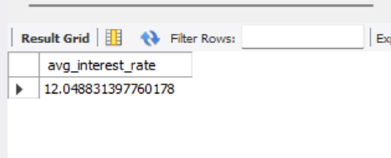
11. Mtd average interest rate select round(avg(int_rate), 4)*100 As mtd_avg_interest_rate from financial_loan
where str_to_date(issue_date ,' %d-%m-%Y') between '2021-12-01' and '2021-12-31';
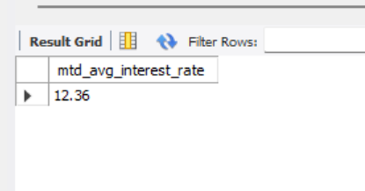
12 Pmtd Average Interest Rate
select round(avg(int_rate), 4)*100 As pmtd_avg_interest_rate from financial_loan
where str_to_date(issue_date ,' %d-%m-%Y') between '2021-11-01' and '2021-11-30';
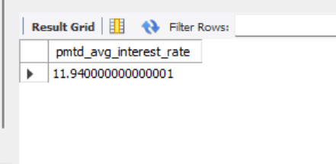
13. Avg Dti
select round(avg(dti) , 4)*100 as avg_dti from financial_loan;
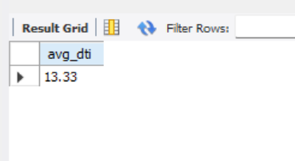
14. MTD Avg DTI
select round(avg(dti),4)*100 as mtd_avg_dti from financial_loan
where str_to_date(issue_date , '%d-%m-%Y') between '2021-12-01' and '2021-12-31';
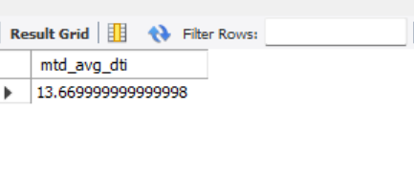
15.PMTD Avg DTIselect round(avg(dti),4)*100 as pmtd_avg_dti from financial_loan
where str_to_date(issue_date , '%d-%m-%Y') between '2021-11-01' and '2021-11-30';
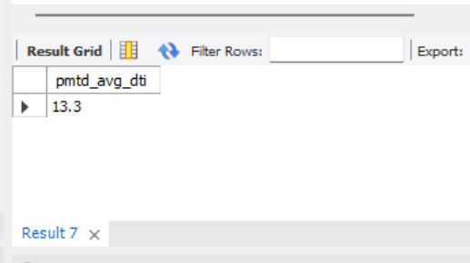
16. Good Loan Percentage
select
(count(case when loan_status = 'Fully Paid' or loan_status = 'Current' then id end)*100)/
count(id) as good_loan_percentage
from financial_loan;
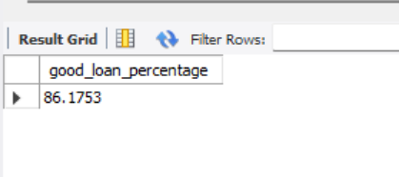
17. Good Loan Applications
select count(id) as good_loan_applications from financial_loan
where loan_status = 'Fully Paid' or loan_status = 'Current'
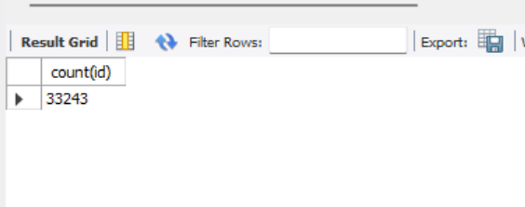
18.Good Loan Funded Amount select sum(loan_amount) as good_loan_funded_amount from financial_loan
where loan_status = 'Fully Paid' or loan_status = 'Current';
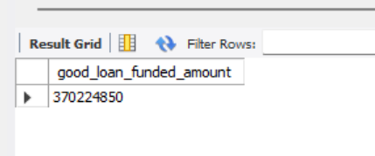
19. Good Loan Received Amount
select sum(total_payment) as good_loan_received_amt from financial_loan
where loan_status = 'Fully Paid' or loan_status = 'Current';
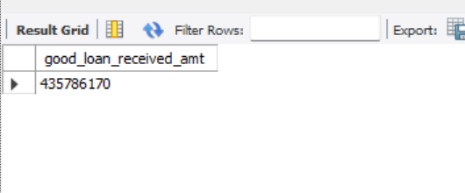
20. Bad Loan Percentage
select
(count(case when loan_status = 'Charged Off' then id end )*100.0) /
count(id) as bad_loan_percentage
from financial_loan;
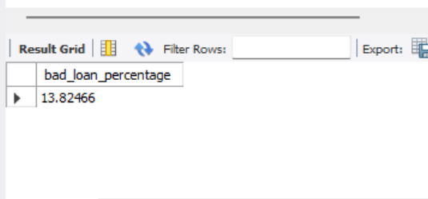
21 . Bad loan Applications
select count(id) as bad_loan_applications from financial_loan
where loan_status= 'Charged Off';
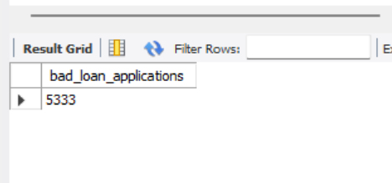
22. Bad loan funded amount select sum(loan_amount) as bad_loan_funded_amount from financial_loan
where loan_status = 'Charged Off' ;
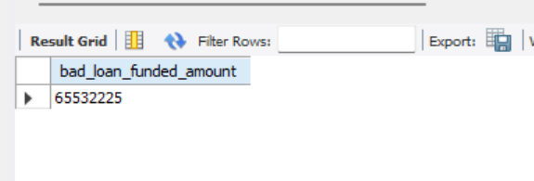
23. Bad loan Amount Received
select sum(total_payment) as bad_loan_amount_received from financial_loan
where loan_status = 'Charged Off' ;
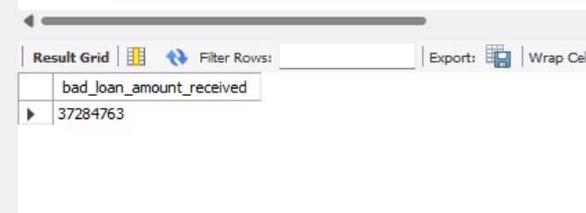

24. select
loan_status,
count(id) as total_loan_applications ,
sum(total_payment) as total_amount_received,
sum(loan_amount) as total_funded_amount,
avg(int_rate*100) as interest_rate,
avg(dti*100) as DTI
from
financial_loan
group by
loan_status;
25. select loan_status ,
sum(total_payment) as mtd_total_amount_received ,
sum(loan_amount) as mtd_total_funded_amount
from financial_loan
where str_to_date(issue_date , '%d-%m-%Y') between '2021-12-01 ' and '2021-12-31'
group by loan_status;

Overview dashboard
26.SELECT
MONTH(STR_TO_DATE(issue_date, '%Y-%m-%d')) AS month_number,
MONTHNAME(STR_TO_DATE(issue_date, '%Y-%m-%d')) AS month_name,
COUNT(id) AS total_loan_applications,
SUM(loan_amount) AS total_funded_amount,
SUM(total_payment) AS total_received_amount
FROM financial_loan
WHERE issue_date IS NOT NULL
GROUP BY MONTH(STR_TO_DATE(issue_date, '%Y-%m-%d')), MONTHNAME(STR_TO_DATE(issue_date, '%Y-%m-%d'))
ORDER BY MONTH(STR_TO_DATE(issue_date, '%Y-%m-%d'));

27.select address_state ,
count(id) as Total_loan_applications ,
sum(loan_amount) as total_funded_amount ,
sum(total_payment) as total_received_amount
from financial_loan
group by address_state
order by address_state;

