Objective Questions

1. **What is the total no. of tables present in the data?**

2 tables – Raw Data and Country Description.

1. **What is the total no. of attributes present in the data?**

* 20 attributes in Raw Data
* 2 attributes in Country Description (country code is a common attribute present in both table

1. **How many categorical columns are there in the data? [Search about categorical and continuous data, and try to answer this question]**

* Categorical columns represent distinct groups, while continuous data refers to numerical columns (data that can be collected in decimals)
* The following columns are categorical:
  + Restaurant ID (unique ID which is not considered as a measure as we cannot apply calculations like sum, average on them)
  + Restaurant name
  + Country code (unique code for each country)
  + Country
  + City
  + Address
  + Locality
  + Locality/verbose
  + Cuisine
  + Has table booking
  + Has online delivery
  + Is delivering now
  + Switch to order menu

There are 13 categorical columns.

1. **The data consists of some inconsistent and missing values so ensure that the data used for further analysis is cleaned.**

**1. Identify Missing or Inconsistent Data**

* Use **Conditional Formatting**:
  1. Select the data range.
  2. Go to **Home → Conditional Formatting → Highlight Cells Rules → Blanks** to highlight missing values.
* Sort or filter columns to group blank or inconsistent values.

**2. Fill Missing Values**

**Fill with Default Values**

* **Text or Numeric Data**:
  1. Select the column with missing values.
  2. Use **Find & Select → Go To Special → Blanks**.
  3. Type a default value and press **Ctrl + Enter** to fill all blanks at once.

**3. Remove Duplicates**

* Use **Remove Duplicates**:
  1. Select your data range.
  2. Go to **Data → Remove Duplicates**.
  3. Choose columns that define duplicates and confirm.

1. **Using the LookUp functions, fill up the countries in the original data using the country code.**

This is done in ‘Country Description’ sheet.

The formula used for this purpose is:

= VLOOKUP(C2,'country description'!$A$1:$B$16,2)

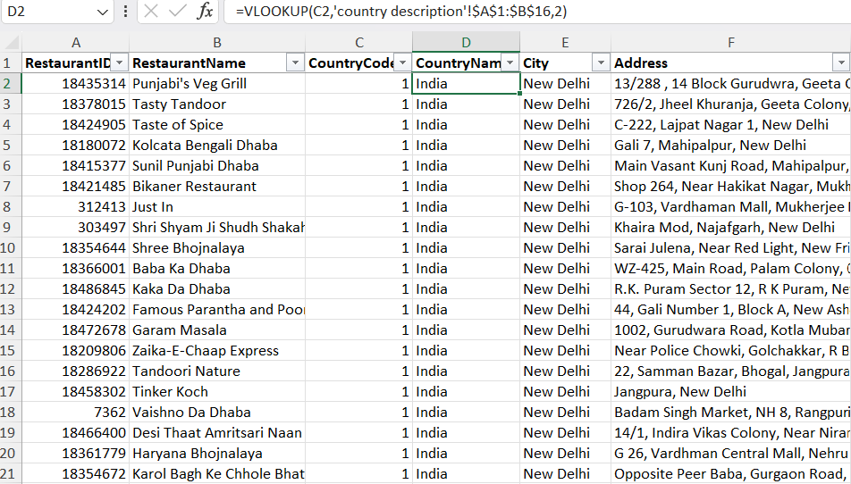

1. **Create a table to represent the number of restaurants opened in each country.**

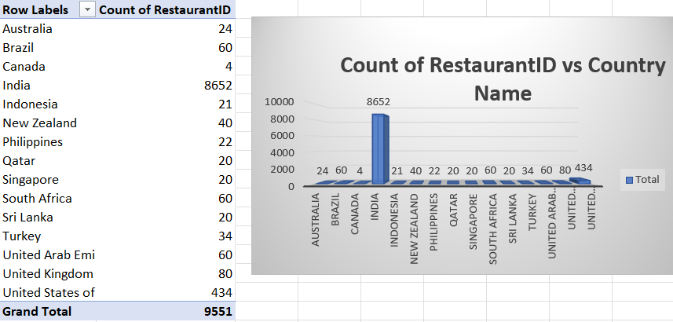

1. **Also, the management wants to look at the number of restaurants opened each year, so provide them with something here.**

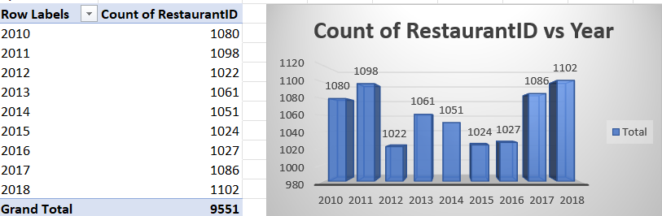

1. **What is the total number of restaurants in India in the price range of 4?**

There are a total of 388 restaurants in India in the price range of 4.

Approach-1: Create filters and count

Approach-2: =COUNTIFS('Raw Data'!D:D,"India",'Raw Data'!Q:Q,4)

1. **What is the average number of voters for the restaurants in each country according to the data?**

Refer to the following Pivot & Chart-

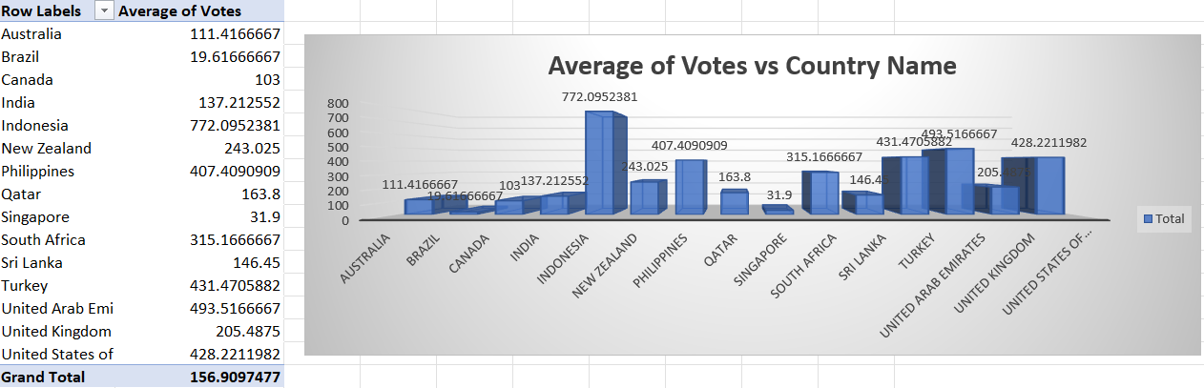

1. **Calculate the average rating for all the restaurants that have price_range < 4 and provide online delivery. Use only the “IF” function, Logical Operators, and Aggregation functions to solve this problem. [Note: Don’t use Conditional aggregation in this question.]**

The average rating for all the restaurants that have price_range < 4 and provide online delivery is 3.27381151

**Approach and Formulae used:**

=AVERAGEIFS('Raw Data'!T:T,'Raw Data'!Q:Q,"<4",'Raw Data'!N:N,"Yes")

1. **Using Conditional formatting highlight the rows of restaurants that are located in the countries or cities that you’ve suggested to the management for opening new restaurants.**

Criteria used to filter the preferred countries:

Has a rating>=4 (suggests popularity of restaurants, i.e. indicating the interest of population as well)

Has_Online_delivery as “Yes”

(Excluded India since it already has the highest number of restaurants)

Left with United States of Emirates

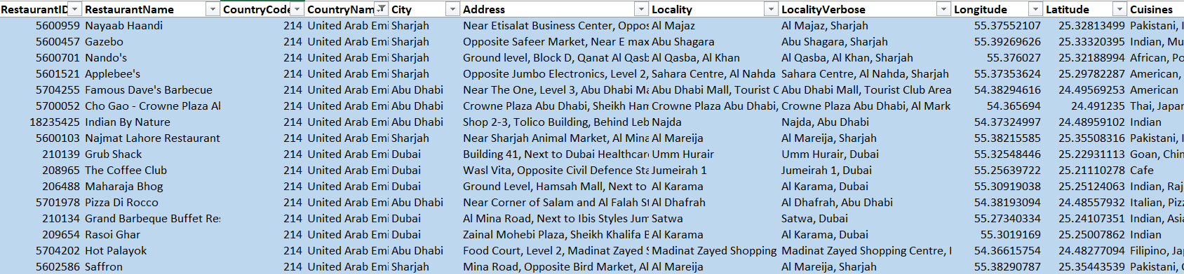

1. **Create a new customized price column that consists of the abbreviation/symbol of the currency along with the Average_cost_for_two value. [Use string operations to do this task]**

Refer to Column T of Sheet Raw Data

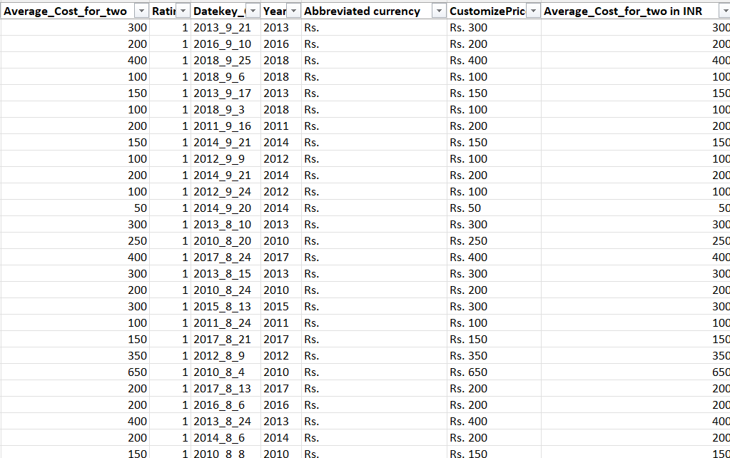

1. **How can you create an array formula in Excel or Google Sheets to count the number of restaurants listed that do not offer online delivery, are in the lowest price range, and have an average cost for two people less than or equal to 250 Indian Rupees?**

{ =COUNTIFS('Raw Data'!N:N,"No",'Raw Data'!Q:Q,"1",'Raw Data'!Y:Y,"<=250") }

1694

Subjective Questions

1. **Suggest a few countries where the team can open newer restaurants with lesser competition. Which visualization/technique will you use here to justify the suggestions?**

**Reference:**

Sheets – Pivots and Dashboard

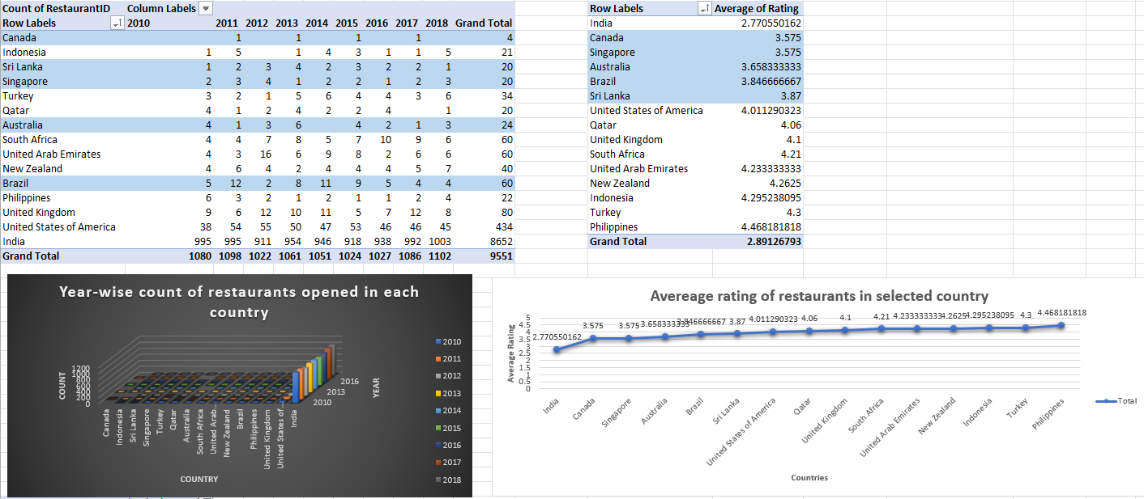

**Approach Used:**

Spot the countries with lesser competition are as follows:

* Countries with lesser number of restaurants
* Countries with low rating of restaurants

**Insights:**

A few countries where the team can open newer restaurants with lesser competition are as follows

1. Canada
2. Sri-Lanka
3. Singapore
4. Brazil
5. Australia

**Suggestions:**

The team should open restaurants in countries with a smaller number of restaurants with low ratings and high votes. The new restaurants can offer online delivery and table booking to cater

1. **Come up with the names of States and cities in the suggested countries suitable for opening restaurants.**

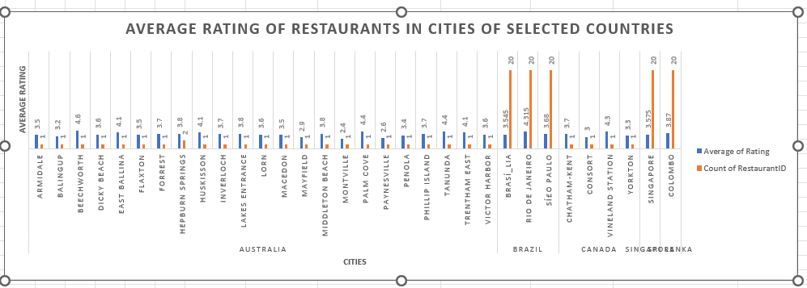

**Approach Used:**

Created a pivot table (cities grouped by countries in rows, count of restaurants in values)

Chose cities with rating around 3 or less.

**Insights:**

Montville, Paynesville, Mayfield, Penola in Australia and Consort in Canada, Singapore, Brasí_lia in Brazil and Colombo in Sri Lanka have less number of restaurants, that too with rating less than equal to 3.

**Suggestions:**

Montville, Paynesville, Mayfield, Penola in Australia and Consort in Canada, Singapore, Brasí_lia in Brazil and Colombo in Sri Lanka are some good options for opening restaurants as they have only one restaurant, that too with rating around 3 or less (suggesting low competition).

1. **According to the countries you suggested, what is the current quality regarding ratings for restaurants that are open there?**

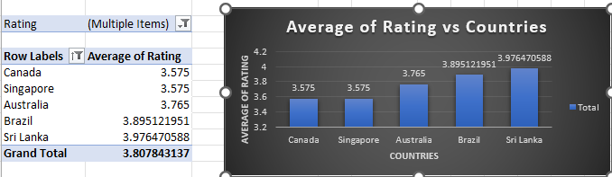

**Approach Used:**

Created a pivot table (rows- countries, values – average ratings)

Filter out selected countries

**Insights:**

The average rating of restaurants opened in the selected countries ranges from 3 to 4.5.

**Suggestion:**

To match the quality standards, the new to-be opened restaurants must target rating of 4.5

1. **Also, what is the current expenditure on food in the suggested countries, so we can keep our financial expenditure in control?**

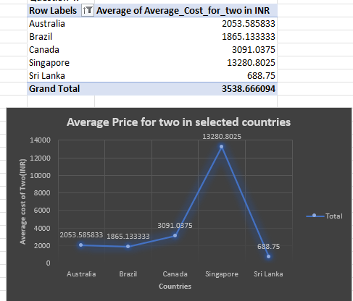

**Approach Used:**

Converted Average cost of two in restaurants into INR for comparison. Filtered out the selected countries to check the current expenditure on food.

**Insights:**

Out of the selected countries, Brazil, Sri-Lanka and Australia seem to have average cost of two in restaurants as <= INR2000. The highest average cost of two can go up to INR 14000 in Singapore.

**Suggestions:**

The expenditure on food in the selected countries is apparently lower than most of the other countries, hence financial expenditure can be kept in control.

1. **Come up with the names of restaurants from the recommended states that are our biggest competitors and also those that are rated in the lower brackets, i.e. 1-2 or 2-3.**

Our Biggest competitors according to the rating is greater than 4.

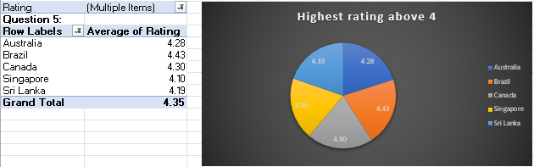

Our least competitors according to the rating in between 1 – 2.

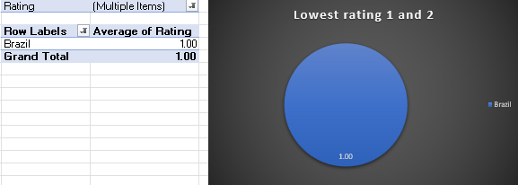

Our least competitors according to the rating in between 2 – 3.

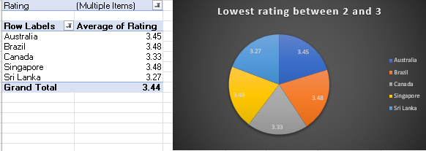

1. **Which cuisines should we focus on in the newer restaurants to get better feedback? Does the choice of cuisines affect the restaurant ratings?**

According to suggested country recommend the Cuisines having rating greater than 4.

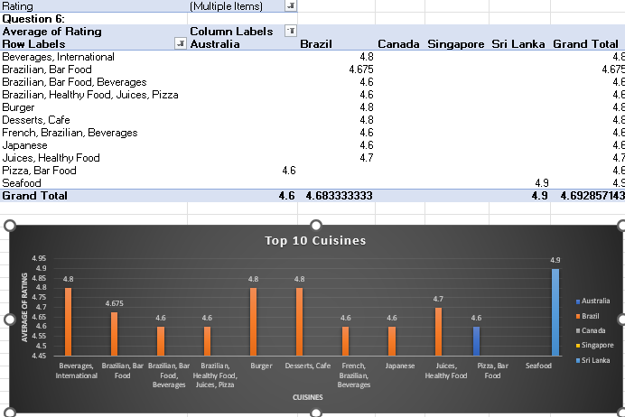

**Approach Used:**

Create a Pivot Table, select Cuisines as Rows and Average of Rating in Values. Apply individual filter out the selected countries with Rating > 4.

**Insights:**

We focus on Top 10 cuisines according to selected country. Yes, the choice of cuisines does affect the restaurant ratings to some extent.

**Suggestions**:  
To narrow down the cuisine option, we can conduct a survey to identify the most popular local cuisine in the selected cities.

1. **According to our current data, should we go for online delivery and table booking? Does that affect the customer’s ratings?**

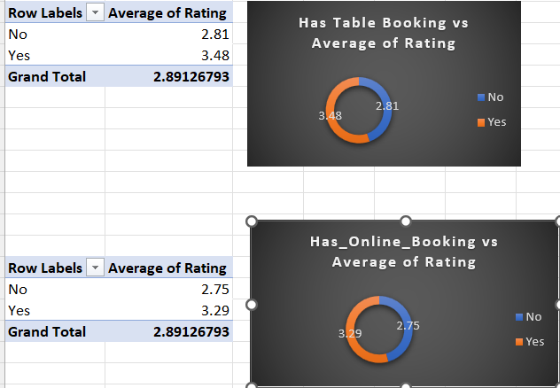

* **Insights:**
* Restaurants with online delivery have a higher average rating compared to others. This suggests that offering online delivery services can enhance customer satisfaction and overall ratings.
* Similarly, restaurants that provide table booking options have a higher average rating compared to those that don’t. This indicates that customers value the convenience of reserving a table.
* **Recommendations:**
* It is evident in the charts that restaurants that provide online deliveries and table bookings receive a higher rating than those that don’t.
* Considering this it is recommended to provide delivery options with the help of popular delivery platforms and offer table booking through websites or apps. Not only in new restaurants but also in existing ones. Implementing these features across all locations can improve customer satisfaction and the overall ratings.

1. **Should the team keep the rate of cuisines higher? Will that affect the feedback? According to our data are the rates of cuisines and ratings, correlated?**

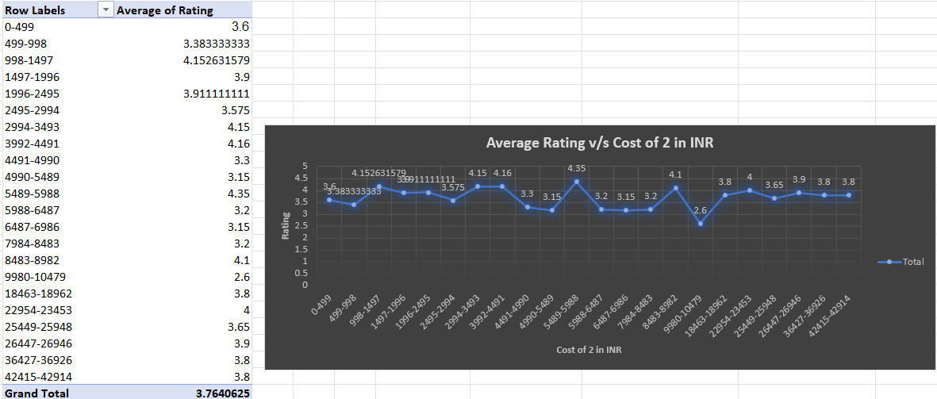

**Approach Used:**

Create a Pivot Table keeping Cost of two in INR in Rows and Average Rating in Values. Apply filter on the pivot table for the selected cities. Use correlation function to find the correlation between average rating and cost of 2 in INR. The formula used is as follows-

**=** **CORREL('Raw Data'!T:T,'Raw Data'!Y:Y)**

Alternative way to find correlation: Data > Data Analysis > Correlation > [Select range of data and output to evaluate correlation coefficient].

**Insights:**

The ratings based on the average cost of two in INR slightly differs from each other . Hence, it can be said that the rates of cuisines are not much correlated. The correlation between rating and average cost of two in INR is **0.298807**. This shows that the rating is not really affected by the rates of cuisines.

**Suggestions:**

No, the team should not keep the rate of cuisines higher. It might affect the votes or feedback. However, according to our data, the rates of cuisines and ratings are not correlated as the rating is almost constant over the range of cuisine price.

1. **What is the distribution of the number of restaurants of different price ranges in all the countries?**

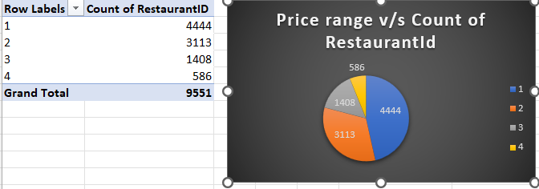

**Approach Used:**

Create a Pivot Table, keep Price Range in Rows and Count of Restaurant IDs in Values.

**Insights:**

Maximum restaurants are in the Price Range of 1. There are very less restaurants in Price Range 4.

**Suggestions:**

Opening restaurants in the price range of 1-2 would help us attract a large clientele since we know that majority of the market is between these ranges.

Opening restaurants in higher price range like 3-4 would cater to a small audience, offering unique and special dining experience with good quality food may help attract this clientele as they are willing to pay for better experience.

1. **Explain your approach in brief for suggesting countries/cities in order to open new restaurants, if the objective and subjective questions would have not been given to assist you**. **[you have to give bullet pointers in order to answer this question]**

I would have gone for the following approach-

* Define objective of opening new restaurant
* Identify the countries with least no. of restaurants
* Identify countries with highest ratings (if objective is to select a country with peaking food interest)
* Identify countries with lowest ratings (if objective is to select a country with low competition)
* Identify if there is any correlation of cuisine and rating. If there is no correlation, will identify the city with least variety of cuisines
* Identify the cities having restaurants with minimum price range and maximum price range. Select the city based on defined objective and expenditure

**The dashboard must consist of Year-wise and country slicers.**

